2. <https://ctflearn.com/challenge/138>

Help! I can't open this file. Something to do with the file header… Whatever that is. <https://mega.nz/#!aKwGFARR!rS60DdUh8-jHMac572TSsdsANClqEsl9PD2sGl-SyDk>

Solution

Firstly, I downloaded the file from the provided link and checked the File Extension to determine the type of file it is.

Since the issue is related to the file header. This could mean that the file's header is corrupted or doesn't match the expected format for the file type.

Using a hxd editor to allow me to view and edit the binary content of a file. There seem to be anomalies in the header section of the file.

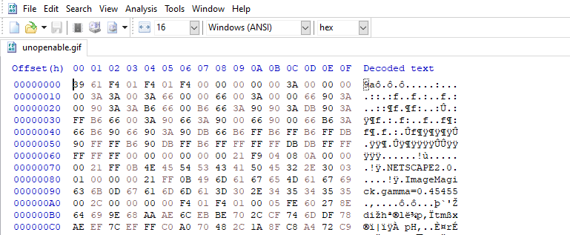

Researching the File Format of a GIF online, I corrected the header to contain the bytes ‘47 49 46 38’ which were missing in the original file.

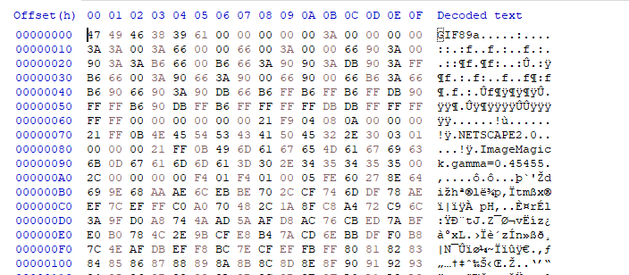

I exported the file as openable.gif and using the online tool <https://ezgif.com> I exported the .gif into frames.

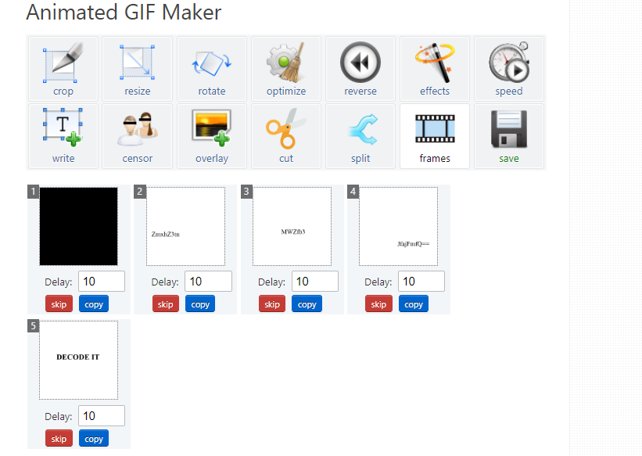

This revealed a base64 string ‘ZmxhZ3tnMWZfb3JfajFmfQ==’

Using my terminal, I converted to the base64 string to reveal the flag

flag{g1f_or_j1f}

