2.4 https://play.picoctf.org/practice/challenge/44?category=4&pag

e=1

### **Glory of the Garden**

Author: jedavis/Danny

#### **Description**

This [garden](https://jupiter.challenges.picoctf.org/static/43c4743b3946f427e883f6b286f47467/garden.jpg) contains more than it seems.

Solution.

I downloaded the picture and examine it by running the command exiftool garden.jpg

To check the meta data and other information about the picture.

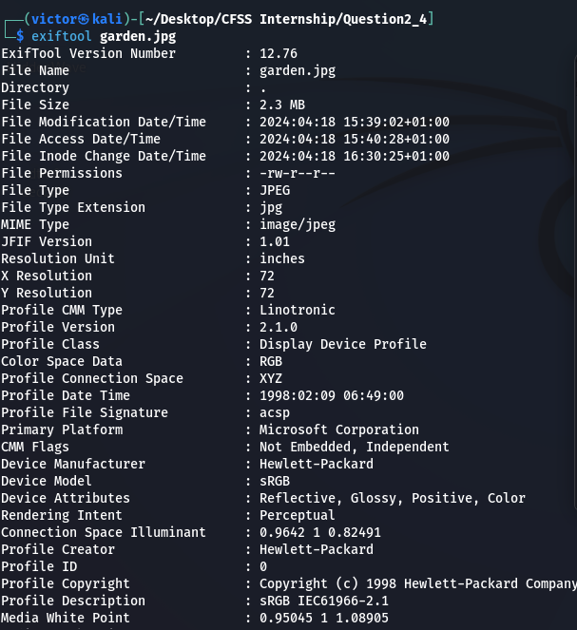

I couldn’t find the flag so i ran the **hexedit garden.jpg**

This command gave the hex values of the file, so to streamline to text contained i ran the command **strings -ao garden.jpg**

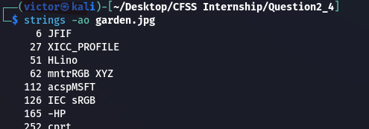

Copied the flag

picoCTF{more_than_m33ts_the_3y3657BaB2C}

And submitted

