2.5. <https://play.picoctf.org/practice/challenge/26?category=4&page=3>

### **m00nwalk**

#### **Description**

Decode this [message](https://jupiter.challenges.picoctf.org/static/d6fcea5e3c6433680ea4f914e24fab61/message.wav) from the moon.

Hint1: How did pictures from the moon landing get sent back to Earth?

Hint2: What is the CMU mascot?, that might help select a RX option

Solution

Solution:

Nothing meaningful can be identified by listening to the file. Also visualizing the file didn't lead anywhere. The hint suggests that this is related to how images from the moon landing were transmitted back to earth. Some research leads to SSTV.

I ran the following commands:

**apt-get install qsstv**

**pactl load-module module-null-sink sink_name=virtual-cable**

**pavucontrol**

# A GUI will pop-up, go to the "Output Devices" tab to verify that you have the "Null Output" device

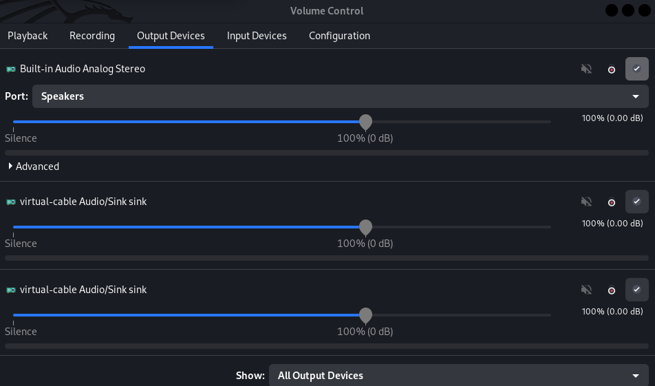

qsstv

# The program GUI will pop-up, go to "Options" -> "Configuration" -> "Sound" and select the "PulseAudio" Audio Interface

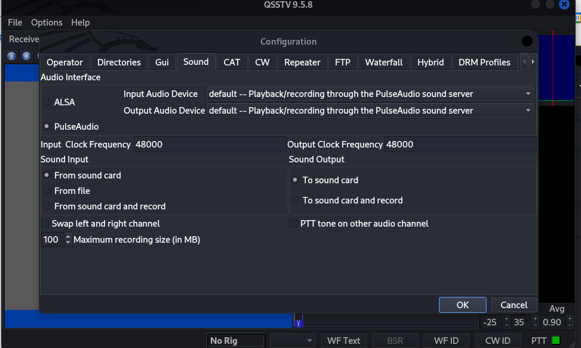

# Back in the pavucontrol GUI, select the "Recording" tab and specify that QSSTV should capture audio from the Null Output

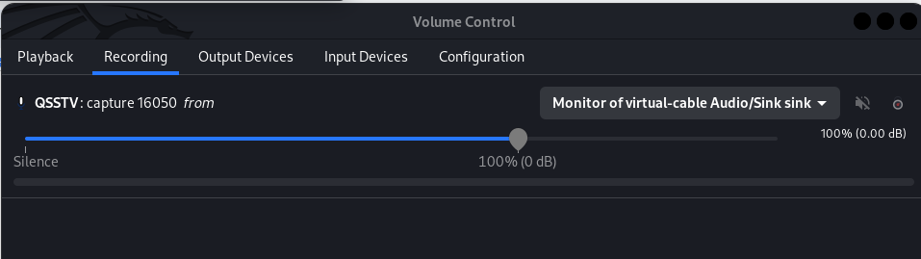

The hint asked "What is the CMU mascot?" - the answer is "Scotty the Scottie Dog". This hinted that we should select "Scottie 1" as QSSTV's "Mode". I also had to select "Auto Slant" via trial and error.

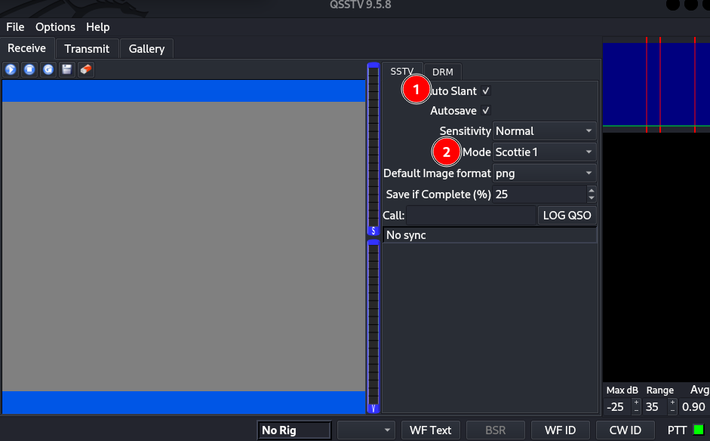

At this point we can click the "Play" button in QSSTV to start the receiver, and then play the audio file by running this command

paplay -d virtual-cable message.wav

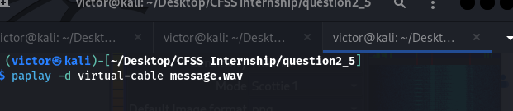

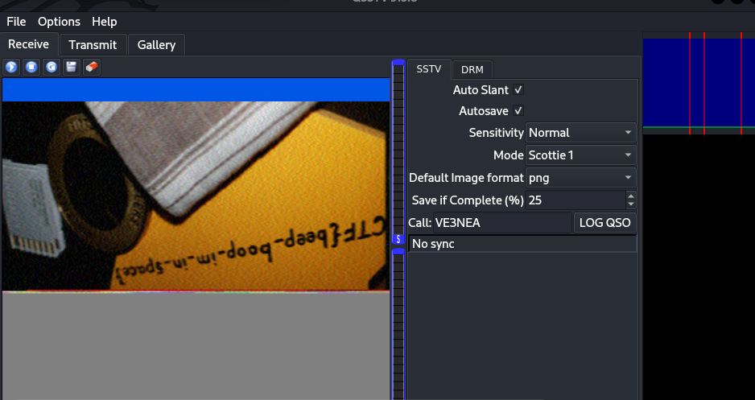

picoCTF{beep_boop_im_in_space}