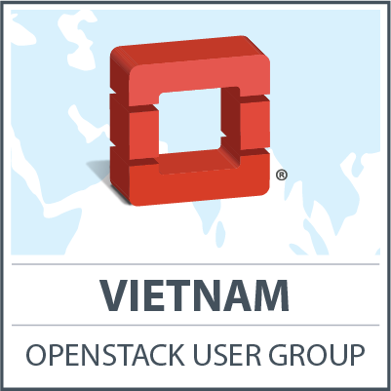



Advisors

Users

DevOps

VietOpenStack