Module Timesheet

Current version **4.0.0**

Dolibarr minimum version : **3.5.6**

Dolibarr latest version tested : **8.0.4**

Author: Patrick Delcroix [contact@pmpd.eu](mailto:contact@pmpd.eu)

Table des matières

1. Prerequisites: 2

• Other module 2

• Project created and validated 2

• Project open 2

• Task created and open 2

• User assigned to the task 2

2. Module setup 3

• How to access the setup page 3

• Setup page 3

• Setup page: General Tab 3

• Setup Page: Advanced tab 4

• Setup page: Invoice tab 4

3. Entering time spent 5

• Blank/draft/saved timesheet: 5

Notes: 5

• Submitted timesheet 6

• Timesheet approved 6

• Timesheet rejected 7

• Timesheet challenged 7

4. Chronos page 7

5. Favourite 8

• Favourite list 8

• New favourite item 8

6. Approval: 8

• Timesheets rights 9

• Timesheet approval: team leader 9

Timesheet approval: other 11

User report 12

• User report: Normal layout: 12

• User report: Export friendly layout 12

• User report: Short layout 12

7. Project report 12

• Project report: Normal layout 13

• Project report: Export friendly layout 13

• Project report: Short layout 13

8. Project Invoice 14

• First invoice step: the general project’s invoice parameters 14

• Second Invoice step: assignation of service to each time spent group 14

9. Attendance sheets 15

10. Timesheet approval admin access 16

• Timesheet approval admin list 16

• Timesheet approval admin details 16

• Timesheet approval admin edit 16

11. Timesheet Attendance admin access 17

Note: this module is not able to do any changes to invoices; the only invoice related action possible is the creation of a draft invoice by using the Dolibarr core methods (there is no invoice related database request in the module)

# Prerequisites:

## Other module

Project module must be activated (should be automatically activated upon timesheet activation)

## Project created and validated

draft project won’t be shown by default but they can be shown by changing the module configuration (see setup page part)

## Project open

Timespent entry is only possible if date of the entry is between start and end date of the project; no start date mean that the project’s task will be shown until the end date; no end date means that the project’s task will be always shown after the start date

## Task created and open

Timespent entry is only possible if date of the entry is between start and end date for the task. No start date mean that the task will be shown until the end date; no end date means that the task will be always shown after the start date

## User assigned to the task

in order to assign a user to a task he must be first assign to the project via Project→contact Project. Then he can be assigned to the task : Task > resource assignation.

# Module setup

## How to access the setup page

The module setup can be found in the Home (top menu)>Setup (left Menu)>module

then on the timesheet line one must click on the icon at the right



## Setup page

The module setup page is made of 4 tabs, the changes are not lost while changing tab so to reset the changes one must reload the page. The “Other” tab won’t be detailed in this manual as it is mostly a feedback email link.

## Setup page: General Tab

This tab includes the setup that must be done after the module installation.

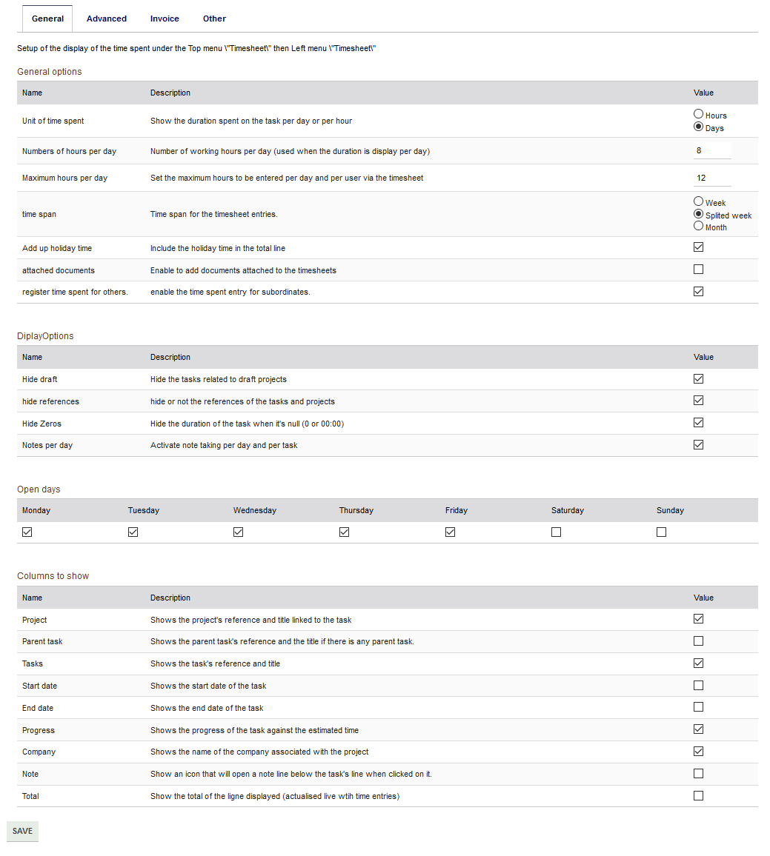

## Setup Page: Advanced tab

This tab is to setup advanced behaviour of the timesheet such as the favourite task or the approval flows, this one can be left unchanged

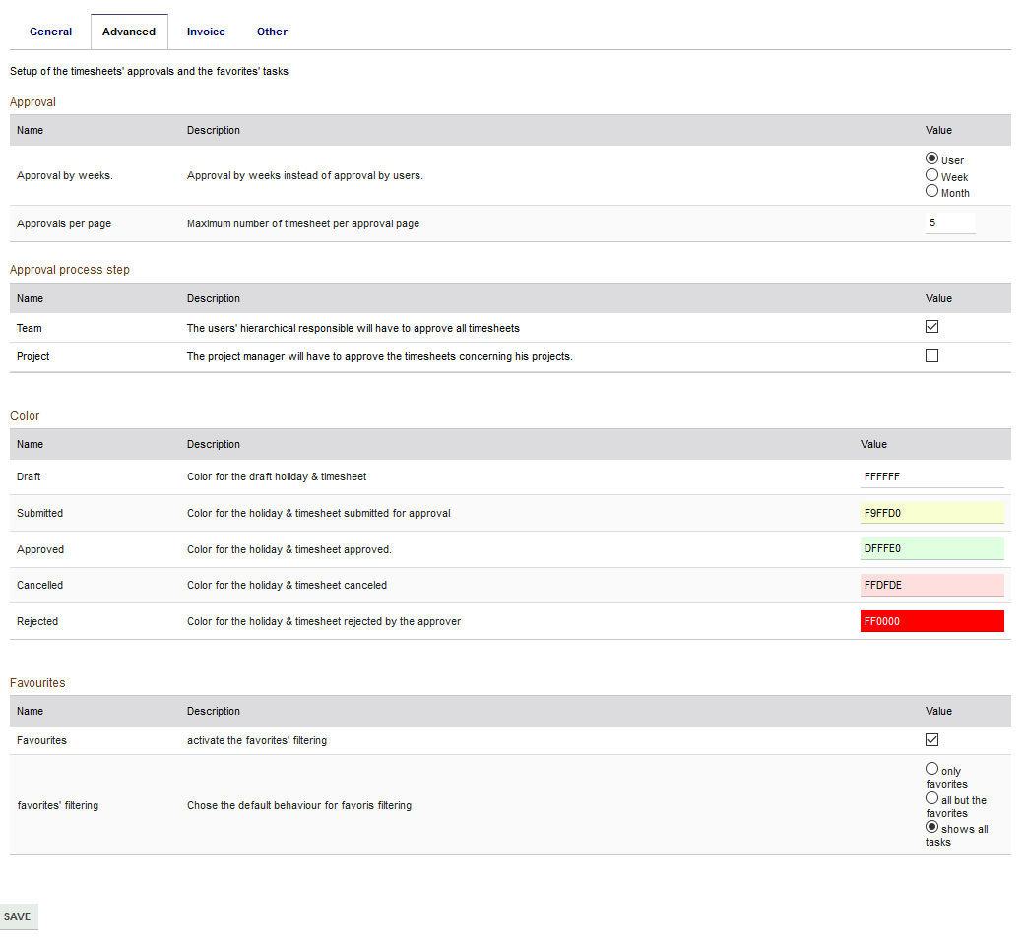

## Setup page: Invoice tab

This tab is to setup the default option in the invoice generation, the invoice generation is accessible from the project menu: either via the project report or via the Invoice Project Time left menu.

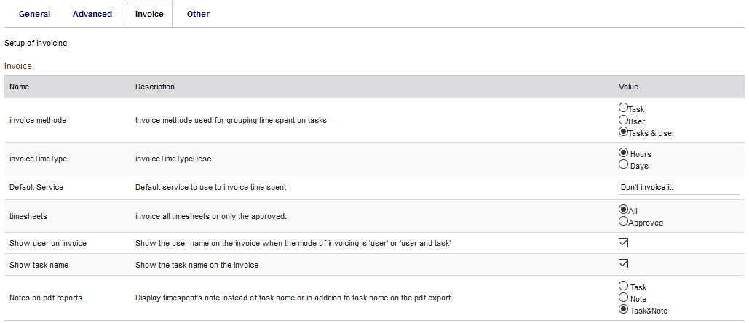

# Entering time spent

Timesheet user right is required to have access to timesheet

The default page of the timesheet main menu is the user screen to log the time spent on task (can be change to the chrono page in the setup). The screenshot was taken with the favourite, approval flow & note per day and note activated

## Blank/draft/saved timesheet:

This screen id shown when no timesheet where submitted for approval, if there is already time saved, the time will be on a light green background (not configurable) and the day/task that are not eligible for time spend are on a grey background (not configurable) and are not editable

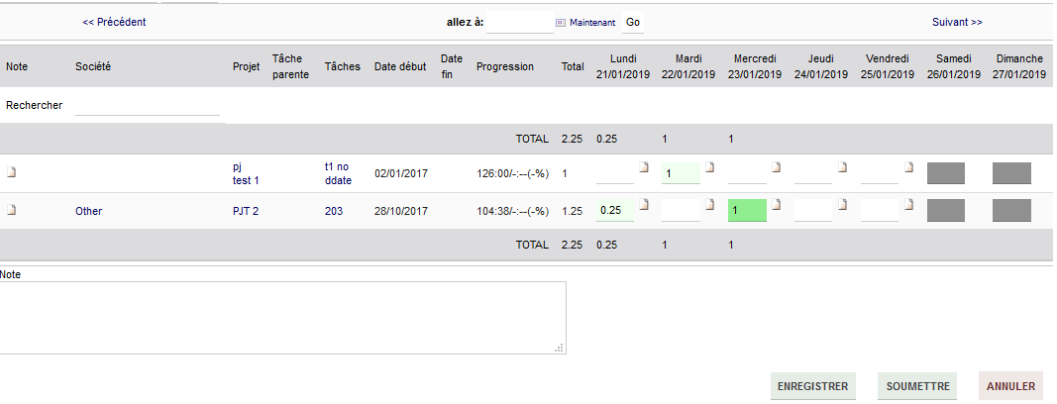Once filled in the timesheet can be save (the same layout will be used) and modified later or submitted for approval if the approval is set in the module configuration

the start is used to show and (un)set favourite by one click

## Notes:

There is 3 level of notes:

* User timesheet notes are per timesheet pages: might be useful for the team approver, those are the note in the bottom of the timesheet pages
* Task user timesheet note are per task line and per timesheet page: might be useful for the project approver, those are the note at the beginning of a line. Once open a modal box will open.
* Day notes are per day and task, those are saved in the core table: might be useful for the customer because they can be present on the attendance sheet, those are next to the time entry box

## Submitted timesheet

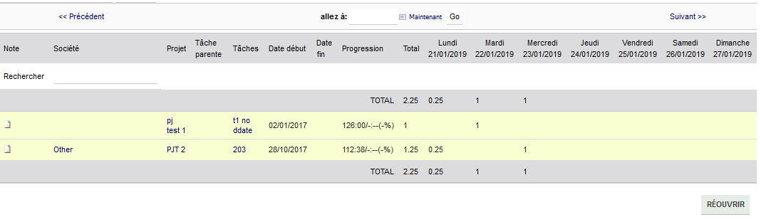

Once submitted, only the task with time spent entered when it was “submitted “will be shown, the colour of the line background enables to have a quick idea of the timesheet status (colours can be changed in the module config page).

The timesheet will also appear in the “timesheet to approve” of his managers ( N+1 & N+2 based on Dolibarr organization chart, the manager should also have the approver right Admin>User>Rights>timesheet>Approver)

The user can recall his timesheet to make change until the timesheet is approved

When the timesheet is under approval (eg. project approval activated), the user can no longer recall it but the layout & colour will remain the same.

## Timesheet approved

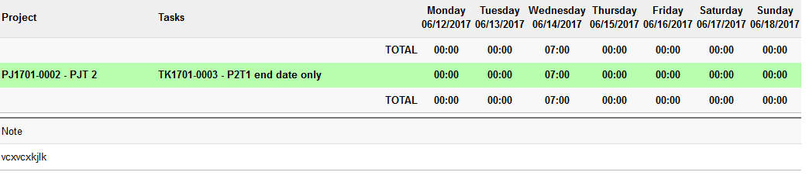

Once the timesheet is approved, the user can’t recall it anymore but he can still see what was approved (colours can be changed in the module config page). If for some reason the timesheet should be modified then it should be set back to draft via the timesheet admin view

## Timesheet rejected

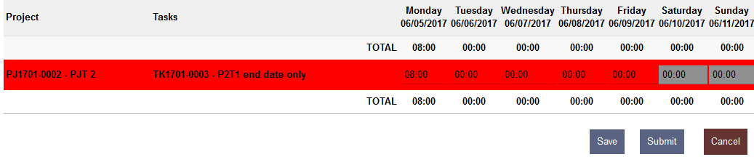The timesheet appears redetected (editable) only when the team leader will have rejected the timesheet, when a timesheet is challenged in the approval flow, it is sent back to the previous approval until the team leader rejected it (cf. challenged timesheet)

## Timesheet challenged

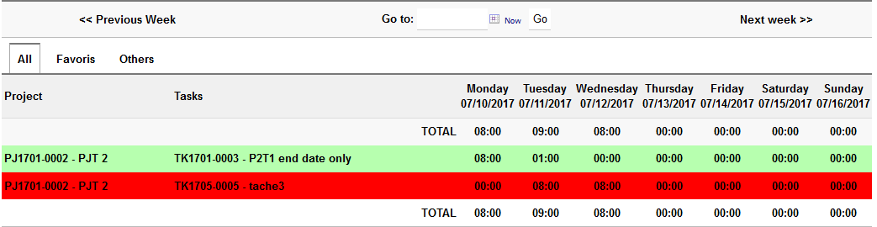During the approval flow a task of a timesheet could be challenged (eg. by the project lead) but the timesheet won’t be rejected directly, the decision remains on the team leader hand, the timesheet will appear again in the “timesheet to approved” and he could contact the project leader for more details.

# Chronos page

This page needs a special right attendance/chrono user right

This page aims to enable user to launch chrono to the task on which they are currently working.



the chrono could be started by clicking on the arrow next to the task



Then the task details will be shown on the chrono

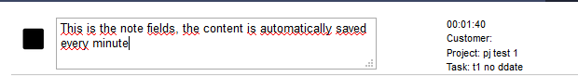

The chrono can be stop by clicking on the square next to the chrono or next to the task, starting the chrono for another task will automatically stop the running chrono for the user.

Once the chrono is stop the task and the time are added on the timespent for the day and task

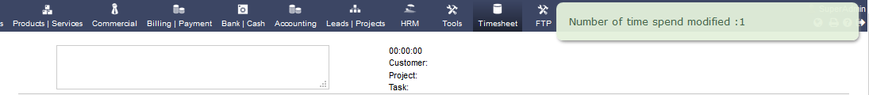

# Favourite

The favourite (white list & black list) enable a filtering the task list on the timesheet page so one can remove project/task from the default list

The behaviour can be set in the setup page: favourite, all but favourite or all by default

Additionally, there is an option for the deactivation of this feature.

## Favourite list

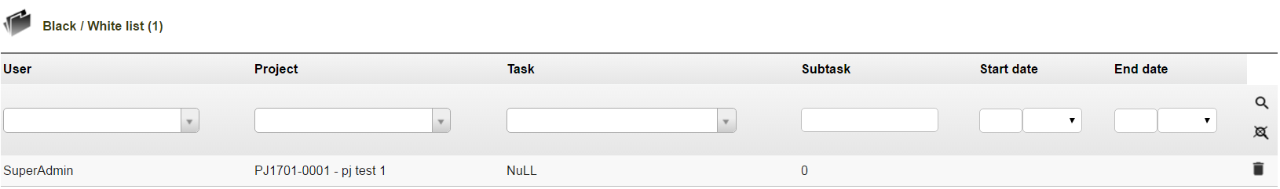

This view show the current favourite list, one can remove easily items if not needed anymore.

## New favourite item

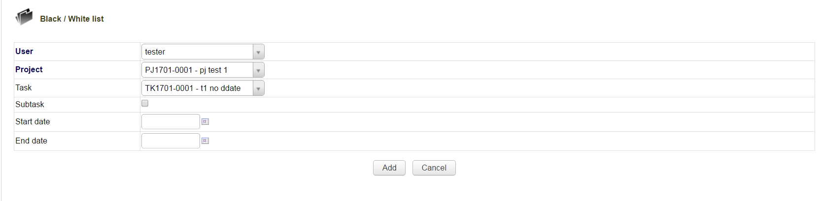

Add one item to the favourite list by setting those parameters:

**User:** user to whom the item will be applied, Admin can choose it but the normal user can only set favourite list for themselves

**Project / Task / subtask**: define the target of the favourite list item, only project is mandatory; to apply the item to a specific task and its subtask is optional;

**Start Date/ End date:** define the timesheet timespan when the item should be taken into account. No date means no time limits

# Approval:

There is two types of approvals; the team approval and the “other” approval, the difference is that the team approval shows all the tasks for a week and for one user when the other approval shows only the task that concern the approver ( ie. a project leader should only see the time spent on his projects not on the others.)

The timesheet module approval feature takes the assumption that the team leader is the responsible for the team resources management therefore only the team manager can send back the timesheet to the user.

In order to have access to approve his subordinate’s timesheets one should have the timesheet approver rights

## Timesheets rights

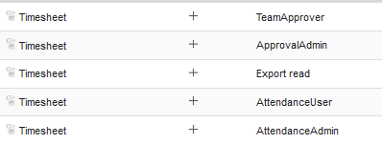

ApprovalAdmin can access approvals and favourites for all.

ExportRead enable the access to all files (pdf) generated by the module

TeamApprover enable the user to approve the timesheet of his subordinates.

AttendanceUser has access to the attendance page

AttendanceAdmin has access to attendance admin page

## Timesheet approval: team leader

The team approval screen can show the timesheet grouped per user, per week or per user/month, the maximum number of timesheets shown per page can be set in the module setup page.

Eg: timesheet per month.

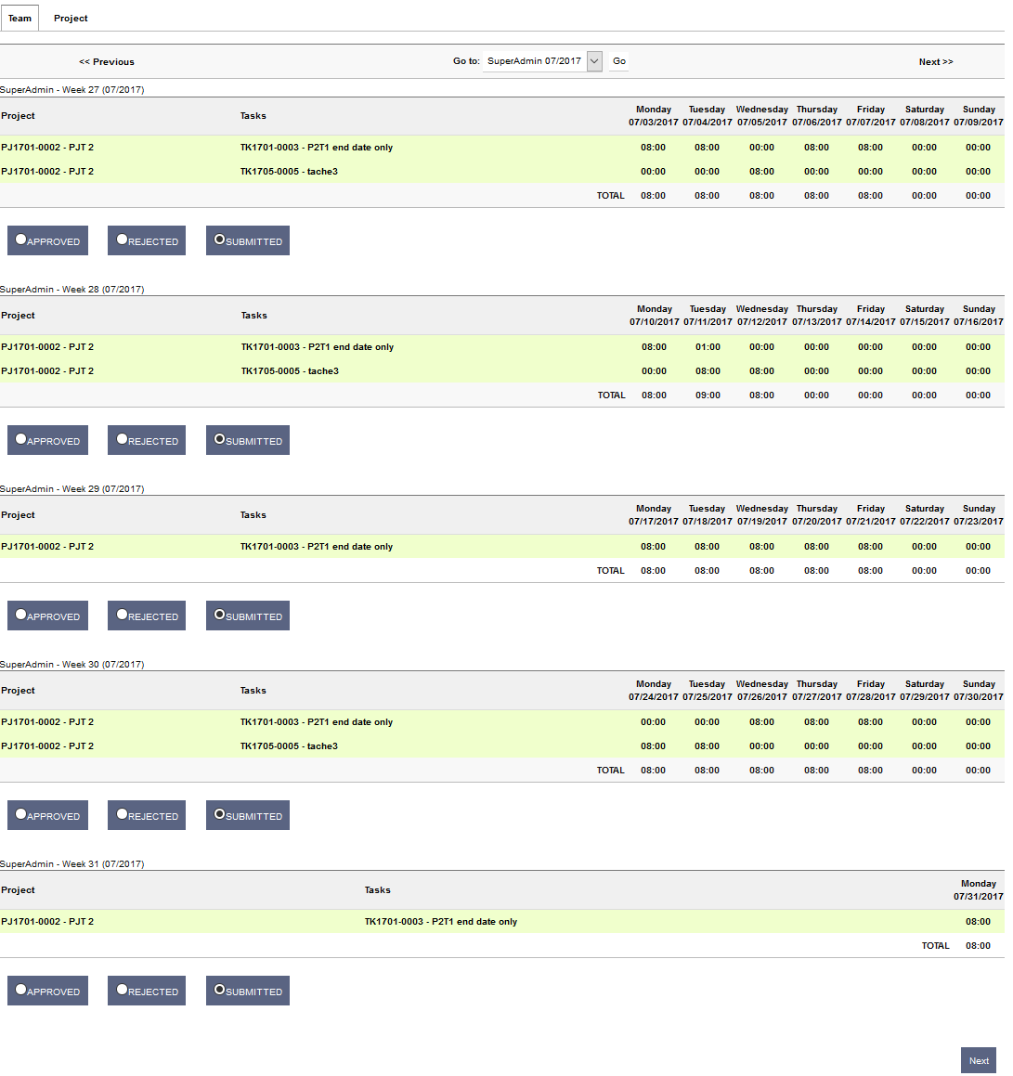

Timesheet approval: other

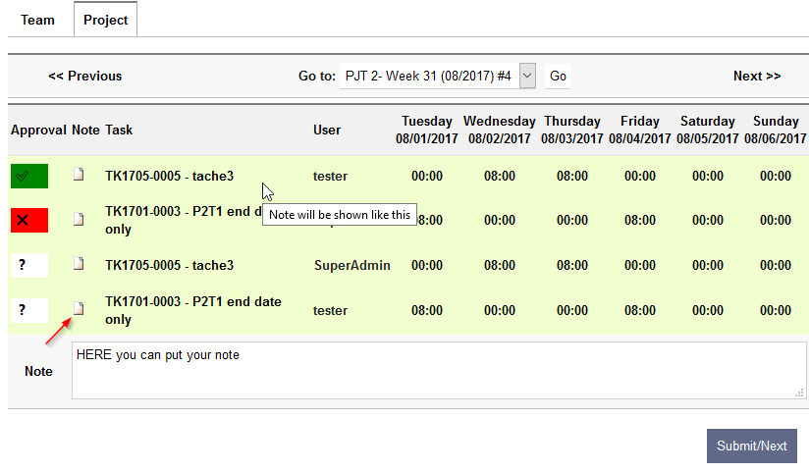The other approvals are showed by week, the number of item to approve is indicated by the ‘#’ in the drop down list.

The approval is done by line by clicking on the

* means no change,
*  means approved
* and mean rejected.

Note section will appear when the user will click on the icon in the note column, when a note is saved it will appear as an info as shown in the screenshot.

User report

A limited report by user is available by month (in timesheet main tab), several layouts are possible, if both short and export friendly are chosen then the export friendly will be shown.

Note: the search ribbon appears in every layout but only the normal layout screenshot shows it.

## User report: Normal layout:

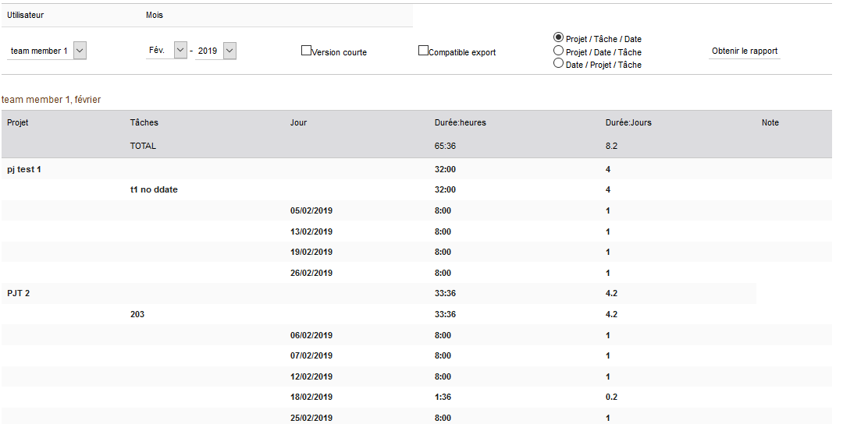

## User report: Export friendly layout

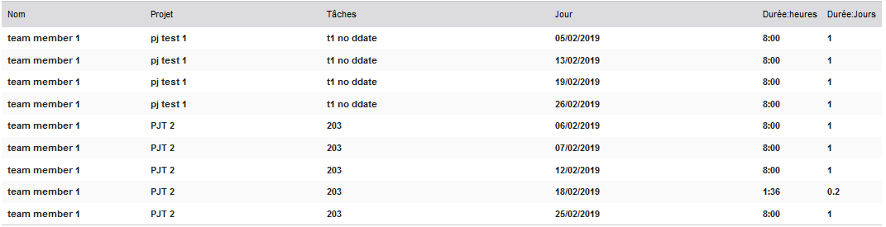

## User report: Short layout

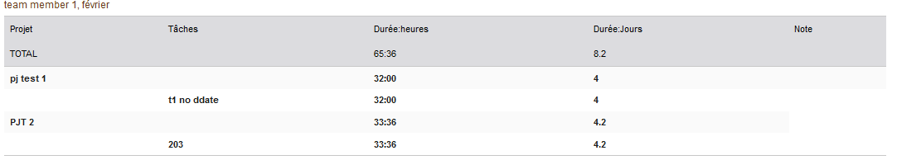

# Project report

A limited report by project is available by month (in project main tab), several layouts are possible like for user reports, once the report is generated,

* A button appears to start the invoice creation based on this report.
* A button appears to generate the attendances sheet related to the report generated.

Note: the search ribbon appears in every layout but only the normal layout screenshot shows it.

The “Only invoiceable task” option will take only the task that are defined as invoiceable in the task card.

## Project report: Normal layout

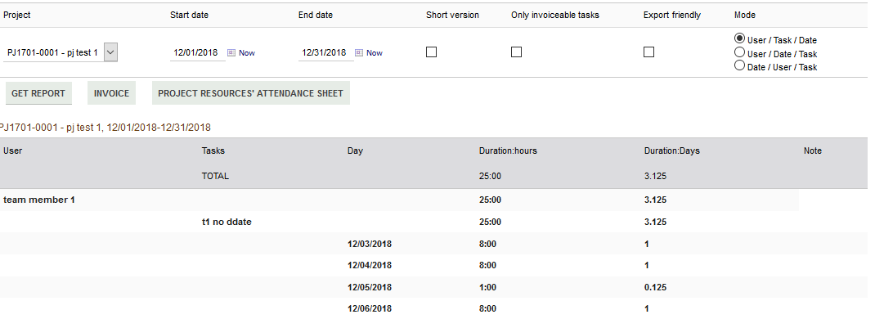

## Project report: Export friendly layout

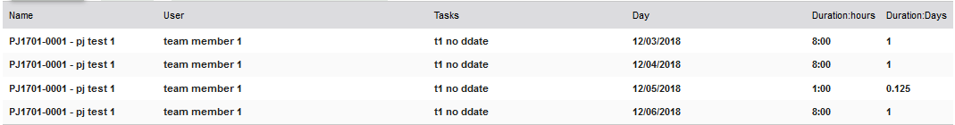

## Project report: Short layout

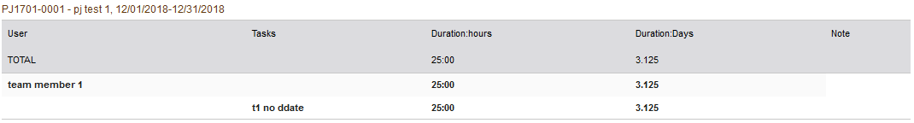

# Project Invoice

This module enables the creation of an invoice based on the time spent. The time spent can be grouped by user, by task or by user and task to convert the sum of the time spent in quantity of existing services, or one-time services (only for the invoice, not saved) or to not be invoiced.

**Prerequisite**: the user making the invoice must be part of the project, have right to make invoice and able to see the customer to bill.

In order to achieve it, there is two steps before the draft invoice creation.

## First invoice step: the general project’s invoice parameters

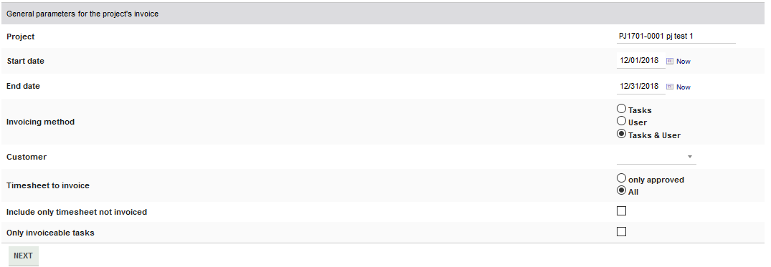 in this screen, the project, the dates, the customer, the grouping method, invoiceable task need to be defined, if one comes from the report the same value should be checked.

## Second Invoice step: assignation of service to each time spent group

This screen will define what will be shown in the invoice.

The “Existing” field

Services defined in Product/service menu could be used. This field is a search box, just typing text in it will fetch services with a name close to the text entered. the service consumption will be updated correctly as for a normal invoice where an existing service is used. This field can have a default value, this value can come from different places:

* If there is a default service defined on the **task** card, this one will be used
* if not and If there is a default service defined on the **user** card, this one will be used
* if not and If there is a default service defined on the **module setup**, this one will be used

the “New” fields

If something is entered in those fields then an ad-hoc service will be used with the price & VAT specified in the different columns.

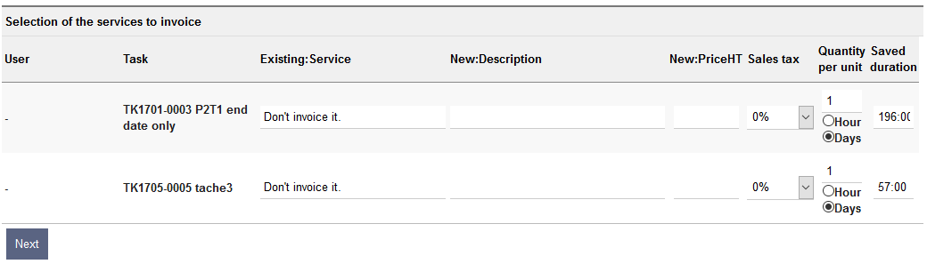The two last columns are used the generate the quantity of the service that will be invoiced. The duration of the time spent on task are shown in the column “Saved duration” and it will be converted base on quantity based on the Quantity per unit column. If day is selected, the calculation will use the hours per day set in the module setup page. The quantity is editable

Example:

196 hours, with 1 day (8 h) as Quantity per unit will make a quantity of 196/(1*8)= 24,5.

in the Latest Dolibarr, once the invoice is created the time spend will be linked to the invoice and invoice line (information not used today)

# Attendance sheets

From the project report, attendances sheets can be generated (only after the report is launch on a specific project and for a specific month and year.)

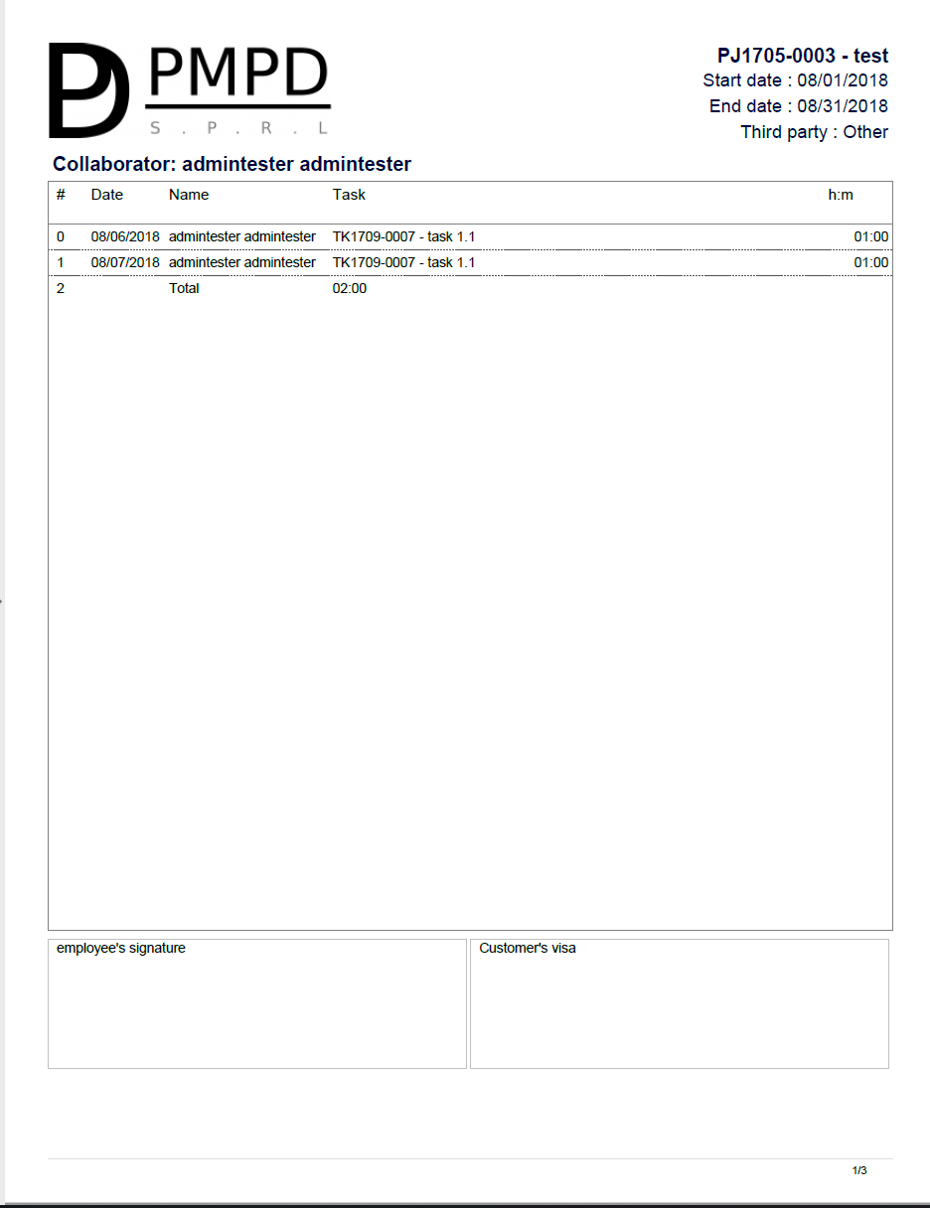

# Timesheet approval admin access

To be able to modify the status of the timesheet, an admin page is available (see the users rights screenshots in the Approval section), even if all fields are editable it’s not recommended to change anything beside the status and/or note (a task-time need to be in the correct week for the correct user to be taken into account in all the other screens)

## Timesheet approval admin list

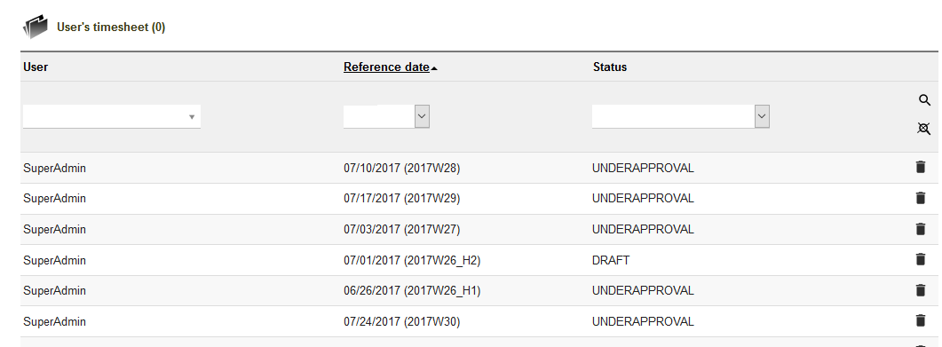

## Timesheet approval admin details

## Timesheet approval admin edit

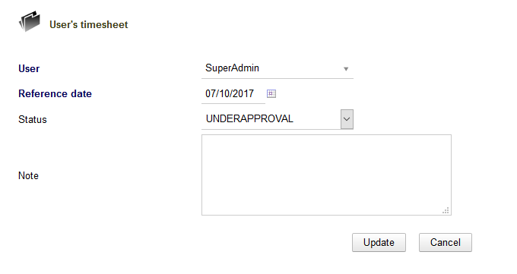

# Timesheet Attendance admin access

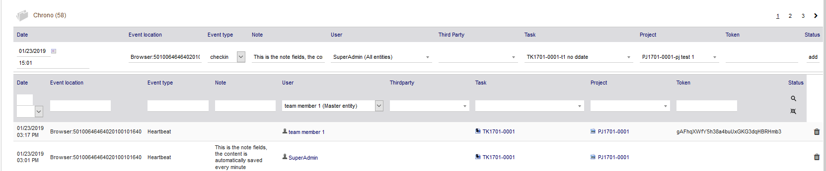

This screen can be used to correct a checkout time or to add a missing start or stop