1. In the below elements which of them are values or an expression? eg:- values can be integer or string and expressions will be mathematical operators.

* Ans: Expression

'hello' Ans: Value

-87.8 Ans: Value

- Ans: Expression

/ Ans: Expression

* Ans: Expression

6 Ans: Value

2. What is the difference between string and variable?

Ans: **String** - String is a data type. We can define a variable if it is string type.

**Variable** – It is used to stored / hold a value in memory.

For e.g. X= “India” 🡪 X is a **variable** which hold the **value** India which has data type as **string**.

3. Describe three different data types.

Ans: 1. String

2. Int

3. List

4. What is an expression made up of? What do all expressions do?

Ans: Expression is a combination of Operands and Operators which perform some logical operations and given output. Ex: 2+3 given 5. 2 and 3 are Operands and + is operator.

5. This assignment statements, like spam = 10. What is the difference between an expression and a statement?

Ans: In given assignment statement, the value 10 is assigned to spam.

Where in the expression some operation will be performed on operands in order to get the new value using operators.

6. After running the following code, what does the variable bacon contain?

bacon = 22

bacon + 1

Ans:

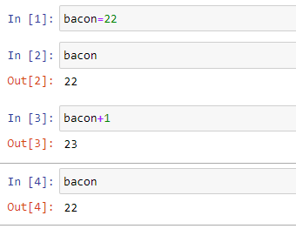

Here, We have assign value 22 to variable bacon. When we perform expression bacon+1 we have just perform the operation but we have not stored the new value to any variable/Var bacon. So the value of bacon is 🡪22.

7. What should the values of the following two terms be?

'spam' + 'spamspam'

'spam' * 3

Ans:

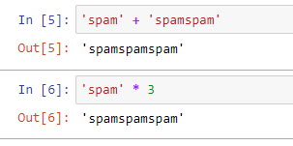

8. Why is eggs a valid variable name while 100 is invalid?

Ans: Variable cannot start with number, hence its Invalid.

9. What three functions can be used to get the integer, floating-point number, or string version of a value?

Ans: int(), float() and str() function.

10. Why does this expression cause an error? How can you fix it?

'I have eaten ' + 99 + ' burritos.'

Ans: As we can see in the error, compiler considers 99 as an int value. We cannot concatenate int value to string.

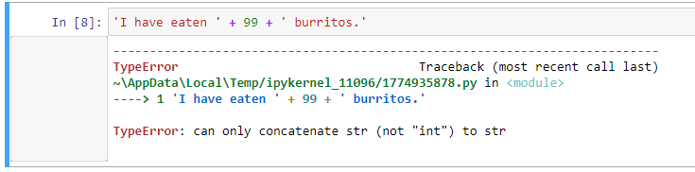

In order to fix it, we can use 🡪 'I have eaten ' +’ 99 ’ + ' burritos.'

