TPM Data Migration Tool

Contents

Purpose 1

Prior Checks: 1

Pre-Requisites 2

Walkthrough 2

Common Errors and Resolutions 15

# Purpose

The trading partner data migration tool migrates schemas, certificates, partners and agreements from BizTalk Server 2016 to Azure Logic Apps Integration Account. This document outlines the series of steps required by the wizard for successful completion of the B2B artefacts migration.

# Prior Checks:

1. **User Account Access** 
   1. User should have access to BizTalk Management Database and Certificate store for Windows Authentication.
   2. If using SQL Authentication to connect to BizTalk database server, SQL authentication should be enabled on the server.
2. **Private certificates**
   1. For Private Certificates, a key vault should exist in Resource Group and should be selected while running the tool.
   2. Private certs should be marked as Exportable for extraction.
3. **AAD Authentication**
   1. For AAD Authentication, user (organizational account) should have access at the subscription level, or the RG level or at Integration Account level at the very least.
   2. The user (organizational account) should have access to Key Vault to be able to add keys to the key vault.
4. **Key Vault**
   1. In the **Key Vault -> Advanced Access Policies -> Enable Access to ARM for template deployment**, should be configured to deploy private certificates that refer the key vault.

# Pre-Requisites

1. **Microsoft .Net Framework 4.5** should be installed on the system.
2. **Tool Running Location**
   1. Tool should be running from BizTalk Front End Server to access all the certificates and GAC (for schemas) on that server.
   2. All certificate(s) and Schema DLLs should present on the machine where tool is running on.
   3. To access Integration account with different credential than current user, Run tool as different user.
3. **Host Partner**
   1. Host Partner should already exist in Integration Account. If it doesn't exist, user must explicitly select and migrate it through the tool before migrating any agreement to IA.
   2. If certificate for host partner is configured at group level in BizTalk and not at partner/agreement level, Certificate should be manually migrated to IA and the mapping of Partner and Certificate name as in Integration Account should be included in the mapping file.

# Walkthrough

1. Double click the TpmMigration.exe to launch the TPM data migration wizard. A window like the following displays:

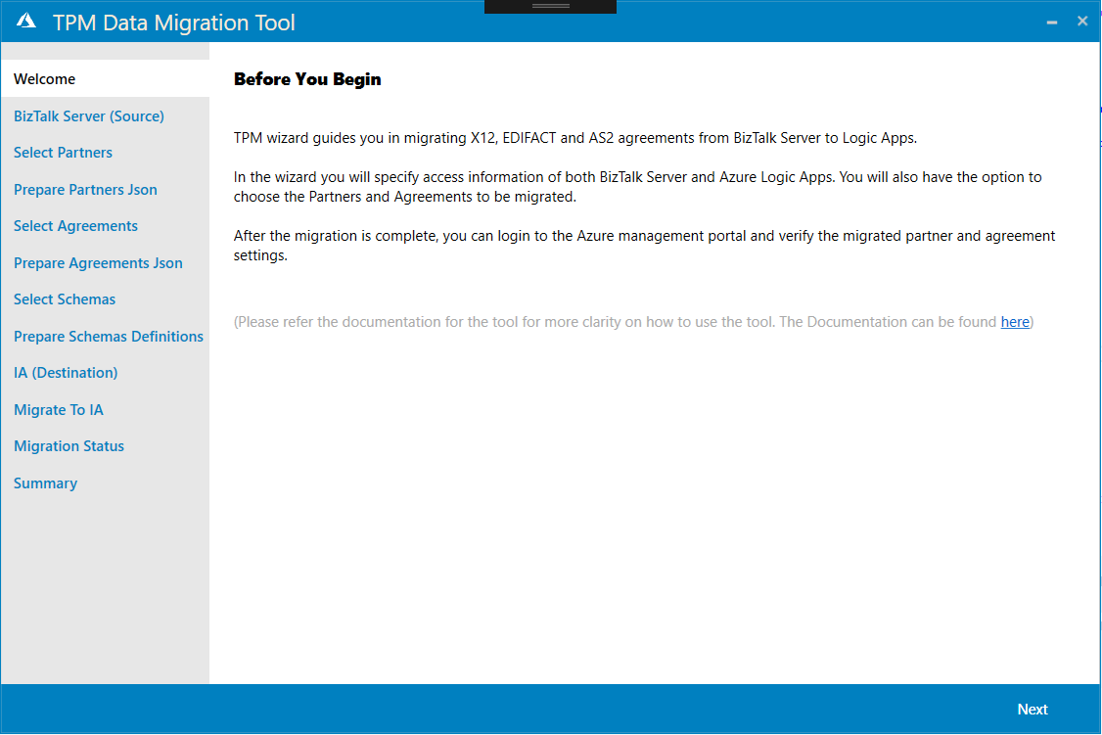

1. Click Next. Provide Server name which hosts BizTalk Server Management Db to retrieve the B2B Trading partner settings. If required, enter the name of the database. The default name is “BizTalkMgmtDb”.

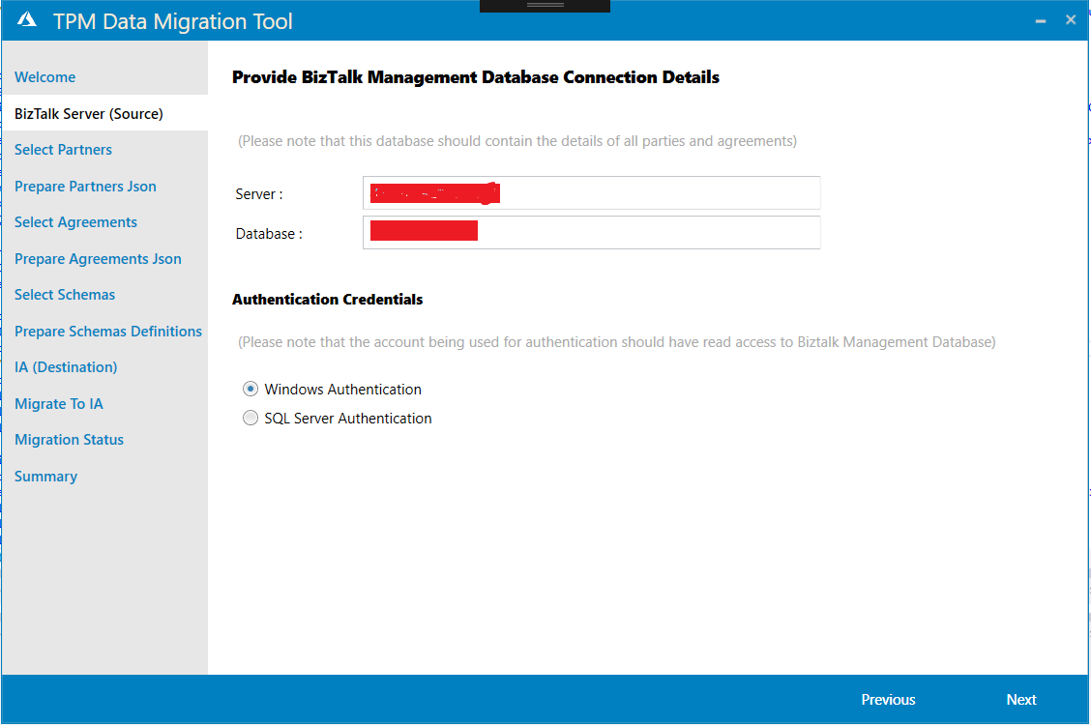

1. Click Next. In **Select Partners**, select one or more partners based on searched text to migrate from BizTalk Server to Logic Apps platform.

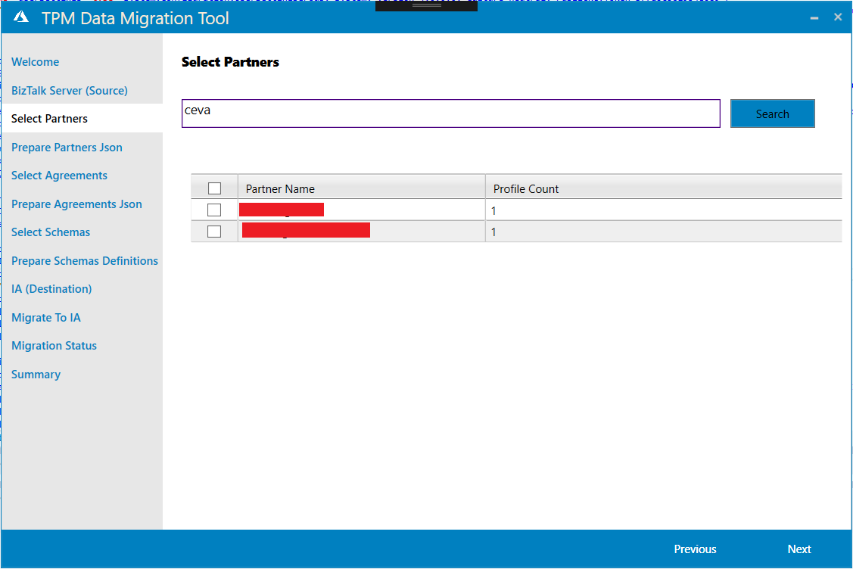

1. Click Next to generate JSON files as needed by Logic Apps platform for selected partners at below mentioned path. This screen shows the status of JSON artefact creation. In case the status shows an error, hover over the status icon to know error description.  
   Note: Migration is done as a twostep process:
   1. Step 1 - JSON creation – To allow user to maintain the artefacts in VSO and use continuous integration process
   2. Step 2 - Upload JSON artefacts to Logic App platform integration account.

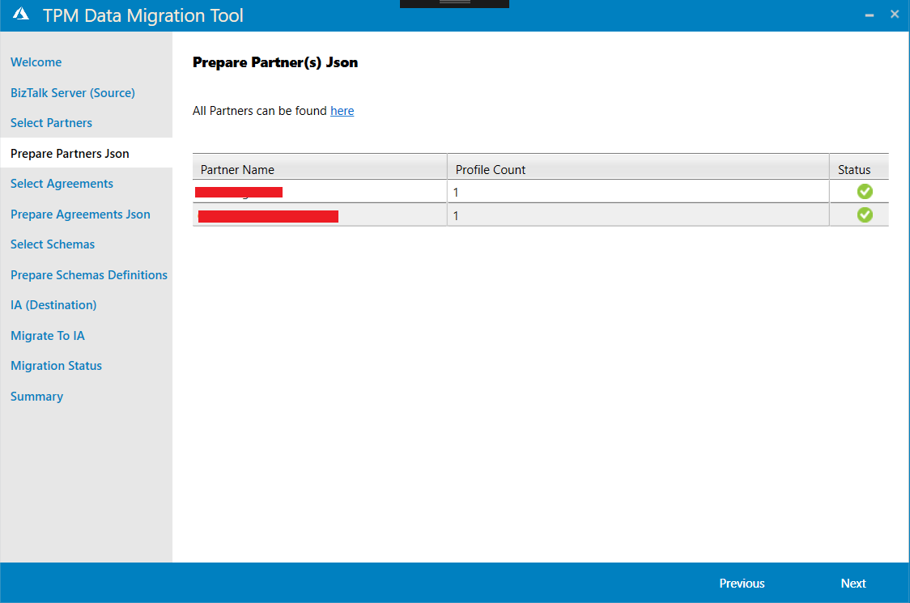

1. Click Next. In **Select Agreements**, select one or more agreements for the selected partners to be migrated from BizTalk Server to Logic Apps Platform Integration Account.

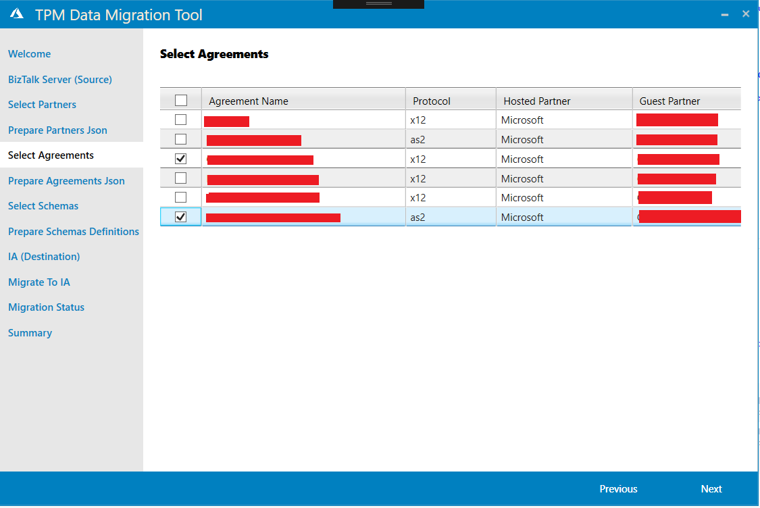

1. Click next to generate JSON files for selected agreements. Hover over the status icon to get error description in case of failure.

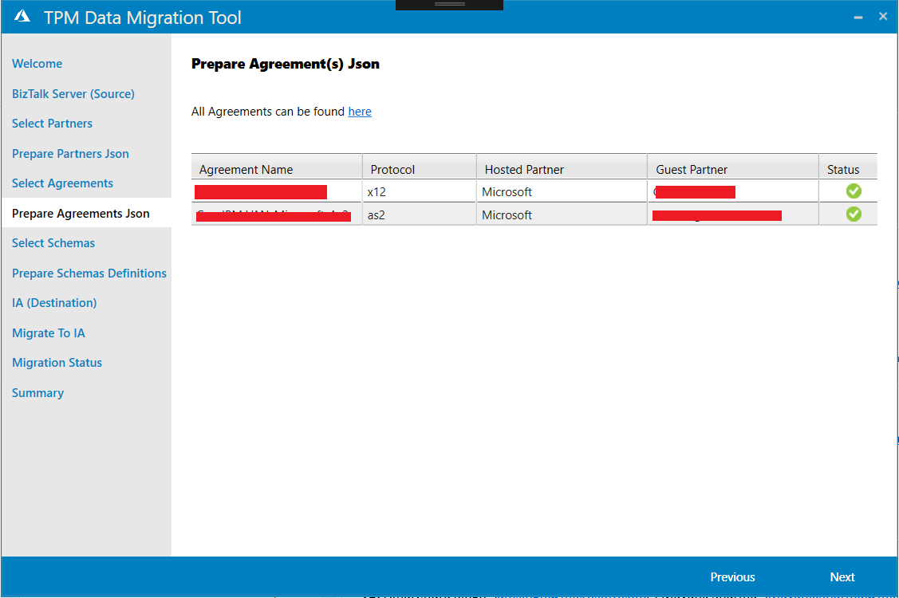

1. Click Next. In **Select Schemas**, select one or more schemas to be migrated from BizTalk Server to Logic Apps Platform Integration Account. Either all the schemas can be migrated at once or ensure that the schemas referred by the agreement are selected. Use the search box to look for particular schema(s).

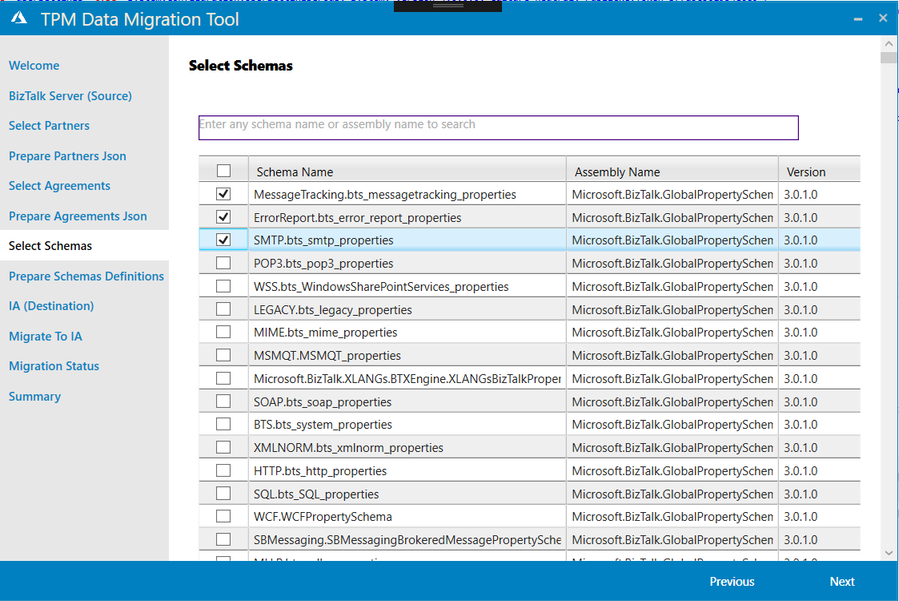

1. Click Next to generate schema definition (xsd) files for selected schema artefacts (Biztalk assemblies) at mentioned path.
   1. It is assumed that whatever schema is being selected for upload to IA, has its DLL gac’ed on the machine where this tool is executed.
   2. Note that Integration Account has a limitation for the name of the schema to 80 characters.
   3. While creating schema artefacts in integration account, the tool follows below
      1. Schema Naming convention:-

E.g.

DLL Name: The.Name.Of.Dll

Version: 1.0.1.1

Schema Name: Schema.xsd

Then, naming convention for Schema: The_Name_Of_Dll_V_1_0_1_1_Schema.xsd

* 1. Any kind of dependency among schemas gets identified and resolved by the tool. But, it’s schema DLL should be available in GAC of the BizTalk system. Dependencies are of following types
     1. within the same DLL
     2. outside the DLL
     3. selected in the Tpm Tool
     4. not selected in the Tpm tool explicitly
  2. Error messages can be seen by hovering on the red failure mark, if it comes. Though, to see the detailed stack trace, one has to go to the log file on last screen of the tool.

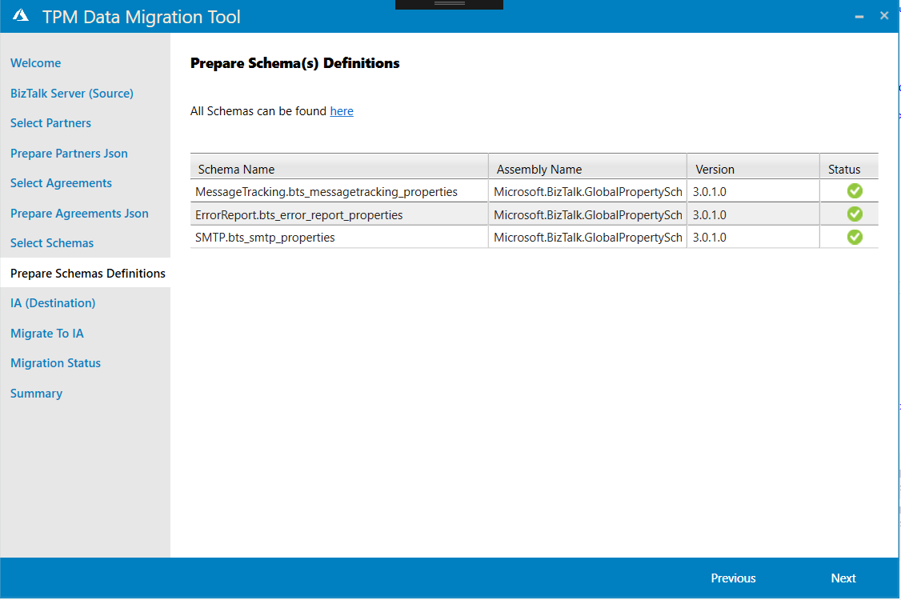

1. Click Next. This screen asks you to login to your Azure Account. Based on the credentials used for login, it fetches all subscriptions accessible to that user. AAD Authentication is used here to get all access tokens to access different azure resources.

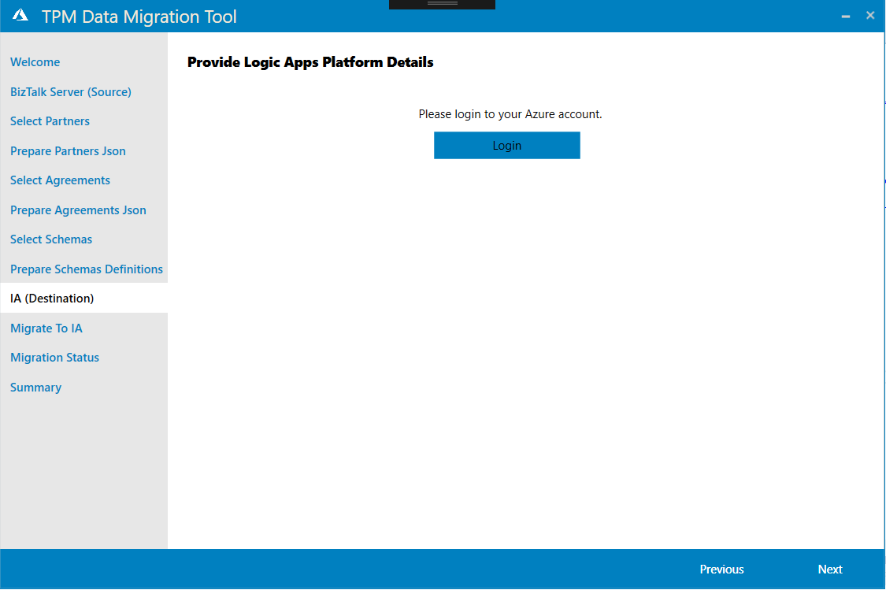

Select one subscription from the dropdown. Based on selected Subscription, all Resource Groups in that subscription that are accessible to the user are displayed. Select one Resource Group. Then based on RG selected, all Integration Accounts and KeyVaults in that RG accessible to user are displayed. Select one Integration Account. If you wish to migrate private certificates as well (for example a host certificate), select a key vault.

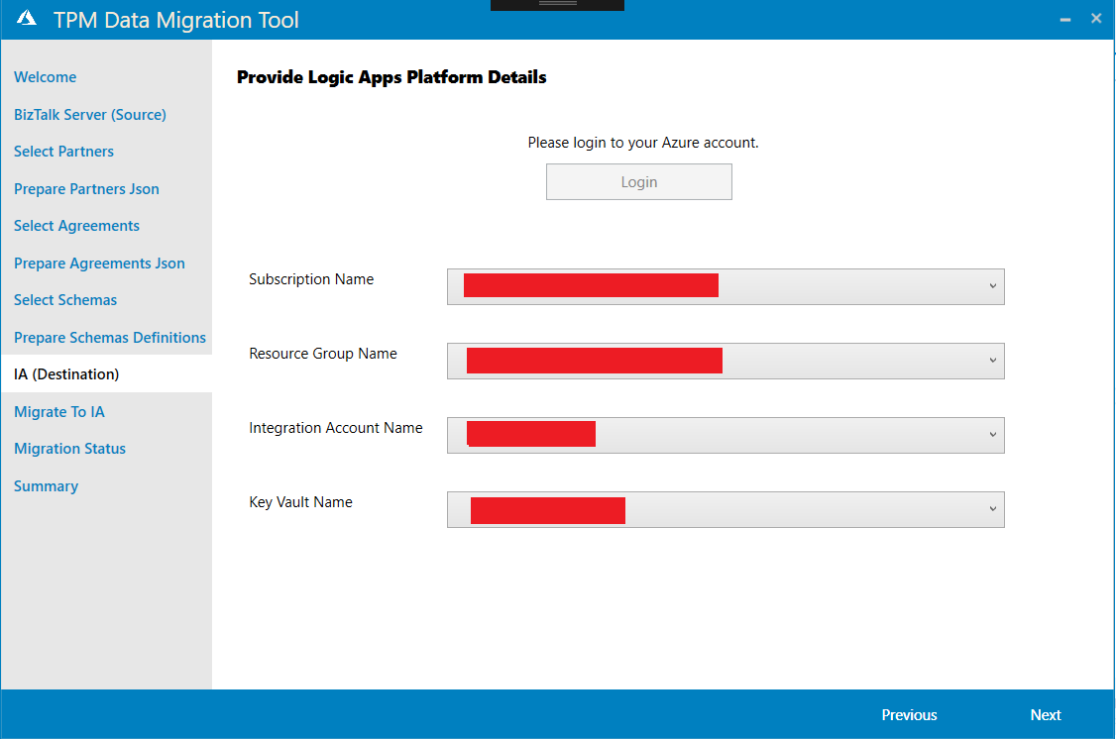

1. Click next. User is asked to select which artefacts need to be migrated to logic apps platform Integration Account.   
   This option is provided to enable user to migrate various artefacts at different interval of time. For example: User has migrated all partners earlier and then in next run he is trying to migrate agreements. In that case user may not select Partner(s) even though he had to choose the partner artefact on Select partners screen.   
   User is also asked explicitly if he intends to overwrite the artefact in Logic Apps platform.  
   Note that there is not incremental deployment concept for agreements, schemas or certificates. This means if any of this artefact is migrated twice with different values then the last artefact will be overwritten of Overwrite is checked. This need manual attention.

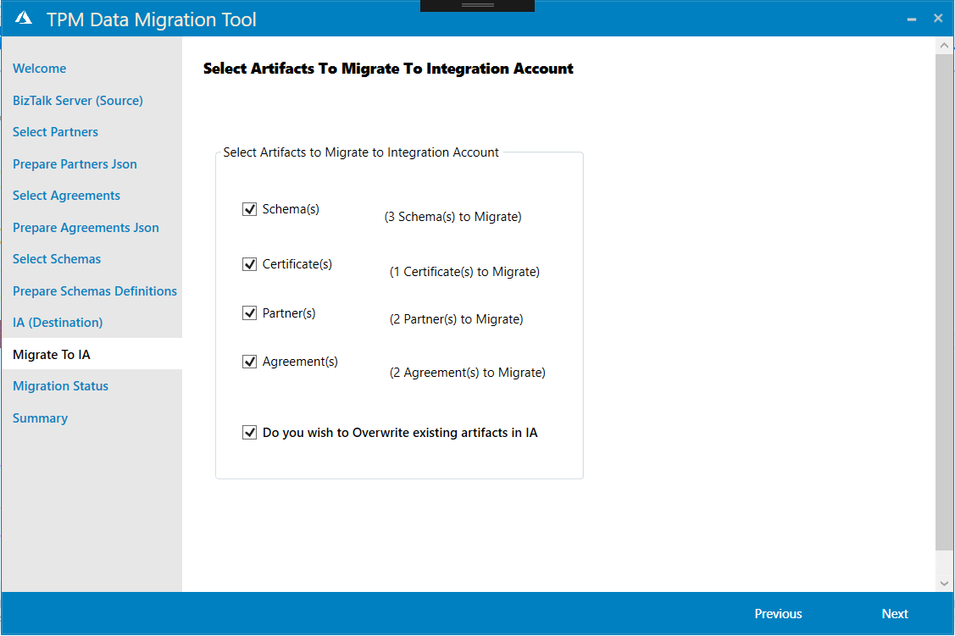

1. Click Next to view the progress status and error information if any about the migration of JSON artefacts into Logic Apps Platform Integration Account. To get detailed information about the migration status, hover over the status icon with each record.

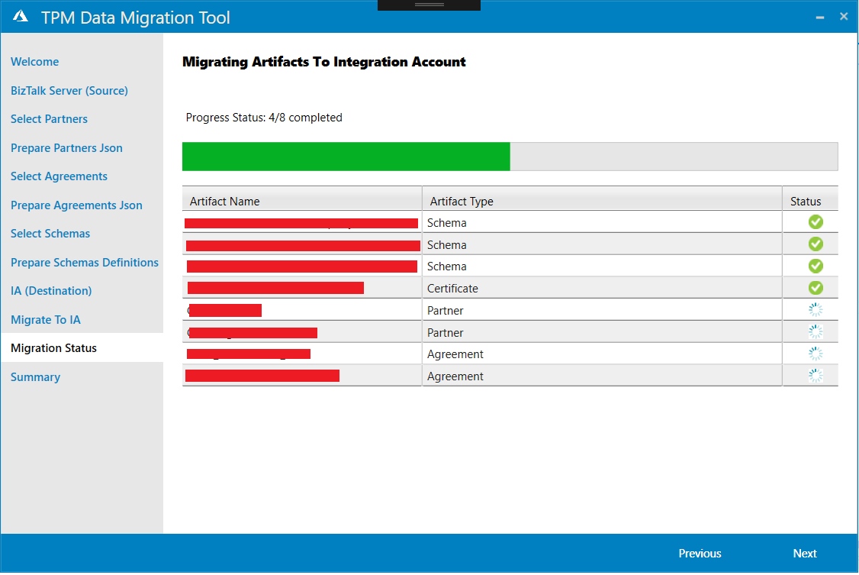

1. Click Next. **Summary** screen lists the number of partners, certificates, agreements and schemas migrated. It also links to the migration log file which provides more detail into what kind of migration process happened.

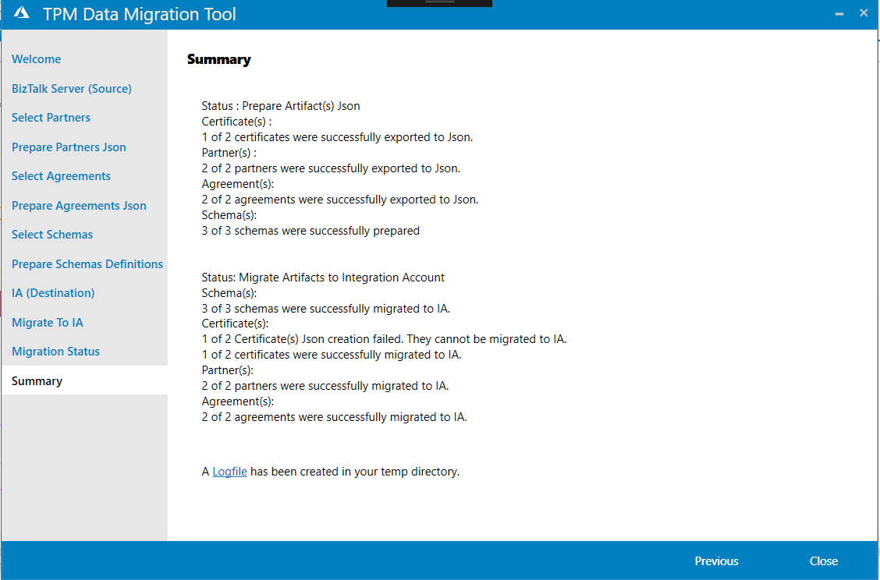

1. Close the wizard and verify artefacts by logging into Azure Portal Logic App platform Integration Account.

# Common Errors and Resolutions

The following table describes the errors/warnings and resolution that can occur with the migration:



|  |  |
| --- | --- |
| Errors | Resolution |
| Server name cannot be empty | BizTalk management database server name needs to be provided. *Example: .\sqlexpress* |
| SQL Connection could not be established | Check the Server, BizTalk management database names, and the credentials supplied |
| Error getting the Access Tokens | AAD Authentication failed. Make sure all prior checks are true and all pre-requisites are met. |
| Error reading user subscriptions from Portal | Either the account used to login to azure has no subscriptions/ user doesn’t have access to any subscriptions. |
| Error reading user RG's from Portal | Either the subscription selected has no Resource groups/ user doesn’t have access to any resource groups in that subscription. |
| Error reading user IA's from Portal. | Either the RG selected has no Integration Account/ user doesn’t have access to any IA in that RG. |
| No Key Vaults are available for the user in the current RG. | No key vault is accessible to the user in selected RG/ there is no RG in selected RG. |
| A partner with the name already exists | The partner with the same name already exists in the Integration Account from an earlier migration or creation. You can proceed with the migration and verify the existing partner when the migration is complete. |
| An agreement with the name already exists | An agreement with the same name already exists in the Integration Account from an earlier migration or creation. You can proceed with the migration and verify the existing agreement when the migration is complete. |
| A certificate with the name already exists | The certificate with the same name already exists in the Integration Account from an earlier migration or creation. You can proceed with the migration and verify the existing certificate when the migration is complete. |
| A schema with the name already exists | The schema with the same name already exists in the Integration Account from an earlier migration or creation. You can proceed with the migration and verify the existing schema when the migration is complete. |
| Schema Not found | Schema cannot be extracted as corresponding dll could not be found in local server’s GAC. GAC the dll on the server. |
| Certificate Not Found | Certificate cannot be found in the Local certificate store. Import the certificate on the server. |
| Integration Account API: Bad Request | This error can be encountered while migrating artefacts to IA. This means the artefact is incorrect. Check the artefact file manually to identify the error. |

The log file logs everything, host partner not found, the schema names from IA mapped to the namespaces in agreement, the certs used for signing/encryption at both receive and send side. If any changes are required, they must be made manually in IA.

***(In case you want us to investigate any issue in detail, please send us the log file and screenshot of the error at* BTSMigrationTool@microsoft.com*)***