

**COMSATS University Islamabad (CUI)**

Project Proposal  
(SCOPE DOCUMENT)

for

**EMPLOYEE IDENTIFICATION AND TRACKING**  
Version 1.0

***By***

**Muhammad Umer Naeem CIIT/FA17-BSE-140/ISB**

**Hamza Tahir CIIT/FA17-BSE-148/ISB**

***Supervisor*Mr. Umar Nauman**

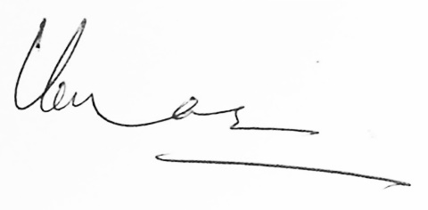

*Bachelor of Science in Software Engineering (2017-2021)*

**SCOPE DOCUMENT REVISION HISTORY**

|  |  |  |
| --- | --- | --- |
| **No.** | **Comment** | **Action** |
|  |  |  |
|  |  |  |
|  |  |  |
|  |  |  |
|  |  |  |
|  |  |  |

**Supervisor Signature:**

**Date:**

Table of Contents

Abstract 4

1. Introduction 5

2. Problem Statement 5

3. Problem Solution for the Proposed System 5

4. Related System Analysis/Literature Review 5

5. Advantages/Benefits of Proposed System 7

6. Project Scope 7

7. Modules 7

7.1 Module 1: Facial Detection 7

7.2 Module 2: Model Training 7

7.3 Module 3: Model Deployment and Tracking 8

7.4 Module 4: RFID Configuration 8

7.5 Module 5: RFID Tracking 8

7.6 Module 6: Web Application Development 8

7.7 Module 7: Mobile Application Development 8

8. System Limitations/Constraints 8

9. Software Process and Design Methodology 9

9.1 Software process methodology: 9

9.2 Design methodology: 9

10. Tools and Technologies 9

11. Project Stakeholders and Roles 10

12. Team Members Individual Tasks/Work Division 10

13. Data Gathering Approach 11

13.1 Interviews: 11

13.2 Observation: 11

14. Concepts 11

14.1 Concept 1: Machine Learning 11

14.2 Concept 2: Databases 11

14.3 Concept 3: Image Processing 11

14.4 Concept 4: Mobile Development 11

14.5 Concept 5: Web Application Development 12

15. Gantt Chart 12

16. Mockups 13

17. Conclusion 14

18. References 14

19. Plagiarism Report 15

List of Figures

Figure 1: Gant Chart of the Targeted Project 12

Figure 2: Mockup-01 – List of all camera feeds. 13

Figure 3: Mockup-02 – Detail of Single Camera. 13

Figure 4: Mockup-03- Attendance 14

List of Tables

Table 1: Related System Analysis with Targeted Project Solution. 6

Table 2: Tools and Technologies for the Targeted Project. 9

Table 3: Project Stakeholders for the Targeted Project. 10

Table 4: Team Member Work Division, the Targeted Project. 10

* **B-**Web Application/Web Application based Information System
* **C-** Problem Solving and Artificial Intelligence
* **E-** Smartphone Application
* **H-** Image Processing
* **I-** Industrial Project

**Project Category: (**Select all the major domains of the proposed project**)**

# Abstract

Employee identification and tracking are web and smartphone applications that provide a real-time platform to monitor employees and visitors in the facility. This system uses RFID sensors and surveillance cameras to track the location of a user. The system users can register with proper roles and permissions to use the application.

Many systems in the market support RFID location tracking, but RFID sensing efficiency is affected by environmental factors. Moreover, there are many chances that the employees can cheat in that case as the system cannot track their activities. Our proposed solution uses RFID and security cameras to get the user's location with improved accuracy. Also, get the report for the overall time spent of that user at various locations. The system also supports searching the user's location using the database registered person's entity or uploading an image.

# Introduction

According to Forbes, during a survey where 89% of respondents said they wasted time every day, which was with an increase of 20% from the previous year. The manual process of employee tracking and identification is very time consuming and still not efficient. Our product is automating the process of employee tracking and identification. The scope document describes the limits of what would or would not be used in the finished product. This document points out the issue that current systems have and a solution to these problems effectively. The Scope Document also briefly outlines the system's key features. The scope document also describes the system limitations, process methodologies, methods and techniques used for system creation, the role of key stakeholders, stakeholders, and sponsors.

# Problem Statement

In large organizations, managing and tracking employees during working hours is always a challenge for the managers. Sometimes the employees get way too casual, which ultimately affects the employee's efficiency, resulting in less productivity. The primary purpose of developing this system is to let the employer track the employees' all-day location. Many similar systems exist in the market, supporting facial recognition attendance but do not provide the tracking of location and real-time analytics for the employees. The currently available systems do not support searching for real-time locations using the images or their names registered in the system. Also, the current systems do not support the visitors tracking in the office. We expect to learn machine learning, web development, computer vision, and mobile application after implementing it.

# Problem Solution for the Proposed System

Our proposed system shall automate the employee's tracking by using the security camera with RFID detectors' aid giving us real-time information of the employees such as their current location. The system shall register the users in a hierarchy with proper roles and permission with the dynamic installation of cameras as well as RFID sensors. Which can be configured to allow the system to track the employees with respect to the configured hardware's location. Moreover, the system will also allow the quick registration of visitors to have access control in the facility. The system will also be monitoring the time-in and time-out of all people in the building based on the camera's places on the entrance. As the users are being tracked with the live security cameras, the system can also search for users based on their names or image and tell the user's real-time location and activity. Moreover, an overall report can be generated for the employee to check his time spent at various locations.[1][2]

# Related System Analysis/Literature Review

Globally many websites provide employee tracking systems, but none of them have the features of automating employee tracking and surveillance. Below in Table 1, We have mentioned three of the top leading websites in employee tracking.

Table 1: Related System Analysis with Targeted Project Solution.

|  |  |  |
| --- | --- | --- |
| **Application Name** | **Weakness** | **Proposed Project Solution** |
| * Jibble.io | * The application only takes the attendance of employees using their webcams. * The application does not track the location of the employees. * The application does not give real-time surveillance. | * The proposed solution shall use security cameras to monitor the attendance of the employees. * With the help of RFID cards and a camera, the system shall also monitor the location. * The system shall be able to generate an overall report for the employees. |
| * Hexahash.com | * The employees can dodge the application for attendance by sharing RFID cards with other employees. * The application does not support searching for visitors' locations using an image. * The application does not generate report for the employees. | * The proposed solution shall double-check the employee with the help of cameras as well as RFID cards. * The system shall be able to generate an overall report for the employees. * The system shall support real-time searching for users' locations within the facility using both image and name. |
| * Litumiot.com | * The employees can dodge the application for attendance by sharing RFID cards with other employees. * The application does not support searching for visitors' locations using an image. * The application does not generate report for the employees. | * The proposed solution shall double-check the employee with the help of cameras as well as RFID cards. * The system shall be able to generate an overall report for the employees. * The system shall support real-time searching for users' locations within the facility using both image and name. |

# Advantages/Benefits of Proposed System

Following are the advantages and benefits of our system:

* Get real-time tracking and surveillance of employees and visitors.
* Identify the location of users within the facility.
* Set up geofences.
* Push notification for users violating geo-fencing.

Get personalized reports for each user.

* Search users within the facility using names and pictures.

# Project Scope

Our system is focused on offices that want to monitor their employee using an automated system. Once the user is registered on the system, he can create his organization and add users to the organization with different roles created by the user. Once it is done, the user can add cameras and RFID sensors, and label them with their positions. Now the system is ready for use, and the user with appropriate permissions defined in the roles can add an employee with their images to train the system. As soon as the employee is registered, the system will be trained with the employees face and issued with an RFID card. As the employees are registered, the employees will be clocked in based on the camera at the entrance and clocked out. An overall report of employees can also be reviewed at any time. Moreover, warning and challans can also be generated and sent to the employees. The system also allows the user with appropriate permissions to search a user with an image or name to search for the location. The same system will be used to monitor the visitors in the office.[2]

# Modules

The following are our project's module.

## Module 1: Facial Detection

This module shall help the system to detect faces from the video and images. In this module, the system shall first scan the faces to detect all faces. The second is to check if any of the faces need some enhancements. The third is to select all the facial features and return them as encoding that can be used to compare with other faces.

## Module 2: Model Training

This module shall train the system by running a machine learning algorithm by giving it data to learn. We shall train the faces to detect individuals inside the facility whenever the user is in the video feed.

## Module 3: Model Deployment and Tracking

This module involves model deployment, enabling the system to use these models to perform the classification. Moreover, the system shall relate the profile stored in the database with the faces detected.

## Module 4: RFID Configuration

This module involves the management of RFID cards. This will allow the system user to create new RFID cards as well as manage the existing RFID cards to map them with the users profile.

## Module 5: RFID Tracking

As the RFID sensors have fixed locations and the RFID sensors are labelled with different locations. This module shall enable the system to track the location of the user within a particular location as well as cross check it with the camera feed to validate the location.

## Module 6: Web Application Development

This module involves creating the backend API's as well as front-end to interact with the business logic. Moreover, this will include user profiling, localization, multiple-tenants, Roles and Permissions, Social Media Logins, Two Factor Authentication, Hierarchal organization unit's system to group users and entities, real-time push notifications, report generation, and analytics.

## Module 7: Mobile Application Development

This module involves the development of an android native mobile application. The application will send real-time requests to the web application's backend to perform all kinds of actions and receive a real-time push notification.

# System Limitations/Constraints

Following are the limitations of our proposed project:

* The system requires the internet to operate.
* The system requires RFID sensor in each room.

# Software Process and Design Methodology

Below are the details of the software process methodologies and the design methodologies used for the development.

## Software process methodology:

For our proposed solution, we shall use the Rapid Application Development methodology. The reason for using this model is because it focuses more on testing and iteration. Moreover, all the modules of the application are integrated from the beginning leading to fewer errors. [3][4]

## Design methodology:

To develop our proposed solution, we shall use the SOLID design principle (Object-Oriented Design Principle). We are using this design methodology because it makes the code extendable and flexible with overall improved quality.[5]

# Tools and Technologies

We are using the following tools and technologies for the targeted project.

Table 2: Tools and Technologies for the Targeted Project.

|  |  |  |  |
| --- | --- | --- | --- |
| **Tools**  **And**  **Technologies** | **Tools** | **Version** | **Rationale** |
| MS Visual Studio | 2019 | IDE |
| Visual Studio Code | 1.49.3 | IDE |
| Spyder | 4.1.5 | IDE |
| Android Studio | 4.0.2 | IDE |
| MS SQL Server | 2014 | DBMS |
| Adobe Photoshop | 2020 | Design Work |
| MS Word | 2015 | Documentation |
| MS PowerPoint | 2015 | Presentation |
| Pencil | 2.0.5 | Mockups Creation |
| **Technology** | **Version** | **Rationale** |
| C# | 8.0 | Programming language |
| Python | 3.6 | Programming language |
| Java | 11 | Programming language |
| SQL | 2014 | Query Language |
| Html | 5 | Web Development |
|  | ASP.NET Core | 3 | Web Development |
|  | Angular | 7 | Web Development |
|  | CSS | 3 | Web Development |

# Project Stakeholders and Roles

Following are the Project Sponsors and Stakeholders of the proposed system:

Table 3: Project Stakeholders for the Targeted Project.

|  |  |
| --- | --- |
| **Project Sponsor** | **COMSATS University Islamabad** |
| **Stakeholder** | * Mr. Umar Nauman (Project Supervisor) * Muhammad Umer Naeem, Hamza Tahir (Students) * Final Year Project Committee (Evaluation of project) |

# Team Members Individual Tasks/Work Division

Below is the detail of how the system's modules and functionality are divided among the group members.

Table 4: Team Member Work Division, the Targeted Project.

|  |  |  |
| --- | --- | --- |
| **Student Name** | **Student Registration Number** | **Responsibility/ Modules** |
| * Muhammad Umer Naeem | * FA17-BSE-140 (Student 1) | Module-1: Facial detection  Module-3: Model deployment and tracking  Module-5: RFID Tracking  Module-6: Web Application Development   * Web-Backend, Web-Frontend, Database Management, Machine Learning, Image Processing |
| * Hamza Tahir | * FA17-BSE-148 (Student 2) | Module-2: Model Training  Module-4: RFID Configuration  Module-7: Mobile Application Development   * Machine Learning, Database Management, Image Processing, Android Development, Web Backend |

# Data Gathering Approach

Below are the data gathering approaches used to get the functionality of the system from stakeholders:

## Interviews:

We used interviews to gather data from the project stakeholders. This interview also had a question related to the problems they were facing to track the employees. This interview was to gather all requirements and the confusion that we had in our minds.

## Observation:

We visited the stakeholder and observed their employee. We noted the building measurements to measure the dimensions to use suitable sensors to track the employees.

# Concepts

Below are the concepts that we will apply while implementing this system:

## Concept 1: Machine Learning

Machine learning is an application of Artificial intelligence in which we write an algorithm that takes the labeled data to train itself and make appropriate decisions with new data. In this project, we have used machine learning to recognize faces and track activities.[6]

## Concept 2: Databases

Storing any information on a computer server electronically and viewing it in a manner that is the end user's necessity. It is possible to modify this stored data as the user communicates with the device. Databases also only provide managed access to protect the user's privacy and provide them with data protection and dignity.

## Concept 3: Image Processing

Image processing is a method to perform some operations on an image to get an enhanced image or extract some useful information. We have used image processing to detect faces from the video feed.

## Concept 4: Mobile Development

Mobile application development is a process by which we develop an application that can run on smartphone devices. These mobile applications are written to serve for a specific purpose and take advantage of those mobile devices' features.

## Concept 5: Web Application Development

Web Application Development is a programming technique that enables us to get the desired functionality as per the stakeholder's requirements by providing an interface to the user. Website development includes client-side, server-side scripting. These websites are hosted over the internet to access them remotely anywhere from the internet.

# Gantt Chart

Below is the Gantt chart that will be followed along the time:

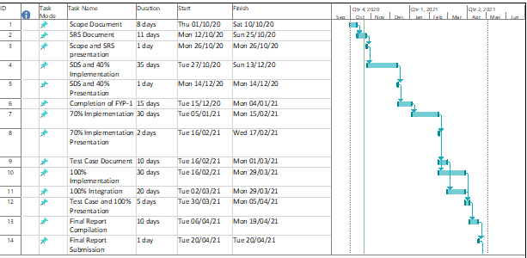

Figure 1: Gant Chart of the Targeted Project

# Mockups

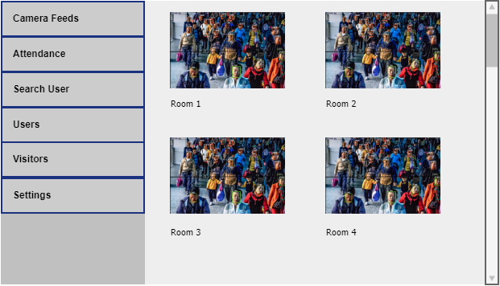

Figure 2: Mockup-01 – List of all camera feeds.

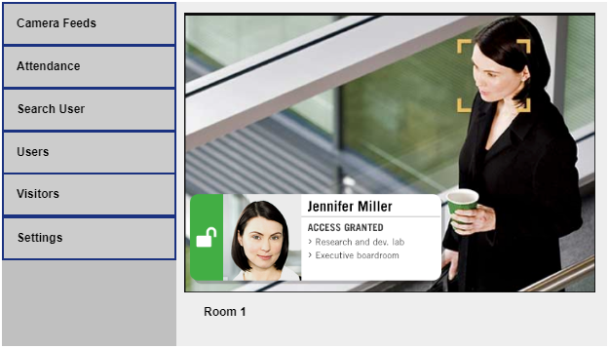

Figure 3: Mockup-02 – Detail of Single Camera.

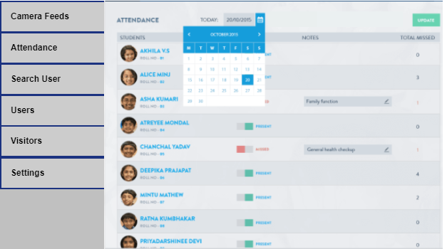

Figure 4: Mockup-03- Attendance

# Conclusion

The scope document for Employee Tracking and Identification is providing all the initial details regarding the system, the need for the system, problems the existing systems have, and their solution. This document describes the main functionality, Gantt charts, and the mockup with the system's timing constraints described. This document is used as an initial proposal. All the development later in this project will be based on this. This project will learn Machine Learning, Image Processing, Web development, android development, and database management. We will try to complete the project on time and make it a complete product.

# References

* 1. Chu Luo, "Video Summarization for Object Tracking in the Internet of Things", *Next Generation Mobile Apps Services and Technologies (NGMAST) 2014 Eighth International Conference on*, pp. 288-293, 2014.
  2. Ching-Sheng Wang, Chien-Liang Chen, "RFID-based and Kinect-based indoor positioning system", *Wireless Communications Vehicular Technology Information Theory and Aerospace & Electronic Systems (VITAE) 2014 4th International Conference on*, pp. 1-4, 2014.
  3. Sommerville, I. (2011). *Software engineering* (9th ed.). Boston: Pearson.
  4. Pressman, R. (2020). *Software engineering* (7th ed.). Boston, Mass.: McGraw Hill.
  5. Meyer, B. *Object-oriented software construction*. London: Prentice-Hall International.
  6. Mitchell, T. (2017). *Machine learning*. New York: McGraw Hill.

# Plagiarism Report