Kafka – Producer -> Consumer communication

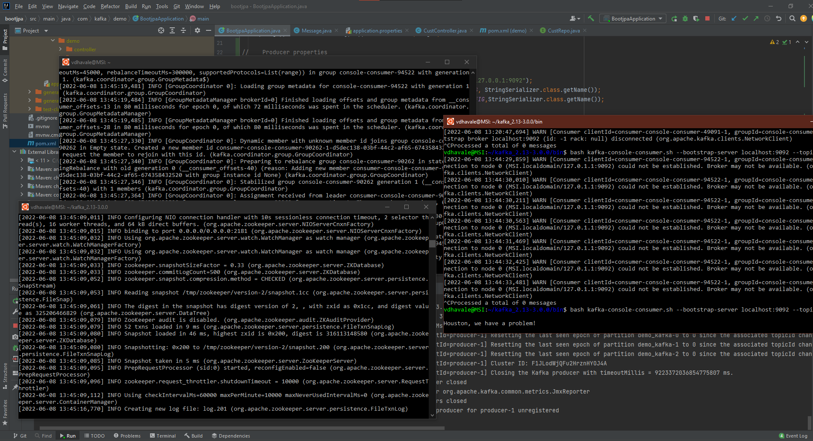

Sample data for a few customer IDs loaded into BASE_DATA initially (for baseline credit and authentication)

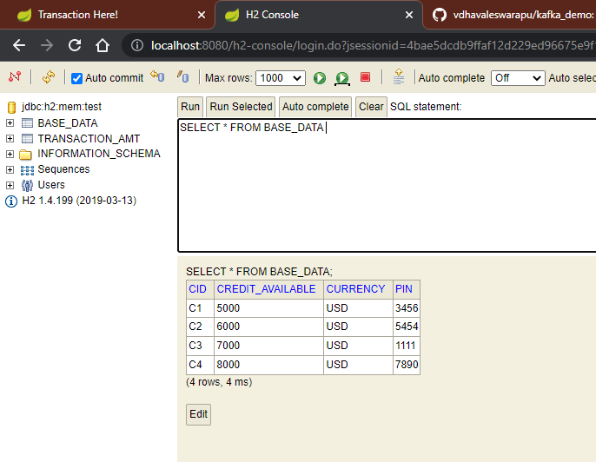

Performing a transaction

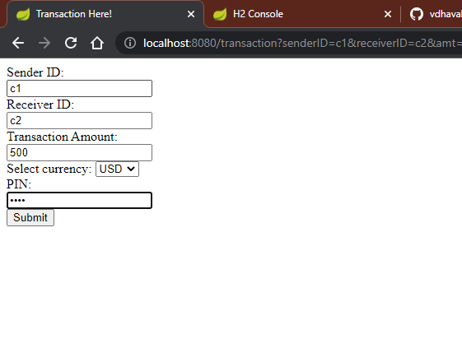

Updated BASE_DATA table for running credit information

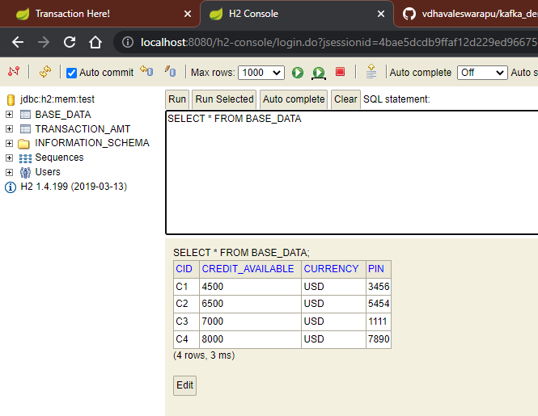

Recorded successful transaction in TRANSACTION_RECORD entity