

AWS First Cloud AI Journey – Project Plan

CloudTeam – FPT University – X100 Auction System

December 2025
Table of Contents
1 BACKGROUND and motivation 3
1.1 executive summary 3
1.2 PROJECT SUCCESS CRITERIA 3
1.3 Assumptions 3
2 SOLUTION ARCHITECTURE / ARCHITECTURAL DIAGRAM 3
2.1 Technical Architecture Diagram 3
2.2 Technical Plan 4
2.3 Project Plan 4
2.4 Security Considerations 4
3 Activities AND Deliverables 5
3.1 Activities and deliverables 5
3.2 OUT OF SCOPE 5
3.3 PATH TO PRODUCTION 5
4 EXPECTED AWS COST BREAKDOWN BY SERVICES 5
5 TEAM 6
6 resources & cost estimates 6
7 Acceptance 7

BACKGROUND and motivation

executive summary
[Customer background]
The project is initiated by students from FPT University (FPTU) in Ho Chi Minh City. The target customers and beneficiaries are the community of users who desire a modern, transparent, and secure online auction platform, overcoming the spatial and temporal limitations of traditional auction methods.
[Business and technical objectives - drivers for moving to the AWS cloud]
Business Objectives:
* Build a fair, transparent, and accessible online auction marketplace for everyone.
* Create a real-time interaction environment between buyers and sellers.
* Ensure the authenticity of participants through electronic identity verification.
Technical Objectives:
* Build the system on AWS Cloud to ensure Scalability and High Availability.
* Integrate AI services like Amazon Rekognition and Textract to automate the identity verification process (eKYC).
* Optimize performance and user experience with Amazon CloudFront and ElastiCache.
* Maintain optimal operating costs (estimated ~$50/month).
[Use cases]
- Registration & Verification (eKYC): Users register an account and verify their identity by uploading ID cards and portrait photos. The system automatically extracts information and compares faces.
- Auction Management: Users can create new auctions with full product information and monitor status.
- Real-time Bidding: Participants place bids and receive immediate feedback.
- Notifications: The system automatically sends verification emails (OTP), win notifications, or alerts when there is a higher new bid.
[Briefly summarize the partner’s professional services to be delivered to meet the customer’s objectives]
The implementation team provides a full package solution including:
- Full-stack Web Application Development (ReactJS Frontend and Springboot Backend).
- Cloud Infrastructure Design and Deployment on AWS (VPC, EC2, RDS, S3).
- Security Configuration and Access Management (IAM).
- Continuous Integration and Deployment (CI/CD with GitLab) setup.

PROJECT SUCCESS CRITERIA

- Functionality: The eKYC system operates accurately, correctly extracting information from ID documents and verifying faces.
- Performance: Web pages load under 2 seconds; APIs respond quickly thanks to Caching mechanisms.
- Reliability: The system operates stably and handles load well during auctions.
- Security: User data and databases are protected in Private Subnets and private buckets.
- Cost: Total operating costs do not exceed the estimated budget ($59.37/month).

Assumptions

Prerequisites:
- An AWS account with appropriate Service Quotas is available.
- Domain name has been registered and managed by Route 53.
Dependencies:
- Stability of AWS managed services (Rekognition, Textract) in the deployment region.
Constraints:
- Limited operating budget.
- Deployment and testing time within the 3-month internship period.
Risks & Mitigation:
- Budget Overrun: Set up AWS Budget Alerts for early warning.
- Network Latency: Use CloudFront CDN to distribute content.
- Data Loss: Set up periodic backups for RDS and S3.

SOLUTION ARCHITECTURE / ARCHITECTURAL DIAGRAM

Technical Architecture Diagram

The proposed solution utilizes a highly available and scalable 3-tier architecture on AWS, adhering to Well-Architected best practices.

- Frontend: Hosted on Amazon S3 and distributed globally via Amazon CloudFront (CDN) to ensure low latency and high performance.
- Backend: Amazon EC2 instances running Springboot applications handle business logic. These instances are placed in public subnets for security and managed by AWS Load Balancing (ALB) to distribute traffic.
- Database & Storage:
+ Amazon RDS (MySQL): Primary relational database for transactions, located in a private subnet.
+ Amazon ElastiCache: Caching layer to reduce database load and improve API response times.
+ Amazon S3: Stores static assets, user-uploaded images, and verification documents.
- AI Integration:
+ Amazon Rekognition: Used for facial verification (eKYC).
+ Amazon Textract: Used for OCR extraction from identity documents.
- Security: IAM Roles for service-to-service permissions, Security Groups for network access control, and VPC for network isolation.
- Monitoring: Amazon CloudWatch is used for logging and monitoring system health.

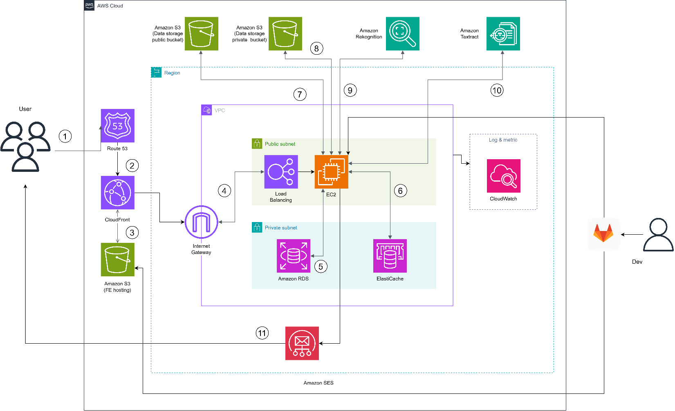

Tools Proposed:
- Development: ReactJS (Frontend), Java Springboot (Backend), AWS SDK.
- Database: MySQL, Redis.
- DevOps & CI/CD: GitLab, GitLab CI Runner.
- Testing: Postman.
- Monitoring: Amazon CloudWatch.

Technical Plan

The partner will develop GitLab CI/CD scripts to automate the build and deployment process. This allows for quick and repeatable deployments into AWS accounts.
- Infrastructure Setup: Usage of manual configuration guided by "Workshop" documentation initially, transitioning to scripted deployments where applicable.
- Configuration Management: Application configuration is managed via environment variables and AWS Systems Manager (if applicable).
- Critical Paths & Testing: All critical paths (e.g., Bidding, Identity Verification) include extensive coverage. Please refer to Appendix A for test-cases.

Project Plan

The partner will adopt the **Agile Scrum framework over x8 2-week sprints** (covering the 4-month timeline from Month 0 to Month 3).
Team Responsibilities:
- Cloud Architect: AWS infrastructure design, VPC, IAM, Security.
- Backend Developer: API development, DB design, AWS SDK integration.
- Frontend Developer: UI/UX implementation, API integration.
- QA Engineer: Testing and validation.
Communication Cadences:
- Daily Standup: 15 minutes updates.
- Sprint Reviews: Demo of working software at the end of each sprint.
- Sprint Retrospective: Process improvement discussions.
- Knowledge Transfer: Sessions will be conducted by the end of Month 3 to ensure the customer team can operate and maintain the system.

Security Considerations
The partner will implement AWS security best practices across the following 5 categories:
1. Access (Identity & Access Management):
- IAM Roles: Grant least-privilege permissions to EC2 instances to access specific AWS services (S3, Rekognition, Textract) without storing long-term credentials.
- MFA: Enable Multi-Factor Authentication (MFA) for the root account and all IAM users with console access.
- Security Groups: Act as a virtual firewall for EC2 instances and RDS databases, restricting inbound traffic to only necessary ports and sources (e.g., only ALB can access EC2, only EC2 can access RDS).

2. Infrastructure Protection:
- VPC: Deploy resources within a Virtual Private Cloud (VPC) to isolate the Auction System's network.
- Subnet Isolation: Place backend servers (EC2) and databases (RDS, ElastiCache) in Private Subnets with no direct internet access. Only the Load Balancer and NAT Gateway reside in Public Subnets.
- DDoS Protection: Leverage AWS Shield Standard (enabled by default) and CloudFront to provide protection against common network and transport layer DDoS attacks.

3. Data Protection:
- Encryption at Rest: Enable encryption for RDS instances (using AWS KMS) and S3 buckets (SSE-S3) to protect data stored on disk.
- Encryption in Transit: Use HTTPS (TLS/SSL) for all communication between clients and CloudFront/ALB, and between internal services where applicable.
- S3 Bucket Policies: Configure policies to block public access to private S3 buckets containing sensitive user documents.

4. Detection & Monitoring:
- Amazon CloudWatch: Monitor system metrics (CPU, memory, disk I/O) and set up alarms for anomalies.
- AWS CloudTrai: (Recommended) Enable to log all API calls for auditing and compliance purposes.
- VPC Flow Logs: (Optional) Capture information about the IP traffic going to and from network interfaces in the VPC.

5. Incident Management:
- Backup & Recovery: Configure automated backups for RDS (Snapshot) to allow point-in-time recovery in case of data corruption or accidental deletion.
- Playbooks: Document standard operating procedures for handling common security events (e.g., unauthorized access attempts, system/service downtime).
- Alerting: Configure SNS notifications to alert administrators immediately when critical security or performance thresholds are breached.

Activities AND Deliverables

Activities and deliverables

Project Phase | Timeline | Activities | Deliverables/Milestones | Total man-day
Assessment & Planning | Week 1 | - Learn AWS Cloud fundamentals.  - Analyze system requirements.  - Create Budget Plan. | - AWS Account Setup.  - Budget Plan.  - Requirement Analysis Doc. | [5 man-day]
Base Infrastructure & Design | Week 2-3 | - Database Schema Design (RDS).  - AWS Service Selection.  - Architecture Diagramming. | - Database Schema.  - Technical Architecture Diagram.  - VPC & Subnet Design. | [10 man-day]
Setup Component 1 (Backend Core) | Week 4-7 | - Develop Auth/User APIs (Custom).  - Implement Auction Logic APIs.  - Integrate Wallet & Transaction features.  - Setup Redis Locking for bids.  - Implement Shipping features. | - Backend API Source Code.  - API Documentation (Swagger/Postman)  - Redis Caching Implementation. | [20 man-day]
Setup Component 2 (Frontend & AI) | Week 8-11 | - Integrate Rekognition (eKYC) & Textract.  - Implement Shipping features.  - Develop ReactJS Frontend (Home, User, Admin). | - Frontend Source Code.  - eKYC Module. | [20 man-day]
Testing & Golive | Week 12 | - End-to-End Testing & Bug Fixing.  - Deploy to AWS Cloud (EC2, S3, CloudFront).  - Performance Optimization. | - Deployed System on AWS.  - User Acceptance Test (UAT) Report.  - Final Source Code. | [4 man-day]
Handover | Week 12 | - Transfer knowledge to operations team.  - Final Project Report. | - Handover Documentation. | [1 man-day]

OUT OF SCOPE
The following items are considered out of scope for this project:
- Mobile Application: Development of native iOS/Android applications.
- Legacy Data Migration: Migration of data from any previous auction systems.
- Real-money Payment Gateway: Integration with banking APIs or live payment gateways (simulated wallet used).
- 24/7 Managed Services: Post-deployment 24/7 monitoring and incident support.

PATH TO PRODUCTION
The Proof of Concept (POC) will be built with specific and targeted use-cases outlined in "Section 1. Background".
- Gap Analysis: It may lack advanced features such as complex fraud detection beyond basic eKYC or high-frequency trading capabilities required for enterprise production.
- Production Readiness: Production setup will require further fine-tuning, such as:
- Auto-scaling: Implementing Auto Scaling Groups for EC2 to handle variable traffic loads.
- Disaster Recovery: Setting up Cross-Region Replication for S3 and Multi-AZ deployments for RDS involved in "Business Continuity Plan".
- Operational Excellence: Extended logging, comprehensive monitoring dashboards, and automated incident response workflows.

EXPECTED AWS COST BREAKDOWN BY SERVICES
AWS monthly calculator

Service | Configuration | Monthly Cost (USD)
Amazon Rote 53 | - 1 hosted zone | $0.5
Amazon EC2 | - t3.medium (2 vCPU, 4 GiB Memory)  - ap-southeast-1  - Pricing Model: Compute Savings Plans (3 years, No Upfront) | $16.35
Amazon RDS | - db.t3.micro (MySQL)  - Storage: 20GB GP2 | $8.38
Amazon ElastiCache | - cache.t3.micro (Redis)  - Pricing Model: Reserved Nodes (3 years, No Upfront) | $9.49
Amazon S3 | - Standard Storage  - Capacity: 10 GB  - Requests: 30,000 GET  - Request: 1000 PUT, POST  - 5GB outbound | $0.72
Elastic Load Balancing | - 1 ALB  - 50 GB data | $18.8
Amazon Rekognition | - 100 Face Compare | $0.13
Amazon Textract | - Analyze 200 pages document ID | $5
TOTAL |  | $59.37

Assumptions for Cost Estimation:
- Region: All resources are provisioned in Asia Pacific (Singapore) - ap-southeast-1.
- Pricing Model:
+ EC2 & ElastiCache: Calculated based on 3-year Reserved Instance/Savings Plans (No Upfront) to optimize long-term costs.
+ RDS: Calculated based on On-Demand pricing (can be optimized further with RI).
- Traffic: Estimated based on initial low-to-medium traffic volume (approx. 4GB data transfer out per month).
- Tooling Costs: Costs for GitLab (Free Tier), Postman (Free Tier), and local development tools are excluded ($0).
- Free Tier: AWS Free Tier benefits (e.g., first 12 months for certain services) have NOT been applied to this calculation to provide a conservative "worst-case" long-term estimate.

TEAM
Partner Executive Sponsor
Name | Title | Description | Email / Contact Info
Project Stakeholders
Name | Title | Stakeholder for | Email / Contact Info
Partner Project Team
Name | Title | Role | Email / Contact Info
Vo Duc Hoang | Developer | Fullstack Developer  Cloud Engineer | Hoangvdse182010@fpt.edu.vn
Nguyen Minh Thai |  |  | Thainmse180331@fpt.edu.vn
Le Nguyen Diep Huy |  |  | Huylndse182703@fpt.edu.vn
Van Quang Truong |  |  | Truongvqse182458@fpt.edu.vn
Nguyen Minh Hai |  |  | Hainmse182618@fpt.edu.vn
Project Escalation Contacts
Name | Title | Role | Email / Contact Info
Vo Duc Hoang | Developer | Fullstack Developer  Cloud Engineer | Hoangvdse182010@fpt.edu.vn

resources & cost estimates

Resource | Responsibility | Rate (USD) / Hour
Solution Architects [1] | Design Architecture, Security, Cloud Infrastructure | $0
Engineers [1] | Backend, Frontend, AI Integration, DevOps | $0
Other (Please specify)

Note: Total Days based on 1 headcount working full-time (8 hours/day).
Project Phase | Solution Architects | Engineers | Other  (Please specify) | Total Hours
Assessment & Planning | 20 | 20 |  | 40
Base Infrastructure & Design | 40 | 40 |  | 80
Setup Component 1 (Backend) |  | 160 |  | 160
Setup Component 2 (Frontend) |  | 160 |  | 160
Testing & Go-live | 8 | 24 |  | 32
Handover | 4 | 4 |  | 8
Total Hours | 72 | 408 |  | 480
Total Cost

Cost Contribution distribution between Partner, Customer, AWS:
Party | Contribution (USD) | % Contribution of Total
Customer | $59.37 (AWS Infrastructure Cost for monthly) | 100%
Partner | $0 (Implementation & Services) | 0%
AWS | $0 (No Credits Applied) | 0%

Acceptance
Upon completion of a Phase, Partner will submit the associated tangible Deliverables to Customer, accompanied by an Acceptance Form.

- Review Period: Upon such submission, Customer will review, evaluate, and/or test the applicable Deliverable(s) within eight (8) business days (the "Acceptance Period") to determine whether each Deliverable satisfies the acceptance criteria in all material respects.
- Approval: If the Deliverable satisfies its acceptance criteria, Customer will furnish a written acceptance confirmation to Partner prior to the end of the Acceptance Period.
- Rejection & Correction:
+ For a Deliverable that is not accepted due to a non-conformity or defect, Customer will indicate the detailed reasons for such rejection on the Acceptance Form (a "Rejection Notice") within the Acceptance Period.
+ Upon receipt of a Rejection Notice, Partner will promptly correct any defects or non-conformities so that each Deliverable satisfies the requirements.
+ Partner will resubmit the modified Deliverable to Customer, and the review process set forth above will be repeated.
- Deemed Acceptance: If Customer fails to provide Partner with a Rejection Notice prior to the end of the applicable Acceptance Period, then the corresponding Deliverable(s) are deemed accepted.

