

**Supporting Information for**

Going beyond the gender gap in healthy lifespans

Vanessa di Lego1*, Marília R. Nepomuceno2, Cássio M. Turra 3

1 Wittgenstein Centre for Demography and Global Human Capital (IIASA, OeAW, Univ. Vienna), Vienna Institute of Demography at the Austrian Academy of Sciences

2 Max Planck Institute for Demographic Research, Rostock, Germany.

3 Universidade Federal de Minas Gerais, Cedeplar, Brazil.

*Vanessa di Lego corresponding author

**Email:**  [Vanessa.DiLego@oeaw.ac.at](mailto:Vanessa.DiLego@oeaw.ac.at)

**This PDF file includes:**

Supporting text

Figures S1 to S3

Tables S1 to S3

SI References

Supporting Information Text

**Subhead.** Type or paste text here. This should be additional explanatory text such as an extended technical description of results, full details of mathematical models, etc. Supporting information text for Brief Reports is limited to extended methods only.

Heading

**Subhead.** Type or paste text here. You may break this section up into subheads as needed (e.g., one section on “Materials” and one on “Methods”).

<insert page break then Fig. S1 here. Supporting figures and tables are not allowed for Brief Reports.>

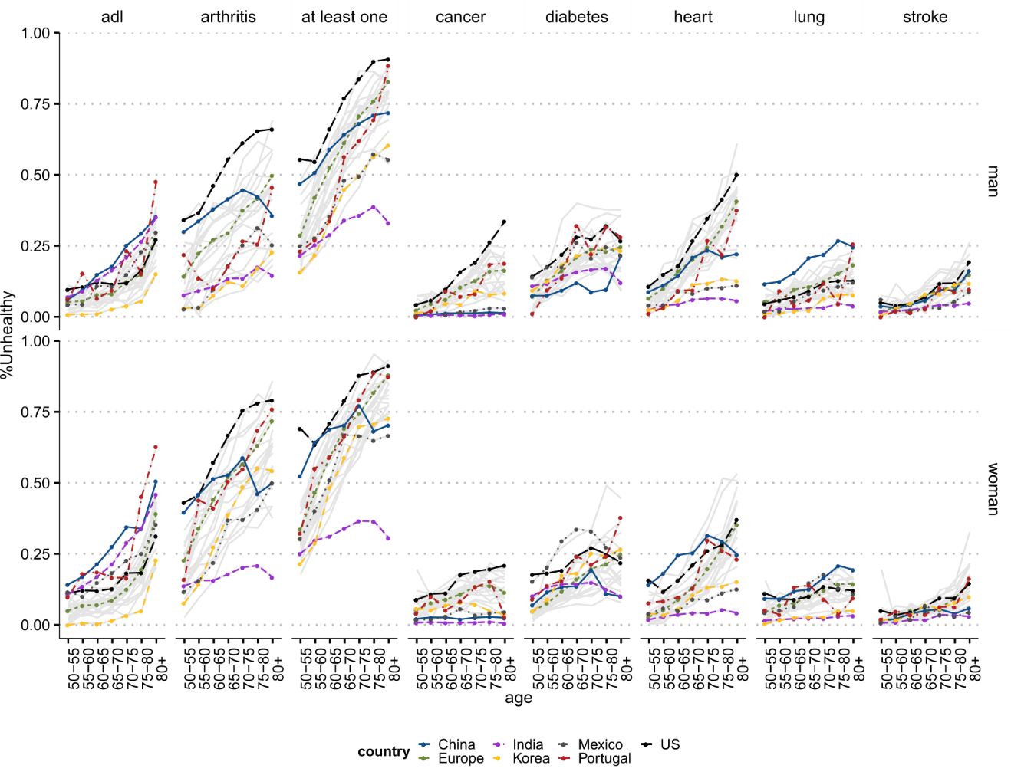

Fig. S1. Type or paste legend here. Paste figure above the legend.

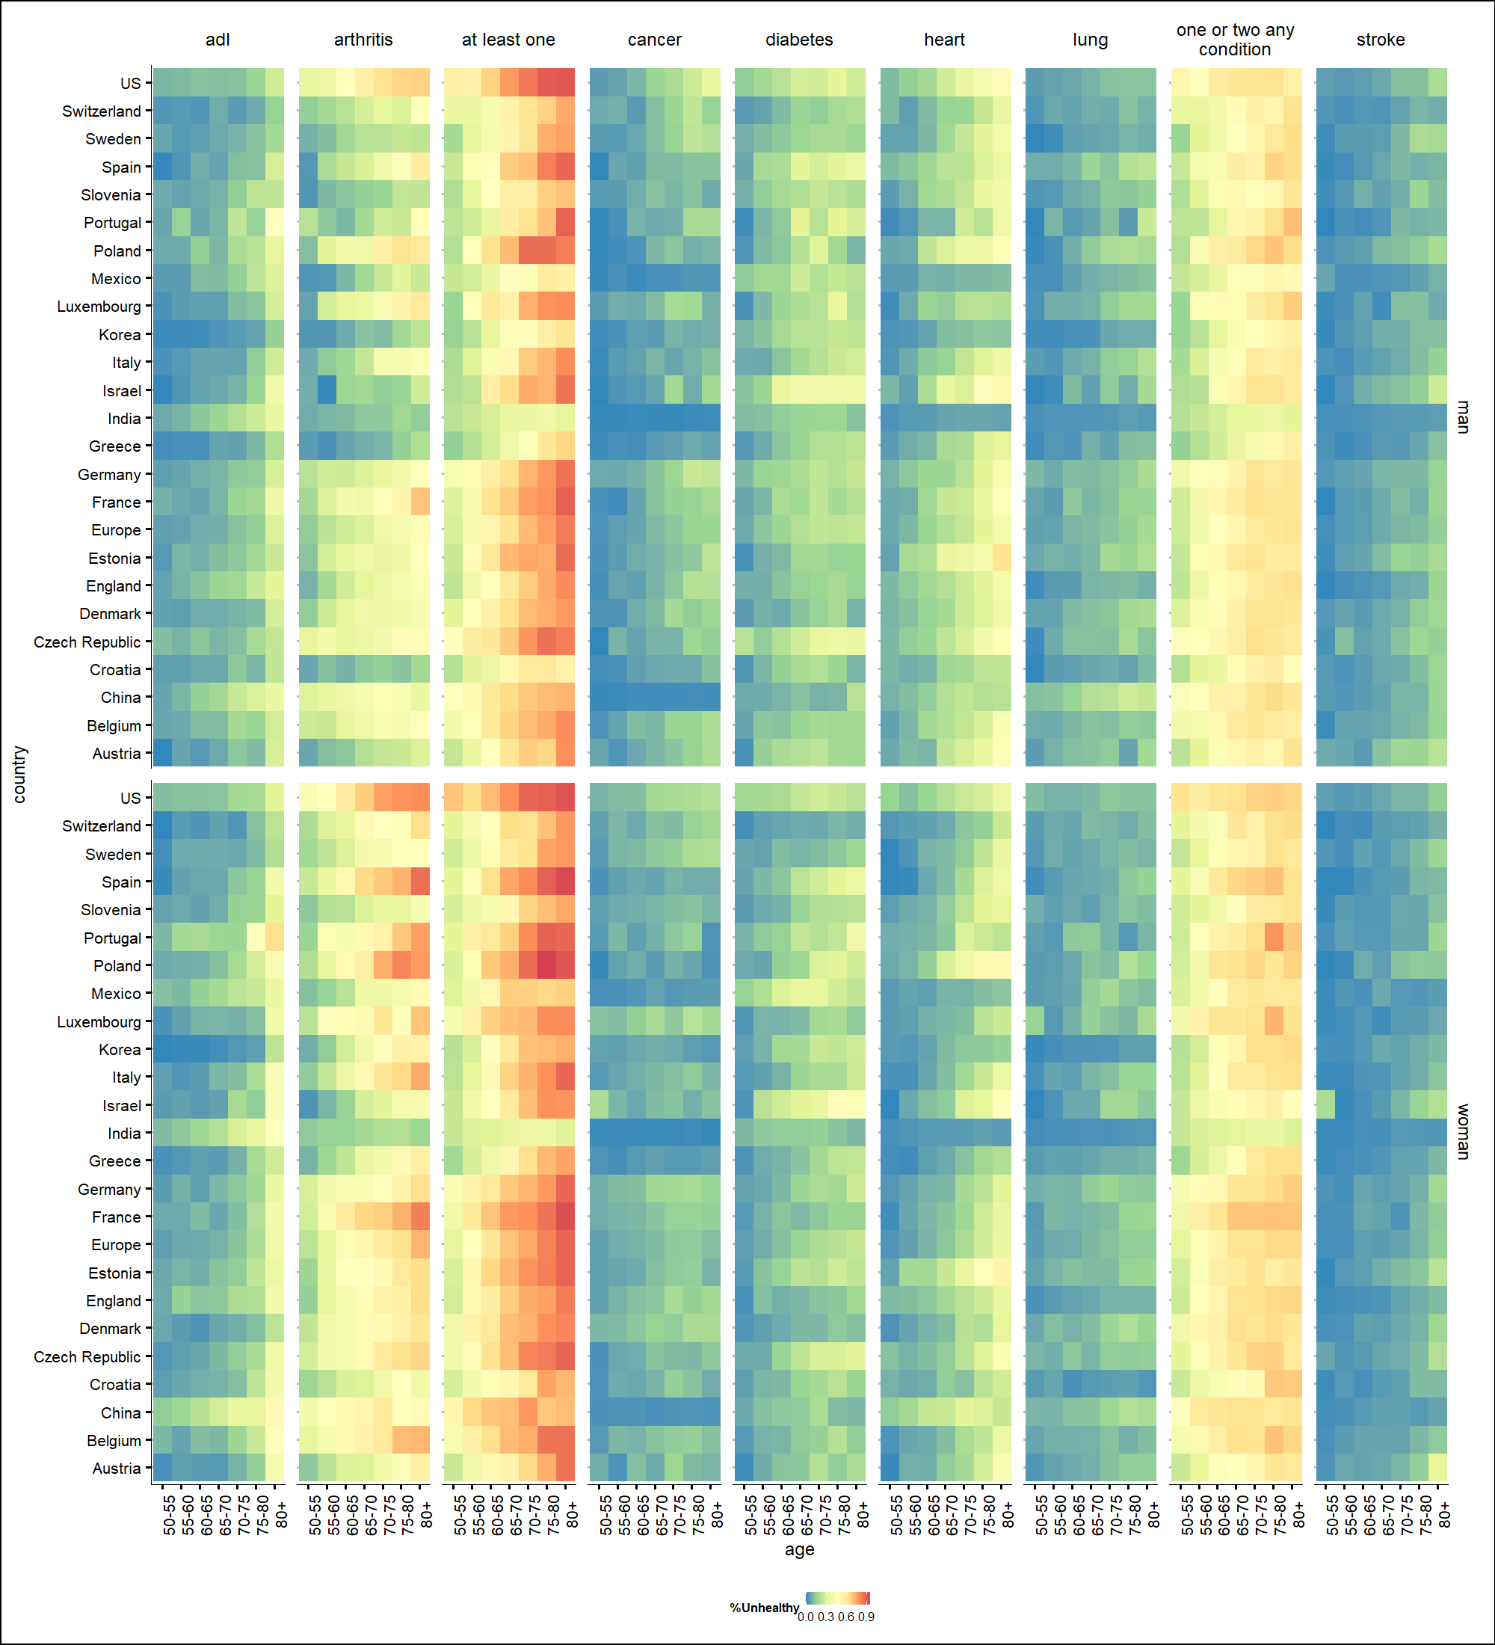

Fig. S2. Type or paste legend here. Paste figure above the legend.

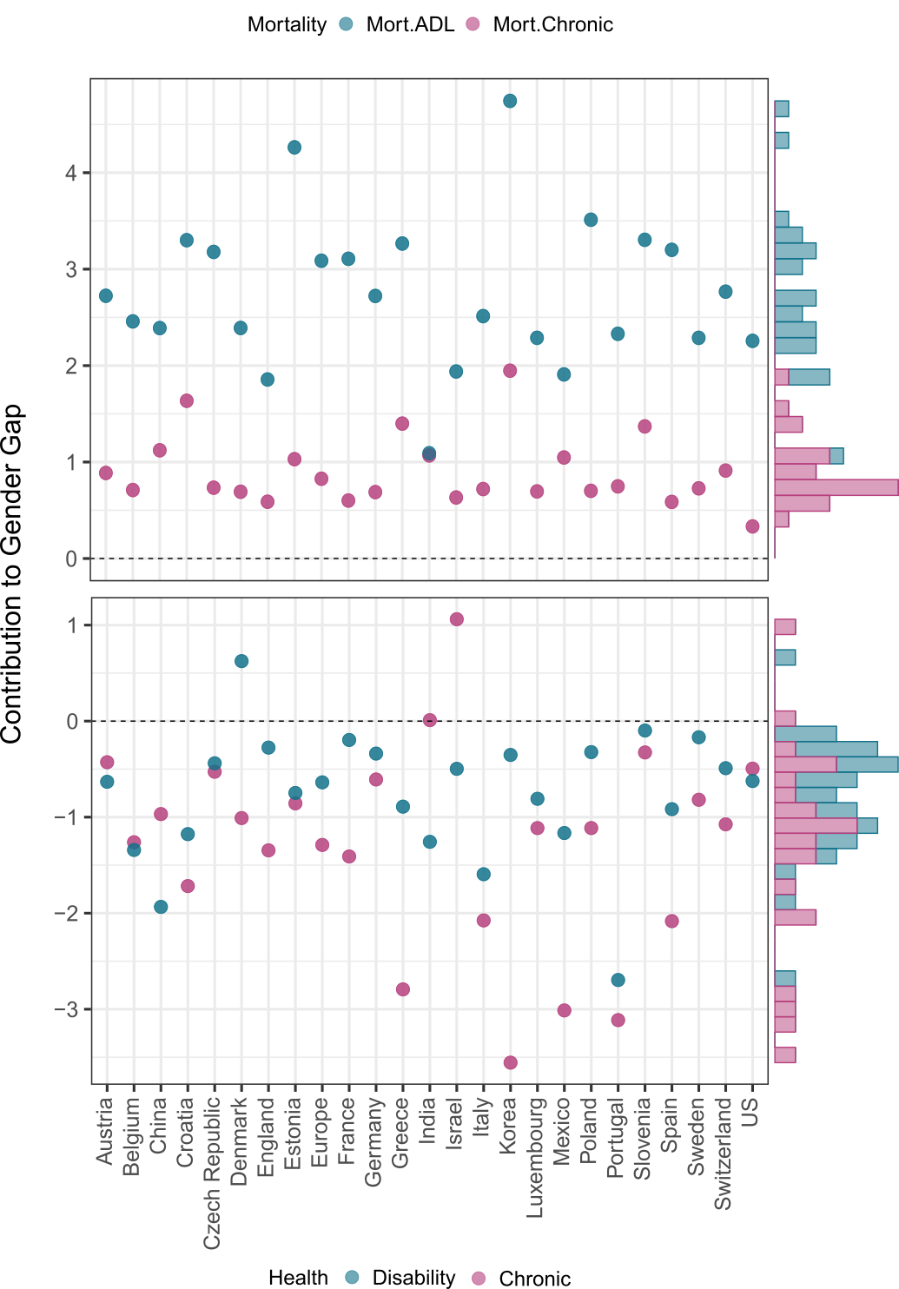

Fig. S3. Type or paste legend here. Paste figure above the legend.

Table S1. Type or paste table title here. Paste table below the title.



Table S2. Type or paste table title here. Paste table below the title.



Table S3. Type or paste table title here. Paste table below the title.



**Age specific prevalence for each country**

**SI References**