

**Supporting Information for**

Going beyond the gender gap in healthy lifespans

Vanessa di Lego1*, Marília R. Nepomuceno2, Cássio M. Turra 3

1 Wittgenstein Centre for Demography and Global Human Capital (IIASA, OeAW, Univ. Vienna), Vienna Institute of Demography at the Austrian Academy of Sciences

2 Max Planck Institute for Demographic Research, Rostock, Germany.

3 Universidade Federal de Minas Gerais, Cedeplar, Brazil.

*Vanessa di Lego corresponding author

**Email:**  [Vanessa.DiLego@oeaw.ac.at](mailto:Vanessa.DiLego@oeaw.ac.at)

**This PDF file includes:**

Supporting text

Figures S1 to S3

Tables S1 to S3

SI References

Supporting Information Text

Methods

Decomposition analyses help us to disentangle the components of gaps derived from aggregate health measures. For instance, when the gender gap comes from differences in healthy life expectancies, decomposition analyses break down the gap into two components: mortality and health (Nusselder and Looman 2004; van Raalte and Nepomuceno 2020; Nepomuceno et al. 2021). The contributions of mortality and disability to the gender gap in health expectancy have shown that gender differences in mortality and disability can be masked when only the total gap is analyzed (Nusselder and Looman 2004; Jagger et al. 2010; Mairey et al. 2014). In some contexts, this effect can be substantial (Van Oyen et al. 2013; Yokota et al. 2019).

For some countries, where the gender gap in health expectancies was virtually zero, decomposition analyses revealed considerable differences in both mortality and health, but in different directions (Nusselder et al. 2010; Van Oyen et al. 2013). As a consequence, the combination of a high prevalence of disability coupled with a high mortality advantage among women resulted in a small gender gap (Nepomuceno et al. 2021). In such cases, interpreting a small gender gap in health expectancy as a metric for low gender inequality ignores the higher burden of disability among women and disregards the intricate relationship between health and mortality.

The number of person-years lived free of disability (${{{}_{n}^{}L}_{x}^{i}}_{ }$) is calculated as,

${{{}_{n}^{}{{L_{x}^{ }}_{ }}}_{}^{i}}_{ }={}_{n}^{}{{L_{x}^{ }}_{ }} \left(1- {{{}_{n}^{}π}_{x}^{ }}_{ }\right) (1)$

where *nLxi*  is the number of person-years lived without disability between ages *x* and *x+n*, *nLx* is the total number of person-years lived in the age group *x* and *x+n*, and *nπx* is the proportion of disabled individuals in the age group *x* and *x+n*. The same is for chronic-free person-years lived, however with the prevalence for at least one chronic condition instead of prevalence of ADLs, and we call the person-years derived by the same process as

Then, life expectancy free of disability (*DFLE*) is calculated as:

$${DFLE}_{x}^{ }=\frac{\sum_{k=x}^{w}{ }\left(n L _{k}^{i}\right)}{l_{x}} (2)$$

With its equivalent life expectancy free of chronic disease (*CFLE*):

We then calculate gender gap in *DFLE* as:

And the gender gap in *CFLE* as:

We later split the gender differences in *DFLE* and *CFLE* at age *x* into mortality and disability/chronic effects by five-year age groups. To decompose the gap, we apply the continuous change decomposition method (Horiuchi et al. 2008; Riffe 2018; van Raalte and Nepomuceno 2020)

The continuous change decomposition method assumes that covariates (e.g., age-specific mortality rates and age-specific prevalence of disability) change continuously along an actual or hypothetical dimension, such as between two periods or between two populations, thereby modifying aggregate measures such as life expectancy and healthy life expectancy. Each of these tiny changes in the aggregate indices can be approximated by a linear combination of *n* partial derivatives of the function with respect to the covariates (Horiuchi et al. 2008). Then, numerical integration is used to obtain the total contribution of the covariates for the variation of the aggregate measure. This allows us to estimate the contribution of disability and chronic conditions to explaining gender inequality. In addition, the method is very flexible, and can be used for decomposing gaps in different aggregate measures, including healthy life expectancy, as presented by van Raalte and Nepomuceno (2020). Previous research has employed the methodology to estimate gaps in disability for Latin American and Caribbean (LAC) countries (Nepomuceno et al. 2021).

Heading

**Subhead.** Type or paste text here. You may break this section up into subheads as needed (e.g., one section on “Materials” and one on “Methods”).

<insert page break then Fig. S1 here. Supporting figures and tables are not allowed for Brief Reports.>

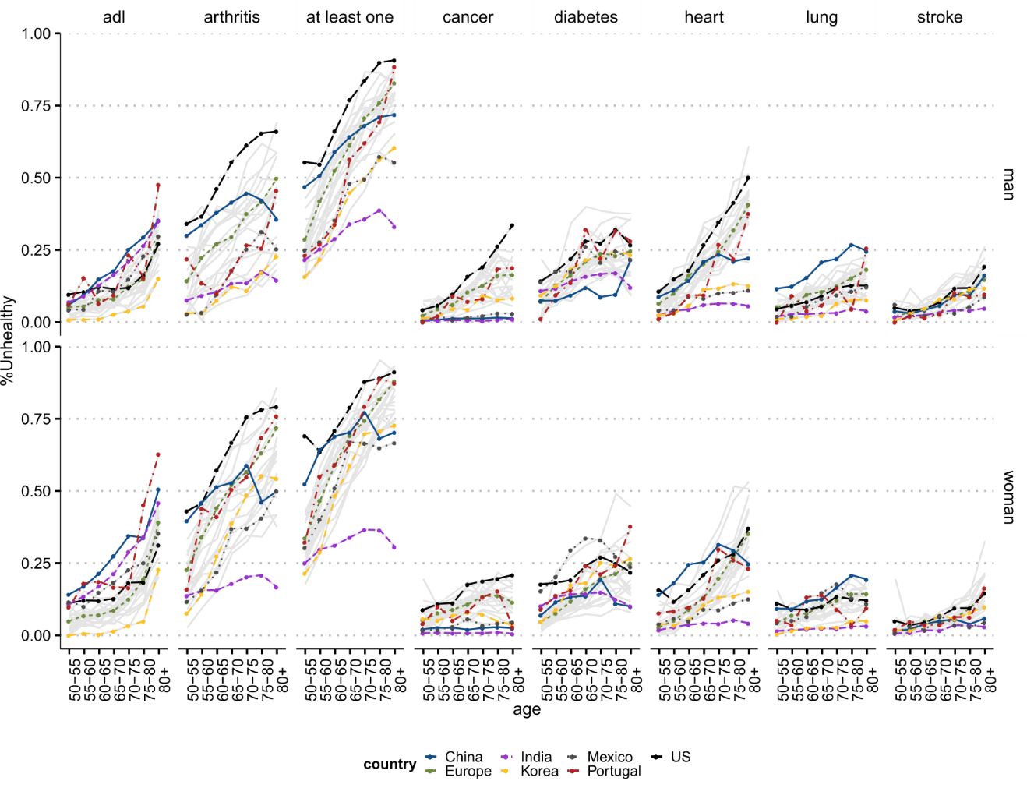

Fig. S1. Type or paste legend here. Paste figure above the legend.

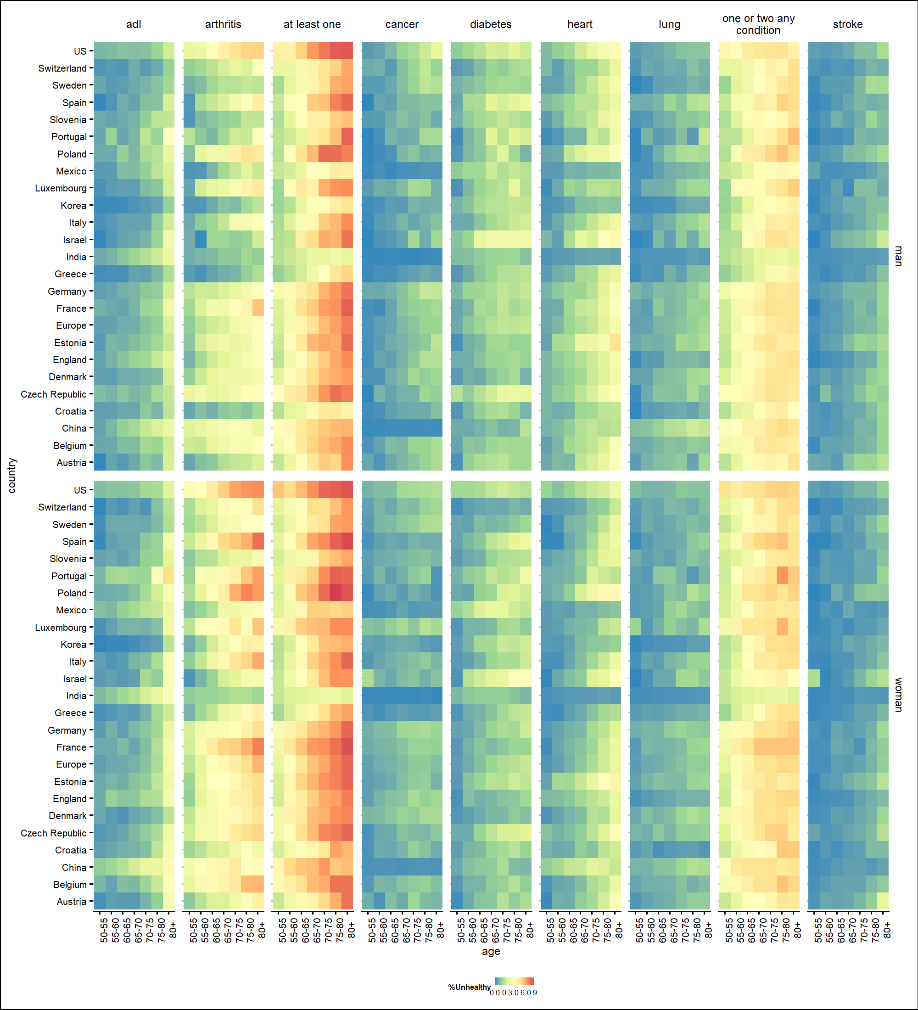

Fig. S2. Type or paste legend here. Paste figure above the legend.

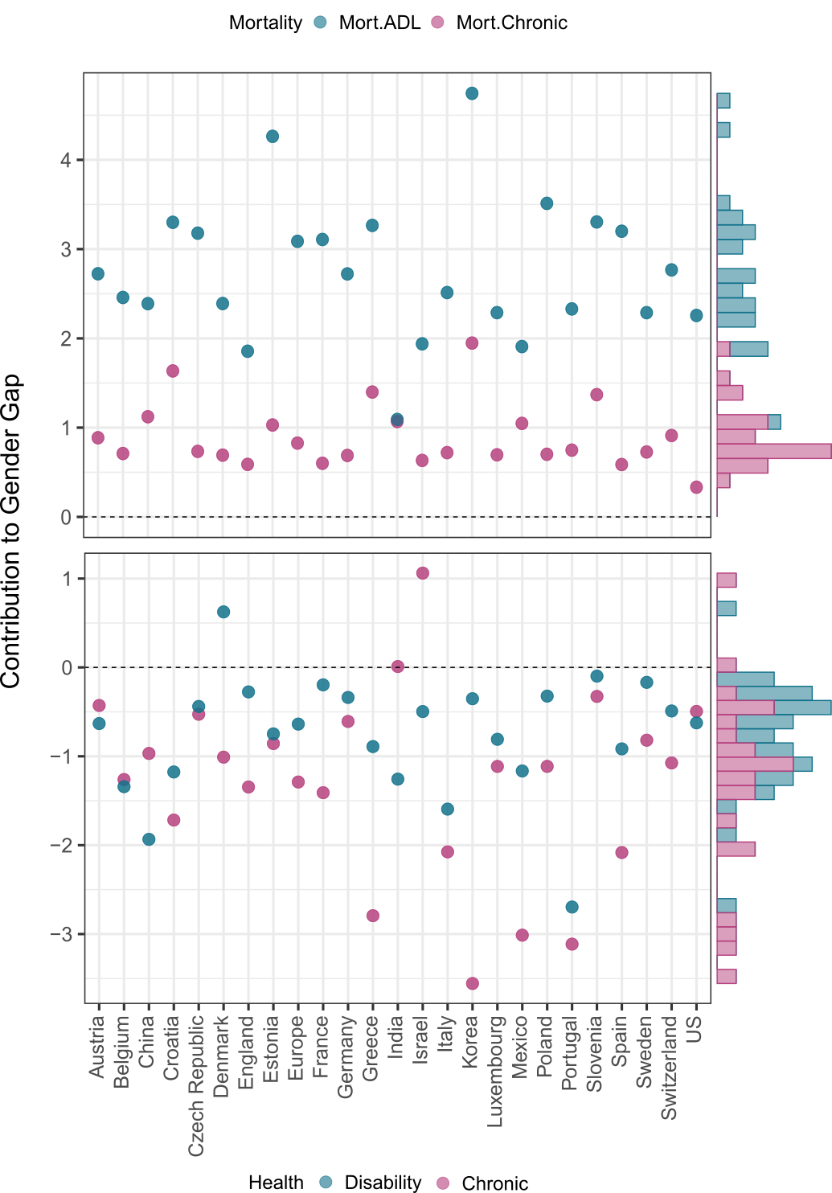

Fig. S3. Type or paste legend here. Paste figure above the legend.

Table S1. Type or paste table title here. Paste table below the title.



Table S2. Type or paste table title here. Paste table below the title.



**Data.** We follow the recommendation by the official report carefully written on the data that for harmonization purpose, general diagnosis of chronic medical conditions (e.g. heart diseases), rather than a more specific condition (e.g. congestive heart failure), may be used to maximize the number of studies that may be included. We thus use the diagnosed chronic conditions surveyed for all HRS-sister studies, which were hypertension, diabetes, cancers, chronic lung diseases, stroke, and arthritis or rheumatism. We focus on diagnosis and treatment of chronic medical conditions, as they were available for all surveys and are considered the most suitable for comparative purposes.

**Disease variables:** RwDIABE, RwCANCRE, RwLUNGE, RwHEARTE, RwSTROKE, and RwARTHRE are indicator variables denoting whether or not the Respondent reports a doctor has ever told her/him that s/he had the specified condition. The conditions are 1) diabetes or high blood sugar; 2) cancer or a malignant tumor of any kind except skin cancer; 3) chronic lung disease except asthma such as chronic bronchitis or emphysema; 4) heart problems, which include heart attack, coronary heart disease, angina, congestive heart failure, or other heart problems; 5) stroke or transient ischemic attack (TIA); and 6) arthritis or rheumatism. The Rand HRS 1992_2018v1 files we use as basis for these doctor-diagnosed conditions, with the exception of cases that dispute a report from a prior wave, each of these variables is set to "yes" if the Respondent answered yes to the pertinent question in the current or any prior wave, and to "no" if the Respondent responded no at the current and all prior waves. We have constructed three new variables that capture prevalence of chronic conditions. “chronic” refers to having at least one of the conditions cited above. “chronic_sum” refers to the total number of conditions ever diagnosed. “chronic_severe” is a dummy variable that measures comorbidity, where an individual is diagnosed with having three or more of those conditions. At first, in order to evaluate further differences in onset of disease, we included the variable RADIAGDIAB, which indicates the age at which the respondent was first diagnosed with diabetes. RwRECCANCR indicates the most recent age at which the respondent was diagnosed with cancer. Respondents are asked the year in which they were most recently diagnosed with cancer, and these responses are converted to their age at diagnosis. Previous responses are carried forward if the respondent does not report a new cancer diagnosis. RwRECHRTATT indicates the most recent age at which the respondent had a heart attack. RAFRHRTATT indicates the age at which the respondent had their first heart attack. However, a first analysis showed that in the sample of HRS and other countries more than 75% was missing for age variables. So, we did not use these variables in the analysis.

**Each Country**

**US (HRS).** We are using the Harmonized version B HRS: 37,495 observations. October 2018- There is a new updated version C, until 2019 that was updated now in 2022 and contains 42,233 observations. It is a Respondent level file so each row represents a unique Respondent. This leaves us with 18,747 observations using only wave 12 (year 2014) of HRS.

**Mexico (MHAS).** Version B.4 incorporates the latest released version of MHAS data, and adds several new variables. It contains 22,016 observations or rows- 22016. We are using the Harmonized VERSION B.4 (2001-2015), February 2022, for the MHAS data. The Mexican Health and Aging Study (MHAS) is a longitudinal household survey dataset for the study of health, economic position, and quality of life among the elderly. MHAS datasets as of September 2020. The MHAS (Mexican Health and Aging Study) Version B.4 incorporates the latest released version of MHAS data, and adds several new variables. It contains 22,016 observations or rows. It is a Respondent-level file so each row represents a unique Respondent. We will focus on Wave 4, which is for years 2014/2015. We will have 17,616 observations.

**England (ELSA).** We are using the Version G.2 (2002-2019), July 2021 for The English Longitudinal Study on Ageing (ELSA). It is a longitudinal household survey dataset for the study of health, economic position, and quality of life among the elderly (panel survey of people aged 50 and over and their partners, living in private households in England). Version G.2 incorporates the latest released version of ELSA data, which includes eleven main modules and the associated datasets, and adds variables and observations from Wave 9 with a total of 19,802 observations. It also adds new variables and makes adjustments and corrections. We will focus on Wave 7, nonetheless. The samples have been drawn from households which previously responded to the Health Survey for England (HSE). The seventh wave was conducted between June 2014 and May 2015 and included a refreshment sample selected from HSE 2011-2012.

**India (LASI).** The Longitudinal Aging Study in India (LASI) is a multidisciplinary, internationally harmonized panel study designed to be nationally representative of India’s population aged 45 and older. LASI is a joint project of three partnering institutions: International Institute for Population Sciences (IIPS), Harvard T.H. Chan School of Public Health (HSPH), and University of Southern California (USC). The first wave was conducted between 2017 and 2019 in 35 of India’s 36 states and union territories (except Sikkim). This initial sample, as released by USC, included 42,951 households and 72,262 individuals. The LASI sampling plan is complex and was based on the 2011 Indian Census with a multistage, stratified cluster sample design. The sample design includes three distinct selection stages in rural areas and four stages in urban areas. We use Version A.2 that makes corrections using the January 2021 released version of Wave 1 of the LASI data.

**Europe (SHARE).** This is Version F in the harmonized files and incorporates the latest released version of SHARE data, release 8.0.0, and adds observations from Wave 8. It contains 139,620 observations or rows. It is a Respondent-level file so each row represents a unique Respondent. It also adds new variables and makes adjustments and corrections. We focus on data from SHARE Wave 6, with the release 8.0.0 as of February 2022. SHARE uses a multistage stratified sample. Its weighting variables make its data representative of the target populations in constituent countries. Wave 6 does not still have full coverage of European countries, with the following countries only added in Wave 7: Finland, Lithuania, Latvia, Slovakia, Romania, Bulgaria, Malta and Cyprus.

**China (CHARLS).** The China Health and Retirement Longitudinal Study (CHARLS) is a longitudinal study of individuals over age 45 in China. Version D incorporates the latest released version of CHARLS data, and adds variables for Wave 4. It contains 25,586 observations or rows. It is a Respondent-level file so each row represents a unique Respondent; The sample population was selected as part of a stratified, multistage probability design. We will use Wave 3. As we concentrate on ages 50 and above due to the other samples we do not include individuals younger than 50. This leaves us with a sample size of 16,344 individuals.

**KLOSA- Korea.** The Korean Longitudinal Study of Ageing (KLoSA) is a panel survey of people aged 45 and over and their partners, living in private households in Korea. The survey elicits information about demographics, income, assets, health, cognition, family structure and connections, health care use and costs, housing, job status and history, expectations, and insurance. KLoSA surveys respondents every two years. Funded by the Korean Ministry of Labor, the Korean Institute of Labor (KLI) collected the first two waves, and the Korea Employment Information Service (KEIS) collected the Waves 3, 4, 5 and 6 of KLoSA, with the first wave of the KLoSA survey being conducted in fall/winter of 2006. The sample population was selected as part of a stratified, multi-stage area probability design. The first component of this sampling framework is the probability proportional to size (PPS) systematic sampling of the 2005 (South Korean) Census enumeration districts after stratifying by the location (15 major metropolitan cities and provinces) and characteristic of the district (urban or rural, and apartment building or non-apartment dwelling). Households were selected within PSUs from a listing of households in the Census identified as age-eligible; that is, inhabited by at least one person 45 years of age and older. This initial sample included 10,254 respondents age 45 and over. The second wave was conducted in 2008 and had 8,688 respondents. The third wave was conducted in 2010 and had 7,920 respondents. The fourth wave was conducted in 2012 and had 7,486 respondents. There was no refresher sample in Waves two through four. In 2014, a refreshment sample of individuals born in 1962 or 1963 was drawn and it included 920 individuals, which were added to the 7,029 remaining core sample respondents for a total of 7,949 Wave 5 respondents. The sixth wave was conducted in 2016 and had 7,490 respondents. We will focus on Wave 5. However, because we focus on ages >50, the sample is not 7,949. We use the hamornized Version C that contains 11,174 observations or rows. It is a Respondent-level file so each row represents a unique Respondent.

of health component to the gender gap.

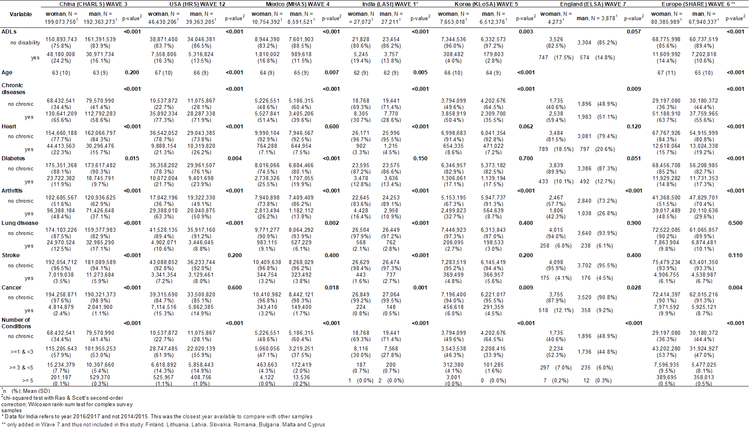

Table S1 Sample Characteristics and sample tests for different characteristics for women and men separately, weighted.

**Country-Specific Figures for health conditions**

**HRS**

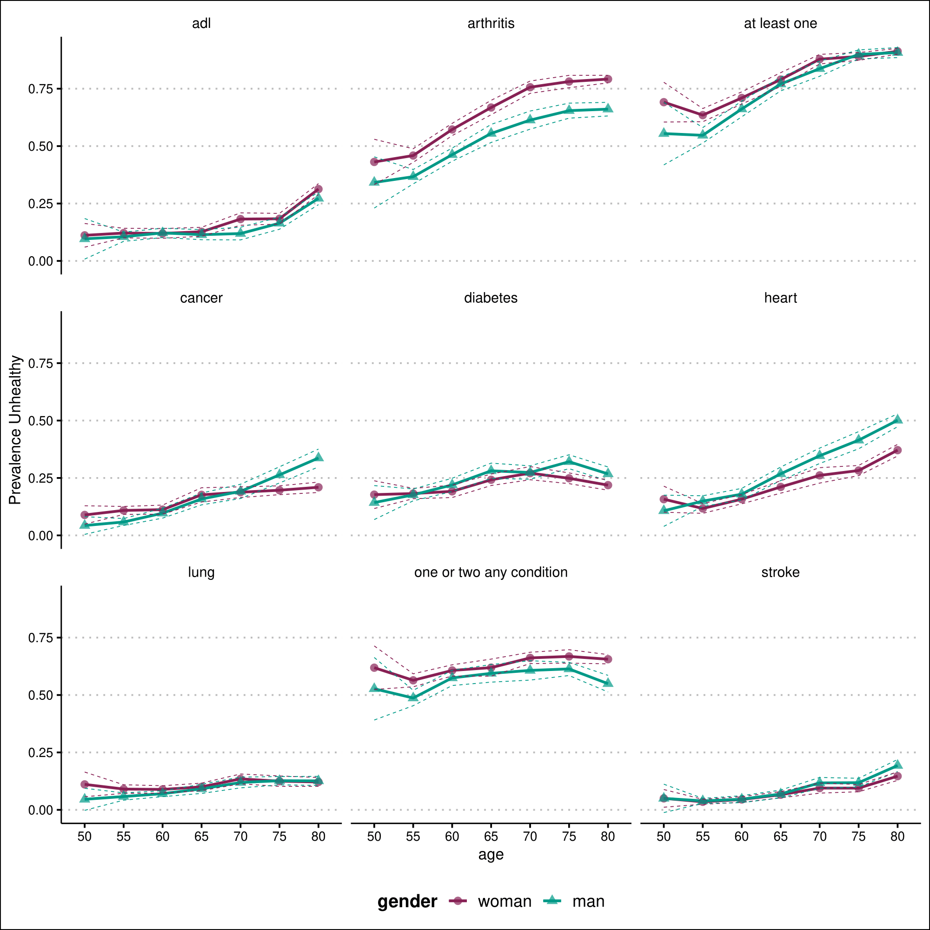

ELSA

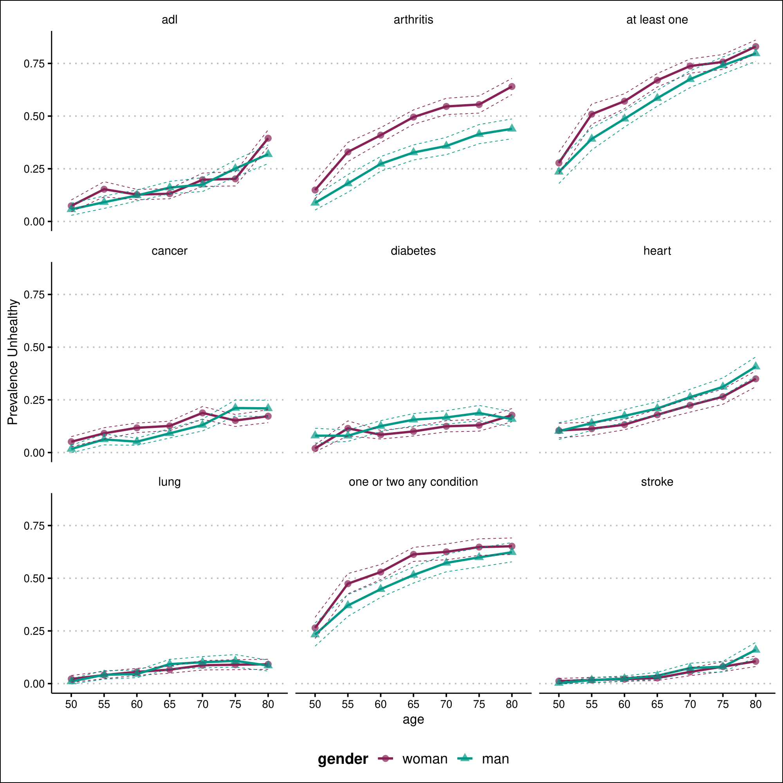

KLOSA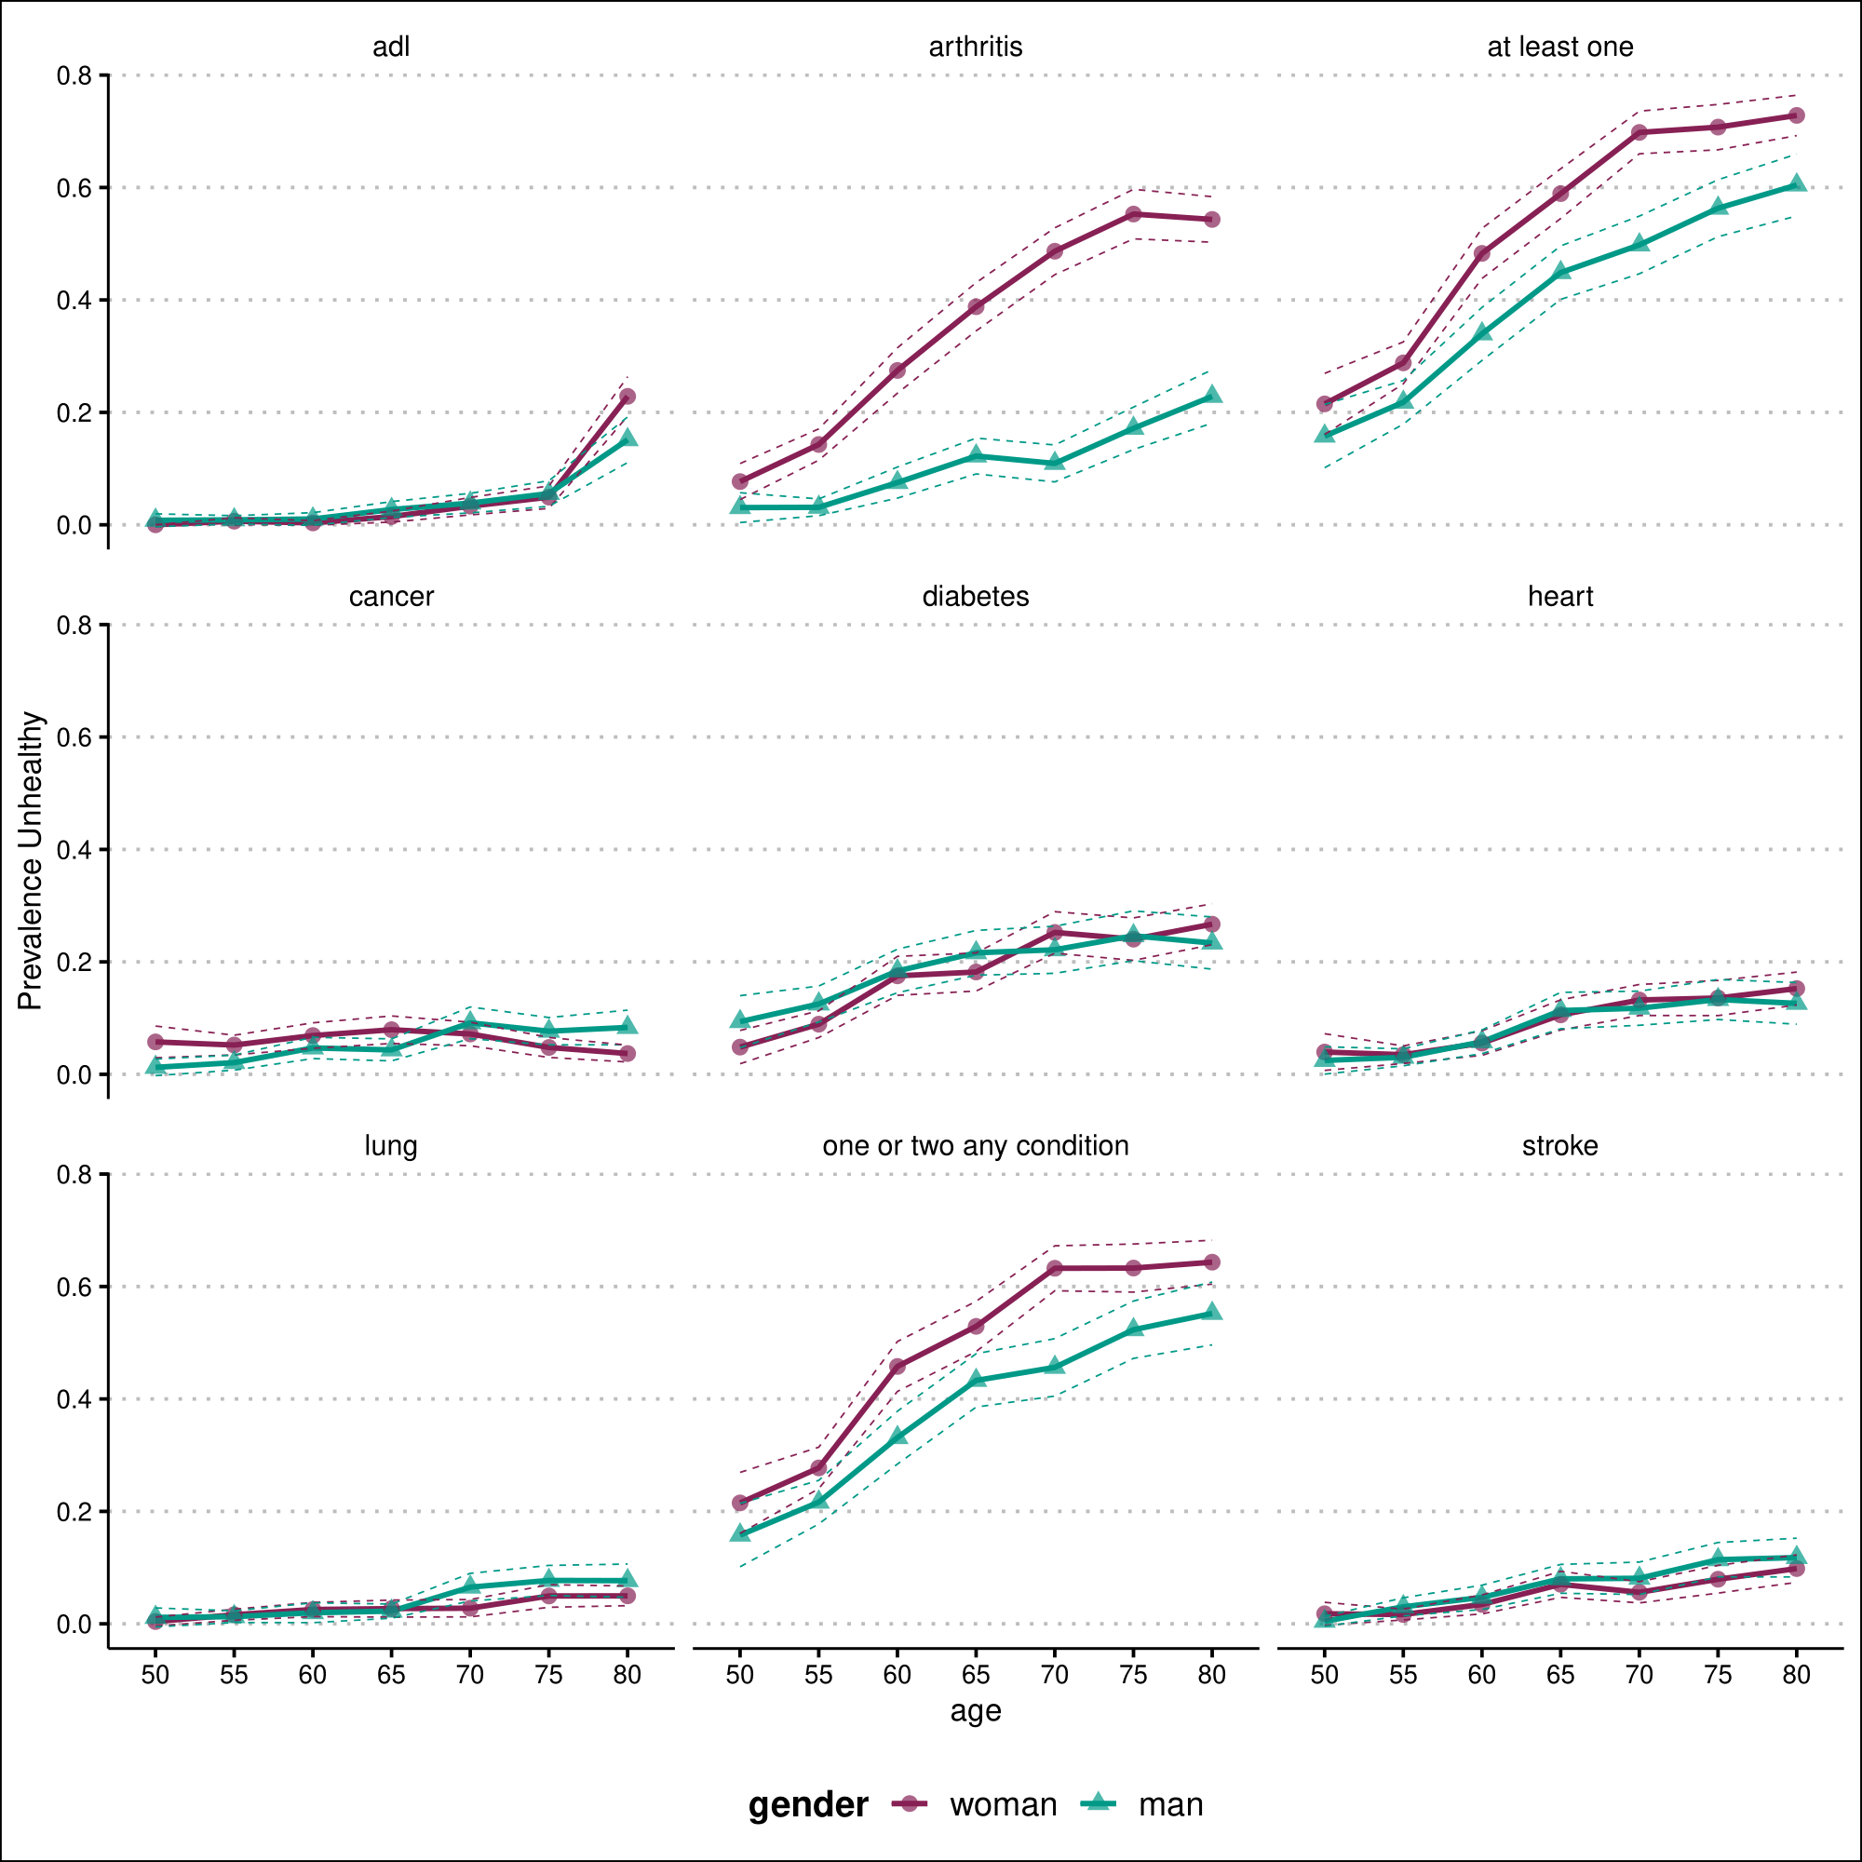

India- LASI

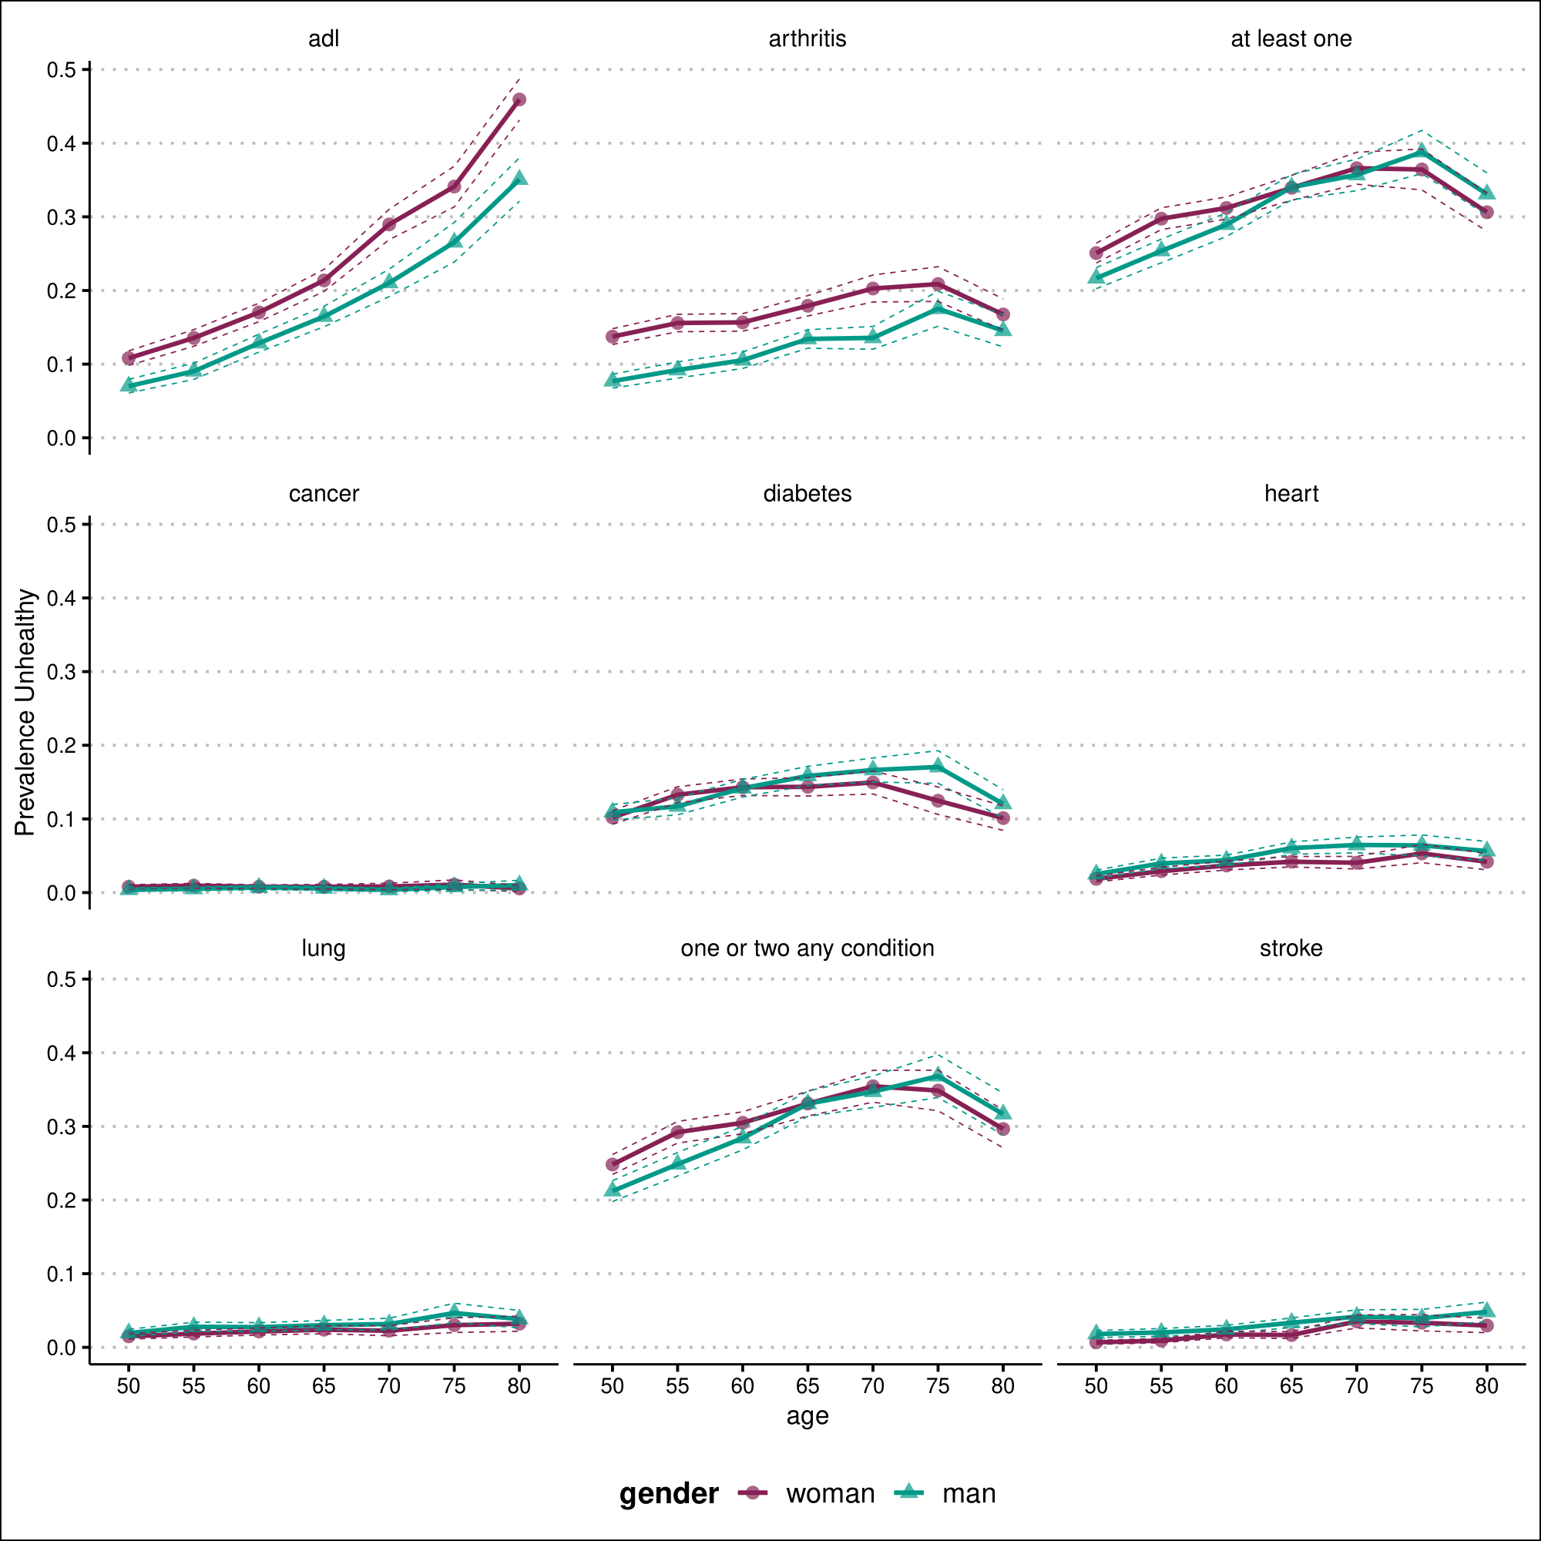

Mexico- MHAS

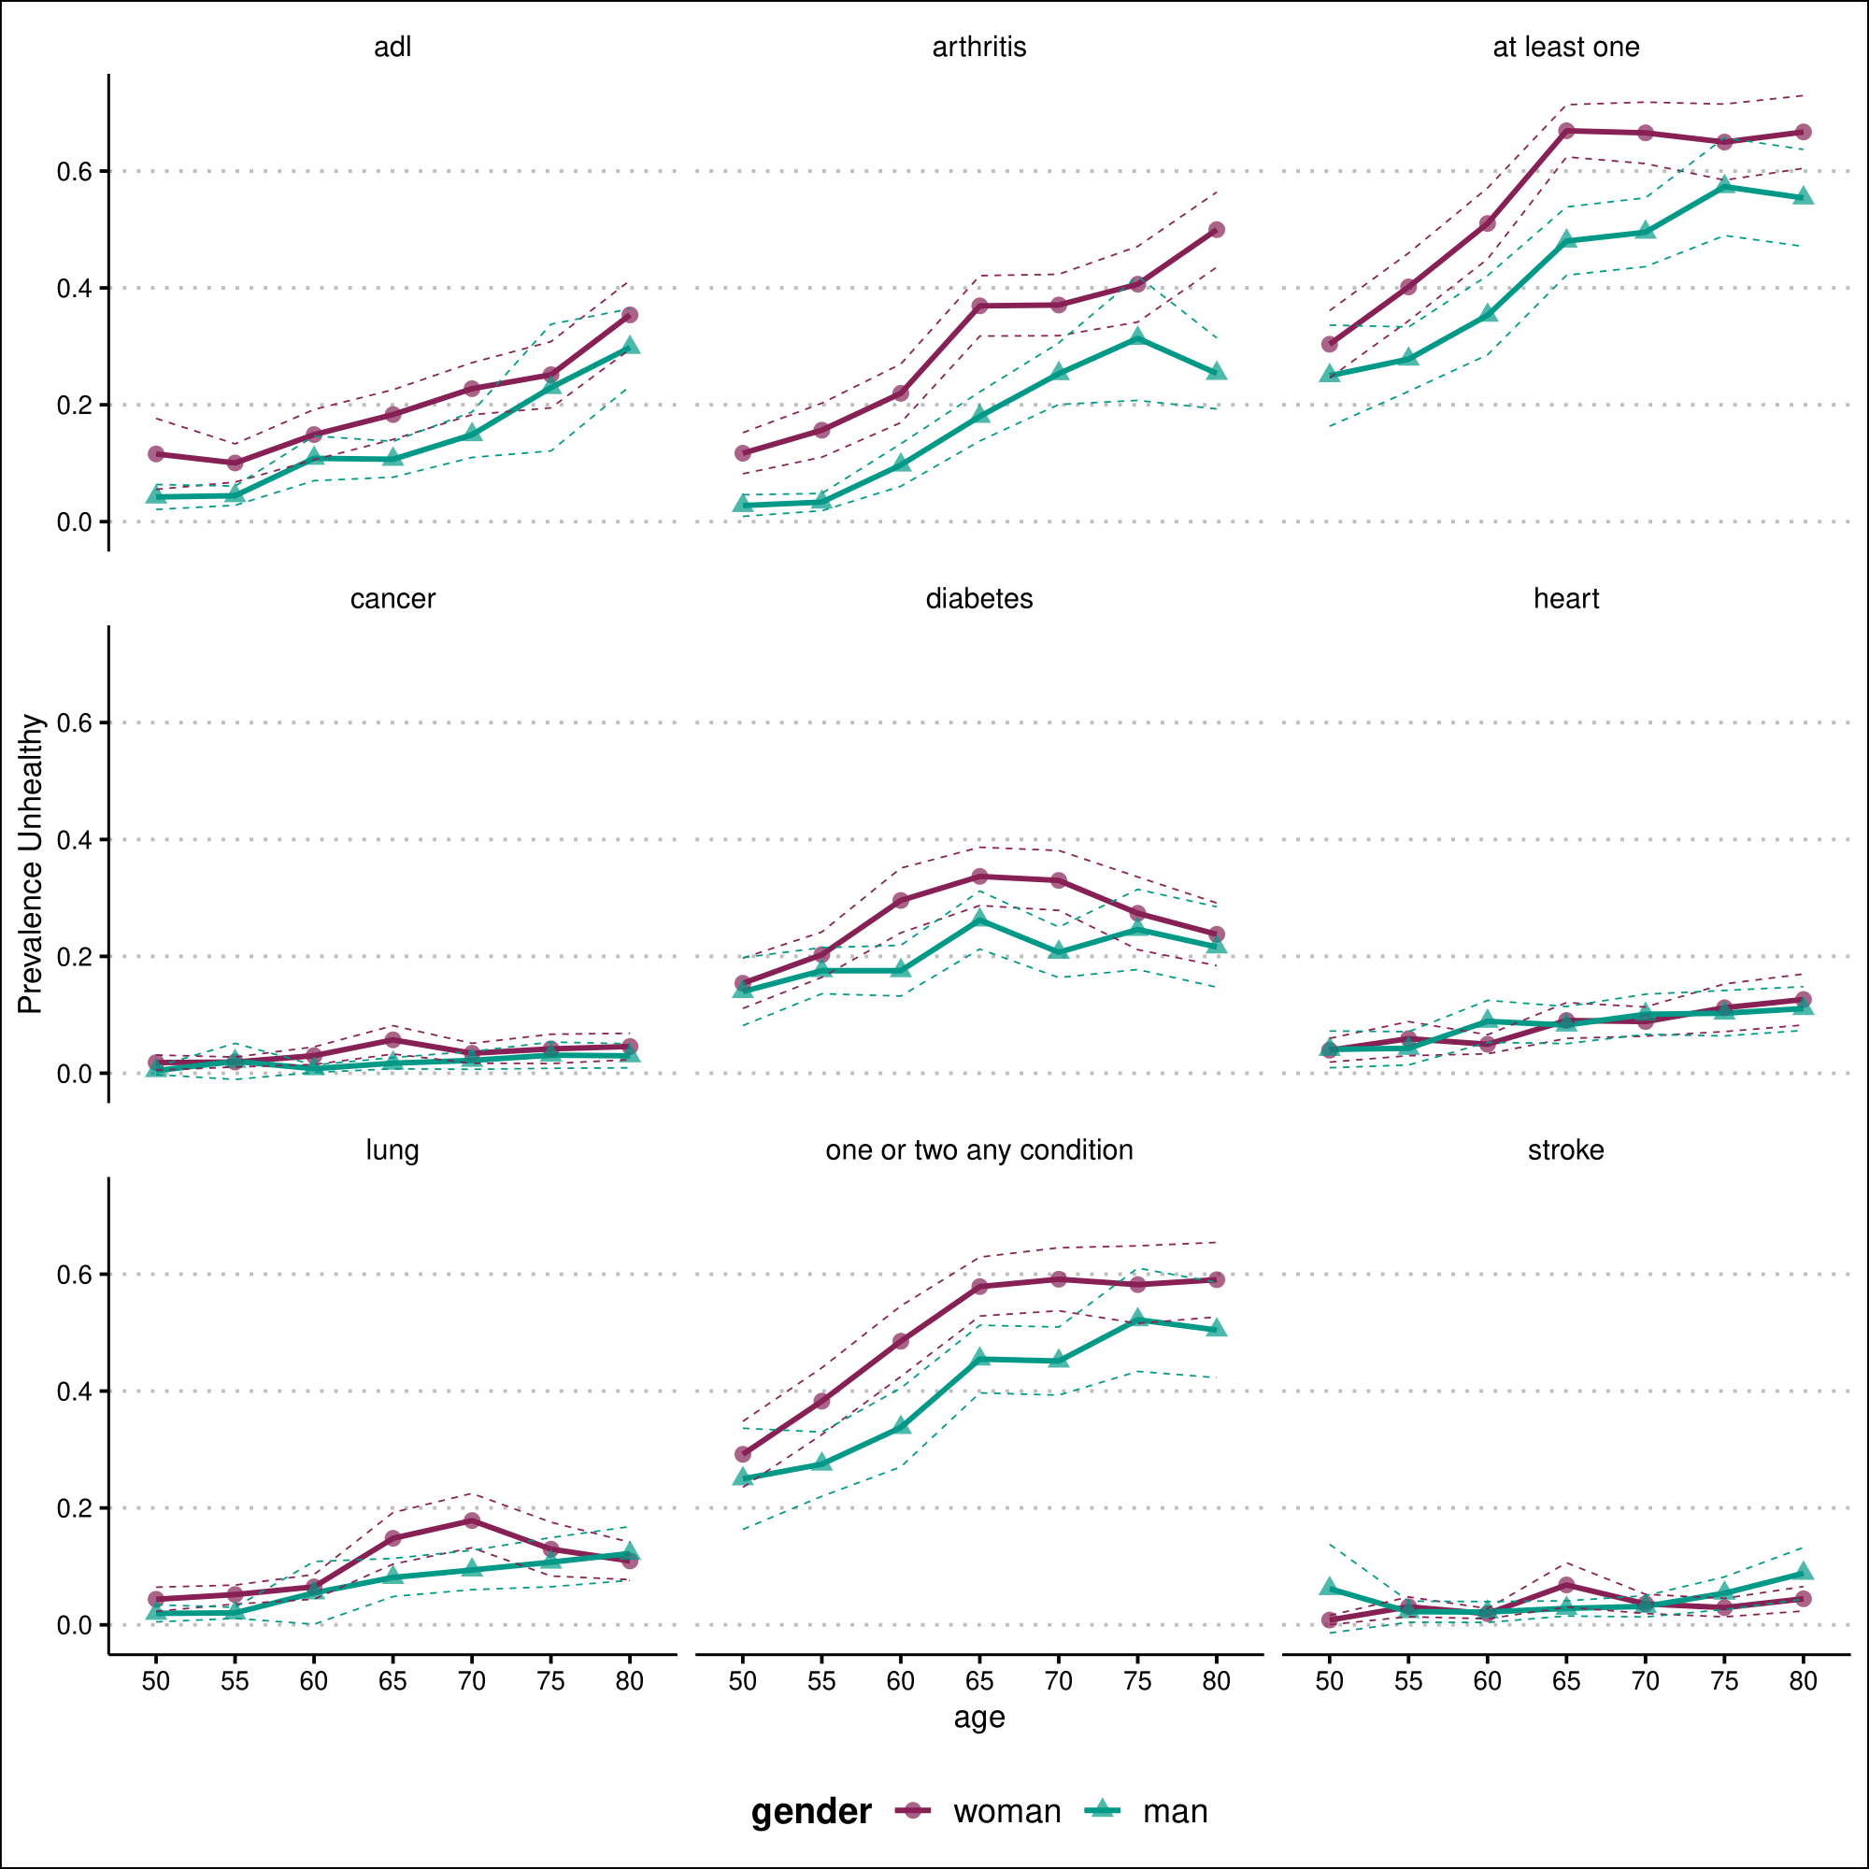

SHARE- Europe

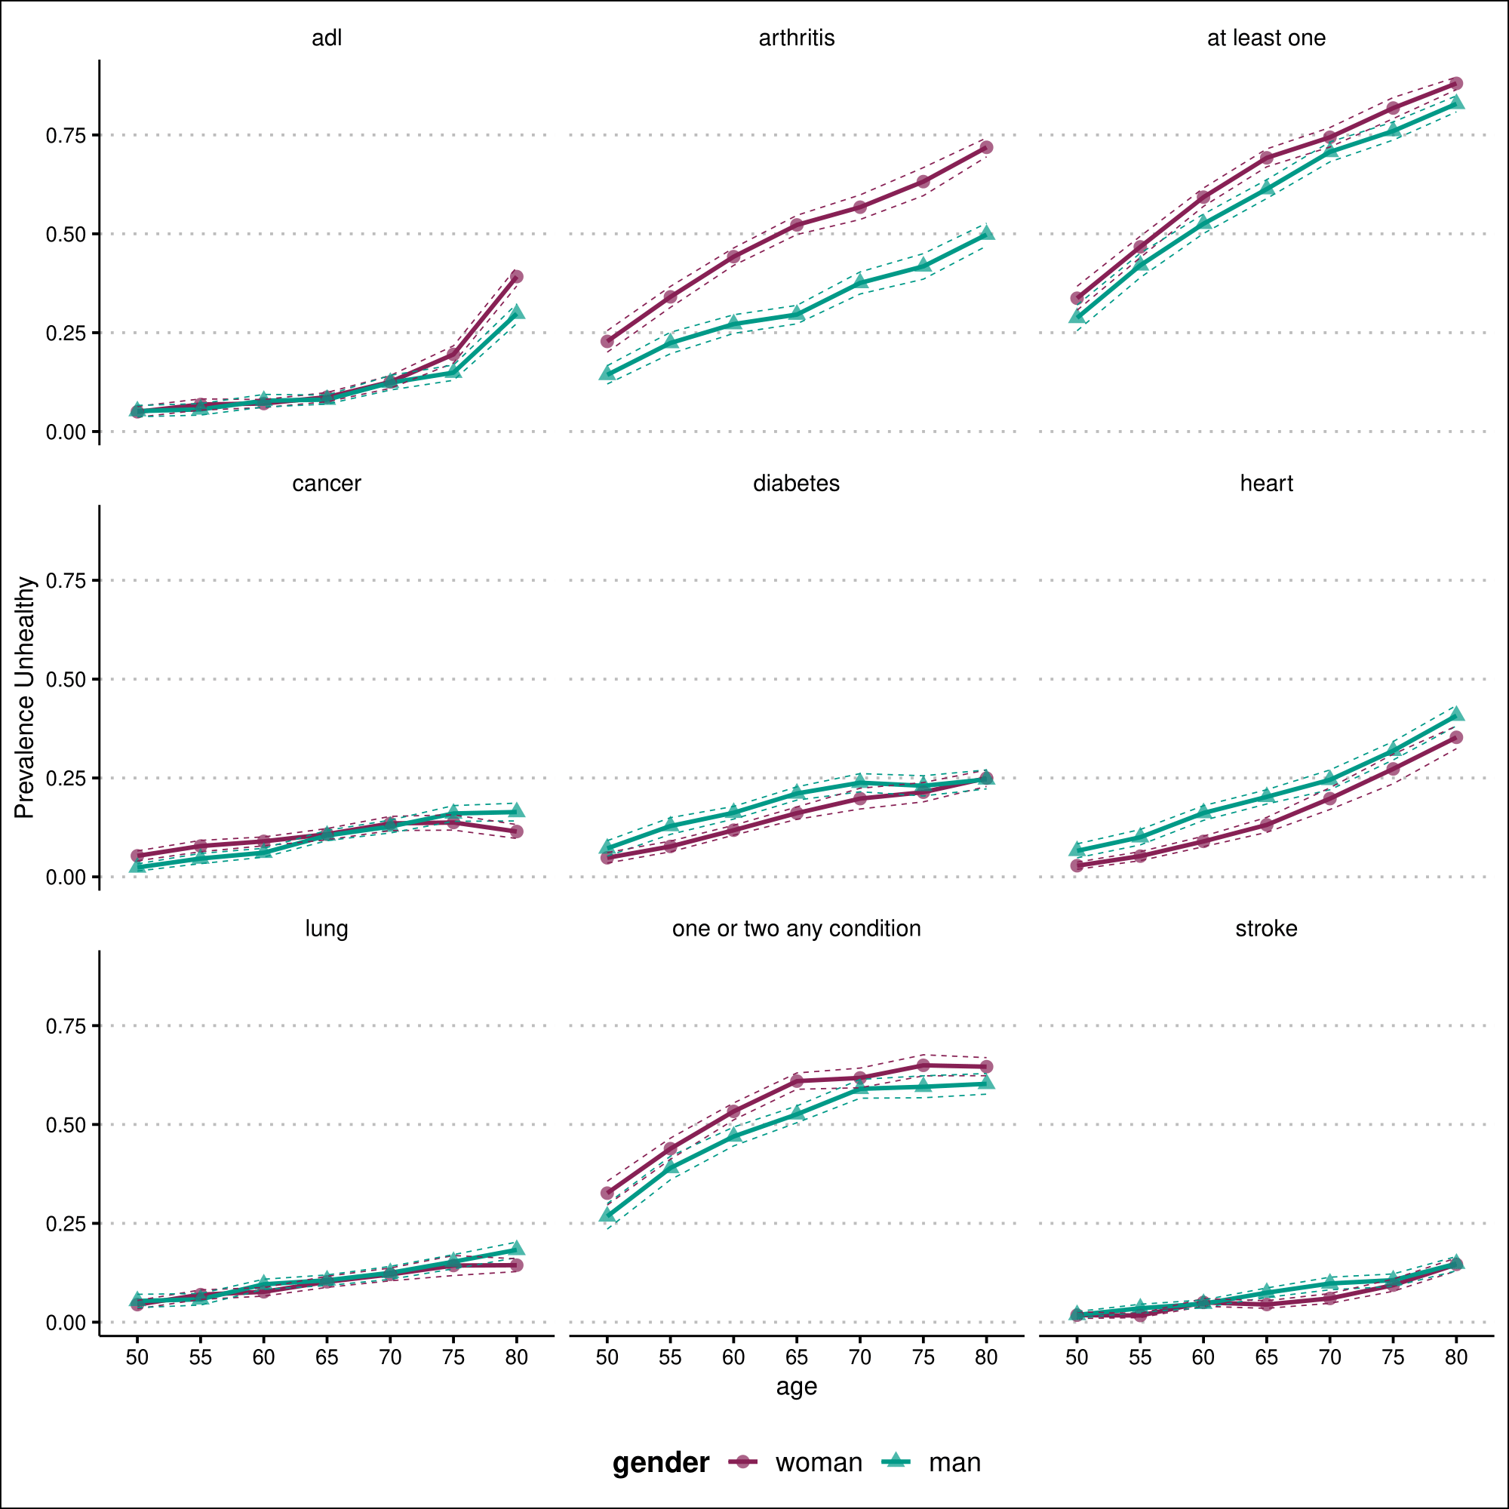

**SI References**