Going beyond the gender gap in healthy lifespans

Vanessa di Lego1*, Marília R. Nepomuceno2, Cássio M. Turra 3

1 Vienna Institute of Demography at the Austrian Academy of Sciences, Wittgenstein Centre for Demography and Global Human Capital (IIASA, OeAW, Univ. Vienna)

2 Max Planck Institute for Demographic Research, Rostock, Germany.

3 Universidade Federal de Minas Gerais, Cedeplar, Brazil.

*Corresponding author

**Email:**  [Vanessa.DiLego@oeaw.ac.at](mailto:Vanessa.DiLego@oeaw.ac.at)

Gender gap indices in healthy lifespans are routinely used as indicators of gender inequality. Policy makers use these gaps to benchmark countries, monitor changes over time, and identify the pace at which countries are closing or widening gender inequality in health (1–3). Overall, gaps are an easy and straightforward way to relate the difference between two quantities. However, gender gaps in health may blend several aspects of health differences between women and men, and can elicit misleading conclusions when used interchangeably as indicators of inequality.

Gender gaps in health are multifaceted and the the complex interplay between gender, health, and mortality unveils a paradox: women tend to outlive men but experience more years with poorer health. Despite women’s survival advantage even under extreme conditions (cite Zarulli et al.,) , they tend to have disadvantages in terms of physical health, self-rated health, and cognition at older ages (refs). Women also tend to experience higher morbidity from acute and chronic conditions and more short-term disability (refs). When analyzing the gender gap from an aggregate measure such as healthy life expectancy, some of these facets may be overlooked, which highlights the importance of disentangling the various components of gender gaps in healthy lifespans.

Breaking down the gender gap in healthy life expectancy into mortality and morbidity has been shown to be a crucial factor in understanding gender disparities in health (4–6). For some countries, where the gender gap in health expectancies was virtually zero, decomposition analyses revealed considerable differences in both mortality and health, but in different directions (7, 8). Consequently, the combination of a high prevalence of disability coupled with a high mortality advantage among women resulted in a small gender gap. In such cases, interpreting a small gender gap in health expectancy as a measure for low gender inequality ignores the higher disability experienced by women and disregards the intricate relationship between health and mortality.

In this paper, we estimate the gender gap in health expectancy as measured by disability- and chronic-free life expectancy for ages 60 and over. We additionally decompose the gender gap and assess the impact of health and mortality on gender inequalities in healthy lifespans across various countries. To date, studies that have disentangled gender gaps in healthy lifespans by separating healthand mortality dimensions have mostly focused on a specific set of countries or regions with shared societal values and gender roles. This is mainly due to the fact that comparative analyses are challenging, as the quality and validity of health indicators vary from country to country (9–11).In this paper, we use the harmonized surveys from the Gateway to Global Aging Data (12), a unique dataset that allows for comparisons in health outcomes across a diverse range of low-, middle-, and high-income countries. We focus on the U.S., England, South Korea, China, India, Mexico and EU Countries. This set of countries not only has a particular epidemiological and mortality trajectories, but different cultural backgrounds, gender norms, and health systems, , which enables us to investigate the impact of interpreting the gender gap in health and mortality as a measure of inequality in different settings.

**Materials and Methods**

**Data**

For the health measures, we use data from the Gateway to Global Aging Data, produced by the Program on Global Aging, Health & Policy that created harmonized versions of sister-HRS studies. The harmonized versions have followed the RAND HRS conventions of variable naming and data structure which allow for cross-country comparisons. We use the harmonized versions available for HRS (United States), ELSA (England), KLoSA (South Korea), CHARLS (China), LASI (India), MHAS (Mexico), and Europe (SHARE). To perform comparisons at points in time that were as close as possible across countries we used survey waves pertaining to year 2014-2015 (HRS: Wave 12; ELSA : Wave 7; SHARE: Wave 6; KLoSA: Wave 5; CHARLS: Wave 2; and LASI Wave 1). The only exception is India, since the first wave of LASI was carried on between 2017-2019. We focus on this specific set of countries as our aim is to have the most diverse group of nations while retaining the highest possible level of concordance across the harmonized health variables. Hence, we choose these countries and years due to the following specific reasons: 1. these are the available countries for which the highest possible concordance among surveys is available for health information; 2. these countries have unique epidemiological and mortality trajectories that include countries with fast-paced mortality transitions, such as Korea and slow pioneering countries like Sweden; 3. Different cultural backgrounds, gender norms, and health systems, which enable us to investigate whether specific gender patterns in inequality in health and mortality emerge in those settings. We focus on age 60 y and above to be coherent towards the definition of old age across countries. While most developed countries define old age as 65 y, for China and Mexico it is age 60 y. For more details on the data characteristics, refer to the Supplementary Information.

For mortality data, we use UN life tables from the 2022 Revision of World Population Prospects (United Nations 2022) for all countries with the exceptions of England, where the life tables are from the Office for National Statistics UK (ONS), as the ELSA study does not include Wales.

**Methods**

To examine gender gaps in health expectancy, we first estimate the disability-free life expectancy () and the chronic-free life expectancy () for ages 60 y and over using the Sullivan Method (13), the most widely adoptedmethodological approach for estimating prevalence-based health expectancies (14, 15). For disability, we use the variable constructed from a 5-item list of activities of daily living (ADLs), which include bathing, dressing, eating, getting in and out of bed, and using the toilet (16). For chronic doctor diagnosed diseases, we use the variables on specific chronic conditions diagnosed by a physician, which include diabetes, heart conditions, arthritis, cancer, stroke, and lung disease. Using the respective weighted proportions of women and men who report a limitation in activities of daily living (ADL) and of at least one chronic doctor diagnosed disease (Chronic) in the population for each survey, we computed the prevalence of unhealthy individuals for each disability and at least one chronic condition for each country and by 5 y age groups for women and men separately. We then combine the computed prevalence with the total number of person-years lived obtained from the United Nations life tables (ONS for England). is then defined as the number of person-years lived free of disability, while is the number of person-years lived without chronic conditions.See SI for more details on the Sullivan method. For estimating the gaps, we calculate

We then calculate the gender gap in *DFLE* as - and the gender gap in *CFLE* as - .

To decompose the gap, we apply the continuous change decomposition method (17, 18), and split the gender differences in *DFLE* and *CFLE* at age60 y into mortality and disability/chronic effects by 5 y age groups, following previous research (5).

**Results**

**Age-Specific Prevalence**

Figure 1 shows the age-specific prevalence of individuals who report a limitation in activities of daily living (ADL), and of at least one chronic doctor-diagnosed disease (Chronic). Panel A is a heatmap with the prevalence of unhealthy women and men in activities of daily living (ADL), and chronic conditions (Chronic) by age for all countries. Panel B presents most countries in shaded grey lines in the background, to show the overall age pattern for women and men, and highlights some countries (see Figs S1-S2 in the Supplementary Information for all countries and separately for each chronic condition). Overall, the prevalence of ADLs increases with age for both women and men, with a steeper increase happening from ages 70 y and over in most countries. Across all countries, prevalence mostly falls between Korea and China, which are the low and high levels, respectively, for both women and men. The US age pattern falls between Korea and England. Korea presents the lowest prevalence of disability of all countries, both for women and men, with the greatest increase starting from age 75 y. The overall pattern for women across countries is more dispersed than for men, with the difference between Korean women and Chinese and Indian being higher than for men. Compared to the age pattern of men, women have a higher rate of increase in prevalence across all countries with age, with the burden increasing at a much faster pace. Chinese and Indian women have a prevalence rate level at ages 60-65 y that is only observed at ages 70-75 y for men, a gap of almost 10 y.

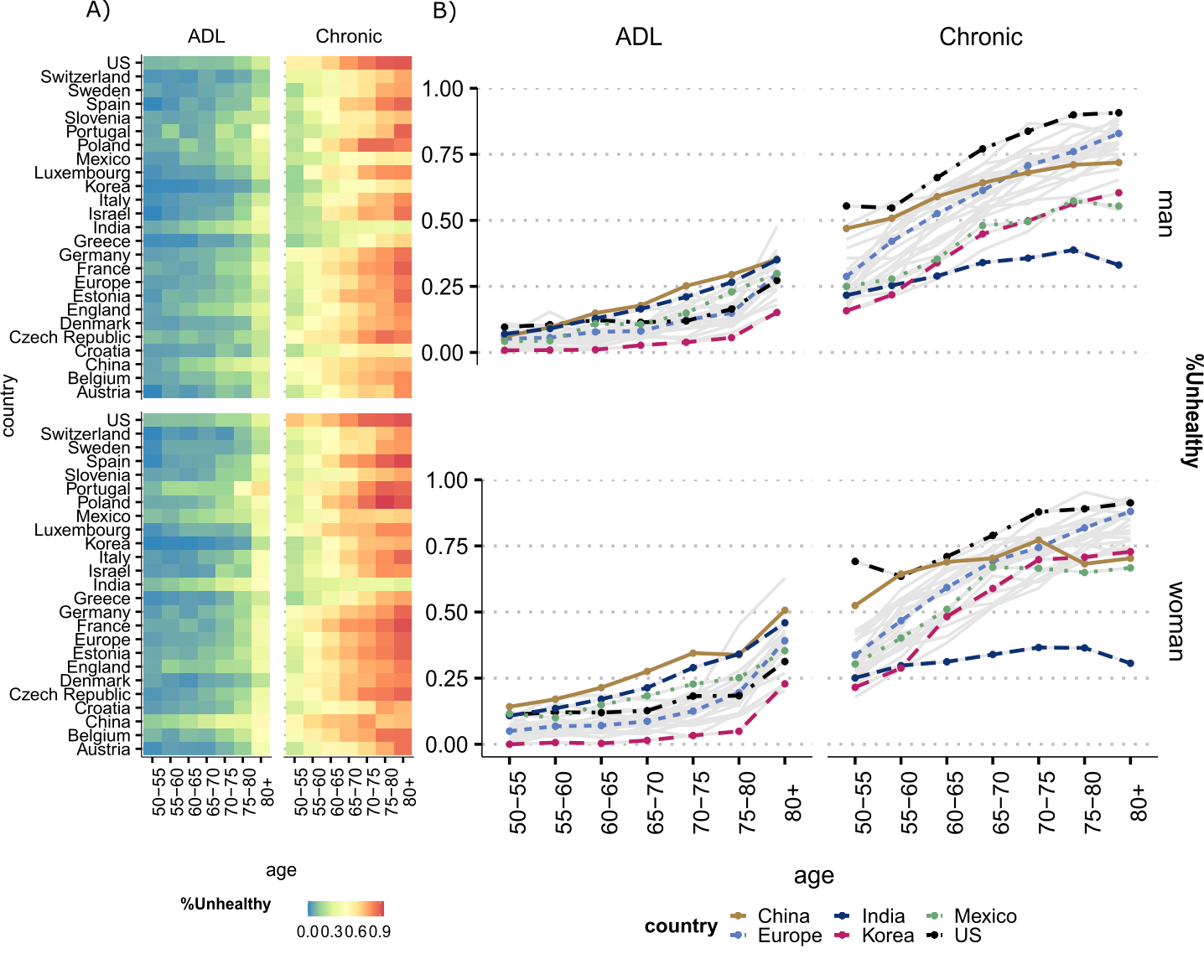

**Figure 1**. Prevalence of unhealthy women and men by activity of daily limitation (ADL) and doctor diagnosed chronic conditions (Chronic) by age. All countries are presented in (Panel A) and selected countries in (Panel B).

Source: Gateway to Global Aging Data, Produced by the Program on Global Aging, Health & Policy, University of Southern California with funding from the National Institute on Aging (R01 AG030153). *Notes:* Chronic is defined as being diagnosed with at least one of six doctor diagnosed conditions present at all country surveys that were harmonized: 1. Arthritis, 2. Cancer, 3. Diabetes, 4. Heart Conditions, 5. Lung disease, 6. Stroke. For more details on how diagnoses are defined and which criteria are used, refer to the Supplementary Information. For country-specific profiles for each condition, also see individual figures in the Supplementary Information.

Panel B also shows how the figure changes when we analyze chronic conditions. First, the prevalence of having at least one chronic condition is higher than experiencing limitation in daily activities for both women and men at all countries. The US has the highest prevalence for women and men at all ages. China is right after the US with high prevalence at younger ages (50-60 y), but then levels off at older ages, while other countries still experience a steep age gradient in prevalence. India is the country with the lowest prevalence of at least one chronic condition. The low level for India is most likely due to limited access to healthcare, as these are diseases that must be diagnosed by a doctor.

**The gender gap and contributions of mortality, disability and chronic conditions**

I think that before we start writing about the components of the gap we should write about the total gap. I am thinking if we should show table 1 before or maybe include another bar in Panel A with the total gap.

Figure 2 shows the gender gap in DFLE and its decomposition into mortality and disability effects at age 60 for all countries (see Table 1 for all values for each country with confidence intervals). The sum of the mortality and disability components correspond to the total gender gap (women-men). The mortality component is positive, which means that it contributes to increase the gender gap (women have advantage), while the disability part is negative (with the exception of Denmark), contributing to decrease the gap (women have the disadvantage).

In Panel B we highlight the countries according to total gender gaps in DFLE and their corresponding mortality and disability effects. India and Portugal are among the countries with the lowest gender gaps in DFLE at ages 60 y and over (-0.16 and -0.36, respectively), but experience a substantial effect of disability and mortality, which go in opposite directions, almost offsetting each other. However, since the effect of disability is larger than mortality (-1.25 and -2.69, respectively), this leads to a negative gap in DFLE, implying that women have a disadvantage relative to men.

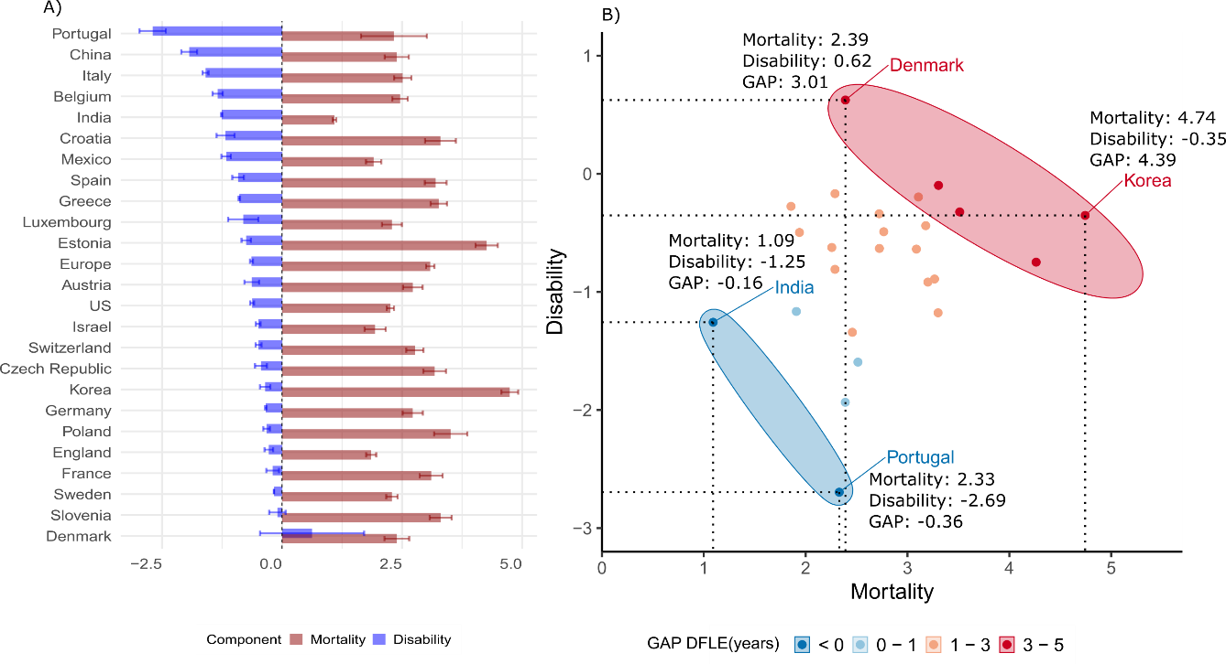

**Figure 2.** Decomposition of the gender gap (women-men) in disability-free life expectancy (DFLE) at ages 60 y and over into mortality and disability effects by country. Source: Gateway to Global Aging Data, Produced by the Program on Global Aging, Health & Policy, University of Southern California with funding from the National Institute on Aging (R01 AG030153). Note: Panel A presents the effects by each country, ranked from the highest to lowest disability contribution. Panel B presents selected countries, grouped by their GAP in DFLE (Women-Men) and the contributions of disability and mortality to the total GAP.

Korea and Denmark are among the countries with the highest gender gaps in DFLE (between 3-5 y), with Korea being the country with one of the highest gaps at ages 60 y and over in favor of women (4.39 y). The contribution stems mainly from the mortality advantage of women in Korea (4.74 against -0.35 the role of disability). The mortality advantage of women in Denmark is also the key factor in explaining the gap (2.39), but their advantage relative to men is also stemming from a positive disability effect, being the only country where the gap is also explained by an advantage of women with regards to disability.

Figure 3 presents the results for the gender gap in CFLE, where the signal of the total gap inverts, as women face more disadvantage than men for most countries. Portugal and Korea are thus among the countries where the gap is the largest across countries with a negative gender gap in CFLE, or where men have more advantage than women. Conversely, Israel and Slovenia are among the countries with the highest positive gap, or where women have an advantage relative to men.

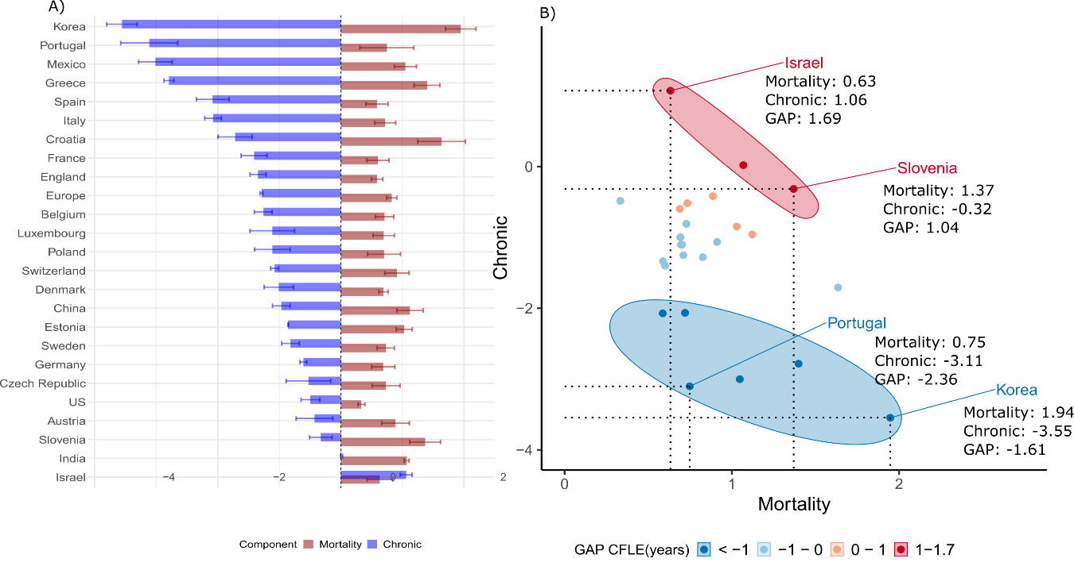

**Figure 3.** Decomposition of the gender gap (women-men) in chronic disease-free life expectancy (CFLE) at ages 60+ into mortality and chronic effects by country. Source: Gateway to Global Aging Data, Produced by the Program on Global Aging, Health & Policy, University of Southern California with funding from the National Institute on Aging (R01 AG030153). Note: Panel A presents the effects by each country, ranked from the highest to lowest chronic disease contribution. Panel B presents selected countries, grouped by their GAP in CFLE (Women-Men) and the contributions of chronic and mortality to the total GAP.

Similar to gaps in DFLE, however, gaps in CFLE are not necessarily driven by the same effects of chronic and mortality components. Israel has a total gender gap in CFLE of 1.69 and Slovenia of 1.04. Despite this similarity and a positive gap in CFLE, in Slovenia the gap is explained by a high mortality effect and a negative chronic effect, while in Israel both components contribute to increase the advantage of women relative to men. In Korea and Portugal, the negative gap in CFLE implies that men have an advantage relative to women in these countries when it comes to chronic disease-free life expectancy, with a strong effect of chronic conditions.

**Table 1.** Decomposition of the gender gap (women-men) in disability-free life expectancy (DFLE) at ages 60 y and over into mortality and disability effects by country, with 95% confidence intervals.

|  |  |  |  |  |  |  |  |
| --- | --- | --- | --- | --- | --- | --- | --- |
| Country | LE | DFLE | 95%CI | Components | | | |
| Mortality | 95%CI | Disability | 95%CI |
|  |
| US | 2.99 | 1.63 | [1.60, 1.67] | 2.26 | [2.18, 2.33] | -0.62 | [-0.58, -0.66] |  |
| China | 3.81 | 0.45 | [0.37, 0.54] | 2.39 | [2.14, 2.64] | -1.93 | [-1.77, -2.10] |  |
| Mexico | 2.64 | 0.74 | [0.68, 0.80] | 1.91 | [1.75, 2.07] | -1.17 | [-1.07, -1.26] |  |
| India | 1.63 | -0.17 | [-0.22, -0.1] | 1.09 | [1.05, 1.13] | -1.26 | [-1.27, -1.25] |  |
| Korea | 5.56 | 4.39 | [4.33, 4.46] | 4.74 | [4.57, 4.93] | -0.35 | [-0.24, -0.46] |  |
| England | 2.68 | 1.58 | [1.57, 1.60] | 1.86 | [1.75, 1.96] | -0.28 | [-0.19, -0.37] |  |
| Europe |  |  |  |  |  |  |  |  |
| (*Pooled*) | 4.15 | 2.45 | [2.39, 2.50] | 3.09 | [3.00, 3.17] | -0.64 | [-0.60, -0.67] |  |
| Austria | 3.70 | 2.09 | [2.04, 2.14] | 2.72 | [2.52, 2.93] | -0.63 | [-0.48, -0.79] |  |
| Belgium | 3.53 | 1.12 | [1.06, 1.17] | 2.46 | [2.30, 2.62] | -1.34 | [-1.24, -1.45] |  |
| Croatia | 4.28 | 2.12 | [1.62, 2.63] | 3.30 | [2.98, 3.62] | -1.18 | [-1.36, -0.99] |  |
| Czechia | 4.17 | 2.74 | [2.63, 2.85] | 3.18 | [2.94, 3.41] | -0.44 | [-0.31, -0.56] |  |
| Denmark | 2.99 | 3.01 | [2.19, 3.84] | 2.39 | [2.13, 2.65] | 0.62 | [1.71, -0.46] |  |
| Estonia | 5.65 | 3.51 | [3.38, 3.65] | 4.26 | [4.03, 4.49] | -0.75 | [-0.65, -0.85] |  |
| France | 4.53 | 2.91 | [2.80, 3.02] | 3.11 | [2.87, 3.35] | -0.20 | [-0.06, -0.33] |  |
| Germany | 3.64 | 2.38 | [2.16, 2.61] | 2.72 | [2.51, 2.93] | -0.34 | [-0.35, -0.32] |  |
| Greece | 4.01 | 2.37 | [2.22, 2.53] | 3.27 | [3.10, 3.44] | -0.89 | [-0.88, -0.91] |  |
| Israel | 2.80 | 1.44 | [1.27, 1.61] | 1.94 | [1.72, 2.16] | -0.50 | [-0.45, -0.55] |  |
| Italy | 3.51 | 0.92 | [0.68, 1.16] | 2.51 | [2.33, 2.69] | -1.59 | [-1.66, -1.53] |  |
| Luxembourg | 3.07 | 1.48 | [0.96, 2.00] | 2.29 | [2.08, 2.50] | -0.81 | [-1.12, -0.49] |  |
| Poland | 5.01 | 3.19 | [2.91, 3.47] | 3.51 | [3.17, 3.86] | -0.32 | [-0.25, -0.39] |  |
| Portugal | 4.15 | -0.37 | [-1.32,0.59] | 2.33 | [1.64, 3.02] | -2.70 | [-2.97, -2.42] |  |
| Slovenia | 4.31 | 3.21 | [3.15, 3.26] | 3.30 | [3.08, 3.53] | -0.10 | [0.07, -0.27] |  |
| Spain | 4.37 | 2.28 | [2.18, 2.39] | 3.20 | [2.97, 3.43] | -0.92 | [-0.80, -1.04] |  |
| Sweden | 2.73 | 2.12 | [2.00, 2.24] | 2.29 | [2.17, 2.41] | -0.17 | [-0.17, -0.16] |  |
| Switzerland | 3.26 | 2.28 | [2.03, 2.52] | 2.77 | [2.59, 2.95] | -0.49 | [-0.55, -0.43] |  |
|  |  |  |  |  |  |  |  |  |

Source: Gateway to Global Aging Data, Produced by the Program on Global Aging, Health & Policy, University of Southern California with funding from the National Institute on Aging (R01 AG030153).

**Table 2.** Decomposition of the gender gap (women-men) in chronic disease-free life expectancy (CFLE) at ages 60 y and over into mortality and disability effects by country, with 95% confidence intervals.

|  |  |  |  |  |  |  |  |
| --- | --- | --- | --- | --- | --- | --- | --- |
| Country | LE | CFLE | 95%CI | Components | | | |
| Mortality | 95%CI | Chronic | 95%CI |
|  |
| US | 2.99 | -0.16 | [-0.07, -0.26] | 0.33 | [0.27, 0.39] | -0.49 | [-0.34, -0.65] |  |
| China | 3.81 | 0.15 | [0.08, 0.23] | 1.12 | [0.91, 1.34] | -0.97 | [-0.82, -1.11] |  |
| Mexico | 2.64 | -1.97 | [-1.87, -2.06] | 1.05 | [0.87, 1.23] | -3.01 | [-2.74, -3.29] |  |
| India | 1.63 | 1.08 | [1.06, 1.10] | 1.07 | [1.03, 1.11] | 0.01 | [0.03, -0.01] |  |
| Korea | 5.56 | -1.61 | [-1.61, -1.61] | 1.95 | [1.70, 2.20] | -3.56 | [-3.31, -3.80] |  |
| England | 2.68 | -0.76 | [-0.72, -0.79] | 0.59 | [0.49, 0.68] | -1.35 | [-1.22, -1.47] |  |
| Europe |  |  |  |  |  |  |  |  |
| (*Pooled*) | 4.15 | -0.46 | [-0.52, -0.40] | 0.83 | [0.74, 0.91] | -1.29 | [-1.27, -1.31] |  |
| Austria | 3.70 | 0.46 | [0.53, 0.39] | 0.89 | [0.66, 1.11] | -0.43 | [-0.13, -0.73] |  |
| Belgium | 3.53 | -0.55 | [-0.56, -0.55] | 0.71 | [0.56, 0.86] | -1.26 | [-1.12, -1.41] |  |
| Croatia | 4.28 | -0.08 | [-0.19, 0.03] | 1.64 | [1.25, 2.02] | -1.72 | [-1.44, -1.99] |  |
| Czechia | 4.17 | 0.21 | [0.34, 0.07] | 0.73 | [0.51, 0.96] | -0.53 | [-0.16, -0.89] |  |
| Denmark | 2.99 | -0.32 | [-0.16, -0.48] | 0.69 | [0.62, 0.77] | -1.01 | [-0.77, -1.25] |  |
| Estonia | 5.65 | 0.17 | [0.05, 0.30] | 1.03 | [0.90, 1.16] | -0.86 | [-0.85, -0.86] |  |
| France | 4.53 | -0.81 | [-0.78, -0.84] | 0.60 | [0.42, 0.78] | -1.41 | [-1.20, -1.62] |  |
| Germany | 3.64 | 0.08 | [-0.05, 0.22] | 0.69 | [0.50, 0.88] | -0.61 | [-0.55, -0.66] |  |
| Greece | 4.01 | -1.39 | [-1.53, -1.26] | 1.40 | [1.19, 1.61] | -2.79 | [-2.71, -2.87] |  |
| Israel | 2.80 | 1.69 | [1.58, 1.81] | 0.63 | [0.42, 0.84] | 1.06 | [1.16, 0.96] |  |
| Italy | 3.51 | -1.36 | [-1.39, -1.32] | 0.72 | [0.55, 0.89] | -2.08 | [-1.94, -2.21] |  |
| Luxembourg | 3.07 | -0.42 | [-0.23, -0.61] | 0.70 | [0.52, 0.87] | -1.11 | [-0.75, -1.48] |  |
| Poland | 5.01 | -0.41 | [-0.39, -0.43] | 0.70 | [0.43, 0.97] | -1.11 | [-0.82, -1.40] |  |
| Portugal | 4.15 | -2.37 | [-2.34, -2.39] | 0.75 | [0.31, 1.19] | -3.11 | [-2.65, -3.58] |  |
| Slovenia | 4.31 | 1.04 | [0.98, 1.11] | 1.37 | [1.12, 1.62] | -0.33 | [-0.14, -0.51] |  |
| Spain | 4.37 | -1.50 | [-1.41, -1.58] | 0.59 | [0.41, 0.77] | -2.08 | [-1.82, -2.35] |  |
| Sweden | 2.73 | -0.09 | [-0.09, -0.10] | 0.73 | [0.59, 0.87] | -0.82 | [-0.67, -0.96] |  |
| Switzerland | 3.26 | -0.16 | [-0.43, 0.10] | 0.91 | [0.71, 1.11] | -1.07 | [-1.14, -1.01] |  |

Source: Gateway to Global Aging Data, Produced by the Program on Global Aging, Health & Policy, University of Southern California with funding from the National Institute on Aging (R01 AG030153).

What Figures 2 and 3 both indicate that countries with similar gender gaps do not necessarily have the same mortality and health effect. In addition, when we group countries according to their gender gap in years, very different countries in terms of development levels, health care system and gender roles can be in the same category. The lack of a systematic pattern across countries as regards their gender gap in DFLE and CFLE signals that similar gaps do not necessarily capture the inequality in health conditions across women and men in these countries.

Figure 4 highlights the substantial variations in country rankings when considering gaps in DFLE and CFLE compared to the contributions of the health effect. Low gender gaps are first places in the ranks while the last ranks are high gender gaps or high contribution of health component.

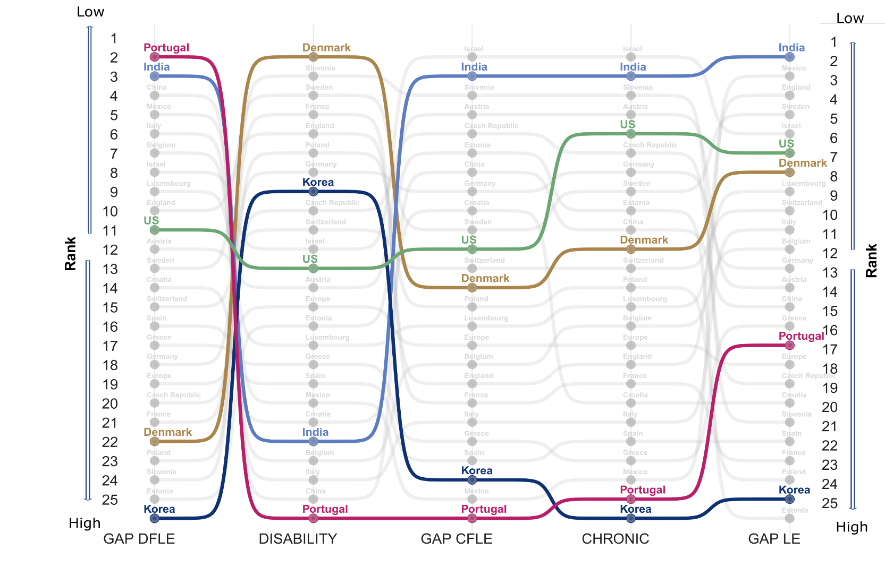

**Figure 4.** Ranking of countries (from lower to higher gaps) by gender gap in life expectancy, disability and chronic disease-free life expectancy (DFLE, CFLE), and the contribution of disability and chronic component to the total gender gap at ages 60+, by country. Note: In terms of gaps, the ranking is from low to high gap and in terms of disability and chronic from low to high contributions of these components to the total gap.

Indeed, Portugal has the lowest gender gap across all countries in DFLE (Rank 1), but the country with the strongest effect of disability, pushing it to the last place (Rank 25). At the same time, it is among the countries with the highest gaps in total life expectancy (Rank 16 out of 25). Denmark is the opposite, being placed at first Rank when considering the effect of disability, while it is among the last countries (Rank 21) when considering the gender gap in DFLE.

**Discussion**

Gender gap indices in health and mortality are routinely used as indicators of inequality. Gaps are used by policy makers to benchmark countries, monitor changes over time, and identify the pace at which countries are closing or widening gender gaps in health (1–3). Aggregate indices, such as the World Bank Global Gender Gap Index, measure gender equality based on gaps between women and men across health, education, economy, and politics. Likewise, the WHO European Health Equity Status Report initiative (HESRi) uses gender gaps in disability-adjusted life years (DALYs) and life expectancy to implement policy action for health equity and well-being in the European Region. Gender gaps in healthy life years are also used by the Gender Equality Index to assess gender inequalities in the EU.

Overall, gaps are widely used because they are an easy and straightforward way to relate the difference between two quantities. However, we show how using gender gaps in health as a metric for inequality can be misleading. Reducing gender gaps in health expectancy may not necessarily mean that we are reducing inequality between women and men. It is important to take a cautionary approach when interpreting those gaps and especially when using them to guide policy. Recent work has shown that policies that aim to advance gender equality in health across different countries have surprisingly poor design and implementation flaws, which are mostly due to scarcity of relevant data and accurate indicators (19). Taking gender gaps as a standpoint for conducting studies on gender differences when they are masking important underlying differences in health and mortality may also explain why some studies find conflicting results or no correlation between cross-national variation in gender gaps and societal-level gender inequality (20). By focusing on the gap, these studies may be missing important changes in the patterns of health and mortality, which may not go together with societal level changes in health and gender inequality. This is particularly due to the relationship between health and mortality and the specific role of certain conditions among women and men. Women live longer but face a higher burden of chronic, non-lethal but debilitating conditions, such as arthritis (21), while men experience higher levels of diabetes and heart disease (22). Despite long standing effort from researchers worldwide to understand gender disparities in health, there has been no conclusive explanation for why, despite living longer than men, women experience poorer health for most outcomes (23–29). This has startling effects since debilitating conditions such as arthritis limit the ability of women to remain independent, engage in social activities, and usually demand long-term care (30).

In addition, since gender gaps in health expectancy can be masking important effects of health, they may also hinder appropriate country-specific analysis. As we have shown, countries from very different epidemiological and cultural contexts can have similar gaps at a given point in time, but which are most likely driven by very different reasons. It has been shown that the son preference in Chinese traditions has impacted female health in very different ways than other countries in the western world, where families often invested more in sons at the expenses of daughters (31). Indeed, our results showed how China is the only country where heart conditions among women is more prevalent than among men. This is in line with previous studies that have shown that among chronic conditions, women have higher rates in arthritis and angina and are less covered by health insurance than men (32). Korea is also a remarkable case, where in our sample it has the highest female advantage in survival, with a 5.56 difference in life expectancy at age 60. Some studies have showed that the persistently high gap in life expectancy at older ages in Korea is due to excess male mortality from lung cancer, suicide, chronic lower respiratory diseases, and ischemic heart diseases, most of all which have been attributed to smoking (33). Another case noteworthy of mention is India, where we found the gap between women and men is negative, i.e., women have lower DFLE than man. This result is in line with what was found in other studies using different data, such as the nationally representative survey of Bangladesh on Household Income and Expenditure Survey-2010) (34). This aspect deserves further investigation and stresses the importance of health. The fact that the prevalence of doctor diagnosed conditions was so low in India suggests that healthcare access is limited and people do not have proper access to diagnosis of diseases and that patterns of diagnosis may differ for women and men (35).

Furthermore, an important contribution of this study is the extent of the comparative analysis. So far, most of the research has focused on western countries, with few studies including countries like China, India and Korea and even fewer that include developing or Latin American countries like Mexico in the study.

Studies that have performed global comparisons use less detailed health indicators and often lack in harmonization across the indicators health (36). It is particularly important when investigating those patterns by gender, as country-specific levels of development and to societal roles of women and men may directly or indirectly impact health and mortality indicators (37–39).(40, 41).

Nonetheless, it is important to acknowledge that this study has some limitations. First, this is a cross-sectional analysis so we do not look into trends nor use the longitudinal potential of the dataset. In addition, despite the efforts to harmonize the variables, diagnosis is performed differently across countries, which could explain results such as those observed for India. The HRS study, for example, specifically excludes diagnosis made by nurses/nurse practitioners, chiropractors, and dentists, while both CHARLS and LASI allow diagnosis by nurses, practitioners of traditional medicine, and other health care professionals. However, our aim was to have the most countries included in the comparison and pinpoint the importance of going beyond gender gaps in health expectancy. Hence, our results hold regardless of the research design.

**Acknowledgments**

This paper uses data from SHARE Wave 6 (10.6103/SHARE.w6.800), see Börsch-Supan et al. (2013) for methodological details. The SHARE data collection has been funded by the European Commission, DG RTD through FP5 (QLK6-CT-2001-00360), FP6 (SHARE-I3: RII-CT-2006-062193, COMPARE: CIT5-CT-2005-028857, SHARELIFE: CIT4-CT-2006-028812), FP7 (SHARE-PREP: GA N°211909, SHARE-LEAP: GA N°227822, SHARE M4: GA N°261982, DASISH: GA N°283646) and Horizon 2020 (SHARE-DEV3: GA N°676536, SHARE-COHESION: GA N°870628, SERISS: GA N°654221, SSHOC: GA N°823782, SHARE-COVID19: GA N°101015924) and by DG Employment, Social Affairs & Inclusion through VS 2015/0195, VS 2016/0135, VS 2018/0285, VS 2019/0332, and VS 2020/0313. Additional funding from the German Ministry of Education and Research, the Max Planck Society for the Advancement of Science, the U.S. National Institute on Aging (U01_AG09740-13S2, P01_AG005842, P01_AG08291, P30_AG12815, R21_AG025169, Y1-AG-4553-01, IAG_BSR06-11, OGHA_04-064, HHSN271201300071C, RAG052527A) and from various national funding sources is gratefully acknowledged (see [www.share-project.org](http://www.share-project.org/)).

This analysis uses data or information from the following Harmonized datasets: KLoSA dataset and Codebook, Version C as of June 2019 developed by the Gateway to Global Aging Data. The development of the Harmonized KLoSA was funded by the National Institute on Ageing (R01 AG030153, RC2 AG036619, R03 AG043052). LASI dataset and Codebook, Version A.2 as of October 2021, developed by the Gateway to Global Aging Data (DOI: https://doi.org/10.25549/h-lasi). The development of the Harmonized LASI was funded by the National Institute on Aging (R01 AG042778, 2R01 AG030153, 2R01 AG051125). CHARLS dataset and Codebook, Version D as of June 2021 developed by the Gateway to Global Aging Data. The development of the Harmonized CHARLS was funded by the National Institute on Aging (R01 AG030153, RC2 AG036619, R03 AG043052). ELSA dataset and Codebook, Version G.2 as of July 2021 developed by the Gateway to Global Aging Data. The development of the Harmonized ELSA was funded by the National Institute on Aging (R01 AG030153, RC2 AG036619, R03 AG043052). SHARE dataset and Codebook, Version F as of June 2022 developed by the Gateway to Global Aging Data. The development of the Harmonized SHARE was funded by the National Institute on Aging (R01 AG030153, RC2 AG036619, R03 AG043052). MHAS dataset and Codebook, Version B.4 as of February 2022 developed by the Gateway to Global Aging Data in collaboration with the MHAS research team. The development of the Harmonized MHAS was funded by the National Institute on Aging (R01 AG030153). The Harmonized MHAS data files and documentation are public use and available at www.MHASweb.org. The MHAS (Mexican Health and Aging Study) receives support from the National Institutes of Health/National Institute on Aging (R01 AG018016) in the United States and the Instituto Nacional de Estadística y Geografía (INEGI) in Mexico. HRS dataset and Codebook, Version C as of January 2022 developed by the Gateway to Global Aging Data. The development of the Harmonized HRS was funded by the National Institute on Aging (R01 AG030153, RC2 AG036619, 1R03AG043052). For more information about the Harmonization project, please refer to<https://g2aging.org/>.

This work is supported within the EU Framework Programme for Research and Innovation Horizon 2020, ERC Grant Agreement No. 725187 (LETHE)

**References**

1. World Economic Forum, “The Global Gender Gap Report 2021” (2021).

2. WHO, “Understanding the drivers of health equity: the power of political participation” (2020).

3. European Institute for Gender Equality, “Gender Equality Index 2021: Health” (2021) https:/doi.org/10.2839/633501.

4. W. Nusselder, C. Looman, Decomposition of differences in health expectancy by cause. *Demography* **41**, 315–34 (2004).

5. M. R. Nepomuceno, V. di Lego, C. M. Turra, Gender disparities in health at older ages and their consequences for well-being in Latin America and the Caribbean. *Vienna Yearb. Popul. Res.* **19** (2021).

6. A. A. van Raalte, M. R. Nepomuceno, “Decomposing Gaps in Healthy Life Expectancy” in (2020), pp. 107–122.

7. W. J. Nusselder, C. W. N. Looman, H. van Oyen, J. M. Robine, C. Jagger, Gender differences in health of EU10 and EU15 populations: the double burden of EU10 men. *Eur. J. Ageing* **7**, 219–227 (2010).

8. H. Van Oyen, *et al.*, Gender differences in healthy life years within the EU: an exploration of the “health–survival” paradox. *Int. J. Public Health* **58**, 143–155 (2013).

9. P. Gardner, K. Katagiri, J. Parsons, J. Lee, R. Thevannoor, “Not for the fainthearted”: Engaging in cross-national comparative research. *J. Aging Stud.* **26**, 253–261 (2012).

10. J. Ailshire, D. Carr, Cross-National Comparisons of Social and Economic Contexts of Aging. *Journals Gerontol. Ser. B* **76**, S1–S4 (2021).

11. E. M. Crimmins, H. Shim, Y. S. Zhang, J. K. Kim, Differences between men and women in mortality and the health dimensions of the morbidity process. *Clin. Chem.* **65**, 135–145 (2019).

12. J. Lee, D. Phillips, J. Wilkens, Gateway to Global Aging Data: Resources for Cross-National Comparisons of Family, Social Environment, and Healthy Aging. *Journals Gerontol. Ser. B Psychol. Sci. Soc. Sci.* **76**, S5 (2021).

13. D. . Sullivan, A single index of mortality and morbidity. *HSMHA Health Rep.* **86**, 347–54 (1971).

14. Y. Saito, J. M. Robine, E. M. Crimmins, The methods and materials of health expectancy. *Stat. J. IAOS* **30**, 209–223 (2014).

15. E. M. Crimmins, Y. Zhang, Y. Saito, Trends Over 4 Decades in Disability-Free Life Expectancy in the United States. **106**, 1287–1293 (2016).

16. L. a Beckett, *et al.*, Analysis of change in self-reported physical function among older persons in four population studies. *Am. J. Epidemiol.* **143**, 766–78 (1996).

17. S. Horiuchi, J. R. Wilmoth, S. D. Pletcher, A decomposition method based on a model of continuous change. *Demography* **45**, 785–801 (2008).

18. T. Riffe, Package “DemoDecomp” Type Package Title Decompose Demographic Functions (2018) https:/doi.org/10.1353/dem.0.0033 (October 15, 2019).

19. N. Crespí-Lloréns, I. Hernández-Aguado, E. Chilet-Rosell, Have Policies Tackled Gender Inequalities in Health? A Scoping Review. *Int. J. Environ. Res. Public Health* **18**, 327 (2021).

20. J. Dahlin, J. Härkönen, Cross-national differences in the gender gap in subjective health in Europe: Does country-level gender equality matter? *Soc. Sci. Med.* **98**, 24–28 (2013).

21. T. Boerma, A. R. Hosseinpoor, E. Verdes, S. Chatterji, A global assessment of the gender gap in self-reported health with survey data from 59 countries. *BMC Public Health* **16**, 675 (2016).

22. J. Lee, *et al.*, Cross-country comparisons of disability and morbidity: Evidence from the gateway to global aging data. *Journals Gerontol. - Ser. A Biol. Sci. Med. Sci.* **73**, 1519–1524 (2018).

23. A. Case, C. Paxson, Sex differences in morbidity and mortality. *Demography* **42**, 189–214 (2005).

24. E. M. Crimmins, J. K. Kim, A. Solé-Auró, Gender differences in health: results from SHARE, ELSA and HRS. *Eur. J. Public Health* **21**, 81–91 (2011).

25. L. M. Verbrugge, D. L. Wingard, Sex Differentials in Health and Mortality. *Women Health* **12**, 103–145 (1987).

26. F. C. Drumond Andrade, P. E. Guevara, M. L. Lebrão, Y. A. de Oliveira Duarte, J. L. F. Santos, Gender Differences in Life Expectancy and Disability-Free Life Expectancy Among Older Adults in São Paulo, Brazil. *Women’s Heal. Issues* **21**, 64–70 (2011).

27. V. Di Lego, P. Di Giulio, M. Luy, “Gender Differences in Healthy and Unhealthy Life Expectancy” in (2020), pp. 151–172.

28. A. Oksuzyan, H. Brønnum-Hansen, B. Jeune, Gender gap in health expectancy. *Eur. J. Ageing* **7**, 213–218 (2010).

29. M. Luy, Y. Minagawa, Gender gaps--Life expectancy and proportion of life in poor health. *Heal. reports* **25**, 12–9 (2014).

30. V. A. Freedman, D. A. Wolf, B. C. Spillman, Disability-Free Life Expectancy Over 30 Years: A Growing Female Disadvantage in the US Population. *Am. J. Public Health* **106**, 1079–1085 (2016).

31. H. Zhang, T. Bago D’Uva, E. Van Doorslaer, The gender health gap in China: A decomposition analysis. *Econ. Hum. Biol.* **18**, 13–26 (2015).

32. M. Zhou, S. Zhao, Z. Zhao, Gender differences in health insurance coverage in China. *Int. J. Equity Health* **20** (2021).

33. S. Yang, Y. H. Khang, H. Chun, S. Harper, J. Lynch, The changing gender differences in life expectancy in Korea 1970-2005. *Soc. Sci. Med.* **75**, 1280–1287 (2012).

34. M. I. Tareque, S. Begum, Y. Saito, Gender differences in disability-free life expectancy at old ages in Bangladesh. *J. Aging Health* **25**, 1299–1312 (2013).

35. F. Mauvais-Jarvis, *et al.*, Sex and gender: modifiers of health, disease, and medicine. *Lancet* **396**, 565–582 (2020).

36. H. Tolonen, *et al.*, Cross-national comparisons of health indicators require standardized definitions and common data sources. *Arch. Public Heal. 2021 791* **79**, 1–14 (2021).

37. J. L. Angel, W. Vega, M. López-Ortega, R. Pruchno, Aging in Mexico: Population trends and emerging issues. *Gerontologist* **57**, 153–162 (2017).

38. R. Pelletier, *et al.*, Sex Versus Gender-Related Characteristics Which Predicts Outcome after Acute Coronary Syndrome in the Young? *J. Am. Coll. Cardiol.* **67**, 127–135 (2016).

39. C. E. Ross, R. K. Masters, R. A. Hummer, Education and the Gender Gaps in Health and Mortality. *Demography* **49**, 1157–1183 (2012).

40. C. E. E. Okojie, Gender inequalities of health in the third world. *Soc. Sci. Med.* **39**, 1237–1247 (1994).

41. WCF, “The Global Gender Gap Report 2018 Insight Report” (2018).