

**Main Manuscript for**

Going beyond the gender gap in healthy lifespans

Vanessa di Lego1*, Marília R. Nepomuceno2,*, Cássio M. Turra 3

1 Vienna Institute of Demography at the Austrian Academy of Sciences, Wittgenstein Centre for Demography and Global Human Capital (IIASA, OeAW, Univ. Vienna)

2 Max Planck Institute for Demographic Research, Rostock, Germany.

3 Universidade Federal de Minas Gerais, Cedeplar, Brazil.

*Corresponding authors

**Email:**  [Vanessa.DiLego@oeaw.ac.at](mailto:Vanessa.DiLego@oeaw.ac.at)

**Email:**  nepomuceno@demogr.mpg.de

**Author Contributions: still to be added**

**Competing Interest Statement:** Authors have no competing interest to disclose.

**Classification: still to be added**

**Keywords:** Gender inequalities, healthy life expectancy, decomposition, gender policy

**This PDF file includes:**

Main Text

Figures 1 to 3

**Abstract**

Gender gaps in healthy lifespans are often used to assess gender inequality in health. However, as these gaps mask important differences in health and mortality between women and men, we question whether they are robust indicators to benchmark countries and guide gender equity policies. For this, we use the harmonized health data from the Gateway to Global Aging Data to estimate disability- and chronic-free life expectancy for individuals aged above 60 y and decompose the gender gap in health expectancy into its mortality and health components. We conduct a comparative analysis of the gender gap in health expectancy across multiple countries with different cultural backgrounds, gender norms, and health systems, including the U.S., England, South Korea, China, India, Mexico, and EU countries. Our findings indicate that using gender gaps in healthy lifespans as a metric for gender inequality is misleading. Countries with similar gender gaps do not necessarily have the same size of mortality and health contributions. In addition, when we group countries according to their total gender gap, countries that substantially differ in terms of development levels, health care system, and gender roles can be in the same category. The lack of a systematic pattern across countries signals that gaps do not necessarily capture inequality in health across women and men and should thus be interpreted with caution.

**Significance Statement**

Gender gaps in healthy lifespans are often used to assess gender inequality in health and perform comparisons across countries. However, as these gaps mask important differences in health and mortality between women and men, we question whether these gaps represent the most effective way to benchmark countries and guide gender equity policies. We decompose gender gaps in health across a wide range of countries, including European, American, and Asian nations to demonstrate that it can be misleading to use gender gaps in healthy lifespans as indicators of inequality.

**Main Text**

Gender gap indices in healthy lifespans are routinely used as indicators of gender inequality. The WHO European Health Equity Status Report initiative (HESRi) uses gender gaps in both health and life expectancy to implement policy action for health equity and well-being in the European Region (1). Likewise, the World Bank Global Gender Gap Index measures gender equality based on gaps between women and men across health, education, economy, and politics (2). Gender gaps in healthy life years are used by the Gender Equality Index to assess gender inequalities in the EU (3). Policy makers use these gaps to benchmark countries, monitor changes over time, and identify the pace at which countries are closing or widening gender inequality in health (2–4). Overall, gaps are an easy and straightforward way to relate the difference between two quantities. However, it can be misleading to use gender gaps in healthy lifespans interchangeably as indicators of inequality, since these gaps often entangle several aspects of health differences between women and men.

Gender gaps in health are multifaceted and the complex interplay between gender, health, and mortality unveils a paradox: women tend to outlive men but experience more years with poorer health. Despite women’s survival advantage even under extreme conditions (1, 5–7), they tend to have disadvantages in terms of physical health, self-rated health, and cognition at older ages (8–10). Women also tend to experience higher morbidity from acute and chronic conditions and more short-term disability (11–14). When analyzing the gender gap from an aggregate measure such as healthy life expectancy, some of these facets may be overlooked, which highlights the importance of disentangling the various components of gender gaps in healthy lifespans.

Breaking down the gender gap in healthy life expectancy into its mortality and health components has been shown to be a crucial factor in understanding gender disparities in health (15–17). In certain countries, where the gender gap in health expectancies was virtually zero, decomposition analyses revealed considerable gender differences in both mortality and health, albeit in divergent directions (18, 19). Consequently, the combination of high prevalence of unhealthy women coupled with a high women’s survival advantage resulted in a small gender gap. Simply interpreting a small gender gap in health expectancy as a measure for low gender inequality ignores that women usually live more years in poorer health and disregards the intricate relationship between health and mortality.

To date, studies that have disentangled gender gaps in healthy lifespans by separating health and mortality dimensions have mostly focused on a specific set of countries or regions with shared societal values and gender roles (20–24). What is lacking in the literature of the gender gap in health is a comparative analysis that includes a wider range of countries, including European, American, and Asian nations (25–27). Moreover, there is a lack of knowledge regarding the comparison of the magnitude of the gap components across this set of countries.

The goal of this paper is to critically assess whether gender gaps in healthy lifespan are robust indicators for capturing gender inequality in health outcomes. For this, we decompose the gender gap in health expectancy into its mortality and health components. We additionally complement the existing literature by conducting a comparative analysis of the gender gap in health expectancy across multiple countries on four different continents.

Drawing from the rich data provided by the Gateway to Global Aging Data (28), a unique dataset that allows for a broader comparison in health outcomes, we estimate disability- and chronic-free life expectancy for individuals aged 60 and above, including a diverse set of nations: the U.S., England, South Korea, China, India, Mexico, and EU countries. This set of countries not only has a particular epidemiological and mortality trajectory, but different cultural backgrounds, gender norms, and health systems, which enables us to investigate the impact of interpreting the gender gap in health and mortality as a measure of inequality in different settings.

**Materials and Methods**

**Data**

For the health measures, we use data from the Gateway to Global Aging Data, produced by the Program on Global Aging, Health & Policy that created harmonized versions of sister-HRS studies. The harmonized versions have followed the RAND HRS conventions of variable naming and data structure which allow for cross-country comparisons. We use the harmonized versions available for years 2014-2015 for HRS (United States of America), ELSA (England), KLoSA (South Korea), CHARLS (China), MHAS (Mexico), and Europe (SHARE). India is the only country where the LASI was carried on between 2017-2019. For more details on the health data, refer to the Supplementary Information (SI) section on Materials and Table S3 for sample characteristics.

For mortality data, we use UN life tables from the 2022 Revision of World Population Prospects (United Nations 2022) for all countries. The only exception is England, where the life tables are from the Office for National Statistics UK (ONS), as the ELSA study does not include Wales.

**Methods**

To examine gender gaps in health expectancy, we first estimate the disability-free life expectancy ($DFLE$) and the chronic-free life expectancy ($CFLE$) at age 60 y using the Sullivan Method (29), an approach widely adopted for estimating prevalence-based health expectancies (30, 31). For disability, we use the variable constructed from a 5-item list of activities of daily living (ADLs), which include bathing, dressing, eating, getting in and out of bed, and using the toilet (32). For chronic diseases (Chronic), we use the variables on specific chronic conditions diagnosed by a physician, which include diabetes, heart conditions, arthritis, cancer, stroke, and lung disease.

Using the weighted proportions of women and men who report limitations in ADLs and of at least one chronic disease in the population for each survey, we computed the prevalence of unhealthy individuals for each country and by 5 y age groups. We then combine the computed prevalence with country-specific life tables to estimate healthy life expectancies. $DFLE$ is then defined as the number of years lived free of disability, while $CFLE$ is the number of years lived without chronic diseases. We then calculate the gender gap in $DFLE$ as $∆_{DFLE}^{ }={DFLE}^{Women}$- ${DFLE}^{Men}$ and the gender gap in $CFLE$ as $∆_{CFLE}^{ }={CFLE}^{Women}$- ${CFLE}^{Men}$.

To decompose the gap, we apply the continuous change decomposition method (33, 34), and split the gender differences in $DFLE$ and $CFLE$ at age60 y into mortality and disability/chronic effects (16, 17) (See SI section on Methods for more details on the Sullivan method and the decomposition approach). Codes to reproduce the results will be fully available at a public GitHub repository.

**Results**

**Age-Specific Prevalence**

Fig 1 shows the age-specific prevalence of individuals who report a limitation in activities of daily living, and of at least one chronic disease. Panel A is a heatmap with the age-specific prevalence of unhealthy women and men in ADLs, and chronic disease for all countries. While the prevalence of ADLs and Chronic both increase with age, it is important to note that the prevalence of having at least one chronic disease surpasses the prevalence of having limitations in activities of daily living at all ages.

Panel B in Figure 1 highlights the prevalence curves by age for women and men in some countries and presents other in shaded grey lines in the background (see Figs S1-S8 in the SI for all countries and separately for each chronic condition). Overall, there is a steeper increase in the prevalence of ADLs from ages 70 y and over and for both genders in most countries. Across all countries, prevalence mostly falls between Korea and China, which are the low and high levels, respectively, for both women and men. The US age pattern falls between Korea and England. Korea presents the lowest prevalence of ADLs of all countries, for both genders, with the greatest increase starting from age 75 y. The overall pattern for women across countries is more dispersed than for men, with the difference between Korean women and Chinese and Indian being higher than for men. Compared to the age pattern of men, women have a higher rate of increase in prevalence across all countries with age, with the burden increasing at a much faster pace. Chinese and Indian women have a prevalence rate level at ages 60-65 y that is only observed at ages 70-75 y for men, a gap of almost 10 y.

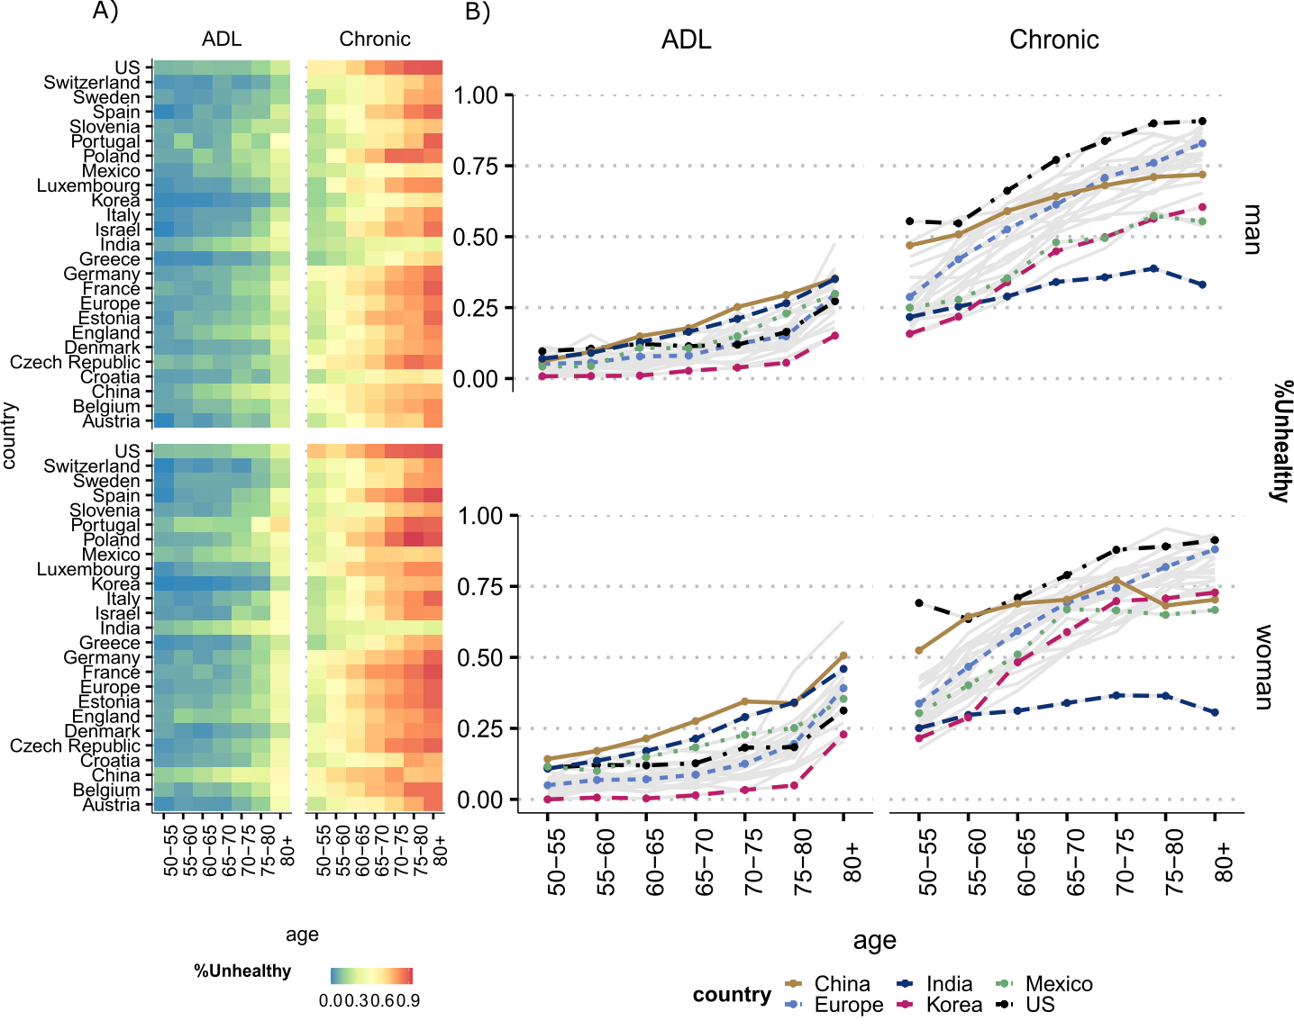

**Fig 1**. Prevalence of unhealthy women and men by activity of daily limitation (ADL) and chronic diseases (Chronic) by age. All countries are presented in (Panel A) and selected countries in (Panel B). *Notes:* ADLs refer to the 5-item list of activities of daily living (ADLs), which include bathing, dressing, eating, getting in and out of bed, and using the toilet. Chronic is defined as being diagnosed with at least one of six doctor diagnosed conditions present at all country surveys that were harmonized: 1. Arthritis, 2. Cancer, 3. Diabetes, 4. Heart Conditions, 5. Lung disease, 6. Stroke. For more details on how diagnoses are defined and which criteria are used, refer to the SI section on Materials. For country-specific and all countries profiles for each condition, also see Figs S1-S8 in the SI. Source: Gateway to Global Aging Data, Produced by the Program on Global Aging, Health & Policy, University of Southern California with funding from the National Institute on Aging (R01 AG030153).

Additionally, Panel B shows that the US has the highest prevalence of having at least one chronic disease for women and men at all ages. China is right after the US with high prevalence at younger ages (50-60 y), but then levels off at older ages, while other countries still experience a steep age gradient in the Chronic prevalence. India is the country with the lowest prevalence of at least one chronic disease. The low level for India is most likely due to limited access to healthcare, as these are diseases that must be diagnosed by a medical doctor and previous research has shown that India experiences higher rates of underdiagnosed conditions (35, 36).

**Gender gap in** **healthy life expectancy and its decomposition**

Fig 2 shows the total gender gap in $DFLE$ (Panel A – values shown on the bars) and $CFLE$ (Panel B – values shown on the bars) and their respective decompositions into mortality and health components at age 60 y for all countries (see Tables S1 and S2 in the SI for all values for each country with confidence intervals). The sum of the mortality and health components correspond to the total gender gap (women-men). When the total gap is positive, it means that women live more healthy years than men (women’s advantage in healthy lifespans). In such cases, when both the mortality and health components are positive, they contribute to widening the gender gap. Conversely, when one component is positive and the other is negative, they can sum up in a narrower gap. Fig 2 ranks the countries from greatest to smallest women advantage in $DFLE$ (Panel A) and in $CFLE$ (Panel B).

Panel A in Fig 2 shows that women in Korea have the highest advantage in terms of $DFLE$ compared to all countries, with a total gender gap in $DFLE$ of 4.39 y. The women’s survival advantage in Korea surpass the women disadvantage in disability by 13 times, resulting in this wider gender gap. China, and Mexico are the countries with the smallest women’s advantage in $DFLE$, while in Portugal and India women face a disadvantage in the number of years lived without disability compared to men. However, despite Portugal having one of the smallest gaps in $DFLE$, with women facing a disadvantage in healthy lifespan, the contribution of both disability and mortality to the gap are remarkably high, but act in opposite directions (mortality contribution = 2.33 y, and disability contribution = - 2.69 y). The small and negative gap in $DFLE$ in Portugal is thus entirely driven by an offsetting effect of disability and mortality and is not indicative of low inequality in healthy lifespans between women and men in this setting.

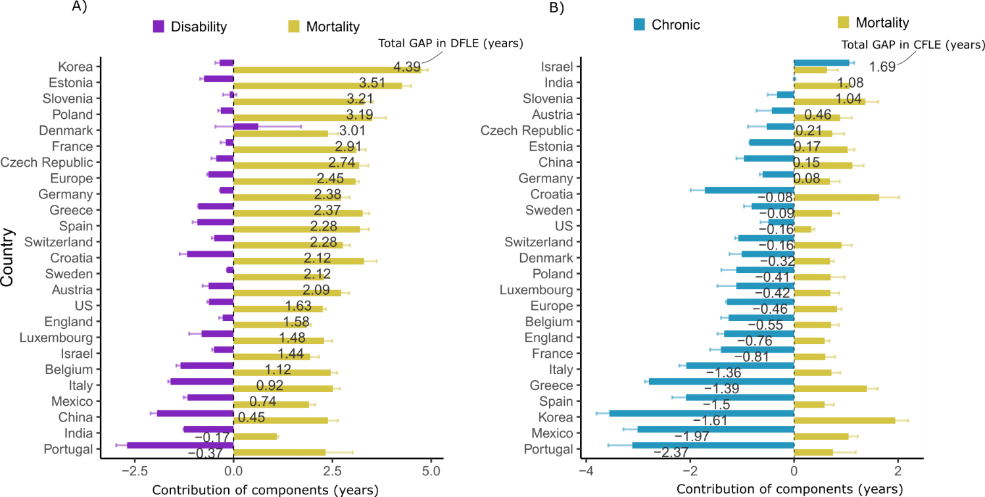

Fig 2 Decomposition of the gender gap (women-men) in disability-free life expectancy ( $DFLE$ at age 60 y into mortality and disability effects (Panel A) and in chronic disease-free life expectancy ($CFLE$) at ages 60 y into mortality and chronic effects (Panel B) by country. Values of total gender gap (women-men) in $DFLE$ (Panel A) and $CFLE$ (Panel B) are presented on the bars. *Notes.* disability refers to the 5-item list of activities of daily living (ADLs), which include bathing, dressing, eating, getting in and out of bed, and using the toilet. Chronic is defined as being diagnosed with at least one of six doctor diagnosed conditions present at all country surveys that were harmonized: 1. Arthritis, 2. Cancer, 3. Diabetes, 4. Heart Conditions, 5. Lung disease, 6. Stroke. Source: Gateway to Global Aging Data, Produced by the Program on Global Aging, Health & Policy, University of Southern California with funding from the National Institute on Aging (R01 AG030153).

Panel B in Figure 2 shows a contrasting pattern between the gender gap in $CFLE$ and $DFLE$ (Panel A). Chronic diseases reveal a different impact on the total gender gap compared to disability. Panel B shows that overall women live less years without chronic diseases than men (see Figs S1-S8 in the SI for the contribution of each chronic disease). However, despite these contrasting results, similar implications remain. Not necessarily countries that have similar total gaps in $CFLE$ are alike in terms of chronic and mortality contributions. While both Switzerland and the US exhibit a $CFLE$ gap of -0.16 years, there are notable disparities in the magnitudes of the contributions from mortality and chronic diseases across these countries. In Switzerland, the magnitude of the contribution of mortality and chronic diseases are three and two times higher, respectively, compared to the US.

These aspects become clearer in Fig 3, where we group countries according to the total gender gaps in $DFLE$ (Panel A) and $CFLE$ (Panel B) and their corresponding mortality, disability, and chronic components. It is noticeable how different countries can be grouped together when only total gender gaps in $DFLE$ and $CFLE$ are used as criteria. India and Portugal are among the countries with the lowest gender gap values in $DFLE$ at ages 60 y (-0.16 y and -0.36 y, respectively), but experience a substantial contribution of disability and mortality to the gap, which go in opposite directions, almost offsetting each other (Panel A). However, since the magnitude of the disability component (-1.25 y and -2.69 y, respectively for India and Portugal) is greater than mortality (1.09 y and 2.33 y, respectively), this leads to a negative gap in $DFLE$, implying that women have a disadvantage relative to men.

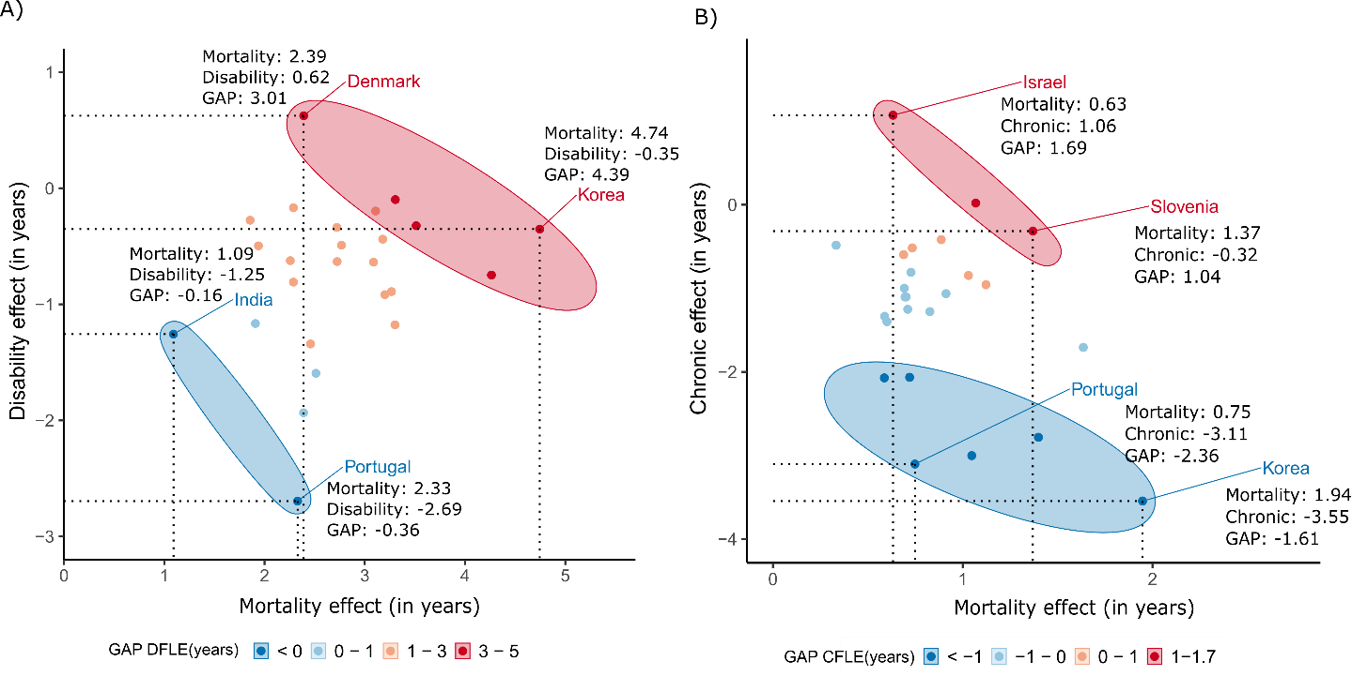

**Fig 3.** Decomposition of the gender gap (women-men) in disability-free life expectancy ($DFLE$) at ages 60 y into mortality and disability effects (Panel A) and in chronic disease-free life expectancy ($CFLE$) at ages 60 y into mortality and chronic effects (Panel B) by country. Note: Panel A presents selected countries, grouped by their GAP in $DFLE$ (Women-Men) and the contributions of disability and mortality to the total GAP. Panel B presents selected countries, grouped by their GAP in $CFLE$ (Women-Men) and the contributions of chronic and mortality to the total GAP. Source: Gateway to Global Aging Data, Produced by the Program on Global Aging, Health & Policy, University of Southern California with funding from the National Institute on Aging (R01 AG030153).

Korea and Denmark are among the countries with the widest gender gaps in $DFLE$, 4.39 y and 3.01y, respectively (Panel A). In Korea, the contribution stems mainly from the mortality advantage of women (4.74 y for the mortality contribution against -0.35 y the role of disability). The mortality advantage of women in Denmark is also the key factor in explaining the gap, but their advantage relative to men is also stemming from a positive disability contribution, being the only country where the gap is also explained by an advantage of women with regards to disability.

Panel B shows the gender gap in $CFLE$, where the signal of the total gap inverts, as women live less years without chronic diseases than men for most countries, as already shown in Fig 2. Portugal and Korea present the widest gaps in $CFLE$, both negative. Conversely, Israel and Slovenia are among the countries with the greatest positive gaps, or where women have an advantage in the number of years lived without chronic diseases relative to men.

Similar to gaps in $DFLE$, however, gaps in $CFLE$ are not necessarily driven by the same size of the contributions of the chronic and mortality components (Panel B). Israel has a total gender gap in $CFLE$ of 1.69 y and Slovenia of 1.04 y. Despite this similarity and a positive gap in $CFLE$, in Slovenia the gap is explained by a large and positive mortality contribution and a small and negative chronic contribution to the gap. Conversely, in Israel both components are small and positive, resulting in a women advantage in term of the number of years lived without chronic diseases. In Korea and Portugal, the negative gap in $CFLE$ implies that women live less years with chronic diseases relative to men, with a strong contribution of chronic diseases to the gap.

**Discussion**

Our findings show that using gender gaps in healthy lifespans as a metric for gender inequality is misleading. Gender gaps in healthy lifespans are often used to assess gender inequality in health and perform comparisons across countries. However, it is worth questioning whether these gaps truly represent the most effective way to benchmark countries and guide gender equity policies.

Recent work has shown that policies that aim to advance gender equality in health across different countries have surprisingly poor design and implementation flaws, which are mostly due to scarcity of relevant data and accurate indicators (37). Taking gender gaps as a standpoint for conducting studies on gender differences when they are masking important underlying differences in health and mortality may also explain why some studies find conflicting results or no correlation between cross-national variation in gender gaps and societal-level gender inequality (38). By focusing on the gap, these studies may be missing important changes in the patterns of health and mortality, which may not go together with societal level changes in health and gender inequality. This is particularly due to the relationship between health and mortality and the specific role of certain conditions among women and men. Women live longer but face a higher burden of chronic, non-lethal but debilitating conditions, such as arthritis (39), while men experience higher levels of diabetes and heart disease (40). Despite long standing effort from researchers worldwide to understand gender disparities in health, there has been no conclusive explanation for why, despite living longer than men, women experience poorer health for most outcomes (9, 10, 12, 14, 41, 42). This has startling effects since debilitating conditions such as arthritis limit the ability of women to remain independent, engage in social activities, and usually demand long-term care (43).

In addition, since gender gaps in health expectancy can be masking important effects of health, they may also hinder appropriate country-specific analysis. As we have shown, countries from very different epidemiological and cultural contexts can have similar gender gaps at a given point in time, but which are most likely driven by different reasons which affect the prevalence of health conditions. It has been shown that the son preference in Chinese traditions has impacted female health in very different ways than other countries in the western world, where families often invested more in sons at the expenses of daughters (23). This is in line with previous studies that have shown that among chronic conditions, women have higher rates in arthritis and angina and are less covered by health insurance (44). Korea is also a remarkable case, where in our sample it has the highest female advantage in survival, with a 5.56 y difference in life expectancy at age 60. Some studies have showed that the persistently high gap in life expectancy at older ages in Korea is due to excess male mortality from lung cancer, suicide, chronic lower respiratory diseases, and ischemic heart diseases, most of all which have been attributed to smoking (22). Another case noteworthy of mention is India, where we found the gap between women and men is negative, i.e., women have lower $DFLE$ than man. This result is in line with what was found in other studies using different data, such as the nationally representative survey of Bangladesh on Household Income and Expenditure Survey-2010) (45). This aspect deserves further investigation and stresses the importance of the health component. The fact that the prevalence of doctor diagnosed diseases was so low in India suggests that healthcare access is limited and people do not have proper access to diagnosis of diseases and that patterns of diagnosis may differ for women and men (36, 46, 47).

Furthermore, an important contribution of this study is the extent of the comparative analysis. So far, most of the research has focused on western countries, with few studies including countries like China, India and Korea and even fewer that include developing or Latin American countries like Mexico in the study (16, 48–51) . Studies that have performed global comparisons use less detailed health indicators and often lack in harmonization across the indicators health (52). It is particularly important when investigating those patterns by gender, as country-specific levels of development and societal roles of women and men may directly or indirectly impact health and mortality indicators (53–57).

It is important to acknowledge that this study has some limitations. Despite the efforts to harmonize the variables, disease diagnosis is performed differently across countries. In some settings, the low prevalence of chronic diagnosed diseases may reflect the low quality of the healthcare, such as the case of India. Another relevant difference across countries is who can make the diagnose. The HRS (Unite States of America) study, for example, specifically excludes diagnosis made by nurses/nurse practitioners, chiropractors, and dentists, while both CHARLS (China) and LASI (India) allow diagnosis by nurses, practitioners of traditional medicine, and other health care professionals. However, in addition to believe that this fact impacts both genders in a similar way, our aim was to have the most countries included in the comparison and pinpoint the importance of going beyond gender gaps in health expectancy and not perform a study of the determinants of health in these countries. Hence, our results hold regardless of the research design.

In conclusion, closing the gender gap in health expectancy may not necessarily mean that we are reducing health inequality between women and men. Our findings indicate that countries with similar gender gaps do not necessarily have the same size of mortality and health contributions. In addition, when we group countries according to their total gender gap, countries that substantially differ in terms of development levels, health care system, and gender roles can be in the same category. The lack of a systematic pattern across countries as regards both $DFLE$ and $CFLE$ signals that gaps do not necessarily capture inequality in health across women and men in these countries and should thus be interpreted with caution. In order to have a clearer understanding of gender inequality in health and improve cross-country comparison, it is necessary to deeply understand the gap, as its decomposition into its mortality and health components.

**Acknowledgments**

This paper uses data from SHARE Wave 6 (10.6103/SHARE.w6.800), see Börsch-Supan et al. (2013) for methodological details. The SHARE data collection has been funded by the European Commission, DG RTD through FP5 (QLK6-CT-2001-00360), FP6 (SHARE-I3: RII-CT-2006-062193, COMPARE: CIT5-CT-2005-028857, SHARELIFE: CIT4-CT-2006-028812), FP7 (SHARE-PREP: GA N°211909, SHARE-LEAP: GA N°227822, SHARE M4: GA N°261982, DASISH: GA N°283646) and Horizon 2020 (SHARE-DEV3: GA N°676536, SHARE-COHESION: GA N°870628, SERISS: GA N°654221, SSHOC: GA N°823782, SHARE-COVID19: GA N°101015924) and by DG Employment, Social Affairs & Inclusion through VS 2015/0195, VS 2016/0135, VS 2018/0285, VS 2019/0332, and VS 2020/0313. Additional funding from the German Ministry of Education and Research, the Max Planck Society for the Advancement of Science, the U.S. National Institute on Aging (U01_AG09740-13S2, P01_AG005842, P01_AG08291, P30_AG12815, R21_AG025169, Y1-AG-4553-01, IAG_BSR06-11, OGHA_04-064, HHSN271201300071C, RAG052527A) and from various national funding sources is gratefully acknowledged (see [www.share-project.org](http://www.share-project.org/)).

This analysis uses data or information from the following Harmonized datasets: KLoSA dataset and Codebook, Version C as of June 2019 developed by the Gateway to Global Aging Data. The development of the Harmonized KLoSA was funded by the National Institute on Ageing (R01 AG030153, RC2 AG036619, R03 AG043052). LASI dataset and Codebook, Version A.2 as of October 2021, developed by the Gateway to Global Aging Data (DOI: https://doi.org/10.25549/h-lasi). The development of the Harmonized LASI was funded by the National Institute on Aging (R01 AG042778, 2R01 AG030153, 2R01 AG051125). CHARLS dataset and Codebook, Version D as of June 2021 developed by the Gateway to Global Aging Data. The development of the Harmonized CHARLS was funded by the National Institute on Aging (R01 AG030153, RC2 AG036619, R03 AG043052). ELSA dataset and Codebook, Version G.2 as of July 2021 developed by the Gateway to Global Aging Data. The development of the Harmonized ELSA was funded by the National Institute on Aging (R01 AG030153, RC2 AG036619, R03 AG043052). SHARE dataset and Codebook, Version F as of June 2022 developed by the Gateway to Global Aging Data. The development of the Harmonized SHARE was funded by the National Institute on Aging (R01 AG030153, RC2 AG036619, R03 AG043052). MHAS dataset and Codebook, Version B.4 as of February 2022 developed by the Gateway to Global Aging Data in collaboration with the MHAS research team. The development of the Harmonized MHAS was funded by the National Institute on Aging (R01 AG030153). The Harmonized MHAS data files and documentation are public use and available at www.MHASweb.org. The MHAS (Mexican Health and Aging Study) receives support from the National Institutes of Health/National Institute on Aging (R01 AG018016) in the United States and the Instituto Nacional de Estadística y Geografía (INEGI) in Mexico. HRS dataset and Codebook, Version C as of January 2022 developed by the Gateway to Global Aging Data. The development of the Harmonized HRS was funded by the National Institute on Aging (R01 AG030153, RC2 AG036619, 1R03AG043052). For more information about the Harmonization project, please refer to<https://g2aging.org/>.

This work is supported within the EU Framework Programme for Research and Innovation Horizon 2020, ERC Grant Agreement No. 725187 (LETHE)

**References**

1. P. C. L. Siviero, C. M. Turra, R. . Rodrigues, Diferenciais de mortalidade: níveis e padrões segundo o sexo no município de São Paulo de 1920 a 2005. *Rev. Bras. Estud. Popul.* **28**, 283–301 (2011).

2. World Economic Forum, “The Global Gender Gap Report 2021” (2021).

3. European Institute for Gender Equality, “Gender Equality Index 2021: Health” (2021) https:/doi.org/10.2839/633501.

4. WHO, “Understanding the drivers of health equity: the power of political participation” (2020).

5. V. Zarulli, *et al.*, Women live longer than men even during severe famines and epidemics. *Proc. Natl. Acad. Sci.* **115**, E832–E840 (2018).

6. V. Zarulli, I. Kashnitsky, J. W. Vaupel, Death rates at specific life stages mold the sex gap in life expectancy. *Proc. Natl. Acad. Sci.* **118**, e2010588118 (2021).

7. S. N. Austad, Why women live longer than men: Sex differences in longevity. *Gend. Med.* **3**, 79–92 (2006).

8. A. P. Belon, M. G. Lima, M. B. A. Barros, Gender differences in healthy life expectancy among Brazilian elderly. *Health Qual. Life Outcomes* **12** (2014).

9. A. Case, C. Paxson, Sex Differences in Morbidity and Mortality. *Demography* **42**, 189–214 (2005).

10. E. M. Crimmins, J. K. Kim, A. Solé-Auró, Gender differences in health: results from SHARE, ELSA and HRS. *Eur. J. Public Health* **21**, 81–91 (2011).

11. A. Oksuzyan, H. Brønnum-Hansen, B. Jeune, Gender gap in health expectancy. *Eur. J. Ageing* **7**, 213–218 (2010).

12. M. Luy, Y. Minagawa, Gender gaps--Life expectancy and proportion of life in poor health. *Heal. reports* **25**, 12–9 (2014).

13. H. Van Oyen, *et al.*, Gender gaps in life expectancy and expected years with activity limitations at age 50 in the European Union: associations with macro-level structural indicators. *Eur. J. Ageing* **7**, 229–237 (2010).

14. V. di Lego, P. Di Giulio, M. Luy, “Gender Differences in Healthy and Unhealthy Life Expectancy” in *International Handbook of Health Expectancies.*, Internatio, R. J. Jagger C., Crimmins E., Saito Y., De Carvalho Yokota R., Van Oyen H., Ed. (Springer, Cham, 2020), pp. 151–172.

15. W. Nusselder, C. Looman, Decomposition of differences in health expectancy by cause. *Demography* **41**, 315–34 (2004).

16. M. R. Nepomuceno, V. di Lego, C. M. Turra, Gender disparities in health at older ages and their consequences for well-being in Latin America and the Caribbean. *Vienna Yearb. Popul. Res.* **19** (2021).

17. A. A. van Raalte, M. R. Nepomuceno, “Decomposing Gaps in Healthy Life Expectancy” in *International Handbooks of Population*, R. J. Jagger C., Crimmins E., Saito Y., De Carvalho Yokota R., Van Oyen H., Ed. (Springer, Cham, 2020), pp. 107–122.

18. W. J. Nusselder, C. W. N. Looman, H. van Oyen, J. M. Robine, C. Jagger, Gender differences in health of EU10 and EU15 populations: the double burden of EU10 men. *Eur. J. Ageing* **7**, 219–227 (2010).

19. H. Van Oyen, *et al.*, Gender differences in healthy life years within the EU: an exploration of the “health–survival” paradox. *Int. J. Public Health* **58**, 143–155 (2013).

20. W. Nusselder, *et al.*, Women’s excess unhealthy life years: disentangling the unhealthy life years gap. *Eur. J. Public Health* **29**, 914–919 (2019).

21. E. M. Crimmins, H. Shim, Y. S. Zhang, J. K. Kim, Differences between men and women in mortality and the health dimensions of the morbidity process. *Clin. Chem.* **65**, 135–145 (2019).

22. S. Yang, Y. H. Khang, H. Chun, S. Harper, J. Lynch, The changing gender differences in life expectancy in Korea 1970-2005. *Soc. Sci. Med.* **75**, 1280–1287 (2012).

23. H. Zhang, T. Bago D’Uva, E. Van Doorslaer, The gender health gap in China: A decomposition analysis. *Econ. Hum. Biol.* **18**, 13–26 (2015).

24. A. M. Costa Filho, J. V. de M. Mambrini, D. C. Malta, M. F. Lima-Costa, S. V. Peixoto, Contribution of chronic diseases to the prevalence of disability in basic and instrumental activities of daily living in elderly Brazilians: the National Health Survey (2013). *Cad. Saude Publica* **34**, 1–12 (2018).

25. P. Gardner, K. Katagiri, J. Parsons, J. Lee, R. Thevannoor, “Not for the fainthearted”: Engaging in cross-national comparative research. *J. Aging Stud.* **26**, 253–261 (2012).

26. J. Ailshire, D. Carr, Cross-National Comparisons of Social and Economic Contexts of Aging. *Journals Gerontol. Ser. B* **76**, S1–S4 (2021).

27. J. Lee, *et al.*, Cross-country comparisons of disability and morbidity: Evidence from the gateway to global aging data. *Journals Gerontol. - Ser. A Biol. Sci. Med. Sci.* **73**, 1519–1524 (2018).

28. J. Lee, D. Phillips, J. Wilkens, Gateway to Global Aging Data: Resources for Cross-National Comparisons of Family, Social Environment, and Healthy Aging. *Journals Gerontol. Ser. B Psychol. Sci. Soc. Sci.* **76**, S5 (2021).

29. D. . Sullivan, A single index of mortality and morbidity. *HSMHA Health Rep.* **86**, 347–54 (1971).

30. Y. Saito, J. M. Robine, E. M. Crimmins, The methods and materials of health expectancy. *Stat. J. IAOS* **30**, 209–223 (2014).

31. E. M. Crimmins, Y. Zhang, Y. Saito, Trends Over 4 Decades in Disability-Free Life Expectancy in the United States. *Am. J. Public Health* **106**, 1287–1293 (2016).

32. L. a Beckett, *et al.*, Analysis of change in self-reported physical function among older persons in four population studies. *Am. J. Epidemiol.* **143**, 766–78 (1996).

33. S. Horiuchi, J. R. Wilmoth, S. D. Pletcher, A decomposition method based on a model of continuous change. *Demography* **45**, 785–801 (2008).

34. T. Riffe, Package “DemoDecomp” Type Package Title Decompose Demographic Functions (2018) https:/doi.org/10.1353/dem.0.0033 (October 15, 2019).

35. D. E. Bloom, T. V. Sekher, J. Lee, Longitudinal Aging Study in India (LASI): new data resources for addressing aging in India. *Nat. Aging* **1**, 1070–1072 (2021).

36. S. K. Mohanty, *et al.*, Sociodemographic and geographic inequalities in diagnosis and treatment of older adults’ chronic conditions in India: a nationally representative population-based study. *BMC Health Serv. Res.* **23**, 332 (2023).

37. N. Crespí-Lloréns, I. Hernández-Aguado, E. Chilet-Rosell, Have Policies Tackled Gender Inequalities in Health? A Scoping Review. *Int. J. Environ. Res. Public Health* **18**, 327 (2021).

38. J. Dahlin, J. Härkönen, Cross-national differences in the gender gap in subjective health in Europe: Does country-level gender equality matter? *Soc. Sci. Med.* **98**, 24–28 (2013).

39. T. Boerma, A. R. Hosseinpoor, E. Verdes, S. Chatterji, A global assessment of the gender gap in self-reported health with survey data from 59 countries. *BMC Public Health* **16**, 675 (2016).

40. J. Lee, *et al.*, Cross-country comparisons of disability and morbidity: Evidence from the gateway to global aging data. *Journals Gerontol. - Ser. A Biol. Sci. Med. Sci.* **73**, 1519–1524 (2018).

41. L. M. Verbrugge, D. L. Wingard, Sex Differentials in Health and Mortality. *Women Health* **12**, 103–145 (1987).

42. F. C. Drumond Andrade, P. E. Guevara, M. L. Lebrão, Y. A. de Oliveira Duarte, J. L. F. Santos, Gender Differences in Life Expectancy and Disability-Free Life Expectancy Among Older Adults in São Paulo, Brazil. *Women’s Heal. Issues* **21**, 64–70 (2011).

43. V. A. Freedman, D. A. Wolf, B. C. Spillman, Disability-Free Life Expectancy Over 30 Years: A Growing Female Disadvantage in the US Population. *Am. J. Public Health* **106**, 1079–1085 (2016).

44. M. Zhou, S. Zhao, Z. Zhao, Gender differences in health insurance coverage in China. *Int. J. Equity Health* **20** (2021).

45. M. I. Tareque, S. Begum, Y. Saito, Gender differences in disability-free life expectancy at old ages in Bangladesh. *J. Aging Health* **25**, 1299–1312 (2013).

46. D. E. Bloom, T. V. Sekher, J. Lee, Longitudinal Aging Study in India (LASI): new data resources for addressing aging in India. *Nat. Aging* **1**, 1070–1072 (2021).

47. F. Mauvais-Jarvis, *et al.*, Sex and gender: modifiers of health, disease, and medicine. *Lancet* **396**, 565–582 (2020).

48. F. V. Wheaton, E. M. Crimmins, Female disability disadvantage: a global perspective on sex differences in physical function and disability. *Ageing Soc.* **36**, 1136–1156 (2016).

49. M. Kühn, C. Díaz-Venegas, D. Jasilionis, A. Oksuzyan, Gender differences in health in Havana versus in Mexico City and in the US Hispanic population. *Eur. J. Ageing* **18**, 217–226 (2021).

50. M. V. Zunzunegui, B. E. Alvarado, F. Béland, B. Vissandjee, Explaining health differences between men and women in later life: A cross-city comparison in Latin America and the Caribbean. *Soc. Sci. Med.* **68**, 235–242 (2009).

51. A. Palloni, M. McEniry, Aging and health status of elderly in Latin America and the Caribbean: Preliminary findings. *J. Cross. Cult. Gerontol.* **22**, 263–285 (2007).

52. H. Tolonen, *et al.*, Cross-national comparisons of health indicators require standardized definitions and common data sources. *Arch. Public Heal. 2021 791* **79**, 1–14 (2021).

53. J. L. Angel, W. Vega, M. López-Ortega, R. Pruchno, Aging in Mexico: Population trends and emerging issues. *Gerontologist* **57**, 153–162 (2017).

54. R. Pelletier, *et al.*, Sex Versus Gender-Related Characteristics Which Predicts Outcome after Acute Coronary Syndrome in the Young? *J. Am. Coll. Cardiol.* **67**, 127–135 (2016).

55. C. E. Ross, R. K. Masters, R. A. Hummer, Education and the Gender Gaps in Health and Mortality. *Demography* **49**, 1157–1183 (2012).

56. C. E. E. Okojie, Gender inequalities of health in the third world. *Soc. Sci. Med.* **39**, 1237–1247 (1994).

57. WCF, “The Global Gender Gap Report 2018 Insight Report” (2018).