Going beyond the gender gap in healthy lifespans

Vanessa di Lego1*, Marília R. Nepomuceno2, Cássio M. Turra 3

1 Wittgenstein Centre for Demography and Global Human Capital (IIASA, OeAW, Univ. Vienna), Vienna Institute of Demography at the Austrian Academy of Sciences

2 Max Planck Institute for Demographic Research, Rostock, Germany.

3 Universidade Federal de Minas Gerais, Cedeplar, Brazil.

*Vanessa di Lego

**Email:**  [Vanessa.DiLego@oeaw.ac.at](mailto:Vanessa.DiLego@oeaw.ac.at)

**Author Contributions:** Paste the author contributions here.

**Competing Interest Statement:** The authors have no competing interest to declare.

**Keywords:**

**Abstract**

Paste your abstract here. Please note it may not exceed 250 words. It may include up to three cited (non-numerical) references.

**Main Text**

**Introduction**

Gender gap indices in healthy lifespans are routinely used as indicators of gender inequality. Policy makers use gaps to benchmark countries, monitor changes over time, and identify the pace at which countries are closing or widening gender gaps in health (1–3). Overall, gaps are an easy and straightforward way to relate the difference between two quantities. However, to measure health differences between genders, gaps may blend several dimensions of health differences between women and men, and consequently lead to misleading conclusions.

Decomposition analyses help us to disentangle the components of gaps derived from aggregate health measures. For instance, when the gender gap comes from differences in healthy life expectancies, decomposition analyses break down the gap into two components: mortality and health (20,22,29). The contributions of mortality and disability to the gender gap in health expectancy have shown that gender differences in mortality and disability can be masked when only the total gap is analyzed (18–22). In some contexts, this effect can be substantial.

For some countries, where the gender gap in health expectancies was virtually zero, decompositions analyses revealed considerable differences in both mortality and health, but in different directions (19,20,22). As a consequence, tThe combination of a high prevalence of disability coupled with a high mortality advantage amongof women resulteds in a small gender gap (22). In such cases, iInterpreting athe small gender gap in health expectancy as a metric for low gender inequality ignores the higher burden of disability among women and disregards the intricate relationship between health and mortality.

To date, studies that have performed decomposition analysis on healthy lifespans have mostly focused on a specific set of countries or regions that usually share the same societal values and gender roles, mostly due to lack of comparable data and the challenging enterprise of comparative analysis on health (CITE). In this paper, we take advantage of the harmonized surveys from the Gateway to Global Aging Data (23), in order to estimate the gender gap in health expectancy and quantify the contribution of health and mortality to gender gaps in healthy lifespans across different countries. This data resource allows for a unique opportunity to perform comparisons among identically defined health variables across several countries. We focus on the U.S., England, South Korea, China, India, Mexico and EU Countries. These countries have specific gender roles, healthcare policies and welfare state systems, which enable us to investigate the impact of interpreting the gender gap in health and mortality as a measure of inequality in different settings.

We show how the gender gap in health expectancy for disability and chronic conditions varies greatly across countries and that despite being a and straightforward way to perform cross-country comparisons and monitor health progress, gender gaps may not reflect actual inequalities when it comes to health. Hence, it is important to take a more cautionary approach when using and interpreting gender gaps in healthy lifespans and go beyond such oversimplified metrics.

**Results**

*Age-Specific Prevalence*

Figure 1 shows the age-specific prevalence of individuals who report a limitation in activities of daily living (ADL), and of at least one chronic doctor-diagnosed disease (Chronic).

The right panel presents most countries in shaded grey lines in the background, to show the overall age pattern for women and men, and highlights some countries (see Figs S1-S2 in the Supplementary Information for all countries for all conditions). Overall, the prevalence of ADLs increases with age for both women and men, with a steeper increase happening from ages 70+ in most countries. Across all countries, prevalence mostly falls between Korea and China, which are the low and high levels, respectively, for both women and men. The US age pattern falls between Korea and England. Korea presents the lowest prevalence of disability of all countries, both for women and men, with the greatest increase starting from age 75. The overall pattern for women across countries is more dispersed than for men, with the difference between Korean women and Chinese and Indian being higher than for men. Compared to the age pattern of men, women have a higher rate of increase in prevalence across all countries with age, with the burden increasing at a much faster pace. Chinese and Indian women have a prevalence rate level at ages 60-65 that is only observed at ages 70-75 for men, a gap of almost 10 years.

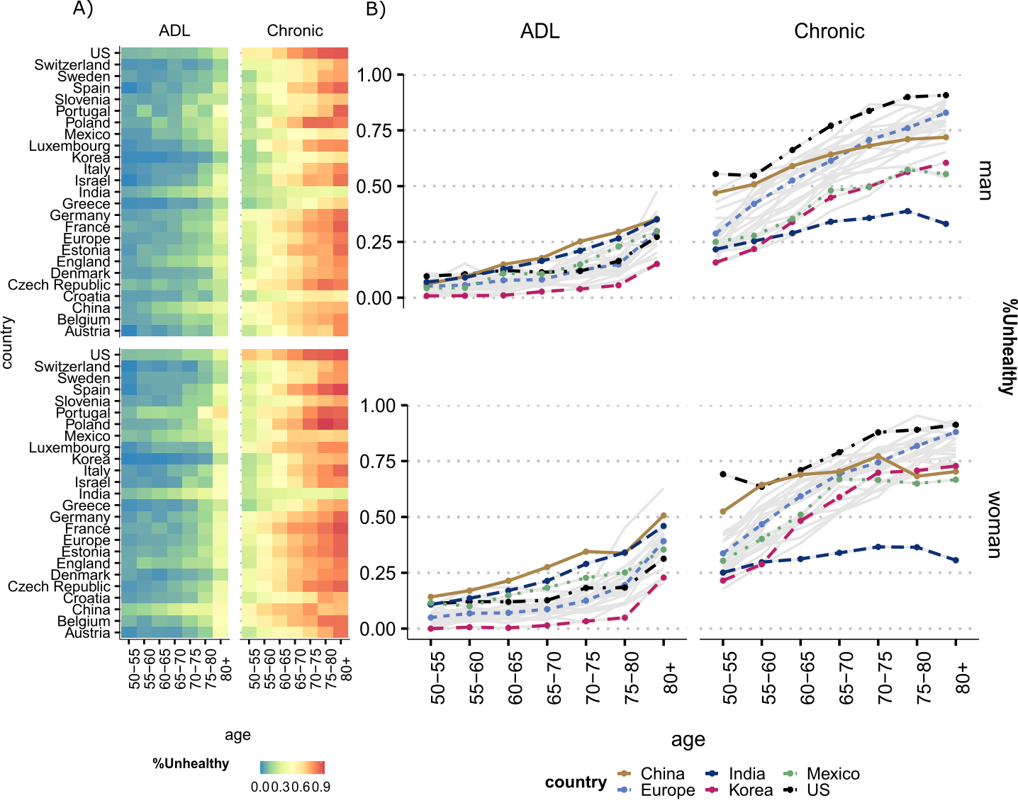

**Figure 1**. Prevalence of unhealthy women and men by activity of daily limitation (ADL) and doctor diagnosed chronic conditions (Chronic) by age. All countries are presented in (Panel A) and selected countries in (Panel B).

Source: Gateway to Global Aging Data, Produced by the Program on Global Aging, Health & Policy, University of Southern California with funding from the National Institute on Aging (R01 AG030153). *Notes:* Chronic is defined as being diagnosed with at least one of six doctor diagnosed conditions present at all country surveys that were harmonized: 1. Arthritis, 2. Cancer, 3. Diabetes, 4. Heart Conditions, 5. Lung disease, 6. Stroke. For more details on how diagnoses are defined and which criteria are used, refer to the Supplementary Information. For country-specific profiles for each condition, also see individual figures in the Supplementary Information.

Panel B shows how the figure changes when we analyze chronic conditions. First, the prevalence of having at least one chronic condition is higher than experiencing limitation in daily activities already at age 50 and increases at all ages for both women and men at all countries. The US has the highest prevalence for women and men at all ages compared to all countries. China is right after the US with the highest prevalence at relatively younger ages (50-60), but then levels off, while other countries still experience and increase in prevalence with age. After age 60, the country with the lowest prevalence of at least one chronic condition is India. Among the countries in the European region, Portugal and Poland are the ones with the highest prevalence of at least one chronic condition at ages above 60, as shown in the heat map in Panel A of Figure 1. India is the country with the lowest levels of chronic condition by age, while US, Europe and China the highest, followed closely by Korea. The low level for India is most likely due to limited access to healthcare, as these are diseases that must be diagnosed by a doctor.

*Estimating and decomposing the gender gap into contributions of mortality, disability and chronic conditions*

We combine the age-specific prevalence of disability and chronic conditions with the respective life tables for each country to derive disability-free life expectancy (DFLE) and chronic-free life expectancy (CFLE) (see details in the Methods section). Afterwards, the continuous change decomposition method is implemented to split gender differences in healthy life expectancy into mortality and disability/chronic disease effects.

Figure 2 shows the gender gap in DFLE and its decomposition into mortality and disability effects above age 60 for all countries (see Table 1 for all values for each country with confidence intervals). In Panel A, all countries and the mortality and disability effects at ages 60+ are shown. The sum of the mortality and disability components correspond to the total gender gap (women-men). The mortality component is positive, which means that it contributes to increase the gender gap (women have advantage), while the disability part is negative (with the exception of Denmark), contributing to decrease the gap (women have the disadvantage).

In Panel B we highlight the countries according to total gender gaps in DFLE and their corresponding mortality and disability effects. India and Portugal are among the countries with the lowest gender gaps in DFLE at ages 60+ (-0.16 and -0.36, respectively), but experience a substantial effect of disability and mortality, which go in opposite directions, almost offsetting each other. However, since the effect of disability is larger than mortality (-1.25 and -2.69, respectively), this leads to a negative gap in DFLE, implying that women have a disadvantage relative to men.

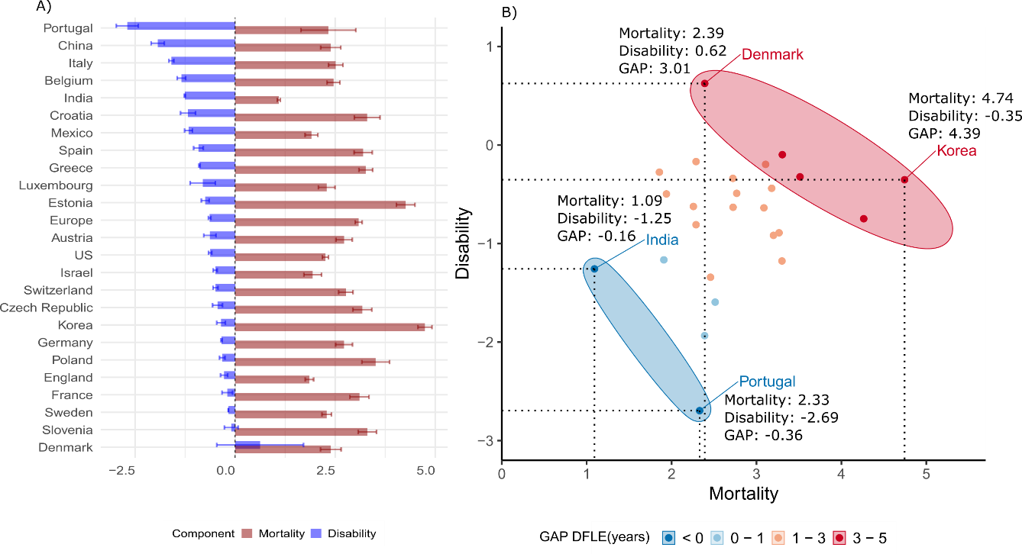

**Figure 2.** Decomposition of the gender gap in disability-free life expectancy (DFLE) at ages 60+ into mortality and disability effects by country. Note: Panel A presents the effects by each country, ranked from the highest to lowest disability contribution. Panel B presents selected countries, grouped by their GAP in DFLE (Women-Men) and the contributions of disability and mortality to the total GAP.

Korea and Denmark are among the countries with the highest gender gaps in DFLE (between 3-5 years), with Korea being the country with one of the highest gaps at ages 60+ in favor of women (4.39 years). The contribution stems mainly from the mortality advantage of women in Korea (4.74 against -0.35 the role of disability). The mortality advantage of women in Denmark is also the key factor in explaining the gap (2.39), but their advantage relative to men is also stemming from a positive disability effect, being the only country where the gap is also explained by an advantage of women with regards to disability.

Figure 3 presents the results for the gender gap in CFLE, where the signal of the total gap inverts, as women face more disadvantage than men for most countries. Portugal and Korea are thus among the countries where the gap is the largest across countries with a negative gender gap in CFLE, or where men have more advantage than women. Conversely, Israel and Slovenia are among the countries with the highest positive gap, or where women have an advantage relative to men.

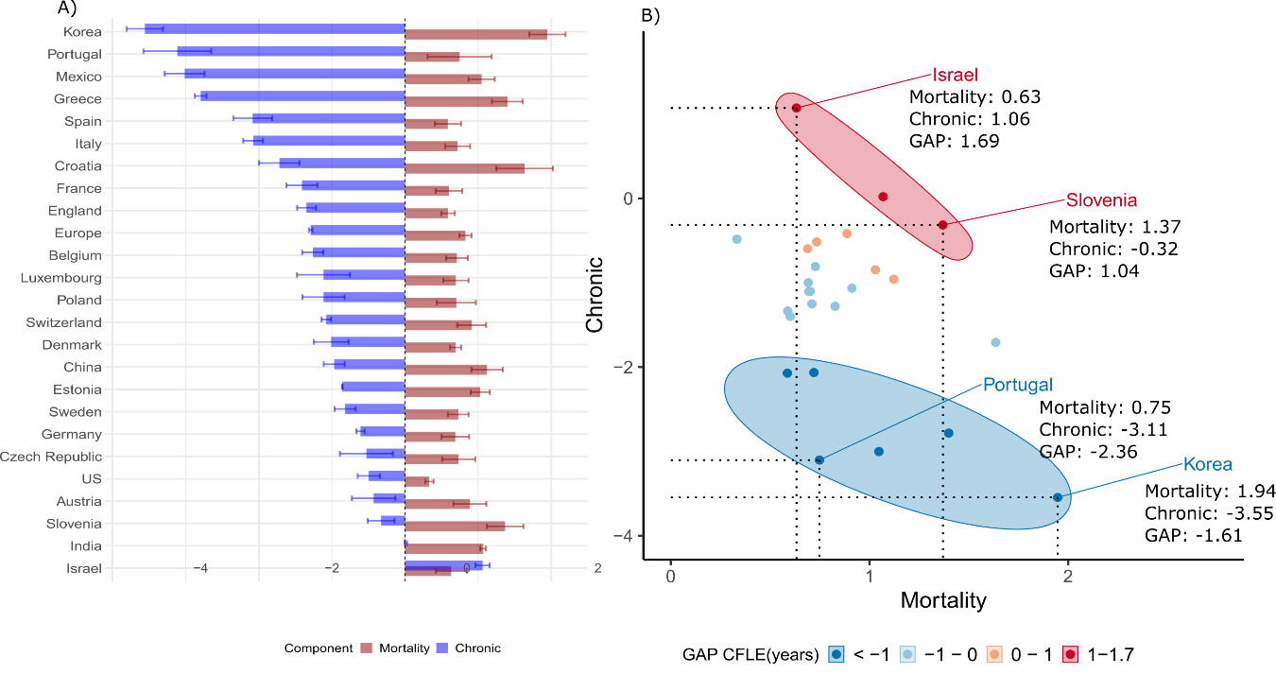

**Figure 3.** Decomposition of the gender gap in chronic disease-free life expectancy (CFLE) at ages 60+ into mortality and chronic effects by country. Note: Panel A presents the effects by each country, ranked from the highest to lowest chronic disease contribution. Panel B presents selected countries, grouped by their GAP in CFLE (Women-Men) and the contributions of chronic and mortality to the total GAP.

Similar to gaps in DFLE, however, gaps in CFLE are not necessarily driven by the same effects of chronic and mortality components. Israel has a total gender gap in CFLE of 1.69 and Slovenia of 1.04. Despite this similarity and a positive gap in CFLE, in Slovenia the gap is explained by a high mortality effect and a negative chronic effect, while in Israel both components contribute to increase the advantage of women relative to men. In Korea and Portugal, the negative gap in CFLE implies that men have an advantage relative to women in these countries when it comes to chronic disease free life expectancy, with a strong effect of chronic conditions.

**Table 1.** Decomposition of the gender gap in disability-free life expectancy (DFLE) at ages 60+ into mortality and disability effects by country, with 95% confidence intervals.

|  |  |  |  |  |  |  |  |
| --- | --- | --- | --- | --- | --- | --- | --- |
| Country | LE | DFLE | 95%CI | Components | | | |
| Mortality | 95%CI | Disability | 95%CI |
|  |
| US | 2.99 | 1.63 | [1.60, 1.67] | 2.26 | [2.18, 2.33] | -0.62 | [-0.58, -0.66] |  |
| China | 3.81 | 0.45 | [0.37, 0.54] | 2.39 | [2.14, 2.64] | -1.93 | [-1.77, -2.10] |  |
| Mexico | 2.64 | 0.74 | [0.68, 0.80] | 1.91 | [1.75, 2.07] | -1.17 | [-1.07, -1.26] |  |
| India | 1.63 | -0.17 | [-0.22, -0.1] | 1.09 | [1.05, 1.13] | -1.26 | [-1.27, -1.25] |  |
| Korea | 5.56 | 4.39 | [4.33, 4.46] | 4.74 | [4.57, 4.93] | -0.35 | [-0.24, -0.46] |  |
| England | 2.68 | 1.58 | [1.57, 1.60] | 1.86 | [1.75, 1.96] | -0.28 | [-0.19, -0.37] |  |
| Europe |  |  |  |  |  |  |  |  |
| (*Pooled*) | 4.15 | 2.45 | [2.39, 2.50] | 3.09 | [3.00, 3.17] | -0.64 | [-0.60, -0.67] |  |
| Austria | 3.70 | 2.09 | [2.04, 2.14] | 2.72 | [2.52, 2.93] | -0.63 | [-0.48, -0.79] |  |
| Belgium | 3.53 | 1.12 | [1.06, 1.17] | 2.46 | [2.30, 2.62] | -1.34 | [-1.24, -1.45] |  |
| Croatia | 4.28 | 2.12 | [1.62, 2.63] | 3.30 | [2.98, 3.62] | -1.18 | [-1.36, -0.99] |  |
| Czechia | 4.17 | 2.74 | [2.63, 2.85] | 3.18 | [2.94, 3.41] | -0.44 | [-0.31, -0.56] |  |
| Denmark | 2.99 | 3.01 | [2.19, 3.84] | 2.39 | [2.13, 2.65] | 0.62 | [1.71, -0.46] |  |
| Estonia | 5.65 | 3.51 | [3.38, 3.65] | 4.26 | [4.03, 4.49] | -0.75 | [-0.65, -0.85] |  |
| France | 4.53 | 2.91 | [2.80, 3.02] | 3.11 | [2.87, 3.35] | -0.20 | [-0.06, -0.33] |  |
| Germany | 3.64 | 2.38 | [2.16, 2.61] | 2.72 | [2.51, 2.93] | -0.34 | [-0.35, -0.32] |  |
| Greece | 4.01 | 2.37 | [2.22, 2.53] | 3.27 | [3.10, 3.44] | -0.89 | [-0.88, -0.91] |  |
| Israel | 2.80 | 1.44 | [1.27, 1.61] | 1.94 | [1.72, 2.16] | -0.50 | [-0.45, -0.55] |  |
| Italy | 3.51 | 0.92 | [0.68, 1.16] | 2.51 | [2.33, 2.69] | -1.59 | [-1.66, -1.53] |  |
| Luxembourg | 3.07 | 1.48 | [0.96, 2.00] | 2.29 | [2.08, 2.50] | -0.81 | [-1.12, -0.49] |  |
| Poland | 5.01 | 3.19 | [2.91, 3.47] | 3.51 | [3.17, 3.86] | -0.32 | [-0.25, -0.39] |  |
| Portugal | 4.15 | -0.37 | [-1.32,0.59] | 2.33 | [1.64, 3.02] | -2.70 | [-2.97, -2.42] |  |
| Slovenia | 4.31 | 3.21 | [3.15, 3.26] | 3.30 | [3.08, 3.53] | -0.10 | [0.07, -0.27] |  |
| Spain | 4.37 | 2.28 | [2.18, 2.39] | 3.20 | [2.97, 3.43] | -0.92 | [-0.80, -1.04] |  |
| Sweden | 2.73 | 2.12 | [2.00, 2.24] | 2.29 | [2.17, 2.41] | -0.17 | [-0.17, -0.16] |  |
| Switzerland | 3.26 | 2.28 | [2.03, 2.52] | 2.77 | [2.59, 2.95] | -0.49 | [-0.55, -0.43] |  |
|  |  |  |  |  |  |  |  |  |

**Table 2.** Decomposition of the gender gap in chronic disease-free life expectancy (CFLE) at ages 60+ into mortality and disability effects by country, with 95% confidence intervals.

|  |  |  |  |  |  |  |  |
| --- | --- | --- | --- | --- | --- | --- | --- |
| Country | LE | CFLE | 95%CI | Components | | | |
| Mortality | 95%CI | Chronic | 95%CI |
|  |
| US | 2.99 | -0.16 | [-0.07, -0.26] | 0.33 | [0.27, 0.39] | -0.49 | [-0.34, -0.65] |  |
| China | 3.81 | 0.15 | [0.08, 0.23] | 1.12 | [0.91, 1.34] | -0.97 | [-0.82, -1.11] |  |
| Mexico | 2.64 | -1.97 | [-1.87, -2.06] | 1.05 | [0.87, 1.23] | -3.01 | [-2.74, -3.29] |  |
| India | 1.63 | 1.08 | [1.06, 1.10] | 1.07 | [1.03, 1.11] | 0.01 | [0.03, -0.01] |  |
| Korea | 5.56 | -1.61 | [-1.61, -1.61] | 1.95 | [1.70, 2.20] | -3.56 | [-3.31, -3.80] |  |
| England | 2.68 | -0.76 | [-0.72, -0.79] | 0.59 | [0.49, 0.68] | -1.35 | [-1.22, -1.47] |  |
| Europe |  |  |  |  |  |  |  |  |
| (*Pooled*) | 4.15 | -0.46 | [-0.52, -0.40] | 0.83 | [0.74, 0.91] | -1.29 | [-1.27, -1.31] |  |
| Austria | 3.70 | 0.46 | [0.53, 0.39] | 0.89 | [0.66, 1.11] | -0.43 | [-0.13, -0.73] |  |
| Belgium | 3.53 | -0.55 | [-0.56, -0.55] | 0.71 | [0.56, 0.86] | -1.26 | [-1.12, -1.41] |  |
| Croatia | 4.28 | -0.08 | [-0.19, 0.03] | 1.64 | [1.25, 2.02] | -1.72 | [-1.44, -1.99] |  |
| Czechia | 4.17 | 0.21 | [0.34, 0.07] | 0.73 | [0.51, 0.96] | -0.53 | [-0.16, -0.89] |  |
| Denmark | 2.99 | -0.32 | [-0.16, -0.48] | 0.69 | [0.62, 0.77] | -1.01 | [-0.77, -1.25] |  |
| Estonia | 5.65 | 0.17 | [0.05, 0.30] | 1.03 | [0.90, 1.16] | -0.86 | [-0.85, -0.86] |  |
| France | 4.53 | -0.81 | [-0.78, -0.84] | 0.60 | [0.42, 0.78] | -1.41 | [-1.20, -1.62] |  |
| Germany | 3.64 | 0.08 | [-0.05, 0.22] | 0.69 | [0.50, 0.88] | -0.61 | [-0.55, -0.66] |  |
| Greece | 4.01 | -1.39 | [-1.53, -1.26] | 1.40 | [1.19, 1.61] | -2.79 | [-2.71, -2.87] |  |
| Israel | 2.80 | 1.69 | [1.58, 1.81] | 0.63 | [0.42, 0.84] | 1.06 | [1.16, 0.96] |  |
| Italy | 3.51 | -1.36 | [-1.39, -1.32] | 0.72 | [0.55, 0.89] | -2.08 | [-1.94, -2.21] |  |
| Luxembourg | 3.07 | -0.42 | [-0.23, -0.61] | 0.70 | [0.52, 0.87] | -1.11 | [-0.75, -1.48] |  |
| Poland | 5.01 | -0.41 | [-0.39, -0.43] | 0.70 | [0.43, 0.97] | -1.11 | [-0.82, -1.40] |  |
| Portugal | 4.15 | -2.37 | [-2.34, -2.39] | 0.75 | [0.31, 1.19] | -3.11 | [-2.65, -3.58] |  |
| Slovenia | 4.31 | 1.04 | [0.98, 1.11] | 1.37 | [1.12, 1.62] | -0.33 | [-0.14, -0.51] |  |
| Spain | 4.37 | -1.50 | [-1.41, -1.58] | 0.59 | [0.41, 0.77] | -2.08 | [-1.82, -2.35] |  |
| Sweden | 2.73 | -0.09 | [-0.09, -0.10] | 0.73 | [0.59, 0.87] | -0.82 | [-0.67, -0.96] |  |
| Switzerland | 3.26 | -0.16 | [-0.43, 0.10] | 0.91 | [0.71, 1.11] | -1.07 | [-1.14, -1.01] |  |

What Figures 2 and 3 both highlight is that countries with similar gender gaps do not necessarily have the same mortality and health effect. In addition, when we group countries according to the number of years in gender gap, very different countries in terms of development levels, health care system and gender roles can often be in the same category. The lack of a systematic pattern across countries as regards their gender gap in DFLE and CFLE signals that similar gaps do not necessarily capture the inequality in health conditions across women and men in these countries.

As seen in Figure 4, countries can have very different rankings if the criteria adopted are gaps in DFLE and CFLE versus the contribution of disability and mortality effects. Low gender gaps are first places in the ranks while the last ranks are high gender gaps or high contribution of health component.

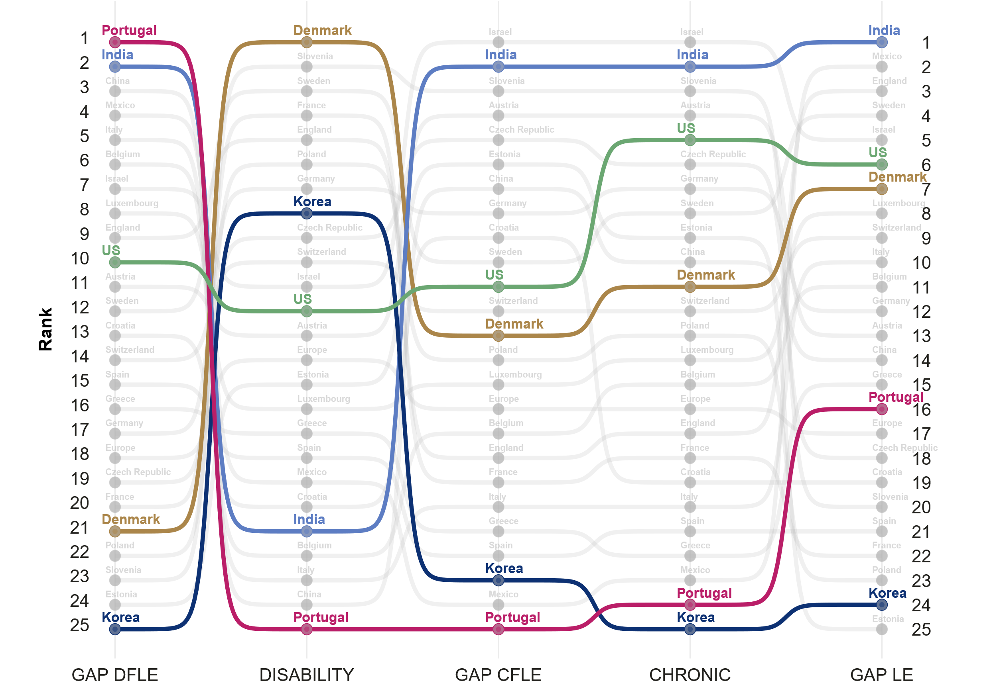

**Figure 4.** Ranking of countries (from lower to higher gaps) by gender gap in life expectancy, disability and chronic disease-free life expectancy (DFLE, CFLE), and the contribution of disability and chronic component to the total gender gap at ages 60+, by country. Note: In terms of gaps, the ranking is from low to high gap and in terms of disability and chronic from low to high contributions of these components to the total gap.

Indeed, Portugal has the lowest gender gap across all countries in DFLE (Rank 1), but the country with the strongest effect of disability, pushing it to the last place (Rank 25). At the same time, it is among the countries with the highest gaps in total life expectancy (Rank 16 out of 25). Denmark is the opposite, being placed at first Rank when considering the effect of disability, while it is among the last countries (Rank 21) when considering the gender gap in DFLE.

**Discussion**

Reducing gender gaps in health expectancy may not necessarily mean that we are reducing inequality between women and men. Using the gap as a measure of inequality in gender differences in health and mortality is tempting and seems straightforward. Despite being a simple and overall useful measure, it is nonetheless important to take a cautionary approach when interpreting those gaps and especially when using them to guide policy. Recent work has shown that policies that aim to advance gender equality in health across different countries have surprisingly poor design and implementation flaws, which are mostly due to scarcity of relevant data and accurate indicators (Crespi-Llorens 2021).

Taking gender gaps as a standpoint for conducting studies on gender differences when they are masking important underlying differences in health and mortality may also explain why some studies find conflicting results or no correlation between cross-national variation in gender gaps and societal-level gender inequality (30). Other studies point out that even summary indicators of health like health expectancy are linked to other indices of gender inequality, but not aggregate indices based on gender gaps (CITE). By focusing on the gap, these studies may be missing important changes in the patterns of health and mortality, which may not go together with societal level changes in health and gender inequality.

RELATE OUR RESULTS TO THE LITERATURE. DISCUSS MORE OUR OWN RESULTS AND HOW IT CONNECTS TO THE AVAILABLE EVIDENCE.

female-male gaps in the prevalence of chronic conditions, especially arthritis and depression and gender characteristics of the society. (Boerma, Ties). Arthritis is consistent with the literature from different data sources and for a wide range of countries.

Evidence using the same data source as our study showed substantial heterogeneity in disability and morbidity across countries, especially after controlling for population age composition. However, they found that overall women have higher life expectancy and lower levels of diabetes and heart disease than men( Lee2018a).

ADD CONTRIBUTIONS

Another contribution of this study is the extent of the comparative analysis. Studies that have performed global comparisons use less detailed health indicators and often lack in harmonization across the indicators health.(CITE). So far, most of the research has focused on western countries, with few studies including countries like China, India and Korea and even fewer that include developing or Latin American countries like Mexico in the study.

women live longer and expect to spend a higher proportion of their lives in poorer health has startling effects on their well-being since poorer health for women usually means non-lethal, but debilitating conditions such as arthritis, which limit their ability to remain independent, engage in social activities, and usually demand long-term care (Freedman et al., 2016).

Performing cross-country comparisons is crucial to identify common patterns and divergences that exist in health and mortality for different societal regimes (31, 32). It is particularly important when investigating those patterns by gender, as there is great variation in gender norms, welfare state systems, and socioeconomic development across countries that may directly or indirectly impact health and mortality indicators (33–37). However, comparative analysis are challenging, mainly because the quality, and validity of health indicators vary from country to country, which can lead to variations in results that are not accurately capturing health outcomes (38). Some studies using the Gateway of Global Ageing have

Furthermore, measuring gender disparities in health and mortality and what contributes to the gender gap across different countries is key for understanding what drives the gap. Different countries not only have specific health and mortality trajectories but their own cultural and gender roles, which may in turn affect the differentials. Cross-national comparisons are thus important to further shed light into the topic, as gender inequality in health is correlated to country-specific levels of development and to societal roles of women and men (Okojie 1994; WCF 2018). Therefore, it is important to quantify health inequalities by gender and across countries with different levels of development.

ADD LIMITATIONS

study is cross-sectional - we do not look into trends nor use the longitudinal potential of the dataset. However, our aim was to have the most countries included in the comparison.

An important aspect is who is allowed to provide such diagnosis. HRS specifically excludes diagnosis made by nurses/nurse practitioners, chiropractors, and dentists. However, both CHARLS and LASI allow diagnosis by nurses, practitioners of traditional medicine, and other health care professionals.

**Materials and Methods**

**Data**

*Health*

For the health measures, we use data from the Gateway to Global Aging Data, produced by the Program on Global Aging, Health & Policy that created harmonized versions of sister-HRS studies. The harmonized versions have followed the RAND HRS conventions of variable naming and data structure which allow for cross-country comparisons. We use the harmonized versions available for HRS (United States), ELSA (England), KLoSA (South Korea), CHARLS (China), LASI (India), MHAS (Mexico), and Europe (SHARE). In order to perform comparisons at points in time that were as close as possible across countries we used survey waves pertaining to year 2014-2015 (HRS: Wave 12; ELSA : Wave 7; SHARE: Wave 6; KLoSA: Wave 5; CHARLS: Wave 2; and LASI Wave 1). The only exception is India, since the first wave of LASI was carried on between 2017-2019. We focus on this specific set of countries as our aim is to have the most diverse group of countries while retaining the highest possible level of concordance across the harmonized health variables. Hence, we choose these countries and years due to the following specific reasons: 1. these are the available countries for which the highest possible concordance among surveys is available for health information; 2. these countries have unique epidemiological and mortality trajectories that include countries with fast-paced mortality transitions, such as Korea and slow pioneering countries like Sweden; 3. Different welfare state models and gender roles, which enable us to investigate whether specific gender patterns in inequality in health and mortality emerge in those settings.

For mortality we use life tables from the 2022 Revision of World Population Prospects (United Nations 2022) for all countries with the exceptions of England, where the life tables from the ONS estimates, as the ELSA study does not include Wales.

We estimate disability- and chronic disease-free life expectancies (DFLE and CFLE) for ages 60 and over using the Sullivan Method (24–26). For disability, we use the harmonized dummy variable constructed from a 5-item list of activities of daily living (ADLs), which include bathing, dressing, eating, getting in and out of bed, and using the toilet. For chronic doctor diagnosed diseases, we use the harmonized variables on specific chronic conditions diagnosed by a physician, which include diabetes, heart conditions, arthritis, cancer, stroke and lung disease. We use waves pertaining to year 2014-2015 (HRS: Wave 12; ELSA: Wave 7; SHARE: Wave 6; KLoSA: Wave 5; CHARLS: Wave 2; and LASI Wave 1). The only exception is India, since the first wave of LASI was carried on between 2017-2019. The choice of years refers to the most recent waves for which harmonized data on health for this set of countries is available and there is concordance across surveys. We focus on age 60 and above to be coherent towards the definition of old age across countries. While most developed countries define old age as 65, for China and Mexico it is age 60. Lastly, we apply the continuous change decomposition method (27, 28), so we can split gender differences in healthy life expectancy into mortality and disability/chronic disease effects by age (29).

**Methods**

To examine gender disparities in health expectancy, we estimate the disability-free life expectancy (*DFLE*) and the chronic-free life expectancy (CFLE) using the Sullivan Method (24), a methodological approach that has been used before in similar analyses (26). For each age group, we estimate the prevalence of disability and at least one chronic doctor diagnosed condition from the survey data for each country and combine it with the total number of person-years lived obtained from the life tables. The number of person-years lived free of disability () is calculated as,

where *nLxi*  is the number of person-years lived without disability between ages *x* and *x+n*, *nLx* is the total number of person-years lived in the age group *x* and *x+n*, and *nπx* is the proportion of disabled individuals in the age group *x* and *x+n*. The same is for chronic-free person-years lived, however with the prevalence for at least one chronic condition instead of prevalence of ADLs, and we call the person-years derived by the same process as .

Then, life expectancy free of disability (*DFLE*) is calculated as:

With its equivalent life expectancy free of chronic disease (*CFLE*):

where is the number of years lived without disability at age *x*, *w* is the starting age of the open age interval, and *l*x is the number of survivors at age *x*. Similarly, is the number of years lived without chronic conditions at age *x*, *w* is the starting age of the open age interval, and *l*x is the number of survivors at age *x*.

We then calculate gender gap in *DFLE* as:

And the gender gap in *CFLE* as:

We later split the gender differences in *DFLE* and *CFLE* at age *x* into mortality and disability/chronic effects by five-year age groups. To decompose the gap, we apply the continuous change decomposition method that was developed by Horiuchi et al. (27) and implemented in R by Riffe (28). The continuous change decomposition method assumes that covariates (e.g., age-specific mortality rates and age-specific prevalence of disability) change continuously along an actual or hypothetical dimension, such as between two periods or between two populations, thereby modifying aggregate measures such as life expectancy and healthy life expectancy. Each of these tiny changes in the aggregate indices can be approximated by a linear combination of *n* partial derivatives of the function with respect to the covariates (27). Then, numerical integration is used to obtain the total contribution of the covariates for the variation of the aggregate measure. This allows us to estimate the contribution of disability and chronic conditions to explaining gender inequality. In addition, the method is very flexible, and can be used for decomposing gaps in different aggregate measures, including healthy life expectancy, as presented by van Raalte and Nepomuceno (29). Previous research has employed the methodology to estimate gaps in disability for LAC countries (22).

**Acknowledgments**

This paper uses data from SHARE Wave 6 (10.6103/SHARE.w6.800), see Börsch-Supan et al. (2013) for methodological details. The SHARE data collection has been funded by the European Commission, DG RTD through FP5 (QLK6-CT-2001-00360), FP6 (SHARE-I3: RII-CT-2006-062193, COMPARE: CIT5-CT-2005-028857, SHARELIFE: CIT4-CT-2006-028812), FP7 (SHARE-PREP: GA N°211909, SHARE-LEAP: GA N°227822, SHARE M4: GA N°261982, DASISH: GA N°283646) and Horizon 2020 (SHARE-DEV3: GA N°676536, SHARE-COHESION: GA N°870628, SERISS: GA N°654221, SSHOC: GA N°823782, SHARE-COVID19: GA N°101015924) and by DG Employment, Social Affairs & Inclusion through VS 2015/0195, VS 2016/0135, VS 2018/0285, VS 2019/0332, and VS 2020/0313. Additional funding from the German Ministry of Education and Research, the Max Planck Society for the Advancement of Science, the U.S. National Institute on Aging (U01_AG09740-13S2, P01_AG005842, P01_AG08291, P30_AG12815, R21_AG025169, Y1-AG-4553-01, IAG_BSR06-11, OGHA_04-064, HHSN271201300071C, RAG052527A) and from various national funding sources is gratefully acknowledged (see [www.share-project.org](http://www.share-project.org/)).

This analysis uses data or information from the following Harmonized datasets: KLoSA dataset and Codebook, Version C as of June 2019 developed by the Gateway to Global Aging Data. The development of the Harmonized KLoSA was funded by the National Institute on Ageing (R01 AG030153, RC2 AG036619, R03 AG043052). LASI dataset and Codebook, Version A.2 as of October 2021, developed by the Gateway to Global Aging Data (DOI: https://doi.org/10.25549/h-lasi). The development of the Harmonized LASI was funded by the National Institute on Aging (R01 AG042778, 2R01 AG030153, 2R01 AG051125). CHARLS dataset and Codebook, Version D as of June 2021 developed by the Gateway to Global Aging Data. The development of the Harmonized CHARLS was funded by the National Institute on Aging (R01 AG030153, RC2 AG036619, R03 AG043052). ELSA dataset and Codebook, Version G.2 as of July 2021 developed by the Gateway to Global Aging Data. The development of the Harmonized ELSA was funded by the National Institute on Aging (R01 AG030153, RC2 AG036619, R03 AG043052). SHARE dataset and Codebook, Version F as of June 2022 developed by the Gateway to Global Aging Data. The development of the Harmonized SHARE was funded by the National Institute on Aging (R01 AG030153, RC2 AG036619, R03 AG043052). MHAS dataset and Codebook, Version B.4 as of February 2022 developed by the Gateway to Global Aging Data in collaboration with the MHAS research team. The development of the Harmonized MHAS was funded by the National Institute on Aging (R01 AG030153). The Harmonized MHAS data files and documentation are public use and available at www.MHASweb.org. The MHAS (Mexican Health and Aging Study) receives support from the National Institutes of Health/National Institute on Aging (R01 AG018016) in the United States and the Instituto Nacional de Estadística y Geografía (INEGI) in Mexico. HRS dataset and Codebook, Version C as of January 2022 developed by the Gateway to Global Aging Data. The development of the Harmonized HRS was funded by the National Institute on Aging (R01 AG030153, RC2 AG036619, 1R03AG043052). For more information about the Harmonization project, please refer to<https://g2aging.org/>.

This work is supported within the EU Framework Programme for Research and Innovation Horizon 2020, ERC Grant Agreement No. 725187 (LETHE)

**References**

1. World Economic Forum, “The Global Gender Gap Report 2021” (2021).

2. WHO (World Health Organization), “Understanding the drivers of health equity: the power of political participation” (2020).

3. European Institute for Gender Equality, “Gender Equality Index 2021: Health” (2021) https:/doi.org/10.2839/633501.

4. A. Case, C. Paxson, Sex Differences in Morbidity and Mortality. *Demography* **42**, 189–214 (2005).

5. E. M. Crimmins, J. K. Kim, A. Solé-Auró, Gender differences in health: results from SHARE, ELSA and HRS. *Eur. J. Public Health* **21**, 81–91 (2011).

6. L. M. Verbrugge, D. L. Wingard, Sex Differentials in Health and Mortality. *Women Health* **12**, 103–145 (1987).

7. G. Doblhammer, J. Gumà, *A Demographic Perspective on Gender, Family and Health in Europe*, G. Doblhammer, J. Gumà, Eds. (Springer International Publishing, 2018) https:/doi.org/10.1007/978-3-319-72356-3.

8. V. Zarulli, *et al.*, Women live longer than men even during severe famines and epidemics. *Proc. Natl. Acad. Sci.* (2018) https:/doi.org/10.1073/pnas.1701535115.

9. F. C. Drumond Andrade, P. E. Guevara, M. L. Lebrão, Y. A. de Oliveira Duarte, J. L. F. Santos, Gender Differences in Life Expectancy and Disability-Free Life Expectancy Among Older Adults in São Paulo, Brazil. *Women’s Heal. Issues* **21**, 64–70 (2011).

10. V. Di Lego, P. Di Giulio, M. Luy, “Gender Differences in Healthy and Unhealthy Life Expectancy” in (2020), pp. 151–172.

11. E. Grundy, “Gender and healthy aging” in *Longer Life and Healthy Aging*, (2006), pp. 173–199.

12. C. D. Mathers, R. Sadana, J. A. Salomon, C. J. L. Murray, A. D. Lopez, Healthy life expectancy in 191 countries, 1999. *Lancet* **357**, 1685–1691 (2001).

13. A. Oksuzyan, M. Shkolnikova, J. W. Vaupel, K. Christensen, V. M. Shkolnikov, Sex differences in health and mortality in Moscow and Denmark. *Eur. J. Epidemiol.* **29**, 243–252 (2014).

14. E. M. Crimmins, J. K. Kim, A. Hagedorn, Life With and Without Disease: Women Experience More of Both. *J. Women Aging* **14**, 47–59 (2002).

15. M. Luy, Y. Minagawa, Gender gaps--Life expectancy and proportion of life in poor health. *Heal. reports* **25**, 12–9 (2014).

16. J.-M. Robine, C. Jagger, I. Romieu, Disability-free life expectancies in the European Union countries: calculation and comparisons. *Genus* **57**, 89–101 (2001).

17. T. Riffe, A. A. van Raalte, M. J. Bijlsma, “Healthy life expectancy, mortality, and age prevalence of morbidity” (2017) https:/doi.org/10.4054/MPIDR-WP-2017-015.

18. I. Mairey, P. Bjerregaard, H. Brønnum Hansen, Gender difference in health expectancy trends in Greenland. *Scand. J. Public Health* **42**, 751–758 (2014).

19. W. J. Nusselder, C. W. N. Looman, H. van Oyen, J. M. Robine, C. Jagger, Gender differences in health of EU10 and EU15 populations: the double burden of EU10 men. *Eur. J. Ageing* **7**, 219–227 (2010).

20. W. J. Nusselder, C. W. Looman, Decomposition of differences in health expectancy by cause. *Demography* **41**, 315–34 (2004).

21. H. Van Oyen, *et al.*, Gender differences in healthy life years within the EU: an exploration of the “health–survival” paradox. *Int. J. Public Health* **58**, 143–155 (2013).

22. M. R. Nepomuceno, V. di Lego, C. M. Turra, Gender disparities in health at older ages and their consequences for well-being in Latin America and the Caribbean. *Vienna Yearb. Popul. Res.* **19** (2021).

23. J. Lee, D. Phillips, J. Wilkens, Gateway to Global Aging Data: Resources for Cross-National Comparisons of Family, Social Environment, and Healthy Aging. *Journals Gerontol. Ser. B Psychol. Sci. Soc. Sci.* **76**, S5 (2021).

24. D. . Sullivan, A single index of mortality and morbidity. *HSMHA Health Rep.* **86**, 347–54 (1971).

25. Y. Saito, J. M. Robine, E. M. Crimmins, The methods and materials of health expectancy. *Stat. J. IAOS* **30**, 209–223 (2014).

26. E. M. Crimmins, Y. Zhang, Y. Saito, Trends Over 4 Decades in Disability-Free Life Expectancy in the United States. **106**, 1287–1293 (2016).

27. S. Horiuchi, J. R. Wilmoth, S. D. Pletcher, A decomposition method based on a model of continuous change. *Demography* **45**, 785–801 (2008).

28. T. Riffe, Package “DemoDecomp” Type Package Title Decompose Demographic Functions (2018) https:/doi.org/10.1353/dem.0.0033 (October 15, 2019).

29. A. A. van Raalte, M. R. Nepomuceno, “Decomposing Gaps in Healthy Life Expectancy” in (2020), pp. 107–122.

30. J. Dahlin, J. Härkönen, Cross-national differences in the gender gap in subjective health in Europe: Does country-level gender equality matter? *Soc. Sci. Med.* **98**, 24–28 (2013).

31. J. Ailshire, D. Carr, Cross-National Comparisons of Social and Economic Contexts of Aging. *Journals Gerontol. Ser. B* **76**, S1–S4 (2021).

32. P. Gardner, K. Katagiri, J. Parsons, J. Lee, R. Thevannoor, “Not for the fainthearted”: Engaging in cross-national comparative research. *J. Aging Stud.* **26**, 253–261 (2012).

33. J. L. Angel, W. Vega, M. López-Ortega, R. Pruchno, Aging in Mexico: Population trends and emerging issues. *Gerontologist* **57**, 153–162 (2017).

34. R. Pelletier, *et al.*, Sex Versus Gender-Related Characteristics Which Predicts Outcome after Acute Coronary Syndrome in the Young? *J. Am. Coll. Cardiol.* **67**, 127–135 (2016).

35. R. D. Edwards, S. Tuljapurkar, Inequality in Life Spans and Mortality Convergence Across Industrialized Countries. *Popul. Dev. Rev.* **31**, 1–36 (2005).

36. I. Permanyer, J. Spijker, A. Blanes, E. Renteria, Longevity and Lifespan Variation by Educational Attainment in Spain: 1960–2015. *Demography* (2018) https:/doi.org/10.1007/s13524-018-0718-z.

37. C. E. Ross, R. K. Masters, R. A. Hummer, Education and the Gender Gaps in Health and Mortality. *Demography* **49**, 1157–1183 (2012).

38. H. Tolonen, *et al.*, Cross-national comparisons of health indicators require standardized definitions and common data sources. *Arch. Public Heal. 2021 791* **79**, 1–14 (2021).