Going beyond the gender gap in healthy lifespans

Vanessa di Lego1*, Marília R. Nepomuceno2, Cássio M. Turra 3

1 Wittgenstein Centre for Demography and Global Human Capital (IIASA, OeAW, Univ. Vienna), Vienna Institute of Demography at the Austrian Academy of Sciences

2 Max Planck Institute for Demographic Research, Rostock, Germany.

3 Universidade Federal de Minas Gerais, Cedeplar, Brazil.

*Corresponding author

**Email:**  [Vanessa.DiLego@oeaw.ac.at](mailto:Vanessa.DiLego@oeaw.ac.at)

**Introduction**

Gender gap indices in healthy lifespans are routinely used as indicators of gender inequality. Policy makers use these gaps to benchmark countries, monitor changes over time, and identify the pace at which countries are closing or widening gender inequality in health (WHO 2020; European Institute for Gender Equality 2021; World Economic Forum 2021). Overall, gaps are an easy and straightforward way to relate the difference between two quantities. However, to measure health differences between genders, gaps may blend several dimensions of health differences between women and men, and consequently lead to misleading conclusions.

The complex interplay between gender, health, and mortality unveils a paradox: women tend to outlive men but experience more years of ill health. This paradox underscores the multifaceted nature of gender gaps in health. Despite women survival advantage, they tend to have disadvantages in terms of physical health, self-rated health, and cognition at older ages (refs). Women also tend to experience higher morbidity from acute and chronic conditions and more short-term disability (refs). When analyzing the gender gap from an aggregate measure such as healthy life expectancy, some of these facets may be overlooked, which highlights the importance of disentangling the various components of gender gaps in healthy lifespans.

Breaking down the gender gap in healthy life expectancy into mortality and morbidity has been shown to be a crucial factor in understanding gender disparities in health (Nusselder and Looman 2004; van Raalte and Nepomuceno 2020; Nepomuceno et al. 2021; Jagger et al. 2010; Mairey et al. 2014). For some countries, where the gender gap in health expectancies was virtually zero, decomposition analyses revealed considerable differences in both mortality and health, but in different directions (Nusselder et al. 2010; Van Oyen et al. 2013; Nepomuceno et al. 2021). As a consequence, the combination of a high prevalence of disability coupled with a high mortality advantage among women resulted in a small gender gap. In such cases, interpreting a small gender gap in health expectancy as a measure for low gender inequality ignores the higher disability experienced by women and disregards the intricate relationship between health and mortality.

To date, studies that have disentangled gender gaps in healthy lifespans by separating health (disability and chronic conditions) and mortality dimensions have mostly focused on a specific set of countries or regions with shared societal values and gender roles. This is mainly due to lack of comparable data and the challenging enterprise of comparative analysis on health (Ailshire and Carr 2021). In this paper, we leverage the harmonized surveys from the Gateway to Global Aging Data (Lee et al. 2021), to estimate the gender gap in health expectancy and assess the impact of health and mortality on gender inequalities in healthy lifespans across various countries. This is a unique dataset that allows us to compare health outcomes across a diverse range of low-, middle-, and high-income countries. We focus on the U.S., England, South Korea, China, India, Mexico and EU Countries. These countries have specific gender roles, healthcare policies and welfare state systems, which enable us to investigate the impact of interpreting the gender gap in health and mortality as a measure of inequality in different settings. To the best of our knowledge, this study represents the first in its approach.

We show how the gender gap in health expectancy for disability and chronic conditions varies greatly across countries and that despite being a straightforward way to perform cross-country comparisons and monitor health progress, gender gaps may not reflect actual inequalities when it comes to health. Hence, it is important to take a more cautionary approach when using and interpreting gender gaps in healthy lifespans and go beyond such oversimplified metrics.

**Materials and Methods**

**Data**

For the health measures, we use data from the Gateway to Global Aging Data, produced by the Program on Global Aging, Health & Policy that created harmonized versions of sister-HRS studies. The harmonized versions have followed the RAND HRS conventions of variable naming and data structure which allow for cross-country comparisons. We use the harmonized versions available for HRS (United States), ELSA (England), KLoSA (South Korea), CHARLS (China), LASI (India), MHAS (Mexico), and Europe (SHARE). To perform comparisons at points in time that were as close as possible across countries we used survey waves pertaining to year 2014-2015 (HRS: Wave 12; ELSA : Wave 7; SHARE: Wave 6; KLoSA: Wave 5; CHARLS: Wave 2; and LASI Wave 1). The only exception is India, since the first wave of LASI was carried on between 2017-2019. We focus on this specific set of countries as our aim is to have the most diverse group of nations while retaining the highest possible level of concordance across the harmonized health variables. Hence, we choose these countries and years due to the following specific reasons: 1. these are the available countries for which the highest possible concordance among surveys is available for health information; 2. these countries have unique epidemiological and mortality trajectories that include countries with fast-paced mortality transitions, such as Korea and slow pioneering countries like Sweden; 3. Different welfare state models and gender roles, which enable us to investigate whether specific gender patterns in inequality in health and mortality emerge in those settings. We focus on age 60 and above to be coherent towards the definition of old age across countries. While most developed countries define old age as 65, for China and Mexico it is age 60. For more details on the data characteristics, refer to the Supplementary Material.

For mortality data we use life tables from the 2022 Revision of World Population Prospects (United Nations 2022) for all countries with the exceptions of England, where the life tables from the ONS estimates, as the ELSA study does not include Wales.

**Methods**

To examine gender gaps in health expectancy, we estimate the disability-free life expectancy (*DFLE*) and the chronic-free life expectancy (CFLE) using the Sullivan Method (Sullivan 1971), a methodological approach that has been used before in similar analyses (Saito et al. 2014; Crimmins et al. 2016). We estimate disability- and chronic disease-free life expectancies (DFLE and CFLE) for ages 60 and over. For disability, we use the variable constructed from a 5-item list of activities of daily living (ADLs), which include bathing, dressing, eating, getting in and out of bed, and using the toilet (Beckett et al. 1996). For chronic doctor diagnosed diseases, we use the variables on specific chronic conditions diagnosed by a physician, which include diabetes, heart conditions, arthritis, cancer, stroke and lung disease. Using the respective weighted proportions of women and men who report a limitation in activities of daily living (ADL) and of at least one chronic doctor diagnosed disease (Chronic) in the population for each survey, we computed the prevalence of unhealthy individuals for each condition and by 5-year age groups.

For each age group, we estimate the prevalence of disability and at least one chronic condition for each country and combine it with the total number of person-years lived obtained from the life tables.

The number of person-years lived free of disability () is calculated as,

where *nLxi*  is the number of person-years lived without disability between ages *x* and *x+n*, *nLx* is the total number of person-years lived in the age group *x* and *x+n*, and *nπx* is the proportion of disabled individuals in the age group *x* and *x+n*. The same is for chronic-free person-years lived, however with the prevalence for at least one chronic condition instead of prevalence of ADLs, and we call the person-years derived by the same process as .

Then, life expectancy free of disability (*DFLE*) is calculated as:

With its equivalent life expectancy free of chronic disease (*CFLE*):

where is the number of years lived without disability at age *x*, *w* is the starting age of the open age interval, and *l*x is the number of survivors at age *x*. Similarly, is the number of years lived without chronic conditions at age *x*, *w* is the starting age of the open age interval, and *l*x is the number of survivors at age *x*.

We then calculate gender gap in *DFLE* as:

And the gender gap in *CFLE* as:

We later split the gender differences in *DFLE* and *CFLE* at age *x* into mortality and disability/chronic effects by five-year age groups. To decompose the gap, we apply the continuous change decomposition method (Horiuchi et al. 2008; Riffe 2018; van Raalte and Nepomuceno 2020)The continuous change decomposition method assumes that covariates (e.g., age-specific mortality rates and age-specific prevalence of disability) change continuously along an actual or hypothetical dimension, such as between two periods or between two populations, thereby modifying aggregate measures such as life expectancy and healthy life expectancy. Each of these tiny changes in the aggregate indices can be approximated by a linear combination of *n* partial derivatives of the function with respect to the covariates (Horiuchi et al. 2008). Then, numerical integration is used to obtain the total contribution of the covariates for the variation of the aggregate measure. This allows us to estimate the contribution of disability and chronic conditions to explaining gender inequality. In addition, the method is very flexible, and can be used for decomposing gaps in different aggregate measures, including healthy life expectancy, as presented by van Raalte and Nepomuceno (2020). Previous research has employed the methodology to estimate gaps in disability for Latin American and Caribbean (LAC) countries (Nepomuceno et al. 2021).

**Results**

*Age-Specific Prevalence*

Figure 1 shows the age-specific prevalence of individuals who report a limitation in activities of daily living (ADL), and of at least one chronic doctor-diagnosed disease (Chronic). Panel A is a heatmap with the prevalence of unhealthy women and men in activities of daily living (ADL), and chronic conditions (Chronic) by age for all countries. Panel B presents most countries in shaded grey lines in the background, to show the overall age pattern for women and men, and highlights some countries (see Figs S1-S2 in the Supplementary Information for all countries and separately for each chronic condition). Overall, the prevalence of ADLs increases with age for both women and men, with a steeper increase happening from ages 70+ in most countries. Across all countries, prevalence mostly falls between Korea and China, which are the low and high levels, respectively, for both women and men.. Korea presents the lowest prevalence of disability of all countries, both for women and men, with the greatest increase starting from age 75. The overall pattern for women across countries is more dispersed than for men, with the difference between Korean women and Chinese and Indian being higher than for men. Compared to the age pattern of men, women have a higher rate of increase in prevalence across all countries with age, with the burden increasing at a much faster pace. Chinese and Indian women have a prevalence rate level at ages 60-65 that is only observed at ages 70-75 for men, a gap of almost 10 years.

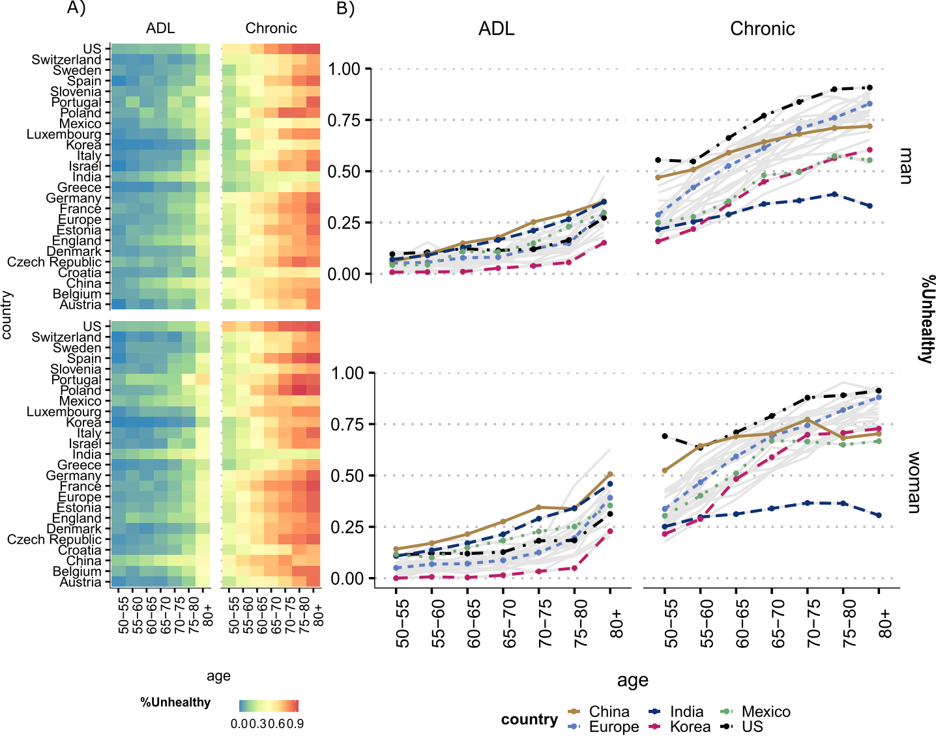

**Figure 1**. Prevalence of unhealthy women and men by activity of daily limitation (ADL) and doctor diagnosed chronic conditions (Chronic) by age. All countries are presented in (Panel A) and selected countries in (Panel B).

Source: Gateway to Global Aging Data, Produced by the Program on Global Aging, Health & Policy, University of Southern California with funding from the National Institute on Aging (R01 AG030153). *Notes:* Chronic is defined as being diagnosed with at least one of six doctor diagnosed conditions present at all country surveys that were harmonized: 1. Arthritis, 2. Cancer, 3. Diabetes, 4. Heart Conditions, 5. Lung disease, 6. Stroke. For more details on how diagnoses are defined and which criteria are used, refer to the Supplementary Information. For country-specific profiles for each condition, also see individual figures in the Supplementary Information.

Panel B also shows how the figure changes when we analyze chronic conditions. First, the prevalence of having at least one chronic condition is higher than experiencing limitation in daily activities for both women and men at all countries. The US has the highest prevalence for women and men at all ages. China is right after the US with high prevalence at younger ages (50-60), but then levels off at older ages, while other countries still experience a steep age gradient in prevalence. India is the country with the lowest prevalence of at least one chronic condition.. The low level for India is most likely due to limited access to healthcare, as these are diseases that must be diagnosed by a doctor.

*Estimating and decomposing the gender gap into contributions of mortality, disability and chronic conditions*

I think that before we start writing about the components of the gap we should write about the total gap. I am thinking if we should show table 1 before or maybe include another bar in Panel A with the total gap.

Figure 2 shows the gender gap in DFLE and its decomposition into mortality and disability effects at age 60 for all countries (see Table 1 for all values for each country with confidence intervals). The sum of the mortality and disability components correspond to the total gender gap (women-men). The mortality component is positive, which means that it contributes to increase the gender gap (women have advantage), while the disability part is negative (with the exception of Denmark), contributing to decrease the gap (women have the disadvantage).

In Panel B we highlight the countries according to total gender gaps in DFLE and their corresponding mortality and disability effects. India and Portugal are among the countries with the lowest gender gaps in DFLE at ages 60+ (-0.16 and -0.36, respectively), but experience a substantial effect of disability and mortality, which go in opposite directions, almost offsetting each other. However, since the effect of disability is larger than mortality (-1.25 and -2.69, respectively), this leads to a negative gap in DFLE, implying that women have a disadvantage relative to men.

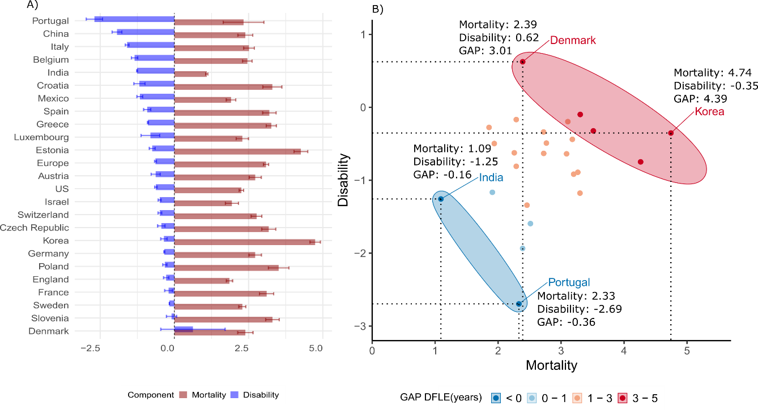

**Figure 2.** Decomposition of the gender gap (women-men) in disability-free life expectancy (DFLE) at ages 60+ into mortality and disability effects by country. Source: Gateway to Global Aging Data, Produced by the Program on Global Aging, Health & Policy, University of Southern California with funding from the National Institute on Aging (R01 AG030153). Note: Panel A presents the effects by each country, ranked from the highest to lowest disability contribution. Panel B presents selected countries, grouped by their GAP in DFLE (Women-Men) and the contributions of disability and mortality to the total GAP.

Korea and Denmark are among the countries with the highest gender gaps in DFLE (between 3-5 years), with Korea being the country with one of the highest gaps at ages 60+ in favor of women (4.39 years). The contribution stems mainly from the mortality advantage of women in Korea (4.74 against -0.35 the role of disability). The mortality advantage of women in Denmark is also the key factor in explaining the gap (2.39), but their advantage relative to men is also stemming from a positive disability effect, being the only country where the gap is also explained by an advantage of women with regards to disability.

Figure 3 presents the results for the gender gap in CFLE, where the signal of the total gap inverts, as women face more disadvantage than men for most countries. Portugal and Korea are thus among the countries where the gap is the largest across countries with a negative gender gap in CFLE, or where men have more advantage than women. Conversely, Israel and Slovenia are among the countries with the highest positive gap, or where women have an advantage relative to men.

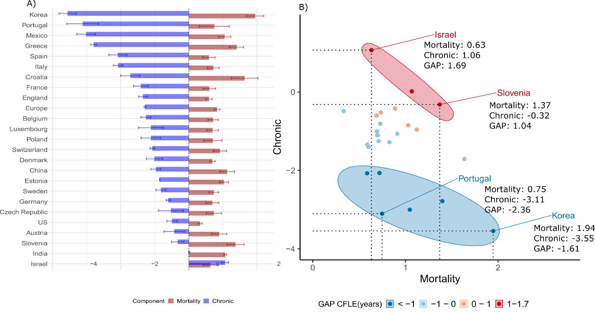

**Figure 3.** Decomposition of the gender gap (women-men) in chronic disease-free life expectancy (CFLE) at ages 60+ into mortality and chronic effects by country. Source: Gateway to Global Aging Data, Produced by the Program on Global Aging, Health & Policy, University of Southern California with funding from the National Institute on Aging (R01 AG030153). Note: Panel A presents the effects by each country, ranked from the highest to lowest chronic disease contribution. Panel B presents selected countries, grouped by their GAP in CFLE (Women-Men) and the contributions of chronic and mortality to the total GAP.

Similar to gaps in DFLE, however, gaps in CFLE are not necessarily driven by the same effects of chronic and mortality components. Israel has a total gender gap in CFLE of 1.69 and Slovenia of 1.04. Despite this similarity and a positive gap in CFLE, in Slovenia the gap is explained by a high mortality effect and a negative chronic effect, while in Israel both components contribute to increase the advantage of women relative to men. In Korea and Portugal, the negative gap in CFLE implies that men have an advantage relative to women in these countries when it comes to chronic disease-free life expectancy, with a strong effect of chronic conditions.

**Table 1.** Decomposition of the gender gap (women-men) in disability-free life expectancy (DFLE) at ages 60+ into mortality and disability effects by country, with 95% confidence intervals.

|  |  |  |  |  |  |  |  |
| --- | --- | --- | --- | --- | --- | --- | --- |
| Country | LE | DFLE | 95%CI | Components | | | |
| Mortality | 95%CI | Disability | 95%CI |
|  |
| US | 2.99 | 1.63 | [1.60, 1.67] | 2.26 | [2.18, 2.33] | -0.62 | [-0.58, -0.66] |  |
| China | 3.81 | 0.45 | [0.37, 0.54] | 2.39 | [2.14, 2.64] | -1.93 | [-1.77, -2.10] |  |
| Mexico | 2.64 | 0.74 | [0.68, 0.80] | 1.91 | [1.75, 2.07] | -1.17 | [-1.07, -1.26] |  |
| India | 1.63 | -0.17 | [-0.22, -0.1] | 1.09 | [1.05, 1.13] | -1.26 | [-1.27, -1.25] |  |
| Korea | 5.56 | 4.39 | [4.33, 4.46] | 4.74 | [4.57, 4.93] | -0.35 | [-0.24, -0.46] |  |
| England | 2.68 | 1.58 | [1.57, 1.60] | 1.86 | [1.75, 1.96] | -0.28 | [-0.19, -0.37] |  |
| Europe |  |  |  |  |  |  |  |  |
| (*Pooled*) | 4.15 | 2.45 | [2.39, 2.50] | 3.09 | [3.00, 3.17] | -0.64 | [-0.60, -0.67] |  |
| Austria | 3.70 | 2.09 | [2.04, 2.14] | 2.72 | [2.52, 2.93] | -0.63 | [-0.48, -0.79] |  |
| Belgium | 3.53 | 1.12 | [1.06, 1.17] | 2.46 | [2.30, 2.62] | -1.34 | [-1.24, -1.45] |  |
| Croatia | 4.28 | 2.12 | [1.62, 2.63] | 3.30 | [2.98, 3.62] | -1.18 | [-1.36, -0.99] |  |
| Czechia | 4.17 | 2.74 | [2.63, 2.85] | 3.18 | [2.94, 3.41] | -0.44 | [-0.31, -0.56] |  |
| Denmark | 2.99 | 3.01 | [2.19, 3.84] | 2.39 | [2.13, 2.65] | 0.62 | [1.71, -0.46] |  |
| Estonia | 5.65 | 3.51 | [3.38, 3.65] | 4.26 | [4.03, 4.49] | -0.75 | [-0.65, -0.85] |  |
| France | 4.53 | 2.91 | [2.80, 3.02] | 3.11 | [2.87, 3.35] | -0.20 | [-0.06, -0.33] |  |
| Germany | 3.64 | 2.38 | [2.16, 2.61] | 2.72 | [2.51, 2.93] | -0.34 | [-0.35, -0.32] |  |
| Greece | 4.01 | 2.37 | [2.22, 2.53] | 3.27 | [3.10, 3.44] | -0.89 | [-0.88, -0.91] |  |
| Israel | 2.80 | 1.44 | [1.27, 1.61] | 1.94 | [1.72, 2.16] | -0.50 | [-0.45, -0.55] |  |
| Italy | 3.51 | 0.92 | [0.68, 1.16] | 2.51 | [2.33, 2.69] | -1.59 | [-1.66, -1.53] |  |
| Luxembourg | 3.07 | 1.48 | [0.96, 2.00] | 2.29 | [2.08, 2.50] | -0.81 | [-1.12, -0.49] |  |
| Poland | 5.01 | 3.19 | [2.91, 3.47] | 3.51 | [3.17, 3.86] | -0.32 | [-0.25, -0.39] |  |
| Portugal | 4.15 | -0.37 | [-1.32,0.59] | 2.33 | [1.64, 3.02] | -2.70 | [-2.97, -2.42] |  |
| Slovenia | 4.31 | 3.21 | [3.15, 3.26] | 3.30 | [3.08, 3.53] | -0.10 | [0.07, -0.27] |  |
| Spain | 4.37 | 2.28 | [2.18, 2.39] | 3.20 | [2.97, 3.43] | -0.92 | [-0.80, -1.04] |  |
| Sweden | 2.73 | 2.12 | [2.00, 2.24] | 2.29 | [2.17, 2.41] | -0.17 | [-0.17, -0.16] |  |
| Switzerland | 3.26 | 2.28 | [2.03, 2.52] | 2.77 | [2.59, 2.95] | -0.49 | [-0.55, -0.43] |  |
|  |  |  |  |  |  |  |  |  |

Source: Gateway to Global Aging Data, Produced by the Program on Global Aging, Health & Policy, University of Southern California with funding from the National Institute on Aging (R01 AG030153).

**Table 2.** Decomposition of the gender gap (women-men) in chronic disease-free life expectancy (CFLE) at ages 60+ into mortality and disability effects by country, with 95% confidence intervals.

|  |  |  |  |  |  |  |  |
| --- | --- | --- | --- | --- | --- | --- | --- |
| Country | LE | CFLE | 95%CI | Components | | | |
| Mortality | 95%CI | Chronic | 95%CI |
|  |
| US | 2.99 | -0.16 | [-0.07, -0.26] | 0.33 | [0.27, 0.39] | -0.49 | [-0.34, -0.65] |  |
| China | 3.81 | 0.15 | [0.08, 0.23] | 1.12 | [0.91, 1.34] | -0.97 | [-0.82, -1.11] |  |
| Mexico | 2.64 | -1.97 | [-1.87, -2.06] | 1.05 | [0.87, 1.23] | -3.01 | [-2.74, -3.29] |  |
| India | 1.63 | 1.08 | [1.06, 1.10] | 1.07 | [1.03, 1.11] | 0.01 | [0.03, -0.01] |  |
| Korea | 5.56 | -1.61 | [-1.61, -1.61] | 1.95 | [1.70, 2.20] | -3.56 | [-3.31, -3.80] |  |
| England | 2.68 | -0.76 | [-0.72, -0.79] | 0.59 | [0.49, 0.68] | -1.35 | [-1.22, -1.47] |  |
| Europe |  |  |  |  |  |  |  |  |
| (*Pooled*) | 4.15 | -0.46 | [-0.52, -0.40] | 0.83 | [0.74, 0.91] | -1.29 | [-1.27, -1.31] |  |
| Austria | 3.70 | 0.46 | [0.53, 0.39] | 0.89 | [0.66, 1.11] | -0.43 | [-0.13, -0.73] |  |
| Belgium | 3.53 | -0.55 | [-0.56, -0.55] | 0.71 | [0.56, 0.86] | -1.26 | [-1.12, -1.41] |  |
| Croatia | 4.28 | -0.08 | [-0.19, 0.03] | 1.64 | [1.25, 2.02] | -1.72 | [-1.44, -1.99] |  |
| Czechia | 4.17 | 0.21 | [0.34, 0.07] | 0.73 | [0.51, 0.96] | -0.53 | [-0.16, -0.89] |  |
| Denmark | 2.99 | -0.32 | [-0.16, -0.48] | 0.69 | [0.62, 0.77] | -1.01 | [-0.77, -1.25] |  |
| Estonia | 5.65 | 0.17 | [0.05, 0.30] | 1.03 | [0.90, 1.16] | -0.86 | [-0.85, -0.86] |  |
| France | 4.53 | -0.81 | [-0.78, -0.84] | 0.60 | [0.42, 0.78] | -1.41 | [-1.20, -1.62] |  |
| Germany | 3.64 | 0.08 | [-0.05, 0.22] | 0.69 | [0.50, 0.88] | -0.61 | [-0.55, -0.66] |  |
| Greece | 4.01 | -1.39 | [-1.53, -1.26] | 1.40 | [1.19, 1.61] | -2.79 | [-2.71, -2.87] |  |
| Israel | 2.80 | 1.69 | [1.58, 1.81] | 0.63 | [0.42, 0.84] | 1.06 | [1.16, 0.96] |  |
| Italy | 3.51 | -1.36 | [-1.39, -1.32] | 0.72 | [0.55, 0.89] | -2.08 | [-1.94, -2.21] |  |
| Luxembourg | 3.07 | -0.42 | [-0.23, -0.61] | 0.70 | [0.52, 0.87] | -1.11 | [-0.75, -1.48] |  |
| Poland | 5.01 | -0.41 | [-0.39, -0.43] | 0.70 | [0.43, 0.97] | -1.11 | [-0.82, -1.40] |  |
| Portugal | 4.15 | -2.37 | [-2.34, -2.39] | 0.75 | [0.31, 1.19] | -3.11 | [-2.65, -3.58] |  |
| Slovenia | 4.31 | 1.04 | [0.98, 1.11] | 1.37 | [1.12, 1.62] | -0.33 | [-0.14, -0.51] |  |
| Spain | 4.37 | -1.50 | [-1.41, -1.58] | 0.59 | [0.41, 0.77] | -2.08 | [-1.82, -2.35] |  |
| Sweden | 2.73 | -0.09 | [-0.09, -0.10] | 0.73 | [0.59, 0.87] | -0.82 | [-0.67, -0.96] |  |
| Switzerland | 3.26 | -0.16 | [-0.43, 0.10] | 0.91 | [0.71, 1.11] | -1.07 | [-1.14, -1.01] |  |

Source: Gateway to Global Aging Data, Produced by the Program on Global Aging, Health & Policy, University of Southern California with funding from the National Institute on Aging (R01 AG030153).

What Figures 2 and 3 both indicate that countries with similar gender gaps do not necessarily have the same mortality and health effect. In addition, when we group countries according to their gender gap in years, very different countries in terms of development levels, health care system and gender roles can be in the same category. The lack of a systematic pattern across countries as regards their gender gap in DFLE and CFLE signals that similar gaps do not necessarily capture the inequality in health conditions across women and men in these countries.

Figure 4 highlights the substantial variations in country rankings when considering gaps in DFLE and CFLE compared to the contributions of the health effect. Low gender gaps are first places in the ranks while the last ranks are high gender gaps or high contribution of health component.

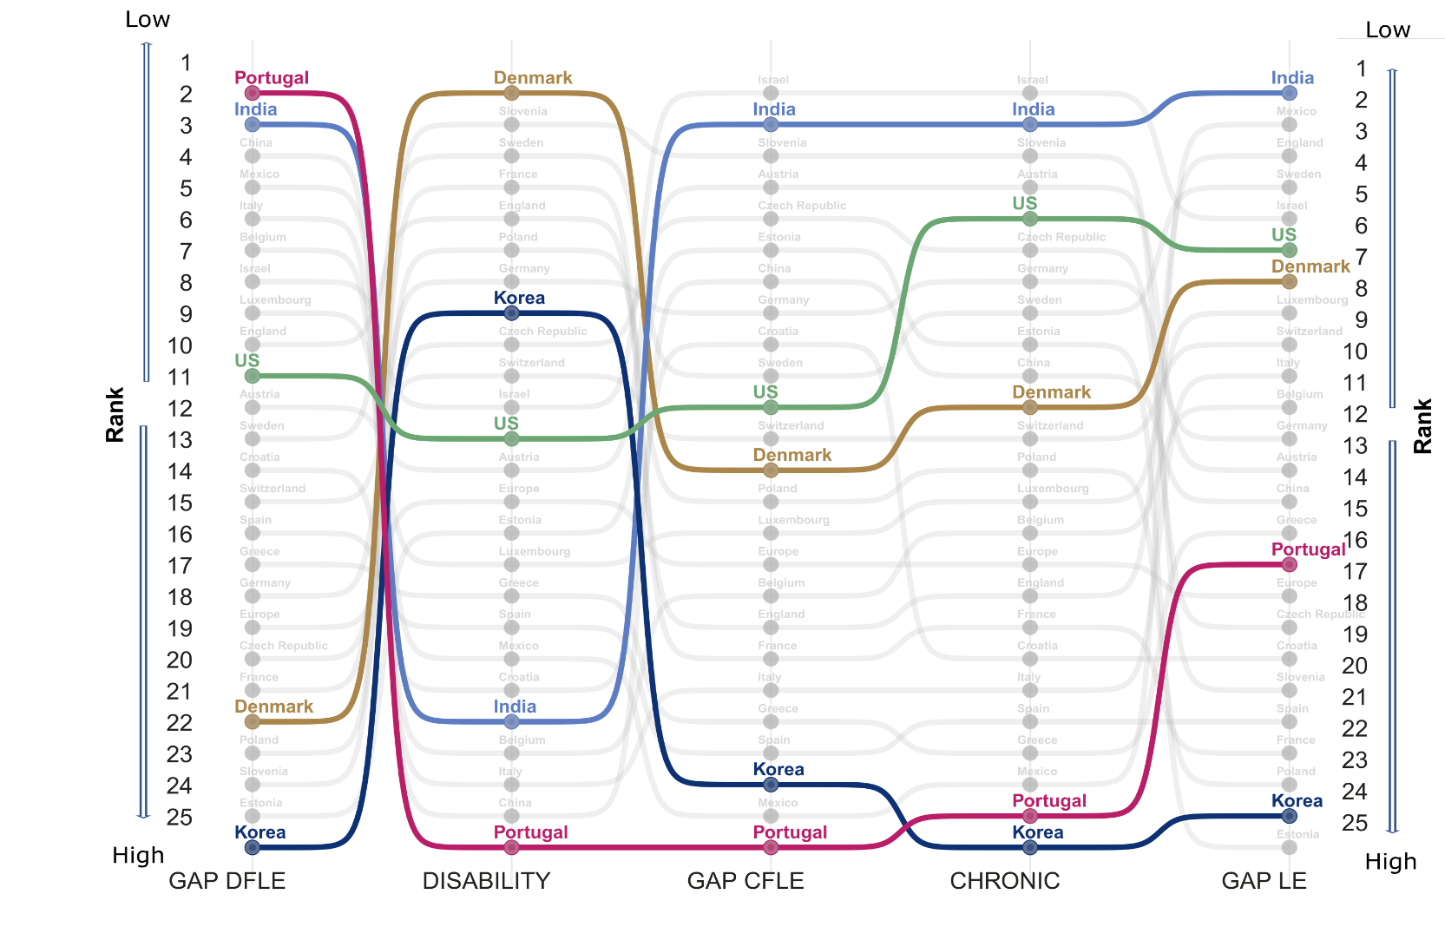

**Figure 4.** Ranking of countries (from lower to higher gaps) by gender gap in life expectancy, disability and chronic disease-free life expectancy (DFLE, CFLE), and the contribution of disability and chronic component to the total gender gap at ages 60+, by country. Note: In terms of gaps, the ranking is from low to high gap and in terms of disability and chronic from low to high contributions of these components to the total gap.

Indeed, Portugal has the lowest gender gap across all countries in DFLE (Rank 1), but the country with the strongest effect of disability, pushing it to the last place (Rank 25). At the same time, it is among the countries with the highest gaps in total life expectancy (Rank 16 out of 25). Denmark is the opposite, being placed at first Rank when considering the effect of disability, while it is among the last countries (Rank 21) when considering the gender gap in DFLE.

**Discussion**

Gender gap indices in health and mortality are routinely used as indicators of inequality. Gaps are used by policy makers to benchmark countries, monitor changes over time, and identify the pace at which countries are closing or widening gender gaps in health (WHO 2020; European Institute for Gender Equality 2021; World Economic Forum 2021). Aggregate indices, such as the World Bank Global Gender Gap Index, measure gender equality based on gaps between women and men across health, education, economy, and politics. Likewise, the WHO European Health Equity Status Report initiative (HESRi) uses gender gaps in disability-adjusted life years (DALYs) and life expectancy to implement policy action for health equity and well-being in the European Region. Gender gaps in healthy life years are also used by the Gender Equality Index to assess gender inequalities in the EU.

Overall, gaps are widely used because they are an easy and straightforward way to relate the difference between two quantities. However, we show how using gender gaps in health as a metric for inequality can be misleading. Reducing gender gaps in health expectancy may not necessarily mean that we are reducing inequality between women and men. It is important to take a cautionary approach when interpreting those gaps and especially when using them to guide policy. Recent work has shown that policies that aim to advance gender equality in health across different countries have surprisingly poor design and implementation flaws, which are mostly due to scarcity of relevant data and accurate indicators (Crespí-Lloréns et al. 2021). Taking gender gaps as a standpoint for conducting studies on gender differences when they are masking important underlying differences in health and mortality may also explain why some studies find conflicting results or no correlation between cross-national variation in gender gaps and societal-level gender inequality (Dahlin and Härkönen 2013). By focusing on the gap, these studies may be missing important changes in the patterns of health and mortality, which may not go together with societal level changes in health and gender inequality. This is particularly due to the relationship between health and mortality and the specific role of certain conditions among women and men. Women live longer but face a higher burden of chronic, non-lethal but debilitating conditions, such as arthritis (Boerma et al. 2016), while men experience higher levels of diabetes and heart disease (Lee et al. 2018). Despite long standing effort from researchers worldwide to understand gender disparities in health, there has been no conclusive explanation for why, despite living longer than men, women experience poorer health for most outcomes (Verbrugge and Wingard 1987; Case and Paxson 2005; Oksuzyan et al. 2010; Drumond Andrade et al. 2011; Crimmins et al. 2011; Luy and Minagawa 2014; Di Lego et al. 2020). This has startling effects since debilitating conditions such as arthritis limit the ability of women to remain independent, engage in social activities, and usually demand long-term care (Freedman et al. 2016).

In addition, since gender gaps in health expectancy can be masking important effects of health, they may also hinder appropriate country-specific analysis. As we have shown, countries from very different epidemiological contexts can have similar gaps at a given point in time. Countries may also have similar results but driven by very different contexts. It has been shown that the son preference in Chinese traditions has impacted female health in very different ways than other countries in the western world, where families often invested more in sons at the expenses of daughters (Zhang et al. 2015). Indeed, our results showed how China is the only country where heart conditions among women is more prevalent than among men. This is in line with previous studies that have shown that among chronic conditions, women have higher rates in arthritis and angina and are less covered by health insurance than men (Zhou et al. 2021). Korea is also a remarkable case, where in our sample it has the highest female advantage in survival, with a 5.56 difference in life expectancy at age 60. Some studies have showed that the persistently high gap in life expectancy at older ages in Korea is due to excess male mortality from lung cancer, suicide, chronic lower respiratory diseases, and ischemic heart diseases, most of all which have been attributed to smoking (Yang et al. 2012). Another case noteworthy of mention is India, where we found the gap between women and men is negative, i.e., women have lower DFLE than man. This result is in line with what was found in other studies using different data, such as the nationally representative survey of Bangladesh on Household Income and Expenditure Survey-2010) (Tareque et al. 2013). This aspect deserves further investigation and stresses the importance of health. The fact that the prevalence of doctor diagnosed conditions was so low in India suggests that healthcare access is limited and people do not have proper access to diagnosis of diseases and that patterns of diagnosis may differ for women and men (Mauvais-Jarvis et al. 2020).

Furthermore, an important contribution of this study is the extent of the comparative analysis. So far, most of the research has focused on western countries, with few studies including countries like China, India and Korea and even fewer that include developing or Latin American countries like Mexico in the study. Performing cross-country comparisons is crucial to identify common patterns and divergences that exist in health and mortality for different societal regimes Studies that have performed global comparisons use less detailed health indicators and often lack in harmonization across the indicators health (Tolonen et al. 2021). It is particularly important when investigating those patterns by gender, as there is great variation in gender norms, welfare state systems, and socioeconomic development across countries that may directly or indirectly impact health and mortality indicators (Ross et al. 2012; Pelletier et al. 2016; Angel et al. 2017). However, comparative analysis are challenging, mainly because the quality, and validity of health indicators vary from country to country, which can lead to variations in results that are not accurately capturing health outcomes (Gardner et al. 2012; Crimmins et al. 2019; Ailshire and Carr 2021). Cross-national comparisons are thus important to further shed light into the topic, as gender inequality in health is correlated to country-specific levels of development and to societal roles of women and men (Okojie 1994; WCF 2018). Therefore, it is important to quantify health inequalities by gender and across countries with different levels of development.

Nonetheless, it is important to acknowledge that this study has some limitations. First, this is a cross-sectional analysis so we do not look into trends nor use the longitudinal potential of the dataset. In addition, despite the efforts to harmonize the variables, diagnosis is performed differently across countries, which could explain results such as those observed for India. The HRS study, for example, specifically excludes diagnosis made by nurses/nurse practitioners, chiropractors, and dentists, while both CHARLS and LASI allow diagnosis by nurses, practitioners of traditional medicine, and other health care professionals. However, our aim was to have the most countries included in the comparison and pinpoint the importance of going beyond gender gaps in health expectancy. Hence, our results hold regardless of the research design.

**Acknowledgments**

This paper uses data from SHARE Wave 6 (10.6103/SHARE.w6.800), see Börsch-Supan et al. (2013) for methodological details. The SHARE data collection has been funded by the European Commission, DG RTD through FP5 (QLK6-CT-2001-00360), FP6 (SHARE-I3: RII-CT-2006-062193, COMPARE: CIT5-CT-2005-028857, SHARELIFE: CIT4-CT-2006-028812), FP7 (SHARE-PREP: GA N°211909, SHARE-LEAP: GA N°227822, SHARE M4: GA N°261982, DASISH: GA N°283646) and Horizon 2020 (SHARE-DEV3: GA N°676536, SHARE-COHESION: GA N°870628, SERISS: GA N°654221, SSHOC: GA N°823782, SHARE-COVID19: GA N°101015924) and by DG Employment, Social Affairs & Inclusion through VS 2015/0195, VS 2016/0135, VS 2018/0285, VS 2019/0332, and VS 2020/0313. Additional funding from the German Ministry of Education and Research, the Max Planck Society for the Advancement of Science, the U.S. National Institute on Aging (U01_AG09740-13S2, P01_AG005842, P01_AG08291, P30_AG12815, R21_AG025169, Y1-AG-4553-01, IAG_BSR06-11, OGHA_04-064, HHSN271201300071C, RAG052527A) and from various national funding sources is gratefully acknowledged (see [www.share-project.org](http://www.share-project.org/)).

This analysis uses data or information from the following Harmonized datasets: KLoSA dataset and Codebook, Version C as of June 2019 developed by the Gateway to Global Aging Data. The development of the Harmonized KLoSA was funded by the National Institute on Ageing (R01 AG030153, RC2 AG036619, R03 AG043052). LASI dataset and Codebook, Version A.2 as of October 2021, developed by the Gateway to Global Aging Data (DOI: https://doi.org/10.25549/h-lasi). The development of the Harmonized LASI was funded by the National Institute on Aging (R01 AG042778, 2R01 AG030153, 2R01 AG051125). CHARLS dataset and Codebook, Version D as of June 2021 developed by the Gateway to Global Aging Data. The development of the Harmonized CHARLS was funded by the National Institute on Aging (R01 AG030153, RC2 AG036619, R03 AG043052). ELSA dataset and Codebook, Version G.2 as of July 2021 developed by the Gateway to Global Aging Data. The development of the Harmonized ELSA was funded by the National Institute on Aging (R01 AG030153, RC2 AG036619, R03 AG043052). SHARE dataset and Codebook, Version F as of June 2022 developed by the Gateway to Global Aging Data. The development of the Harmonized SHARE was funded by the National Institute on Aging (R01 AG030153, RC2 AG036619, R03 AG043052). MHAS dataset and Codebook, Version B.4 as of February 2022 developed by the Gateway to Global Aging Data in collaboration with the MHAS research team. The development of the Harmonized MHAS was funded by the National Institute on Aging (R01 AG030153). The Harmonized MHAS data files and documentation are public use and available at www.MHASweb.org. The MHAS (Mexican Health and Aging Study) receives support from the National Institutes of Health/National Institute on Aging (R01 AG018016) in the United States and the Instituto Nacional de Estadística y Geografía (INEGI) in Mexico. HRS dataset and Codebook, Version C as of January 2022 developed by the Gateway to Global Aging Data. The development of the Harmonized HRS was funded by the National Institute on Aging (R01 AG030153, RC2 AG036619, 1R03AG043052). For more information about the Harmonization project, please refer to<https://g2aging.org/>.

This work is supported within the EU Framework Programme for Research and Innovation Horizon 2020, ERC Grant Agreement No. 725187 (LETHE)

**References**

Ailshire J, Carr D (2021) Cross-National Comparisons of Social and Economic Contexts of Aging. Journals Gerontol Ser B 76:S1–S4. https://doi.org/10.1093/GERONB/GBAB049

Angel JL, Vega W, López-Ortega M, Pruchno R (2017) Aging in Mexico: Population trends and emerging issues. Gerontologist 57:153–162. https://doi.org/10.1093/geront/gnw136

Beckett L a, Brock DB, Lemke JH, et al (1996) Analysis of change in self-reported physical function among older persons in four population studies. Am J Epidemiol 143:766–78

Boerma T, Hosseinpoor AR, Verdes E, Chatterji S (2016) A global assessment of the gender gap in self-reported health with survey data from 59 countries. BMC Public Health 16:675. https://doi.org/10.1186/s12889-016-3352-y

Case A, Paxson C (2005) Sex differences in morbidity and mortality. Demography 42:189–214

Crespí-Lloréns N, Hernández-Aguado I, Chilet-Rosell E (2021) Have Policies Tackled Gender Inequalities in Health? A Scoping Review. Int J Environ Res Public Health 18:327. https://doi.org/10.3390/ijerph18010327

Crimmins EM, Kim JK, Solé-Auró A (2011) Gender differences in health: results from SHARE, ELSA and HRS. Eur J Public Health 21:81–91. https://doi.org/10.1093/eurpub/ckq022

Crimmins EM, Shim H, Zhang YS, Kim JK (2019) Differences between men and women in mortality and the health dimensions of the morbidity process. Clin Chem 65:135–145. https://doi.org/10.1373/CLINCHEM.2018.288332

Crimmins EM, Zhang Y, Saito Y (2016) Trends Over 4 Decades in Disability-Free Life Expectancy in the United States. 106:1287–1293. https://doi.org/10.2105/AJPH.2016.303120

Dahlin J, Härkönen J (2013) Cross-national differences in the gender gap in subjective health in Europe: Does country-level gender equality matter? Soc Sci Med 98:24–28. https://doi.org/10.1016/J.SOCSCIMED.2013.08.028

Di Lego V, Di Giulio P, Luy M (2020) Gender Differences in Healthy and Unhealthy Life Expectancy. pp 151–172

Drumond Andrade FC, Guevara PE, Lebrão ML, et al (2011) Gender Differences in Life Expectancy and Disability-Free Life Expectancy Among Older Adults in São Paulo, Brazil. Women’s Heal Issues 21:64–70. https://doi.org/10.1016/j.whi.2010.08.007

European Institute for Gender Equality (2021) Gender Equality Index 2021: Health. Luxembourg

Freedman VA, Wolf DA, Spillman BC (2016) Disability-Free Life Expectancy Over 30 Years: A Growing Female Disadvantage in the US Population. Am J Public Health 106:1079–1085. https://doi.org/10.2105/AJPH.2016.303089

Gardner P, Katagiri K, Parsons J, et al (2012) “Not for the fainthearted”: Engaging in cross-national comparative research. J Aging Stud 26:253–261. https://doi.org/10.1016/J.JAGING.2012.02.004

Horiuchi S, Wilmoth JR, Pletcher SD (2008) A decomposition method based on a model of continuous change. Demography 45:785–801. https://doi.org/10.1353/dem.0.0033

Jagger C, Gillies C, Cambois E, et al (2010) The Global Activity Limitation Index measured function and disability similarly across European countries. J Clin Epidemiol 63:892–899. https://doi.org/10.1016/j.jclinepi.2009.11.002

Lee J, Phillips D, Wilkens J (2021) Gateway to Global Aging Data: Resources for Cross-National Comparisons of Family, Social Environment, and Healthy Aging. Journals Gerontol Ser B Psychol Sci Soc Sci 76:S5. https://doi.org/10.1093/GERONB/GBAB050

Lee J, Phillips D, Wilkens J, et al (2018) Cross-country comparisons of disability and morbidity: Evidence from the gateway to global aging data. Journals Gerontol - Ser A Biol Sci Med Sci 73:1519–1524. https://doi.org/10.1093/gerona/glx224

Luy M, Minagawa Y (2014) Gender gaps--Life expectancy and proportion of life in poor health. Heal reports 25:12–9

Mairey I, Bjerregaard P, Brønnum Hansen H (2014) Gender difference in health expectancy trends in Greenland. Scand J Public Health 42:751–758. https://doi.org/10.1177/1403494814550174

Mauvais-Jarvis F, Bairey Merz N, Barnes PJ, et al (2020) Sex and gender: modifiers of health, disease, and medicine. Lancet 396:565–582. https://doi.org/10.1016/S0140-6736(20)31561-0

Nepomuceno MR, di Lego V, Turra CM (2021) Gender disparities in health at older ages and their consequences for well-being in Latin America and the Caribbean. Vienna Yearb Popul Res 19:. https://doi.org/10.1553/populationyearbook2021.res2.1

Nusselder W, Looman C (2004) Decomposition of differences in health expectancy by cause. Demography 41:315–34

Nusselder WJ, Looman CWN, van Oyen H, et al (2010) Gender differences in health of EU10 and EU15 populations: the double burden of EU10 men. Eur J Ageing 7:219–227. https://doi.org/10.1007/s10433-010-0169-x

Okojie CEE (1994) Gender inequalities of health in the third world. Soc Sci Med 39:1237–1247. https://doi.org/10.1016/0277-9536(94)90356-5

Oksuzyan A, Brønnum-Hansen H, Jeune B (2010) Gender gap in health expectancy. Eur J Ageing 7:213–218. https://doi.org/10.1007/s10433-010-0170-4

Pelletier R, Khan NA, Cox J, et al (2016) Sex Versus Gender-Related Characteristics Which Predicts Outcome after Acute Coronary Syndrome in the Young? J Am Coll Cardiol 67:127–135. https://doi.org/10.1016/j.jacc.2015.10.067

Riffe T (2018) Package “DemoDecomp” Type Package Title Decompose Demographic Functions. https://doi.org/10.1353/dem.0.0033

Ross CE, Masters RK, Hummer RA (2012) Education and the Gender Gaps in Health and Mortality. Demography 49:1157–1183. https://doi.org/10.1007/s13524-012-0130-z

Saito Y, Robine JM, Crimmins EM (2014) The methods and materials of health expectancy. Stat J IAOS 30:209–223. https://doi.org/10.3233/SJI-140840

Sullivan D. (1971) A single index of mortality and morbidity. HSMHA Health Rep 86:347–54

Tareque MI, Begum S, Saito Y (2013) Gender differences in disability-free life expectancy at old ages in Bangladesh. J Aging Health 25:1299–1312. https://doi.org/10.1177/0898264313501388

Tolonen H, Reinikainen J, Koponen P, et al (2021) Cross-national comparisons of health indicators require standardized definitions and common data sources. Arch Public Heal 2021 791 79:1–14. https://doi.org/10.1186/S13690-021-00734-W

Van Oyen H, Nusselder W, Jagger C, et al (2013) Gender differences in healthy life years within the EU: an exploration of the “health–survival” paradox. Int J Public Health 58:143–155. https://doi.org/10.1007/s00038-012-0361-1

van Raalte AA, Nepomuceno MR (2020) Decomposing Gaps in Healthy Life Expectancy. pp 107–122

Verbrugge LM, Wingard DL (1987) Sex Differentials in Health and Mortality. Women Health 12:103–145. https://doi.org/10.1300/J013v12n02_07

WCF (2018) The Global Gender Gap Report 2018 Insight Report

WHO (2020) Understanding the drivers of health equity: the power of political participation. Copenhagen

World Economic Forum (2021) The Global Gender Gap Report 2021

Yang S, Khang YH, Chun H, et al (2012) The changing gender differences in life expectancy in Korea 1970-2005. Soc Sci Med 75:1280–1287. https://doi.org/10.1016/j.socscimed.2012.04.026

Yokota RTC, Nusselder WJ, Robine J-M, et al (2019) Contribution of chronic conditions to gender disparities in health expectancies in Belgium, 2001, 2004 and 2008. Eur J Public Health 29:82–87. https://doi.org/10.1093/eurpub/cky105

Zhang H, Bago D’Uva T, Van Doorslaer E (2015) The gender health gap in China: A decomposition analysis. Econ Hum Biol 18:13–26. https://doi.org/10.1016/J.EHB.2015.03.001

Zhou M, Zhao S, Zhao Z (2021) Gender differences in health insurance coverage in China. Int J Equity Health 20:. https://doi.org/10.1186/s12939-021-01383-9

**Supplementary Information**

**Data.** We follow the recommendation by the official report carefully written on the data that for harmonization purpose, general diagnosis of chronic medical conditions (e.g. heart diseases), rather than a more specific condition (e.g. congestive heart failure), may be used to maximize the number of studies that may be included. We thus use the diagnosed chronic conditions surveyed for all HRS-sister studies, which were hypertension, diabetes, cancers, chronic lung diseases, stroke, and arthritis or rheumatism. We focus on diagnosis and treatment of chronic medical conditions, as they were available for all surveys and are considered the most suitable for comparative purposes.

**Disease variables:** RwDIABE, RwCANCRE, RwLUNGE, RwHEARTE, RwSTROKE, and RwARTHRE are indicator variables denoting whether or not the Respondent reports a doctor has ever told her/him that s/he had the specified condition. The conditions are 1) diabetes or high blood sugar; 2) cancer or a malignant tumor of any kind except skin cancer; 3) chronic lung disease except asthma such as chronic bronchitis or emphysema; 4) heart problems, which include heart attack, coronary heart disease, angina, congestive heart failure, or other heart problems; 5) stroke or transient ischemic attack (TIA); and 6) arthritis or rheumatism. The Rand HRS 1992_2018v1 files we use as basis for these doctor-diagnosed conditions, with the exception of cases that dispute a report from a prior wave, each of these variables is set to "yes" if the Respondent answered yes to the pertinent question in the current or any prior wave, and to "no" if the Respondent responded no at the current and all prior waves. We have constructed three new variables that capture prevalence of chronic conditions. “chronic” refers to having at least one of the conditions cited above. “chronic_sum” refers to the total number of conditions ever diagnosed. “chronic_severe” is a dummy variable that measures comorbidity, where an individual is diagnosed with having three or more of those conditions. At first, in order to evaluate further differences in onset of disease, we included the variable RADIAGDIAB, which indicates the age at which the respondent was first diagnosed with diabetes. RwRECCANCR indicates the most recent age at which the respondent was diagnosed with cancer. Respondents are asked the year in which they were most recently diagnosed with cancer, and these responses are converted to their age at diagnosis. Previous responses are carried forward if the respondent does not report a new cancer diagnosis. RwRECHRTATT indicates the most recent age at which the respondent had a heart attack. RAFRHRTATT indicates the age at which the respondent had their first heart attack. However, a first analysis showed that in the sample of HRS and other countries more than 75% was missing for age variables. So, we did not use these variables in the analysis.

**Each Country**

**US (HRS).** We are using the Harmonized version B HRS: 37,495 observations. October 2018- There is a new updated version C, until 2019 that was updated now in 2022 and contains 42,233 observations. It is a Respondent level file so each row represents a unique Respondent. This leaves us with 18,747 observations using only wave 12 (year 2014) of HRS.

**Mexico (MHAS).** Version B.4 incorporates the latest released version of MHAS data, and adds several new variables. It contains 22,016 observations or rows- 22016. We are using the Harmonized VERSION B.4 (2001-2015), February 2022, for the MHAS data. The Mexican Health and Aging Study (MHAS) is a longitudinal household survey dataset for the study of health, economic position, and quality of life among the elderly. MHAS datasets as of September 2020. The MHAS (Mexican Health and Aging Study) Version B.4 incorporates the latest released version of MHAS data, and adds several new variables. It contains 22,016 observations or rows. It is a Respondent-level file so each row represents a unique Respondent. We will focus on Wave 4, which is for years 2014/2015. We will have 17,616 observations.

**England (ELSA).** We are using the Version G.2 (2002-2019), July 2021 for The English Longitudinal Study on Ageing (ELSA). It is a longitudinal household survey dataset for the study of health, economic position, and quality of life among the elderly (panel survey of people aged 50 and over and their partners, living in private households in England). Version G.2 incorporates the latest released version of ELSA data, which includes eleven main modules and the associated datasets, and adds variables and observations from Wave 9 with a total of 19,802 observations. It also adds new variables and makes adjustments and corrections. We will focus on Wave 7, nonetheless. The samples have been drawn from households which previously responded to the Health Survey for England (HSE). The seventh wave was conducted between June 2014 and May 2015 and included a refreshment sample selected from HSE 2011-2012.

**India (LASI).** The Longitudinal Aging Study in India (LASI) is a multidisciplinary, internationally harmonized panel study designed to be nationally representative of India’s population aged 45 and older. LASI is a joint project of three partnering institutions: International Institute for Population Sciences (IIPS), Harvard T.H. Chan School of Public Health (HSPH), and University of Southern California (USC). The first wave was conducted between 2017 and 2019 in 35 of India’s 36 states and union territories (except Sikkim). This initial sample, as released by USC, included 42,951 households and 72,262 individuals. The LASI sampling plan is complex and was based on the 2011 Indian Census with a multistage, stratified cluster sample design. The sample design includes three distinct selection stages in rural areas and four stages in urban areas. We use Version A.2 that makes corrections using the January 2021 released version of Wave 1 of the LASI data.

**Europe (SHARE).** This is Version F in the harmonized files and incorporates the latest released version of SHARE data, release 8.0.0, and adds observations from Wave 8. It contains 139,620 observations or rows. It is a Respondent-level file so each row represents a unique Respondent. It also adds new variables and makes adjustments and corrections. We focus on data from SHARE Wave 6, with the release 8.0.0 as of February 2022. SHARE uses a multistage stratified sample. Its weighting variables make its data representative of the target populations in constituent countries. Wave 6 does not still have full coverage of European countries, with the following countries only added in Wave 7: Finland, Lithuania, Latvia, Slovakia, Romania, Bulgaria, Malta and Cyprus.

**China (CHARLS).** The China Health and Retirement Longitudinal Study (CHARLS) is a longitudinal study of individuals over age 45 in China. Version D incorporates the latest released version of CHARLS data, and adds variables for Wave 4. It contains 25,586 observations or rows. It is a Respondent-level file so each row represents a unique Respondent; The sample population was selected as part of a stratified, multistage probability design. We will use Wave 3. As we concentrate on ages 50 and above due to the other samples we do not include individuals younger than 50. This leaves us with a sample size of 16,344 individuals.

**KLOSA- Korea.** The Korean Longitudinal Study of Ageing (KLoSA) is a panel survey of people aged 45 and over and their partners, living in private households in Korea. The survey elicits information about demographics, income, assets, health, cognition, family structure and connections, health care use and costs, housing, job status and history, expectations, and insurance. KLoSA surveys respondents every two years. Funded by the Korean Ministry of Labor, the Korean Institute of Labor (KLI) collected the first two waves, and the Korea Employment Information Service (KEIS) collected the Waves 3, 4, 5 and 6 of KLoSA, with the first wave of the KLoSA survey being conducted in fall/winter of 2006. The sample population was selected as part of a stratified, multi-stage area probability design. The first component of this sampling framework is the probability proportional to size (PPS) systematic sampling of the 2005 (South Korean) Census enumeration districts after stratifying by the location (15 major metropolitan cities and provinces) and characteristic of the district (urban or rural, and apartment building or non-apartment dwelling). Households were selected within PSUs from a listing of households in the Census identified as age-eligible; that is, inhabited by at least one person 45 years of age and older. This initial sample included 10,254 respondents age 45 and over. The second wave was conducted in 2008 and had 8,688 respondents. The third wave was conducted in 2010 and had 7,920 respondents. The fourth wave was conducted in 2012 and had 7,486 respondents. There was no refresher sample in Waves two through four. In 2014, a refreshment sample of individuals born in 1962 or 1963 was drawn and it included 920 individuals, which were added to the 7,029 remaining core sample respondents for a total of 7,949 Wave 5 respondents. The sixth wave was conducted in 2016 and had 7,490 respondents. We will focus on Wave 5. However, because we focus on ages >50, the sample is not 7,949. We use the hamornized Version C that contains 11,174 observations or rows. It is a Respondent-level file so each row represents a unique Respondent.

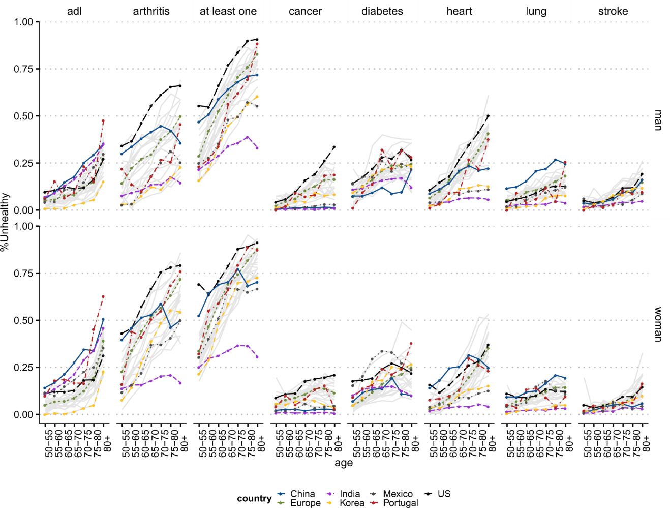

Fig S1. All health conditions for all countries for women and men

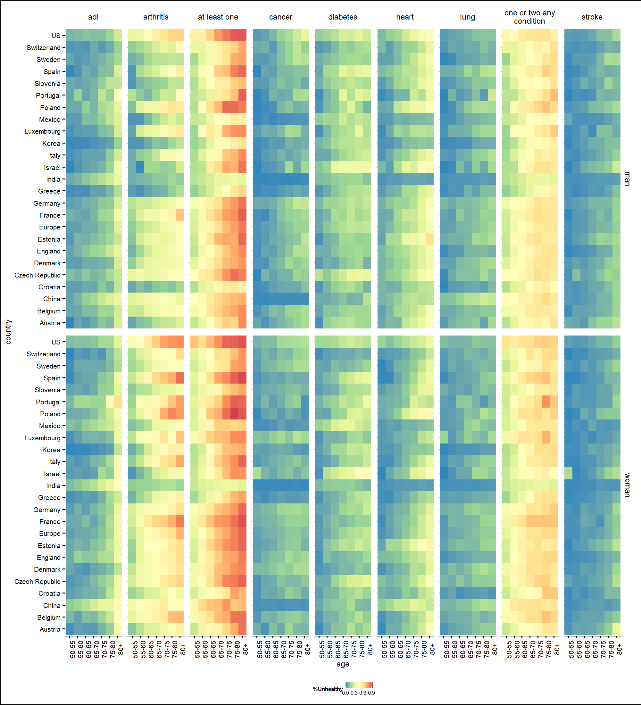

Fig S2. Heatmap with health conditions for all countries for women and men

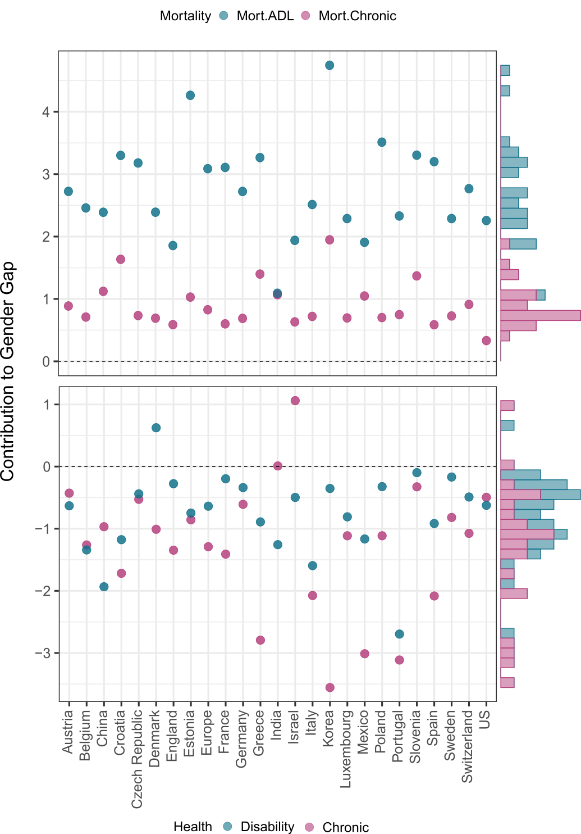

Fig S3 The contribution of each type of health component to the gender gap.

Table S1 Sample Characteristics and sample tests for different characteristics for women and men separately, weighted.



**Country-Specific Figures for health conditions**

**HRS**

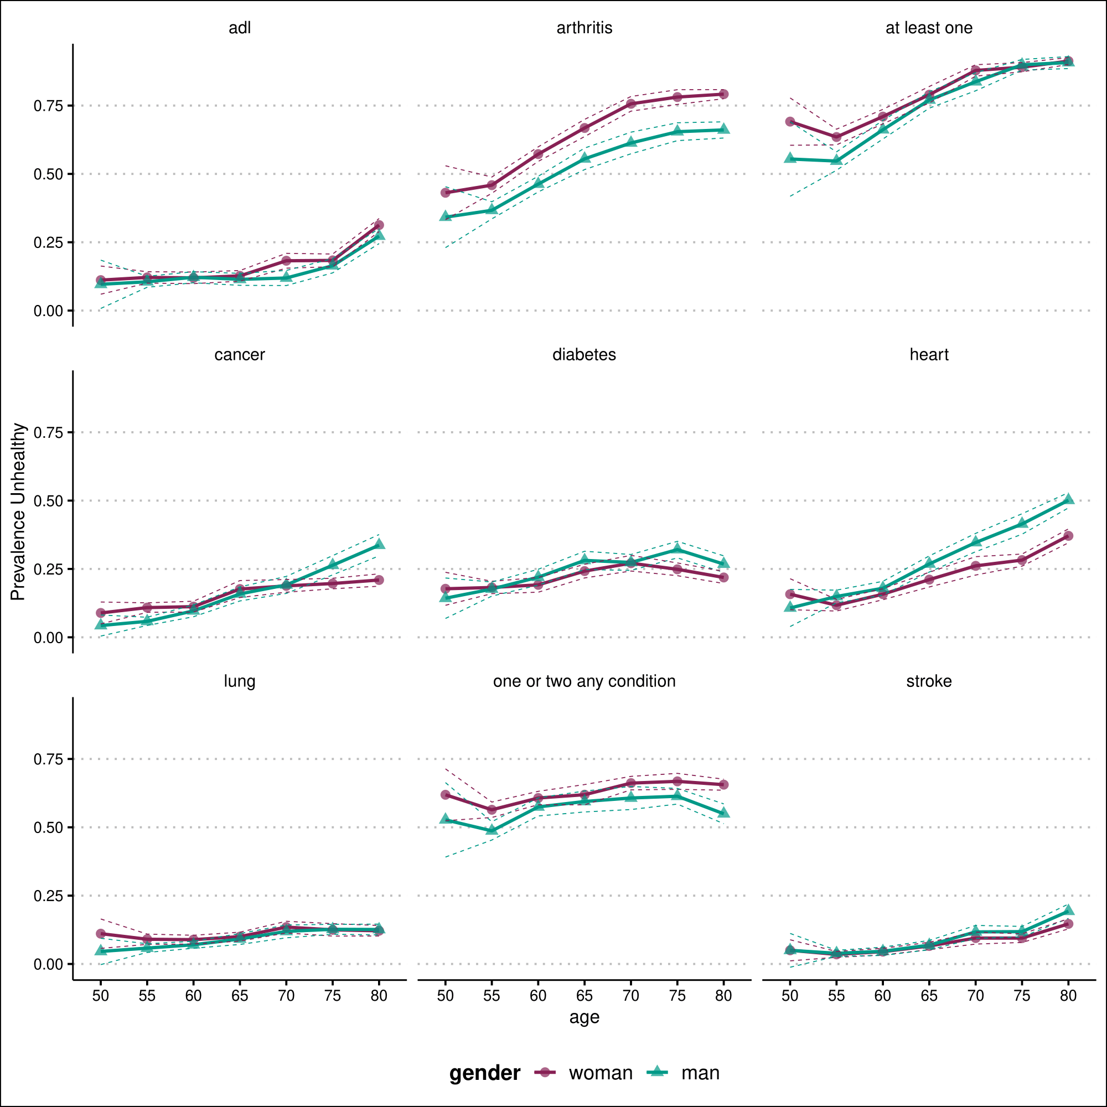

ELSA

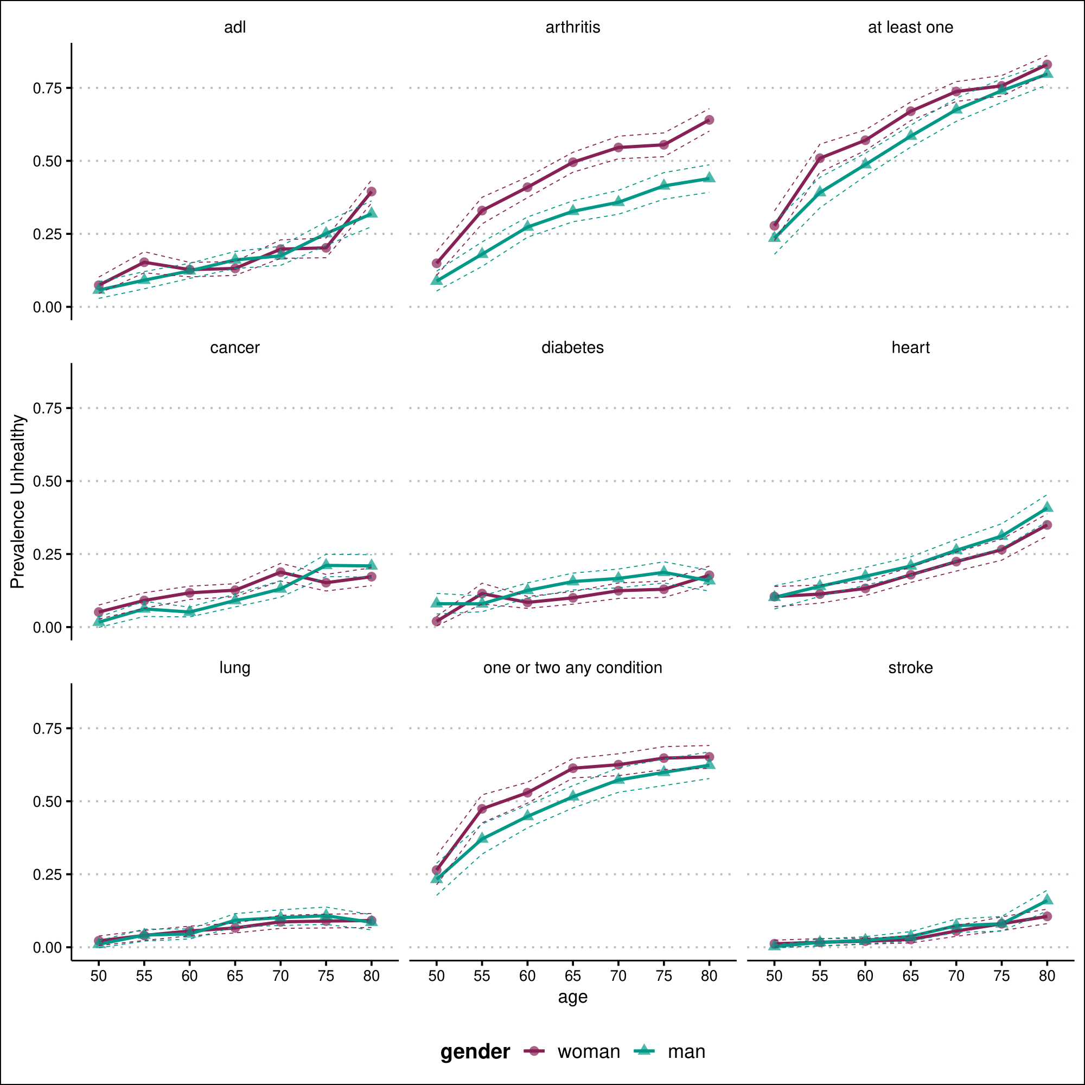

KLOSA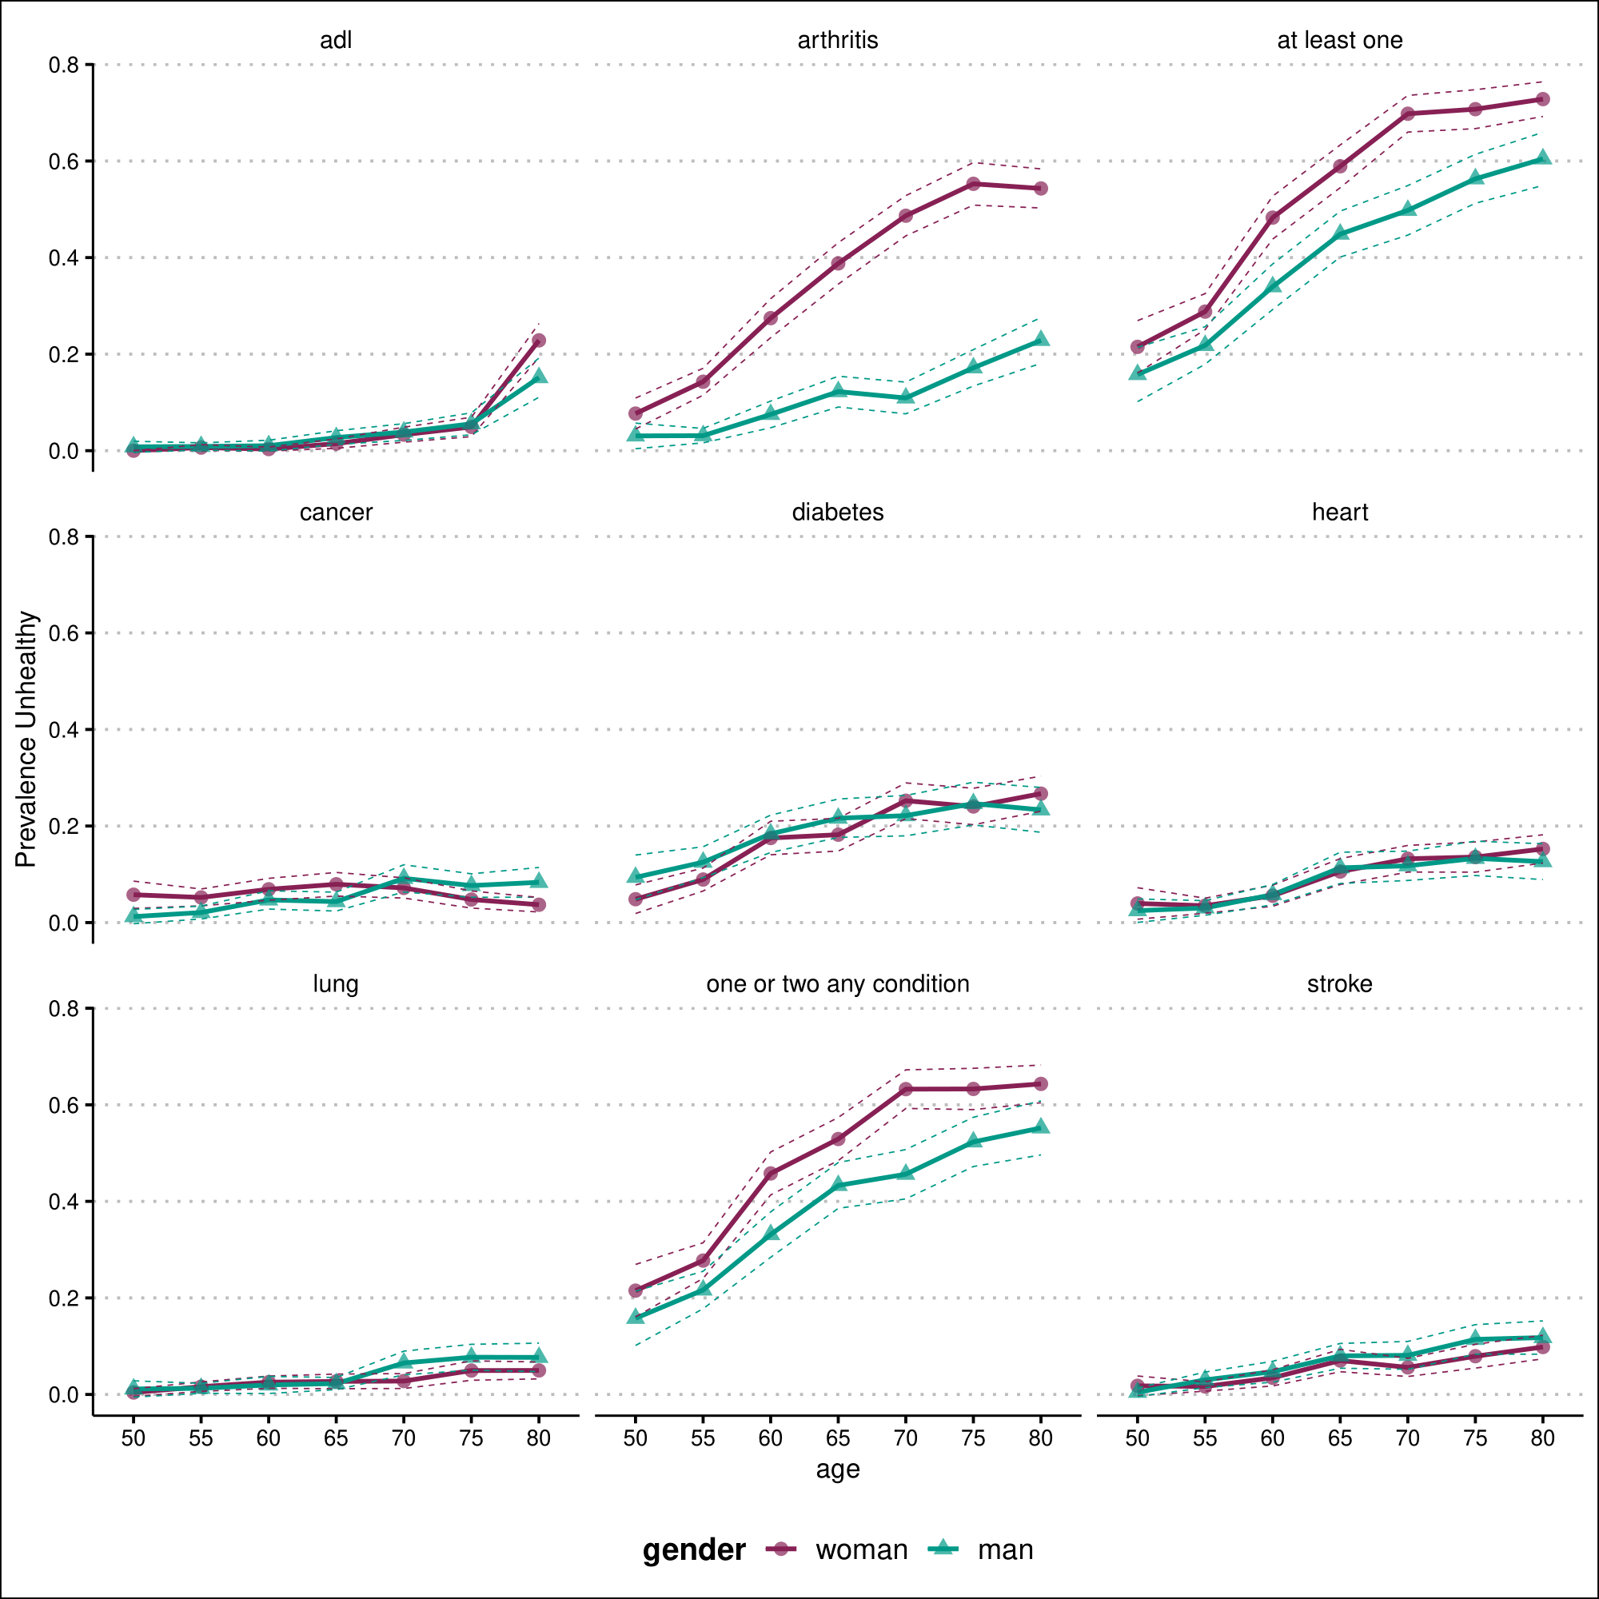

India- LASI

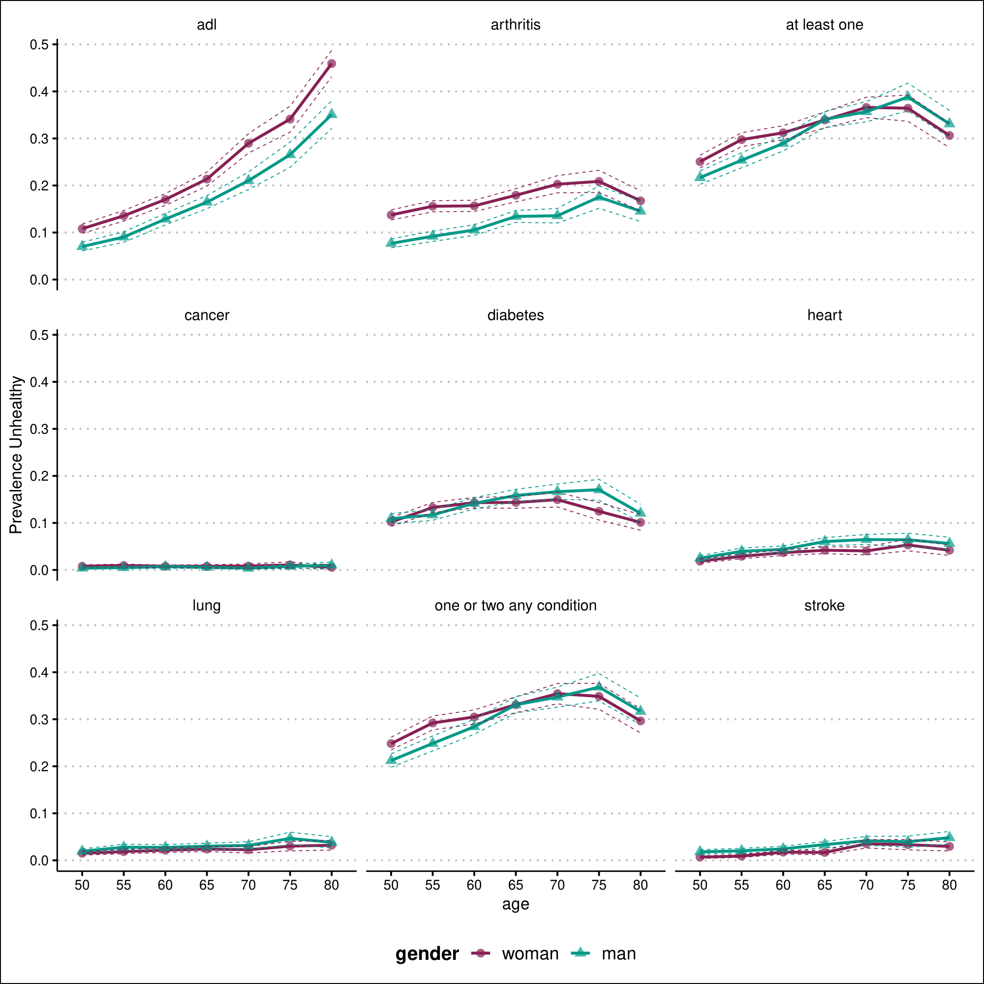

Mexico- MHAS

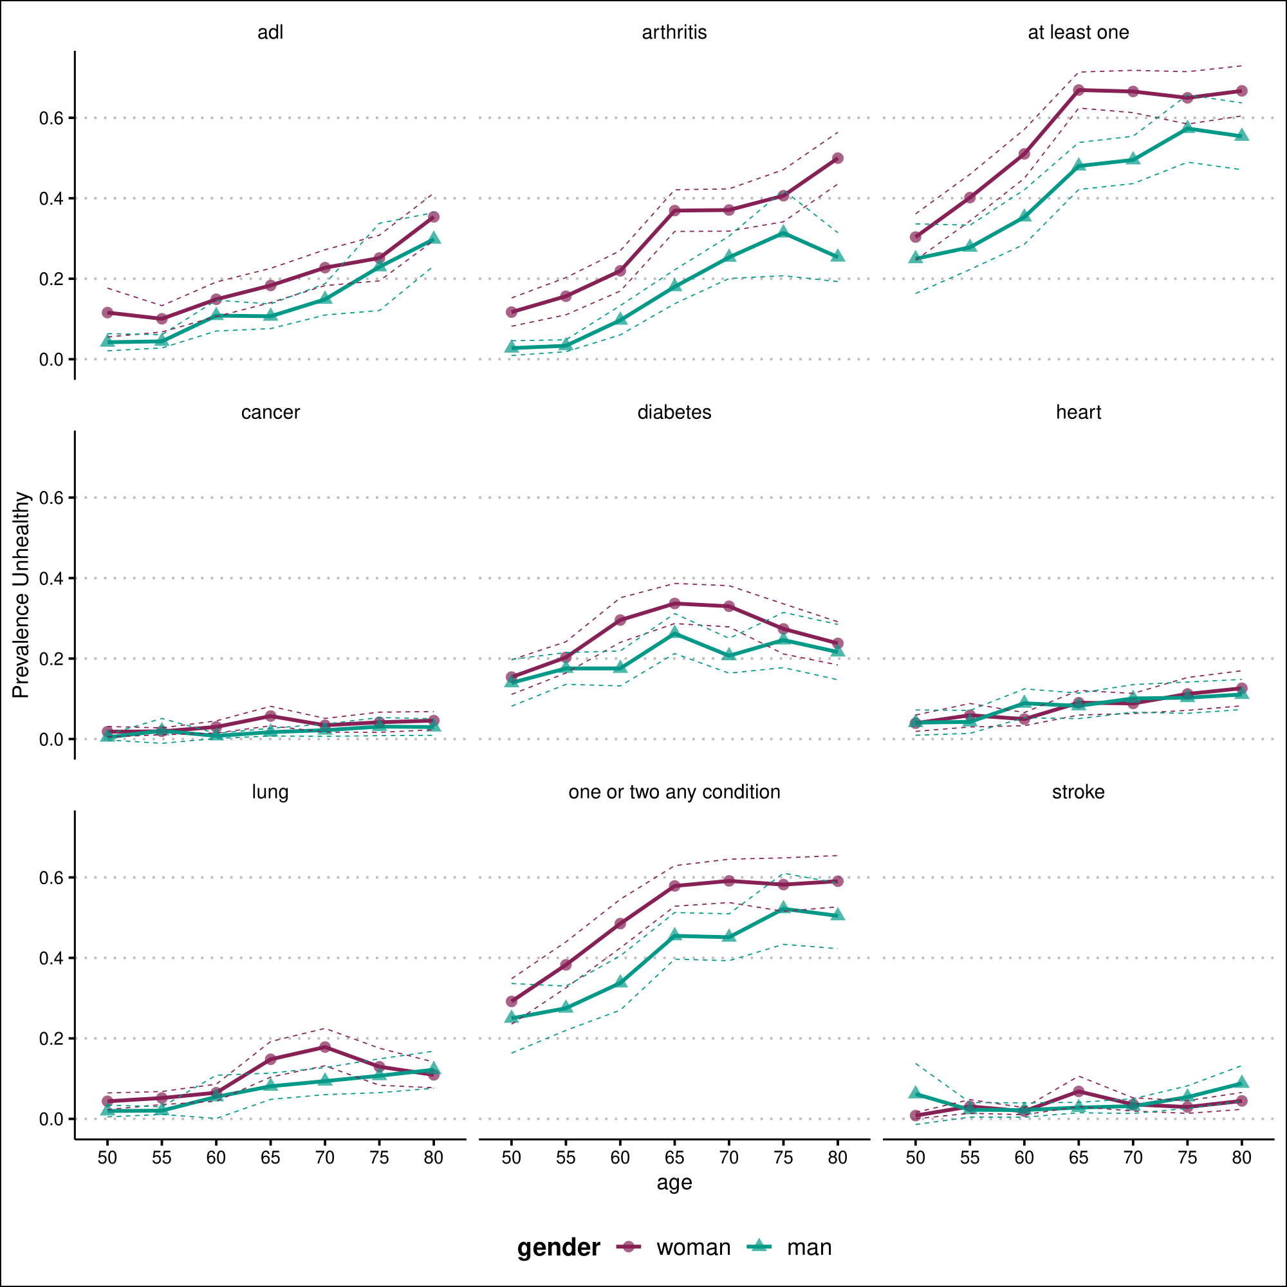

SHARE- Europe

