

**Main Manuscript for**

Going beyond the gender gap in health and mortality

Vanessa di Lego1*, Marília R. Nepomuceno2, Cássio M. Turra 3

1 Wittgenstein Centre for Demography and Global Human Capital (IIASA, OeAW, Univ. Vienna), Vienna Institute of Demography at the Austrian Academy of Sciences

2 Max Planck Institute for Demographic Research, Rostock, Germany.

3 Universidade Federal de Minas Gerais, Cedeplar, Brazil.

*Vanessa di Lego

**Email:**  [Vanessa.DiLego@oeaw.ac.at](mailto:Vanessa.DiLego@oeaw.ac.at)

**Author Contributions:** Paste the author contributions here.

**Competing Interest Statement:** The authors have no competing interest to declare.

**Classification:** Social Sciences. Social Sciences.

**Keywords:** Paste the keywords here. There should be at least three and no more than five.

**This PDF file includes:**

Main Text

Figures 1 to 4

Tables 1 to

**Abstract**

Paste your abstract here. Please note it may not exceed 250 words. It may include up to three cited (non-numerical) references.

**Significance Statement**

Paste your significance statement here. Please note that it should not exceed 120 words, but should be at least 50 words in length. It should not include any references.

4,000 words, 50 references, and 4 medium-size graphical elements

**Main Text**

**Introduction**

Gender gap indices in health and mortality are routinely used as indicators of inequality. Gaps are used by policy makers to benchmark countries, monitor changes over time, and identify the pace at which countries are closing or widening gender gaps in health (1–3). Aggregate indices, such as the World Bank Global Gender Gap Index, measure gender equality based on gaps between women and men across health, education, economy, and politics (1). Likewise, the WHO European Health Equity Status Report initiative (HESRi) uses gender gaps in disability-adjusted life years (DALYs) and life expectancy to implement policy action for health equity and well-being in the European Region (2). Gender gaps are also used by the Gender Equality Index to assess gender inequalities in the EU in all areas (3).

In research, gender gaps have also been widely used to analyze the various gender disparities in health and the so-called male–female health-survival paradox. Despite long standing effort from researchers worldwide, there has been no conclusive explanation for why, despite living longer than men, women experience poorer health for most outcomes (4–16).

Overall, gaps are widely used because they are an easy and straightforward way to relate the difference between two quantities. However, it can be misleading to use gender gaps as a measure that accurately captures inequality when applied to gender differences in health. In part, this is due to the complex interaction between health and mortality, which can change in ways that do not necessarily go in the same direction (17). Decomposition analyses of the contributions of mortality and disability to the gender gap in health expectancy have shown that gender differences in mortality and disability can be masked when only the total gap is analyzed (18–22). In some contexts, this effect can be substantial. A study found that while there was virtually no gender gap in health expectancy in Mexico City at ages >60y this was due to the combination of a high prevalence of disability among women coupled with a small mortality advantage (22). Interpreting the small absolute gender gap in health expectancy of only 0.18y in Mexico City in this context as a metric for low inequality would ignore the higher burden of disability among women. Similarly, the substantial effects of mortality (3.1 years) and disability (-3.5 years) by gender were not captured by the small gender gap of -0.4 y in a high-income country like the Netherlands, which was the result of two strong effects working in opposite directions. For the EU10 region, decomposing the gender gap showed that higher disability in women only partially offset the effect of lower mortality (19). However, these studies focused on a specific set of countries or regions that usually share the same societal values and gender roles, mostly due to lack of comparable data and the challenging enterprise of comparative analysis on health.

In this paper, we take advantage of the harmonized surveys from the Gateway to Global Aging Data (23) in order to estimate the gender gap in health expectancy and quantify the relative contribution of disability and mortality to gender gaps in health expectancy across different countries. This data resource allows for a unique opportunity to perform comparisons among identically defined health variables across countries. We focus on harmonized HRS (U.S.), ELSA (England), KLoSA (South Korea), CHARLS (China), LASI (India), MHAS (Mexico) and SHARE (EU Countries) due to their unique epidemiological and mortality trajectories. These countries also have diverse country-specific gender roles, which enable us to investigate the impact of interpreting the gender gap in health and mortality as a measure of inequality in different settings.

We estimate disability- and chronic disease-free life expectancies (DFLE and CFLE) for ages 60 and over using the Sullivan Method (24–26). For disability, we use the harmonized dummy variable constructed from a 5-item list of activities of daily living (ADLs), which include bathing, dressing, eating, getting in and out of bed, and using the toilet. For chronic doctor diagnosed diseases, we use the harmonized variables on specific chronic conditions diagnosed by a physician, which include diabetes, heart conditions, arthritis, cancer, stroke and lung disease. We use waves pertaining to year 2014-2015 (HRS: Wave 12; ELSA: Wave 7; SHARE: Wave 6; KLoSA: Wave 5; CHARLS: Wave 2; and LASI Wave 1). The only exception is India, since the first wave of LASI was carried on between 2017-2019. The choice of years refers to the most recent waves for which harmonized data on health for this set of countries is available and there is concordance across surveys. We focus on age 60 and above to be coherent towards the definition of old age across countries. While most developed countries define old age as 65, for China and Mexico it is age 60. Lastly, we apply the continuous change decomposition method (27, 28), so we can split gender differences in healthy life expectancy into mortality and disability/chronic disease effects by age (29).

We show how the gender gap in health expectancy for disability and chronic conditions varies greatly across countries and that despite being a simple and straightforward way to perform cross-country comparisons and monitor progress, gender gaps may not be reflecting actual inequalities when it comes to health. Hence, it is important to take a more cautionary approach when using and interpreting gender gaps.

**Results**

Make a table with the variables that are significant, but not the full one. Put in the appendix the big one.

Focus on the decomposition at age 60+.

The relationship between the gender gap and other indicators of gender inequality

Fig 1 shows the

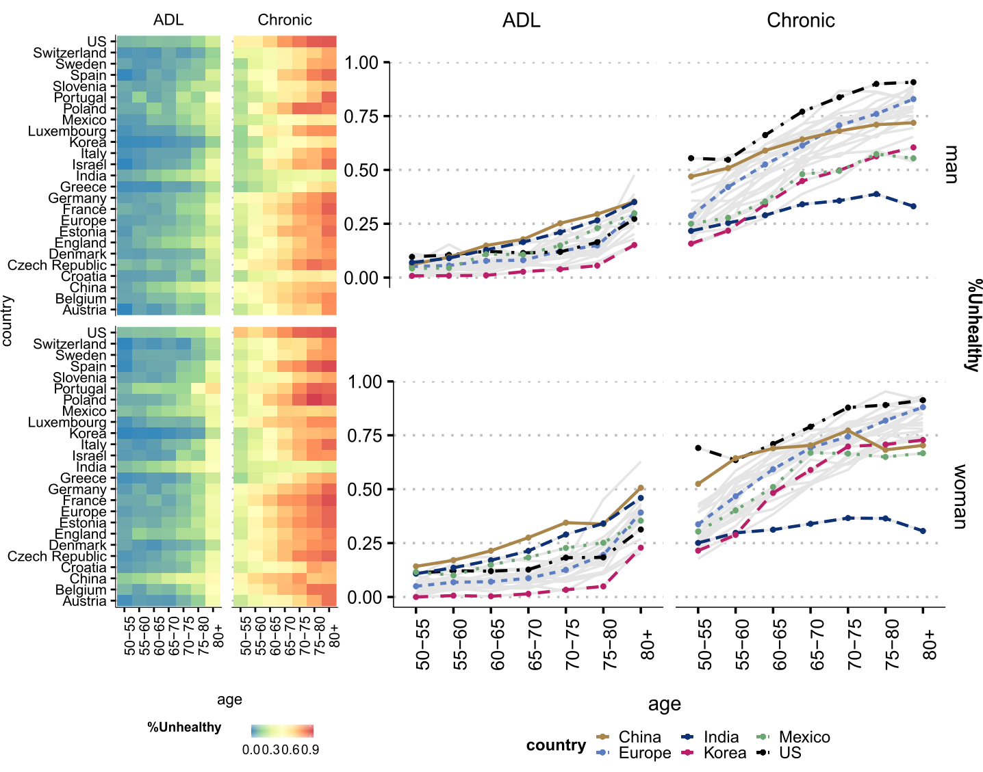

**Figure 1**. Prevalence of unhealthy women and men by activity of daily limitation (ADL) and doctor diagnosed chronic conditions (Chronic), by age, all countries (left panel) and selected countries (right panel).

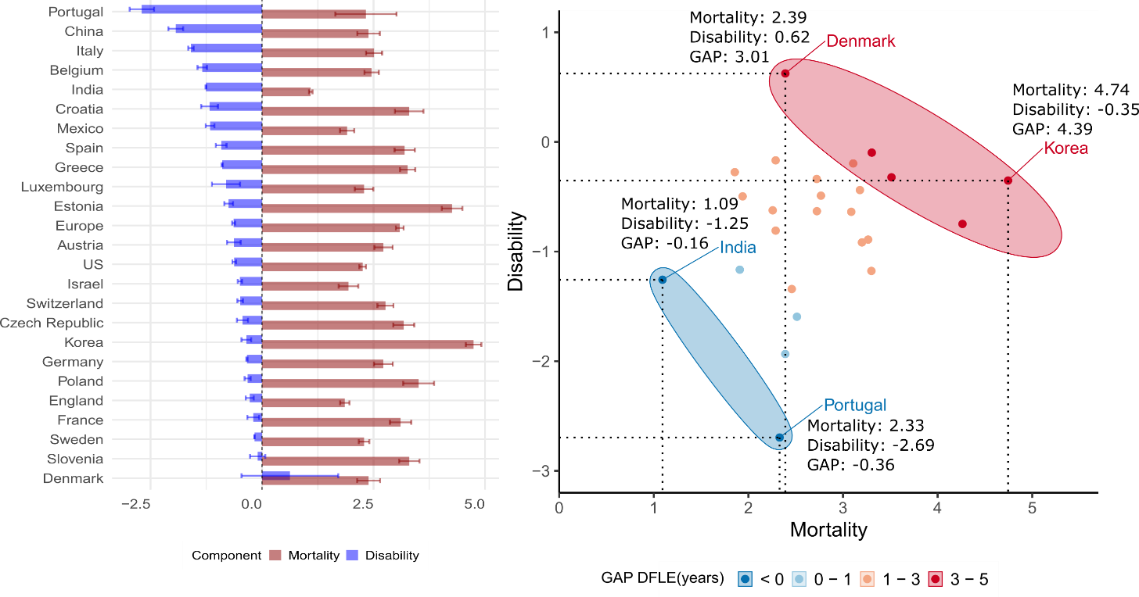

**Figure 2.** Decomposition of the gender gap in disability-free life expectancy (DFLE) and chronic-free life expectancy (CFLE) at ages 60+ into mortality and chronic effects by country.

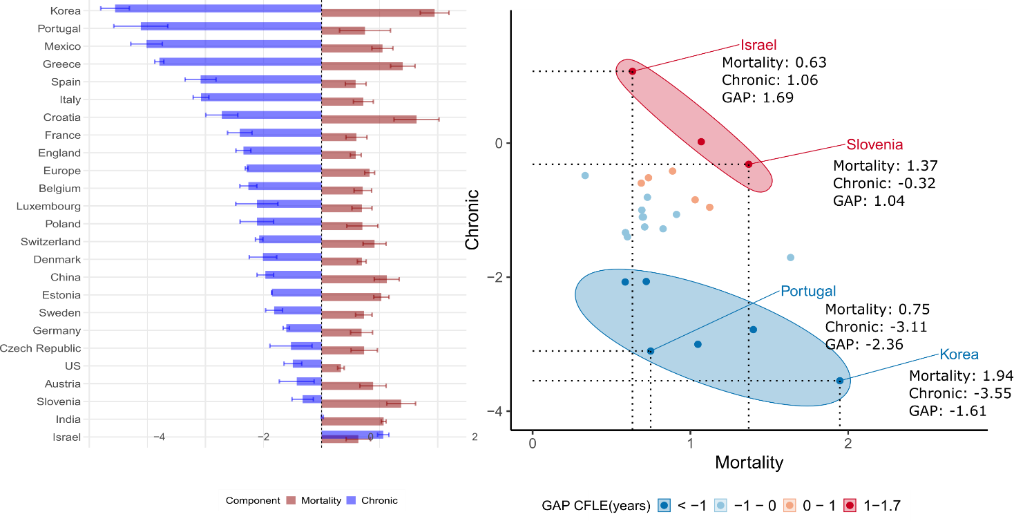

**Figure 3.** Decomposition of the gender gap in disability-free life expectancy (DFLE) and chronic-free life expectancy (CFLE) at ages 60+ into mortality and chronic effects by country.

**Table 1.** Decomposition of the gender gap in disability-free life expectancy (DFLE) at ages 60+ into mortality and disability effects by country, with 95% confidence intervals.

|  |  |  |  |  |  |  |  |
| --- | --- | --- | --- | --- | --- | --- | --- |
| Country | LE | DFLE | 95%CI | Components | | | |
| Mortality | 95%CI | Disability | 95%CI |
|  |
| US | 2.99 | 1.63 | [1.60, 1.67] | 2.26 | [2.18, 2.33] | -0.62 | [-0.58, -0.66] |  |
| China | 3.81 | 0.45 | [0.37, 0.54] | 2.39 | [2.14, 2.64] | -1.93 | [-1.77, -2.10] |  |
| Mexico | 2.64 | 0.74 | [0.68, 0.80] | 1.91 | [1.75, 2.07] | -1.17 | [-1.07, -1.26] |  |
| India | 1.63 | -0.17 | [-0.22, -0.1] | 1.09 | [1.05, 1.13] | -1.26 | [-1.27, -1.25] |  |
| Korea | 5.56 | 4.39 | [4.33, 4.46] | 4.74 | [4.57, 4.93] | -0.35 | [-0.24, -0.46] |  |
| England | 2.68 | 1.58 | [1.57, 1.60] | 1.86 | [1.75, 1.96] | -0.28 | [-0.19, -0.37] |  |
| Europe |  |  |  |  |  |  |  |  |
| (*Pooled*) | 4.15 | 2.45 | [2.39, 2.50] | 3.09 | [3.00, 3.17] | -0.64 | [-0.60, -0.67] |  |
| Austria | 3.70 | 2.09 | [2.04, 2.14] | 2.72 | [2.52, 2.93] | -0.63 | [-0.48, -0.79] |  |
| Belgium | 3.53 | 1.12 | [1.06, 1.17] | 2.46 | [2.30, 2.62] | -1.34 | [-1.24, -1.45] |  |
| Croatia | 4.28 | 2.12 | [1.62, 2.63] | 3.30 | [2.98, 3.62] | -1.18 | [-1.36, -0.99] |  |
| Czechia | 4.17 | 2.74 | [2.63, 2.85] | 3.18 | [2.94, 3.41] | -0.44 | [-0.31, -0.56] |  |
| Denmark | 2.99 | 3.01 | [2.19, 3.84] | 2.39 | [2.13, 2.65] | 0.62 | [1.71, -0.46] |  |
| Estonia | 5.65 | 3.51 | [3.38, 3.65] | 4.26 | [4.03, 4.49] | -0.75 | [-0.65, -0.85] |  |
| France | 4.53 | 2.91 | [2.80, 3.02] | 3.11 | [2.87, 3.35] | -0.20 | [-0.06, -0.33] |  |
| Germany | 3.64 | 2.38 | [2.16, 2.61] | 2.72 | [2.51, 2.93] | -0.34 | [-0.35, -0.32] |  |
| Greece | 4.01 | 2.37 | [2.22, 2.53] | 3.27 | [3.10, 3.44] | -0.89 | [-0.88, -0.91] |  |
| Israel | 2.80 | 1.44 | [1.27, 1.61] | 1.94 | [1.72, 2.16] | -0.50 | [-0.45, -0.55] |  |
| Italy | 3.51 | 0.92 | [0.68, 1.16] | 2.51 | [2.33, 2.69] | -1.59 | [-1.66, -1.53] |  |
| Luxembourg | 3.07 | 1.48 | [0.96, 2.00] | 2.29 | [2.08, 2.50] | -0.81 | [-1.12, -0.49] |  |
| Poland | 5.01 | 3.19 | [2.91, 3.47] | 3.51 | [3.17, 3.86] | -0.32 | [-0.25, -0.39] |  |
| Portugal | 4.15 | -0.37 | [-1.32,0.59] | 2.33 | [1.64, 3.02] | -2.70 | [-2.97, -2.42] |  |
| Slovenia | 4.31 | 3.21 | [3.15, 3.26] | 3.30 | [3.08, 3.53] | -0.10 | [0.07, -0.27] |  |
| Spain | 4.37 | 2.28 | [2.18, 2.39] | 3.20 | [2.97, 3.43] | -0.92 | [-0.80, -1.04] |  |
| Sweden | 2.73 | 2.12 | [2.00, 2.24] | 2.29 | [2.17, 2.41] | -0.17 | [-0.17, -0.16] |  |
| Switzerland | 3.26 | 2.28 | [2.03, 2.52] | 2.77 | [2.59, 2.95] | -0.49 | [-0.55, -0.43] |  |
|  |  |  |  |  |  |  |  |  |

**Table 2.** Decomposition of the gender gap in chronic disease-free life expectancy (CFLE) at ages 60+ into mortality and disability effects by country, with 95% confidence intervals.

|  |  |  |  |  |  |  |  |
| --- | --- | --- | --- | --- | --- | --- | --- |
| Country | LE | CFLE | 95%CI | Components | | | |
| Mortality | 95%CI | Chronic | 95%CI |
|  |
| US | 2.99 | -0.16 | [-0.07, -0.26] | 0.33 | [0.27, 0.39] | -0.49 | [-0.34, -0.65] |  |
| China | 3.81 | 0.15 | [0.08, 0.23] | 1.12 | [0.91, 1.34] | -0.97 | [-0.82, -1.11] |  |
| Mexico | 2.64 | -1.97 | [-1.87, -2.06] | 1.05 | [0.87, 1.23] | -3.01 | [-2.74, -3.29] |  |
| India | 1.63 | 1.08 | [1.06, 1.10] | 1.07 | [1.03, 1.11] | 0.01 | [0.03, -0.01] |  |
| Korea | 5.56 | -1.61 | [-1.61, -1.61] | 1.95 | [1.70, 2.20] | -3.56 | [-3.31, -3.80] |  |
| England | 2.68 | -0.76 | [-0.72, -0.79] | 0.59 | [0.49, 0.68] | -1.35 | [-1.22, -1.47] |  |
| Europe |  |  |  |  |  |  |  |  |
| (*Pooled*) | 4.15 | -0.46 | [-0.52, -0.40] | 0.83 | [0.74, 0.91] | -1.29 | [-1.27, -1.31] |  |
| Austria | 3.70 | 0.46 | [0.53, 0.39] | 0.89 | [0.66, 1.11] | -0.43 | [-0.13, -0.73] |  |
| Belgium | 3.53 | -0.55 | [-0.56, -0.55] | 0.71 | [0.56, 0.86] | -1.26 | [-1.12, -1.41] |  |
| Croatia | 4.28 | -0.08 | [-0.19, 0.03] | 1.64 | [1.25, 2.02] | -1.72 | [-1.44, -1.99] |  |
| Czechia | 4.17 | 0.21 | [0.34, 0.07] | 0.73 | [0.51, 0.96] | -0.53 | [-0.16, -0.89] |  |
| Denmark | 2.99 | -0.32 | [-0.16, -0.48] | 0.69 | [0.62, 0.77] | -1.01 | [-0.77, -1.25] |  |
| Estonia | 5.65 | 0.17 | [0.05, 0.30] | 1.03 | [0.90, 1.16] | -0.86 | [-0.85, -0.86] |  |
| France | 4.53 | -0.81 | [-0.78, -0.84] | 0.60 | [0.42, 0.78] | -1.41 | [-1.20, -1.62] |  |
| Germany | 3.64 | 0.08 | [-0.05, 0.22] | 0.69 | [0.50, 0.88] | -0.61 | [-0.55, -0.66] |  |
| Greece | 4.01 | -1.39 | [-1.53, -1.26] | 1.40 | [1.19, 1.61] | -2.79 | [-2.71, -2.87] |  |
| Israel | 2.80 | 1.69 | [1.58, 1.81] | 0.63 | [0.42, 0.84] | 1.06 | [1.16, 0.96] |  |
| Italy | 3.51 | -1.36 | [-1.39, -1.32] | 0.72 | [0.55, 0.89] | -2.08 | [-1.94, -2.21] |  |
| Luxembourg | 3.07 | -0.42 | [-0.23, -0.61] | 0.70 | [0.52, 0.87] | -1.11 | [-0.75, -1.48] |  |
| Poland | 5.01 | -0.41 | [-0.39, -0.43] | 0.70 | [0.43, 0.97] | -1.11 | [-0.82, -1.40] |  |
| Portugal | 4.15 | -2.37 | [-2.34, -2.39] | 0.75 | [0.31, 1.19] | -3.11 | [-2.65, -3.58] |  |
| Slovenia | 4.31 | 1.04 | [0.98, 1.11] | 1.37 | [1.12, 1.62] | -0.33 | [-0.14, -0.51] |  |
| Spain | 4.37 | -1.50 | [-1.41, -1.58] | 0.59 | [0.41, 0.77] | -2.08 | [-1.82, -2.35] |  |
| Sweden | 2.73 | -0.09 | [-0.09, -0.10] | 0.73 | [0.59, 0.87] | -0.82 | [-0.67, -0.96] |  |
| Switzerland | 3.26 | -0.16 | [-0.43, 0.10] | 0.91 | [0.71, 1.11] | -1.07 | [-1.14, -1.01] |  |

**Discussion**

Reducing gender gaps in health expectancy may not necessarily mean that we are reducing inequality between women and men. Using the gap as a measure of inequality in gender differences in health and mortality is tempting and seems straightforward. Despite being a simple and overall useful measure, it is nonetheless important to take a cautionary approach when interpreting those gaps and especially when using them to guide policy. Recent work has shown that policies that aim to advance gender equality in health across different countries have surprisingly poor design and implementation flaws, which are mostly due to scarcity of relevant data and accurate indicators (Crespi-Llorens 2021).

Taking gender gaps as a standpoint for conducting studies on gender differences when they are masking important underlying differences in health and mortality may also explain why some studies find conflicting results or no correlation between cross-national variation in gender gaps and societal-level gender inequality (30). Other studies point out that even summary indicators of health like health expectancy are linked to other indices of gender inequality, but not aggregate indices based on gender gaps (CITE).

By focusing on the gap, these studies may be missing important changes in the patterns of health and mortality, which may not go together with societal level changes in health and gender inequality.

RELATE OUR RESULTS TO THE LITERATURE. DISCUSS MORE OUR OWN RESULTS AND HOW IT CONNECTS TO THE AVAILABLE EVIDENCE.

female-male gaps in the prevalence of chronic conditions, especially arthritis and depression and gender characteristics of the society. (Boerma, Ties). Arthritis is consistent with the literature from different data sources and for a wide range of countries.

Evidence using the same data source as our study showed substantial heterogeneity in disability and morbidity across countries, especially after controlling for population age composition. However, they found that overall women have higher life expectancy and lower levels of diabetes and heart disease than men( Lee2018a).

ADD CONTRIBUTIONS

Another contribution of this study is the extent of the comparative analysis. Studies that have performed global comparisons use less detailed health indicators and often lack in harmonization across the indicators health.(CITE). So far, most of the research has focused on western countries, with few studies including countries like China, India and Korea and even fewer that include developing or Latin American countries like Mexico in the study.

Performing cross-country comparisons is crucial to identify common patterns and divergences that exist in health and mortality for different societal regimes (31, 32). It is particularly important when investigating those patterns by gender, as there is great variation in gender norms, welfare state systems, and socioeconomic development across countries that may directly or indirectly impact health and mortality indicators (33–37). However, comparative analysis are challenging, mainly because the quality, and validity of health indicators vary from country to country, which can lead to variations in results that are not accurately capturing health outcomes (38). Some studies using the Gateway of Global Ageing have

ADD LIMITATIONS

study is cross-sectional - we do not look into trends nor use the longitudinal potential of the dataset. However, our aim was to have the most countries included in the comparison.

**Materials and Methods**

**Data**

*Health*

For the health measures, we use data from the Gateway to Global Aging Data, produced by the Program on Global Aging, Health & Policy that created harmonized versions of sister-HRS studies. The harmonized versions have followed the RAND HRS conventions of variable naming and data structure which allow for cross-country comparisons. We use the harmonized versions available for HRS (United States), ELSA (England), KLoSA (South Korea), CHARLS (China), LASI (India), MHAS (Mexico), and Europe (SHARE). In order to perform comparisons at points in time that were as close as possible across countries we used survey waves pertaining to year 2014-2015 (HRS: Wave 12; ELSA : Wave 7; SHARE: Wave 6; KLoSA: Wave 5; CHARLS: Wave 2; and LASI Wave 1). The only exception is India, since the first wave of LASI was carried on between 2017-2019. We focus on this specific set of countries as our aim is to have the most diverse group of countries while retaining the highest possible level of concordance across the harmonized health variables. Hence, we choose these countries and years due to the following specific reasons: 1. these are the available countries for which the highest possible concordance among surveys is available for health information; 2. these countries have unique epidemiological and mortality trajectories that include countries with fast-paced mortality transitions, such as Korea and slow pioneering countries like Sweden; 3. Different welfare state models and gender roles, which enable us to investigate whether specific gender patterns in inequality in health and mortality emerge in those settings.

For mortality we use life tables from the 2022 Revision of World Population Prospects (United Nations 2022) for all countries with the exceptions of England, where the life tables from the ONS estimates, as the ELSA study does not include Wales.

**Methods**

To examine gender disparities in health expectancy, we estimate the disability-free life expectancy (*DFLE*) and the chronic-free life expectancy (CFLE) using the Sullivan Method (24), a methodological approach that has been used before in similar analyses (26). For each age group, we estimate the prevalence of disability and at least one chronic doctor diagnosed condition from the survey data for each country and combine it with the total number of person-years lived obtained from the life tables. The number of person-years lived free of disability ($n {L_{x}^{i}}_{ }$) is calculated as,

$n {L_{x}^{i}}_{ }=n {L_{x}^{ }}_{ }\left(1-n {π_{x}^{ }}_{ }\right) (1)$

where *nLxi*  is the number of person-years lived without disability between ages *x* and *x+n*, *nLx* is the total number of person-years lived in the age group *x* and *x+n*, and *nπx* is the proportion of disabled individuals in the age group *x* and *x+n*. The same is for chronic-free person-years lived, however with the prevalence for at least one chronic condition instead of prevalence of ADLs, and we call the person-years derived by the same process as $n L _{k}^{c}$.

Then, life expectancy free of disability (*DFLE*) is calculated as:

$${DFLE}_{x}^{ }=\frac{\sum_{k=x}^{w}{}\left(n L _{k}^{i}\right)}{l_{x}} (2)$$

With its equivalent life expectancy free of chronic disease (*CFLE*):

$${CFLE}_{x}^{ }=\frac{\sum_{k=x}^{w}{}\left(n L _{k}^{c}\right)}{l_{x}} (3)$$

where ${DFLE}_{x}^{ }$ is the number of years lived without disability at age *x*, *w* is the starting age of the open age interval, and *l*x is the number of survivors at age *x*. Similarly, ${CFLE}_{x}^{ }$ is the number of years lived without chronic conditions at age *x*, *w* is the starting age of the open age interval, and *l*x is the number of survivors at age *x*.

We then calculate gender gap in *DFLE* as:

$$∆_{xDFLE}^{ }={DFLE}_{x}^{Women}-{DFLE}_{x}^{Men} (4)$$

And the gender gap in *CFLE* as:

$$∆_{xCFLE}^{ }={CFLE}_{x}^{Women}-{CFLE}_{x}^{Men} (4)$$

We later split the gender differences in *DFLE* and *CFLE* at age *x* into mortality and disability/chronic effects by five-year age groups. To decompose the gap, we apply the continuous change decomposition method that was developed by Horiuchi et al. (27) and implemented in R by Riffe (28). The continuous change decomposition method assumes that covariates (e.g., age-specific mortality rates and age-specific prevalence of disability) change continuously along an actual or hypothetical dimension, such as between two periods or between two populations, thereby modifying aggregate measures such as life expectancy and healthy life expectancy. Each of these tiny changes in the aggregate indices can be approximated by a linear combination of *n* partial derivatives of the function with respect to the covariates (27). Then, numerical integration is used to obtain the total contribution of the covariates for the variation of the aggregate measure. This allows us to estimate the contribution of disability and chronic conditions to explaining gender inequality. In addition, the method is very flexible, and can be used for decomposing gaps in different aggregate measures, including healthy life expectancy, as presented by van Raalte and Nepomuceno (29). Previous research has employed the methodology to estimate gaps in disability for LAC countries (22).

**Acknowledgments**

This paper uses data from SHARE Wave 6 (10.6103/SHARE.w6.800), see Börsch-Supan et al. (2013) for methodological details. The SHARE data collection has been funded by the European Commission, DG RTD through FP5 (QLK6-CT-2001-00360), FP6 (SHARE-I3: RII-CT-2006-062193, COMPARE: CIT5-CT-2005-028857, SHARELIFE: CIT4-CT-2006-028812), FP7 (SHARE-PREP: GA N°211909, SHARE-LEAP: GA N°227822, SHARE M4: GA N°261982, DASISH: GA N°283646) and Horizon 2020 (SHARE-DEV3: GA N°676536, SHARE-COHESION: GA N°870628, SERISS: GA N°654221, SSHOC: GA N°823782, SHARE-COVID19: GA N°101015924) and by DG Employment, Social Affairs & Inclusion through VS 2015/0195, VS 2016/0135, VS 2018/0285, VS 2019/0332, and VS 2020/0313. Additional funding from the German Ministry of Education and Research, the Max Planck Society for the Advancement of Science, the U.S. National Institute on Aging (U01_AG09740-13S2, P01_AG005842, P01_AG08291, P30_AG12815, R21_AG025169, Y1-AG-4553-01, IAG_BSR06-11, OGHA_04-064, HHSN271201300071C, RAG052527A) and from various national funding sources is gratefully acknowledged (see [www.share-project.org](http://www.share-project.org/)).

This analysis uses data or information from the following Harmonized datasets: KLoSA dataset and Codebook, Version C as of June 2019 developed by the Gateway to Global Aging Data. The development of the Harmonized KLoSA was funded by the National Institute on Ageing (R01 AG030153, RC2 AG036619, R03 AG043052). LASI dataset and Codebook, Version A.2 as of October 2021, developed by the Gateway to Global Aging Data (DOI: https://doi.org/10.25549/h-lasi). The development of the Harmonized LASI was funded by the National Institute on Aging (R01 AG042778, 2R01 AG030153, 2R01 AG051125). CHARLS dataset and Codebook, Version D as of June 2021 developed by the Gateway to Global Aging Data. The development of the Harmonized CHARLS was funded by the National Institute on Aging (R01 AG030153, RC2 AG036619, R03 AG043052). ELSA dataset and Codebook, Version G.2 as of July 2021 developed by the Gateway to Global Aging Data. The development of the Harmonized ELSA was funded by the National Institute on Aging (R01 AG030153, RC2 AG036619, R03 AG043052). SHARE dataset and Codebook, Version F as of June 2022 developed by the Gateway to Global Aging Data. The development of the Harmonized SHARE was funded by the National Institute on Aging (R01 AG030153, RC2 AG036619, R03 AG043052). MHAS dataset and Codebook, Version B.4 as of February 2022 developed by the Gateway to Global Aging Data in collaboration with the MHAS research team. The development of the Harmonized MHAS was funded by the National Institute on Aging (R01 AG030153). The Harmonized MHAS data files and documentation are public use and available at www.MHASweb.org. The MHAS (Mexican Health and Aging Study) receives support from the National Institutes of Health/National Institute on Aging (R01 AG018016) in the United States and the Instituto Nacional de Estadística y Geografía (INEGI) in Mexico. HRS dataset and Codebook, Version C as of January 2022 developed by the Gateway to Global Aging Data. The development of the Harmonized HRS was funded by the National Institute on Aging (R01 AG030153, RC2 AG036619, 1R03AG043052). For more information about the Harmonization project, please refer to<https://g2aging.org/>.

This work is supported within the EU Framework Programme for Research and Innovation Horizon 2020, ERC Grant Agreement No. 725187 (LETHE)

**References**

1. World Economic Forum, “The Global Gender Gap Report 2021” (2021).

2. WHO (World Health Organization), “Understanding the drivers of health equity: the power of political participation” (2020).

3. European Institute for Gender Equality, “Gender Equality Index 2021: Health” (2021) https:/doi.org/10.2839/633501.

4. A. Case, C. Paxson, Sex Differences in Morbidity and Mortality. *Demography* **42**, 189–214 (2005).

5. E. M. Crimmins, J. K. Kim, A. Solé-Auró, Gender differences in health: results from SHARE, ELSA and HRS. *Eur. J. Public Health* **21**, 81–91 (2011).

6. L. M. Verbrugge, D. L. Wingard, Sex Differentials in Health and Mortality. *Women Health* **12**, 103–145 (1987).

7. G. Doblhammer, J. Gumà, *A Demographic Perspective on Gender, Family and Health in Europe*, G. Doblhammer, J. Gumà, Eds. (Springer International Publishing, 2018) https:/doi.org/10.1007/978-3-319-72356-3.

8. V. Zarulli, *et al.*, Women live longer than men even during severe famines and epidemics. *Proc. Natl. Acad. Sci.* (2018) https:/doi.org/10.1073/pnas.1701535115.

9. F. C. Drumond Andrade, P. E. Guevara, M. L. Lebrão, Y. A. de Oliveira Duarte, J. L. F. Santos, Gender Differences in Life Expectancy and Disability-Free Life Expectancy Among Older Adults in São Paulo, Brazil. *Women’s Heal. Issues* **21**, 64–70 (2011).

10. V. Di Lego, P. Di Giulio, M. Luy, “Gender Differences in Healthy and Unhealthy Life Expectancy” in (2020), pp. 151–172.

11. E. Grundy, “Gender and healthy aging” in *Longer Life and Healthy Aging*, (2006), pp. 173–199.

12. C. D. Mathers, R. Sadana, J. A. Salomon, C. J. L. Murray, A. D. Lopez, Healthy life expectancy in 191 countries, 1999. *Lancet* **357**, 1685–1691 (2001).

13. A. Oksuzyan, M. Shkolnikova, J. W. Vaupel, K. Christensen, V. M. Shkolnikov, Sex differences in health and mortality in Moscow and Denmark. *Eur. J. Epidemiol.* **29**, 243–252 (2014).

14. E. M. Crimmins, J. K. Kim, A. Hagedorn, Life With and Without Disease: Women Experience More of Both. *J. Women Aging* **14**, 47–59 (2002).

15. M. Luy, Y. Minagawa, Gender gaps--Life expectancy and proportion of life in poor health. *Heal. reports* **25**, 12–9 (2014).

16. J.-M. Robine, C. Jagger, I. Romieu, Disability-free life expectancies in the European Union countries: calculation and comparisons. *Genus* **57**, 89–101 (2001).

17. T. Riffe, A. A. van Raalte, M. J. Bijlsma, “Healthy life expectancy, mortality, and age prevalence of morbidity” (2017) https:/doi.org/10.4054/MPIDR-WP-2017-015.

18. I. Mairey, P. Bjerregaard, H. Brønnum Hansen, Gender difference in health expectancy trends in Greenland. *Scand. J. Public Health* **42**, 751–758 (2014).

19. W. J. Nusselder, C. W. N. Looman, H. van Oyen, J. M. Robine, C. Jagger, Gender differences in health of EU10 and EU15 populations: the double burden of EU10 men. *Eur. J. Ageing* **7**, 219–227 (2010).

20. W. J. Nusselder, C. W. Looman, Decomposition of differences in health expectancy by cause. *Demography* **41**, 315–34 (2004).

21. H. Van Oyen, *et al.*, Gender differences in healthy life years within the EU: an exploration of the “health–survival” paradox. *Int. J. Public Health* **58**, 143–155 (2013).

22. M. R. Nepomuceno, V. di Lego, C. M. Turra, Gender disparities in health at older ages and their consequences for well-being in Latin America and the Caribbean. *Vienna Yearb. Popul. Res.* **19** (2021).

23. J. Lee, D. Phillips, J. Wilkens, Gateway to Global Aging Data: Resources for Cross-National Comparisons of Family, Social Environment, and Healthy Aging. *Journals Gerontol. Ser. B Psychol. Sci. Soc. Sci.* **76**, S5 (2021).

24. D. . Sullivan, A single index of mortality and morbidity. *HSMHA Health Rep.* **86**, 347–54 (1971).

25. Y. Saito, J. M. Robine, E. M. Crimmins, The methods and materials of health expectancy. *Stat. J. IAOS* **30**, 209–223 (2014).

26. E. M. Crimmins, Y. Zhang, Y. Saito, Trends Over 4 Decades in Disability-Free Life Expectancy in the United States. **106**, 1287–1293 (2016).

27. S. Horiuchi, J. R. Wilmoth, S. D. Pletcher, A decomposition method based on a model of continuous change. *Demography* **45**, 785–801 (2008).

28. T. Riffe, Package “DemoDecomp” Type Package Title Decompose Demographic Functions (2018) https:/doi.org/10.1353/dem.0.0033 (October 15, 2019).

29. A. A. van Raalte, M. R. Nepomuceno, “Decomposing Gaps in Healthy Life Expectancy” in (2020), pp. 107–122.

30. J. Dahlin, J. Härkönen, Cross-national differences in the gender gap in subjective health in Europe: Does country-level gender equality matter? *Soc. Sci. Med.* **98**, 24–28 (2013).

31. J. Ailshire, D. Carr, Cross-National Comparisons of Social and Economic Contexts of Aging. *Journals Gerontol. Ser. B* **76**, S1–S4 (2021).

32. P. Gardner, K. Katagiri, J. Parsons, J. Lee, R. Thevannoor, “Not for the fainthearted”: Engaging in cross-national comparative research. *J. Aging Stud.* **26**, 253–261 (2012).

33. J. L. Angel, W. Vega, M. López-Ortega, R. Pruchno, Aging in Mexico: Population trends and emerging issues. *Gerontologist* **57**, 153–162 (2017).

34. R. Pelletier, *et al.*, Sex Versus Gender-Related Characteristics Which Predicts Outcome after Acute Coronary Syndrome in the Young? *J. Am. Coll. Cardiol.* **67**, 127–135 (2016).

35. R. D. Edwards, S. Tuljapurkar, Inequality in Life Spans and Mortality Convergence Across Industrialized Countries. *Popul. Dev. Rev.* **31**, 1–36 (2005).

36. I. Permanyer, J. Spijker, A. Blanes, E. Renteria, Longevity and Lifespan Variation by Educational Attainment in Spain: 1960–2015. *Demography* (2018) https:/doi.org/10.1007/s13524-018-0718-z.

37. C. E. Ross, R. K. Masters, R. A. Hummer, Education and the Gender Gaps in Health and Mortality. *Demography* **49**, 1157–1183 (2012).

38. H. Tolonen, *et al.*, Cross-national comparisons of health indicators require standardized definitions and common data sources. *Arch. Public Heal. 2021 791* **79**, 1–14 (2021).

**Figures and Tables**

**Figure 1.** Type or paste legend here. Paste figure above the legend.

<insert page break here>

**Figure 2.** Type or paste legend here. Paste figure above the legend.

<insert page break here>

**Table 1.** Type or paste table title here. Paste table below the title.

<insert page break here>

**Table 2.** Type or paste table title here. Paste table below the title.