Gender Disparities in Healthy Life Expectancy at Older Ages: A Cross-National Comparison

Vanessa di Lego1*, Marília R. Nepomuceno2, Cássio M. Turra 3

1 Wittgenstein Centre for Demography and Global Human Capital (IIASA, OeAW, Univ. Vienna), Vienna Institute of Demography at the Austrian Academy of Sciences

2Max Planck Institute for Demographic Research, Rostock, Germany.

3Universidade Federal de Minas Gerais, Cedeplar, Brazil.

*Corresponding author

**\*Email:**  [Vanessa.DiLego@oeaw.ac.at](mailto:Vanessa.DiLego@oeaw.ac.at)

**Introduction**

Population aging is a key challenge of the 21st Century. By 2050, the number of persons aged 65 years and older is projected to double to 1.5 billion, compared with the 703 million in 2019 (United Nations Population Prospects, 2019 Revision). Survival beyond age 65 is increasing at a fast pace, with high income countries expecting to add a further 7 years of survival, from 17.9 years to 23.9 years in the period. This demographic change marks a remarkable achievement in human history, but it comes with important societal challenges, such as pressures in the healthcare sector, increase in fiscal imbalances and higher disease burden. Most importantly, the drivers and consequences of aging are not gender neutral. Despite their higher longevity, women expect to spend a higher proportion of their lives in poorer health, presenting worse indicators of disability, chronic morbidity, and self-rated health outcomes for all countries in the world (Crimmins et al., 2002; Luy and Minagawa, 2014; Robine et al., 2001; di Lego et al., 2019; 2020; Nepomuceno et al., 2021). In addition, women are the main recipients of formal long-term care services over the age of 65, both at home and in institutional settings, due to their higher prevalence of debilitating conditions such as arthritis, fall-related fractures, and dementia. These conditions limit women’s ability to remain independent, engage in social activities, and often demand long-term care (Freedman et al., 2016). Women also face widowhood at an earlier age, have lower labor force participation rates, and tend to retire earlier with lower income than men, being more exposed to poverty and financial insecurity, as their economic resources are more limited (Ruel and Hauser, 2013). Not only this makes lives more vulnerable for women overall, but it is also incredibly costly: total losses (in terms of GDP) associated to the burden of chronic conditions in extremely aged societies have been shown to be a staggering $16 trillion for China, $5.7 trillion for Japan, and $1.5 trillion for South Korea over 2010-2030 (Bloom et al. 2019). Consequently, in order to ensure healthy and equitable aging for all, gender gaps must be considered and better understood.

Gender disparities in health have often been measured through gaps in healthy life expectancy indicators, as it is a summary measure that allows for quantifying the level of average health across different domains and population groups (Murray et al. 2002; Nusselder et al. 2010; Robine et al. 2009; Van Oyen et al. 2010; Yokota et al. 2019). However, due to the complex interplay between health and mortality, considerable gender differences in mortality and disability can be masked when only the total gap is analyzed.

(Mairey et al. 2014; Nusselder et al. 2010; Nusselder and Looman 2004; Van Oyen et al. 2013, Nepomuceno et al. 2021). Indeed, as health is expected to be highly correlated to mortality, there is no conclusive explanation for why, despite living longer than men, women have overall poorer health, a phenomenon that has been deemed contradictory and referred to as the “male–female health-survival paradox” (Rieker and Bird 2005; Gorman and Read 2006; Kulminski et al. 2008; Oksuzyan et al. 2018; Crimmins et al. 2002; Spiers et al. 2003; Luy and Minagawa 2014; Luy and Wegner-Siegmundt 2015; Luy 2016; Yokota et al. 2019). For this reason, decomposition analyses that evaluate the role of mortality and disability in explaining gender differences in healthy life expectancy have been shown to be important, as considerable gender differences in mortality and disability can be masked when only the total gap is analyzed (Mairey et al. 2014; Nusselder et al. 2010; Nusselder and Looman 2004; Van Oyen et al. 2013, Nepomuceno et al. 2021). Furthermore, gender gaps in health are country-specific, as different countries not only have specific health and mortality trajectories but their own cultural and gender roles, which may in turn affect the differentials (Okojie 1994; WCF 2018). Therefore, it is crucial to quantify health inequalities by gender and across countries with different levels of development in order to retrieve valuable insights for healthy aging at older ages.

In this paper, we quantify the relative contribution of disability and mortality to explain the gender inequality in healthy life expectancy across U.S., England, Korea, China, India, Mexico and selected European countries for years 2014-2015 and 2017-2019 at ages 60 and over. Our work takes advantage of the harmonized versions of data from the international aging and retirement studies developed by the USC Program on Global Aging, Health, and Policy, which allow for a unique opportunity to perform comparisons among identically defined variables across countries. We focus on harmonized HRS (U.S.), ELSA (England), KLoSA (South Korea), CHARLS (China), LASI (India), MHAS (Mexico) and SHARE (EU Countries) due to their unique epidemiological and mortality trajectories coupled with country-specific gender roles, which enable us to investigate gender inequality in health and mortality in different settings. We estimate disability- and chronic disease-free life expectancies (DFLE and CDFLE) for ages 60 and over using the Sullivan Method (Sullivan 1971; Crimmins et al. 2016). For disability, we use the harmonized dummy variable constructed from a 5-item list of activities of daily living (ADLs), which include bathing, dressing, eating, getting in and out of bed, and using the toilet. For chronic diseases, we use the harmonized variables on specific chronic conditions diagnosed by a physician, which include diabetes, arthritis, cancer, and cardiovascular diseases. The choice of years refers to the most recent waves for which harmonized data on health for this set of countries is available and there is concordance across surveys. We thus used waves pertaining to year 2014-2015 (HRS: Wave 12; ELSA: Wave 7; SHARE: Wave 6; KLoSA: Wave 5; CHARLS: Wave 2; and LASI Wave 1). The only exception is India, since the first wave of LASI was carried on between 2017-2019. We focus on age 60 and above to be coherent towards the definition of old age across countries. While most developed countries define old age as 65, for China and Mexico it is age 60. We estimate disability- and chronic disease-free life expectancies (DFLE and CDFLE) for ages 60 and over using the Sullivan Method (Sullivan 1971; Crimmins et al. 2016). For disability, we use the harmonized dummy variable constructed from a 5-item list of activities of daily living (ADLs), which include bathing, dressing, eating, getting in and out of bed, and using the toilet. For chronic diseases, we use the harmonized variables on specific chronic conditions diagnosed by a physician, which include diabetes, arthritis, cancer, and cardiovascular diseases. Lastly, we apply the continuous change decomposition method (Horiuchi et al. 2008) implemented in R by Riffe (2018), so we can split gender differences in healthy life expectancy into mortality and disability/chronic disease effects by age (van Raalte and Nepomuceno 2020; Nepomuceno et al. 2021). By performing cross-country comparisons and looking into countries that have different cultural outlooks on gender we can provide further insights into how gender norms interact with health and mortality.

**Material and Methods**

The data is retrieved from the Gateway to Global Aging Data, produced by the Program on Global Aging, Health & Policy that created harmonized versions of sister-HRS studies. Currently, the harmonized versions available are HRS (United States), ELSA (England), KLoSA (South Korea), JSTAR (Japan), CHARLS (China), LASI (India), MHAS (Mexico), and Europe (SHARE). The harmonized versions have followed the RAND HRS conventions of variable naming and data structure which allow for cross-country comparisons. We focus on this specific set of countries due to the following reasons: 1. most recent data available for comparison; 2. unique epidemiological and mortality trajectories that include countries with fast-paced mortality transitions, such as Korea and slow pioneering countries like Sweden; 3. Different welfare state models and gender roles, which enable us to investigate gender inequality in health and mortality in different settings. Mortality data for SHARE countries , Republic of Korea and US is retrieved from the Human Mortality Database (HMD 2018). Mortality data for China, Mexico and India is from the 2022 Revision of World Population Prospects (United Nations 2022). Data from England is from the ONS estimates, as ELSA does not include Wales.

Table 1 shows the concordance among surveys across all years available and provide an overview of our variables of interest. Especially when interpreting chronic conditions, it is important to consider that not all surveys include the same heart conditions into the broad heart problems category. Table 2 presents the sample size, summary of years and countries for the non-institutionalized, eligible population.

We first estimate the age-specific prevalence rates by 5-year age groups and gender. We then estimate disability- and chronic disease-free life expectancies (DFLE and CDFLE) for ages 50 and over using the Sullivan Method (Sullivan 1971; Crimmins et al. 2016). Lastly, we apply the continuous change decomposition method (Horiuchi et al. 2008) implemented in R by Riffe (2018), so we can split gender differences in healthy life expectancy into mortality and disability/chronic disease effects by age, as shown by previous analyses (van Raalte and Nepomuceno 2020; Nepomuceno et al. 2021). This allows us to estimate the contribution of disability and chronic conditions to explaining gender inequality.

Table 1. Concordance among surveys across all years available



Source: Gateway to Global Aging Data, Produced by the Program on Global Aging, Health & Policy, University of Southern California with funding from the National Institute on Aging (R01 AG030153)

In order to perform comparisons at points in time that were as close as possible across countries and that had concordance among surveys, we used survey waves pertaining to year 2014-2015 (HRS: Wave 12; ELSA : Wave 7; SHARE: Wave 6; KLoSA: Wave 5; CHARLS: Wave 2; and LASI Wave 1). The only exception is India, since the first wave of LASI was carried on between 2017-2019.

Table 2. Sample size, wave and year



Source: Gateway to Global Aging Data, Produced by the Program on Global Aging, Health & Policy, University of Southern California with funding from the National Institute on Aging (R01 AG030153)

**Results**

***Age-Specific Prevalence***

Figure 1 shows the prevalence of any difficulty bathing, dressing, eating, getting in and out of bed, and using the toilet, by gender, age groups and selected countries in year 2014.

**Figure 1**. Prevalence of any difficulty bathing, dressing, eating, getting in and out of bed, and using the toilet, by gender, age-groups and selected countries, year 2014

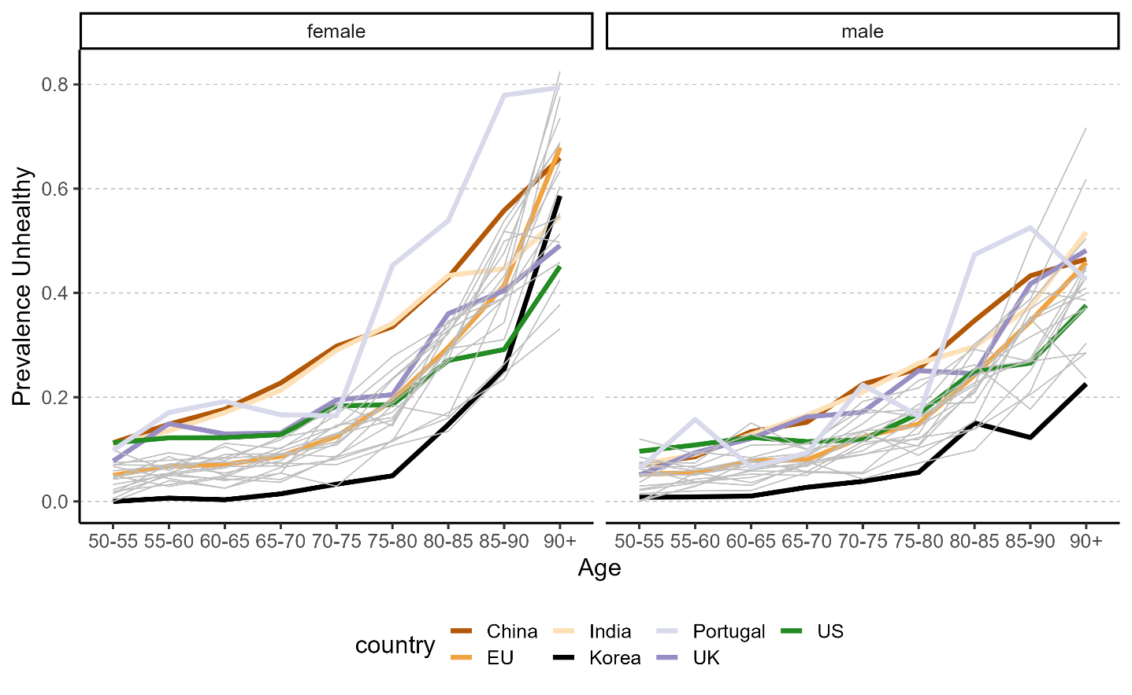

Source: Gateway to Global Aging Data, Produced by the Program on Global Aging, Health & Policy, University of Southern California with funding from the National Institute on Aging (R01 AG030153)

Most values are within the range between Korea and China, which are the extreme low and high levels, respectively, for both women and men. The grey lines are all EU-countries and fall mostly between Korea and England. The prevalence for the pooled EU countries is in the middle of the range of values across all countries observed. Compared to any country, Korea has lower levels of age-specific prevalence for men at all ages, while for women it increases after age 85-90 to higher levels than US, England, India and some European countries. The overall pattern for women across countries is more dispersed than for men, with the difference between Korean women and Chinese and Indian being higher than for men. Portugal has an atypical pattern, with prevalence after age 70 increasing considerably, especially for women. Compared to the age pattern of men, women have a higher rate of increase in prevalence across all countries with age, with the burden increasing at a much faster than pace. Chinese and Indian women have a prevalence rate level at ages 60-65 that is only observed at ages 70-75 for men, with a gap of almost 10 years. However, the difference is not important for women and men in England with men facing higher prevalence than women at some ages and very similar levels after age 80. Indeed, as shown in Table 2, when considering ages 65+ England is the country with the second lowest gender difference, with Denmark being the first.

Table 2. Prevalence of Women and Men ages 65+ with any ADL difficulty captures any difficulty bathing, dressing, eating, getting in and out of bed, and using the toilet, selected countries, year 2014

|  |  |  |  |  |  |  |
| --- | --- | --- | --- | --- | --- | --- |
| Country | Men age 65+ | | | Women age 65+ | | |
| % Any ADL | 95%CI | | % Any ADL | 95%CI | |
| USA | 14.33 | 13.15 | 15.59 | 15.96 | 14.93 | 17.05 |
| China | 16.31 | 14.36 | 18.47 | 20.1 | 18.14 | 22.21 |
| England | 20.43 | 18.72 | 22.26 | 21.4 | 19.79 | 23.11 |
| Korea | 5.05 | 4.12 | 6.19 | 7.5 | 6.47 | 8.67 |
| Austria | 13.61 | 11.4 | 16.16 | 17.53 | 15.25 | 20.07 |
| Belgium | 17.01 | 15.04 | 19.17 | 25.08 | 22.95 | 27.34 |
| Croatia | 10.73 | 8.03 | 14.19 | 19.6 | 16.19 | 23.54 |
| Czech Republic | 13.28 | 11.21 | 15.67 | 18.01 | 15.85 | 20.41 |
| Denmark | 12.03 | 9.92 | 14.52 | 11.25 | 9.31 | 13.54 |
| Estonia | 15.47 | 13.49 | 17.68 | 20.56 | 18.76 | 22.48 |
| France | 18.51 | 16.05 | 21.26 | 19.94 | 17.75 | 22.33 |
| Germany | 15.29 | 13.12 | 17.75 | 19.35 | 16.69 | 22.33 |
| Greece | 10.01 | 8.35 | 11.96 | 13.09 | 11.29 | 15.13 |
| Israel | 15.32 | 12.35 | 18.86 | 19.22 | 16.25 | 22.6 |
| Italy | 12.49 | 10.67 | 14.56 | 22.12 | 19.71 | 24.74 |
| Luxembourg | 12.78 | 9.37 | 17.19 | 17.09 | 13.09 | 22.01 |
| Poland | 17.35 | 13.72 | 21.69 | 22.96 | 19.21 | 27.2 |
| Portugal | 22.28 | 15.41 | 31.08 | 31.57 | 24.47 | 39.66 |
| Slovenia | 15.48 | 13.27 | 17.98 | 17.41 | 15.22 | 19.84 |
| Spain | 13.81 | 11.54 | 16.44 | 21.01 | 18.63 | 23.61 |
| Sweden | 10.46 | 8.83 | 12.37 | 11.09 | 9.4 | 13.05 |
| Switzerland | 8.51 | 6.73 | 10.72 | 10.82 | 8.77 | 13.28 |
|  |  |  |  |  |  |  |

Source: Gateway to Global Aging Data, Produced by the Program on Global Aging, Health & Policy, University of Southern California with funding from the National Institute on Aging (R01 AG030153)

As a second step, we combine the age-specific prevalence with the respective lifetables for each country in order to derive disability-free life expectancy. Afterwards, the decomposition will be applied using the continuous change decomposition method (Horiuchi et al. 2008) implemented in R (Riffe 2018), so we can split gender differences in healthy life expectancy into mortality and disability/chronic disease effects by age.

***Decomposing the gender gap into contributions of mortality and disability***

Figures 1-3 present the decomposition for selected countries in the sample. India and Portugal are the only countries where women have a disadvantage relative to men in terms of disability-free life expectancy.

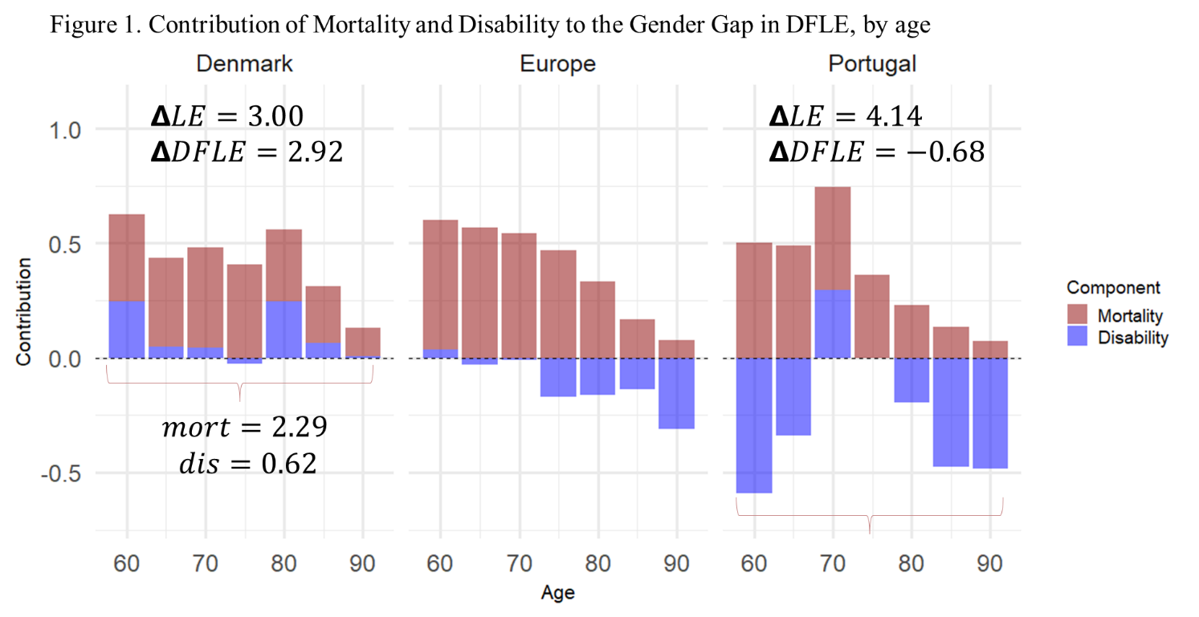

Source: Gateway to Global Aging Data, Produced by the Program on Global Aging, Health & Policy, University of Southern California with funding from the National Institute on Aging (R01 AG030153)

In both countries, this is explained by a larger effect of disability. Korea is the country with one of the highest gaps in favor of women both in terms of life expectancy and disability-free life expectancy. The contribution stems mainly from the mortality advantage of women.

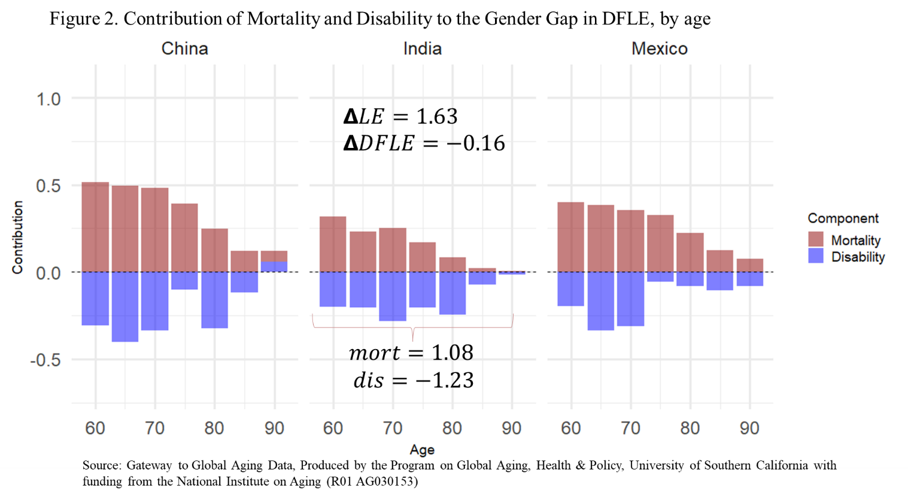

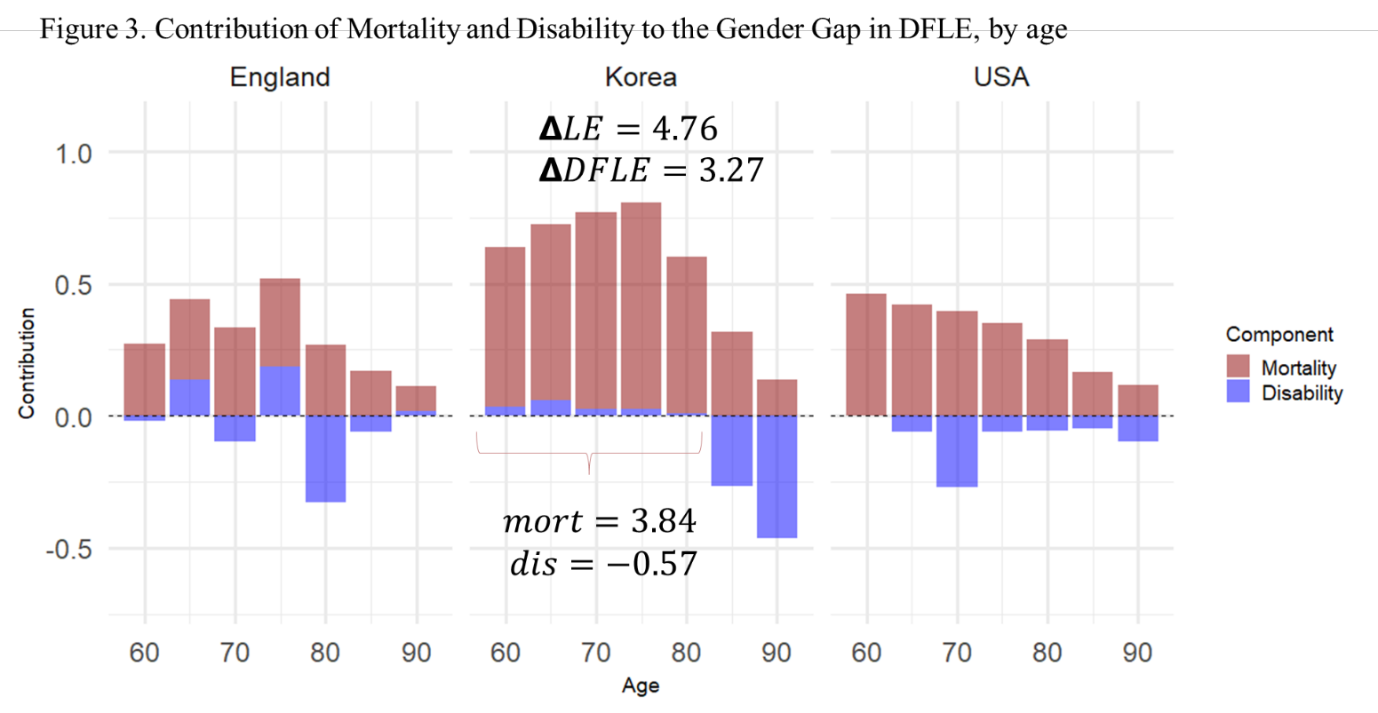

Source: Gateway to Global Aging Data, Produced by the Program on Global Aging, Health & Policy, University of Southern California with funding from the National Institute on Aging (R01 AG030153)

An exception is Denmark, where the contribution of disability is positive for the gap, in favor of women. Table 3 shows results for all countries.

|  |  |  |  |  |  |  |  |
| --- | --- | --- | --- | --- | --- | --- | --- |
| Table 3 - Decomposition of Gender Difference in Total Life Expectancy (LE), Life Expectancy Free of Disability (DFLE), and Life Expectancy With Disability (LEWD) into mortality and disability effect at age 60 | | | | | | | |
| Country/Survey | LE | DFLE | Components | | LEWD | Components | |
| Mortality | Disability | Mortality | Disability |
| USA (HRS) | 2.98 | 1.59 | 2.18 | -0.59 | 1.39 | 0.80 | 0.59 |
| China (CHARLS) | 3.81 | 0.79 | 2.31 | -1.52 | 3.02 | 1.50 | 1.52 |
| Mexico (MHAS) | 2.64 | 0.71 | 1.88 | -1.16 | 1.93 | 0.76 | 1.16 |
| **India (LASI)** | **1.63** | **-0.16** | **1.08** | **-1.23** | 1.79 | 0.55 | 1.23 |
| Korea (KLoSA) | 4.76 | 3.27 | 3.84 | -0.57 | 1.49 | 0.92 | 0.57 |
| England (ELSA) | 2.68 | 1.60 | 1.77 | -0.17 | 1.08 | 0.91 | 0.17 |
| Europe (SHARE) |  |  |  |  |  |  |  |
| Europe (*Pooled*) | 4.01 | 1.94 | 2.72 | -0.78 | 2.07 | 1.29 | 0.78 |
| Austria | 3.70 | 2.06 | 2.63 | -0.58 | 1.64 | 1.07 | 0.58 |
| Belgium | 3.53 | 0.98 | 2.32 | -1.34 | 2.55 | 1.21 | 1.34 |
| Croatia | 4.25 | 2.09 | 3.20 | -1.12 | 2.16 | 1.05 | 1.12 |
| Czechia | 4.17 | 2.49 | 3.05 | -0.57 | 1.68 | 1.12 | 0.57 |
| **Denmark** | **3.00** | **2.92** | **2.29** | **0.62** | 0.08 | 0.71 | -0.62 |
| Estonia | 5.82 | 3.58 | 4.28 | -0.69 | 2.24 | 1.54 | 0.69 |
| France | 4.53 | 2.83 | 2.84 | -0.02 | 1.70 | 1.69 | 0.02 |
| Germany | 3.64 | 2.12 | 2.57 | -0.44 | 1.52 | 1.07 | 0.44 |
| Greece | 3.56 | 1.86 | 2.83 | -0.97 | 1.70 | 0.73 | 0.97 |
| Israel | 2.83 | 1.13 | 1.79 | -0.66 | 1.70 | 1.04 | 0.66 |
| Italy | 3.51 | 0.86 | 2.26 | -1.40 | 2.65 | 1.25 | 1.40 |
| Luxembourg | 2.99 | 1.08 | 2.08 | -1.00 | 1.91 | 0.91 | 1.00 |
| Poland | 5.00 | 2.97 | 3.37 | -0.40 | 2.03 | 1.63 | 0.40 |
| **Portugal** | **4.14** | **-0.69** | **2.23** | **-2.92** | 4.83 | 1.91 | 2.92 |
| Slovenia | 4.23 | 2.89 | 3.14 | -0.25 | 1.34 | 1.09 | 0.25 |
| Spain | 4.36 | 2.07 | 3.03 | -0.96 | 2.29 | 1.33 | 0.96 |
| Sweden | 2.73 | 2.02 | 2.19 | -0.16 | 0.71 | 0.54 | 0.16 |
| Switzerland | 3.26 | 2.38 | 2.59 | -0.21 | 0.89 | 0.67 | 0.21 |

Source: Gateway to Global Aging Data, Produced by the Program on Global Aging, Health & Policy, University of Southern California with funding from the National Institute on Aging (R01 AG030153)

**Discussion**

Measuring gender disparities in health and mortality and what contributes to the gender gap across different countries is key for understanding what drives the gap. Different countries not only have specific health and mortality trajectories but their own cultural and gender roles, which may in turn affect the differentials. Cross-national comparisons are thus important to further shed light into the topic. Embracing a macro perspective on gender gaps is key for reducing health inequalities within and between populations and ensuring equal opportunities for healthy aging. The fact that in many places, women live longer and expect to spend a higher proportion of their lives in poorer health has startling effects on their well-being since poorer health for women usually means non-lethal, but debilitating conditions such as arthritis, fall-related fractures, and dementia, which limit their ability to remain independent, engage in social activities, and usually demand long-term care (Freedman et al., 2016). Because women face widowhood at an earlier age, have lower labor force participation rates, and tend to retire earlier with lower income than men, they are more exposed to poverty and financial insecurity, as their economic resources are more limited (Ruel and Hauser, 2013).

Furthermore, health is a fundamental element of human capital and individual productivity, so gender inequality in health can have profound macroeconomic implications (Bloom and Canning 2004; Prettner et al. 2013). Because women live longer than men but face greater morbidity during their lives, they experience higher productivity losses and lower labor force participation (Bonilla and Rodriguez 1993; Case and Paxson 2005b; Luy and Minagawa 2014; Oksuzyan et al. 2018). This gender inequality accumulates over the life-course, exposing older women to poverty and poor health conditions, imposing a burden to both pension and health systems (Weil 2007). Consequently, investing in female health has shown to have a strong effect on economic development in both the short and the long run. In the short run, it increases productive participation in the labor market and consequently the level and growth of economic output; on the long-run, it directly impacts intergenerational transmission of human capital, since healthier women lead to healthier offspring (Bloom et al. 2014a). Lastly, gender inequality in health is correlated to country-specific levels of development and to societal roles of women and men (Okojie 1994; WCF 2018).Therefore, to quantify health inequalities by gender and across countries with different levels of development can provide valuable insights for healthy ageing.

**Acknowledgements**

This paper uses data from SHARE Wave 6 (10.6103/SHARE.w6.800), see Börsch-Supan et al. (2013) for methodological details. The SHARE data collection has been funded by the European Commission, DG RTD through FP5 (QLK6-CT-2001-00360), FP6 (SHARE-I3: RII-CT-2006-062193, COMPARE: CIT5-CT-2005-028857, SHARELIFE: CIT4-CT-2006-028812), FP7 (SHARE-PREP: GA N°211909, SHARE-LEAP: GA N°227822, SHARE M4: GA N°261982, DASISH: GA N°283646) and Horizon 2020 (SHARE-DEV3: GA N°676536, SHARE-COHESION: GA N°870628, SERISS: GA N°654221, SSHOC: GA N°823782, SHARE-COVID19: GA N°101015924) and by DG Employment, Social Affairs & Inclusion through VS 2015/0195, VS 2016/0135, VS 2018/0285, VS 2019/0332, and VS 2020/0313. Additional funding from the German Ministry of Education and Research, the Max Planck Society for the Advancement of Science, the U.S. National Institute on Aging (U01_AG09740-13S2, P01_AG005842, P01_AG08291, P30_AG12815, R21_AG025169, Y1-AG-4553-01, IAG_BSR06-11, OGHA_04-064, HHSN271201300071C, RAG052527A) and from various national funding sources is gratefully acknowledged (see [www.share-project.org](http://www.share-project.org)).

This analysis uses data or information from the following Harmonized datasets: KLoSA dataset and Codebook, Version C as of June 2019 developed by the Gateway to Global Aging Data. The development of the Harmonized KLoSA was funded by the National Institute on Ageing (R01 AG030153, RC2 AG036619, R03 AG043052). For more information, please refer to <https://g2aging.org/>. LASI dataset and Codebook, Version A.2 as of October 2021, developed by the Gateway to Global Aging Data (DOI: https://doi.org/10.25549/h-lasi). The development of the Harmonized LASI was funded by the National Institute on Aging (R01 AG042778, 2R01 AG030153, 2R01 AG051125). For more information about the Harmonization project, please refer to https://g2aging.org/.

This work is supported within the EU Framework Programme for Research and Innovation Horizon 2020, ERC Grant Agreement No. 725187 (LETHE).

**References**

Beckett L a, Brock DB, Lemke JH, et al (1996) Analysis of change in self-reported physical function among older persons in four population studies. Am J Epidemiol 143:766–78

Bloom DE, Canning D (2004) Population Growth , Age Structure , and Economic Growth The 1986 Report

Bloom DE, Canning D, Fink G (2014) Disease and development revisited. J. Polit. Econ. 122:1355–1366

Bloom DE, Chen S, Kuhn M, et al (2019) The economic burden of chronic diseases: Estimates and projections for China, Japan, and South Korea. J Econ Ageing. doi: 10.1016/j.jeoa.2018.09.002

Bonilla E, Rodriguez A (1993) Determining malaria effects in rural Colombia. Soc Sci Med 37:1109–1114. doi: 10.1016/0277-9536(93)90249-4

Case A, Paxson C (2005a) Sex Differences in Morbidity and Mortality. Demography 42:189–214. doi: 10.2307/4147343

Case A, Paxson C (2005b) Sex Differences in Morbidity and Mortality. Demography 42:189–214. doi: 10.2307/4147343

Crimmins EM, Kim JK, Hagedorn A (2002) Life With and Without Disease: Women Experience More of Both. J Women Aging 14:47–59. doi: 10.1300/J074v14n01_04

Crimmins EM, Zhang Y, Saito Y (2016) Trends Over 4 Decades in Disability-Free Life Expectancy in the United States. 106:1287–1293. doi: 10.2105/AJPH.2016.303120

Cristina Drumond Andrade F, Egüez Guevara P, Lúcia Lebrão M, et al (2011) Gender Differences in Life Expectancy and Disability-Free Life Expectancy Among Older Adults in SAo Paulo, Brazil. doi: 10.1016/j.whi.2010.08.007

Di Lego V, Di Giulio P, Luy M (2020) Gender Differences in Healthy and Unhealthy Life Expectancy. pp 151–172

Gorman BK, Read JG (2006) Gender disparities in adult health: An examination of three measures of morbidity. J Health Soc Behav 47:95–110. doi: 10.1177/002214650604700201

Green CA, Pope CR (1999) Gender, psychosocial factors and the use of medical services: a longitudinal analysis. Soc Sci Med 48:1363–72. doi: 10.1016/S0277-9536(98)00440-7

Grundy E (2006) Gender and healthy aging. In: Longer life and healthy aging. pp 173–199

HMD (2018) Human Mortality Database. University of California, Berkeley (USA), and Max Planck Institute for Demographic Research (Germany). www.mortality.org or www.humanmortality.de. Accessed 17 Sep 2019

Jacobsen R, Oksuzyan A, Engberg H, et al (2008) Sex differential in mortality trends of old-aged Danes: a nation wide study of age, period and cohort effects. Eur J Epidemiol 23:723–730. doi: 10.1007/s10654-008-9288-5

Jagger C, Gillies C, Cambois E, et al (2010) The Global Activity Limitation Index measured function and disability similarly across European countries. J Clin Epidemiol 63:892–899. doi: 10.1016/j.jclinepi.2009.11.002

Keevil VL, Hayat S, Dalzell N, et al (2013) The physical capability of community-based men and women from a British cohort: the European Prospective Investigation into Cancer (EPIC)-Norfolk study. BMC Geriatr 13:93. doi: 10.1186/1471-2318-13-93

Kulminski AM, Culminskaya I V., Ukraintseva S V., et al (2008) Sex-specific health deterioration and mortality: The morbidity-mortality paradox over age and time. Exp Gerontol 43:1052–1057. doi: 10.1016/j.exger.2008.09.007

Leong DP, Teo KK, Rangarajan S, et al (2015) Prognostic value of grip strength: findings from the Prospective Urban Rural Epidemiology (PURE) study. Lancet 386:266–273. doi: 10.1016/S0140-6736(14)62000-6

Luy M (2016) The impact of biological factors on sex differences in life expectancy: insights gained from a natural experiment. In: Dinges M, Weigl A (eds) Gender-specific life expectancy in Europe 1850-2010. Steiner, Stuttgart, pp 17–46

Luy M, Minagawa Y (2014) Gender gaps--Life expectancy and proportion of life in poor health. Heal reports 25:12–9

Luy M, Wegner-Siegmundt C (2015) The impact of smoking on gender differences in life expectancy: more heterogeneous than often stated. Eur J Public Health 25:706–710. doi: 10.1093/eurpub/cku211

Nepomuceno MR, di Lego V, Turra CM (2021) Gender disparities in health at older ages and their consequences for well-being in Latin America and the Caribbean. Vienna Yearb Popul Res. doi: 10.1553/populationyearbook2021.res2.1

Okojie CEE (1994) Gender inequalities of health in the third world. Soc Sci Med 39:1237–1247. doi: 10.1016/0277-9536(94)90356-5

Oksuzyan A, Crimmins E, Saito Y, et al (2010) Cross-national comparison of sex differences in health and mortality in Denmark, Japan and the US. Eur J Epidemiol 25:471–480. doi: 10.1007/s10654-010-9460-6

Oksuzyan A, Gumà J, Doblhammer G (2018) Sex Differences in Health and Survival. In: A Demographic Perspective on Gender, Family and Health in Europe. Springer International Publishing, Cham, pp 65–100

Oksuzyan A, Shkolnikova M, Vaupel JW, et al (2014) Sex differences in health and mortality in Moscow and Denmark. Eur J Epidemiol 29:243–252. doi: 10.1007/s10654-014-9893-4

Prettner K, Bloom DE, Strulik H (2013) Declining fertility and economic well-being: Do education and health ride to the rescue? Labour Econ 22:70–79. doi: 10.1016/j.labeco.2012.07.001

Redondo-Sendino Á, Guallar-Castillón P, Banegas J, Rodríguez-Artalejo F (2006) Gender differences in the utilization of health-care services among the older adult population of Spain. BMC Public Health 6:155. doi: 10.1186/1471-2458-6-155

Rieker PP, Bird CE (2005) Rethinking gender differences in health: why we need to integrate social and biological perspectives. Journals Gerontol Ser B, Psychol Sci Soc Sci 60B:40–47. doi: 10.1093/geronb/60.Special_Issue_2.S40

Riffe T (2018) Package “DemoDecomp” Type Package Title Decompose Demographic Functions. doi: 10.1353/dem.0.0033

Roe CM, McNamara AM, Motheral BR (2002) Gender- and age-related prescription drug use patterns. Ann Pharmacother 36:30–39. doi: 10.1345/aph.1A113

Sanderson WC, Scherbov S (2014) Measuring the speed of aging across population subgroups. PLoS One 9:3–6. doi: 10.1371/journal.pone.0096289

Spiers N, Jagger C, Clarke M, Arthur A (2003) Are gender differences in the relationship between self-rated health and mortality enduring? Results from three birth cohorts in Melton Mowbray, United Kingdom. Gerontologist 43:406–411. doi: 10.1093/geront/43.3.406

Sullivan D. (1971) A single index of mortality and morbidity. HSMHA Health Rep 86:347–54

Verbrugge LM (1989) The twain meet: empirical explanations of sex differences in health and mortality. J Health Soc Behav 30:282–304

WCF (2018) The Global Gender Gap Report 2018 Insight Report

Weil DN (2007) Accounting for the effect of health on economic growth. Q. J. Econ. 122:1265–1306

Yokota RTC, Nusselder WJ, Robine J-M, et al (2019) Contribution of chronic conditions to gender disparities in health expectancies in Belgium, 2001, 2004 and 2008. Eur J Public Health 29:82–87. doi: 10.1093/eurpub/cky105

Yong V, Saito Y, Chan A (2010) Changes in the Prevalence of Mobility Limitations and Mobile Life Expectancy of Older Adults in Singapore, 1995-2005. J Aging Health 22:120–140. doi: 10.1177/0898264309351932

**Appendix**

Data characteristics

US (HRS):

We are using the Harmonized version B HRS: 37,495 observations. October 2018- There is a new updated version C, until 2019 that was updated now in 2022 and contains 42,233 observations. It is a Respondent level file so each row represents a unique Respondent. This leaves us with 18,747 observations using only wave 12 (year 2014) of HRS.

Mexico (MHAS):

Version B.4 incorporates the latest released version of MHAS data, and adds several new variables. It contains 22,016 observations or rows- 22016. We are using the Harmonized VERSION B.4 (2001-2015), February 2022, for the MHAS data. The Mexican Health and Aging Study (MHAS) is a longitudinal household survey dataset for the study of health, economic position, and quality of life among the elderly. MHAS datasets as of September 2020. The MHAS (Mexican Health and Aging Study) Version B.4 incorporates the latest released version of MHAS data, and adds several new variables. It contains 22,016 observations or rows. It is a Respondent-level file so each row represents a unique Respondent. We will focus on Wave 4, which is for years 2014/2015. We will have 17,616 observations.

England (ELSA):

We are using the Version G.2 (2002-2019), July 2021 for The English Longitudinal Study on Ageing (ELSA). It is a longitudinal household survey dataset for the study of health, economic position, and quality of life among the elderly (panel survey of people aged 50 and over and their partners, living in private households in England). Version G.2 incorporates the latest released version of ELSA data, which includes eleven main modules and the associated datasets, and adds variables and observations from Wave 9 with a total of 19,802 observations. It also adds new variables and makes adjustments and corrections. We will focus on Wave 7, nonetheless. The samples have been drawn from households which previously responded to the Health Survey for England (HSE). The seventh wave was conducted between June 2014 and May 2015 and included a refreshment sample selected from HSE 2011-2012.

Acknowledgements. “This analysis uses data or information from the Harmonized ELSA dataset and Codebook, Version G.2 as of July 2021 developed by the Gateway to Global Aging Data. The development of the Harmonized ELSA was funded by the National Institute on Aging (R01 AG030153, RC2 AG036619, R03 AG043052). For more information, please refer to <https://g2aging.org/>.”

India (LASI)

The Longitudinal Aging Study in India (LASI) is a multidisciplinary, internationally harmonized panel study designed to be nationally representative of India’s population aged 45 and older. LASI is a joint project of three partnering institutions: International Institute for Population Sciences (IIPS), Harvard T.H. Chan School of Public Health (HSPH), and University of Southern California (USC). The first wave was conducted between 2017 and 2019 in 35 of India’s 36 states and union territories (except Sikkim). This initial sample, as released by USC, included 42,951 households and 72,262 individuals. The LASI sampling plan is complex and was based on the 2011 Indian Census with a multistage, stratified cluster sample design. The sample design includes three distinct selection stages in rural areas and four stages in urban areas. We use Version A.2 that makes corrections using the January 2021 released version of Wave 1 of the LASI data.

Europe (SHARE)

This is Version F in the harmonized files and incorporates the latest released version of SHARE data, release 8.0.0, and adds observations from Wave 8. It contains 139,620 observations or rows. It is a Respondent-level file so each row represents a unique Respondent. It also adds new variables and makes adjustments and corrections. We focus on data from SHARE Wave 6, with the release 8.0.0 as of February 2022. SHARE uses a multistage stratified sample. Its weighting variables make its data representative of the target populations in constituent countries.

Wave 6 does not still have full coverage of European countries, with the following countries only added in Wave 7: Finland, Lithuania, Latvia, Slovakia, Romania, Bulgaria, Malta and Cyprus.

Acknowledgements. "This analysis uses data or information from the Harmonized SHARE dataset and Codebook, Version F as of June 2022 developed by the Gateway to Global Aging Data. The development of the Harmonized SHARE was funded by the National Institute on Aging (R01 AG030153, RC2 AG036619, R03 AG043052). For more information, please refer to “https://g2aging.org/”.

China -CHARLS

The China Health and Retirement Longitudinal Study (CHARLS) is a longitudinal study of individuals over age 45 in China. Version D incorporates the latest released version of CHARLS data, and adds variables for Wave 4. It contains 25,586 observations or rows. It is a Respondent-level file so each row represents a unique Respondent; The sample population was selected as part of a stratified, multistage probability design. We will use Wave 3. As we concentrate on ages 50 and above due to the other samples we do not include individuals younger than 50. This leaves us with a sample size of 16,344 individuals.

Acknowledgements . "This analysis uses data or information from the Harmonized CHARLS dataset and Codebook, Version D as of June 2021 developed by the Gateway to Global Aging Data. The development of the Harmonized CHARLS was funded by the National Institute on Aging (R01 AG030153, RC2 AG036619, R03 AG043052). For more information, please refer to <https://g2aging.org/>.” This document used CHARLS Waves 1 through 4 as of June 2021. CHARLS is supported by Peking University, the National Natural Science Foundation of China, the National Institute on Aging, and the World Bank.

KLOSA- Korea

The Korean Longitudinal Study of Ageing (KLoSA) is a panel survey of people aged 45 and over and their partners, living in private households in Korea. The survey elicits information about demographics, income, assets, health, cognition, family structure and connections, health care use and costs, housing, job status and history, expectations, and insurance. KLoSA surveys respondents every two years. Funded by the Korean Ministry of Labor, the Korean Institute of Labor (KLI) collected the first two waves, and the Korea Employment Information Service (KEIS) collected the Waves 3, 4, 5 and 6 of KLoSA, with the first wave of the KLoSA survey being conducted in fall/winter of 2006. The sample population was selected as part of a stratified, multi-stage area probability design. The first component of this sampling framework is the probability proportional to size (PPS) systematic sampling of the 2005 (South Korean) Census enumeration districts after stratifying by the location (15 major metropolitan cities and provinces) and characteristic of the district (urban or rural, and apartment building or non-apartment dwelling). Households were selected within PSUs from a listing of households in the Census identified as age-eligible; that is, inhabited by at least one person 45 years of age and older. This initial sample included 10,254 respondents age 45 and over. The second wave was conducted in 2008 and had 8,688 respondents. The third wave was conducted in 2010 and had 7,920 respondents. The fourth wave was conducted in 2012 and had 7,486 respondents. There was no refresher sample in Waves two through four. In 2014, a refreshment sample of individuals born in 1962 or 1963 was drawn and it included 920 individuals, which were added to the 7,029 remaining core sample respondents for a total of 7,949 Wave 5 respondents. The sixth wave was conducted in 2016 and had 7,490 respondents. We will focus on Wave 5. However, because we focus on ages >50, the sample is not 7,949, but . We use the hamornized Version C that contains 11,174 observations or rows. It is a Respondent-level file so each row represents a unique Respondent. It also adds new variables and makes adjustments and corrections.