**Full title:** How many times have lives been saved? Trends in mortality improvement through the revivorship approach

**Short title:** How many times have lives been saved?

**Acknowledgements**

I dedicate this work to Jim Vaupel and his support for my research on this topic. I thank three anonymous reviewers for a careful and detailed reading that improved this paper considerably. This study was supported by the European Research Council within the EU Framework Programme for Research and Innovation Horizon 2020, ERC Grant Agreement No. 725187 (LETHE).

**Abstract**

Revivorship models are very unique and remain underexplored in demographic research. They describe improvement as a setting where individuals who would have died under a particular mortality regime are revived and given a second, third, or *i* additional chances to live. This paper explores revivorship models to: 1. estimate the average number of times lives were saved under different mortality schedules; 2. decompose the total gains in life expectancy at birth by the number of life years in each revivorship state; 3. Estimate revivorship entropy and the gains in total lifespan as a consequence of repeatedly saving lives. Progress in mortality is attained not only by saving a lot of lives once at younger ages, but also by repeatedly averting deaths at older ages. The contribution of saving lives once is the most important for all periods, but more than once for older ages and particularly among women.

**Key-words:** Lifesaving, Entropy, Revivorship, Life table, Mortality

1. **Introduction**

‘You have to die a few times before you can really live’

* Charles Bukowski

Just as the “half-empty-half-full” glass conundrum yields a different interpretation to being pessimistic or optimistic regarding the same observed phenomenon, mortality improvement can be understood either as a process of saving lives or reducing deaths. Despite yielding the same end result as deaths are merely postponed in time, they have conceptually different standpoints and with this allow for different insights. There is a set of lifesaving models in demography that describe the process of mortality improvement as one where individuals who would have died at a given mortality schedule are given extra chances to survive or are “revived” (Finkelstein 2013; Mitra 1979; Schmertmann 2020; Vaupel 2005; Vaupel and Yashin 1987a, 1987b). Vaupel and Yashin (1987a, 1987b) defined a particular case on which the concept of the force of mortality at age is coupled with the force of lifesaving . At each age *,* a new mortality regime can be described as the old mortality regime coupled with an intensity of lifesaving (or absolute reduction in ) . The higher the force of lifesaving, the higher the absolute reduction in the force of mortality, consequently leading to more progress in mortality. This construct allows for assessing the formal relationships between lifetable survival , density distribution of deaths and life expectancy between two different mortality schedules in a particular manner, where the new force of mortality can be seen as a decomposition of the old mortality regime plus the force of lifesaving (Vaupel 2005; Vaupel and Yashin 1987a, 1987b). At each age, a proportion of individuals who would have died are given another chance or another “ticket to life” (Wachter 2008). The process is a factorial reminiscent of the Poisson distribution (Vaupel and Yashin 1987a, 1987b), resulting in a revivorship function that estimates the probability that an individual will be given chances by age . Vaupel and Yashin (1987a, 1987b) and Vaupel (2005) coined the term “resuscitation”, as individuals are “revived” from the life table. They restrict the use of revivorship to define the survival function of the “resuscitated”. However, Schmertmman (2020) uses the term “revivorship” and “revival” more prominently and so we chose to keep this term due to the important developments made in this paper for keeping consistency. In addition, the revivorship function is a decomposition of survival, so the concept of revival and the term revivorship makes it easier and more intuitive to interpret.

The relationship established by the revivorship function allows for exploring an alternative interpretation of the life table entropy, an important indicator used in demography to study how relative changes in life expectancy are associated to changes in age-specific mortality rates (Aburto et al. 2019; Demetrius 1979; Fernandez and Beltrán-Sánchez 2015; Goldman and Lord 1986; Keyfitz and Caswell 2005; Vaupel and Canudas-Romo 2003). In the revivorship framework, life table entropy is not only interpreted as a measure of age heterogeneity with regard to death, but also as the impact on life expectancy at birth of saving everyone’s life the *first* time, which implies that for a given mortality schedule, entropy is a measure of the potential impact of lifesaving on average life expectancy (Vaupel 1986). This perspective and the interpretation of entropy as a measure of the potential for lifesaving offers an alternative view on lifespan disparity, which is based not on how unequally deaths are distributed, but on how unequally is the potential life years to be *gained* per life saved. More recently, the connection between this revivorship function and measures of lifespan disparity and the potential years of life lost has been formally established and expanded, enabling further applications of the approach (Schmertmann 2020).

This paper empirically explores mortality change across different countries by year and sex using a revivorship model, in order to conceptually describe mortality improvement as a process which grants people extra chances of survival. In this case, improvement in a given year, represented by lower mortality, is the old mortality regime that instead of killing people now revives those individuals at the same intensity with which the new mortality regime prescribes. We also explore the concept of life table entropy in the revivorship framework in order to assess the impact on total lifespans of repeatedly saving lives. We apply the lifesaving model as described by Vaupel and Yashin (1987a, 1987b) in order to: 1. estimate the average number of times women and men were saved by age for countries that underwent different mortality transitions; 2. decompose the total gains in life expectancy at birth by the number of life years in each revivorship state for each mortality regime; 3. Estimate life table entropy in the revivorship setting and the subsequent gains in total lifespan as a consequence of repeatedly saving lives.

For this, life tables from the Human Mortality Database (HMD) countries are used. We group countries into four mortality transition categories: 1. Pioneers (spearheaded mortality transition mostly beginning-mid of the 19th Century, data from 1850-2017); 2. Laggards (catch-up with Pioneers, mostly beginning of 20th Century, data from 1900-2017); 3. East-Transition (countries from eastern Europe with data from 1950-2017); and 4. Fast-Paced (Asia, data from 1950-2017). The reason for grouping countries into those categories is twofold: 1. The most remarkable progress in life expectancy at birth across all HMD countries starts in the middle of the 20th Century, but each country began experiencing improvements at different points in time and had particular trajectories of convergences and divergences in history (Vallin and Meslé 2004; Aburto and van Raalte 2018). Because we aim to capture the trajectories of mortality improvement by comparing survival schedules, we use the extensive literature on mortality and epidemiologic transition in demography to categorize countries according to the characteristics of their transition, mostly based on their relative position in terms of when they started the transition, their pace and exceptionality (Grigoriev et al. 2014; Héran 2014; Janssen and de Beer 2019; Klenk et al. 2016; Larsson 2019; Lundström 2019; Meslé and Vallin 2017; Sundberg et al. 2018; Vallin and Meslé 2004). 2. The grouping helps to investigate countries with disparate patterns, like countries from eastern Europe and very fast-paced transitioned countries in Asia. We compare the mortality regimes for every fifty years of observations, which coincide with the moments in history where the greatest improvements were observed, depending on the country group (see Fig 1).

The results are highlighted for Sweden representing Pioneering countries, Italy the Laggards, Czechia the East-Transition and Japan the Fast-Paced, as these are the countries within each group with the longest time series available, allowing for a better outlook on each mortality regime. Country-specific results are presented in the Appendix. The last year is 2017 as the most recent data available for most countries before the effect of COVID-19. As discussed in more detail in the data and discussion sections, the approach is restricted to periods where mortality improvements occur. Due to the declines in life expectancy often observed after the COVID-19 pandemic, we limited the analysis to year 2017.

Revivorship models define mortality improvement through how deaths are redistributed once a life is saved, thus providing a different perspective to understanding the nature of mortality change. This perspective adds to the important debate of whether the conventional life table approach, the delayed-death model, the stretched-lifetime model or heterogeneity models best describe mortality change (Vaupel 2005). Age-specific probabilities of death and their impact on life expectancy depend not only on how many lives have been saved, but also on how long those lives have been saved (Vaupel 2005, 2008). In addition, the interpretation of entropy as a measure of the potential for lifesaving offers an alternative view on lifespan disparity, which is based not on how unequally deaths are distributed, but on how unequally is the potential life years to be gained per life saved.

1. **Material and Methods**
   1. *Revivorship model and the effect of repeatedly saving lives*

The demographic model of lifesaving as developed by Vaupel and Yashin (1987a, 1987b) defines progress in mortality as a relationship between the old and new mortality regimes and a force of lifesaving. A key aspect of this model is the revivorship function and the conceptual shift in describing mortality improvement.Let be the new mortality regime after improvement happens, the force of mortality before improvement, and the force of lifesaving. In addition, consider that the new force of mortality , must be necessarily lower than ( at all ages). Hence, improvement can be defined as , where is the absolute reduction in the force of mortality and thus must satisfy the condition of being equal to or higher than 0 at all ages so that . This formulation implies that the new mortality regime can be interpreted as being composed of the old force of mortality and a force of lifesaving that, at each age, revives a proportion of individuals who would have died under the old regime . This revival process can be interpreted as though individuals are given another chance, having the potential to be saved any number of times, provided an intensity of lifesaving The probability of survivors who would otherwise die in the old regime () but are now revived and granted extra chances of survival under the new mortality regime (), has been proven to be related via the following revivorship function (Vaupel and Yashin 1987a, 1987b and Mitra 1979):

Where is the cumulative intensity of lifesaving or the cumulative hazard averted:

Expanding the exponential term in (1) as a Taylor series gives:

Which implies that the new survival can be decomposed as the sum of the old survival and the probability of revivals necessary to reach the new , or the probability that an individual will be revived times, or the number of times a person was saved at age – their revivorship state. This is the key relationship that defines the probability that an individual will be revived times by age given any two survival distributions. These can be any two given time periods or subpopulations that satisfy the condition or as long as one has a higher survival than the other. Relationships (1) – (3) have been proven in Vaupel and Yashin (1987a) as a reminiscent of a Poisson distribution. Indeed, the distribution of survivors at age by the number of times they were revived can be conceived as a Poisson distribution with mean . Following Eq. (3) and the definition of , it is also possible to derive the number of life years lived in each revivorship state , defined as (Vaupel and Yashin 1987b):

Hence, in the same way that the difference in survival between the comparison years can be expressed in terms of extra chances of survival, the life expectancy at birth from the new regime can be decomposed as the old life expectancy and the number of life years lived in each state of revivorship (Vaupel and Yashin 1987a, 1987b), or:

As life expectancy at birth can be defined as (Keyfitz and Caswell 2005; Vaupel 1986) :  
where is the age where no one else survives, in this case, the relative change in life expectancy between and can then be represented as:

It follows from Eq (7) how a proportionate change in mortality rates affect life expectancy in the context of revivorship. Recall that a proportional effect of a small change on the expectation of life has been shown to be (Aburto et al. 2019; Demetrius 1979; Fernandez and Beltrán-Sánchez 2015; Keyfitz and Caswell 2005):

Where is the life table entropy, a measure of the homogeneity of a population with regards to age of death or the degree of concavity of the survivorship function (Aburto et al. 2019; Fernandez and Beltrán-Sánchez 2015; Keyfitz and Caswell 2005; Vaupel 1986). The life table entropy is an important indicator to investigate relative changes in life expectancy associated with changes in age-specific mortality rates. As mortality improves, deaths tend to concentrate at older ages resulting in a decline of entropy values, meaning less heterogeneity in the ages at death (Vaupel and Canudas-Romo 2003). Hence, in the case where the same proportion of deaths are averted at all ages and following the rationale in Eq (8), Eq (7) can be written as:

As entropy in Eq. (8) is defined as:

It follows from Eq. (9) and (10) that the revivorship entropy can be expressed as (See the Appendix for more details on how Eq. (11) only depends on survival):

Eq. (11) presents an additional interpretation to the life table entropy. When , the factorial is also 1, and Eq. (11) reduces to (10). Eq (11) is powerful because it shows that conventional life table entropy can also be interpreted as a measure of the proportional increase in life expectancy at birth if all *first* deaths are averted, or, in other words, the effect of saving a life the *first* time. Additionally, one can think of equation (11) as a decomposition of entropy into higher order of revivals. This is an idea already mentioned in Vaupel (1986) when analyzing how change in age-specific mortality affects life expectancy and is recovered for interpreting entropy in the revivorship framework. The exact quote in Vaupel (1986) is “As suggested by my colleague Anatoli I. Yashin, this implies that gives the proportional increase in life expectancy at birth if everyone´s first death was averted”. The notion is subsequently brought back in Vaupel and Yashin (1987a, 1987b). As Eq. (10) can alternatively be expressed in terms of life expectancy and the force of mortality, while the denominator of Eq. (10) and (11) is simply life expectancy at birth, or (Vaupel 1986; Vaupel and Canudas-Romo 2003):

Then Eq (11) can also be expressed as:

Eq. (13) not only shows that gains in life expectancy depend on the life years of those who were saved, but it also quantifies the years of life expectancy gained among the revived, decomposing entropy by each extra chance of life granted. This implies that is also a measure of the effect of repeatedly saving lives. The numerator of Eq. (12) has been shown to be expressed as the average number of life years lost as a result of death, or (Vaupel and Canudas-Romo 2003). Consequently, the numerator of Eq. (13) can also be defined as :

which, when =1, reduces to the average number of life years lost as a result of death or (Vaupel and Canudas-Romo 2003). Hence, in the revivorship framework, when a person is saved the *th-*time, Eq. (14) can be interpreted as the average number of potential life-years *gained* per life saved, or the expected number of years gained among those who were revived and only times. As can also be expressed as , (refer to Vaupel and Canudas Romo 2003), Vaupel and Yashin (1987a) showed that . What this implies is that if a random person’s life is saved the *th-*time, then this person can expect to live years in state , excluding additional benefits from being saved again (Vaupel and Yashin 1987a). In other words, in the revivorship setting, represents the effect of repeatedly saving lives, the expected number of years gained among those who were revived and only times and the total gains in lifespan due to lifesaving. Because this value depends both on the life table entropy and life expectancy at birth (), it additionally shows how the potential gains from revival are related to the disparity in the distribution of length of life, a result also discussed at length in Schmertmann (2020). For a full description of the approach and more detailed proofs refer to (Finkelstein 2013; Schmertmann 2020; Vaupel and Yashin 1987a) and further details in the Appendix.

* 1. **Data**

The most remarkable progress in life expectancy at birth across all HMD countries starts in the middle of the 20th Century, but each country began experiencing improvements at different points in time and had particular trajectories of convergences and divergences in history. The process of mortality has been described as a series of divergence-convergence cycles (Aburto and Raalte 2018; Vallin and Meslé 2004). For this reason, we group countries into four different and broad categories of transitions: 1. Pioneers (spearheaded mortality transition mostly beginning-mid of the 19th Century, data from 1850-2017); 2. Laggards (catch-up with Pioneers, mostly beginning of 20th Century, data from 1900-2017); 3. East-Transition (countries from eastern Europe with data from 1960-2017); and 4. Fast-Paced (Asia, data from 1950-2017), as shown in Fig 1. Pioneers are the countries which were documented to have spearheaded early sustainable improvements in life expectancy, notably starting in the latter part of the 18th Century, but more consistently beginning-mid of the 19th Century. Even though Sweden and Denmark were already transitioning and there is data availability for Sweden in the 18th Century, trends were extremely irregular with mortality experiencing very sharp peaks and troughs due to a series of famine and war cycles, especially between 1772-73, 1783-85, 1790, 1800 and 1808-09 (Bengtsson and Bröstrom 2011; Bengtsson, Campbell, and Lee 2004; Bengtsson and Dribe 2005; Vigezzi et al. 2022; Zarulli 2013). It is only from 1900 that population becomes more stable and mortality improvements consistently accelerate. Laggards are countries that followed the pioneers catching-up with substantial improvement later, but still before the turn of the 19th to 20th Century; East-Transitioners are Eastern European countries which underwent very particular transitions. Despite most post-communist regimes like Poland and Czechia catching up with Western countries as regards declines in infectious diseases in mid-20th Century, most communist regimes in Central and Eastern Europe did not fully benefit from the cardiovascular revolution, with fluctuating cycles of improvement like Gorbachev’s anti-alcohol campaign in the period 1985–1988, stagnation in the 1960’s and depreciation from 1980-2000, as shown in Fig. 1 (Grigoriev et al. 2014; Meslé and Vallin 2017); Fast-transitioners were countries that underwent dramatically fast transitions particularly after WWII, like Japan, Korea and Hong Kong (Gillespie, Trotter, and Tuljapurkar 2014; Héran 2014; Janssen and de Beer 2019; Klenk et al. 2016; Vallin and Meslé 2004). In 50 years, Japan was able to reach life expectancy levels that pioneer countries took over 100 years to reach. By the 2000’s, Japan had surpassed all industrialized countries.

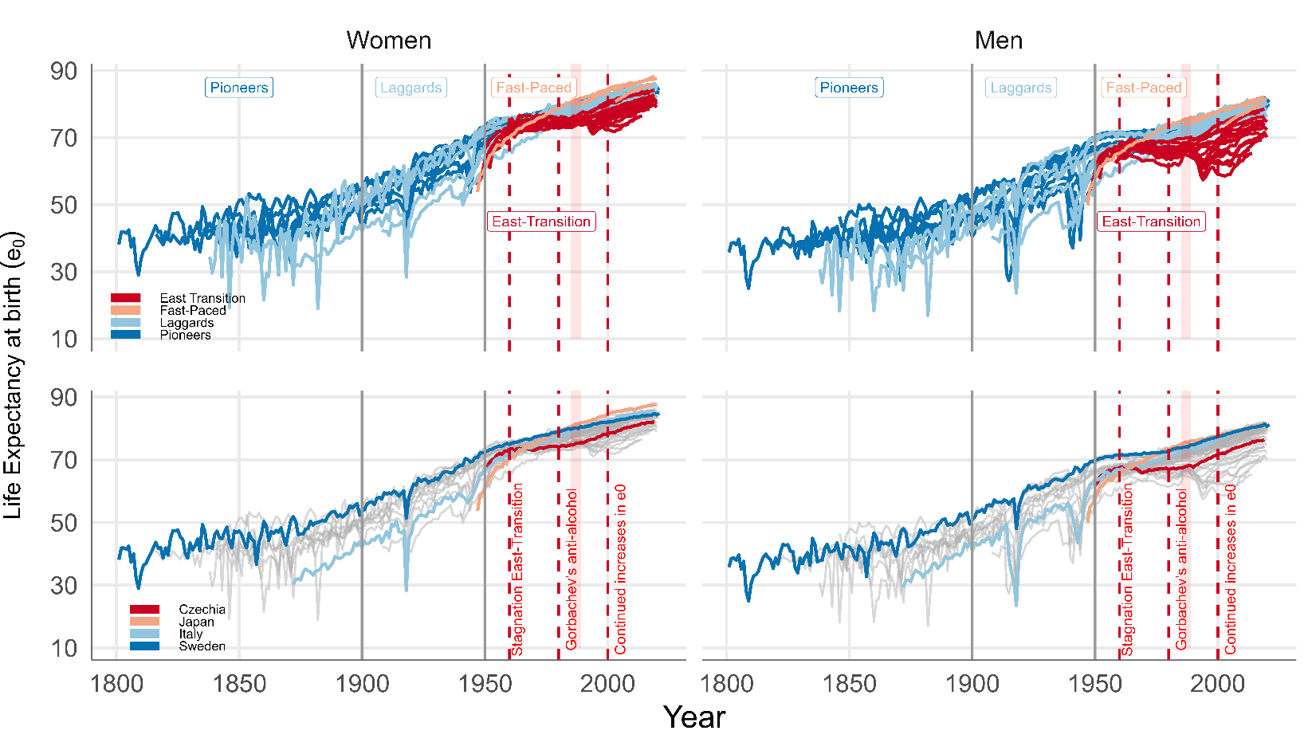

**Fig 1.** Life expectancy at birth trajectories for HMD countries, by mortality transition status, year and sex. Source: Human Mortality Database. University of California, Berkeley (USA), and Max Planck Institute for Demographic Research (Germany). Available at www.mortality.org or www.humanmortality.de

For all groups, the period analyzed was ranging every 50 years, with the exception of the last period, which was from 2000-2017, or 17 years (see which countries are grouped in Table A1 in the Appendix). Due to limited data, a few countries in the grouping fall between that period but do not start from the same period exactly. We make a note for those countries in the results tables. The reason for selecting 50-year range analyses is twofold, First, as shown in Fig 1, these are the periods where changes in life expectancy at birth are observed, with significant improvement particularly in the first half of the 20th Century and an underlying increasing trend across the years. Second, as developed further in the Discussion Section, the revivorship approach does not work in worsening of conditions, but only when comparing two schedules where there is improvement. For ease of presentation and due to their longer time series availability, some countries were selected to represent each of the transition groups and are highlighted in Table A1, with Sweden representing Pioneering countries, Italy the Laggards, Czechia the East-Transition and Japan the Fast-Paced. Their longest time series allow for better describing the process. Overall, with few exceptions and particularly with the case of the east-transition countries, the patterns observed are similar across countries and within each group, as shown in the Appendix.

1. **Results**

*Number of times lives were saved by year, sex, and age and the contribution to total life expectancy*

Figs 2-3 show the profiles with the number of revived persons necessary in order to reach the new mortality regime under comparison for women and men, respectively. For each mortality transition group, the country with the longest time series is highlighted, as well as the peak age of revived survivors by revivorship status. The overall pattern across countries is similar by age and across years, as the peak of the distribution tends to shift to older ages and the whole curve becomes more skewed to the right. With the exception of the very first period of improvement between 1850-1900, all other years have similar patterns across countries, which is expected, as only a few countries like Sweden and Denmark started to experience their mortality transitions already by mid of the 18th Century, so by mid 19th Century they were already more stable in their trajectories. However, as detailed in Tables 1-2, there are differences in the relative contribution of higher order of survival by sex, the absolute number in revivals, and the peak age of revivorship. Pioneering countries have a more skewed distribution towards older ages in the period between 1950-2000, while Laggards were reviving more people at all ages below 60 in an increasing linear fashion. In the same period, women from both pioneering and laggard countries have an overall more skewed pattern of distribution when compared to men, which means that the female pattern of revival is more concentrated at older ages. In addition, the average peak age of revival for women in the period 1950-2000 for all pioneer countries is eight years higher than for men (77 versus 69), while the difference among Laggards is slightly lower, but still 6 years higher for women (77 versus 71 years of age see details on Table A4 in the Appendix).

**FIG 2 HERE**

**FIG 3 HERE**

Among fast-paced countries, the dramatic improvement between years 1950-2000 in Japan is expressed in terms of a high contribution of higher order of survival both among women and men. Indeed, the effect of saving women’s lives three or more times in Japan is even higher then saving them twice, with the contribution at older ages representing 45.8% of all revived persons when comparing the mortality schedules from 1950-2000, as shown in Table 2. In other words, given the 1950 schedule, it would be necessary to save older Japanese women to such an extent that sparing them from death three or more times would represent almost half of all the survivors given the 2000 schedule. This suggests that fast progress in mortality is attained not only by saving a lot of lives once at younger ages and granting those who were saved with long years, but also by repeatedly averting deaths at older ages among those were expected to die. This effect is relatively stronger for older ages for all countries, as it is more likely that in order to reach age 90, for example, one needs to be saved more times. The converse is true for relatively younger ages, such as 50, as shown in Table 1. The contribution of being saved once is comparatively much higher at those ages. In Sweden, comparing the survival between years 1900-1950 shows that the contribution of saving women once represents reviving 25.2% of all survivors in 1900 one time in order that they reach the levels observed in 1950. For Italian women this figure is 30.8%.

East-Transition countries have a more complex cycle of stagnation, divergence, deterioration and improvement. For men, between years 1950-2000, there were actually worsening of conditions and a lower number of survivors observed in 2000 compared to 1950 for some countries (as reflected by a downward trend in ages 30-50). However, as Figs 2-3 show, their overall pattern is also similar with the age pattern being skewed to the right with the years, albeit with a low proportion of survivors revived as shown in Tables 2-3, as their lifesaving process is much more complicated and less linear in time.

**TABLE 1 HERE**

**TABLE 2 HERE**

As detailed in Tables 1-2, the period between 1950-2000 was marked by substantial progress in terms of the total number revived, especially among women at age 90. In Sweden, for example, compared to year 1950, there were 21,119 revived women aged 90, with a remarkable 27,064 women now surviving to be a nonagerian, compared to only 5,945 in year 1900, an increase of almost fourfold in half a century. In the same period, 9,000 men were revived in order to reach a survival of 13,419, compared to 4,419 in 1950. In addition, there was a remarkable contribution of being saved twice and three or more times between 1950-2000 when compared to other periods, with 25% of all women who were saved being granted two extra chances in order to achieve age 90 and 20% were saved three or more times, while for men those figures were 20% and 10%, respectively.

In addition, while the contribution of saving lives once is the most important for all periods at both ages 50 and 90, the contribution of saving lives more than once is higher for nonagerians and particularly for women.

An important difference that distinguishes pioneering and laggard countries from fast-paced and east-transition countries at age 90 is that fact that between 2000-2017 the total number revived is higher for men than for women among the former countries. This suggest that in the last 20 years or so progress in pioneering and laggard countries has been more directed at men than women at these older ages, while in the latter women are still enjoying most of the progress, comparatively. Conversely, at age 50, the contribution of saving male lives is higher than female lives for all countries at virtually all periods. Hence, overall, progress at age 50 is more intense among men, while progress at age 90 is more important among women. This does not necessarily imply that women perform worse at that age, as this refers to the absolute difference in survival. Indeed, the fact that gains in terms of revived persons are higher for men aged 50 and for women aged 90 in this period most likely means that women have already gained all the progress they could attain at that age, while men still have space for improvement. For countries that started their transition later, like Italy, women were revived more than men between both 1900-1950 and 1950-2000, with the relationship also inverting in the last period of 17 years for older ages. Similar to Sweden, the profile is more compressed to older ages between 1950-2000. However, the contribution of being saved twice and more than three times across ages is higher among laggard countries between both 1900-1950 and 1950-2000 and also stronger for women than for men. In the period of 1900-1950, the percentage of women among the survivors of the new regime who were saved three or more times (36.4%) is higher than those that only needed to be saved once (25%). This means that in order to reach age 90 in year 1950 an Italian woman was saved on average more than three times, when compared to year 1900. Also refer to more details in sex differences by age across countries in Table A5 in the Appendix.

What do those differences in revival mean for life expectancy? In order to address this question, we apply Equations (4)-(5) to translate the lifesaving process across regimes into life expectancy changes, by decomposing the revivorship status. In Table 3, differences in total life expectancy at birth for women and men and the life expectancy at each revivorship state are presented for Sweden, Italy, Czechia and Japan. Here we can see the total number of life years lived in each revivorship state and the relative contribution of each revival on improvements in total life expectancy at birth for women and men. Please refer to the Appendix Table A2 for estimates for all the other selected HMD countries shown in Table 1 (Some countries in the east-transition group only have estimates for women for some years, like Latvia and Lithuania, as men experienced worsening of conditions in the period, as mentioned in the data section).

**TABLE 3 HERE**

Overall, for periods with larger improvements in total life expectancy at birth like Italy and Sweden between years 1900-1950, 1950-2000 in Japan and 1950-2000 for Czechia, the relative contribution of life years among those saved more than once to total life expectancy at birth is higher. In comparison of 2000 with 1950, the most dramatic case is among the fast-paced countries, with Japan experiencing an improvement of 24.4 years in life expectancy at birth for women. A significant amount of that improvement, 3.6 years, is added by saving lives more than 3 times, representing almost 15% of all gains between the period. In addition, with the exception of Sweden, whose male lives are saved more than twice relative to women throughout most periods considered (1850-1900,1900-1950 and 2000-2017), for all other countries, improvements in life expectancy at birth for women are due to a higher contribution of higher orders of survival.

*The effect of repeatedly saving lives and the potential for lifesaving*

Using the relationship established in Eq. (11) which shows how represents the effect of repeatedly saving lives, we can compute for different life tables in order to estimate the revivorship entropy. In addition, as is the expected number of years gained among those who were revived and only times and the total gains in lifespan due to lifesaving, we can estimate what is the effect in the total lifespan by repeatedly saving lives. Noteworthy of mention, different from the previous analyses, this does not compare different survival schedules, but instead analyses the potential for lifesaving within each life table. For this, we could use all HMD life tables for countries available from 1750-2017.

Fig 4 shows in the top part the lifespan benefit of repeatedly saving lives with regards to life expectancy at birth and in the bottom part the number of potential life years gained by repeatedly saving lives up to 5 times across the years. In the bottom panel, the number of life years gained is higher for the first time being revived and also higher between years 1750-1900. As life expectancy at birth increases, the potential of gaining life years declines, but as the gains are cumulative with each extra chance of revival, the total lifespan benefit of repeatedly saving lives is large. Specific period effects in the life tables are also evident, with the years following WWI and the 1918 Spanish Flu presenting an increase in the potential of life years gained, especially for men, who were affected by an uptick in mortality across preceding years. In the top panel, countries are highlighted to illustrate some years as an example (1970 and 2010). As of 2010, Japan is the country with the highest life expectancy at birth for women (86.2 years). With the observed survival schedule in this year, the potential for the benefit of saving female lives once is of 8.6 years, which imply that there is a potential for extending their lifespan to almost 95 years at birth. Table 4 shows for the same set of countries we have highlighted in the revivorship comparison what is the potential benefit to total life expectancy at birth of repeated revivals for a given year. To become a centenarian, Italian men at year 2017 would need to be saved 4 times, adding 9.7+ 4.0+ 3.2+ 2.4 = 19.3 years to their life expectancy at birth of 80.5 years. In 1900, men could not expect to reach an average lifespan of a centenarian even if saved 5 times; on the other hand, women were pretty close to becoming a centenarian in 2017 Japan by only being saved twice.

**FIG 4 HERE**

**TABLE 4 HERE**

Despite the fact that the relative gains each time a life is saved is lower, the overall gains are cumulative; by the time a female life is saved 5 times given the Japanese life table of 2017, their relative gains are only 1.8 years, but their lifespans increase from 87.3 years to 105.6, should the potential for saving lives be fulfilled 5 times. Similarly, according to Swedish life table in year 1850, the potential total lifespan benefit for repeatedly saving female lives up to 5 times is to increase life expectancy at birth from 47.3 to 92.2 years, while for men it is from 42.2 to 89.8. The astonishing difference from being an octogenarian to a centenarian shows the impact of higher orders of survival in the population and the contribution of decomposing entropy in order to how far is a mortality regime from fulfilling the potential to reach a specific level of mortality.

1. **Discussion**

One of the most longstanding questions at the core of mortality research is how mortality change affects life expectancy (Beltrán-Sánchez, Preston, and Canudas-Romo 2008; Keyfitz and Caswell 2005; Keyfitz and Littman 1979; Vaupel 1986; Vaupel and Canudas-Romo 2003). Explaining mortality improvement is complex and also linked to lifespan inequality (Aburto et al. 2018; Aburto and van Raalte 2018; Van Raalte, Sasson, and Martikainen 2018; Seligman, Greenberg, and Tuljapurkar 2016; Tuljapurkar and Edwards 2011), shifting distributions of age-at-death, (Basellini and Camarda 2019; Bergeron-Boucher, Ebeling, and Canudas-Romo 2015; Horiuchi et al. 2014; Rizzi et al. 2020; Wilmoth and Horiuchi 1999) heterogeneity, selection and frailty (Keyfitz and Littman 1979; Vaupel, Manton, and Stallard 1979; Vaupel and Zhang 2010; Wrigley-Field 2014, 2020). Lifesaving models like the ones developed by Vaupel and Yashin (1987a, 1987b) may provide further insight into the mechanism behind how deaths are averted and the consequences on explaining mortality improvement. The conventional lifetable model indicates that a few will gain on average the remaining life expectancy at the ages where improvement happened (Vaupel 2002). On the other hand, the delayed death model by Bongaarts and Feeney (Bongaarts 2005; Bongaarts and Feeney 2002) suggests everyone will gain on average a few number of years. However, mortality improvements are most probably neither only the result of death being averted for a few people who gain on average the remaining life expectancy nor everyone gains the same lifespan increment (Vaupel 2002, 2005, 2008). Our results showed that the contribution of saving lives more than three times is concentrated at older ages, implying that for a part of hypothetical life table lives progress in mortality happens by repeatedly saving lives in order to reach a given level of improvement. In addition, the process varies according to the life table considered, being different for women and men across different years, with gains being cumulative over each revivorship state. Most likely, sex differences are driven by the fact that women had historically overall larger improvements than men, experiencing lower mortality even in times of famines and pandemics (Zarulli et al. 2018). Age differences are most probably not only linked to the mortality trajectory and pace of improvement for each country, but also the intensity with which each age contributed to the changes or even the threshold age that separates the early and late deaths (Aburto et al. 2019; Vigezzi et al. 2022; Zhang and Vaupel 2009).

Furthermore, we show how the alternative interpretation of life table entropy proposed by Vaupel (1986) can be incorporated in the lifesaving analysis, being an indicator of the *potential* for lifesaving. Indeed, the total number of years of life expectancy lost by those who die is a measure of the potential for increasing life expectancy by reducing the force of mortality. This potential depends on the density distribution of deaths at each age and on the number of years of life expectancy lost by those dying at each age. When we shift conceptually from the view of life years lost to the potential of lifesaving there is a conceptual gain in the life table entropy and lifespan inequality, as the potential gains from revival are related to the disparity in the distribution of length of life, a result also discussed at length in Schmertmann (2020). This perspective and the interpretation of entropy as a measure of the potential for lifesaving offers an alternative view on lifespan disparity, which is based not on how unequally deaths are distributed, but on how unequally is the potential life years to be *gained* per life saved. In other words, it shows how far off are some lifespans from specific levels of improvements. This also has an implication for communicating with policy makers on mortality improvement. The notion of life years lost is often times harder for people to grasp and interpret, providing a sensation of an event that happened in the past and as such has no viable solution; however, life years gained has a different connotation, with a forward thinking that is more aligned to prospective policy design and improvement in conditions. Both perspectives are important depending on what message one needs to convey and having both alternatives is resourceful for research. Lastly, the revivorship model can be an insightful avenue for advancing on the discussion of tempo effects in mortality and on the conventional interpretation of period measures of life expectancy (Luy et al. 2020).

Noteworthy of mention, this study has important limitations. First, the assumption is that the intensity of lifesaving is constant for each extra chance granted. The effect of saving lives on life expectancy depends both on the number of deaths by age and on the number of additional years of life a person who has been granted another chance will gain (Vaupel and Yashin 1987a). Hence, it is also most likely that a person who needed to be saved once is frailer than those who did not need to be saved at all, so the mortality risk for those who are revived is different. Future research on this topic where we include different intensity of lifesaving for each revivorship state and consider heterogeneity will shed further light into how deaths are redistributed. In addition, we restricted our analysis to period life tables; incorporating cohort information can provide additional insight into the lifesaving model. Decomposing entropy by causes of death and other population subgroups is also an important avenue for expanding this research. Lastly, the revivorship model performs poorly when investigating periods of worsening conditions and thus is restricted to investigating progress. The intensity of lifesaving is the logarithm of the two regimes (or subpopulations). If conditions worsen to the extent that the new survival is lower than the previous one, the result is non-positive, yielding erratic revivorship values. In this approach, different from Bukowski’s take on life, you can be revived many times, but you can only die once.

1. **Acknowledgements**

I dedicate this work to Jim Vaupel and his support for my research on this topic. I also thank three anonymous reviewers for a careful and detailed reading that improved this paper considerably. This study was supported by the European Research Council within the EU Framework Programme for Research and Innovation Horizon 2020, ERC Grant Agreement No. 725187 (LETHE).

**Competing interest**: Authors declare that they have no competing interests.

**Funding**: This study was supported by the European Research Council within the EU Framework Programme for Research and Innovation Horizon 2020, ERC Grant Agreement No. 725187 (LETHE).

**Data and materials availability**: All data is from the Human Mortality Database and is publicy available at <https://www.mortality.org/>. The replication files for this paper include customized functionality written in the R statistical programming language. The code, and all data and analyses pertaining to our analysis, is hosted on OSF: <https://osf.io/axhvk/?view_only=0854cdaaa26b49b295c8e514c5cd9940>.

**References**

Aburto, J.M., Alvarez-Martínez, J.-A., Villavicencio, F., and Vaupel, J.W. (2019). The threshold age of the lifetable entropy. *Demographic Research* 41:83–102. doi:10.4054/DemRes.2019.41.4.

Aburto, J.M. and van Raalte, A. (2018). Lifespan Dispersion in Times of Life Expectancy Fluctuation: The Case of Central and Eastern Europe. *Demography* 55(6):2071–2096. doi:10.1007/s13524-018-0729-9.

Aburto, J.M. and Raalte, A. Van (2018). Lifespan Dispersion in Times of Life Expectancy Fluctuation : The Case of Central and Eastern Europe. :2071–2096.

Aburto, J.M., Wensink, M., Van Raalte, A., and Lindahl-Jacobsen, R. (2018). Potential gains in life expectancy by reducing inequality of lifespans in Denmark: An international comparison and cause-of-death analysis. *BMC Public Health* 18(1). doi:10.1186/s12889-018-5730-0.

Basellini, U. and Camarda, C.G. (2019). Modelling and forecasting adult age-at-death distributions. *Population Studies* 73(1):119–138. doi:10.1080/00324728.2018.1545918.

Beltrán-Sánchez, H., Preston, S.H., and Canudas-Romo, V. (2008). An integrated approach to cause-of-death analysis: Cause-deleted life tables and decompositions of life expectancy. *Demographic Research* 19:1323–1350. doi:10.4054/DEMRES.2008.19.35.

Bengtsson, T. and Bröstrom, G. (2011). Famines and mortality crises in 18th to 19th century southern Sweden. *Genus* 67(2):119–139. http://www.jstor.org/stable/genus.67.2.119.

Bengtsson, T., Campbell, C., and Lee, J.Z. (2004). *Life under Pressure: Mortality and Living Standards in Europe and Asia, 1700-1900*. MIT Press. https://portal.research.lu.se/portal/sv/publications/life-under-pressure-mortality-and-living-standards-in-europe-and-asia-17001900(4d1bacaf-b7b2-40d2-958b-142b19dc7011)/export.html.

Bengtsson, T. and Dribe, M. (2005). New Evidence on the Standard of Living in Sweden During the Eighteenth and Nineteenth Centuries: Long-Term Development of the Demographic Response to Short-Term Economic Stress. *Living Standards in the Past: New Perspectives on Well-Being in Asia and Europe*. doi:10.1093/0199280681.003.0015.

Bergeron-Boucher, M.-P.P., Ebeling, M., and Canudas-Romo, V. (2015). Decomposing changes in life expectancy: Compression versus shifting mortality. *Demographic Research* 33(1):391–424. doi:10.4054/DemRes.2015.33.14.

Bongaarts, J. (2005). Five period measures of longevity. *Demographic Research* 13:547–558. doi:10.4054/DemRes.2005.13.21.

Bongaarts, J. and Feeney, G. (2002). How long do we live? *Population and Development Review* 28(1):13–29. doi:10.1111/j.1728-4457.2002.00013.x.

Demetrius, L. (1979). Relations between demographic parameters. *Demography* 16(2):329–338. doi:10.2307/2061146.

Fernandez, O.E. and Beltrán-Sánchez, H. (2015). The entropy of the life table: A reappraisal. *Theoretical Population Biology* 104:26–45. doi:10.1016/j.tpb.2015.07.001.

Finkelstein, M. (2013). Lifesaving, delayed deaths and cure in mortality modeling. *Theoretical Population Biology* 83:15–19. doi:10.1016/j.tpb.2012.10.005.

Gillespie, D.O.S., Trotter, M. V., and Tuljapurkar, S.D. (2014). Divergence in Age Patterns of Mortality Change Drives International Divergence in Lifespan Inequality. *Demography* 51(3):1003–1017. doi:10.1007/s13524-014-0287-8.

Goldman, N. and Lord, G. (1986). A New Look at Entropy and the Life Table. *Demography* 23(2):275. doi:10.2307/2061621.

Grigoriev, P., Meslé, F., Shkolnikov, V.M., Andreev, E., Fihel, A., Pechholdova, M., and Vallin, J. (2014). The Recent Mortality Decline in Russia: Beginning of the Cardiovascular Revolution? *Population and Development Review* 40(1):107–129. doi:10.1111/J.1728-4457.2014.00652.X.

Héran, F. (2014). Générations sacrifiées : le bilan démographique de la Grande Guerre. *Population & Sociétés* N° 510(4):1. doi:10.3917/POPSOC.510.0001.

Horiuchi, S., Ouellette, N., Cheung, S.L.K., and Robine, J.-M.M. (2014). Modal age at death: lifespan indicator in the era of longevity extension. *Vienna Yearbook of Population Research* Volume 11(1):37–69. doi:10.1553/populationyearbook2013s37.

Janssen, F. and de Beer, J. (2019). The timing of the transition from mortality compression to mortality delay in Europe, Japan and the United States. *Genus 2019 75:1* 75(1):1–23. doi:10.1186/S41118-019-0057-Y.

Keyfitz, N. and Caswell, H. (2005). *Applied Mathematical Demography*. New York: Springer-Verlag. Statistics for Biology and Health. doi:10.1007/b139042.

Keyfitz, N. and Littman, G. (1979). Mortality in a Heterogeneous Population. *Population Studies* 33(2):333. doi:10.2307/2173538.

Klenk, J., Keil, U., Jaensch, A., Christiansen, M.C., and Nagel, G. (2016). Changes in life expectancy 1950-2010: Contributions from age- and disease-specific mortality in selected countries. *Population Health Metrics* 14(1). doi:10.1186/S12963-016-0089-X.

Larsson, D. (2019). Diseases in Early Modern Sweden. *Scandinavian Journal of History* 45(4):407–432. doi:10.1080/03468755.2019.1659178.

Lundström, H. (2019). Mortality Assumptions for Sweden. The 2000–2050 Population Projection. *Demographic Research Monographs*:59–71. doi:10.1007/978-3-030-05075-7_5.

Luy, M., Di Giulio, P., Di Lego, V., Lazarevič, P., and Sauerberg, M. (2020). Life Expectancy: Frequently Used, but Hardly Understood. *Gerontology* 66(1). doi:10.1159/000500955.

Meslé, F. and Vallin, J. (2017). The End of East–West Divergence in European Life Expectancies? An Introduction to the Special Issue. *European Journal of Population = Revue Européenne de Démographie* 33(5):615. doi:10.1007/S10680-017-9452-2.

Mitra, S. (1979). The effects of extra chances to live on life table functions. *Theoretical Population Biology* 16(3):315–322. doi:10.1016/0040-5809(79)90020-0.

Van Raalte, A.A., Sasson, I., and Martikainen, P. (2018). The case for monitoring life-span inequality. *Science* 362(6418):1002–1004. doi:10.1126/science.aau5811.

Rizzi, S., Kjærgaard, S., Bergeron Boucher, M.P., Camarda, C.G., Lindahl-Jacobsen, R., and Vaupel, J.W. (2020). Killing off cohorts: Forecasting mortality of non-extinct cohorts with the penalized composite link model. *International Journal of Forecasting*. doi:10.1016/j.ijforecast.2020.03.003.

Schmertmann, C. (2020). Revivorship and life lost to mortality. *Demographic Research* 42:497–512. doi:10.4054/demres.2020.42.17.

Seligman, B., Greenberg, G., and Tuljapurkar, S. (2016). Equity and length of lifespan are not the same. *Proceedings of the National Academy of Sciences*. doi:10.1073/pnas.1601112113.

Sundberg, L., Agahi, N., Fritzell, J., and Fors, S. (2018). Why is the gender gap in life expectancy decreasing? The impact of age- and cause-specific mortality in Sweden 1997–2014. *International Journal of Public Health* 63(6):673. doi:10.1007/S00038-018-1097-3.

Tuljapurkar, S. and Edwards, R.D. (2011). Variance in death and its implications for modeling and forecasting mortality. *Demographic Research* 24:497–526. doi:10.4054/DemRes.2011.24.21.

Vallin, J. and Meslé, F. (2004). Convergences and divergences in mortality. A new approach to health transition. *Demographic Research* 10(SUPPL. 2):11–44. doi:10.4054/DEMRES.2004.S2.2.

Vaupel, J.W. (1986). How Change in Age-specific Mortality Affects Life Expectancy. *Population Studies* 40(1):147–157. doi:10.1080/0032472031000141896.

Vaupel, J.W. (2002). Life Expectancy at Current Rates vs. Current Conditions. *Demographic Research* 7:365–378. doi:10.4054/DemRes.2002.7.8.

Vaupel, J.W. (2005). Lifesaving, lifetimes and lifetables. *Demographic Research* 13:597–614. doi:10.4054/DemRes.2005.13.24.

Vaupel, J.W. (2008). Turbulence in lifetables: Demonstration by four simple examples. In: Bongaarts J. Barbi E., V. J. W. (ed.). *How Long Do We Live?*. Berlin, Heidelberg: 271–279.

Vaupel, J.W. and Canudas-Romo, V. (2003). Decomposing Change in Life Expectancy: A Bouquet of Formulas in Honor of Nathan Keyfitz’s 90th Birthday. *Demography* 40(2):201–216. doi:10.1353/dem.2003.0018.

Vaupel, J.W., Manton, K.G., and Stallard, E. (1979). The Impact of Heterogeneity in Individual Frailty on the Dynamics of Mortality. *Demography* 16(3):439. doi:10.2307/2061224.

Vaupel, J.W. and Yashin, A.I. (1987a). Repeated Resuscitation: How Lifesaving Alters Life Tables. *Demography* 24(1):123. doi:10.2307/2061512.

Vaupel, J.W. and Yashin, A.I. (1987b). Targeting lifesaving: Demographic linkages between population structure and life expectancy. *European Journal of Population* 2(3–4):335–360. doi:10.1007/BF01796596.

Vaupel, J.W. and Zhang, Z. (2010). Attrition in heterogeneous cohorts. *Demographic Research* 23:737–748. doi:10.4054/DemRes.2010.23.26.

Vigezzi, S., Aburto, J.M., Permanyer, I., and Zarulli, V. (2022). Divergent trends in lifespan variation during mortality crises. *Demographic Research* 46:291–336. doi:10.4054/DEMRES.2022.46.11.

Wachter, K.W. (2008). Tempo and its tribulations. In: Barbi E., Vaupel J.W., B. J. (ed.). *How Long Do We Live?*. Demographi. Berlin, Heidelberg: Springer Berlin Heidelberg: 109–128. doi:10.1007/978-3-540-78520-0_6.

Wilmoth, J.R. and Horiuchi, S. (1999). Rectangularization Revisited: Variability of Age at Death within Human Populations. *Demography* 36(4):475. doi:10.2307/2648085.

Wrigley-Field, E. (2014). Mortality Deceleration and Mortality Selection: Three Unexpected Implications of a Simple Model. *Demography* 51(1):51–71. doi:10.1007/s13524-013-0256-7.

Wrigley-Field, E. (2020). Multidimensional Mortality Selection: Why Individual Dimensions of Frailty Don’t Act Like Frailty. *Demography* 57(2):747–777. doi:10.1007/s13524-020-00858-8.

Zarulli, V. (2013). The Effect of Mortality Shocks on the Age-Pattern of Adult Mortality. *Population* 68(2):303. doi:10.3917/popu.1302.0303.

Zarulli, V., Barthold Jones, J.A., Oksuzyan, A., Lindahl-Jacobsen, R., Christensen, K., and Vaupel, J.W. (2018). Women live longer than men even during severe famines and epidemics. *Proceedings of the National Academy of Sciences*. doi:10.1073/pnas.1701535115.

Zhang, Z. and Vaupel, J.W. (2009). The age separating early deaths from late deaths. *Demographic Research* 20:721–730. doi:10.4054/DemRes.2009.20.29.

**Appendix**

**Fig A1** Life expectancy at birth trajectory of different countries after 1960

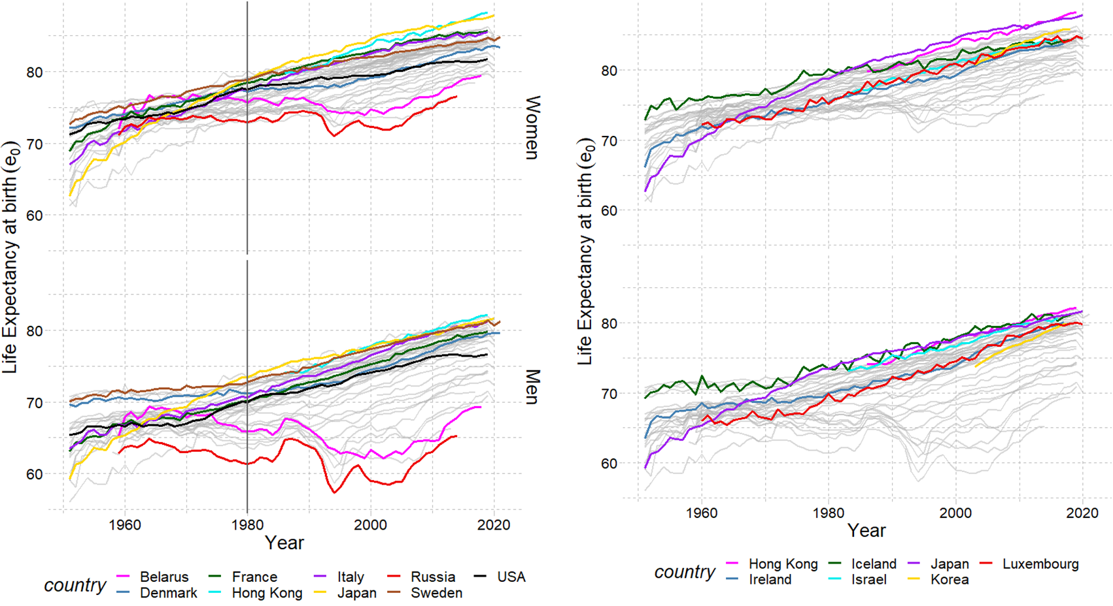

Data from the Human Mortality Database. University of California, Berkeley (USA), and Max Planck Institute for Demographic Research (Germany). Available at www.mortality.org or www.humanmortality.de.

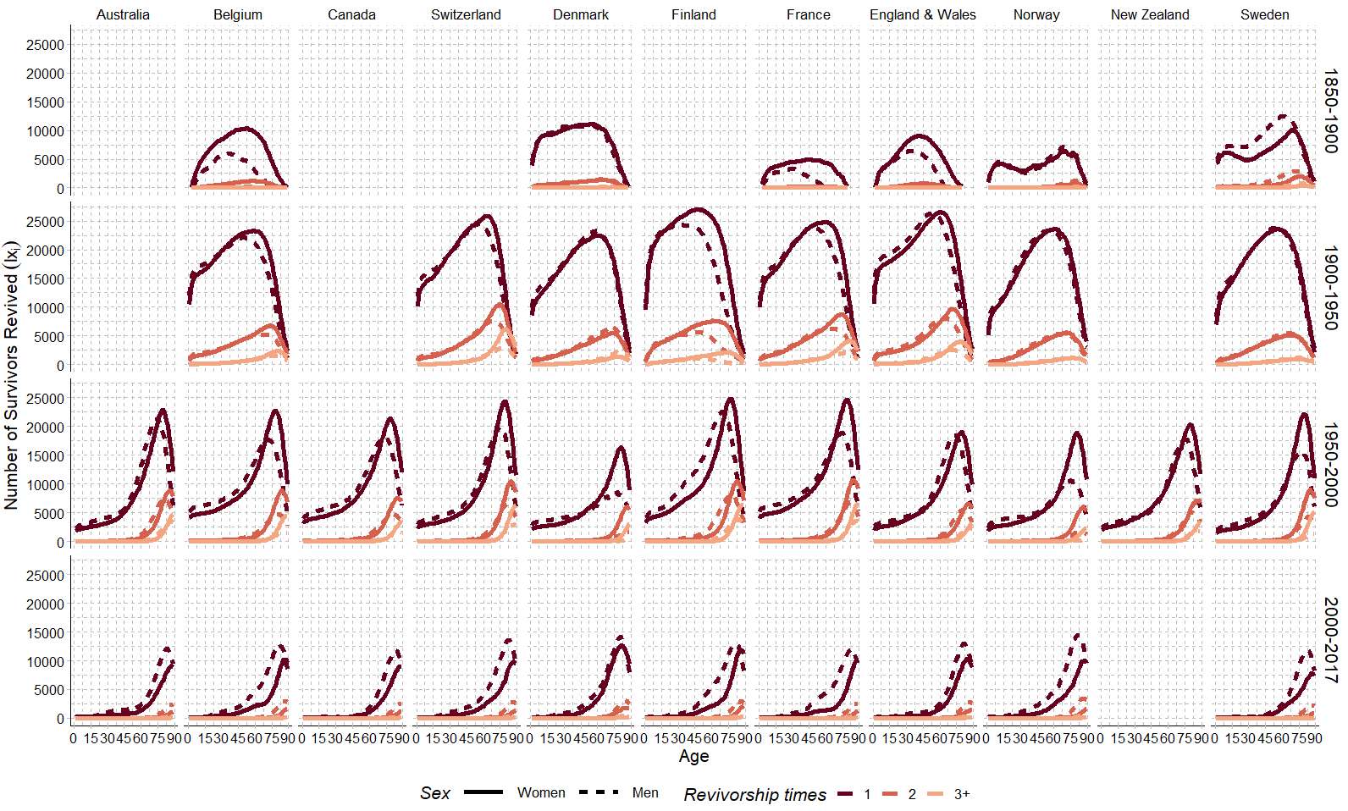

Source: Own calculations. Data from the Human Mortality Database. University of California, Berkeley (USA), and Max Planck Institute for Demographic Research (Germany). Available at www.mortality.org or www.humanmortality.de

**Fig A2.** Revivorship across all pioneer countries, by year and sex

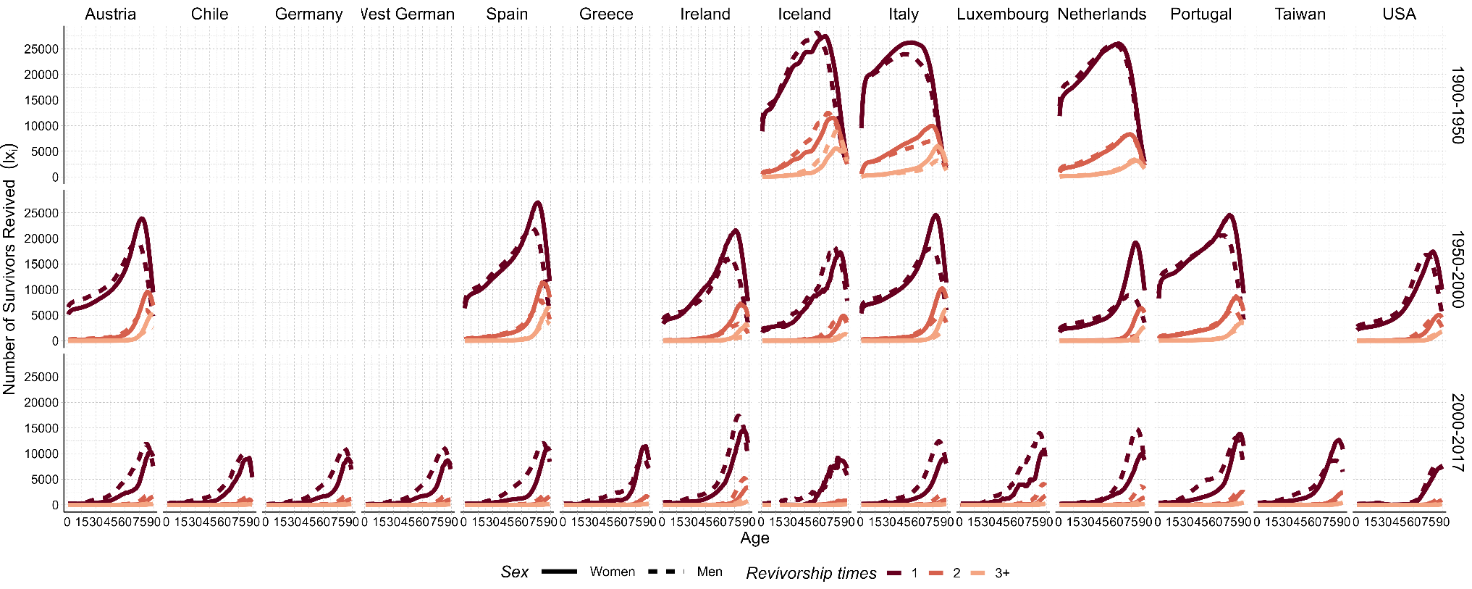

Source: Own calculations. Data from the Human Mortality Database. University of California, Berkeley (USA), and Max Planck Institute for Demographic Research (Germany). Available at www.mortality.org or www.humanmortality.de

**Fig A3.** Revivorship across all laggard countries, by year and sex

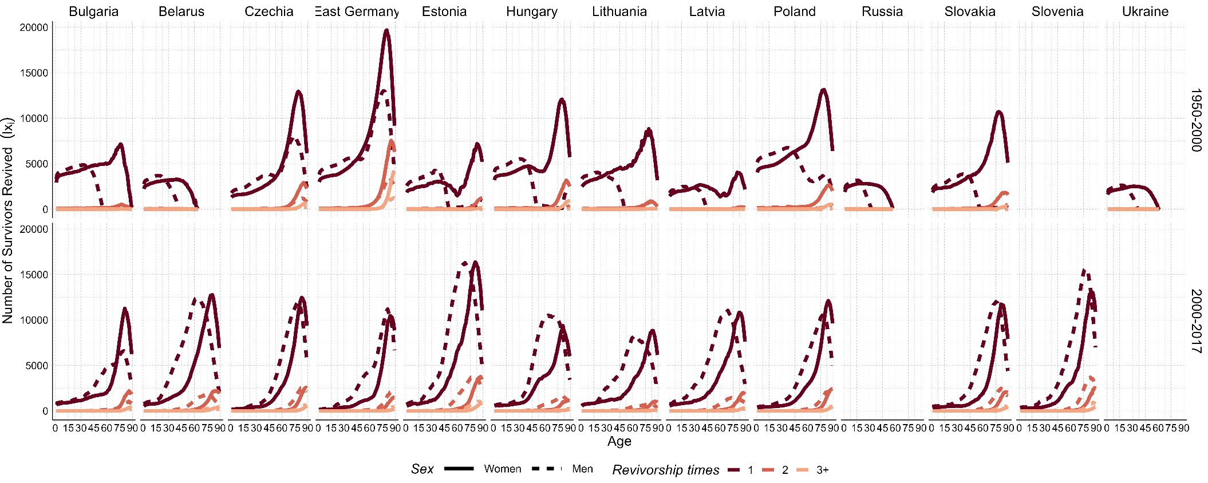

Source: Own calculations. Data from the Human Mortality Database. University of California, Berkeley (USA), and Max Planck Institute for Demographic Research (Germany). Available at www.mortality.org or www.humanmortality.de

**Fig A4.** Revivorship across all east-transition countries, by year and se

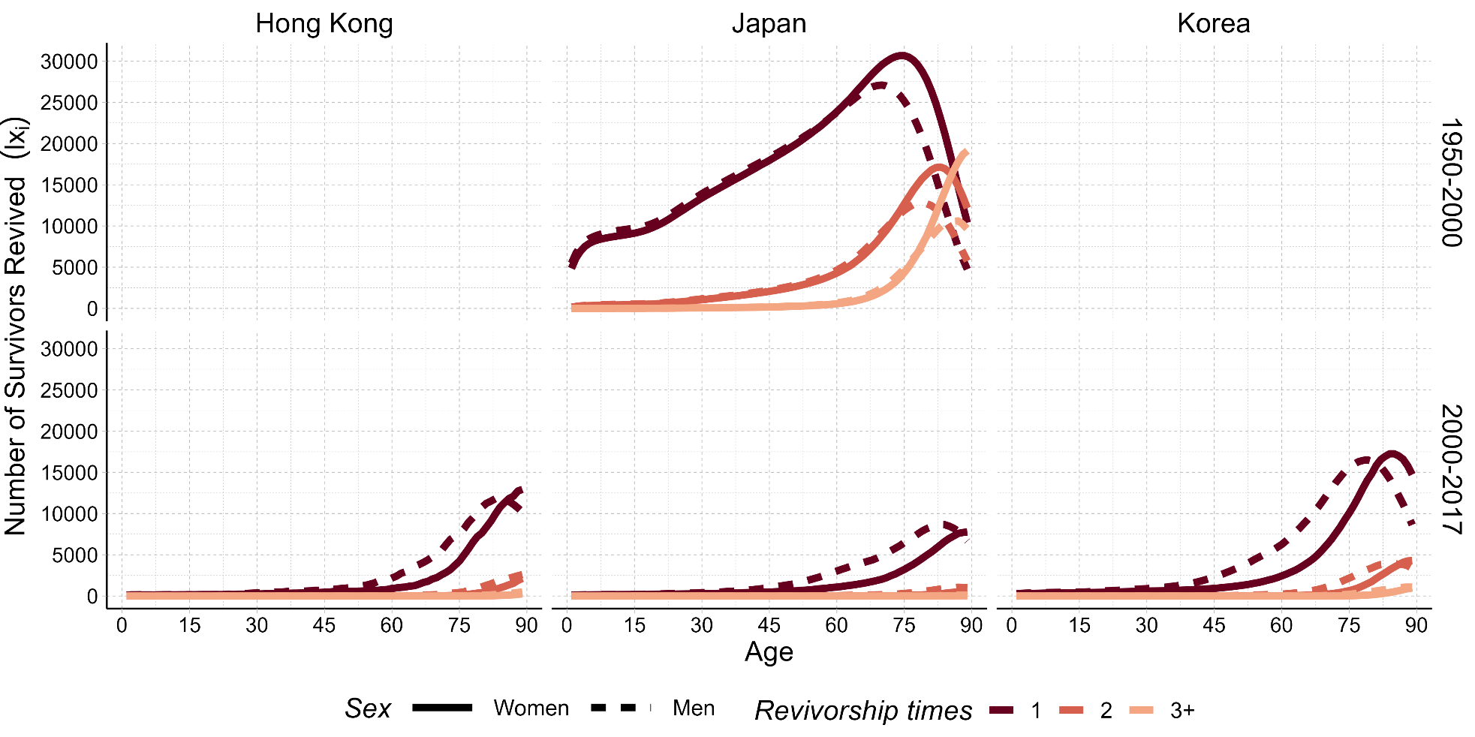

Source: Own calculations. Data from the Human Mortality Database. University of California, Berkeley (USA), and Max Planck Institute for Demographic Research (Germany). Available at www.mortality.org or www.humanmortality.de

**Fig A5.** Revivorship across all fast-paced transition countries, by year and sex

**Fig A6.** Revivorship across all countries, years 2000-2017, by sex

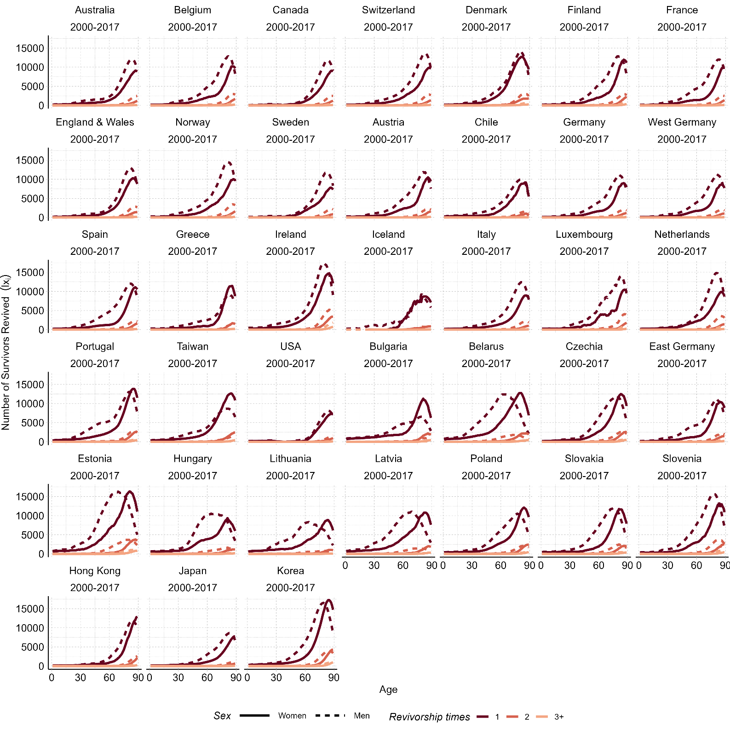

Source: Own calculations. Data from the Human Mortality Database. University of California, Berkeley (USA), and Max Planck Institute for Demographic Research (Germany). Available at www.mortality.org or www.humanmortality.de

**Fig A7** Revivorship across all countries, by year, sex and mortality transition type

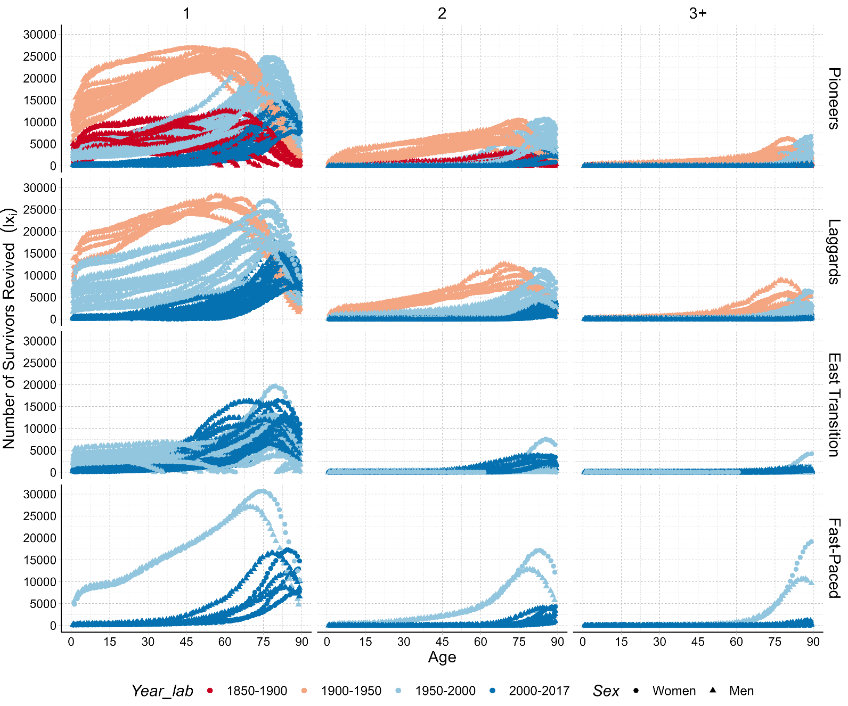

Source: Own calculations. Data from the Human Mortality Database. University of California, Berkeley (USA), and Max Planck Institute for Demographic Research (Germany). Available at www.mortality.org or [www.humanmortality.de](http://www.humanmortality.de)

Fig A8. Life table entropy by revivorship status and mortality transition characteristic.

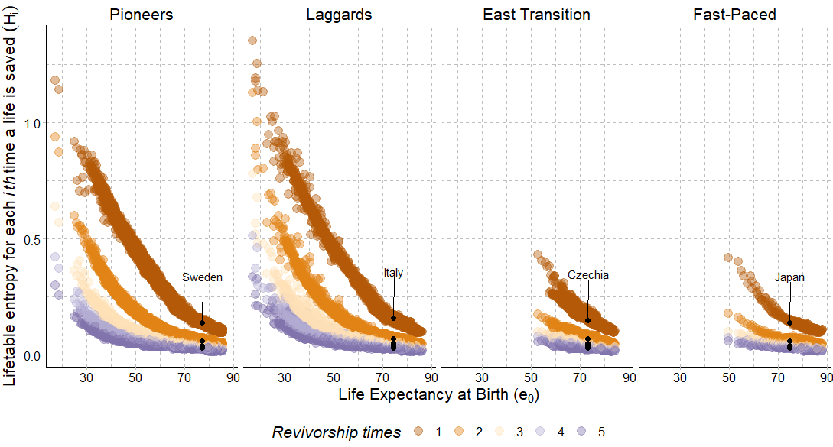

Source: Own calculations. Data from the Human Mortality Database. University of California, Berkeley (USA), and Max Planck Institute for Demographic Research (Germany). Available at www.mortality.org or [www.humanmortality.de](http://www.humanmortality.de). *Note:* The set of countries used in part one is highlighted to give an overview of where they are placed amongst countries across mortality transitions, but nonetheless this part of the analysis does not depend on the specific transitions, only on the life table.

**Table A1.** Country classification by mortality transition status and period used for comparing survival schedules, selected HMD countries

|  |  |  |  |
| --- | --- | --- | --- |
| Pioneers | Laggards | East-Transition | Fast-Paced (Asia) |
| (1850-2017) | (1900-2017) | (1960-2017) | (1950-2017) |
| ***50-years*** | ***50-years*** | ***50-years*** | ***50-years*** |
| France | Portugal | Croatia | Hong Kong* |
| Denmark | USA | Hungary | **Japan** |
| **Sweden** | Germany | Poland | Korea ** |
| Australia | West Germany | Slovakia |  |
| Belgium | Greece | Slovenia |  |
| Canada | Chile | Lithuania |  |
| Switzerland | Spain | Latvia |  |
| Norway | Luxembourg | **Czechia \*\*\*** |  |
| England & Wales | **Italy** | East Germany |  |
| Finland | Israel | Estonia |  |
| New Zealand | Ireland | Bulgaria |  |
|  | Iceland | Belarus |  |
|  | Austria |  |  |
|  | Taiwan |  |  |
| Source: Human Mortality Database. University of California, Berkeley (USA), and Max Planck Institute for Demographic Research (Germany). Available at www.mortality.org or [www.humanmortality.de](http://www.humanmortality.de). Note: * data is from 1986-2000; **data is from 2003 so included only in the analysis with all countries from 2000-2017; *** Czechia has data since 1950, and the other countries from 1960. Russia and Ukraine could not be included as they experience consecutive periods of worsening conditions in all years where data is available in the HMD. Likewise, Lithuania and Latvia have results only for women in some years, due to the same reason. | | | |
|  | | | |
|  | | | |
|  |

Table A2. Life expectancy at each revivorship state and total improvement in life expectancy at birth (in years) by sex, by country and year

|  |  |  |  |  |  |  |  |  |
| --- | --- | --- | --- | --- | --- | --- | --- | --- |
| Country | Year | Sex | Life expectancy at birth | | | Life expectancy at each revivorship state | | |
|  |  |  | 1 | 2 | 3+ |
| Australia | 1950-2000 | Women | 82.3 | 71.7 | 10.5 | 8.0 | 1.8 | 0.8 |
| Men | 77.0 | 66.5 | 10.4 | 8.1 | 1.7 | 0.6 |
| 2000-2017 | Women | 84.8 | 82.3 | 2.5 | 2.3 | 0.2 | 0.0 |
| Men | 80.7 | 77.0 | 3.8 | 3.3 | 0.4 | 0.1 |
| Belgium | 1850-1900 | Women | 48.5 | 42.1 | 6.4 | 5.8 | 0.5 | 0.0 |
| Men | 45.0 | 42.5 | 2.5 | 2.4 | 0.1 | 0.0 |
| 1900-1950 | Women | 68.9 | 48.5 | 20.4 | 16.2 | 3.4 | 0.8 |
| Men | 63.8 | 45.0 | 18.8 | 15.2 | 3.1 | 0.6 |
| 1950-2000 | Women | 80.9 | 68.9 | 12.0 | 9.4 | 1.9 | 0.7 |
| Men | 74.6 | 63.8 | 10.7 | 9.1 | 1.3 | 0.3 |
| 2000-2017 | Women | 83.7 | 80.9 | 2.8 | 2.5 | 0.2 | 0.0 |
| Men | 79.0 | 74.6 | 4.4 | 3.8 | 0.5 | 0.1 |
| Canada | 1950-2000 | Women | 81.8 | 70.6 | 11.2 | 8.9 | 1.7 | 0.6 |
| Men | 76.6 | 66.2 | 10.4 | 8.8 | 1.3 | 0.3 |
| 2000-2017 | Women | 84.1 | 81.8 | 2.3 | 2.1 | 0.2 | 0.0 |
| Men | 79.9 | 76.6 | 3.3 | 2.8 | 0.4 | 0.1 |
| Switzerland | 1900-1950 | Women | 71.1 | 48.9 | 22.1 | 16.5 | 4.1 | 1.5 |
| Men | 66.7 | 46.3 | 20.4 | 15.8 | 3.6 | 1.0 |
| 1950-2000 | Women | 82.6 | 71.1 | 11.5 | 8.5 | 2.0 | 0.9 |
| Men | 76.9 | 66.7 | 10.3 | 8.3 | 1.5 | 0.5 |
| 2000-2017 | Women | 85.4 | 82.6 | 2.8 | 2.6 | 0.2 | 0.0 |
| Men | 81.4 | 76.9 | 4.4 | 3.9 | 0.5 | 0.1 |
| Denmark | 1850-1900 | Women | 53.6 | 45.2 | 8.4 | 7.6 | 0.8 | 0.0 |
| Men | 50.3 | 41.9 | 8.3 | 7.5 | 0.8 | 0.1 |
| 1900-1950 | Women | 71.5 | 53.6 | 17.9 | 14.8 | 2.6 | 0.5 |
| Men | 69.1 | 50.3 | 18.8 | 15.1 | 3.0 | 0.7 |
| 1950-2000 | Women | 79.1 | 71.5 | 7.6 | 6.1 | 1.1 | 0.5 |
| Men | 74.4 | 69.1 | 5.3 | 4.9 | 0.4 | 0.1 |
| 2000-2017 | Women | 83.1 | 79.1 | 4.0 | 3.6 | 0.4 | 0.0 |
| Men | 79.1 | 74.4 | 4.7 | 4.0 | 0.5 | 0.1 |
| Finland | 1900-1950 | Women | 67.9 | 43.2 | 24.7 | 18.9 | 4.7 | 1.0 |
| Men | 60.4 | 40.4 | 19.9 | 16.0 | 3.4 | 0.6 |
| 1950-2000 | Women | 81.0 | 67.9 | 13.1 | 9.9 | 2.2 | 1.0 |
| Men | 74.2 | 60.4 | 13.8 | 10.7 | 2.2 | 0.8 |
| 2000-2017 | Women | 84.2 | 81.0 | 3.2 | 2.8 | 0.4 | 0.1 |
| Men | 78.7 | 74.2 | 4.6 | 3.9 | 0.5 | 0.1 |

**Table A1 Continues**

|  |  |  |  |  |  |  |  |  |
| --- | --- | --- | --- | --- | --- | --- | --- | --- |
| France | 1850-1900 | Women | 47.0 | 44.0 | 3.0 | 2.8 | 0.1 | 0.0 |
| Men | 43.3 | 42.6 | 0.7 | 0.6 | 0.1 | 0.0 |
| 1900-1950 | Women | 69.2 | 47.0 | 22.2 | 16.9 | 4.1 | 1.2 |
| Men | 63.4 | 43.3 | 20.1 | 15.7 | 3.5 | 0.8 |
| 1950-2000 | Women | 82.8 | 69.2 | 13.6 | 10.3 | 2.3 | 1.1 |
| Men | 75.2 | 63.4 | 11.8 | 9.5 | 1.7 | 0.6 |
| 2000-2017 | Women | 85.4 | 82.8 | 2.6 | 2.3 | 0.2 | 0.0 |
| Men | 79.4 | 75.2 | 4.2 | 3.7 | 0.5 | 0.1 |
| England & Wales | 1850-1900 | Women | 48.3 | 43.7 | 4.6 | 4.3 | 0.3 | 0.0 |
| Men | 44.4 | 41.9 | 2.5 | 2.4 | 0.2 | 0.0 |
| 1900-1950 | Women | 71.3 | 48.3 | 23.0 | 17.6 | 4.3 | 1.2 |
| Men | 66.5 | 44.4 | 22.1 | 17.1 | 4.1 | 1.0 |
| 1950-2000 | Women | 80.4 | 71.3 | 9.1 | 7.2 | 1.3 | 0.5 |
| Men | 75.6 | 66.5 | 9.1 | 7.4 | 1.3 | 0.4 |
| 2000-2017 | Women | 83.2 | 80.4 | 2.8 | 2.6 | 0.2 | 0.0 |
| Men | 79.5 | 75.6 | 3.9 | 3.3 | 0.5 | 0.1 |
| Norway | 1850-1900 | Women | 55.1 | 51.3 | 3.9 | 3.6 | 0.2 | 0.0 |
| Men | 51.8 | 47.8 | 4.0 | 3.7 | 0.3 | 0.0 |
| 1900-1950 | Women | 73.3 | 55.1 | 18.1 | 15.0 | 2.7 | 0.4 |
| Men | 69.9 | 51.8 | 18.1 | 14.9 | 2.8 | 0.5 |
| 1950-2000 | Women | 81.4 | 73.3 | 8.1 | 6.7 | 1.1 | 0.3 |
| Men | 76.0 | 69.9 | 6.0 | 5.5 | 0.4 | 0.0 |
| 2000-2017 | Women | 84.3 | 81.4 | 2.9 | 2.6 | 0.2 | 0.0 |
| Men | 80.9 | 76.0 | 5.0 | 4.2 | 0.6 | 0.1 |
| New Zealand | 1950-2000 | Women | 81.2 | 71.2 | 10.0 | 7.9 | 1.5 | 0.6 |
| Men | 76.1 | 67.4 | 8.6 | 7.1 | 1.2 | 0.3 |
| Sweden | 1850-1900 | Women | 53.6 | 47.3 | 6.3 | 5.7 | 0.6 | 0.1 |
| Men | 50.8 | 42.2 | 8.6 | 7.4 | 1.1 | 0.2 |
| 1900-1950 | Women | 72.4 | 53.6 | 18.8 | 15.6 | 2.8 | 0.4 |
| Men | 69.9 | 50.8 | 19.0 | 15.6 | 2.9 | 0.5 |
| 1950-2000 | Women | 82.0 | 72.4 | 9.6 | 7.2 | 1.6 | 0.8 |
| Men | 77.4 | 69.9 | 7.5 | 6.4 | 0.9 | 0.2 |
| 2000-2017 | Women | 84.1 | 82.0 | 2.1 | 2.0 | 0.1 | 0.0 |
| Men | 80.7 | 77.4 | 3.3 | 2.9 | 0.3 | 0.1 |
| Austria | 1950-2000 | Women | 81.1 | 67.3 | 13.8 | 10.8 | 2.1 | 0.8 |
| Men | 75.1 | 62.2 | 12.9 | 10.6 | 1.8 | 0.5 |
| 2000-2017 | Women | 83.9 | 81.1 | 2.8 | 2.5 | 0.2 | 0.0 |
| Men | 79.3 | 75.1 | 4.2 | 3.7 | 0.4 | 0.1 |
| Chile | 2000-2017 | Women | 82.3 | 79.9 | 2.3 | 2.2 | 0.1 | 0.0 |
| Men | 77.1 | 73.7 | 3.4 | 3.1 | 0.3 | 0.0 |
| Germany | 2000-2017 | Women | 83.3 | 81.0 | 2.3 | 2.1 | 0.2 | 0.0 |
| Men | 78.6 | 74.9 | 3.7 | 3.3 | 0.4 | 0.1 |
| West Germany | 2000-2017 | Women | 83.3 | 81.1 | 2.2 | 2.0 | 0.2 | 0.0 |
| Men | 78.8 | 75.1 | 3.7 | 3.3 | 0.4 | 0.1 |
| Spain | 1950-2000 | Women | 82.9 | 64.2 | 18.7 | 14.5 | 3.1 | 1.1 |
| Men | 76.0 | 59.3 | 16.7 | 13.4 | 2.5 | 0.8 |
| 2000-2017 | Women | 85.7 | 82.9 | 2.8 | 2.5 | 0.3 | 0.0 |
| Men | 80.3 | 76.0 | 4.4 | 3.9 | 0.4 | 0.1 |

**Table A1 Continues**

|  |  |  |  |  |  |  |  |  |
| --- | --- | --- | --- | --- | --- | --- | --- | --- |
| Greece | 2000-2017 | Women | 83.8 | 81.2 | 2.6 | 2.3 | 0.2 | 0.0 |
| Men | 78.6 | 75.5 | 3.1 | 2.7 | 0.3 | 0.1 |
| Ireland | 1950-2000 | Women | 79.2 | 66.7 | 12.4 | 10.1 | 1.8 | 0.5 |
| Men | 73.9 | 64.5 | 9.4 | 8.3 | 1.0 | 0.2 |
| 2000-2017 | Women | 83.7 | 79.2 | 4.5 | 3.9 | 0.6 | 0.1 |
| Men | 80.1 | 73.9 | 6.2 | 4.9 | 0.9 | 0.3 |
| Iceland | 1900-1950 | Women | 73.5 | 49.6 | 23.9 | 17.4 | 4.6 | 1.9 |
| Men | 68.6 | 43.7 | 24.9 | 17.2 | 5.3 | 2.3 |
| 1950-2000 | Women | 81.5 | 73.5 | 8.0 | 6.9 | 0.9 | 0.2 |
| Men | 77.8 | 68.6 | 9.3 | 7.9 | 1.2 | 0.2 |
| 2000-2017 | Women | 84.1 | 81.5 | 2.5 | 2.4 | 0.2 | 0.0 |
| Men | 80.8 | 77.8 | 2.9 | 2.7 | 0.2 | 0.0 |
| Italy | 1900-1950 | Women | 67.4 | 42.0 | 25.4 | 18.5 | 5.2 | 1.7 |
| Men | 63.9 | 41.8 | 22.2 | 17.0 | 4.1 | 1.0 |
| 1950-2000 | Women | 82.5 | 67.4 | 15.1 | 11.7 | 2.4 | 1.0 |
| Men | 76.5 | 63.9 | 12.6 | 10.6 | 1.6 | 0.4 |
| 2000-2017 | Women | 84.9 | 82.5 | 2.4 | 2.2 | 0.2 | 0.0 |
| Men | 80.5 | 76.5 | 3.9 | 3.5 | 0.4 | 0.0 |
| Luxembourg | 2000-2017 | Women | 83.9 | 80.8 | 3.1 | 2.8 | 0.3 | 0.0 |
| Men | 79.6 | 74.5 | 5.1 | 4.3 | 0.6 | 0.2 |
| Netherlands | 1900-1950 | Women | 72.6 | 49.9 | 22.7 | 17.7 | 4.0 | 1.0 |
| Men | 70.3 | 47.1 | 23.2 | 17.9 | 4.2 | 1.1 |
| 1950-2000 | Women | 80.6 | 72.6 | 8.0 | 6.4 | 1.2 | 0.4 |
| Men | 75.5 | 70.3 | 5.2 | 4.9 | 0.3 | 0.0 |
| 2000-2017 | Women | 83.3 | 80.6 | 2.8 | 2.5 | 0.2 | 0.0 |
| Men | 80.1 | 75.5 | 4.5 | 3.8 | 0.6 | 0.1 |
| Portugal | 1950-2000 | Women | 80.4 | 61.0 | 19.3 | 15.6 | 3.0 | 0.7 |
| Men | 73.3 | 55.8 | 17.5 | 14.4 | 2.5 | 0.6 |
| 2000-2017 | Women | 84.4 | 80.4 | 4.0 | 3.5 | 0.4 | 0.1 |
| Men | 78.4 | 73.3 | 5.1 | 4.5 | 0.5 | 0.1 |
| Taiwan | 2000-2017 | Women | 83.3 | 79.2 | 4.1 | 3.5 | 0.4 | 0.1 |
| Men | 77.1 | 73.4 | 3.7 | 3.3 | 0.3 | 0.0 |
| USA | 1950-2000 | Women | 79.4 | 71.0 | 8.4 | 7.0 | 1.1 | 0.3 |
| Men | 74.1 | 65.4 | 8.7 | 7.3 | 1.1 | 0.3 |
| 2000-2017 | Women | 81.4 | 79.4 | 1.9 | 1.7 | 0.2 | 0.0 |
| Men | 76.3 | 74.1 | 2.2 | 1.9 | 0.3 | 0.1 |
| Bulgaria | 1960-2000 | Women | 75.0 | 70.9 | 4.1 | 3.9 | 0.2 | 0.0 |
| Men | 68.3 | 67.5 | 0.8 | 0.6 | 0.4 | -0.1 |
| 2000-2017 | Women | 78.3 | 75.0 | 3.3 | 2.9 | 0.3 | 0.1 |
| Men | 71.4 | 68.3 | 3.1 | 2.8 | 0.2 | 0.0 |
| Belarus | 2000-2017 | Women | 79.2 | 74.7 | 4.6 | 4.1 | 0.4 | 0.1 |
| Men | 69.3 | 63.3 | 6.0 | 5.3 | 0.6 | 0.1 |
| Czechia2 | 1950-2000 | Women | 78.3 | 73.3 | 5.0 | 4.4 | 0.5 | 0.1 |
| Men | 71.6 | 67.5 | 4.1 | 3.7 | 0.3 | 0.0 |
| 2000-2017 | Women | 81.9 | 78.3 | 3.5 | 3.1 | 0.4 | 0.1 |
| Men | 76.0 | 71.6 | 4.5 | 3.8 | 0.5 | 0.1 |
| **Table A1 Continues** | | | | | | | | | |

|  |  |  |  |  |  |  |  |  |
| --- | --- | --- | --- | --- | --- | --- | --- | --- |
|  |  | | | | | | | |
| East Germany | 1950-2000 | Women | 80.7 | 71.3 | 9.4 | 7.4 | 1.4 | 0.6 |
| Men | 73.7 | 66.5 | 7.2 | 6.3 | 0.8 | 0.2 |
| 2000-2017 | Women | 83.3 | 80.7 | 2.6 | 2.4 | 0.2 | 0.0 |
| Men | 77.7 | 73.7 | 3.9 | 3.5 | 0.4 | 0.1 |
| Estonia | 1960-2000 | Women | 76.3 | 73.0 | 3.3 | 3.0 | 0.2 | 0.0 |
| Men | 65.6 | 64.7 | 0.9 | 0.8 | 0.1 | 0.0 |
| 2000-2017 | Women | 82.3 | 76.3 | 6.0 | 5.1 | 0.7 | 0.1 |
| Men | 73.7 | 65.6 | 8.1 | 6.7 | 1.1 | 0.2 |
| Hungary | 1960-2000 | Women | 76.0 | 70.2 | 5.8 | 5.2 | 0.6 | 0.1 |
| Men | 67.5 | 65.9 | 1.6 | 1.4 | 0.1 | 0.0 |
| 2000-2017 | Women | 79.3 | 76.0 | 3.2 | 3.0 | 0.2 | 0.0 |
| Men | 72.6 | 67.5 | 5.1 | 4.5 | 0.5 | 0.1 |
| Lithuania | 1960-2000 | Women | 77.4 | 73.0 | 4.3 | 4.1 | 0.3 | 0.0 |
| 2000-2017 | Women | 80.4 | 77.4 | 3.0 | 2.8 | 0.2 | 0.0 |
| Men | 70.7 | 66.7 | 4.0 | 3.7 | 0.2 | 0.0 |
| Latvia | 1960-2000 | Women | 75.7 | 73.5 | 2.2 | 2.1 | 0.1 | 0.0 |
| 2000-2017 | Women | 79.5 | 75.7 | 3.8 | 3.5 | 0.3 | 0.0 |
| Men | 69.8 | 64.5 | 5.3 | 4.7 | 0.5 | 0.1 |
| Poland | 1960-2000 | Women | 77.9 | 70.6 | 7.3 | 6.6 | 0.6 | 0.1 |
| Men | 69.5 | 64.8 | 4.7 | 4.5 | 0.2 | 0.0 |
| 2000-2017 | Women | 81.5 | 77.9 | 3.6 | 3.1 | 0.4 | 0.1 |
| Men | 73.9 | 69.5 | 4.3 | 3.8 | 0.5 | 0.1 |
| Slovakia | 1960-2000 | Women | 77.3 | 72.5 | 4.8 | 4.3 | 0.4 | 0.1 |
| Men | 69.0 | 68.1 | 0.9 | 0.8 | 0.1 | 0.0 |
| 2000-2017 | Women | 80.6 | 77.3 | 3.3 | 2.9 | 0.4 | 0.1 |
| Men | 73.8 | 69.0 | 4.8 | 4.1 | 0.5 | 0.1 |
| Slovenia | 2000-2017 | Women | 83.7 | 79.7 | 3.9 | 3.5 | 0.4 | 0.1 |
| Men | 78.1 | 72.2 | 5.9 | 5.0 | 0.8 | 0.1 |
| Hong Kong | 2000-2017 | Women | 87.7 | 84.1 | 3.6 | 3.0 | 0.5 | 0.1 |
| Men | 81.7 | 78.1 | 3.6 | 3.1 | 0.4 | 0.1 |
| Japan1 | 1950-2000 | Women | 85.3 | 60.9 | 24.4 | 16.1 | 4.7 | 3.6 |
| Men | 78.3 | 57.6 | 20.8 | 14.7 | 3.8 | 2.2 |
| 2000-2017 | Women | 87.3 | 85.3 | 2.0 | 1.9 | 0.1 | 0.0 |
| Men | 81.1 | 78.3 | 2.8 | 2.5 | 0.2 | 0.0 |
| Korea1 | 2000-2017 | Women | 85.8 | 80.7 | 5.1 | 4.2 | 0.7 | 0.2 |
| Men | 79.7 | 73.8 | 6.0 | 5.0 | 0.8 | 0.2 |
|  |  |  |  |  |  |  |  |  |

Source: Own calculations. Data from the Human Mortality Database. University of California, Berkeley (USA), and Max Planck Institute for Demographic Research (Germany). Available at www.mortality.org or [www.humanmortality.de](http://www.humanmortality.de). 1. Survival for Japan and korea refer more precisely to year 2003, in order to make the comparison with Hong Kong and Korea within the fast-paced group consistent, which only have data from 2003. 2. Survival for Czechia refers more precisely to year 1960, in order to make the comparison with all the other countries in the eastern transition, which only have data from 1960.

Table A3. Life years gained by saving a life the i-th time and added lifespan benefit to total life expectancy at birth by sex, selected countries, periods 1850-2017.

|  |  |  |  |  |  |  |  |  |  |  |  |  |  |
| --- | --- | --- | --- | --- | --- | --- | --- | --- | --- | --- | --- | --- | --- |
| Country | Year | Sex |  | Life years gained by saving a life the *i-th* time | | | | | Average lifespans of those revived *i* times | | | | |
|
|
| 1 | 2 | 3 | 4 | 5 | 1 | 2 | 3 | 4 | 5 |
| Australia | 1950 | Women | 71.7 | 12.9 | 5.7 | 3.6 | 2.9 | 2.2 | 84.6 | 90.4 | 94.0 | 96.8 | 99.0 |
| 1950 | Men | 66.5 | 14.0 | 6.0 | 4.0 | 3.3 | 2.7 | 80.5 | 86.5 | 90.5 | 93.8 | 96.5 |
| 2000 | Women | 82.3 | 9.9 | 4.1 | 3.3 | 2.5 | 1.7 | 92.1 | 96.3 | 99.5 | 102.0 | 103.7 |
| 2000 | Men | 77.0 | 10.8 | 4.6 | 3.1 | 2.3 | 2.3 | 87.7 | 92.3 | 95.4 | 97.7 | 100.0 |
| 2017 | Women | 84.8 | 9.3 | 4.2 | 2.5 | 2.5 | 1.7 | 94.1 | 98.4 | 100.9 | 103.5 | 105.2 |
| 2017 | Men | 80.7 | 10.5 | 4.8 | 3.2 | 2.4 | 1.6 | 91.2 | 96.1 | 99.3 | 101.7 | 103.3 |
| Austria | 1950 | Women | 67.3 | 14.8 | 6.1 | 4.0 | 2.7 | 2.7 | 82.1 | 88.1 | 92.2 | 94.9 | 97.6 |
| 1950 | Men | 62.2 | 16.8 | 6.2 | 4.4 | 3.1 | 2.5 | 79.0 | 85.2 | 89.5 | 92.7 | 95.1 |
| 2000 | Women | 81.1 | 8.9 | 4.1 | 3.2 | 2.4 | 1.6 | 90.0 | 94.1 | 97.3 | 99.7 | 101.4 |
| 2000 | Men | 75.1 | 11.3 | 5.3 | 3.8 | 2.3 | 2.3 | 86.4 | 91.6 | 95.4 | 97.6 | 99.9 |
| 2017 | Women | 83.9 | 8.4 | 4.2 | 2.5 | 2.5 | 1.7 | 92.3 | 96.5 | 99.0 | 101.5 | 103.2 |
| 2017 | Men | 79.3 | 10.3 | 4.8 | 3.2 | 2.4 | 1.6 | 89.6 | 94.4 | 97.5 | 99.9 | 101.5 |
| Belgium | 1850 | Women | 42.1 | 25.3 | 11.8 | 6.3 | 4.2 | 3.0 | 67.4 | 79.2 | 85.5 | 89.7 | 92.7 |
| 1850 | Men | 42.5 | 25.1 | 11.5 | 5.9 | 3.8 | 3.0 | 67.5 | 79.0 | 84.9 | 88.7 | 91.7 |
| 1900 | Women | 48.5 | 23.3 | 9.7 | 4.9 | 3.4 | 2.4 | 71.8 | 81.5 | 86.3 | 89.7 | 92.2 |
| 1900 | Men | 45.0 | 23.8 | 10.4 | 5.4 | 3.6 | 2.7 | 68.8 | 79.2 | 84.6 | 88.2 | 90.9 |
| 1950 | Women | 68.9 | 13.8 | 5.5 | 3.4 | 2.8 | 2.1 | 82.7 | 88.2 | 91.6 | 94.4 | 96.5 |
| 1950 | Men | 63.8 | 15.3 | 6.4 | 3.8 | 3.2 | 2.6 | 79.1 | 85.5 | 89.3 | 92.5 | 95.1 |
| 2000 | Women | 80.9 | 9.7 | 4.1 | 3.2 | 2.4 | 1.6 | 90.6 | 94.7 | 97.9 | 100.3 | 102.0 |
| 2000 | Men | 74.6 | 11.2 | 5.2 | 3.7 | 3.0 | 2.2 | 85.8 | 91.0 | 94.7 | 97.7 | 99.9 |
| 2017 | Women | 83.7 | 9.2 | 4.2 | 2.5 | 2.5 | 1.7 | 92.9 | 97.0 | 99.5 | 102.1 | 103.7 |
| 2017 | Men | 79.0 | 10.3 | 4.7 | 3.2 | 2.4 | 1.6 | 89.3 | 94.0 | 97.2 | 99.5 | 101.1 |
| Bulgaria | 1950 | Women | 63.3 | 19.6 | 7.6 | 5.1 | 3.8 | 3.2 | 82.9 | 90.5 | 95.6 | 99.4 | 102.5 |
| 1950 | Men | 59.7 | 20.3 | 8.4 | 5.4 | 4.2 | 3.0 | 80.0 | 88.4 | 93.7 | 97.9 | 100.9 |
| 2000 | Women | 75.0 | 10.5 | 4.5 | 3.0 | 2.3 | 2.3 | 85.5 | 90.0 | 93.0 | 95.3 | 97.5 |
| 2000 | Men | 68.3 | 12.3 | 6.2 | 4.1 | 2.7 | 2.1 | 80.6 | 86.7 | 90.8 | 93.6 | 95.6 |
| 2017 | Women | 78.3 | 10.2 | 4.7 | 3.1 | 2.4 | 2.4 | 88.5 | 93.2 | 96.4 | 98.7 | 101.1 |
| 2017 | Men | 71.4 | 12.1 | 5.7 | 3.6 | 2.9 | 2.1 | 83.5 | 89.2 | 92.8 | 95.6 | 97.8 |
| Belarus | 2000 | Women | 74.7 | 11.2 | 5.2 | 3.7 | 3.0 | 2.2 | 85.9 | 91.1 | 94.8 | 97.8 | 100.1 |
| 2000 | Men | 63.3 | 13.9 | 7.0 | 5.1 | 3.8 | 3.2 | 77.2 | 84.2 | 89.3 | 93.1 | 96.2 |
| 2017 | Women | 79.2 | 9.5 | 4.8 | 3.2 | 2.4 | 2.4 | 88.7 | 93.5 | 96.7 | 99.0 | 101.4 |
| 2017 | Men | 69.3 | 12.5 | 6.2 | 4.2 | 3.5 | 2.8 | 81.7 | 88.0 | 92.1 | 95.6 | 98.4 |
| Canada | 1950 | Women | 70.6 | 14.1 | 5.7 | 3.5 | 2.8 | 2.1 | 84.7 | 90.4 | 93.9 | 96.7 | 98.8 |
| **Table A2 Continues** | | | | | | | | | | | | |
|  | | | | | | | | | | | | |
| 1950 | Men | 66.2 | 15.2 | 6.6 | 4.0 | 3.3 | 2.7 | 81.4 | 88.0 | 92.0 | 95.3 | 97.9 |
| 2000 | Women | 81.8 | 9.8 | 4.9 | 3.3 | 2.5 | 1.6 | 91.6 | 96.5 | 99.8 | 102.2 | 103.9 |
| 2000 | Men | 76.6 | 10.7 | 5.4 | 3.8 | 3.1 | 2.3 | 87.3 | 92.7 | 96.5 | 99.6 | 101.9 |
| 2017 | Women | 84.1 | 10.1 | 4.2 | 3.4 | 2.5 | 1.7 | 94.2 | 98.4 | 101.8 | 104.3 | 106.0 |
| 2017 | Men | 79.9 | 10.4 | 4.8 | 3.2 | 2.4 | 1.6 | 90.3 | 95.1 | 98.3 | 100.7 | 102.3 |
| Switzerland | 1900 | Women | 48.9 | 21.5 | 8.8 | 4.9 | 3.4 | 2.9 | 70.5 | 79.3 | 84.2 | 87.6 | 90.5 |
| 1900 | Men | 46.3 | 22.7 | 9.7 | 5.1 | 3.7 | 2.8 | 68.9 | 78.6 | 83.7 | 87.4 | 90.2 |
| 1950 | Women | 71.1 | 12.8 | 5.0 | 3.6 | 2.8 | 2.1 | 83.9 | 88.9 | 92.4 | 95.3 | 97.4 |
| 1950 | Men | 66.7 | 14.0 | 6.0 | 4.0 | 3.3 | 2.7 | 80.7 | 86.7 | 90.7 | 94.0 | 96.7 |
| 2000 | Women | 82.6 | 9.1 | 4.1 | 2.5 | 2.5 | 1.7 | 91.6 | 95.8 | 98.3 | 100.7 | 102.4 |
| 2000 | Men | 76.9 | 10.8 | 4.6 | 3.1 | 2.3 | 2.3 | 87.7 | 92.3 | 95.4 | 97.7 | 100.0 |
| 2017 | Women | 85.4 | 8.5 | 3.4 | 2.6 | 1.7 | 1.7 | 93.9 | 97.3 | 99.9 | 101.6 | 103.3 |
| 2017 | Men | 81.4 | 9.8 | 4.1 | 3.3 | 2.4 | 1.6 | 91.1 | 95.2 | 98.5 | 100.9 | 102.5 |
| Chile | 2000 | Women | 79.9 | 10.4 | 4.8 | 3.2 | 2.4 | 2.4 | 90.3 | 95.1 | 98.3 | 100.7 | 103.1 |
| 2000 | Men | 73.7 | 12.5 | 5.9 | 3.7 | 3.0 | 2.2 | 86.2 | 92.1 | 95.8 | 98.8 | 101.0 |
| 2017 | Women | 82.3 | 9.9 | 4.1 | 2.5 | 2.5 | 1.7 | 92.1 | 96.2 | 98.7 | 101.2 | 102.8 |
| 2017 | Men | 77.1 | 10.8 | 4.6 | 3.1 | 2.3 | 2.3 | 87.9 | 92.5 | 95.6 | 97.9 | 100.2 |
| Czechia | 1950 | Women | 66.8 | 14.7 | 6.0 | 4.0 | 2.7 | 2.7 | 81.5 | 87.5 | 91.6 | 94.2 | 96.9 |
| 1950 | Men | 62.0 | 16.1 | 6.2 | 3.7 | 3.1 | 2.5 | 78.1 | 84.3 | 88.0 | 91.1 | 93.6 |
| 2000 | Women | 78.3 | 9.4 | 4.7 | 3.1 | 2.4 | 2.4 | 87.7 | 92.4 | 95.6 | 97.9 | 100.3 |
| 2000 | Men | 71.6 | 11.5 | 5.7 | 3.6 | 2.9 | 2.2 | 83.0 | 88.7 | 92.3 | 95.2 | 97.3 |
| 2017 | Women | 81.9 | 9.0 | 4.1 | 2.5 | 2.5 | 1.6 | 90.9 | 95.0 | 97.4 | 99.9 | 101.5 |
| 2017 | Men | 76.0 | 10.6 | 5.3 | 3.0 | 2.3 | 2.3 | 86.7 | 92.0 | 95.0 | 97.3 | 99.6 |
| East Germany | 2000 | Women | 80.7 | 9.7 | 4.8 | 3.2 | 2.4 | 2.4 | 90.4 | 95.2 | 98.4 | 100.9 | 103.3 |
| 2000 | Men | 73.7 | 11.1 | 5.2 | 3.7 | 3.0 | 2.2 | 84.8 | 89.9 | 93.6 | 96.6 | 98.8 |
| 2017 | Women | 83.3 | 9.2 | 4.2 | 2.5 | 2.5 | 1.7 | 92.5 | 96.7 | 99.2 | 101.7 | 103.3 |
| 2017 | Men | 77.7 | 10.9 | 4.7 | 3.1 | 2.3 | 2.3 | 88.5 | 93.2 | 96.3 | 98.6 | 101.0 |
| Germany | 2000 | Women | 81.0 | 9.7 | 4.1 | 3.2 | 2.4 | 1.6 | 90.7 | 94.8 | 98.0 | 100.4 | 102.1 |
| 2000 | Men | 74.9 | 11.2 | 5.2 | 3.7 | 3.0 | 2.3 | 86.1 | 91.3 | 95.1 | 98.1 | 100.3 |
| 2017 | Women | 83.3 | 9.2 | 4.2 | 2.5 | 2.5 | 1.7 | 92.5 | 96.6 | 99.1 | 101.6 | 103.3 |
| 2017 | Men | 78.6 | 10.2 | 4.7 | 3.1 | 2.4 | 2.4 | 88.8 | 93.5 | 96.6 | 99.0 | 101.3 |
| West Germany | 2000 | Women | 81.1 | 9.7 | 4.1 | 3.2 | 2.4 | 1.6 | 90.8 | 94.9 | 98.1 | 100.5 | 102.1 |
| 2000 | Men | 75.1 | 10.5 | 5.3 | 3.8 | 3.0 | 2.3 | 85.7 | 90.9 | 94.7 | 97.7 | 99.9 |
| 2017 | Women | 83.3 | 9.2 | 4.2 | 2.5 | 2.5 | 1.7 | 92.4 | 96.6 | 99.1 | 101.6 | 103.3 |
| 2017 | Men | 78.8 | 10.3 | 4.7 | 3.2 | 2.4 | 2.4 | 89.1 | 93.8 | 96.9 | 99.3 | 101.7 |
| Denmark | 1850 | Women | 45.2 | 25.3 | 11.3 | 6.3 | 4.5 | 3.6 | 70.5 | 81.8 | 88.1 | 92.6 | 96.2 |
| 1850 | Men | 41.9 | 25.2 | 11.7 | 6.3 | 4.2 | 3.4 | 67.1 | 78.8 | 85.1 | 89.3 | 92.6 |
| 1900 | Women | 53.6 | 21.4 | 8.6 | 4.3 | 3.2 | 2.7 | 75.0 | 83.6 | 87.9 | 91.1 | 93.8 |
| 1900 | Men | 50.3 | 22.1 | 8.5 | 4.5 | 3.0 | 2.5 | 72.4 | 80.9 | 85.4 | 88.4 | 90.9 |
| 1950 | Women | 71.5 | 12.2 | 5.0 | 3.6 | 2.9 | 2.2 | 83.7 | 88.7 | 92.3 | 95.1 | 97.3 |
| **Table A2 Continues** | | | | | | | | | | | | |
| 1950 | Men | 69.1 | 13.1 | 5.5 | 3.5 | 2.8 | 2.1 | 82.2 | 87.8 | 91.2 | 94.0 | 96.1 |
| 2000 | Women | 79.1 | 10.3 | 4.8 | 3.2 | 2.4 | 2.4 | 89.4 | 94.2 | 97.3 | 99.7 | 102.1 |
| 2000 | Men | 74.4 | 11.2 | 5.2 | 3.7 | 3.0 | 2.2 | 85.6 | 90.8 | 94.5 | 97.5 | 99.8 |
| 2017 | Women | 83.1 | 9.1 | 4.2 | 3.3 | 2.5 | 1.7 | 92.3 | 96.4 | 99.7 | 102.2 | 103.9 |
| 2017 | Men | 79.1 | 10.3 | 4.8 | 3.2 | 2.4 | 2.4 | 89.4 | 94.1 | 97.3 | 99.7 | 102.0 |
| Spain | 1950 | Women | 64.2 | 18.0 | 7.1 | 4.5 | 3.2 | 2.6 | 82.1 | 89.2 | 93.7 | 96.9 | 99.5 |
| 1950 | Men | 59.3 | 18.4 | 7.1 | 4.7 | 3.6 | 3.0 | 77.7 | 84.8 | 89.5 | 93.1 | 96.0 |
| 2000 | Women | 82.9 | 9.1 | 4.1 | 3.3 | 2.5 | 1.7 | 92.0 | 96.1 | 99.4 | 101.9 | 103.6 |
| 2000 | Men | 76.0 | 11.4 | 5.3 | 3.8 | 3.0 | 2.3 | 87.4 | 92.7 | 96.5 | 99.5 | 101.8 |
| 2017 | Women | 85.7 | 8.6 | 4.3 | 2.6 | 1.7 | 1.7 | 94.2 | 98.5 | 101.1 | 102.8 | 104.5 |
| 2017 | Men | 80.3 | 9.6 | 4.8 | 3.2 | 2.4 | 1.6 | 90.0 | 94.8 | 98.0 | 100.4 | 102.0 |
| Estonia | 2000 | Women | 76.3 | 11.5 | 5.3 | 3.8 | 3.1 | 2.3 | 87.8 | 93.1 | 96.9 | 100.0 | 102.3 |
| 2000 | Men | 65.6 | 13.8 | 7.2 | 4.6 | 3.3 | 2.6 | 79.4 | 86.6 | 91.2 | 94.5 | 97.1 |
| 2017 | Women | 82.3 | 9.1 | 4.1 | 3.3 | 2.5 | 1.7 | 91.3 | 95.5 | 98.7 | 101.2 | 102.9 |
| 2017 | Men | 73.7 | 11.8 | 5.9 | 3.7 | 3.0 | 2.2 | 85.5 | 91.4 | 95.0 | 98.0 | 100.2 |
| Finland | 1900 | Women | 43.2 | 25.5 | 11.2 | 5.6 | 3.5 | 2.6 | 68.8 | 80.0 | 85.6 | 89.1 | 91.7 |
| 1900 | Men | 40.4 | 25.5 | 11.7 | 6.1 | 3.6 | 2.8 | 65.9 | 77.6 | 83.7 | 87.3 | 90.1 |
| 1950 | Women | 67.9 | 13.6 | 5.4 | 3.4 | 2.7 | 2.0 | 81.5 | 86.9 | 90.3 | 93.1 | 95.1 |
| 1950 | Men | 60.4 | 15.7 | 6.6 | 4.2 | 3.0 | 2.4 | 76.1 | 82.7 | 87.0 | 90.0 | 92.4 |
| 2000 | Women | 81.0 | 8.9 | 4.1 | 3.2 | 2.4 | 1.6 | 89.9 | 94.0 | 97.2 | 99.7 | 101.3 |
| 2000 | Men | 74.2 | 11.1 | 5.2 | 3.7 | 3.0 | 2.2 | 85.3 | 90.5 | 94.2 | 97.2 | 99.4 |
| 2017 | Women | 84.2 | 8.4 | 4.2 | 2.5 | 2.5 | 1.7 | 92.6 | 96.9 | 99.4 | 101.9 | 103.6 |
| 2017 | Men | 78.7 | 10.2 | 4.7 | 3.2 | 2.4 | 2.4 | 89.0 | 93.7 | 96.8 | 99.2 | 101.5 |
| France | 1850 | Women | 44.0 | 24.6 | 11.4 | 6.2 | 4.0 | 3.1 | 68.6 | 80.1 | 86.2 | 90.2 | 93.3 |
| 1850 | Men | 42.6 | 24.7 | 11.5 | 6.0 | 3.8 | 3.0 | 67.4 | 78.9 | 84.8 | 88.7 | 91.7 |
| 1900 | Women | 47.0 | 23.5 | 9.9 | 5.2 | 3.3 | 2.8 | 70.4 | 80.3 | 85.5 | 88.7 | 91.6 |
| 1900 | Men | 43.3 | 23.8 | 10.4 | 5.6 | 3.5 | 2.6 | 67.2 | 77.6 | 83.2 | 86.7 | 89.3 |
| 1950 | Women | 69.2 | 14.5 | 5.5 | 3.5 | 2.8 | 2.1 | 83.7 | 89.3 | 92.7 | 95.5 | 97.6 |
| 1950 | Men | 63.4 | 15.9 | 6.3 | 3.8 | 3.2 | 2.5 | 79.3 | 85.6 | 89.4 | 92.6 | 95.2 |
| 2000 | Women | 82.8 | 9.9 | 4.1 | 3.3 | 2.5 | 1.7 | 92.7 | 96.9 | 100.2 | 102.7 | 104.3 |
| 2000 | Men | 75.2 | 12.0 | 5.3 | 3.8 | 3.0 | 2.3 | 87.3 | 92.6 | 96.3 | 99.3 | 101.6 |
| 2017 | Women | 85.4 | 9.4 | 4.3 | 2.6 | 1.7 | 1.7 | 94.7 | 99.0 | 101.6 | 103.3 | 105.0 |
| 2017 | Men | 79.4 | 11.1 | 4.8 | 3.2 | 2.4 | 1.6 | 90.6 | 95.3 | 98.5 | 100.9 | 102.5 |
| England & Wales | 1850 | Women | 43.7 | 25.3 | 11.8 | 6.1 | 4.4 | 3.1 | 69.0 | 80.8 | 86.9 | 91.3 | 94.3 |
| 1850 | Men | 41.9 | 25.1 | 11.7 | 6.3 | 4.2 | 2.9 | 67.0 | 78.7 | 85.0 | 89.2 | 92.1 |
| 1900 | Women | 48.3 | 23.2 | 9.7 | 5.3 | 3.9 | 2.9 | 71.4 | 81.1 | 86.4 | 90.2 | 93.1 |
| 1900 | Men | 44.4 | 23.5 | 10.2 | 5.8 | 4.0 | 3.1 | 67.9 | 78.1 | 83.9 | 87.9 | 91.0 |
| 1950 | Women | 71.3 | 12.8 | 5.7 | 3.6 | 2.9 | 2.1 | 84.2 | 89.9 | 93.4 | 96.3 | 98.4 |
| 1950 | Men | 66.5 | 13.3 | 6.0 | 4.0 | 2.7 | 2.7 | 79.8 | 85.8 | 89.8 | 92.5 | 95.1 |
| 2000 | Women | 80.4 | 9.6 | 4.8 | 3.2 | 2.4 | 2.4 | 90.0 | 94.8 | 98.0 | 100.5 | 102.9 |
| **Table A2 Continues** | | | | | | | | | | | | |
| 2000 | Men | 75.6 | 10.6 | 5.3 | 3.8 | 3.0 | 2.3 | 86.2 | 91.5 | 95.3 | 98.3 | 100.6 |
| 2017 | Women | 83.2 | 9.2 | 4.2 | 3.3 | 2.5 | 1.7 | 92.4 | 96.5 | 99.8 | 102.3 | 104.0 |
| 2017 | Men | 79.5 | 10.3 | 4.8 | 3.2 | 2.4 | 2.4 | 89.9 | 94.7 | 97.8 | 100.2 | 102.6 |
| Greece | 2000 | Women | 81.2 | 8.9 | 4.1 | 3.3 | 2.4 | 2.4 | 90.1 | 94.2 | 97.4 | 99.9 | 102.3 |
| 2000 | Men | 75.5 | 11.3 | 5.3 | 3.8 | 3.0 | 2.3 | 86.9 | 92.1 | 95.9 | 98.9 | 101.2 |
| 2017 | Women | 83.8 | 8.4 | 4.2 | 2.5 | 2.5 | 1.7 | 92.1 | 96.3 | 98.8 | 101.3 | 103.0 |
| 2017 | Men | 78.6 | 11.0 | 5.5 | 3.1 | 2.4 | 2.4 | 89.6 | 95.1 | 98.3 | 100.6 | 103.0 |
| Hong Kong | 2000 | Women | 83.6 | 10.0 | 5.0 | 3.3 | 2.5 | 1.7 | 93.7 | 98.7 | 102.0 | 104.5 | 106.2 |
| 2000 | Men | 77.8 | 10.9 | 5.5 | 3.9 | 3.1 | 2.3 | 88.7 | 94.1 | 98.0 | 101.1 | 103.5 |
| 2017 | Women | 87.7 | 9.6 | 4.4 | 2.6 | 1.8 | 1.8 | 97.3 | 101.7 | 104.3 | 106.1 | 107.8 |
| 2017 | Men | 81.7 | 10.6 | 4.9 | 3.3 | 2.5 | 1.6 | 92.4 | 97.3 | 100.5 | 103.0 | 104.6 |
| Croatia | 2017 | Women | 80.9 | 8.9 | 4.0 | 3.2 | 2.4 | 1.6 | 89.8 | 93.8 | 97.0 | 99.5 | 101.1 |
| 2017 | Men | 74.9 | 10.5 | 5.2 | 3.7 | 3.0 | 2.3 | 85.4 | 90.6 | 94.3 | 97.3 | 99.6 |
| Hungary | 1950 | Women | 64.3 | 16.7 | 6.4 | 3.9 | 3.2 | 2.6 | 81.0 | 87.5 | 91.3 | 94.5 | 97.1 |
| 1950 | Men | 59.9 | 18.6 | 7.2 | 4.2 | 3.0 | 2.4 | 78.5 | 85.7 | 89.9 | 92.9 | 95.3 |
| 2000 | Women | 76.0 | 10.6 | 5.3 | 3.0 | 2.3 | 2.3 | 86.7 | 92.0 | 95.0 | 97.3 | 99.6 |
| 2000 | Men | 67.5 | 12.8 | 6.8 | 4.1 | 3.4 | 2.7 | 80.3 | 87.1 | 91.1 | 94.5 | 97.2 |
| 2017 | Women | 79.3 | 10.3 | 4.8 | 3.2 | 2.4 | 2.4 | 89.6 | 94.3 | 97.5 | 99.9 | 102.3 |
| 2017 | Men | 72.6 | 11.6 | 5.8 | 3.6 | 2.9 | 2.2 | 84.2 | 90.0 | 93.6 | 96.5 | 98.7 |
| Ireland | 1950 | Women | 66.7 | 15.4 | 6.0 | 4.0 | 3.3 | 2.7 | 82.1 | 88.1 | 92.1 | 95.4 | 98.1 |
| 1950 | Men | 64.5 | 15.5 | 6.5 | 3.9 | 3.2 | 2.6 | 80.0 | 86.4 | 90.3 | 93.5 | 96.1 |
| 2000 | Women | 79.2 | 9.5 | 4.8 | 3.2 | 2.4 | 2.4 | 88.7 | 93.4 | 96.6 | 99.0 | 101.4 |
| 2000 | Men | 73.9 | 11.1 | 5.2 | 3.7 | 3.0 | 2.2 | 85.0 | 90.2 | 93.9 | 96.9 | 99.1 |
| 2017 | Women | 83.7 | 8.4 | 4.2 | 2.5 | 2.5 | 1.7 | 92.1 | 96.3 | 98.8 | 101.3 | 103.0 |
| 2017 | Men | 80.1 | 9.6 | 4.8 | 3.2 | 2.4 | 2.4 | 89.7 | 94.5 | 97.7 | 100.1 | 102.5 |
| Iceland | 1850 | Women | 38.4 | 29.9 | 15.0 | 7.3 | 3.8 | 2.7 | 68.3 | 83.3 | 90.6 | 94.4 | 97.1 |
| 1850 | Men | 35.3 | 30.7 | 18.0 | 10.6 | 6.4 | 3.9 | 66.0 | 84.0 | 94.6 | 101.0 | 104.8 |
| 1900 | Women | 49.6 | 22.3 | 9.4 | 5.0 | 3.0 | 2.5 | 71.9 | 81.3 | 86.2 | 89.2 | 91.7 |
| 1900 | Men | 43.7 | 22.7 | 11.4 | 7.4 | 5.7 | 4.8 | 66.4 | 77.8 | 85.2 | 90.9 | 95.7 |
| 1950 | Women | 73.5 | 13.2 | 5.9 | 4.4 | 3.7 | 2.9 | 86.8 | 92.6 | 97.0 | 100.7 | 103.7 |
| 1950 | Men | 68.6 | 14.4 | 6.2 | 4.1 | 3.4 | 2.7 | 83.0 | 89.2 | 93.3 | 96.7 | 99.4 |
| 2000 | Women | 81.5 | 9.0 | 4.1 | 3.3 | 2.5 | 1.6 | 90.5 | 94.6 | 97.8 | 100.3 | 101.9 |
| 2000 | Men | 77.8 | 10.9 | 4.7 | 3.1 | 2.3 | 2.3 | 88.7 | 93.4 | 96.5 | 98.9 | 101.2 |
| 2017 | Women | 84.1 | 8.4 | 4.2 | 2.5 | 2.5 | 1.7 | 92.5 | 96.7 | 99.2 | 101.7 | 103.4 |
| 2017 | Men | 80.8 | 9.7 | 4.9 | 3.2 | 2.4 | 2.4 | 90.5 | 95.3 | 98.6 | 101.0 | 103.4 |
| Israel | 2000 | Women | 80.9 | 9.7 | 4.9 | 3.2 | 2.4 | 2.4 | 90.6 | 95.5 | 98.7 | 101.2 | 103.6 |
| 2000 | Men | 76.6 | 11.5 | 5.4 | 3.8 | 3.1 | 2.3 | 88.1 | 93.5 | 97.3 | 100.4 | 102.7 |
| Italy | 1900 | Women | 42.0 | 25.2 | 11.3 | 5.9 | 3.8 | 2.9 | 67.2 | 78.5 | 84.4 | 88.2 | 91.1 |
| 1900 | Men | 41.8 | 25.1 | 11.3 | 5.9 | 4.2 | 3.3 | 66.8 | 78.1 | 83.9 | 88.1 | 91.4 |
| 1950 | Women | 67.4 | 15.5 | 6.1 | 4.1 | 2.7 | 2.7 | 82.9 | 89.0 | 93.1 | 95.8 | 98.5 |
| **Table A2 Continues** | | | | | | | | | | | | |
| 1950 | Men | 63.9 | 16.6 | 6.4 | 3.8 | 2.6 | 2.6 | 80.6 | 87.0 | 90.8 | 93.4 | 95.9 |
| 2000 | Women | 82.5 | 9.1 | 4.1 | 3.3 | 2.5 | 1.7 | 91.6 | 95.7 | 99.0 | 101.5 | 103.1 |
| 2000 | Men | 76.5 | 10.7 | 5.4 | 3.1 | 2.3 | 2.3 | 87.2 | 92.6 | 95.7 | 98.0 | 100.3 |
| 2017 | Women | 84.9 | 8.5 | 4.2 | 2.6 | 2.6 | 1.7 | 93.4 | 97.6 | 100.1 | 102.7 | 104.4 |
| 2017 | Men | 80.5 | 9.7 | 4.0 | 3.2 | 2.4 | 1.6 | 90.1 | 94.1 | 97.3 | 99.8 | 101.4 |
| Japan | 1950 | Women | 60.9 | 18.3 | 7.3 | 4.3 | 3.0 | 2.4 | 79.1 | 86.5 | 90.7 | 93.8 | 96.2 |
| 1950 | Men | 57.6 | 17.9 | 7.5 | 4.6 | 3.5 | 2.3 | 75.4 | 82.9 | 87.5 | 91.0 | 93.3 |
| 2000 | Women | 84.5 | 9.3 | 4.2 | 3.4 | 2.5 | 1.7 | 93.8 | 98.1 | 101.4 | 104.0 | 105.7 |
| 2000 | Men | 77.7 | 10.9 | 5.4 | 3.1 | 2.3 | 2.3 | 88.6 | 94.0 | 97.1 | 99.4 | 101.8 |
| 2017 | Women | 87.3 | 8.7 | 3.5 | 2.6 | 1.8 | 1.8 | 96.0 | 99.5 | 102.1 | 103.9 | 105.6 |
| 2017 | Men | 81.1 | 9.7 | 4.9 | 3.2 | 2.4 | 1.6 | 90.8 | 95.7 | 98.9 | 101.3 | 103.0 |
| Korea | 2017 | Women | 85.8 | 8.6 | 4.3 | 2.6 | 2.6 | 1.7 | 94.4 | 98.6 | 101.2 | 103.8 | 105.5 |
| 2017 | Men | 79.7 | 10.4 | 4.8 | 3.2 | 2.4 | 2.4 | 90.1 | 94.9 | 98.1 | 100.5 | 102.8 |
| Lithuania | 2000 | Women | 77.4 | 10.8 | 4.6 | 3.1 | 2.3 | 2.3 | 88.2 | 92.8 | 95.9 | 98.3 | 100.6 |
| 2000 | Men | 66.7 | 14.7 | 7.3 | 4.7 | 3.3 | 2.7 | 81.4 | 88.8 | 93.4 | 96.8 | 99.4 |
| 2017 | Women | 80.4 | 9.6 | 4.0 | 3.2 | 2.4 | 1.6 | 90.0 | 94.0 | 97.2 | 99.7 | 101.3 |
| 2017 | Men | 70.7 | 12.7 | 6.4 | 4.2 | 2.8 | 2.1 | 83.4 | 89.8 | 94.0 | 96.9 | 99.0 |
| Luxembourg | 2000 | Women | 80.8 | 9.7 | 4.9 | 3.2 | 2.4 | 2.4 | 90.5 | 95.4 | 98.6 | 101.0 | 103.4 |
| 2000 | Men | 74.5 | 11.2 | 5.2 | 3.7 | 3.0 | 2.2 | 85.7 | 90.9 | 94.6 | 97.6 | 99.9 |
| 2017 | Women | 83.9 | 9.2 | 4.2 | 2.5 | 2.5 | 1.7 | 93.1 | 97.3 | 99.9 | 102.4 | 104.1 |
| 2017 | Men | 79.6 | 10.4 | 4.8 | 3.2 | 2.4 | 1.6 | 89.9 | 94.7 | 97.9 | 100.3 | 101.9 |
| Latvia | 2000 | Women | 75.7 | 11.4 | 5.3 | 3.8 | 3.0 | 2.3 | 87.1 | 92.4 | 96.2 | 99.2 | 101.5 |
| 2000 | Men | 64.5 | 14.2 | 7.1 | 4.5 | 3.2 | 2.6 | 78.7 | 85.8 | 90.4 | 93.6 | 96.2 |
| 2017 | Women | 79.5 | 10.3 | 4.8 | 3.2 | 2.4 | 1.6 | 89.9 | 94.6 | 97.8 | 100.2 | 101.8 |
| 2017 | Men | 69.8 | 13.3 | 6.3 | 4.2 | 2.8 | 2.8 | 83.1 | 89.3 | 93.5 | 96.3 | 99.1 |
| Netherlands | 1850 | Women | 40.8 | 25.7 | 12.2 | 6.5 | 4.1 | 2.9 | 66.5 | 78.7 | 85.3 | 89.4 | 92.2 |
| 1850 | Men | 38.9 | 26.1 | 12.8 | 6.6 | 4.3 | 3.1 | 65.0 | 77.8 | 84.4 | 88.7 | 91.8 |
| 1900 | Women | 49.9 | 23.0 | 9.5 | 5.0 | 3.5 | 2.5 | 72.9 | 82.3 | 87.3 | 90.8 | 93.3 |
| 1900 | Men | 47.1 | 23.6 | 9.9 | 5.2 | 3.3 | 2.8 | 70.7 | 80.6 | 85.8 | 89.1 | 91.9 |
| 1950 | Women | 72.6 | 11.6 | 5.1 | 3.6 | 2.9 | 2.2 | 84.2 | 89.3 | 92.9 | 95.8 | 98.0 |
| 1950 | Men | 70.3 | 12.7 | 5.6 | 3.5 | 2.8 | 2.1 | 83.0 | 88.6 | 92.1 | 94.9 | 97.0 |
| 2000 | Women | 80.6 | 9.7 | 4.8 | 3.2 | 2.4 | 1.6 | 90.2 | 95.1 | 98.3 | 100.7 | 102.3 |
| 2000 | Men | 75.5 | 10.6 | 5.3 | 3.8 | 3.0 | 2.3 | 86.1 | 91.4 | 95.2 | 98.2 | 100.5 |
| 2017 | Women | 83.3 | 9.2 | 4.2 | 2.5 | 2.5 | 1.7 | 92.5 | 96.7 | 99.2 | 101.7 | 103.3 |
| 2017 | Men | 80.1 | 9.6 | 4.8 | 3.2 | 2.4 | 1.6 | 89.7 | 94.5 | 97.7 | 100.1 | 101.7 |
| Norway | 1850 | Women | 51.3 | 23.1 | 9.7 | 5.1 | 3.6 | 3.1 | 74.4 | 84.1 | 89.2 | 92.8 | 95.9 |
| 1850 | Men | 47.8 | 23.4 | 10.5 | 5.7 | 3.8 | 2.9 | 71.2 | 81.7 | 87.4 | 91.3 | 94.1 |
| 1900 | Women | 55.1 | 22.1 | 8.8 | 4.4 | 3.3 | 2.8 | 77.2 | 86.0 | 90.4 | 93.7 | 96.5 |
| 1900 | Men | 51.8 | 22.8 | 9.3 | 4.7 | 3.1 | 2.6 | 74.6 | 83.9 | 88.5 | 91.6 | 94.2 |
| 1950 | Women | 73.3 | 11.7 | 5.1 | 3.7 | 2.9 | 2.2 | 85.0 | 90.1 | 93.8 | 96.7 | 98.9 |
|  | **Table A2 Continues** | | | | | | | | | | | |
| 1950 | Men | 69.9 | 13.3 | 5.6 | 3.5 | 2.8 | 2.1 | 83.2 | 88.8 | 92.3 | 95.1 | 97.2 |
| 2000 | Women | 81.4 | 9.8 | 4.1 | 3.3 | 2.4 | 1.6 | 91.1 | 95.2 | 98.5 | 100.9 | 102.5 |
| 2000 | Men | 76.0 | 10.6 | 4.6 | 3.0 | 2.3 | 2.3 | 86.6 | 91.1 | 94.2 | 96.5 | 98.7 |
| 2017 | Women | 84.3 | 8.4 | 4.2 | 2.5 | 2.5 | 1.7 | 92.7 | 96.9 | 99.5 | 102.0 | 103.7 |
| 2017 | Men | 80.9 | 9.7 | 4.1 | 3.2 | 2.4 | 1.6 | 90.6 | 94.7 | 97.9 | 100.4 | 102.0 |
| New Zealand | 1950 | Women | 71.2 | 13.5 | 5.7 | 3.6 | 2.9 | 2.1 | 84.8 | 90.5 | 94.0 | 96.9 | 99.0 |
| 1950 | Men | 67.4 | 13.5 | 6.1 | 4.0 | 3.4 | 2.7 | 80.9 | 87.0 | 91.0 | 94.4 | 97.1 |
| 2000 | Women | 81.2 | 10.6 | 4.9 | 3.3 | 2.4 | 1.6 | 91.8 | 96.6 | 99.9 | 102.3 | 104.0 |
| 2000 | Men | 76.1 | 11.4 | 5.3 | 3.8 | 3.0 | 2.3 | 87.5 | 92.8 | 96.6 | 99.6 | 101.9 |
| Poland | 2000 | Women | 77.9 | 10.1 | 4.7 | 3.1 | 2.3 | 2.3 | 88.1 | 92.7 | 95.9 | 98.2 | 100.5 |
| 2000 | Men | 69.5 | 12.5 | 6.3 | 4.2 | 3.5 | 2.8 | 82.0 | 88.3 | 92.5 | 95.9 | 98.7 |
| 2017 | Women | 81.5 | 9.8 | 4.1 | 3.3 | 2.5 | 1.6 | 91.3 | 95.4 | 98.7 | 101.1 | 102.7 |
| 2017 | Men | 73.9 | 11.8 | 5.9 | 3.7 | 3.0 | 2.2 | 85.7 | 91.6 | 95.3 | 98.2 | 100.4 |
| Portugal | 1950 | Women | 61.0 | 20.1 | 7.3 | 4.3 | 3.7 | 3.1 | 81.2 | 88.5 | 92.8 | 96.4 | 99.5 |
| 1950 | Men | 55.8 | 20.6 | 7.8 | 4.5 | 3.4 | 2.8 | 76.4 | 84.2 | 88.7 | 92.0 | 94.8 |
| 2000 | Women | 80.4 | 9.6 | 4.8 | 3.2 | 2.4 | 2.4 | 90.0 | 94.8 | 98.0 | 100.4 | 102.8 |
| 2000 | Men | 73.3 | 11.7 | 5.1 | 3.7 | 2.9 | 2.2 | 85.0 | 90.1 | 93.8 | 96.7 | 98.9 |
| 2017 | Women | 84.4 | 8.4 | 4.2 | 2.5 | 2.5 | 1.7 | 92.8 | 97.0 | 99.6 | 102.1 | 103.8 |
| 2017 | Men | 78.4 | 10.2 | 4.7 | 3.1 | 2.4 | 2.4 | 88.6 | 93.3 | 96.4 | 98.8 | 101.1 |
| Russia | 2000 | Women | 72.2 | 12.3 | 5.1 | 3.6 | 2.9 | 2.2 | 84.5 | 89.6 | 93.2 | 96.1 | 98.2 |
| 2000 | Men | 59.0 | 15.3 | 7.7 | 5.3 | 3.5 | 3.0 | 74.3 | 82.0 | 87.3 | 90.8 | 93.8 |
| Slovakia | 1950 | Women | 62.5 | 18.7 | 6.9 | 3.8 | 3.1 | 2.5 | 81.2 | 88.1 | 91.8 | 95.0 | 97.5 |
| 1950 | Men | 59.0 | 19.5 | 7.1 | 4.1 | 3.0 | 2.4 | 78.5 | 85.6 | 89.7 | 92.7 | 95.0 |
| 2000 | Women | 77.3 | 10.1 | 4.6 | 3.1 | 2.3 | 2.3 | 87.4 | 92.0 | 95.1 | 97.4 | 99.7 |
| 2000 | Men | 69.0 | 12.4 | 6.2 | 4.1 | 2.8 | 2.8 | 81.4 | 87.6 | 91.8 | 94.5 | 97.3 |
| 2017 | Women | 80.6 | 9.7 | 4.0 | 3.2 | 2.4 | 1.6 | 90.3 | 94.3 | 97.5 | 99.9 | 101.5 |
| 2017 | Men | 73.8 | 11.8 | 5.9 | 3.7 | 3.0 | 2.2 | 85.6 | 91.5 | 95.2 | 98.1 | 100.3 |
| Slovenia | 2000 | Women | 79.7 | 9.6 | 4.8 | 3.2 | 2.4 | 1.6 | 89.3 | 94.1 | 97.3 | 99.7 | 101.3 |
| 2000 | Men | 72.2 | 11.6 | 5.8 | 3.6 | 2.9 | 2.2 | 83.7 | 89.5 | 93.1 | 96.0 | 98.2 |
| 2017 | Women | 83.7 | 8.4 | 4.2 | 2.5 | 2.5 | 1.7 | 92.1 | 96.2 | 98.7 | 101.3 | 102.9 |
| 2017 | Men | 78.1 | 10.2 | 4.7 | 3.1 | 2.3 | 2.3 | 88.2 | 92.9 | 96.0 | 98.4 | 100.7 |
| Sweden | 1850 | Women | 47.3 | 23.6 | 9.9 | 5.2 | 3.3 | 2.8 | 70.9 | 80.9 | 86.1 | 89.4 | 92.2 |
| 1850 | Men | 42.2 | 24.0 | 11.0 | 5.9 | 3.8 | 3.0 | 66.2 | 77.2 | 83.1 | 86.9 | 89.8 |
| 1900 | Women | 53.6 | 22.0 | 8.6 | 4.3 | 3.2 | 2.2 | 75.6 | 84.2 | 88.5 | 91.7 | 93.9 |
| 1900 | Men | 50.8 | 22.9 | 9.1 | 4.6 | 3.1 | 2.5 | 73.7 | 82.8 | 87.4 | 90.4 | 93.0 |
| 1950 | Women | 72.4 | 11.6 | 5.1 | 3.6 | 2.9 | 2.2 | 84.0 | 89.1 | 92.7 | 95.6 | 97.8 |
| 1950 | Men | 69.9 | 12.6 | 5.6 | 3.5 | 2.8 | 2.1 | 82.4 | 88.0 | 91.5 | 94.3 | 96.4 |
| 2000 | Women | 82.0 | 9.0 | 4.1 | 3.3 | 2.5 | 1.6 | 91.0 | 95.1 | 98.4 | 100.9 | 102.5 |
|  | **Table A2 Continues** | | | | | | | | | | | |
| 2000 | Men | 77.4 | 10.1 | 4.6 | 3.1 | 2.3 | 2.3 | 87.4 | 92.1 | 95.2 | 97.5 | 99.8 |
| 2017 | Women | 84.1 | 8.4 | 4.2 | 2.5 | 2.5 | 1.7 | 92.5 | 96.7 | 99.3 | 101.8 | 103.5 |
| 2017 | Men | 80.7 | 9.7 | 4.0 | 3.2 | 2.4 | 1.6 | 90.4 | 94.5 | 97.7 | 100.1 | 101.7 |
| Taiwan | 2000 | Women | 79.2 | 10.3 | 4.8 | 3.2 | 2.4 | 2.4 | 89.5 | 94.3 | 97.5 | 99.8 | 102.2 |
| 2000 | Men | 73.4 | 12.5 | 5.9 | 3.7 | 2.9 | 2.2 | 85.9 | 91.8 | 95.5 | 98.4 | 100.6 |
| 2017 | Women | 83.3 | 9.2 | 4.2 | 3.3 | 2.5 | 1.7 | 92.5 | 96.6 | 99.9 | 102.4 | 104.1 |
| 2017 | Men | 77.1 | 11.6 | 5.4 | 3.9 | 3.1 | 2.3 | 88.7 | 94.1 | 97.9 | 101.0 | 103.3 |
| Ukraine | 2000 | Women | 73.5 | 11.0 | 5.2 | 3.7 | 2.9 | 2.2 | 84.6 | 89.7 | 93.4 | 96.3 | 98.5 |
| 2000 | Men | 62.1 | 14.9 | 7.5 | 4.4 | 3.1 | 2.5 | 77.0 | 84.4 | 88.8 | 91.9 | 94.4 |
| USA | 1950 | Women | 71.0 | 13.5 | 5.7 | 4.3 | 2.8 | 2.8 | 84.5 | 90.2 | 94.4 | 97.3 | 100.1 |
| 1950 | Men | 65.4 | 15.0 | 6.5 | 4.6 | 3.3 | 2.6 | 80.4 | 87.0 | 91.6 | 94.8 | 97.5 |
| 2000 | Women | 79.4 | 11.1 | 4.8 | 3.2 | 2.4 | 2.4 | 90.6 | 95.3 | 98.5 | 100.9 | 103.3 |
| 2000 | Men | 74.1 | 11.9 | 5.2 | 3.7 | 3.0 | 2.2 | 86.0 | 91.2 | 94.9 | 97.8 | 100.1 |
| 2017 | Women | 81.4 | 11.4 | 4.9 | 3.3 | 2.4 | 1.6 | 92.8 | 97.6 | 100.9 | 103.3 | 105.0 |
| 2017 | Men | 76.3 | 13.0 | 5.3 | 3.8 | 3.1 | 2.3 | 89.3 | 94.6 | 98.4 | 101.5 | 103.8 |

Source: Own calculations. Data from the Human Mortality Database. University of California, Berkeley (USA), and Max Planck Institute for Demographic Research (Germany). Available at www.mortality.org or [www.humanmortality.de](http://www.humanmortality.de)

**Table A4.** Peak Number of revived persons by revivorship status, year, sex and Peak age of revival, averaged across countries in the mortality transition groups.

|  |  |  |  |  |  |  |  |  |
| --- | --- | --- | --- | --- | --- | --- | --- | --- |
| Transition | Year | Sex | Peak Revival | | | Peak Age | | |
| 1 | 2 | 3+ | 1 | 2 | 3+ |
| Pioneers | 1850-1900 | Women | 11102 | 1977 | 374 | 54 | 76 | 79 |
| 1850-1900 | Men | 12471 | 2939 | 776 | 60 | 74 | 76 |
| 1900-1950 | Women | 26984 | 10463 | 6248 | 47 | 75 | 80 |
| 1900-1950 | Men | 26355 | 8068 | 2906 | 53 | 63 | 77 |
| 1950-2000 | Women | 24784 | 10692 | 6826 | 77 | 85 | 90 |
| 1950-2000 | Men | 22547 | 8333 | 3875 | 69 | 78 | 85 |
| 2000-2017 | Women | 12702 | 2430 | 566 | 82 | 91 | 94 |
| 2000-2017 | Men | 14469 | 3441 | 871 | 81 | 86 | 89 |
| Laggards | 1900-1950 | Women | 27468 | 11494 | 6031 | 66 | 74 | 80 |
| 1900-1950 | Men | 28088 | 12467 | 8823 | 58 | 69 | 77 |
| 1950-2000 | Women | 27009 | 11378 | 6441 | 77 | 81 | 87 |
| 1950-2000 | Men | 22029 | 7861 | 3630 | 71 | 79 | 86 |
| 2000-2017 | Women | 14675 | 3451 | 860 | 85 | 90 | 91 |
| 2000-2017 | Men | 17411 | 5210 | 1935 | 79 | 85 | 90 |
| Fast-Paced1 | 1950-2000 | Women | 30665 | 17148 | 19126 | 75 | 83 | 89 |
| 1950-2000 | Men | 27090 | 12813 | 10608 | 70 | 79 | 87 |
| 2000-2017 | Women | 17249 | 4305 | 1215 | 84 | 89 | 94 |
| 2000-2017 | Men | 16516 | 3943 | 1095 | 79 | 84 | 88 |
| East Transition2 | 1950-2000 | Women | 19692 | 7555 | 4299 | 80 | 85 | 90 |
| 1950-2000 | Men | 13013 | 3506 | 1236 | 76 | 83 | 88 |
| 2000-2017 | Women | 16366 | 3765 | 852 | 81 | 87 | 89 |
| 2000-2017 | Men | 16282 | 3775 | 1032 | 69 | 82 | 86 |

Source: Own calculations. Data from the Human Mortality Database. University of California, Berkeley (USA), and Max Planck Institute for Demographic Research (Germany). Available at www.mortality.org or [www.humanmortality.de](http://www.humanmortality.de) 1. Survival for some countries the Fast-Paced group refer more precisely to year 2003, in order to make the comparison with Hong Kong and Korea within the fast-paced group consistent, which only have data from 2003. 2. Survival for most countries in the East-Transition group refer more precisely to year 1960, in order to make the comparison with all the other countries in the eastern transition, which only have data from 1960; Czechia has data since 1950.

**Table A5.** Sex differences in the total number of revived persons by mortality schedule, sex ratio of revived persons by revivorship status, and %sex revival, selected countries, ages 50 and 90.

|  |  |  |  |  |  |  |  |
| --- | --- | --- | --- | --- | --- | --- | --- |
| Country | Years | Total Number Revived | | Sex Ratio of Revived by Revivorship | | | %Sex Difference in Total Revival* |
|
|
|  | |  | | |
| Women | Men | 1 | 2 | 3+ |
|  | **Age 50** |  |  |  |  |  |
| Sweden | 1850-1900 | 7272 | 12343 | 0.6 | 0.3 | 0.2 | -69.7 |
| 1900-1950 | 27851 | 28853 | 1.0 | 0.9 | 0.8 | -3.6 |
| 1950-2000 | 5557 | 6177 | 0.9 | 0.8 | 0.7 | -11.1 |
| 2000-2017 | 631 | 1051 | 0.6 | 0.4 | 0.2 | -66.5 |
| Italy | 1900-1950 | 34252 | 30431 | 1.1 | 1.2 | 1.4 | 11.1 |
| 1950-2000 | 12439 | 13510 | 0.9 | 0.8 | 0.7 | -8.6 |
| 2000-2017 | 885 | 2010 | 0.4 | 0.2 | 0.1 | -127.1 |
| Japan | 1950-2000 | 22408 | 22930 | 1.0 | 0.9 | 0.9 | -2.3 |
| 2000-2017 | 599 | 1439 | 0.4 | 0.2 | 0.1 | -140.2 |
| Czechia | 1950-2000 | 3316 | 3763 | 0.9 | 0.7 | 0.6 | -13.4 |
| 2000-2017 | 1263 | 3011 | 0.4 | 0.2 | 0.1 | -138.4 |
|  | **Age 90** |  |  |  |  |  |  |
| Sweden | 1850-1900 | 1315 | 821 | 1.8 | 1.5 | 1.2 | 37.6 |
| 1900-1950 | 3577 | 3098 | 1.4 | 1.0 | 0.7 | 13.4 |
| 1950-2000 | 21119 | 9000 | 1.8 | 2.5 | 3.9 | 57.4 |
| 2000-2017 | 7682 | 9283 | 1.0 | 0.5 | 0.2 | -20.8 |
| Italy | 1900-1950 | 5400 | 3098 | 1.3 | 1.6 | 2.3 | 42.6 |
| 1950-2000 | 23043 | 9888 | 2.0 | 2.4 | 3.2 | 57.1 |
| 2000-2017 | 8420 | 8668 | 1.1 | 0.6 | 0.3 | -2.9 |
| Japan1 | 1950-2000 | 38260 | 17370 | 2.4 | 2.3 | 2.1 | 54.6 |
| 2000-2017 | 8337 | 6994 | 1.3 | 0.7 | 0.4 | 16.1 |
| Czechia2 | 1950-2000 | 7675 | 2872 | 2.6 | 2.8 | 3.1 | 62.6 |
| 2000-2017 | 10893 | 7062 | 1.8 | 1.2 | 0.8 | 35.2 |

Source: Own calculations. Data from the Human Mortality Database. University of California, Berkeley (USA), and Max Planck Institute for Demographic Research (Germany). Available at www.mortality.org or [www.humanmortality.de](http://www.humanmortality.de). Note: * % Sex difference in total revival is computed as (women-men/women)*100, or the %sex difference with women as a reference. Hence, one interprets this value as how much more (less) in percentage points women are revived relative to men. In Sweden, comparing the 1850-1900 mortality schedules, women were revived less then men by almost 70% at age 50, while the opposite happens at age 90, with women being revived more than men by 38%. 1. Survival for Japan and korea refer more precisely to year 2003, in order to make the comparison with Hong Kong and Korea within the fast-paced group consistent, which only have data from 2003. 2. Survival for Czechia refers more precisely to year 1960, in order to make the comparison with all the other countries in the eastern transition, which only have data from 1960.

Main Manuscript Tables and Figures:

**Table 1.** Total number of revived persons at age 50 by mortality schedule, revivorship status and %revived in the new mortality regime, selected countries, by sex

|  |  |  |  |  |  |  |  |  |  |
| --- | --- | --- | --- | --- | --- | --- | --- | --- | --- |
| Country | Years | Sex | Total Number Revived | Revivorship | | | % Revived in the New Mortality Regime | | |
|  | | | | | |
|  | 1 | 2 | 3+ | 1 | 2 | 3+ |
| Sweden | 1850-1900 | Women | 7272 | 6842 | 412 | 17 | 10.7 | 0.6 | 0.0 |
| Men | 12343 | 10990 | 1252 | 101 | 18.1 | 2.1 | 0.2 |
| 1900-1950 | Women | 27851 | 23124 | 4175 | 552 | 25.2 | 4.5 | 0.6 |
| Men | 28853 | 23597 | 4596 | 660 | 26.4 | 5.1 | 0.7 |
| 1950-2000 | Women | 5557 | 5395 | 158 | 3 | 5.5 | 0.2 | 0.0 |
| Men | 6177 | 5973 | 199 | 5 | 6.2 | 0.2 | 0.0 |
| 2000-2017 | Women | 631 | 629 | 2 | 0 | 0.6 | 0.0 | 0.0 |
| Men | 1051 | 1045 | 6 | 0 | 1.1 | 0.0 | 0.0 |
| Italy | 1900-1950 | Women | 34252 | 26153 | 6765 | 1334 | 30.8 | 8.0 | 1.6 |
| Men | 30431 | 23847 | 5595 | 988 | 29.4 | 6.9 | 1.2 |
| 1950-2000 | Women | 12439 | 11607 | 794 | 38 | 11.9 | 0.8 | 0.0 |
| Men | 13510 | 12498 | 961 | 51 | 13.2 | 1.0 | 0.1 |
| 2000-2017 | Women | 885 | 881 | 4 | 0 | 0.9 | 0.0 | 0.0 |
| Men | 2010 | 1989 | 21 | 0 | 2.1 | 0.0 | 0.0 |
| Japan1 | 1950-2000 | Women | 22408 | 19610 | 2559 | 238 | 20.1 | 2.6 | 0.2 |
| Men | 22930 | 19922 | 2738 | 269 | 20.9 | 2.9 | 0.3 |
| 2000-2017 | Women | 599 | 597 | 2 | 0 | 0.6 | 0.0 | 0.0 |
| Men | 1439 | 1428 | 11 | 0 | 1.5 | 0.0 | 0.0 |
| Czechia2 | 1950-2000 | Women | 3316 | 3258 | 57 | 1 | 3.4 | 0.1 | 0.0 |
| Men | 3763 | 3685 | 77 | 1 | 4.0 | 0.1 | 0.0 |
| 2000-2017 | Women | 1263 | 1255 | 8 | 0 | 1.3 | 0.0 | 0.0 |
| Men | 3011 | 2963 | 48 | 1 | 3.1 | 0.0 | 0.0 |

Source: Own calculations. Data from the Human Mortality Database. University of California, Berkeley (USA), and Max Planck Institute for Demographic Research (Germany). Available at www.mortality.org or [www.humanmortality.de](http://www.humanmortality.de). Note: %Revived is the proportion of revived persons in each revivorship state and the new survival schedule. For example, the % of women at age 50 revived once in the mortality schedule comparison in Sweden from 1850-1900 is 6842 divided by 64031 (the lx in 1900). 1. Survival for Japan refers more precisely to year 2003, in order to make the comparison with Hong Kong and Korea within the fast-paced group consistent, which only have data from 2003. 2. Survival for Czechia refers more precisely to year 1960, in order to make the comparison with all the other countries in the eastern transition, which only have data from 1960.

**Table 2.** Total number of revived persons at age 90 by mortality schedule, revivorship status and %revived in the new mortality regime, selected countries, by sex

|  |  |  |  |  |  |  |  |  |  |
| --- | --- | --- | --- | --- | --- | --- | --- | --- | --- |
| Country | Years | Sex | Total Number Revived | Revivorship | | | % Revived in the New Mortality Regime | | |
|  | | | | | |
|  | 1 | 2 | 3+ | 1 | 2 | 3+ | |
| Sweden | 1850-1900 | Women | 1315 | 853 | 346 | 116 | 36.0 | 14.6 | 4.9 | |
| Men | 821 | 486 | 236 | 99 | 36.8 | 17.9 | 7.5 | |
| 1900-1950 | Women | 3577 | 2180 | 1003 | 394 | 36.7 | 16.9 | 6.6 | |
| Men | 3098 | 1595 | 963 | 540 | 36.1 | 21.8 | 12.2 | |
| 1950-2000 | Women | 21119 | 9011 | 6828 | 5280 | 33.3 | 25.2 | 19.5 | |
| Men | 9000 | 4908 | 2726 | 1366 | 36.6 | 20.3 | 10.2 | |
| 2000-2017 | Women | 7682 | 6762 | 845 | 75 | 19.5 | 2.4 | 0.2 | |
| Men | 9283 | 7055 | 1855 | 373 | 31.1 | 8.2 | 1.6 | |
| Italy | 1900-1950 | Women | 5400 | 1529 | 1645 | 2225 | 25.0 | 26.9 | 36.4 | |
| Men | 3098 | 1152 | 999 | 948 | 30.6 | 26.5 | 25.2 | |
| 1950-2000 | Women | 23043 | 9548 | 7460 | 6035 | 32.8 | 25.6 | 20.7 | |
| Men | 9888 | 4848 | 3124 | 1915 | 35.5 | 22.9 | 14.0 | |
| 2000-2017 | Women | 8420 | 7397 | 938 | 85 | 19.7 | 2.5 | 0.2 | |
| Men | 8668 | 6711 | 1650 | 307 | 30.1 | 7.4 | 1.4 | |
| Japan1 | 1950-2000 | Women | 38260 | 8515 | 10672 | 19073 | 20.4 | 25.6 | 45.8 | |
| Men | 17370 | 3607 | 4701 | 9061 | 19.2 | 25.1 | 48.3 | |
| 2000-2017 | Women | 8337 | 7600 | 693 | 44 | 15.2 | 1.4 | 0.1 | |
| Men | 6994 | 5944 | 942 | 108 | 23.1 | 3.7 | 0.4 | |
| Czechia2 | 1950-2000 | Women | 7675 | 5069 | 1975 | 631 | 35.7 | 13.9 | 4.5 | |
| Men | 2872 | 1970 | 701 | 201 | 34.9 | 12.4 | 3.6 | |
| 2000-2017 | Women | 10893 | 8082 | 2303 | 508 | 32.2 | 9.2 | 2.0 | |
| Men | 7062 | 4579 | 1859 | 624 | 36.0 | 14.6 | 4.9 | |

Source: Own calculations. Data from the Human Mortality Database. University of California, Berkeley (USA), and Max Planck Institute for Demographic Research (Germany). Available at www.mortality.org or [www.humanmortality.de](http://www.humanmortality.de). Note: %Revived is the proportion of revived persons in each revivorship state and the new survival schedule. For example, the % of women at age 90 revived once in the mortality schedule comparison in Sweden from 1850-1900 is 853 divided by 2368 (the lx in 1900). For the sake of presention, here we show only the difference in the mortality regimes expressed as the total number of revived persons. 1. Survival for Japan refers more precisely to year 2003, in order to make the comparison with Hong Kong and Korea within the fast-paced group consistent, which only have data from 2003. 2. Survival for Czechia refers more precisely to year 1960, in order to make the comparison with all the other countries in the eastern transition, which only have data from 1960.

**Table 3.** Total life years lived in each revivorship state and %contribution of each revival on improvements in total life expectancy at birth, selected countries, by mortality schedule and sex.

|  |  |  |  |  |  |  |  |  |  |  |  |
| --- | --- | --- | --- | --- | --- | --- | --- | --- | --- | --- | --- |
| Country | Years | Sex | Life expectancy at birth | | | Life years in each revivorship state | | | Contribution of each revivorship state (%) | | |
|
|  |  |  | 1 | 2 | 3+ | 1 | 2 | 3+ |
| Sweden | 1850-1900 | Women | 53.6 | 47.3 | 6.3 | 5.7 | 0.6 | 0.1 | 90.0 | 9.2 | 1.2 |
| Men | 50.8 | 42.2 | 8.6 | 7.4 | 1.1 | 0.2 | 85.8 | 12.3 | 2.1 |
| 1900-1950 | Women | 72.4 | 53.6 | 18.8 | 15.6 | 2.8 | 0.4 | 83.0 | 14.7 | 2.3 |
| Men | 69.9 | 50.8 | 19.1 | 15.6 | 2.9 | 0.5 | 81.6 | 15.4 | 2.7 |
| 1950-2000 | Women | 82.0 | 72.4 | 9.6 | 7.2 | 1.6 | 0.8 | 74.8 | 16.8 | 8.0 |
| Men | 77.4 | 69.9 | 7.5 | 6.4 | 0.9 | 0.2 | 85.3 | 11.9 | 3.0 |
| 2000-2017 | Women | 84.1 | 82.0 | 2.1 | 2.0 | 0.1 | 0.0 | 93.0 | 6.5 | 0.5 |
| Men | 80.7 | 77.4 | 3.3 | 2.9 | 0.3 | 0.1 | 89.3 | 10.6 | 1.5 |
| Italy | 1900-1950 | Women | 67.4 | 42.0 | 25.4 | 18.5 | 5.2 | 1.7 | 73.0 | 20.4 | 6.8 |
| Men | 63.9 | 41.8 | 22.1 | 17.0 | 4.1 | 1.0 | 76.9 | 18.7 | 4.7 |
| 1950-2000 | Women | 82.5 | 67.4 | 15.1 | 11.7 | 2.4 | 1.0 | 77.4 | 15.7 | 6.7 |
| Men | 76.5 | 63.9 | 12.6 | 10.6 | 1.6 | 0.4 | 84.4 | 12.4 | 3.1 |
| 2000-2017 | Women | 84.9 | 82.5 | 2.4 | 2.2 | 0.2 | 0.0 | 91.6 | 6.3 | 0.5 |
| Men | 80.5 | 76.5 | 4.0 | 3.5 | 0.4 | 0.0 | 87.3 | 9.4 | 1.2 |
| Japan1 | 1950-2000 | Women | 85.3 | 60.9 | 24.4 | 16.1 | 4.7 | 3.6 | 66.0 | 19.3 | 14.6 |
| Men | 78.3 | 57.6 | 20.7 | 14.7 | 3.8 | 2.2 | 71.1 | 18.5 | 10.5 |
| 2000-2017 | Women | 85.3 | 76.9 | 8.4 | 1.9 | 0.1 | 0.0 | 22.6 | 1.3 | 0.1 |
| Men | 81.1 | 78.3 | 2.8 | 2.5 | 0.2 | 0.0 | 92.6 | 6.7 | 0.6 |
| Czechia2 | 1950-2000 | Women | 78.3 | 73.3 | 5.0 | 4.4 | 0.5 | 0.1 | 87.8 | 10.1 | 1.9 |
| Men | 71.6 | 67.5 | 4.1 | 3.7 | 0.3 | 0.0 | 91.4 | 6.7 | 0.9 |
| 2000-2017 | Women | 81.9 | 78.3 | 3.6 | 3.1 | 0.4 | 0.1 | 85.3 | 10.9 | 1.9 |
| Men | 76.0 | 71.6 | 4.4 | 3.8 | 0.5 | 0.1 | 87.2 | 11.8 | 2.2 |

Source: Own calculations. Data from the Human Mortality Database. University of California, Berkeley (USA), and Max Planck Institute for Demographic Research (Germany). Available at www.mortality.org or [www.humanmortality.de](http://www.humanmortality.de). Note: The %contribution of each revivorship state is estimated as the proportion of life years in each revivorship state by the total difference in life expectancy at birth between two regimes. 1. Life expectancy for Japan refers more precisely to year 2003, in order to make the comparison with Hong Kong and Korea within the fast-paced group consistent, which only have data from 2003. 2. Life expectancy for Czechia refers more precisely to year 1960, in order to make the comparison with all the other countries in the eastern transition, which only have data from 1960.

**Table 4.** Life years gained by saving a life the *i-th* time and added lifespan benefit to total life expectancy at birth by sex, Sweden, Italy, Czechia and Japan, periods 1850-2017.

|  |  |  |  |  |  |  |  |  |  |  |  |  |  |
| --- | --- | --- | --- | --- | --- | --- | --- | --- | --- | --- | --- | --- | --- |
| Country | Year | Sex |  | Life years gained by saving a life the *i-th* time | | | | | Average lifespans of those revived *i* times | | | | |
|
|
| 1 | 2 | 3 | 4 | 5 | 1 | 2 | 3 | 4 | 5 |
| Sweden | 1850 | Women | 47.3 | 23.6 | 9.9 | 5.2 | 3.3 | 2.8 | 70.9 | 80.9 | 86.1 | 89.4 | 92.2 |
| Men | 42.2 | 24.0 | 11.0 | 5.9 | 3.8 | 3.0 | 66.2 | 77.2 | 83.1 | 86.9 | 89.8 |
| 1900 | Women | 53.6 | 22.0 | 8.6 | 4.3 | 3.2 | 2.2 | 75.6 | 84.2 | 88.5 | 91.7 | 93.9 |
| Men | 50.8 | 22.9 | 9.1 | 4.6 | 3.1 | 2.5 | 73.7 | 82.8 | 87.4 | 90.4 | 93.0 |
| 1950 | Women | 72.4 | 11.6 | 5.1 | 3.6 | 2.9 | 2.2 | 84.0 | 89.1 | 92.7 | 95.6 | 97.8 |
| Men | 69.9 | 12.6 | 5.6 | 3.5 | 2.8 | 2.1 | 82.4 | 88.0 | 91.5 | 94.3 | 96.4 |
| 2017 | Women | 84.1 | 8.4 | 4.2 | 2.5 | 2.5 | 1.7 | 92.5 | 96.7 | 99.3 | 101.8 | 103.5 |
| Men | 80.7 | 9.7 | 4.0 | 3.2 | 2.4 | 1.6 | 90.4 | 94.5 | 97.7 | 100.1 | 101.7 |
| Italy | 1900 | Women | 42.0 | 25.2 | 11.3 | 5.9 | 3.8 | 2.9 | 67.2 | 78.5 | 84.4 | 88.2 | 91.1 |
| Men | 41.8 | 25.1 | 11.3 | 5.9 | 4.2 | 3.3 | 66.8 | 78.1 | 83.9 | 88.1 | 91.4 |
| 1950 | Women | 67.4 | 15.5 | 6.1 | 4.1 | 2.7 | 2.7 | 82.9 | 89.0 | 93.1 | 95.8 | 98.5 |
| Men | 63.9 | 16.6 | 6.4 | 3.8 | 2.6 | 2.6 | 80.6 | 87.0 | 90.8 | 93.4 | 95.9 |
| 2017 | Women | 84.9 | 8.5 | 4.2 | 2.6 | 2.6 | 1.7 | 93.4 | 97.6 | 100.1 | 102.7 | 104.4 |
| Men | 80.5 | 9.7 | 4.0 | 3.2 | 2.4 | 1.6 | 90.1 | 94.1 | 97.3 | 99.8 | 101.4 |
| Czechia | 1950 | Women | 66.8 | 14.7 | 6.0 | 4.0 | 2.7 | 2.7 | 81.5 | 87.5 | 91.6 | 94.2 | 96.9 |
| Men | 62.0 | 16.1 | 6.2 | 3.7 | 3.1 | 2.5 | 78.1 | 84.3 | 88.0 | 91.1 | 93.6 |
| 2017 | Women | 81.9 | 9.0 | 4.1 | 2.5 | 2.5 | 1.6 | 90.9 | 95.0 | 97.4 | 99.9 | 101.5 |
| Men | 76.0 | 10.6 | 5.3 | 3.0 | 2.3 | 2.3 | 86.7 | 92.0 | 95.0 | 97.3 | 99.6 |
| Japan | 1950 | Women | 60.9 | 18.3 | 7.3 | 4.3 | 3.0 | 2.4 | 79.1 | 86.5 | 90.7 | 93.8 | 96.2 |
| Men | 57.6 | 17.9 | 7.5 | 4.6 | 3.5 | 2.3 | 75.4 | 82.9 | 87.5 | 91.0 | 93.3 |
| 2017 | Women | 87.3 | 8.7 | 3.5 | 2.6 | 1.8 | 1.8 | 96.0 | 99.5 | 102.1 | 103.9 | 105.6 |
| Men | 81.1 | 9.7 | 4.9 | 3.2 | 2.4 | 1.6 | 90.8 | 95.7 | 98.9 | 101.3 | 103.0 |

Source: Own calculations. Data from the Human Mortality Database. University of California, Berkeley (USA), and Max Planck Institute for Demographic Research (Germany). Available at www.mortality.org or [www.humanmortality.de](http://www.humanmortality.de)



**Fig 1.** Life expectancy at birth trajectories for HMD countries, by mortality transition status, year and sex.

Source: Human Mortality Database. University of California, Berkeley (USA), and Max Planck Institute for Demographic Research (Germany). Available at www.mortality.org or www.humanmortality.de

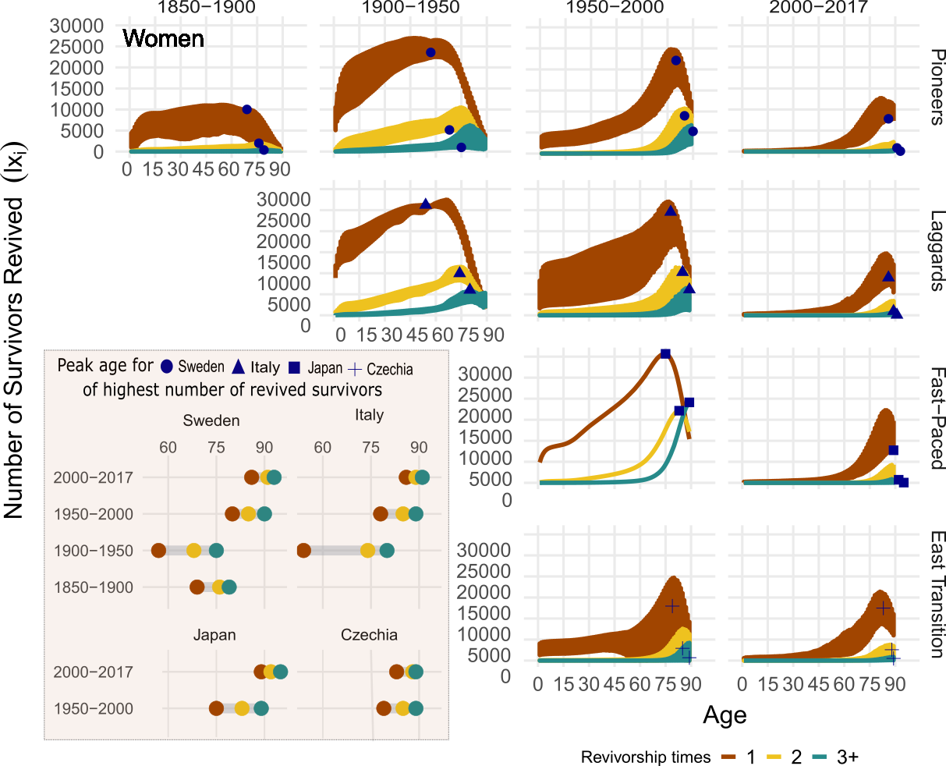

**Fig 2.** Number of female survivors revived by age, revivorship status andmortality transition, with peak age of revived for Sweden, Italy, Japan and Czechia highlighted, 1850-2017.

Source: Own calculations. Data from the Human Mortality Database. University of California, Berkeley (USA), and Max Planck Institute for Demographic Research (Germany). Available at www.mortality.org or [www.humanmortality.de](http://www.humanmortality.de).

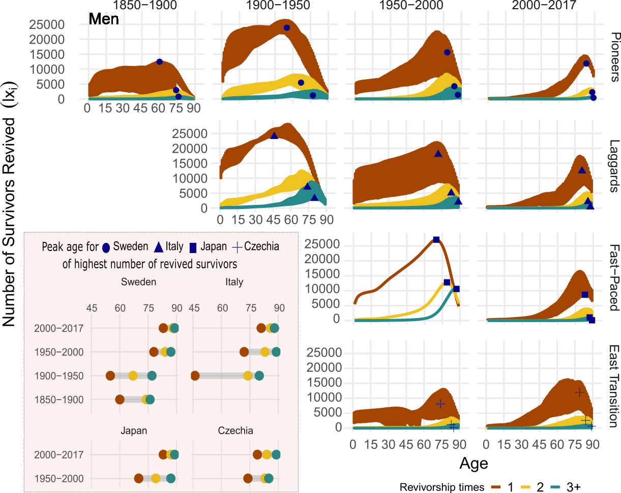

**Fig 3.** Number of male survivors revived by age, revivorship status and mortality transition, with peak age of revived for Sweden, Italy, Japan and Czechia highlighted, 1850-2017.

Source: Own calculations. Data from the Human Mortality Database. University of California, Berkeley (USA), and Max Planck Institute for Demographic Research (Germany). Available at www.mortality.org or [www.humanmortality.de](http://www.humanmortality.de).

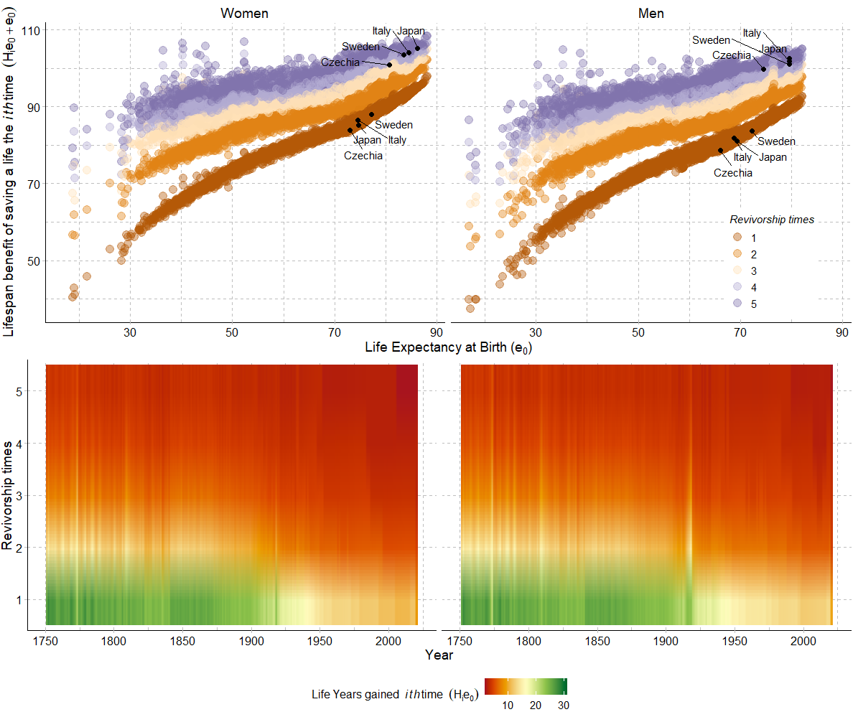

**Fig 4.** Lifespan benefit to total life expectancy at birth by sex of repeatedly saving lives up to 5 times, HMD countries, 1750-2017.

Source: Own calculations. Data from the Human Mortality Database. University of California, Berkeley (USA), and Max Planck Institute for Demographic Research (Germany). Available at www.mortality.org or www.humanmortality.de. *Note*:Sweden, Italy, Czechia and Japan are highlighted in the top panel for being the representatives of Pioneer, Laggards, East-Transition and Fast-Paced transition countries. For lifespan benefit of saving a live once (Revivorship times= 1) countries are highlighted for life expectancy at birth observed in year 1970 and for saving a life 5 times (Revivorship times=5) for year 2010, just as examples.