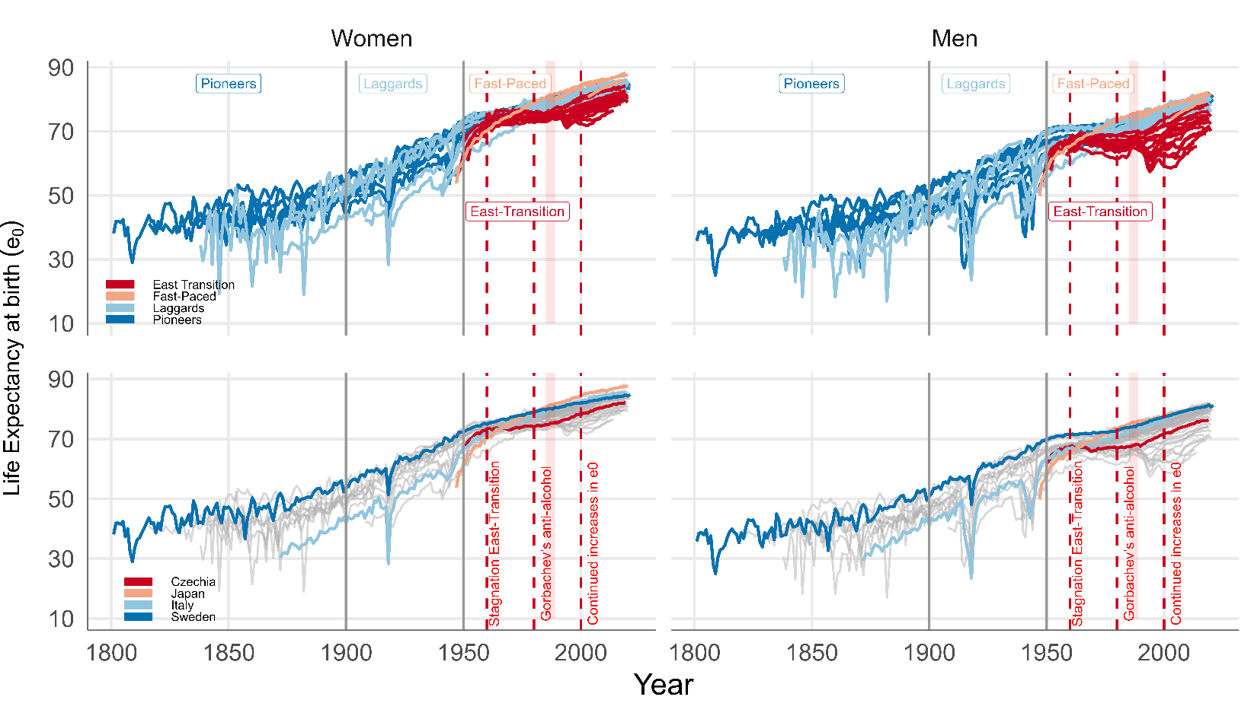

**Fig 1.** Life expectancy at birth trajectories for HMD countries, by mortality transition status, year and sex. Source: Human Mortality Database. University of California, Berkeley (USA), and Max Planck Institute for Demographic Research (Germany). Available at www.mortality.org or www.humanmortality.de