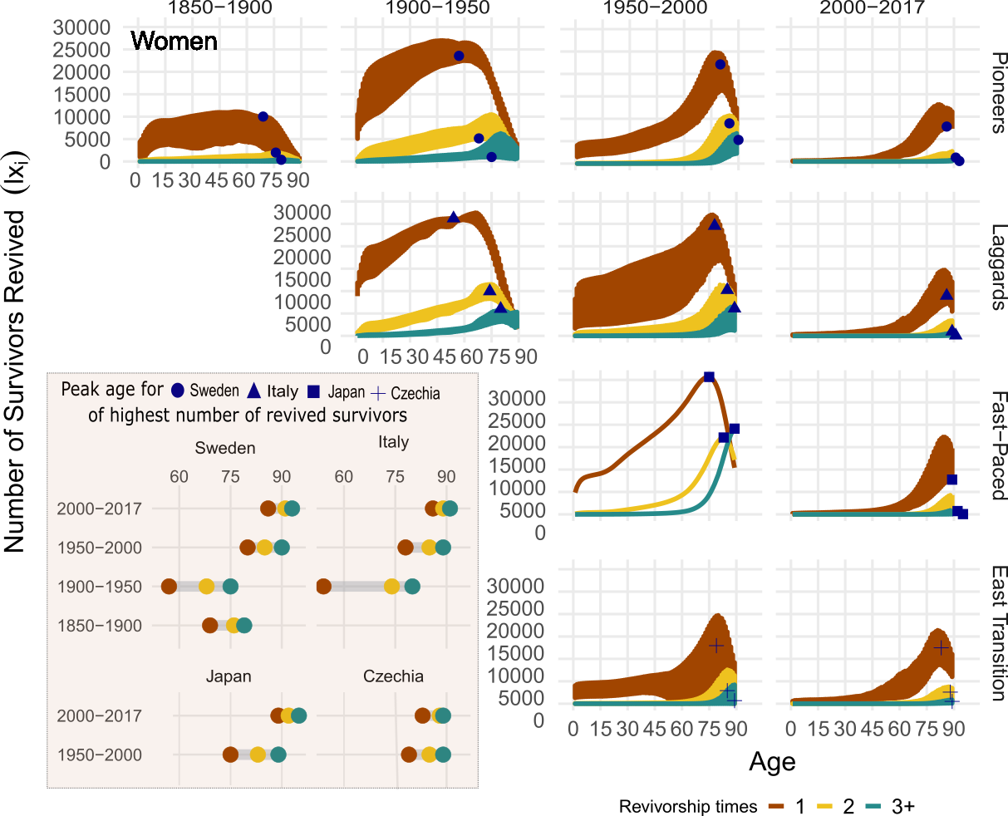

**Fig 2.** Number of female survivors revived by age, revivorship status andmortality transition, with peak age of revived for Sweden, Italy, Japan and Czechia highlighted, 1850-2017. Source: Own calculations. Data from the Human Mortality Database. University of California, Berkeley (USA), and Max Planck Institute for Demographic Research (Germany). Available at www.mortality.org or [www.humanmortality.de](http://www.humanmortality.de).