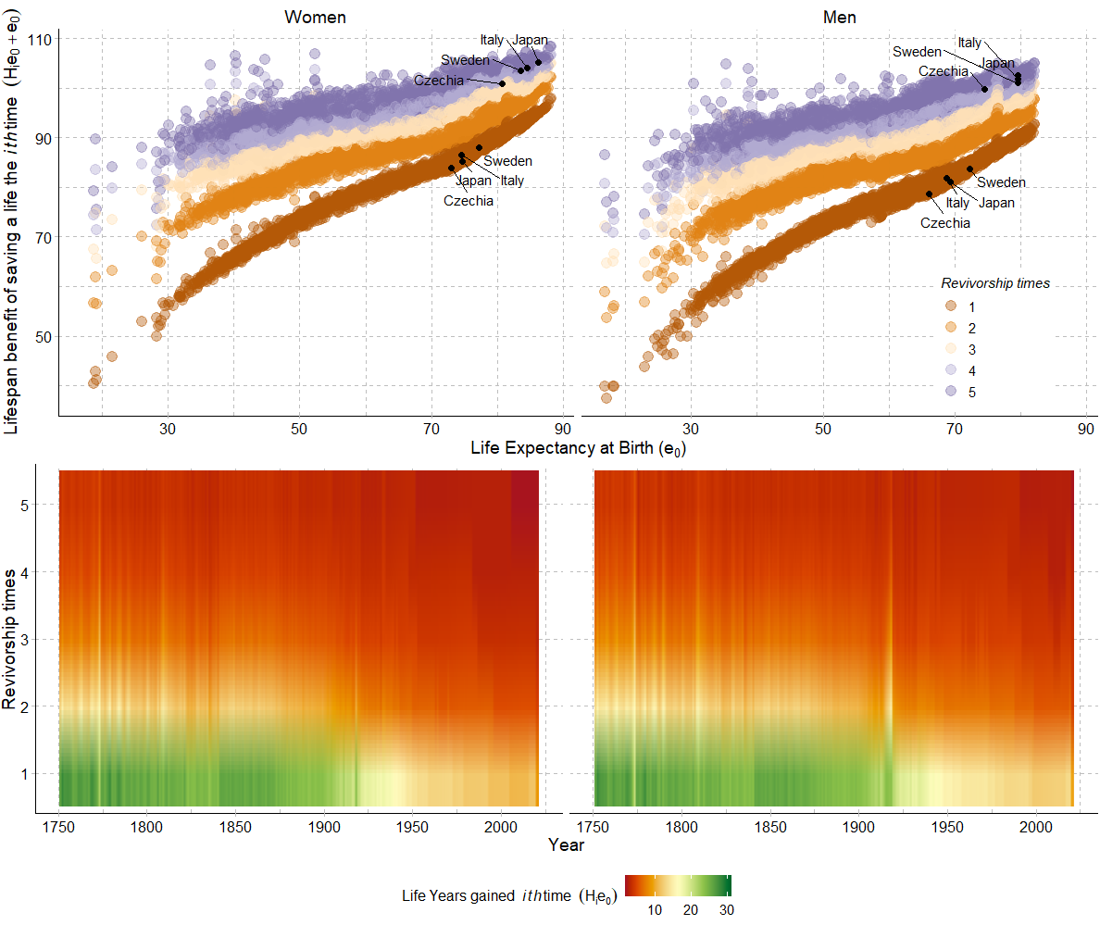

**Fig 4.** Lifespan benefit to total life expectancy at birth by sex of repeatedly saving lives up to 5 times, HMD countries, 1750-2017. Source: Own calculations. Data from the Human Mortality Database. University of California, Berkeley (USA), and Max Planck Institute for Demographic Research (Germany). Available at www.mortality.org or www.humanmortality.de. *Note*:Sweden, Italy, Czechia and Japan are highlighted in the top panel for being the representatives of Pioneer, Laggards, East-Transition and Fast-Paced transition countries. For lifespan benefit of saving a live once (Revivorship times= 1) countries are highlighted for life expectancy at birth observed in year 1970 and for saving a life 5 times (Revivorship times=5) for year 2010, just as examples.