***Language***



***Baanyan Tree***

***A Montessori Casa Name: Date: Class:M***





This is how you write O ***‘***O’ as an Owl ***‘***O’ as an Octopus

Please trace and write alphabet ‘O’:

|  |  |  |  |
| --- | --- | --- | --- |
|  |  |  |  |
|  |  |  |  |
|  |  |  |  |

## Observation:

I’m Learning I can do with little help I’m Independent

## Teacher’s Signature Page:

***Language***



***Baanyan Tree***

***A Montessori Casa Name: Date: Class:M***



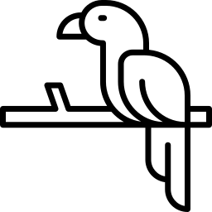

This is how you write P ***‘***P’ as a Parrot ***‘***P’ as a Pig

Please trace and write alphabet ‘P’:

|  |  |  |  |
| --- | --- | --- | --- |
|  |  |  |  |
|  |  |  |  |
|  |  |  |  |

## Observation:

I’m Learning I can do with little help I’m Independent

## Teacher’s Signature Page: