***Language***



***Baanyan Tree***

***A Montessori Casa Name: Date: Class:M***

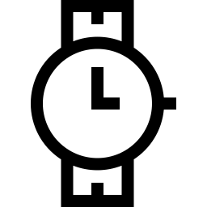



This is how you write W ***‘***W’ as a Watch ***‘***W’ as a Watermelon

Please trace and write alphabet ‘W’:

|  |  |  |  |
| --- | --- | --- | --- |
|  |  |  |  |
|  |  |  |  |
|  |  |  |  |

## Observation:

I’m Learning I can do with little help I’m Independent

## Teacher’s Signature Page:

***Language***



***Baanyan Tree***

***A Montessori Casa Name: Date: Class:M***





This is how you write X ***‘***X’ as a X-mas Tree ***‘***X’ as a Xylophone

Please trace and write alphabet ‘X’:

|  |  |  |  |
| --- | --- | --- | --- |
|  |  |  |  |
|  |  |  |  |
|  |  |  |  |

## Observation:

I’m Learning I can do with little help I’m Independent

## Teacher’s Signature Page: