***Language***



***Baanyan Tree***

***A Montessori Casa Name: Date: Class:M***



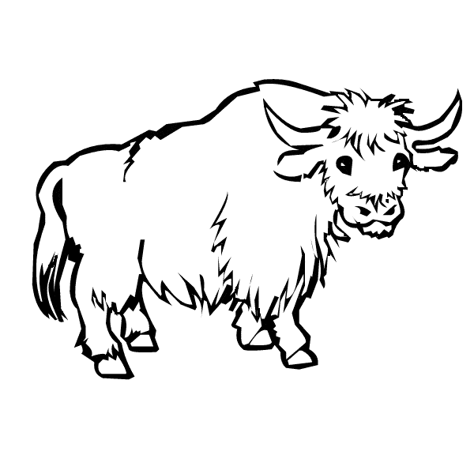

This is how you write Y ***‘***Y’ as a Yak ***‘***Y’ as a Yarn ball

Please trace and write alphabet ‘Y’:

|  |  |  |  |
| --- | --- | --- | --- |
|  |  |  |  |
|  |  |  |  |
|  |  |  |  |

## Observation:

I’m Learning I can do with little help I’m Independent

## Teacher’s Signature Page:

***Language***



***Baanyan Tree***

***A Montessori Casa Name: Date: Class:M***

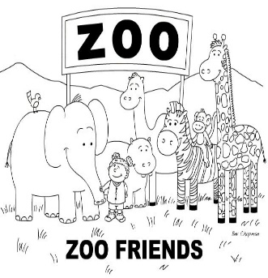******

This is how you write Z ***‘***Z’ as a Zebra ***‘***Z’ as a zoo

Please trace and write alphabet ‘Z’:

|  |  |  |  |
| --- | --- | --- | --- |
|  |  |  |  |
|  |  |  |  |
|  |  |  |  |

## Observation:

I’m Learning I can do with little help I’m Independent

## Teacher’s Signature Page: