Customer Support Intelligence
Introduction

1. Background
Modern customer-support operations accumulate enormous volumes of tickets — every interaction with a customer over email, chat, phone or web is recorded as an unstructured support ticket. In most small and mid-sized teams this data lives in spreadsheets or a generic helpdesk export and is never analyzed. Questions that matter to a business — Are we meeting our SLAs? Which product problems keep recurring? How satisfied are customers who file billing complaints? Which agents resolve issues fastest? — cannot be answered from raw ticket lists. Turning that raw data into insight normally requires expensive analytics platforms, data engineering, and a separate business-intelligence toolchain.
2. Motivation
- Support teams need fast, self-serve analytics without a data-engineering team.
- Ticket categorization and sentiment scoring are done manually today and are inconsistent.
- Existing tools are heavy, cloud-locked, or expose sensitive customer data to third parties.
- This is an academic project to demonstrate a full-stack data product: ingestion, NLP enrichment, analytics, optional LLM intelligence, and a polished UI — all runnable on a laptop.
3. Objectives
1. Provide secure registration and JWT-based authentication.
2. Load a bundled 400-ticket sample dataset or upload a user CSV.
3. Validate and normalize incoming CSV data with automatic column-alias detection.
4. Auto-analyze sentiment (positive / neutral / negative) for every ticket.
5. Auto-classify tickets into ten meaningful support categories.
6. Compute operational KPIs and render an interactive analytics dashboard with eight-plus chart types.
7. Provide a searchable, sortable, paginated ticket explorer with detail views.
8. Detect common recurring issues using TF-IDF clustering.
9. Expose optional LLM-powered insights, ticket summaries and natural-language Q&A.
10. Persist analyses to history for later review.
11. Offer dark/light theming with system-preference detection.
12. Support one-command local startup (start.sh / stop.sh) and Docker Compose deployment.
4. In-Scope / Out-of-Scope
In Scope | Out of Scope
Dataset load/upload (CSV, sample) | Non-CSV formats (JSON/XLSX, APIs/webhooks)
Rule-based sentiment & categorization | Transformer-based ML (BERT/DistilBERT)
Interactive analytics dashboard + filters | Real-time WebSockets
Ticket explorer and common-issue detection | Dashboard / PDF exports
Optional LLM insights, summaries, Q&A | Multi-organization / multi-tenant support
Dark/light mode, analysis history | Role-based access control, email notifications
JWT auth + per-user data isolation | Mobile-optimized layout
5. Project Overview
CSI is composed of four cooperating pieces:
- frontend/ React 18 + TypeScript + Vite SPA. Pages for login/register, dashboard, datasets, tickets, AI insights, Q&A, history and settings; TanStack Query for server state; Recharts for charts; Framer Motion for animations; Tailwind for styling.
- backend/ FastAPI + SQLAlchemy. API routes, analytics service, ML/NLP modules (sentiment, classification, common issues), AI provider abstraction (Ollama/OpenAI-compatible), CSV processor, Alembic migrations and pytest test-suite (26 tests).
- data/ sample_support_tickets.csv — a generated 400-ticket dataset used for evaluation and demos.
- deploy/ start.sh / stop.sh service scripts and docker-compose.yml for the full stack.
Data-flow pipeline: RAW SUPPORT DATA → VALIDATION → DATA PROCESSING → ANALYTICS → ML/NLP → AI INSIGHTS → BUSINESS RECOMMENDATIONS
6. Key Features
- Authentication — register, login, JWT-protected routes
- Dataset management — load sample, upload CSV, select/delete datasets
- CSV processing — validation, column normalization, auto sentiment + categorization
- Interactive dashboard — KPI cards, 8+ Recharts visualizations, click-to-filter
- Ticket explorer — search, sort, paginate, filter, detailed view
- Sentiment analysis — rule-based NLP (Positive / Neutral / Negative)
- Ticket classification — keyword-based, ten categories
- Common issue detection — TF-IDF across ticket text
- AI insights & Q&A — Ollama or API-based LLM
- Analysis history — save and revisit analyses
- Dark/light mode and animated UI
7. Technology Stack
Layer | Technology
Frontend | React 18, TypeScript, Vite, Tailwind CSS
State | TanStack Query (React Query)
Charts | Recharts
Animations | Framer Motion
Backend | FastAPI, Pydantic
Database / ORM | PostgreSQL / SQLite, SQLAlchemy
Migrations | Alembic
Auth | JWT, bcrypt
ML / NLP | Rule-based classifiers, TF-IDF
AI | Ollama (local) / OpenAI-compatible API
Container | Docker, Docker Compose
8. Screenshots
Figure 1 shows the analytics dashboard (light mode), and Figure 2 the secure authentication page.

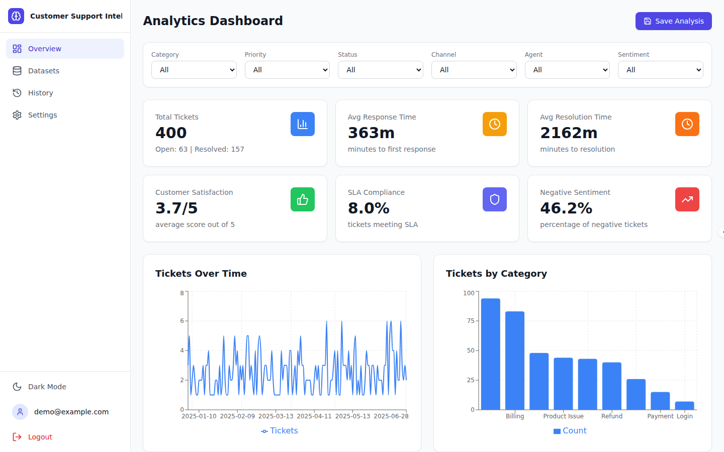
Figure 1 — Analytics Dashboard with KPI cards and interactive charts

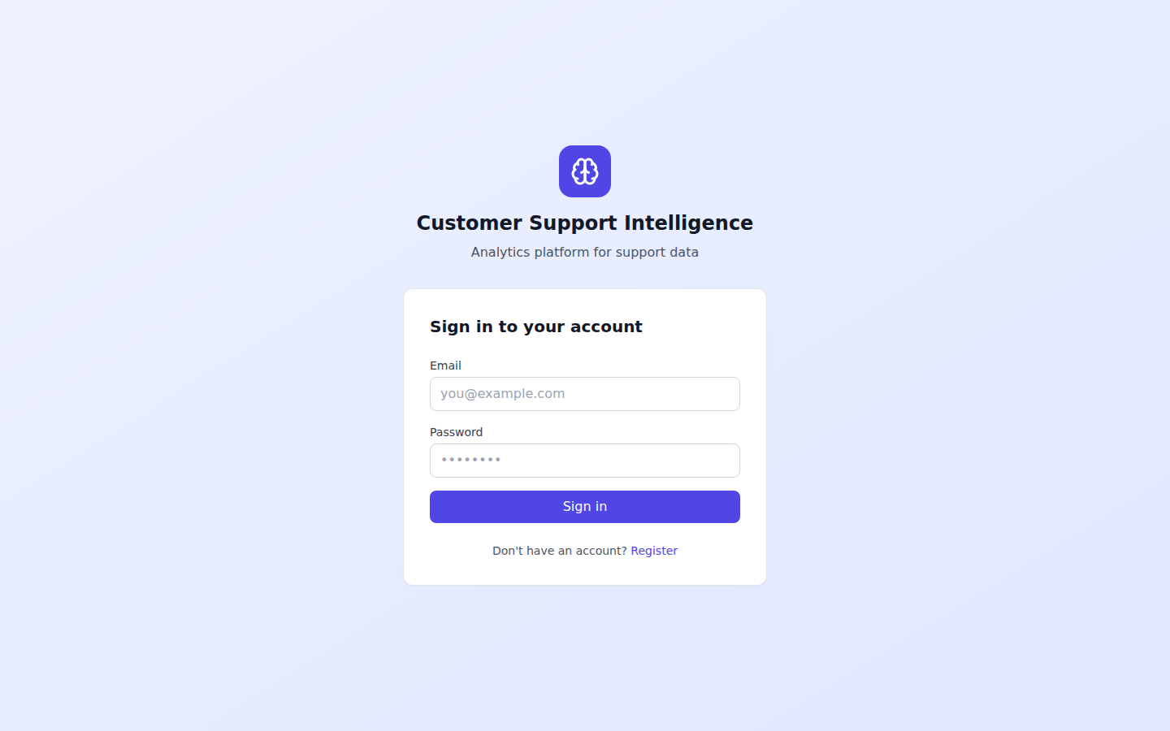
Figure 2 — Authentication (register / login, JWT-protected)
9. Report Structure
1. Abstract — one-page problem/solution summary, formulas, domains, AI, privacy, tech stack, keywords.
2. Introduction — background, motivation, objectives, scope, overview, features, stack, screenshots.
3. Analysis and Requirements — user analysis, functional and non-functional requirements, use cases, data model.
4. Problem Description and Modules Description — problem statement, proposed solution, architecture and the twelve functional modules.

