Customer Support Intelligence
Problem Description and Modules Description

1. Problem Statement
Customer-support operations face four concrete problems today:
1. One-size-fits-all targets — generic dashboards show headline numbers but cannot answer questions specific to this team's tickets, channels, agents and SLAs.
2. Fragmentation — tickets arrive through email, chat, phone and web and live in disconnected lists; joining and comparing them is manual.
3. Privacy & cloud concerns — sensitive customer complaints are pushed to third-party analytics clouds, and AI-powered help requires sending support text to hosted LLM providers.
4. Cost & complexity — commercial BI + data-engineering stacks are overkill for a small team and expensive.
The result is that recurring product failures go unnoticed, SLA breaches are found late, customer-satisfaction trends are invisible, and support text is never reused as insight.
2. Proposed Solution
Customer Support Intelligence is a self-contained, local-first web application that ingests support-ticket data, automatically enriches it with rule-based NLP (sentiment, category, recurring issues), computes operational KPIs, and surfaces everything through an interactive dashboard, a ticket explorer and an optional LLM assistant. No data-engineering team, cloud dependency or external database is required: a single command brings the whole platform up.
3. System Architecture
CSI follows a three-tier architecture with a service-oriented backend.
- Presentation tier — React 18 + TypeScript SPA (Vite). Pages, layouts, charts (Recharts), API client, auth/theme stores and animated transitions.
- Application tier — FastAPI backend exposing REST endpoints. Sub-layers: API routes (auth, datasets, tickets, analytics, AI, history), analytics service, ML/NLP modules (sentiment, classifier, common issues), AI provider abstraction, and the CSV data processor.
- Data tier — SQLAlchemy ORM over SQLite (dev) or PostgreSQL (prod), with Alembic migrations.
Integration: the frontend talks only to the backend REST API; the AI provider layer isolates Ollama/API differences; Docker Compose packages all three tiers.
4. Module Description
The application is decomposed into twelve functional modules (M1–M12). Each module lists its purpose, inputs and outputs.
M1 — Auth & Authorization
- Purpose: Secure user accounts and protect all data routes.
- Inputs: email + password (register/login).
- Outputs: hashed credentials, JWT access token, user profile; 401 responses for invalid/missing tokens.
M2 — Dataset Management
- Purpose: Create, list, select and delete per-user datasets.
- Inputs: sample flag or uploaded CSV file.
- Outputs: dataset records with name, source type, original filename, row count and timestamps.
M3 — CSV Processing & Validation
- Purpose: Accept only well-formed data and normalize it to the internal schema.
- Inputs: CSV bytes (≤ configured size), column aliases auto-detected.
- Outputs: normalized ticket records and/or validation errors; dataset row count.
M4 — Sentiment Analysis (Rule-based NLP)
- Purpose: Score each ticket's customer sentiment.
- Inputs: ticket subject + description.
- Outputs: sentiment label (Positive/Neutral/Negative) and a numeric score.
M5 — Ticket Classification
- Purpose: Assign every ticket to a meaningful support category.
- Inputs: ticket subject + description.
- Outputs: category (one of ten) and optional subcategory.
M6 — Analytics Dashboard & KPI Engine
- Purpose: Compute operational metrics and chart series for the active dataset.
- Inputs: dataset id + filters (category, priority, status, channel, agent, sentiment, date range).
- Outputs: KPIs, eight-plus chart series, and the distinct filter options.
M7 — Ticket Explorer
- Purpose: Enable human inspection of the ticket corpus.
- Inputs: pagination, sort, search and filter parameters.
- Outputs: paginated ticket list and a full ticket detail view.
M8 — Common Issue Detection
- Purpose: Surface recurring customer problems automatically.
- Inputs: dataset ticket text.
- Outputs: ranked list of common issues with frequency counts.
M9 — AI Insights (LLM Provider Abstraction)
- Purpose: Generate business insights and ticket summaries using an LLM, while remaining optional.
- Inputs: prompt context built from analytics; provider config (Ollama or OpenAI-compatible).
- Outputs: natural-language insights, recommendations and per-ticket summaries.
M10 — Natural Language Q&A
- Purpose: Let analysts ask ad-hoc questions about their data.
- Inputs: free-text question + dataset context.
- Outputs: contextual answer grounded in the analytics figures.
M11 — Analysis History
- Purpose: Persist analytics snapshots for later review.
- Inputs: dataset id + label; snapshot metrics.
- Outputs: saved analyses list, detail and deletion.
M12 — Service Manager & Deployment
- Purpose: Start and stop the whole platform with one command.
- Inputs: no user input (start/stop script).
- Outputs: backend on :8000 and frontend on :5173; optional Docker Compose deployment.
5. Module Dependencies & Data Flow
Dependency graph (M12 wraps the whole system):
- M1 Auth is a prerequisite for every other module.
- M2 Dataset Management consumes M3 CSV processing output and feeds M6–M8, M10.
- M4 and M5 enrich tickets produced by M3 and are prerequisites for M6–M8.
- M6 Analytics feeds M9 (insights) and M11 (history); M7 Explorer reuses filters from M6.
- M9 and M10 depend on the AI provider abstraction; M11 consumes analytics snapshots.
End-to-end flow: CSV/sample → M3 validation → M4/M5 enrichment → M6 analytics → M8 common issues → M9/M10 AI → M11 persistence, all gated by M1 and orchestrated by M12.
Stage | Module(s) | Artifact
Ingest | M2, M3 | Validated, normalized tickets
Enrich | M4, M5 | Sentiment + category per ticket
Analyze | M6, M8 | KPIs, charts, common issues
Interpret | M9, M10 | LLM insights, summaries, answers
Persist & serve | M11, M12 | History, saved analyses, live services
6. Screen Examples (Screenshots)
Figures 1–4 capture the principal user-facing modules.

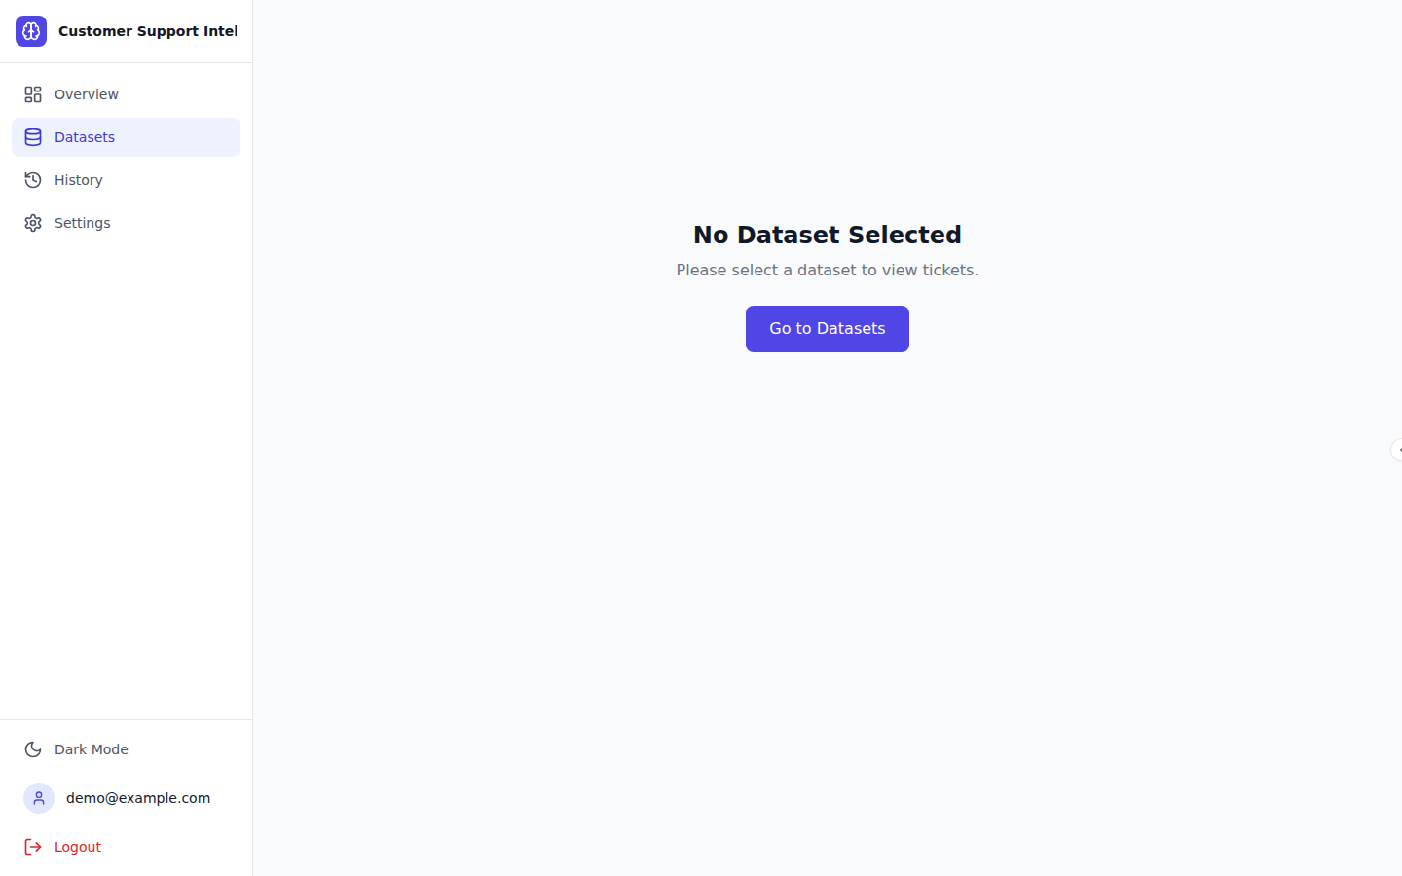
Figure 1 — M7 Ticket Explorer (search, sort, filters, detail)

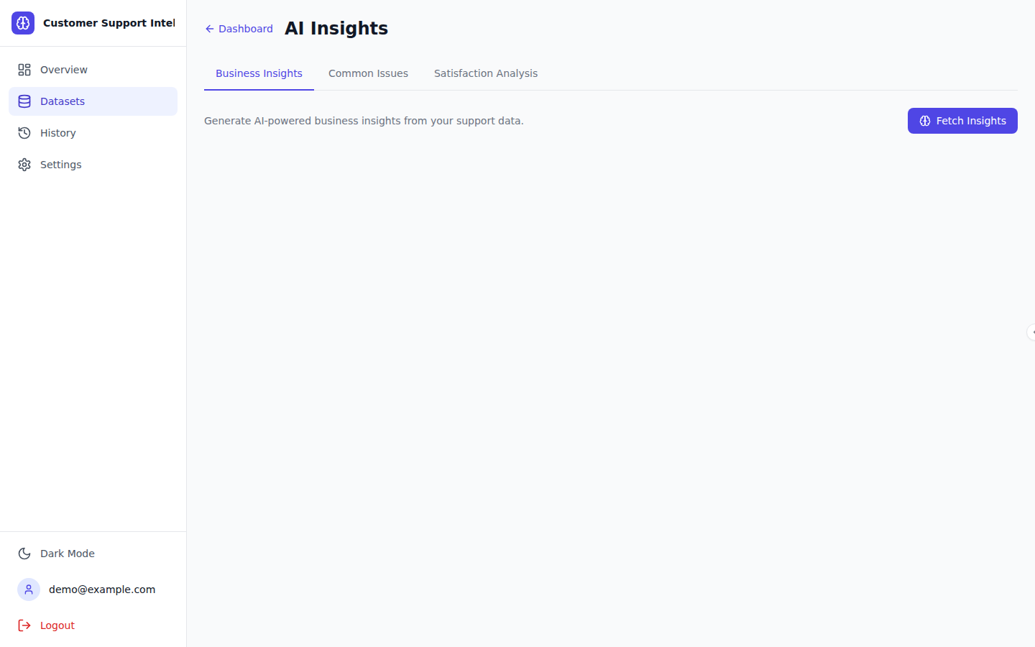
Figure 2 — M9/M10 AI Insights and Natural Language Q&A

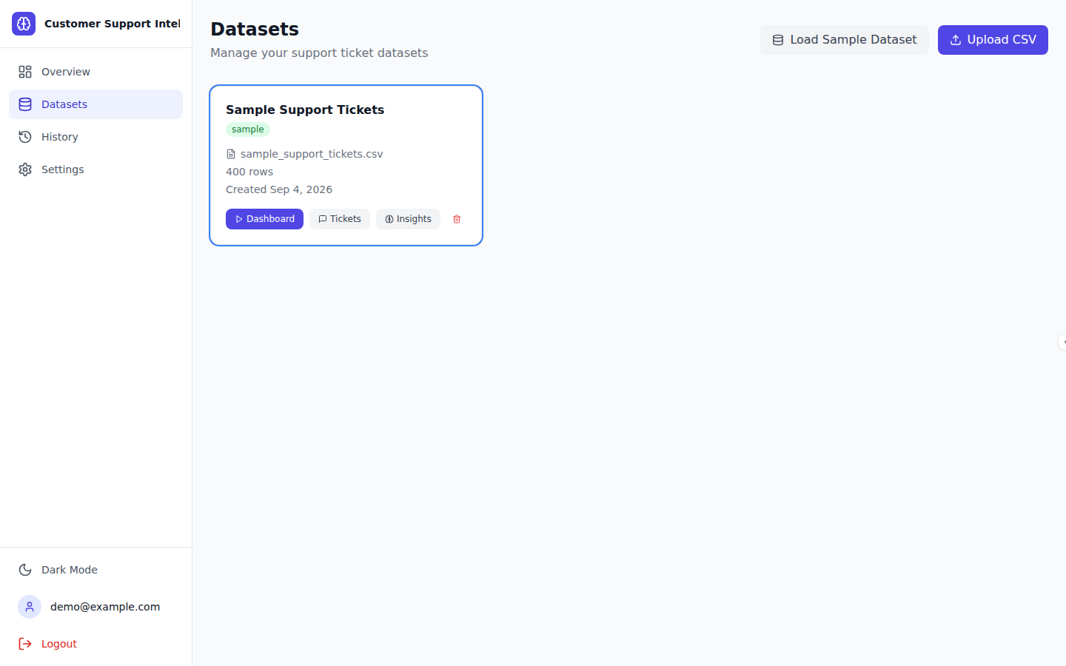
Figure 3 — M2 Dataset Management (sample load, CSV upload, actions)

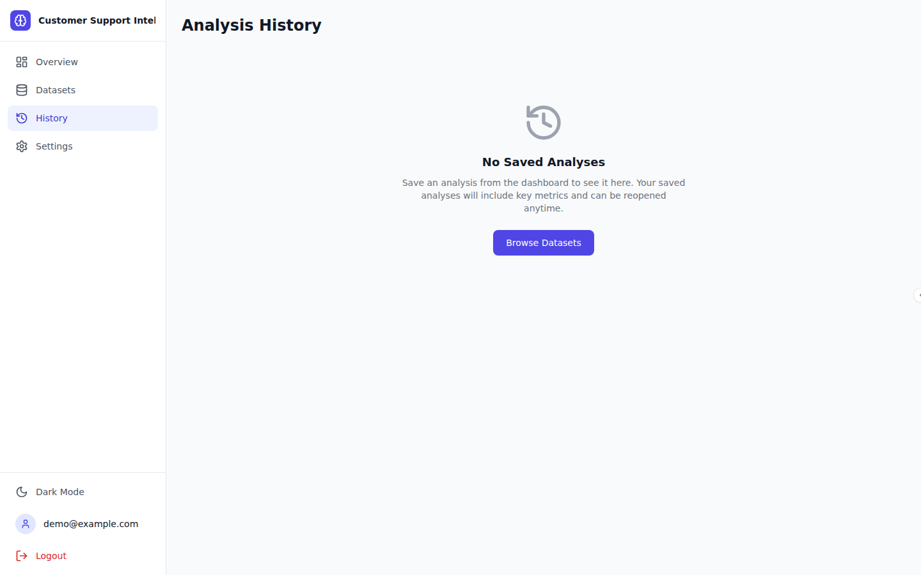
Figure 4 — M11 Analysis History

