**Forecast Green Energy** 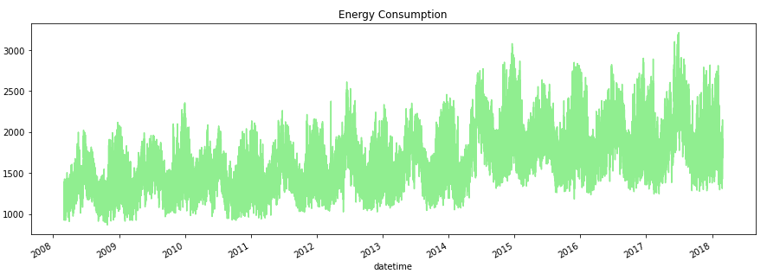

**Approach:**

Steps carried:

1. Importing the Data:

Train and Test data Separately as Data Frames

1. Data Preprocessing:

Converted the datetime column from object to datetime

1. EDA:

Univariant Analysis with the Datetime Column w.r.t Energy Consumption

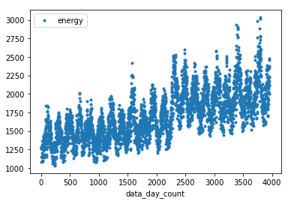

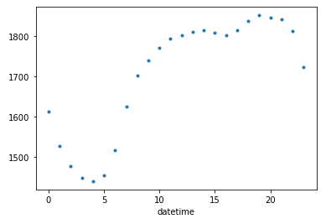

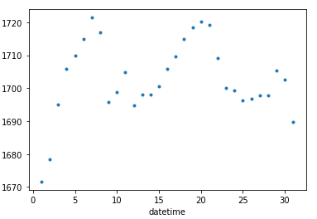

1. Feature Engineering:

Created Many Features from Datetime Column like

* Year: Year
* Month: Month
* Day: Day
* Hour: Hour
* Quarter: Quarter
* month_of_quarter: Month of each Quarter
* day_of_year: Day of the year
* day_of_quater: Day of the Quarter
* day_of_week: Day of the Week
* week_of_the_year: Week of the Year
* is_weekend: Is week-end or not
* is_morning: I s morning (6am to 12pm)
* morning_hour: Morning hour ([1 to 7] or 0)
* is_afternoon: Is afternoon (1pm to 5pm)
* afternoon_hour: Afternoon hour ([1 to 5] or 0)
* is_evening: Is evening (6pm to 10pm)
* evening_hour: Evening hour ([1 to 5] or 0)
* is_night: Is night (11pm to 5am)
* night_hour: Night hour ([1 to 7] or 0)
* is_am: Is am (dividing am separately)
* is_pm: Is pm (dividing pm separately)
* peak_hour: Peak hour (19,20,21 max energy consumption if yes:1 else:0)
* off_hour: off hour (3,4,5 min energy consumption if yes:1 else:0)
* 3hour_interval: dividing 3hour interval (representing [0-3,4-6,7-9,10-12,13-15,16-18,19-21,22-24])
* 6hour_interval: dividing 6hour interval (representing [0-6,7-12,13-18,19-24])

1. Model Selection/Model Training:

Used XG Booster model: Trained model with Evaluation matrix RMSE

1. Model Evaluation:

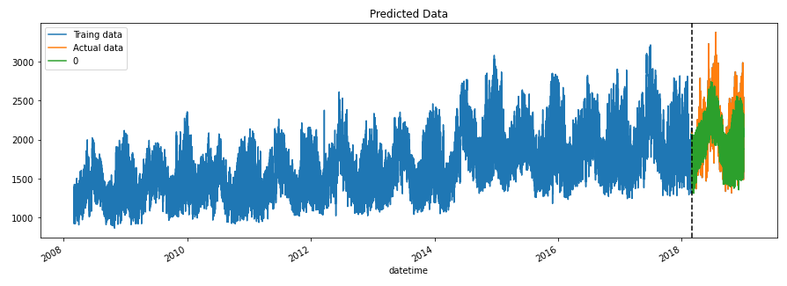Checked the Model has RMSE of 203.50361122041437 for Valid Data Set

1. Prediction:

Predication is Combined with the Test Data Set and Downloaded as .csv file with Row id and Energy consumption

