Title

Natalie Dullerud, Tea Freedman-Susskind, Anthony P West, Vanessa D Jonsson

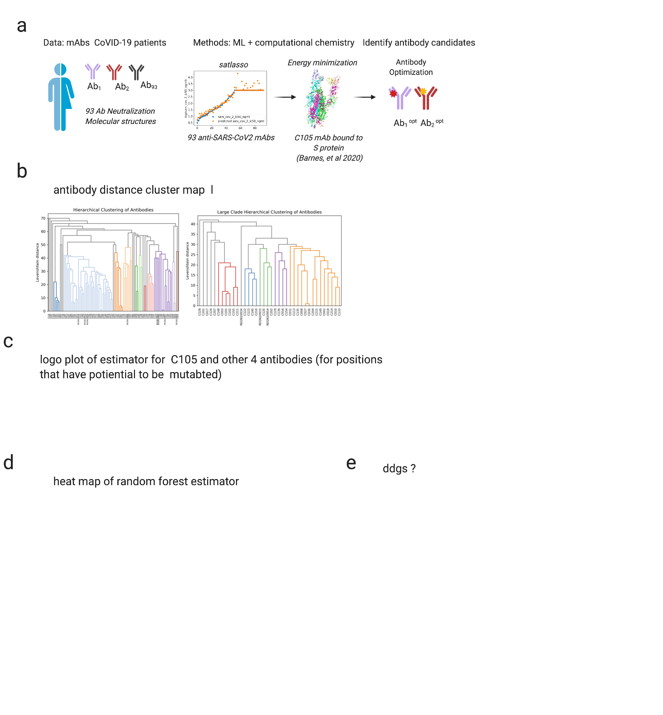

Figure 1 | Uncovering antibody optimization sites. a. b. c. d. e.

Figure 2 | Analyzing viral vulnerabilities. Random forest classifier. Viral ddgs for antibody designs.

Figure 3 | Combination antibodies.

Supplemental Figures

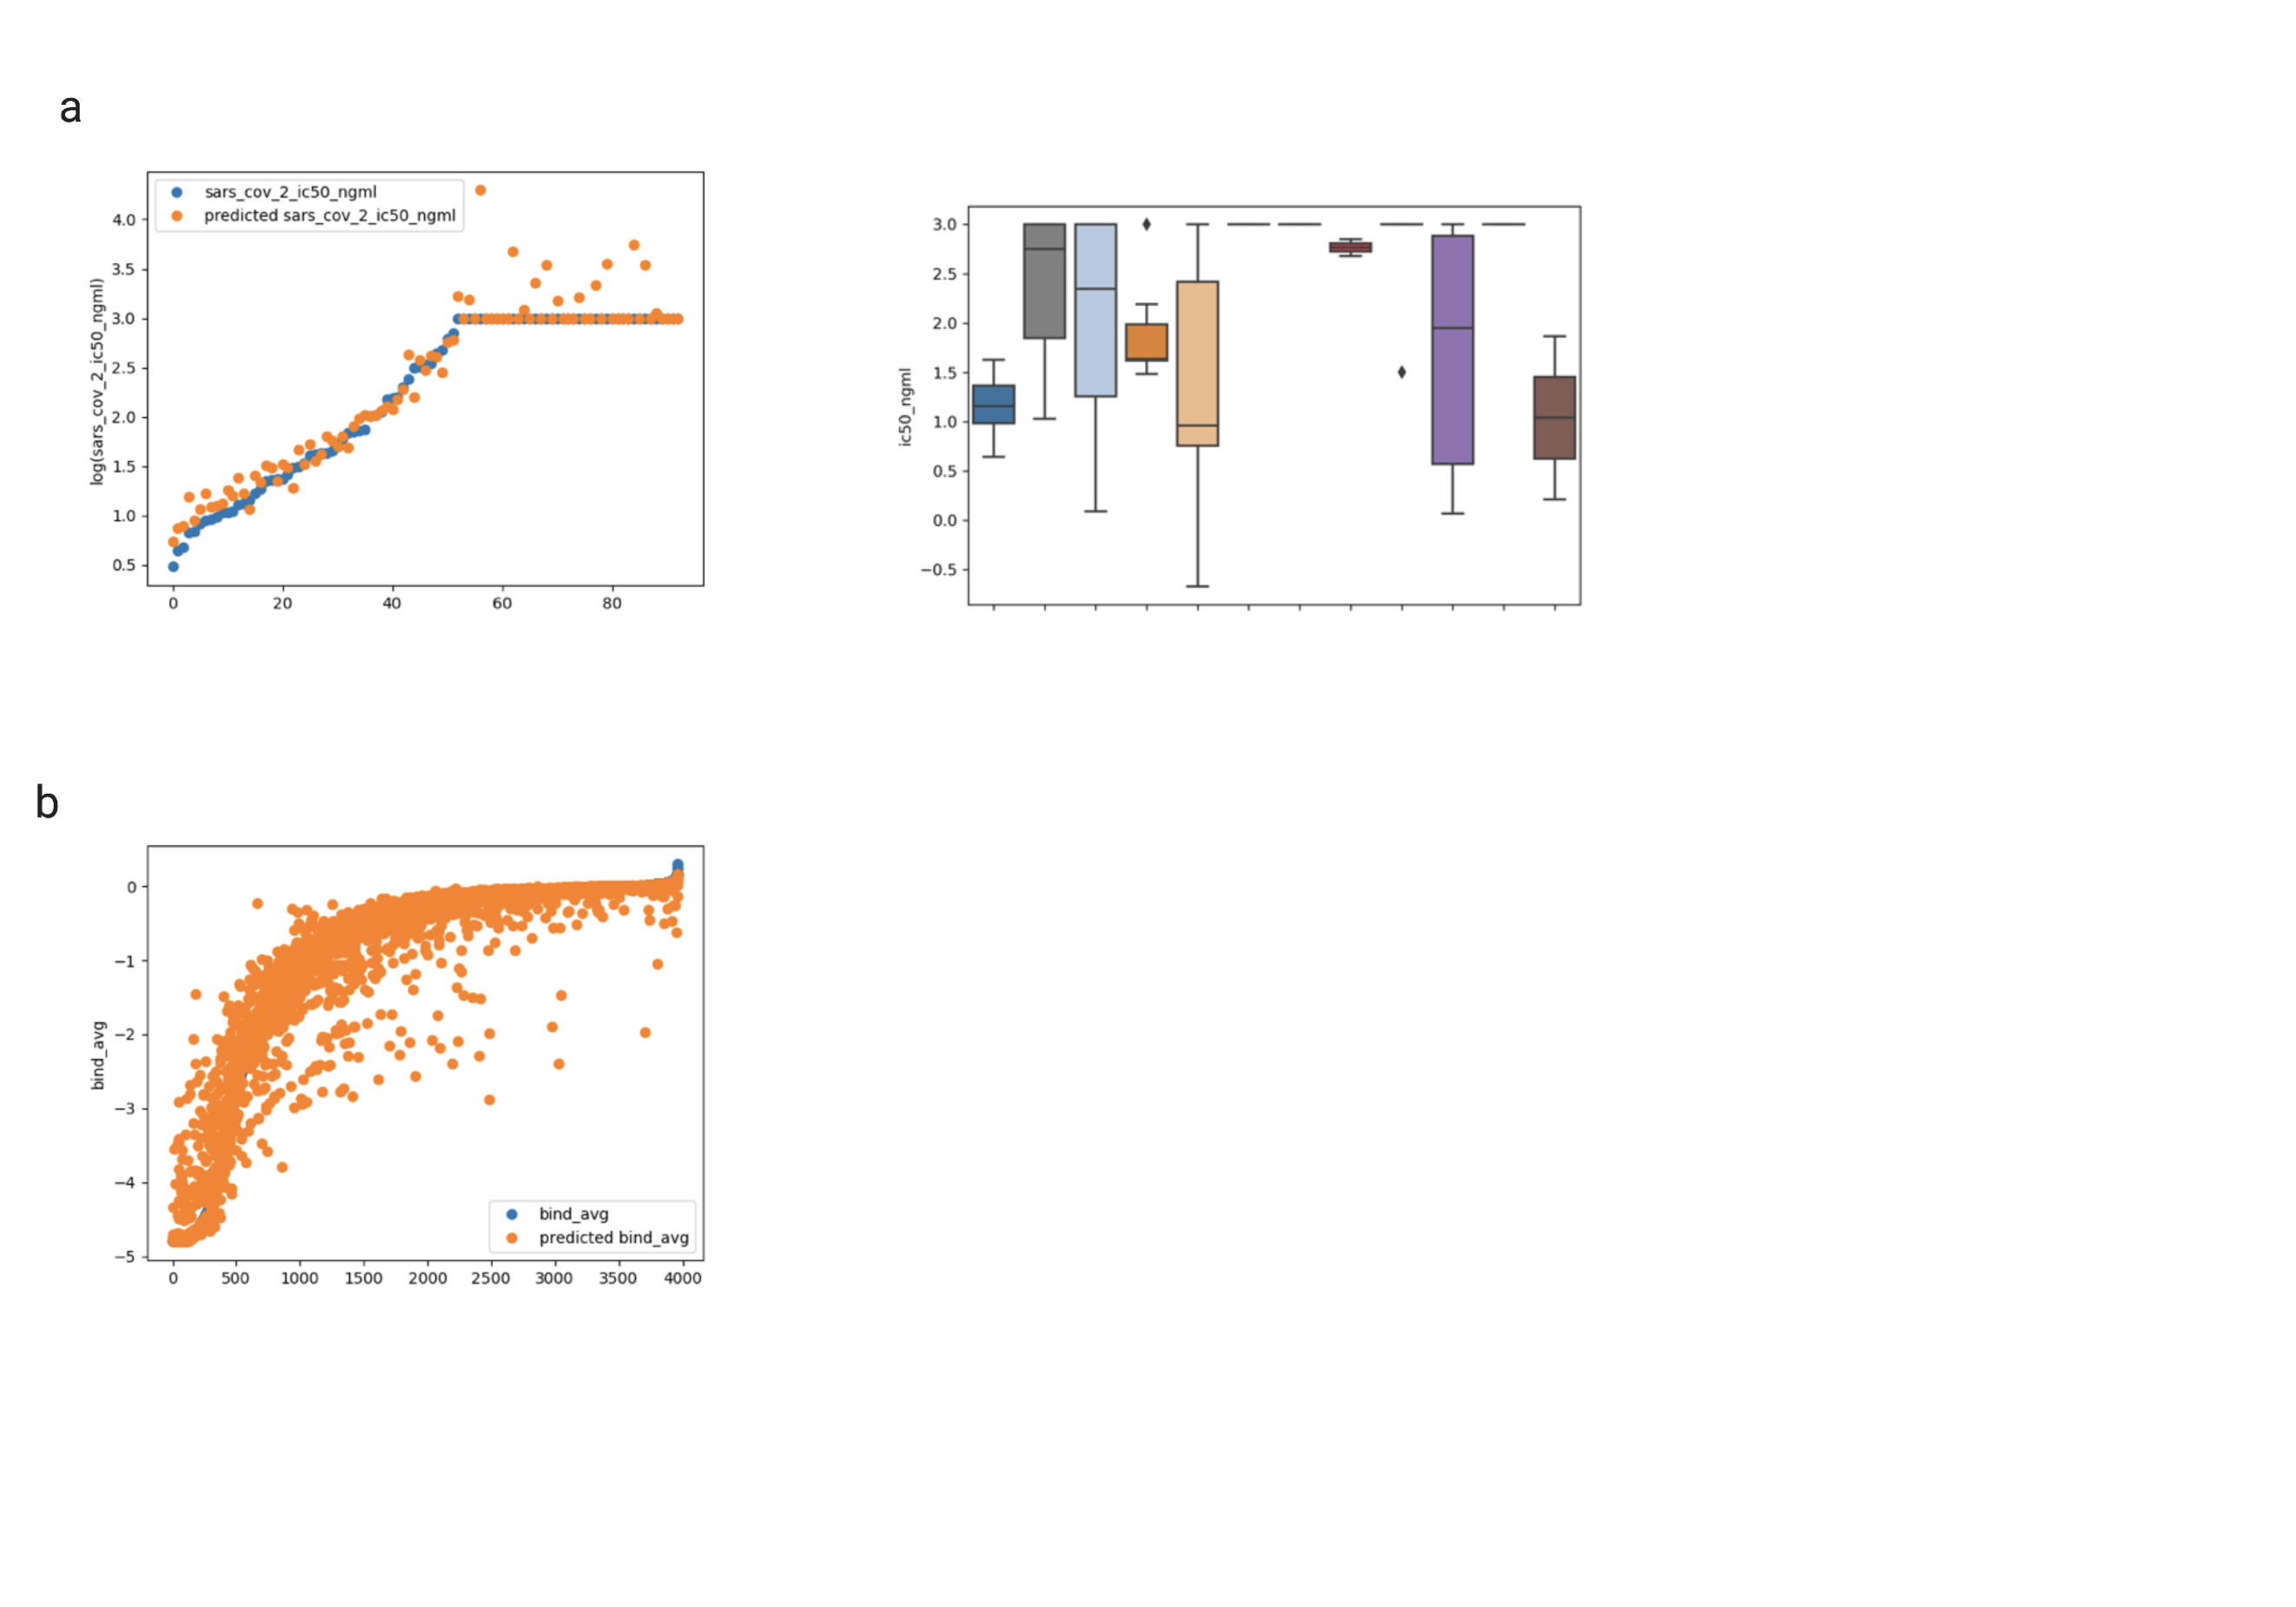

Figure S1 | Some title about the figure. a. b. c. d. e.