1. AngularJS Tree

<https://angular-ui-tree.github.io/angular-ui-tree/#/basic-example>

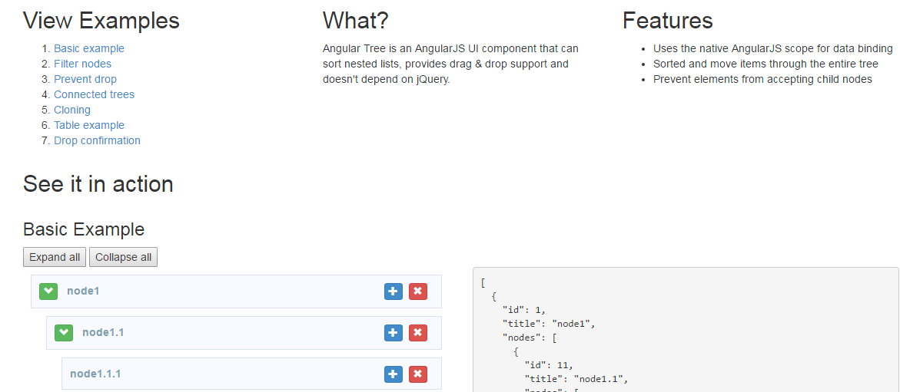

1. CRUD Operations Using the Generic Repository Pattern and Unit of Work in MVC

<http://www.codeproject.com/Articles/814768/CRUD-Operations-Using-the-Generic-Repository-Patte>

1. ASP.NET Identity

<http://www.asp.net/identity>

1. Adding ASP.NET Identity to an Empty or Existing Web Forms

Projecthttp://www.asp.net/identity/overview/getting-started/adding-aspnet-identity-to-an-empty-or-existing-web-forms-project

1. AngularJS Token Authentication using ASP.NET Web API 2, Owin, and Identity

<http://bitoftech.net/2014/06/09/angularjs-token-authentication-using-asp-net-web-api-2-owin-asp-net-identity/>