**Copyfile_Ui**

**import** java.awt.*;

**import** java.awt.event.*;

**import** java.io.*;

**import** java.sql.*;

**import** javax.swing.*;

**public** **class** UI_copy_file **extends** JFrame **implements** ActionListener {

**private** JButton bcmp=**null**;

**private** JButton bcp=**null**;

**private** JButton bshcnt;

**private** JTextField tresults;

**private** JLabel lfilesrc;

**private** JLabel lfiledes;

**private** JTextField tfilesrc;

**private** JTextField tfiledes;

**public** **boolean** compare_file(String filesrc,String filedes) {

**try** (BufferedReader brsrc = **new** BufferedReader(**new** InputStreamReader(**new** FileInputStream(filesrc)));

BufferedReader brdes = **new** BufferedReader(**new** InputStreamReader(**new** FileInputStream(filedes)))) {

**while**(brsrc.ready() || brdes.ready()){

**if** (!brsrc.ready() || !brdes.ready()) **return** **false**;

String strsrc = brsrc.readLine();

String strdes= brdes.readLine();

System.***out***.println("??"+strsrc+">>"+strdes);

**if** (! strsrc.equals(strdes)) {

**return** **false**;

}

}

} **catch** (IOException exc) {

System.***out***.println("I/O Error: " + exc);

}

**return** **true**;

}

**public** **void** copy_file(String filesrc,String filedes) {

String str;

**try** (BufferedReader br = **new** BufferedReader(**new** InputStreamReader(**new** FileInputStream(filesrc)));

FileWriter fw = **new** FileWriter(filedes)) {

**while**(br.ready()){

str = br.readLine();

str = str + "\n"; // add newline

fw.write(str);

}

} **catch** (IOException exc) {

System.***out***.println("I/O Error: " + exc);

}

}

**public** **void** show_content(String filename) {

**try** (BufferedReader br = **new** BufferedReader(**new** InputStreamReader(**new** FileInputStream(filename)))) {

String str="";

**while**(br.ready()){

str =str+ br.readLine();

str = str + "\n"; // add newline

}

tresults.setText(str);

} **catch** (IOException exc) {

System.***out***.println("I/O Error: " + exc);

}

}

UI_copy_file(){

JFrame Jf=**new** JFrame("review on tap thoi cha noi");

Jf.setSize(1000,550);

Jf.setDefaultCloseOperation(JFrame.***EXIT_ON_CLOSE***);

Jf.setLayout(**null**);

Jf.setVisible(**true**);

lfilesrc=**new** JLabel("file source");

lfiledes=**new** JLabel("file destination");

tfilesrc = **new** JTextField(25);

tfiledes = **new** JTextField(25);

lfilesrc.setBounds(20,100,100,20);

tfilesrc.setBounds(100,100,100,20);

lfiledes.setBounds(200,100,100,20);

tfiledes.setBounds(300,100,100,20);

bcmp = **new** JButton("compare");

bcmp.setBounds(50, 150, 100,20);

bcp = **new** JButton("copy");

bcp.setBounds(170, 150, 100,20);

bshcnt = **new** JButton("show content");

bshcnt.setBounds(290, 150, 120,20);

tresults=**new** JTextField();

tresults.setBounds(450,100,400,300);

bcmp.addActionListener(**this**);

bcp.addActionListener(**this**);

bshcnt.addActionListener(**this**);

Jf.add(lfilesrc);

Jf.add(tfilesrc);

Jf.add(lfiledes);

Jf.add(tfiledes);

Jf.add(bcmp);

Jf.add(bcp);

Jf.add(bshcnt);

Jf.add(tresults);

}

@Override

**public** **void** actionPerformed(ActionEvent e) {

// **TODO** Auto-generated method stub

String comStr = e.getActionCommand();

**if** (comStr.equals("show content")) {

show_content(tfilesrc.getText());

}

**else** **if** (comStr.equals("copy")) {

copy_file(tfilesrc.getText(),tfiledes.getText());

}

**else** **if** (comStr.equals("compare")) {

**if** (compare_file(tfilesrc.getText(),tfiledes.getText())) {

tresults.setText("Matched");

}

**else** tresults.setText("Not Matched");

}

//tresults.setText(comStr);

}

}

**import** java.awt.*;

**import** javax.swing.*;

**import** java.awt.event.ActionEvent;

**import** java.awt.event.ActionListener;

**public** **class** copy_file {

copy_file(){

**new** UI_copy_file();

}

**public** **static** **void** main(String[] args) {

// **TODO** Auto-generated method stub

SwingUtilities.*invokeLater*(**new** Runnable() {

**public** **void** run() {

**new** copy_file();

}

});

}

}

**database**

import java.awt.*;

import java.sql.*;

import javax.swing.*;

import javax.swing.table.*;

public class SearchGUI extends JFrame implements ActionListener{

private JFrame add;

private JTable form;

private NhanVien nv;

private int cont=1;

private JTextField hoten;

private JTextField diachi;

private JTextField ngaysinh;

private JTextField dienthoai;

private JTextField chucvu;

private JTextField bangcap;

private JTextField bophan;

private DefaultTableModel MyTablemodel = new DefaultTableModel();

private Connection cnt;

SearchGUI(Connection conn){

cnt = conn;

JMenuBar jmb = new JMenuBar();

JMenu jmFile = new JMenu("Option");

JMenuItem jmiAdd = new JMenuItem("Add");

JMenuItem jmiSearch = new JMenuItem("Search");

jmFile.add(jmiAdd);

jmFile.add(jmiSearch);

jmb.add(jmFile);

JLabel jhoten=new JLabel("Họ tên");

JLabel jbophan=new JLabel("Bộ phận");

hoten = new JTextField(25);

bophan = new JTextField(25);

jhoten.setBounds(20,100,100,20);

hoten.setBounds(100,100,150,20);

jbophan.setBounds(260,100,100,20);

bophan.setBounds(320,100,150,20);

JButton b = new JButton("OK");

b.setBounds(200, 200, 60, 20);

b.addActionListener(this);

form = new JTable(MyTablemodel);

JScrollPane MyScrollPane= new JScrollPane(form);

MyTablemodel.addColumn("stt");

MyTablemodel.addColumn("Họ tên");

MyTablemodel.addColumn("Địa chỉ");

MyTablemodel.addColumn("Ngày sinh");

MyTablemodel.addColumn("Điện thoại");

MyTablemodel.addColumn("Chức vụ");

MyTablemodel.addColumn("Bằng cấp");

MyTablemodel.addColumn("Bộ phận");

// MyTablemodel.addRow(new Object[]{hoten, diachi, ngaysinh, dienthoai, chucvu, bangcap, bophan});

add = new JFrame();

add.setTitle("jTable Column Header Frame");

add.add(jhoten);

add.add(hoten);

add.add(jbophan);

add.add(bophan);

add.add(b);

add.setSize(500, 500);

add.add(MyScrollPane);

add.setVisible(true);

}

@Override

public void actionPerformed(ActionEvent e) {

// TODO Auto-generated method stub

String comStr = e.getActionCommand();

System.out.print(comStr);

if (comStr.equals("OK")) {

String name = hoten.getText();

String bp = bophan.getText();

System.out.println(name+" "+bp);

Statement stmt=null;

try {

cnt.setAutoCommit(false);

stmt = cnt.createStatement();

String sql = "select * from nhanvien where hoten='"+name+"' and "+"bophan='"+bp+"';";

System.out.println(sql);

ResultSet resultSet=stmt.executeQuery(sql);

while (resultSet.next()) {

String namer = resultSet.getString("hoten");

String dob = resultSet.getString("ngaysinh");

String bc = resultSet.getString("bangcap");

String cv = resultSet.getString("chucvu");

String ad = resultSet.getString("diachi");

String dt = resultSet.getString("dienthoai");

String bpr = resultSet.getString("bophan");

MyTablemodel.addRow(new Object[]{cont,namer, ad, dob, dt, cv, bc, bpr});

cont++;

}

cnt.commit();

} catch (SQLException e1) {

// TODO Auto-generated catch block

e1.printStackTrace();

}

}

}

}

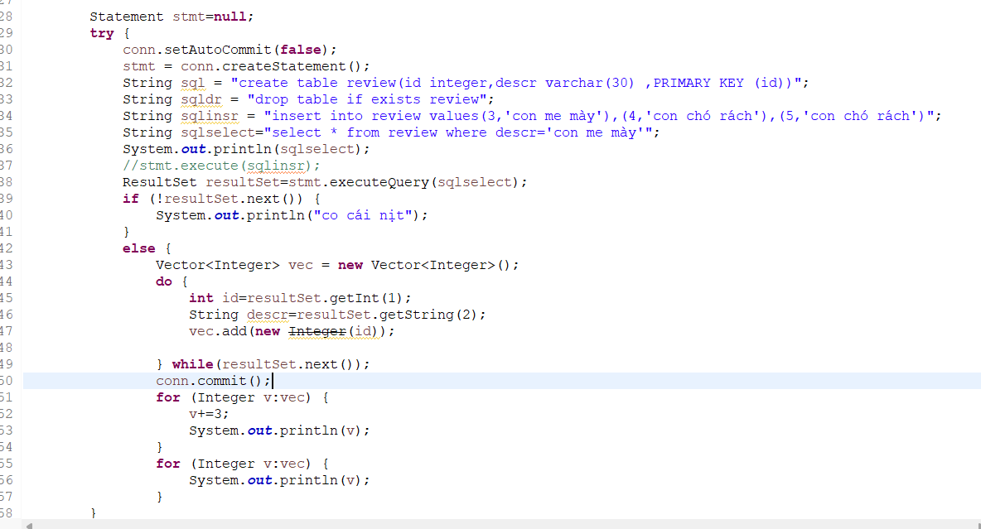

NetWorking multithreads

**package** network;

**import** java.net.*;

**import** javax.net.ssl.*;

**import** java.io.*;

**import** java.util.*;

**import** **static** java.lang.Thread.*currentThread*;

**class** Client_Thread **implements** Runnable {

**private** String my_name;

**private** Socket socket=**null**;

BufferedReader reader;

PrintWriter sender;

Client_Thread (Socket thisSocket) **throws** IOException{

socket=thisSocket;

**try** {

reader=**new** BufferedReader(**new** InputStreamReader(socket.getInputStream()));

sender=**new** PrintWriter(socket.getOutputStream());

} **catch** (IOException e) {

// **TODO** Auto-generated catch block

e.printStackTrace();

};

// authenication username and password from client

String name=reader.readLine();

**if** (name!=**null**) {

my_name=name;

System.***out***.println("Start chat for "+my_name);

}

**else** {

System.***out***.println("Cannot receive name of Client");

}

// end

**try** {

**for** (Map.Entry me : Server.*Name2Socket*.entrySet()) {

System.***out***.println("Key: "+me.getKey());

PrintWriter sender_User=**null**;

sender_User=**new** PrintWriter(((Socket) me.getValue()).getOutputStream());

sender_User.println(my_name+" has joined");

sender_User.flush();

}

} **catch** (IOException e) {

// **TODO** Auto-generated catch block

e.printStackTrace();

}

Server.*Name2Socket*.put(my_name, socket);

//

// sender.println(my_name);

// sender.flush();

}

**public** **void** run()

{

**try** {

**while** (**true**) {

String raw_text=**null**,message=**null**,tag=**null**;

raw_text = reader.readLine();

**if** (raw_text!=**null**) {

tag=raw_text.substring(0,1);

**if** (tag.equals("M")) { // Me message

System.***out***.println("raw text "+raw_text);

message=raw_text.substring(2,raw_text.length());

}

**else** **if** (tag.equals("Q")) { // Qi Quit

message=my_name+" has left";

}

}

**if** (message!=**null**) {

**for** (Map.Entry me : Server.*Name2Socket*.entrySet()) {

**if** (!(my_name.equals(me.getKey()))){

System.***out***.println("send from "+my_name+" to "+me.getKey());

PrintWriter sender_User=**null**;

sender_User=**new** PrintWriter(((Socket) me.getValue()).getOutputStream());

**if** (!tag.equals("Q")) sender_User.println(my_name+": "+message);

**else** sender_User.println(message);

sender_User.flush();

}

}

}

**if** (tag.equals("Q")) {

Server.*Name2Socket*.remove(my_name);

*currentThread*().interrupt();

**return**;

}

}

}

**catch** (IOException e) {

// **TODO** Auto-generated catch blocka

e.printStackTrace();

}

}

}



