Software Requirements Specification

for

Takeout Ordering System

Version 1.0 Draft

Prepared by Alex van der Meulen for CEN 3073

Amimoto

04/24/22

Table of Contents

Table of Contents 2

Revision History 2

1. Introduction 1

1.1 Purpose 1

1.2 Scope 1

1.3 Project Overview 2

1.4 Definitions 3

2. References 4

3. Specific Requirements 4

4. Verification 10

5. Appendices 11

5.1 Assumptions and dependencies 11

5.2 Acronyms and abbreviations 11

Revision History

|  |  |  |  |
| --- | --- | --- | --- |
| **Name** | **Date** | **Reason For Changes** | **Version** |
| Alex van der Meulen | 04/24/22 | Initial Draft | Version 1.0 Draft |
|  |  |  |  |

# 1. Introduction

## 1.1 Purpose

The system allows customers to place takeout orders without interacting with the front-of-house staff, who are often overwhelmed. In the takeout system, customers will be able to view allergy information for the different menu items. They will also be notified of the expected time at which they can pick up their order. The system will archive all customer orders. The proposed system will increase accessibility of ordering, customer satisfaction, business profits, and staff productivity.

## 1.2 Scope

### Product Name

Takeout Ordering System

### Overview

The system allows customers to place takeout orders without interacting with the front-of-house staff. In the takeout system, customers will be able to view allergy information for the different menu items. They will also be notified of the expected time at which they can pick up their order.

### Goals

* Customer satisfaction for takeout orders will increase by at least 25% following one month after the implementation of the system. This will be verified through surveys before the new system and after it is implemented and used.
* Front of house staff productivity will be increased through the use of the system. Front of house staff will be able to take orders from dine in guests 30% faster on average, measured from the time the group sits down until the order is placed, after 3 months when the takeout ordering system is fully in use.
* Business profits from takeout orders will be increased by at least 15% following three months after the system is implemented. Current records of takeout orders will be compared to new records that are archived by the system to verify.

### Out of Scope

* The system will not modify how front of house staff takes orders from guests who are dining in the restaurant.
* The system will not save user accounts or information.
* The system will not take reservations.

## 1.3 Product Overview

### 1.3.1 product perspective

### 

### 1.3.2 Product functions

* Receive takeout order from customer
* Notify kitchen of takeout order
* Accept payment information
* Bill customer
* Display menu
* Display answer to frequently asked questions

### 1.3.3 User Characteristics

* Customers: use system to place take-out orders.
* Front of house staff: use system to identify orders and deliver to the appropriate customers.
* Kitchen staff: Use system to receive orders.

### 1.3.4 Limitations

## 

## 1.4 Definitions

Drop - start preparing a dish  
Comp - give something away for free  
Fire - Order that is given to start prepping food  
In the weeds - busy or overwhelmed

# 2. References

Tony Manabe, restaurant owner  
Andy Vullo, front of house staff  
<http://ibisworld.com>   
Amimoto Facebook Page

# 3. Specific Requirements

[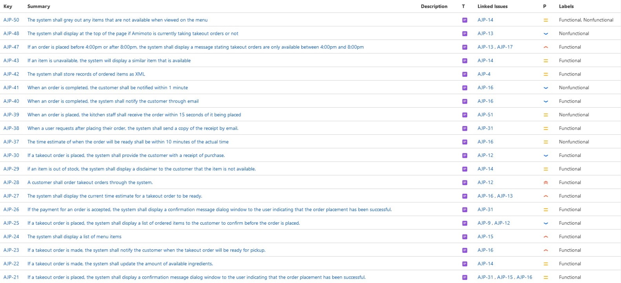](https://amvdm.atlassian.net/secure/IssueNavigator.jspa?reset=true&jqlQuery=type%3Drequirement+&src=confmacro)

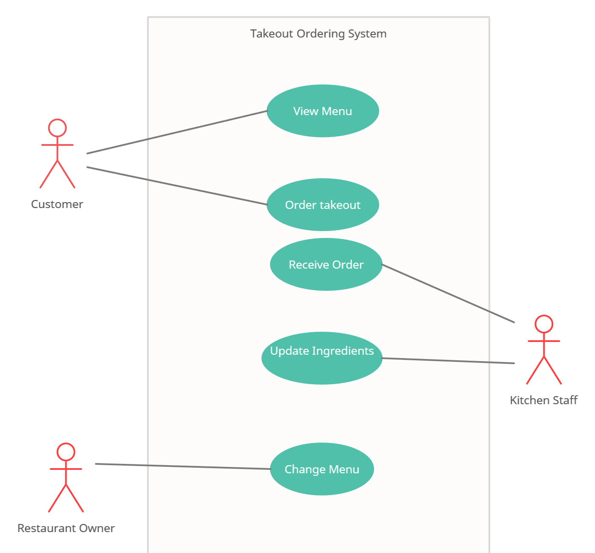

|  |  |
| --- | --- |
| **Primary Actor** | **Use Cases** |
| Customer | 1. View menu  2. Order takeout |
| Kitchen staff | 3. Receive order  4. Update ingredients |
| Restaurant Owner | 5. Change menu |

|  |  |  |  |
| --- | --- | --- | --- |
| **UC ID and Name:** | **UC-1. View menu** | | |
| Created By: | Alex van der Meulen | Date Created: | 3/15/22 |
| Primary Actor: | Customer | Secondary Actors: |  |
| Trigger: |  | | |
| Description: | A customer views a menu displayed by the ordering system | | |
| Preconditions: | PRE-1. A customer has accessed hte onlin eordering system | | |
| Postconditions: | POST-1. Menu is displayed to the customer | | |
| Normal Flow: | 1. A user accesses the system 2. System displays the menu of available items | | |
| Alternative Flows: | 1. A user searches for menu items   1.1 Only desired items are displayed by the system | | |
| Exceptions: |  | | |
| Priority: | Very High | | |
| Frequency of Use: | 100+ times daily | | |
| Business Rules: |  | | |
| Other information: |  | | |
| Assumptions: |  | | |

|  |  |  |  |
| --- | --- | --- | --- |
| **UC ID and Name:** | **UC-2. Order takeout** | | |
| Created By: | Alex van der Meulen | Date Created: | 3/15/22 |
| Primary Actor: | Customer | Secondary Actors: | Kitchen Staff |
| Trigger: |  | | |
| Description: | A customer places a takeout order that will be received by the kitchen staff | | |
| Preconditions: | PRE-1. Items are available  PRE-1. Amimoto is currently taking orders | | |
| Postconditions: | POST-1. Kitchen staff receives order  POST-2. Item quantity in system adjusted | | |
| Normal Flow: | 1. A customer accesses the system 2. Customer views the menu (UC-1) 3. Customer selects item to order 4. inputs payment method 5. places order | | |
| Alternative Flows: | 1. customer does not input payment method   1.1. customer pays in store | | |
| Exceptions: |  | | |
| Priority: | Very high | | |
| Frequency of Use: | 20+ times daily | | |
| Business Rules: |  | | |
| Other information: |  | | |
| Assumptions: |  | | |

|  |  |  |  |
| --- | --- | --- | --- |
| **UC ID and Name:** | **UC-3. Receive order** | | |
| Created By: | Alex van der Meulen | Date Created: | 3/15/22 |
| Primary Actor: | Kitchen staff | Secondary Actors: | Customer |
| Trigger: |  | | |
| Description: | The ktichen staff receives a takeout order placed by a customer | | |
| Preconditions: | PRE-1. Customer placed a takeout order | | |
| Postconditions: | POST-1. Kitchen staff makes the order | | |
| Normal Flow: | 1. customer places order 2. kitchen staff receives the order | | |
| Alternative Flows: | None. | | |
| Exceptions: |  | | |
| Priority: | High | | |
| Frequency of Use: | 20+ times daily | | |
| Business Rules: |  | | |
| Other information: |  | | |
| Assumptions: |  | | |

|  |  |  |  |
| --- | --- | --- | --- |
| **UC ID and Name:** | **UC-4. Update ingredients** | | |
| Created By: | Alex van der Meulen | Date Created: | 3/15/22 |
| Primary Actor: | Kitchen staff | Secondary Actors: |  |
| Trigger: |  | | |
| Description: | The kitchen staff manually updates the ingredients available to the system | | |
| Preconditions: | PRE-1. The amount of ingredients available changed | | |
| Postconditions: | POST-1. Ingredient amounts are updated on the system | | |
| Normal Flow: | 1. kitchen staff is authorized by the system 2. kitchen staff updates the amount of ingredients available | | |
| Alternative Flows: | 1. kitchen staff is not authorized by the system   1.1. kitchen staff cannot make any changes | | |
| Exceptions: |  | | |
| Priority: | Medium | | |
| Frequency of Use: | Once daily | | |
| Business Rules: |  | | |
| Other information: |  | | |
| Assumptions: |  | | |

|  |  |  |  |
| --- | --- | --- | --- |
| **UC ID and Name:** | **UC-5. Change menu** | | |
| Created By: | Alex van der Meulen | Date Created: | 3/15/22 |
| Primary Actor: | Restaurant owner | Secondary Actors: |  |
| Trigger: |  | | |
| Description: | The restaurant owner changes the available menu items or prices in the system | | |
| Preconditions: | PRE-1. Restaurant owner is authorized to change menu | | |
| Postconditions: | POST-1. Menu is updated | | |
| Normal Flow: | 1. Restaurant owner logs into the system 2. Owner modifies available items/prices 3. restaurant owner saves the changes | | |
| Alternative Flows: | 1. Restaurant owner does not save changes   1.1. menu is reverted to previous state | | |
| Exceptions: |  | | |
| Priority: | Medium | | |
| Frequency of Use: | Once monthly | | |
| Business Rules: |  | | |
| Other information: |  | | |
| Assumptions: |  | | |

# 4. Verification

# 

# 5. Appendices

## 5.1 Assumptions and dependencies

Customers will want to make takeout orders and use the system as opposed to calling the restaurant as they did before.

Customers will be able to use the takeout ordering system without needing help from any staff.

## 5.2 Acronyms and abbreviations

COGS - The cost of goods sold  
FOH - Front of house  
FIFO - First in first out  
POS - Point of sale  
BOH – Back of House