BUSINESS REQUIREMENTS DOCUMENT (BRD)

Field | Details
Project Name | Food Delivery Order & Refund Management System
Organization | QuickBite
Document Type | Business Requirements Document
Prepared By | Vaishnavi More
Project Type | Business Analysis Case Study
Date | June 2026

This document defines the business requirements for the proposed Food Delivery Order & Refund Management System. It describes the business problem, objectives, scope, stakeholders, business requirements, business rules, assumptions, constraints, risks, dependencies, and expected outcomes of the proposed solution.

1. Introduction
1.1 Purpose
The purpose of this project is to improve the way QuickBite handles order cancellations, payment issues, and customer refunds. The proposed system will make the process more consistent and give customers better visibility into their refund status.
1.2 Background
QuickBite is a fictional food delivery platform where customers can order food from restaurants through a mobile or web application.
At present, issues such as restaurant rejection, payment failure, order cancellation, and delivery-related complaints may require manual handling by the support team. This can make it difficult for customers to understand whether they are eligible for a refund and when they can expect it.
The project aims to define a clear process and system requirements for handling these situations.

2. Business Problem
QuickBite needs a more structured way to handle order cancellations and refunds. Customers may face situations such as a restaurant rejecting an order after payment, a payment being unsuccessful, or an order needing to be cancelled.
When these cases are handled manually, customers may need to contact support to understand what happens next. This can also make it harder for the support team to track refund requests and their current status.
The proposed system will provide a standard process for checking refund eligibility, initiating refunds, and keeping customers updated.

3. Business Objectives
The main objectives of the project are:
- Allow customers to cancel eligible orders.
- Define clear rules for refund eligibility.
- Reduce manual work involved in processing refunds.
- Allow customers to check their refund status.
- Prevent duplicate refund requests.
- Give customer support access to order and refund details.
- Maintain a record of refund transactions.

4. Scope
4.1 In Scope
The project will cover:
- Customer order cancellation for eligible orders.
- Handling restaurant-rejected orders.
- Handling payment failure scenarios.
- Checking refund eligibility.
- Initiating eligible refunds.
- Showing refund status to customers.
- Sending refund-related notifications.
- Allowing customer support to view order and refund details.
- Maintaining refund transaction records.
4.2 Out of Scope
The project will not cover:
- Restaurant onboarding or menu management.
- Delivery partner recruitment or management.
- Customer registration and login.
- Loyalty and rewards programs.
- Development of the payment gateway.
- Delivery route optimization.
- Restaurant kitchen operations.

5. Stakeholders

Stakeholder | Role
Customer | Places orders, cancels eligible orders, reports issues, and tracks refunds.
Restaurant | Accepts or rejects customer orders and updates order status.
Delivery Partner | Handles delivery and updates delivery status.
Customer Support | Handles customer complaints and assists with cancellation and refund issues.
Payment Gateway | Processes payments and provides payment/refund transaction status.
Admin/Business Team | Monitors refund activity and manages relevant business rules.

6. Current Process (AS-IS)
Currently, cancellation and refund-related issues are handled through a combination of the QuickBite application and customer support.
A typical refund-related situation works like this:

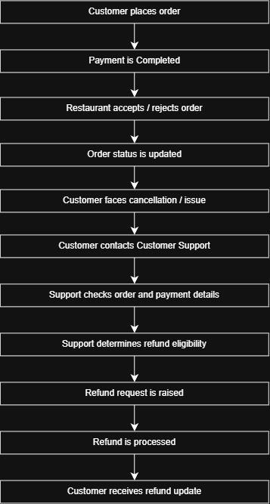

7. Business Requirements

ID | Business Requirement
BR-01 | The system should allow customers to cancel orders when cancellation is permitted.
BR-02 | The system should identify whether a cancelled or failed order is eligible for a refund.
BR-03 | The system should initiate refunds for eligible orders.
BR-04 | The system should show customers the current status of their refund.
BR-05 | The system should notify customers when there is an important update to their refund.
BR-06 | Customer Support should be able to view order, payment, and refund details when handling a customer issue.
BR-07 | The system should prevent more than one refund from being processed for the same order.
BR-08 | The system should maintain refund records for tracking and reference.

8. Business Rules

ID | Business Rule
BRS-01 | A customer can cancel an order only when the order is in an eligible status.
BRS-02 | A refund should be initiated only after the system confirms that the order is eligible for a refund.
BRS-03 | If a restaurant rejects an order after successful payment, the customer should be eligible for a full refund.
BRS-04 | If a payment fails and no amount is successfully captured, a refund should not be initiated by QuickBite.
BRS-05 | A refund should be linked to the original order and payment transaction.
BRS-06 | Only one successful refund should be processed for a single order.
BRS-07 | Customers should be able to view the status of a refund after it has been initiated.
BRS-08 | Refund processing time may vary depending on the payment method or payment provider.

Note : BRS = Business Rule Specification/Business Rule ID

9. Assumptions
For this project, we assume that:
- Customers have an active QuickBite account.
- Order and payment information is available in the system.
- Restaurants update the order status correctly.
- The payment provider provides payment and refund status.
- Refund eligibility rules have been agreed upon by the business.

10. Dependencies
The refund process depends on:
- Payment Gateway — for payment and refund transactions.
- Order Management System — for the current order status.
- Restaurant System — for order acceptance or rejection.
- Notification Service — for sending refund updates to customers.

11. Success Criteria
The project will be considered successful if:
- Customers can cancel eligible orders through the system.
- Refund eligibility is determined using clear business rules.
- Eligible refunds can be initiated without unnecessary manual intervention.
- Customers can view their refund status.
- Duplicate refunds are prevented.
- Customer Support can access the information needed to handle refund-related issues.
- Refund transactions can be tracked from initiation to completion.

