A VDM++ Specification of a KLV System
Niels K. Kirkegaard, IFAD
Abstract
This small document describes a VDM++ specification of a KLV system. The purpose of the KLV system is to provide a continuous monitoring of the speed of a train. The VDM++ specification is inspired by a KLV description provided to the EP26538 FMERail project as case study by Atelier B. This model shows an example of how an informal description can be translated into a precise model that together with a graphical front-end can be used to ensure that the customer and the developer have a common interpretation of the system under development.
The focus of the model is on the logic of the KLV systems when a train meats speed restriction beacons along the tracks, i.e. on events that triggers the KLV system. Issues such as how to determine whether a beacon has been met within a certain distance calculated from speed has been abstracted in away in the current model. They could be issues to extend the model with.
In Sections 1 and 2 below the VDM++ model is first explained. Section 3 presents a VDM++ test environment used to test the model and overview of corresponding test coverage information. The detailed coverage information is also displayed in Section 1 where the grey parts are parts of the VDM++ model which have not been executed with any of the test cases. Finally section 3 presents a small GUI which has been developed for the KLV system. This GUI is a JAVA application using an API of the VDM++ Toolbox and it can be used for illustration purposes towards users who do not understand the VDM model.

The Main Classes
The main classes of the KLV system are the KLV, the CabDisplay, the EmergencyBreak, and the OnBoardComp classes as described in the following figure. These classes are described in this section.
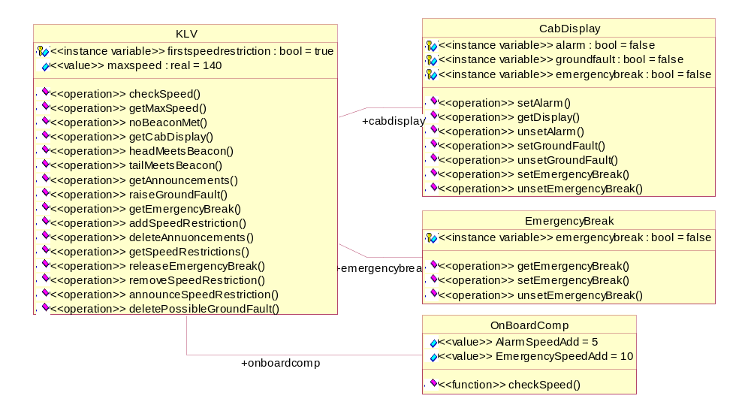

The KLV Class

The KLV class is the main class of the KLV system. It controls a Cab Display, an On Board Computer, and an Emergency Break. Furthermore, it contains operations corresponding to the kinds of events that can trigger the KLV system
--
-- THIS FILE IS AUTOMATICALLY GENERATED!!
--
-- Generated at Thu 04-Feb-99 by the Rose VDM++ Link
--
class KLV

The onboardcomp, cabdisplay, and emergencybreak instance variables are references to objects representing the on-board computer, the cab display, and the emergency break.
instance variables
onboardcomp : OnBoardComp := new OnBoardComp();
cabdisplay : CabDisplay := new CabDisplay();
emergencybreak : EmergencyBreak := new EmergencyBreak();

The announcements and speedrestrictions instance variables model the TIV_D beacons (speed restriction announcements) met and the current TIV_E beacons (speed restrictions) active. Notice the limit of at most 5 active speed restrictions.
announcements : seq of TIV_D := [];

speedrestrictions : seq of TIV_E := [];
inv len speedrestrictions <= 5;

The firstspeedrestriction instance variable ensures that the first TIV_E beacon is not removed when the train tail meets it.
firstspeedrestriction : bool := true;

The maxspeed value represents the general maximal speed of the train.
values
maxspeed : real = 140;

The operation headMeetsBeacon represents the event that the train head meets a beacon. Depending on what kind of beacon is met the actions are different. That the train head meets an FLTV beacon does not trigger any event.
operations
headMeetsBeacon : Beacon ==> ()
headMeetsBeacon (beacon) ==
cases true:
(isofclass(TIV_D, beacon)) -> announceSpeedRestriction(beacon),
(isofclass(TIV_E, beacon)) -> addSpeedRestriction(beacon),
(isofclass(TIV_A, beacon)) -> deleteAnnouncements(),
(isofclass(FLTV, beacon)) -> skip
end;

The operation tailMeetsBeacon represents the event that the end of the train meets a beacon. Depending on what kind of beacon is met the actions are different. That the end of the train meets either a TIV_D or a TIV_A beacon does not trigger any event.
If a TIV_E beacon is the first of a sequence of speed restrictions then it should not be removed when the train tail meets it. Instead the firstspeedrestriction variable is set to false. When an FLTV beacon is met it marks the end of a sequence of speed restrictions and firstspeedrestriction variable is set back to true.
tailMeetsBeacon : Beacon ==> ()
tailMeetsBeacon (beacon) ==
cases true:
(isofclass(TIV_D, beacon)) -> skip,
(isofclass(TIV_E, beacon)) -> if not firstspeedrestriction
then removeSpeedRestriction()
else firstspeedrestriction := false,
(isofclass(TIV_A, beacon)) -> skip,
(isofclass(FLTV, beacon)) -> ( firstspeedrestriction := true;
removeSpeedRestriction () )
end;

The announceSpeedRestriction operation performs the action of the train head meeting a TIV_D beacon. This action is that the announcement of a speed restriction is registered.
announceSpeedRestriction : TIV_D ==> ()
announceSpeedRestriction (tiv_d) ==
( announcements := announcements ^ [tiv_d];
deletePossibleGroundFault () );

The addSpeedRestriction operation performs the action that the train head meets a TIV_E beacon. This action is that an announcement is registered as an actual speed restriction.
addSpeedRestriction : TIV_E ==> ()
addSpeedRestriction (tiv_e) ==
if len speedrestrictions < 5
then ( let speed = (hd announcements).getTargetSpeed() in
tiv_e.setSpeedRestriction (speed);
speedrestrictions := speedrestrictions ^ [tiv_e];
announcements := tl announcements;
deletePossibleGroundFault() )
else raiseGroundFault()
pre announcements <> [] and len speedrestrictions < 5;

The deleteAnnuoncements operation performs the action that the train head meets a TIV_A beacon. This action is that all the speed restriction announcements are deleted.
deleteAnnouncements : () ==> ()
deleteAnnouncements () ==
( announcements := [];
deletePossibleGroundFault() )
pre announcements <> [];

The removeSpeedRestriction operation performs the action that the end of the train meets either a TIV_E or an FLTV beacon. This action is that a speed restriction is cancelled.
removeSpeedRestriction : () ==> ()
removeSpeedRestriction () ==
( speedrestrictions := tl speedrestrictions;
deletePossibleGroundFault() )
pre speedrestrictions <> [];

The raiseGroundFault operation raises a ground fault in the CabDisplay.
raiseGroundFault : () ==> ()
raiseGroundFault () ==
cabdisplay.setGroundFault();

The deletePossibleGroundFault operation is invoked when a beacon is met. If the ground fault lamp is switched on it must be switched off when the next beacon is met. The operation switches the ground fault lamp off if it is switched on.
deletePossibleGroundFault: () ==> ()
deletePossibleGroundFault () ==
let mk_(-,-,gf) = cabdisplay.getDisplay() in
if gf
then cabdisplay.unsetGroundFault();

The noBeaconMet operation performs the action that a TIV_E beacon has not been met corresponding to a TIV_D announcement.
noBeaconMet : () ==> ()
noBeaconMet () ==
( announcements := tl announcements;
raiseGroundFault() )
pre announcements <> [];

The checkSpeed operation checks whether a speed (the speed of the train) is below the maximal speed, within the alarm speed limit, or above the emergency break speed. The On Board Computer performs that actual calculation. The result is switching on and off lamps in the Cab Display, and performing emergency break.
checkSpeed : real ==> ()
checkSpeed (speed) ==
let speedalarm = onboardcomp.checkSpeed (speed, getMaxSpeed()) in
cases speedalarm:
<SpeedOk> -> if not emergencybreak.getEmergencyBreak()
then cabdisplay.unsetAlarm(),
<AlarmSpeed> -> if not emergencybreak.getEmergencyBreak()
then cabdisplay.setAlarm(),
<EmergencyBreakSpeed> -> ( cabdisplay.setEmergencyBreak();
emergencybreak.setEmergencyBreak() )
end;

The getMaxSpeed operation computes what the actual maximal speed is. If there are speed restrictions the maximal speed will be the minimal speed of the speed restrictions. Otherwise it will be the maximal speed.
getMaxSpeed : () ==> real
getMaxSpeed () ==
if speedrestrictions <> []
then let speeds = { tiv_e.getSpeedRestriction()
| tiv_e in set elems speedrestrictions } in
let minspeed in set speeds be st forall sp in set speeds &
minspeed <= sp in
return minspeed
else return maxspeed;

releaseEmergencyBreak : real ==> ()
releaseEmergencyBreak (sp) ==
if sp = 0
then ( cabdisplay.unsetEmergencyBreak ();
emergencybreak.unsetEmergencyBreak () )
pre let mk_(-,eb,-) = cabdisplay.getDisplay() in eb and
emergencybreak.getEmergencyBreak();

The following four operations returns state information of a KLV object.
getCabDisplay : () ==> CabDisplay
getCabDisplay () ==
return cabdisplay;

getEmergencyBreak : () ==> EmergencyBreak
getEmergencyBreak () ==
return emergencybreak;

getAnnouncements: () ==> seq of TIV_D
getAnnouncements () ==
return announcements;

getSpeedRestrictions: () ==> seq of TIV_E
getSpeedRestrictions () ==
return speedrestrictions;

end KLV

name | #calls | coverage
KLV`addSpeedRestriction | 18 | 75%
KLV`announceSpeedRestriction | 20 | 100%
KLV`checkSpeed | 4 | 100%
KLV`deleteAnnouncements | 1 | 57%
KLV`deletePossibleGroundFault | 46 | 75%
KLV`getAnnouncements | 51 | 100%
KLV`getCabDisplay | 5 | 100%
KLV`getEmergencyBreak | 5 | 100%
KLV`getMaxSpeed | 4 | 100%
KLV`getSpeedRestrictions | 51 | 100%
KLV`headMeetsBeacon | 39 | 80%
KLV`noBeaconMet | 0 | 0%
KLV`raiseGroundFault | 1 | 100%
KLV`releaseEmergencyBreak | 0 | 0%
KLV`removeSpeedRestriction | 8 | 62%
KLV`tailMeetsBeacon | 12 | 92%
total |  | 75%

The CabDisplay Class

The CabDisplay class models the three lamps of the Cab Display. The three instance variables each represents one of the lamps.
--
-- THIS FILE IS AUTOMATICALLY GENERATED!!
--
-- Generated at Thu 04-Feb-99 by the Rose VDM++ Link
--
class CabDisplay

instance variables

alarm : bool := false;

emergencybreak : bool := false;

groundfault : bool := false;

set and unset operations exist for each lamp. Setting the alarm lamp requires that neither the emergency break lamp nor the ground fault lamp is set. A side effect of setting the emergency lamp is unsetting the alarm lamp.
operations

setAlarm: () ==> ()
setAlarm () ==
alarm := true
pre not emergencybreak and not groundfault;

unsetAlarm: () ==> ()
unsetAlarm () ==
alarm := false;

setEmergencyBreak: () ==> ()
setEmergencyBreak () ==
( alarm := false;
emergencybreak := true );

unsetEmergencyBreak: () ==> ()
unsetEmergencyBreak () ==
emergencybreak := false;

setGroundFault: () ==> ()
setGroundFault () ==
groundfault := true;

unsetGroundFault: () ==> ()
unsetGroundFault () ==
groundfault := false;

The getDisplay operation returns the state of the lamps.
getDisplay: () ==> bool * bool * bool
getDisplay () ==
return mk_(alarm, emergencybreak, groundfault);

end CabDisplay

name | #calls | coverage
CabDisplay`getDisplay | 51 | 100%
CabDisplay`setAlarm | 2 | 28%
CabDisplay`setEmergencyBreak | 1 | 100%
CabDisplay`setGroundFault | 1 | 100%
CabDisplay`unsetAlarm | 1 | 100%
CabDisplay`unsetEmergencyBreak | 0 | 0%
CabDisplay`unsetGroundFault | 0 | 0%
total |  | 64%

The EmergencyBreak Class

The EmergencyBreak class models the emergency break of a train. The instance variable maintains the state of the emergency break. There are operations for setting and unsetting the emergency break, and for getting the status of it.
--
-- THIS FILE IS AUTOMATICALLY GENERATED!!
--
-- Generated at Thu 04-Feb-99 by the Rose VDM++ Link
--
class EmergencyBreak

instance variables

emergencybreak : bool := false;

operations

setEmergencyBreak : () ==> ()
setEmergencyBreak () ==
emergencybreak := true;

unsetEmergencyBreak : () ==> ()
unsetEmergencyBreak () ==
emergencybreak := false;

getEmergencyBreak : () ==> bool
getEmergencyBreak () ==
return emergencybreak;

end EmergencyBreak

name | #calls | coverage
EmergencyBreak`getEmergencyBreak | 8 | 100%
EmergencyBreak`setEmergencyBreak | 1 | 100%
EmergencyBreak`unsetEmergencyBreak | 0 | 0%
total |  | 66%

The OnBoardComp Class

The OnBoardComp class models the onboard computer of a train. The onboard computer is responsible for checking if the speed of the train is an allowed speed, an alarm speed, or an emergency break speed. The values AlarmSpeedAdd and EmergencySpeedAdd represent the addition to the maximal speed that is allowed before the alarm or emergency break respectively is invoked.
--
-- THIS FILE IS AUTOMATICALLY GENERATED!!
--
-- Generated at Fri 05-Feb-99 by the Rose VDM++ Link
--
class OnBoardComp

types

AlarmLevel = <SpeedOk> | <AlarmSpeed> | <EmergencyBreakSpeed>;

values

AlarmSpeedAdd = 5;
EmergencySpeedAdd = 10;

The checkSpeed functions is the only function of the OnBoard Computer. It checks whether a speed is less than the alarm speed (maximal speed plus AlarmSpeedAdd) and the emergency break speed (maximal speed plus EmergencySpeedAdd).
functions
checkSpeed : real * real -> AlarmLevel
checkSpeed (speed, maxspeed) ==
if speed < maxspeed + AlarmSpeedAdd
then <SpeedOk>
elseif speed < maxspeed + EmergencySpeedAdd
then <AlarmSpeed>
else <EmergencyBreakSpeed>

end OnBoardComp

name | #calls | coverage
OnBoardComp`checkSpeed | 10 | 100%
total |  | 100%

The Beacon Classes
The beacon classes consist of a class hierarchy as described in the following figure. These classes are described in this section.
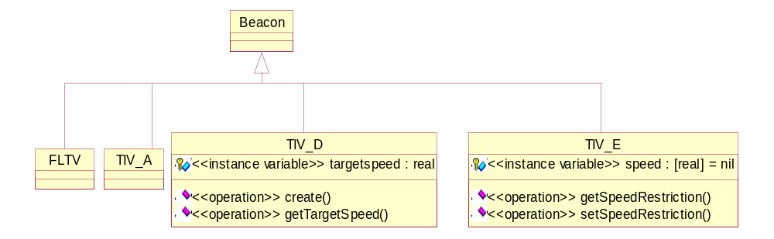

The Beacon Class

The beacon class is an abstract class representing the possible kinds of beacons. Four different kinds of beacons exist:
- TIV_D: speed restriction announcement beacon,
- TIV_E: speed restriction beacon,
- TIV_A: TIV_D cancellation beacon,
- FLTV: end of speed restriction area beacon.
A class implementing the Beacon class exists for each of these four kinds.
--
-- THIS FILE IS AUTOMATICALLY GENERATED!!
--
-- Generated at Thu 04-Feb-99 by the Rose VDM++ Link
--
class Beacon

end Beacon

The TIV_D Class

The TIV_D class represents the TIV_D beacon, and implements the abstract Beacon class. The instance variables represent the information provided by the TIV_D, the target speed (target distance to the speed restriction and declivity are not used in the model and have therefore been left out). In this model only the target speed is used. An operation create for setting the instance variables, operations for getting the target speed and entire information exist.
--
-- THIS FILE IS AUTOMATICALLY GENERATED!!
--
-- Generated at Thu 04-Feb-99 by the Rose VDM++ Link
--
class TIV_D is subclass of Beacon

instance variables
targetspeed : real;

operations
create : real ==> Beacon
create (ts) ==
( targetspeed := ts;
return self );

getTargetSpeed : () ==> real
getTargetSpeed () ==
return targetspeed;

end TIV_D

name | #calls | coverage
TIV_D`create | 20 | 100%
TIV_D`getTargetSpeed | 92 | 100%
total |  | 100%

The TIV_E Class

The TIV_E class represents the TIV_E beacon and implements the abstract Beacon class. The instance variable represents the restricted speed. A TIV_E beacon corresponds to a TIV_D beacon, and the restricted speed is set by to the target speed of that announcement when met. Set and get operations of the restricted speed exist.
--
-- THIS FILE IS AUTOMATICALLY GENERATED!!
--
-- Generated at Thu 04-Feb-99 by the Rose VDM++ Link
--
class TIV_E is subclass of Beacon

instance variables

speed : [real] := nil;

operations

setSpeedRestriction : real ==> ()
setSpeedRestriction (s) ==
speed := s;

getSpeedRestriction : () ==> real
getSpeedRestriction () ==
return speed
pre speed <> nil;

end TIV_E

name | #calls | coverage
TIV_E`getSpeedRestriction | 76 | 40%
TIV_E`setSpeedRestriction | 17 | 100%
total |  | 57%

The TIV_A Class

The TIV_A class represents the TIV_A beacon and implements the abstract Beacon class. The class does not contain any instance variables nor operations as the presence of the beacon defines the action to perform.
--
-- THIS FILE IS AUTOMATICALLY GENERATED!!
--
-- Generated at Thu 04-Feb-99 by the Rose VDM++ Link
--
class TIV_A is subclass of Beacon

end TIV_A

The FLTV Class

The FLTV class represents the FLTV beacon and implements the abstract Beacon class. The class does not contain any instance variables or operations as the presence of the beacon defines the action to perform.
--
-- THIS FILE IS AUTOMATICALLY GENERATED!!
--
-- Generated at Thu 04-Feb-99 by the Rose VDM++ Link
--
class FLTV is subclass of Beacon

end FLTV

The Test Class

The Test class defines an environment for executing test cases. The class maintains a reference to a KLV instance, and it provides two operations, runOneTest for execution of one test event, and runTests for execution of a sequence of test events. Different kinds of test events can be executed. These are defined by the Event class hierarchy defined below.
The data types represent different kinds of categories of results.
class Test

types

TestResult = KLVstate | BeaconsMet | MaxSpeed;

KLVstate :: cd : CabDisp
eb : EmerBreak;

CabDisp :: alarm : bool
emerbr : bool
grfault : bool;

EmerBreak :: break : bool;

BeaconsMet :: ann : seq of TIVD
res : seq of TIVE;

TIVD :: ts : real;

TIVE :: sp : real;

MaxSpeed :: ms: real;

instance variables

klv : KLV := new KLV();

operations

runTests : seq of Event ==> seq of TestResult
runTests (events) ==
return [events(i).execute(klv) | i in set inds events ];

runOneTest : Event ==> TestResult
runOneTest (event) ==
return event.execute(klv);

end Test

The Test Classes
The test classes consist of a Test class, and a class hierarchy of Event classes, as described in the following figure. These classes are described in this section.
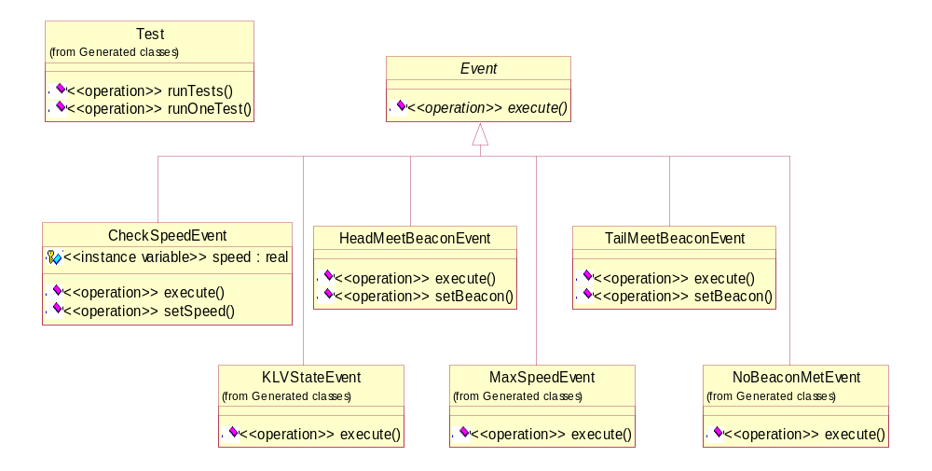

The Event Class

The Event class is the abstract super class of the class hierarchy of test events. Each class implementing this event class must define an execute operation.
--
-- THIS FILE IS AUTOMATICALLY GENERATED!!
--
-- Generated at Fri 05-Feb-99 by the Rose VDM++ Link
--
class Event

operations

execute : KLV ==> Test`TestResult
execute (klv) ==
is subclass responsibility;

end Event

The CheckSpeedEvent Test Class

The CheckSpeedEvent class implements a test event that checks the speed of a train (i.e. of a KLV instance). It provides a setSpeed and an execute operation. The execute operation returns the status of the Cab Display and of the Emergency Break.
--
-- THIS FILE IS AUTOMATICALLY GENERATED!!
--
-- Generated at Fri 05-Feb-99 by the Rose VDM++ Link
--
class CheckSpeedEvent is subclass of Event

instance variables

speed : real;

operations

setSpeed : real ==> Event
setSpeed (s) ==
( speed := s;
return self );

execute : KLV ==> Test`TestResult
execute (klv) ==
( klv.checkSpeed(speed);
let mk_(a,e,g) = klv.getCabDisplay().getDisplay(),
e' = klv.getEmergencyBreak().getEmergencyBreak() in
return mk_Test`KLVstate(mk_Test`CabDisp(a,e,g),
mk_Test`EmerBreak(e')) );

end CheckSpeedEvent

The HeadMeetBeaconEvent Test Class

The HeadMeetBeaconEvent class implements a test event where the head of a train meets a beacon. It provides a setBeacon and an execute operation. The execute operation returns the current announcements and speed restrictions.
--
-- THIS FILE IS AUTOMATICALLY GENERATED!!
--
-- Generated at Fri 05-Feb-99 by the Rose VDM++ Link
--
class HeadMeetBeaconEvent is subclass of Event

instance variables

beacon : Beacon;

operations

setBeacon : Beacon ==> Event
setBeacon (b) ==
( beacon := b;
return self );

execute : KLV ==> Test`TestResult
execute (klv) ==
( klv.headMeetsBeacon(beacon);
let anns = klv.getAnnouncements(),
restr = klv.getSpeedRestrictions() in
return mk_Test`BeaconsMet(
[ mk_Test`TIVD(anns(i).getTargetSpeed()) |
i in set inds anns ],
[ mk_Test`TIVE(restr(i).getSpeedRestriction()) |
i in set inds restr ]) );

end HeadMeetBeaconEvent

The TailMeetBeaconEvent Test Class

The TailMeetBeaconEvent class implements a test event where the tail of a train meets a beacon. It provides a setBeacon and an execute operation. The execute operation returns the current announcements and speed restrictions.
--
-- THIS FILE IS AUTOMATICALLY GENERATED!!
--
-- Generated at Fri 05-Feb-99 by the Rose VDM++ Link
--
class TailMeetBeaconEvent is subclass of Event

instance variables

beacon : Beacon;

operations

setBeacon : Beacon ==> Event
setBeacon (b) ==
( beacon := b;
return self );

execute : KLV ==> Test`TestResult
execute (klv) ==
( klv.tailMeetsBeacon(beacon);
let anns = klv.getAnnouncements(),
restr = klv.getSpeedRestrictions() in
return mk_Test`BeaconsMet(
[ mk_Test`TIVD(anns(i).getTargetSpeed()) |
i in set inds anns ],
[ mk_Test`TIVE(restr(i).getSpeedRestriction()) |
i in set inds restr ]) );

end TailMeetBeaconEvent

The NoBeaconMetEvent Test Class

The NoBeaconMetEvent class implements the event that an announced TIV_E was not met in the distance it was supposed to be located. It provides an execute operation that returns the status of the Cab Display and of the Emergency Break.
--
-- THIS FILE IS AUTOMATICALLY GENERATED!!
--
-- Generated at Fri 05-Feb-99 by the Rose VDM++ Link
--
class NoBeaconMetEvent is subclass of Event

operations

execute : KLV ==> Test`TestResult
execute (klv) ==
( klv.noBeaconMet();
let mk_(a,e,g) = klv.getCabDisplay().getDisplay(),
e' = klv.getEmergencyBreak().getEmergencyBreak() in
return mk_Test`KLVstate(mk_Test`CabDisp(a,e,g),
mk_Test`EmerBreak(e')) );

end NoBeaconMetEvent

The KLVStateEvent Test Class

The KLVStateEvent class implements a test event that does not perform any action, but returns the status of the Cab Display and the Emergency Break.
--
-- THIS FILE IS AUTOMATICALLY GENERATED!!
--
-- Generated at Fri 05-Feb-99 by the Rose VDM++ Link
--
class KLVStateEvent is subclass of Event

operations

execute : KLV ==> Test`TestResult
execute (klv) ==
(let mk_(a,e,g) = klv.getCabDisplay().getDisplay(),
e' = klv.getEmergencyBreak().getEmergencyBreak() in
return mk_Test`KLVstate(mk_Test`CabDisp(a,e,g),
mk_Test`EmerBreak(e')) );

end KLVStateEvent

The MaxSpeedEvent Test Class

The MaxSpeedEvent class implements a test event that does not perform any action, but returns the status of the maximal allowed speed of the train.
--
-- THIS FILE IS AUTOMATICALLY GENERATED!!
--
-- Generated at Fri 05-Feb-99 by the Rose VDM++ Link
--
class MaxSpeedEvent is subclass of Event

operations

execute : KLV ==> Test`TestResult
execute (klv) ==
( let ms = klv.getMaxSpeed() in
return mk_Test`MaxSpeed(ms) );

end MaxSpeedEvent

Graphical Front End
In order to visualise the VDM model in a way that can be understood without knowledge of the VDM specification we have made a graphical user interface from which the model can be executed and the results visualised in an easy-to-understand manner. In the top part of the GUI a track segment has been divided into smaller segments. Each of these segments can contain a beacon. The speed of the train can be set in the GUI and the train can be moved one segment at the time. For each movement the segments at the head and the tail of the train are examined for beacons and corresponding actions are taken. In the Message window messages from the model such as violation of pre-conditions are reported. The GUI has been written in JAVA and it communicates with the VDM++ Toolbox through the Toolbox’s API.

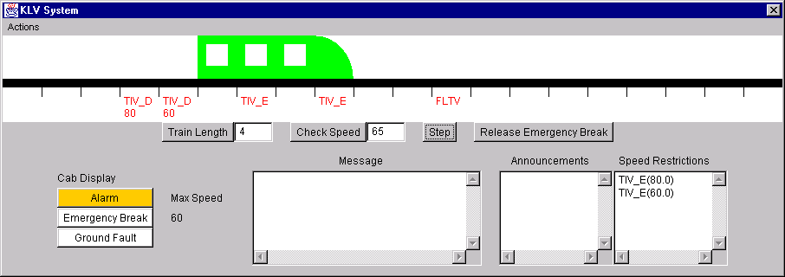

Index

Beacon
Beacon, 8
CabDisplay
CabDisplay, 5
getDisplay, 6
setAlarm, 6
setEmergencyBreak, 6
setGroundFault, 6
unsetAlarm, 6
unsetEmergencyBreak, 6
unsetGroundFault, 6
CheckSpeedEvent
CheckSpeedEvent, 12
execute, 13
setSpeed, 13
EmergencyBreak
EmergencyBreak, 7
getEmergencyBreak, 7
setEmergencyBreak, 7
unsetEmergencyBreak, 7
Event
Event, 12
execute, 12
FLTV
FLTV, 10
HeadMeetBeaconEvent
execute, 13
HeadMeetBeaconEvent, 13
setBeacon, 13
KLV
addSpeedRestriction, 3
announceSpeedRestriction, 3
checkSpeed, 4
deleteAnnouncements, 3
deletePossibleGroundFault, 4
getAnnouncements, 5
getCabDisplay, 4
getEmergencyBreak, 5
getMaxSpeed, 4
getSpeedRestrictions, 5
headMeetsBeacon, 2
KLV, 2
noBeaconMet, 4
raiseGroundFault, 3
releaseEmergencyBreak, 4
removeSpeedRestriction, 3
tailMeetsBeacon, 3
KLVStateEvent
execute, 15
KLVStateEvent, 15
MaxSpeedEvent
execute, 15
MaxSpeedEvent, 15
NoBeaconMetEvent
execute, 14
NoBeaconMetEvent, 14
OnBoardComp
AlarmLevel, 7
checkSpeed, 8
OnBoardComp, 7
TailMeetBeaconEvent
execute, 14
setBeacon, 14
TailMeetBeaconEvent, 14
Test
BeaconsMet, 11
CabDisp, 11
EmerBreak, 11
KLVstate, 11
MaxSpeed, 11
runOneTest, 11
runTests, 11
Test, 11
TestResult, 11
TIVD, 11
TIVE, 11
TIV_A
TIV_A, 10
TIV_D
create, 9
getTargetSpeed, 9
TIV_D, 9
TIV_E
getSpeedRestriction, 10
setSpeedRestriction, 10
TIV_E, 9

