Safer demo user guide

Installation
- Make sure that the paths VDM++ and VDM-SL are set up in the PATH environment variable. Starting the toolbox from a DOS prompt using the commands vdmgde and vppgde easily checks this.
- Copy the file saferdemo.zip to some directory of choice and unzip it. If Winzip is installed on the machine, then select the zip-file and press the right mouse button to activate the context-menu. Select the menu item Extract to folder c:\...\saferdemo. The sub directory saferdemo is created.
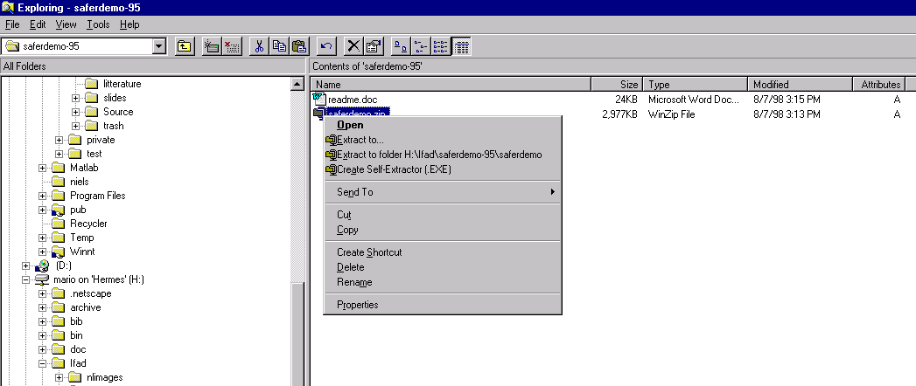
- Before starting MatLab you might want to backup your MatLab “startup.m” file, which contains all your MatLab user start up commands. This file is found in the MatLab directory c:\...\matlab\toolbox\local\startup.m. The set up procedure will add two lines at the beginning of this file. You can now start MatLab using the Windows start menu.
- Use the cd command in the MatLab console to navigate to the recently created saferdemo directory.
- Execute the command setupsafer [OS choice] from the MatLab console, where the OS choice can have the values W95 or NT4. Default installation is W95.
- The file paths in the VDM/VDM++ safer project files will be invalid. Update the VDM/VDM++ safer project files using the VDM toolbox. The project files are installed as saferdemo\safer-sl\safer.prj and saferdemo\safer++\safer.prj. The specification files are found in the same directories as files with extension vdm and rtf.

User guide
- Start MatLab if it has not all ready been started.
- From the MatLab shell execute the command safer [option], where
  - Default option is sl, which starts the demo GUI and a sl-toolbox.
  - The option pp starts the safer demonstration GUI and a ++-toolbox.
  - Appending a minus sign, -, to the sl or pp options starts only a safer demonstration GUI without starting a new toolbox.
- It is possible to have both a SL and a ++-demo running simultaneously, as long as each demo runs in its own MatLab shell and VDM toolbox. However, toolbox sharing is possible but not recommended.

