The Sorting Example in VDM++

This document contains a sorting example using VDM++. The class diagram can be seen in Figure 1. The structure of the example is known as the strategy pattern. This pattern defines a family of algorithms, encapsulate each one and make them interchangeable. The strategy pattern lets the algorithm vary independently from clients that use it. The SortMachine class is the client that uses the different sorting algorithms. The Sorter class is an abstract class that defines a common interface to all supported algorithms.

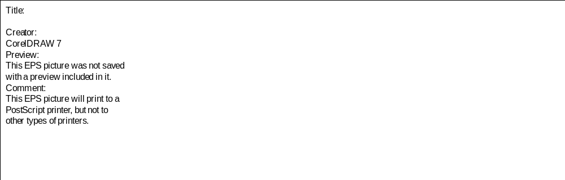
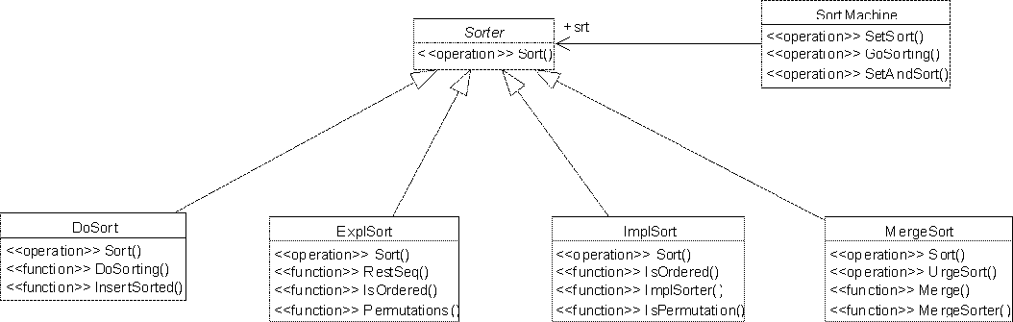
Figure 1. Class hierarchy for the sorting example in VDM++ shown in UML/Rational Rose

The DoSort Class

class DoSort is subclass of Sorter

operations

Sort: seq of int ==> seq of int
Sort(l) ==
return DoSorting(l)

functions

DoSorting: seq of int -> seq of int
DoSorting(l) ==
if l = [] then
[]
else
let sorted = DoSorting (tl l) in
InsertSorted (hd l, sorted);

InsertSorted: int * seq of int -> seq of int
InsertSorted(i,l) ==
cases true :
(l = []) -> [i],
(i <= hd l) -> [i] ^ l,
others -> [hd l] ^ InsertSorted(i,tl l)
end

end DoSort

An overview of the test coverage information for the DoSort class is listed in the table below. The test coverage information is generated using the argument file sort.arg.

DoSort

ExplSort

The class ExplSort is a refinement of the algorithm described in ImplSort.

class ExplSort is subclass of Sorter

operations

Sort: seq of int ==> seq of int
Sort(l) ==
let r in set Permutations(l) be st IsOrdered(r) in
return r

functions

Permutations: seq of int -> set of seq of int
Permutations(l) ==
cases l:
[],[-] -> {l},
others -> dunion {{[l(i)]^j |
j in set Permutations(RestSeq(l,i))} |
i in set inds l}
end;

RestSeq: seq of int * nat -> seq of int
RestSeq(l,i) ==
[l(j) | j in set (inds l \ {i})];

IsOrdered: seq of int -> bool
IsOrdered(l) ==
forall i,j in set inds l & i > j => l(i) >= l(j)

end ExplSort

ExplSort

ImplSort

The class ImplSort is an example of a sorting algorithm defined by implicit functions.

class ImplSort is subclass of Sorter

operations

Sort: seq of int ==> seq of int
Sort(l) ==
return ImplSorter(l);

functions

ImplSorter(l: seq of int) r: seq of int
post IsPermutation(r,l) and IsOrdered(r);

IsPermutation: seq of int * seq of int -> bool
IsPermutation(l1,l2) ==
forall e in set (elems l1 union elems l2) &
card {i | i in set inds l1 & l1(i) = e} =
card {i | i in set inds l2 & l2(i) = e};

IsOrdered: seq of int -> bool
IsOrdered(l) ==
forall i,j in set inds l & i > j => l(i) >= l(j)

end ImplSort

MergeSort

The MergeSort class only provides the operation Sort and the functions MergeSorter and Merge to the outside world. It is a subclass of Sorter which is natural in the sense that it is one way of providing the sorting functionality.

class MergeSort is subclass of Sorter

operations

Sort: seq of int ==> seq of int
Sort(l) ==
return MergeSorter(l)

functions

The function MergeSorter is using the traditional algorith for splitting a sequence into two almost equally long sequences and then merging the results of sorting each of them. The split here is made using a let-be expression where l1 and l2 are introduced in a sequence concatenation pattern. A matching solution must satisfy the predicate which states that the difference of the lengths is less than 2.

MergeSorter: seq of real -> seq of real
MergeSorter(l) ==
cases l:
[] -> l,
[e] -> l,
others -> let l1^l2 in set {l} be st abs (len l1 - len l2) < 2
in
let l_l = MergeSorter(l1),
l_r = MergeSorter(l2) in
Merge(l_l, l_r)
end;

The Merge function is an auxiliary function which simply merges two sorted sequences into a new sorted sequence.

Merge: seq of int * seq of int -> seq of int
Merge(l1,l2) ==
cases mk_(l1,l2):
mk_([],l),mk_(l,[]) -> l,
others -> if hd l1 <= hd l2 then
[hd l1] ^ Merge(tl l1, l2)
else
[hd l2] ^ Merge(l1, tl l2)
end
pre forall i in set inds l1 & l1(i) >= 0 and
forall i in set inds l2 & l2(i) >= 0

end MergeSort

test coverage of the MergeSort class can gathered as:

MergeSort

Sorter class

class Sorter

operations

Sort: seq of int ==> seq of int
Sort(-) ==
is subclass responsibility

end Sorter

Sort Machine
The SortMachine is the context class of the behavioral pattern "Strategy". This is the class that uses the different sorting algorithms.

class SortMachine

instance variables
srt: Sorter := new MergeSort();

The instance variable "srt" is an object reference to the sorting algorithm currently in use. The initial sorting algorithm is MergeSort.

Setting/changing which sorting algorithm to use.

operations

SetSort: Sorter ==> ()
SetSort(s) ==
srt := s;

Sorting with the sorting algorithm currently in use.

GoSorting: seq of int ==> seq of int
GoSorting(arr) ==
return srt.Sort(arr);

Set/change first the sorting algorithm and sort afterwards.

SetAndSort: Sorter * seq of int ==> seq of int
SetAndSort(s, arr) ==
( srt := s;
return srt.Sort(arr)
)

end SortMachine

Index

DoSort
DoSort, 1
DoSorting, 1
InsertSorted, 1
Sort, 1
ExplSort
ExplSort, 2
IsOrdered, 2
Permutations, 2
RestSeq, 2
Sort, 2
ImplSort
ImplSort, 2
ImplSorter, 3
IsOrdered, 3
IsPermutation, 3
Sort, 3
MergeSort
Merge, 4
MergeSort, 3
MergeSorter, 3
Sort, 3
Sorter
Sort, 4
Sorter, 4
SortMachine
GoSorting, 5
SetAndSort, 5
SetSort, 4
SortMachine, 4

