Собрал проект в Debug

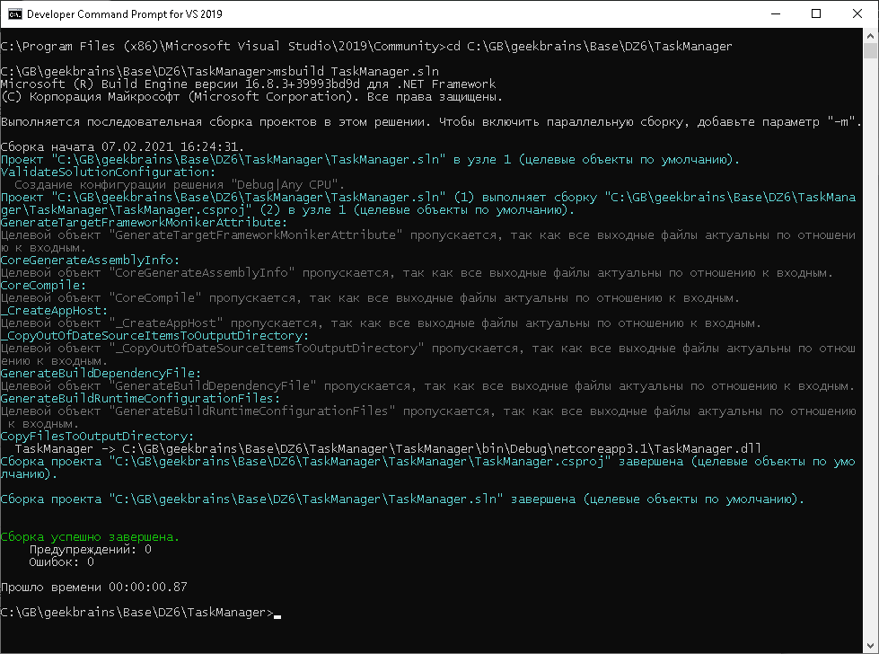

Собрал проект в Релиз

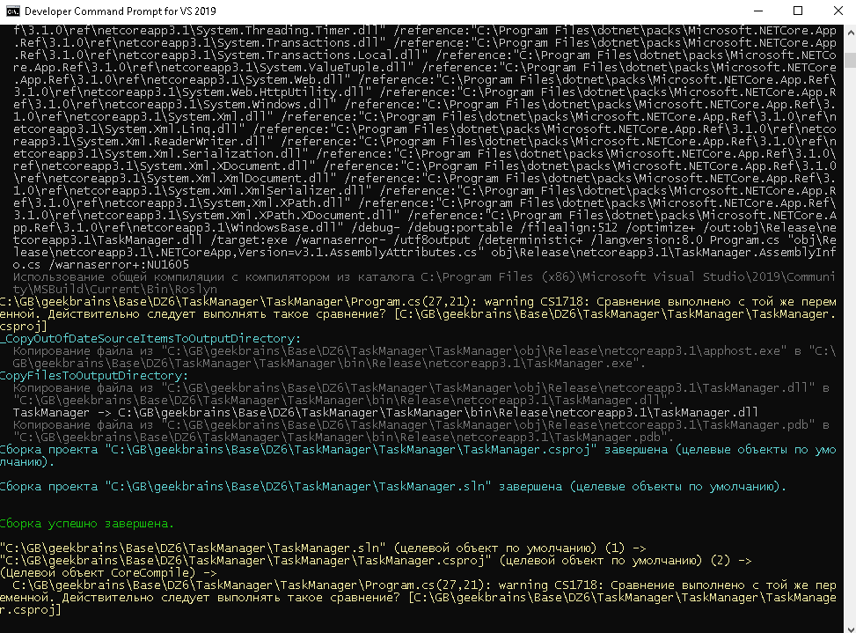

Декомпилировал с помощью dotPeak

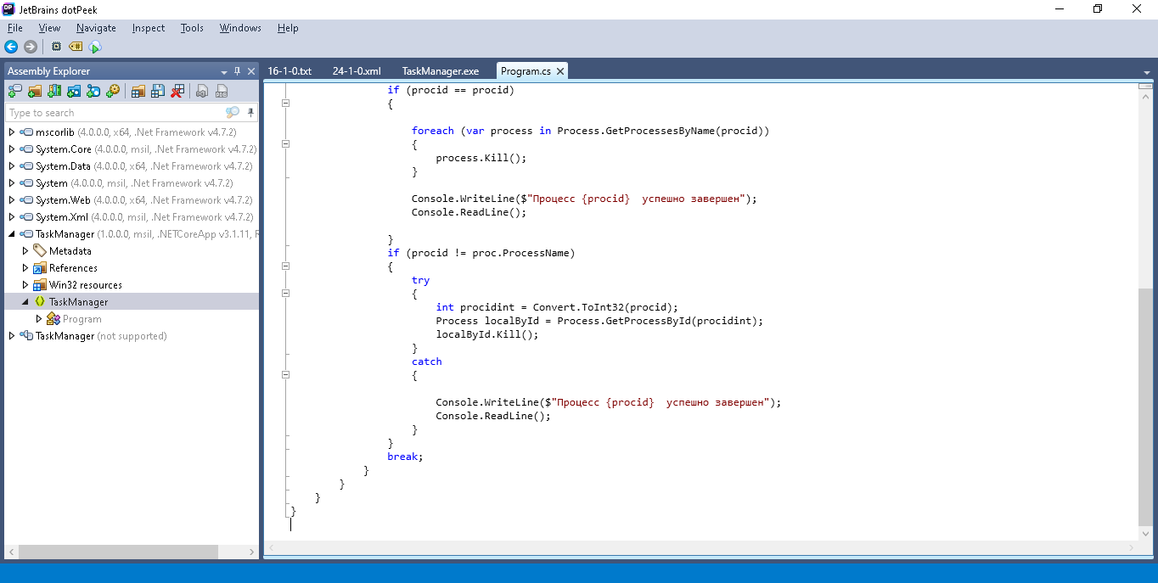

Пересобрал проект

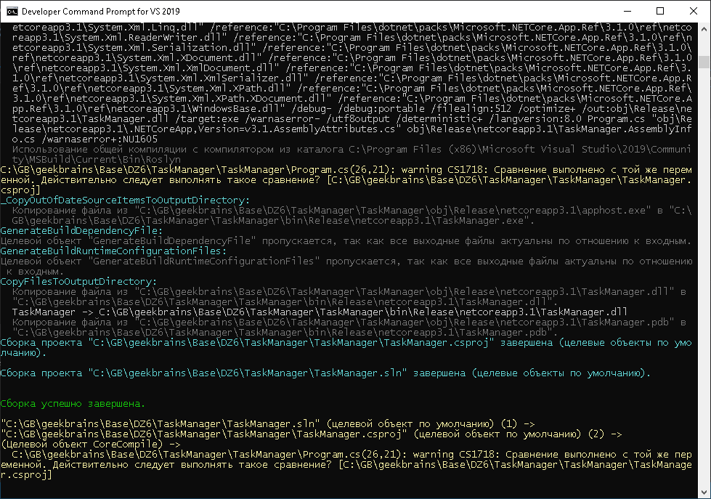

Правки в программе dotPeak отображаются

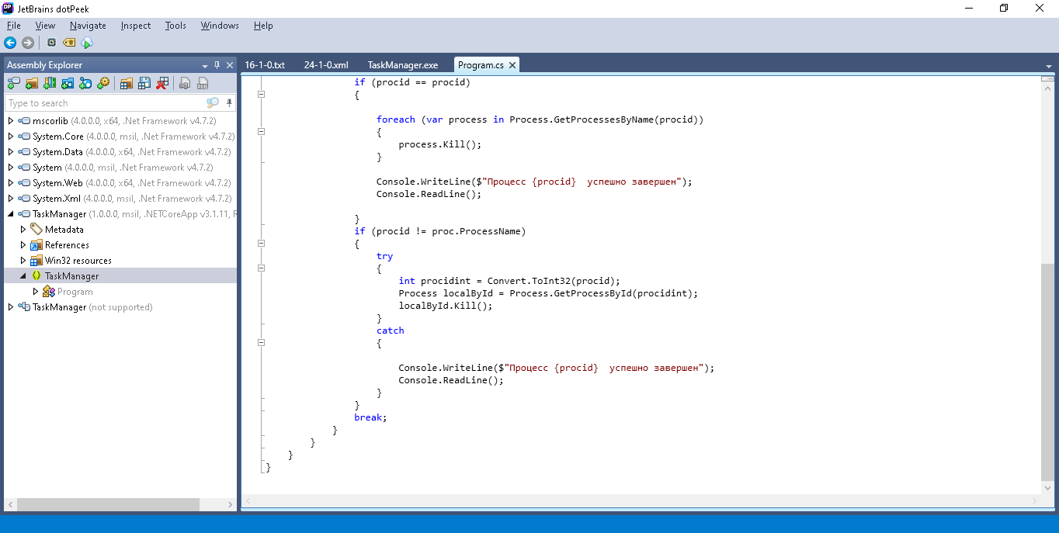

ILDasm

.method private hidebysig static void Main(string[] args) cil managed

{

.entrypoint

// Размер кода: 288 (0x120)

.maxstack 3

.locals init (class [System.Diagnostics.Process]System.Diagnostics.Process[] V_0,

string V_1,

class [System.Diagnostics.Process]System.Diagnostics.Process[] V_2,

int32 V_3,

class [System.Diagnostics.Process]System.Diagnostics.Process V_4,

class [System.Diagnostics.Process]System.Diagnostics.Process[] V_5,

int32 V_6,

class [System.Diagnostics.Process]System.Diagnostics.Process V_7,

bool V_8,

class [System.Diagnostics.Process]System.Diagnostics.Process[] V_9,

int32 V_10,

class [System.Diagnostics.Process]System.Diagnostics.Process V_11,

bool V_12,

int32 V_13,

class [System.Diagnostics.Process]System.Diagnostics.Process V_14)

IL_0000: nop

IL_0001: call class [System.Diagnostics.Process]System.Diagnostics.Process[] [System.Diagnostics.Process]System.Diagnostics.Process::GetProcesses()

IL_0006: stloc.0

IL_0007: nop

IL_0008: ldloc.0

IL_0009: stloc.2

IL_000a: ldc.i4.0

IL_000b: stloc.3

IL_000c: br.s IL_003c

IL_000e: ldloc.2

IL_000f: ldloc.3

IL_0010: ldelem.ref

IL_0011: stloc.s V_4

IL_0013: nop

IL_0014: ldstr "{0} {1}"

IL_0019: ldloc.s V_4

IL_001b: callvirt instance int32 [System.Diagnostics.Process]System.Diagnostics.Process::get_Id()

IL_0020: box [System.Runtime]System.Int32

IL_0025: ldloc.s V_4

IL_0027: callvirt instance string [System.Diagnostics.Process]System.Diagnostics.Process::get_ProcessName()

IL_002c: call string [System.Runtime]System.String::Format(string,

object,

object)

IL_0031: call void [System.Console]System.Console::WriteLine(string)

IL_0036: nop

IL_0037: nop

IL_0038: ldloc.3

IL_0039: ldc.i4.1

IL_003a: add

IL_003b: stloc.3

IL_003c: ldloc.3

IL_003d: ldloc.2

IL_003e: ldlen

IL_003f: conv.i4

IL_0040: blt.s IL_000e

IL_0042: ldstr bytearray (12 04 32 04 35 04 34 04 38 04 42 04 35 04 20 00 // ..2.5.4.8.B.5. .

49 00 44 00 20 00 38 04 3B 04 38 04 20 00 3D 04 // I.D. .8.;.8. .=.

30 04 37 04 32 04 30 04 3D 04 38 04 4F 04 20 00 // 0.7.2.0.=.8.O. .

3F 04 40 04 3E 04 46 04 35 04 41 04 41 04 30 04 ) // ?.@.>.F.5.A.A.0.

IL_0047: call void [System.Console]System.Console::WriteLine(string)

IL_004c: nop

IL_004d: call string [System.Console]System.Console::ReadLine()

IL_0052: stloc.1

IL_0053: nop

IL_0054: ldloc.0

IL_0055: stloc.s V_5

IL_0057: ldc.i4.0

IL_0058: stloc.s V_6

IL_005a: br IL_0114

IL_005f: ldloc.s V_5

IL_0061: ldloc.s V_6

IL_0063: ldelem.ref

IL_0064: stloc.s V_7

IL_0066: nop

IL_0067: ldloc.1

IL_0068: ldloc.1

IL_0069: call bool [System.Runtime]System.String::op_Equality(string,

string)

IL_006e: stloc.s V_8

IL_0070: ldloc.s V_8

IL_0072: brfalse.s IL_00bf

IL_0074: nop

IL_0075: nop

IL_0076: ldloc.1

IL_0077: call class [System.Diagnostics.Process]System.Diagnostics.Process[] [System.Diagnostics.Process]System.Diagnostics.Process::GetProcessesByName(string)

IL_007c: stloc.s V_9

IL_007e: ldc.i4.0

IL_007f: stloc.s V_10

IL_0081: br.s IL_009a

IL_0083: ldloc.s V_9

IL_0085: ldloc.s V_10

IL_0087: ldelem.ref

IL_0088: stloc.s V_11

IL_008a: nop

IL_008b: ldloc.s V_11

IL_008d: callvirt instance void [System.Diagnostics.Process]System.Diagnostics.Process::Kill()

IL_0092: nop

IL_0093: nop

IL_0094: ldloc.s V_10

IL_0096: ldc.i4.1

IL_0097: add

IL_0098: stloc.s V_10

IL_009a: ldloc.s V_10

IL_009c: ldloc.s V_9

IL_009e: ldlen

IL_009f: conv.i4

IL_00a0: blt.s IL_0083

IL_00a2: ldstr bytearray (1F 04 40 04 3E 04 46 04 35 04 41 04 41 04 20 00 ) // ..@.>.F.5.A.A. .

IL_00a7: ldloc.1

IL_00a8: ldstr bytearray (20 00 20 00 43 04 41 04 3F 04 35 04 48 04 3D 04 // . .C.A.?.5.H.=.

3E 04 20 00 37 04 30 04 32 04 35 04 40 04 48 04 // >. .7.0.2.5.@.H.

35 04 3D 04 ) // 5.=.

IL_00ad: call string [System.Runtime]System.String::Concat(string,

string,

string)

IL_00b2: call void [System.Console]System.Console::WriteLine(string)

IL_00b7: nop

IL_00b8: call string [System.Console]System.Console::ReadLine()

IL_00bd: pop

IL_00be: nop

IL_00bf: ldloc.1

IL_00c0: ldloc.s V_7

IL_00c2: callvirt instance string [System.Diagnostics.Process]System.Diagnostics.Process::get_ProcessName()

IL_00c7: call bool [System.Runtime]System.String::op_Inequality(string,

string)

IL_00cc: stloc.s V_12

IL_00ce: ldloc.s V_12

IL_00d0: brfalse.s IL_0112

IL_00d2: nop

.try

{

IL_00d3: nop

IL_00d4: ldloc.1

IL_00d5: call int32 [System.Runtime.Extensions]System.Convert::ToInt32(string)

IL_00da: stloc.s V_13

IL_00dc: ldloc.s V_13

IL_00de: call class [System.Diagnostics.Process]System.Diagnostics.Process [System.Diagnostics.Process]System.Diagnostics.Process::GetProcessById(int32)

IL_00e3: stloc.s V_14

IL_00e5: ldloc.s V_14

IL_00e7: callvirt instance void [System.Diagnostics.Process]System.Diagnostics.Process::Kill()

IL_00ec: nop

IL_00ed: nop

IL_00ee: leave.s IL_0111

} // end .try

catch [System.Runtime]System.Object

{

IL_00f0: pop

IL_00f1: nop

IL_00f2: ldstr bytearray (1F 04 40 04 3E 04 46 04 35 04 41 04 41 04 20 00 ) // ..@.>.F.5.A.A. .

IL_00f7: ldloc.1

IL_00f8: ldstr bytearray (20 00 20 00 43 04 41 04 3F 04 35 04 48 04 3D 04 // . .C.A.?.5.H.=.

3E 04 20 00 37 04 30 04 32 04 35 04 40 04 48 04 // >. .7.0.2.5.@.H.

35 04 3D 04 ) // 5.=.

IL_00fd: call string [System.Runtime]System.String::Concat(string,

string,

string)

IL_0102: call void [System.Console]System.Console::WriteLine(string)

IL_0107: nop

IL_0108: call string [System.Console]System.Console::ReadLine()

IL_010d: pop

IL_010e: nop

IL_010f: leave.s IL_0111

} // end handler

IL_0111: nop

IL_0112: br.s IL_011f

IL_0114: ldloc.s V_6

IL_0116: ldloc.s V_5

IL_0118: ldlen

IL_0119: conv.i4

IL_011a: blt IL_005f

IL_011f: ret

} // end of method Program::Main