Race Pace Championships Management
User tutorial
Create, edit and share custom championships for the Race Pace app (AMS2 career app)

1. Introduction
Race Pace Championships Management lets you build and edit custom championships for the Race Pace app, the AMS2 career app. This tutorial walks through each feature of the application:
- Importing existing championships (Race Pace original, Blitzer69 custom ones, or your own)
- Creating, editing and deleting championships, with their events and cars
- Creating, editing and deleting teams
- Creating, editing and deleting custom drivers
- Exporting your championships
The app runs locally in your browser and keeps your data between visits. To start it from the project folder, run pnpm install, then pnpm start, and open http://localhost:4200.

Home page and navigation
The home page groups the features into three blocks: Import, Manage (Championships, Teams, Drivers) and Export. The same destinations are available at any time from the sidebar on the left (Home, Import, Championships, Teams, Drivers, Export). Every page has a Back button at the top left.
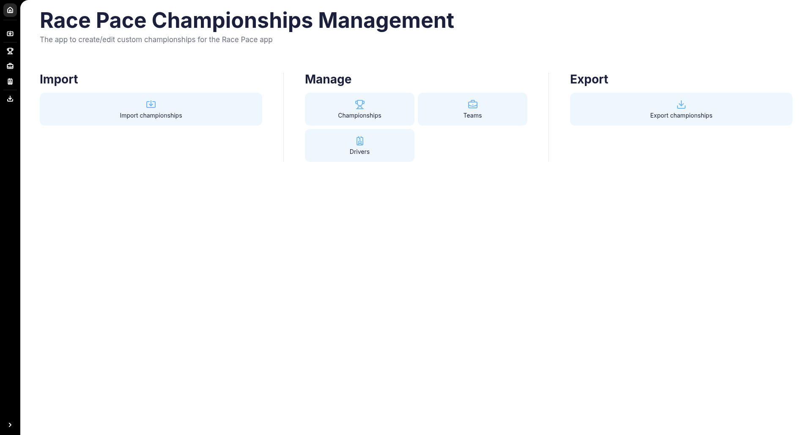
Figure 1 – Home page

2. Importing championships
Open Import from the sidebar or the home page. You have two ways to bring data in.

2.1 Import existing championships
Three one-click buttons load a ready-made data set: Import Race Pace original, Import Blitzer without mods, and Import Blitzer with mods.

2.2 Import custom championships
Upload your own files either as individual CSV files or as one ZIP file. Required files: cars.csv, championships.csv, events.csv, teams.csv. Optional file: drivers.csv. Drop the files on the upload area (or choose them), then click Import custom.
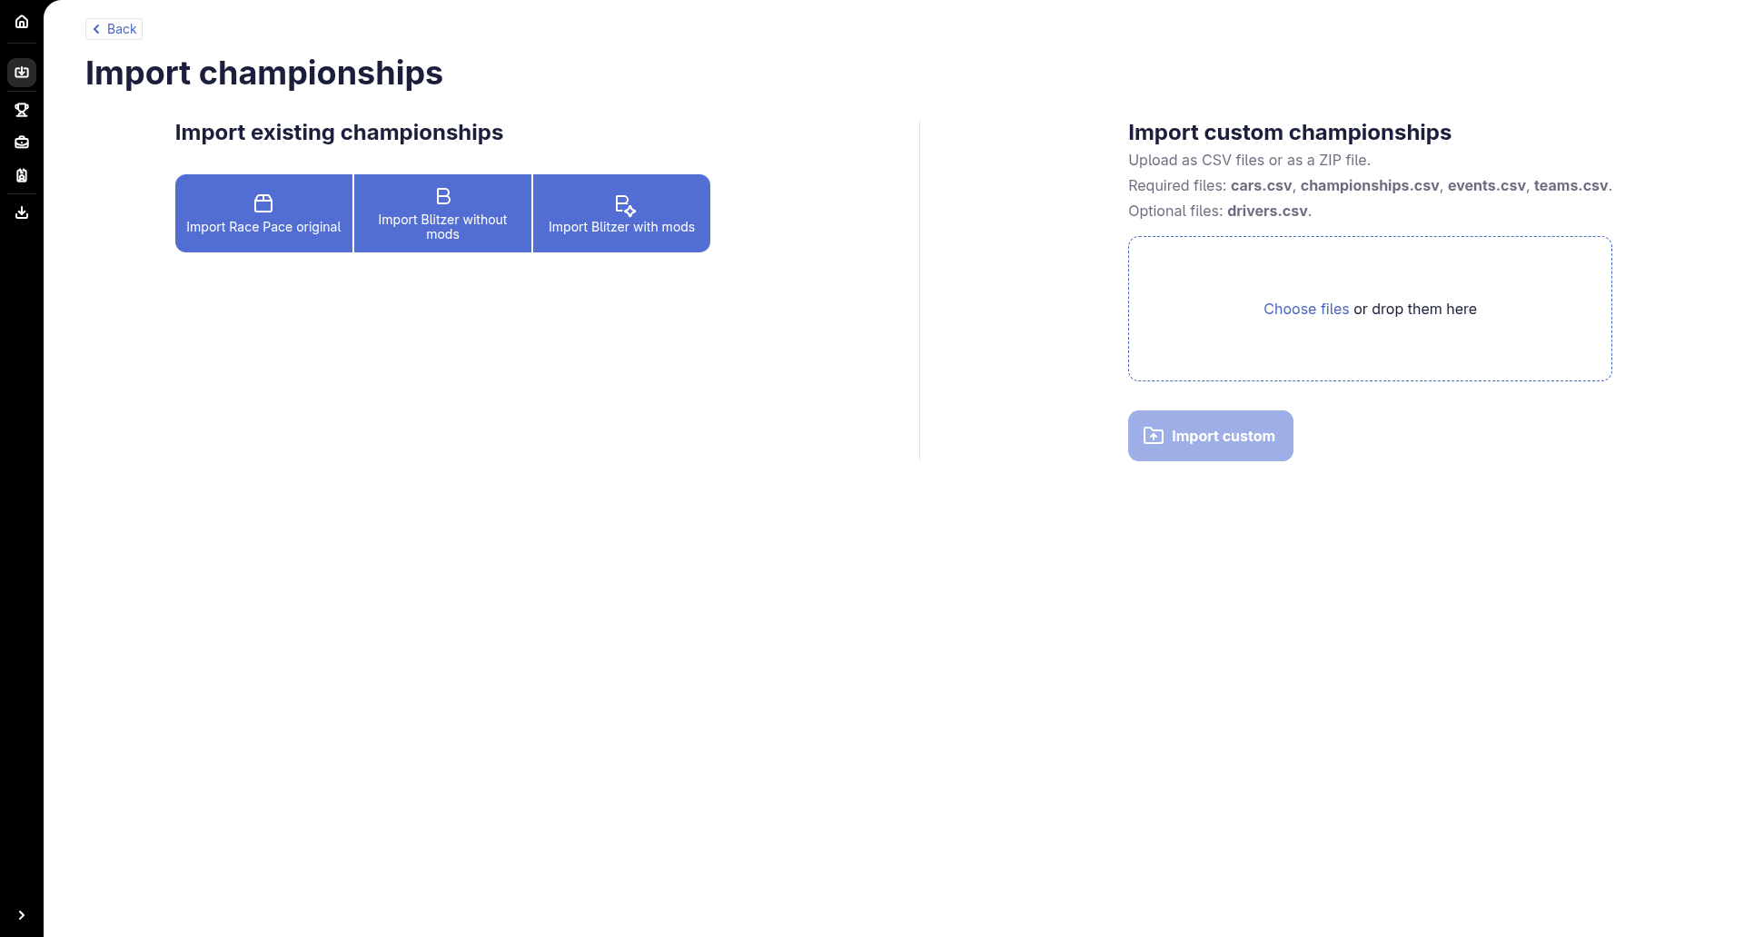
Figure 2 – Import page

2.3 Choose what to import
After picking a data set, a three-step wizard (Championships, Teams, Drivers) lets you choose exactly what to import.
- On the Championships step, tick the championships you want. The checkbox in the header selects every row. You can sort and filter by name, categories, start/end year, prestige, events, tags and default status.
- Click Next to review the Teams step, then Next again for the Drivers step.
- Click Import. A dialog asks how to merge with your existing data.
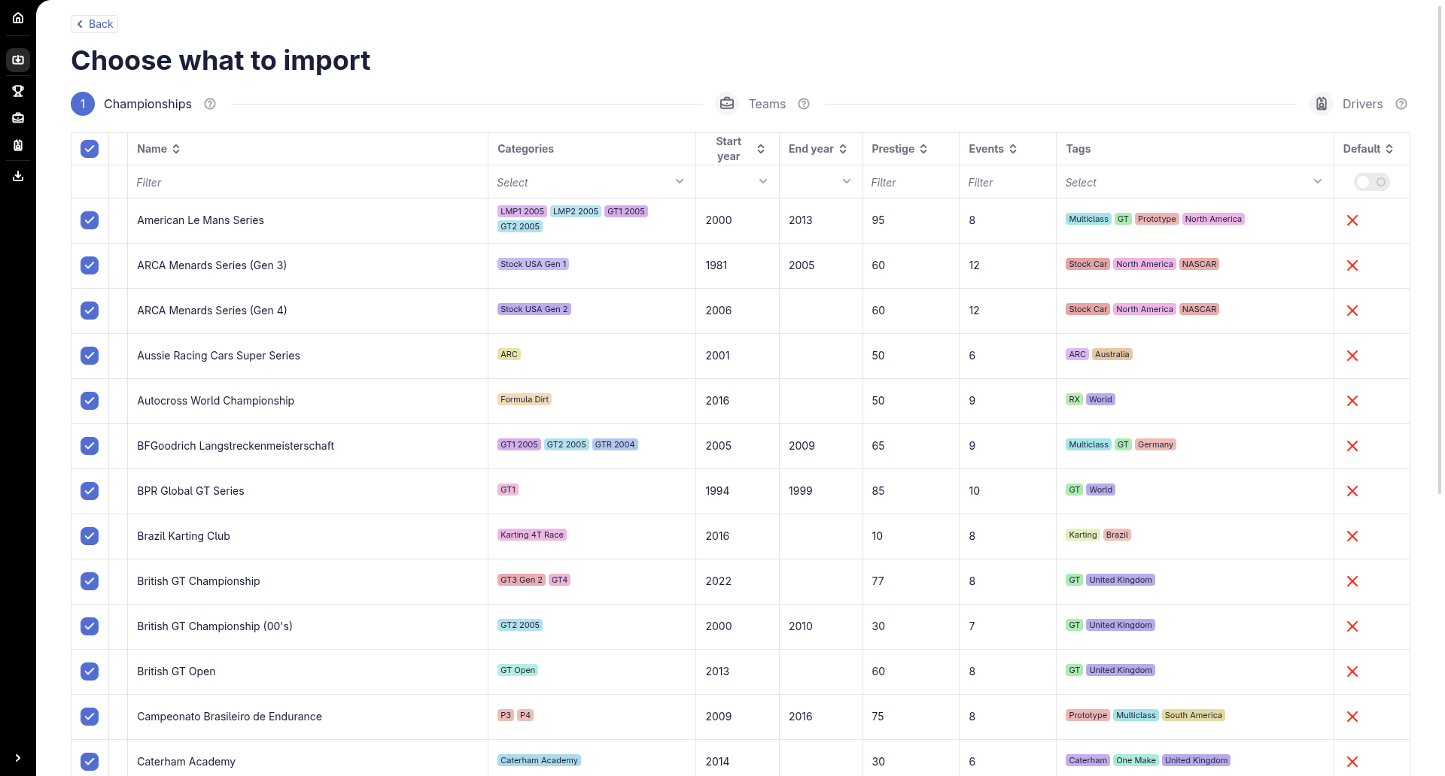
Figure 3 – Selecting championships to import
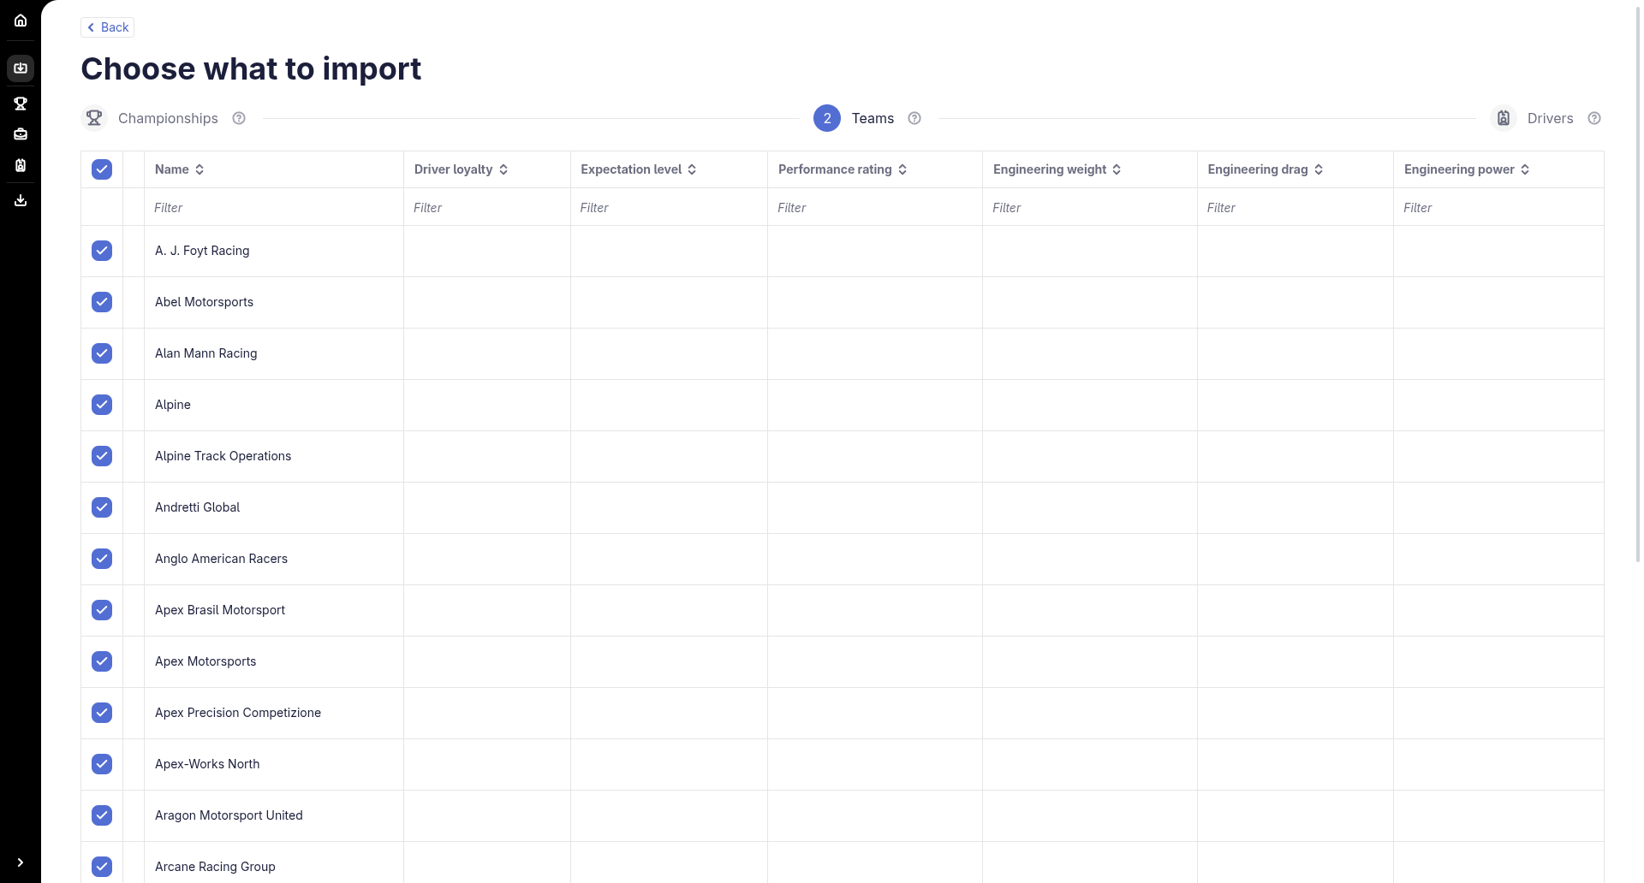
Figure 4 – Teams step
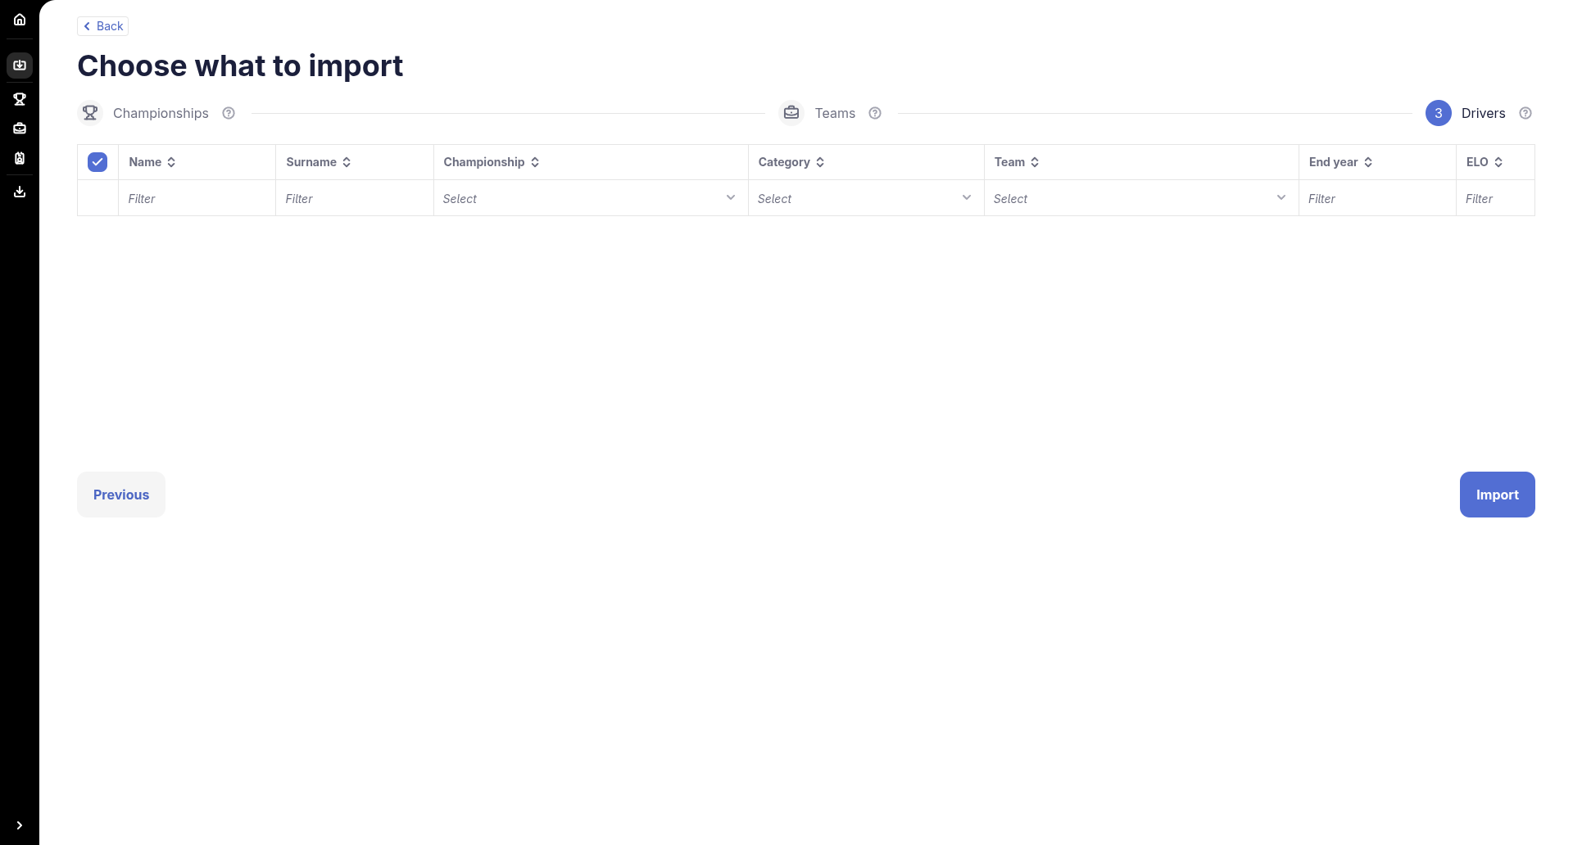
Figure 5 – Drivers step
In the dialog, Import with overwrite replaces all your existing data with the selection. Import with keeping adds the selection to your data; on conflict, the imported content wins. A confirmation message "Data imported successfully!" then appears.
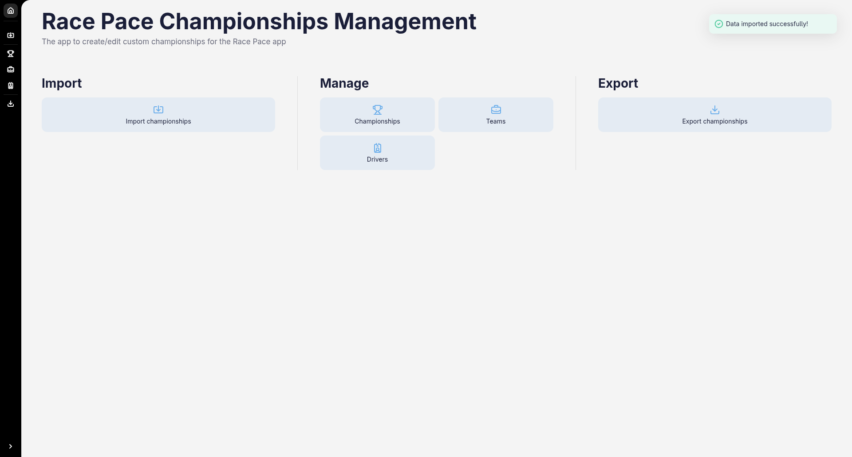
Figure 6 – Import confirmation

3. Managing championships

3.1 The championships list
The Championships page lists every championship with its categories, years, prestige, number of events, tags and default flag. Use the column headers to sort and the filter row to search. Each row has View, Edit and Delete actions. Use New Championship at the top right to create one.
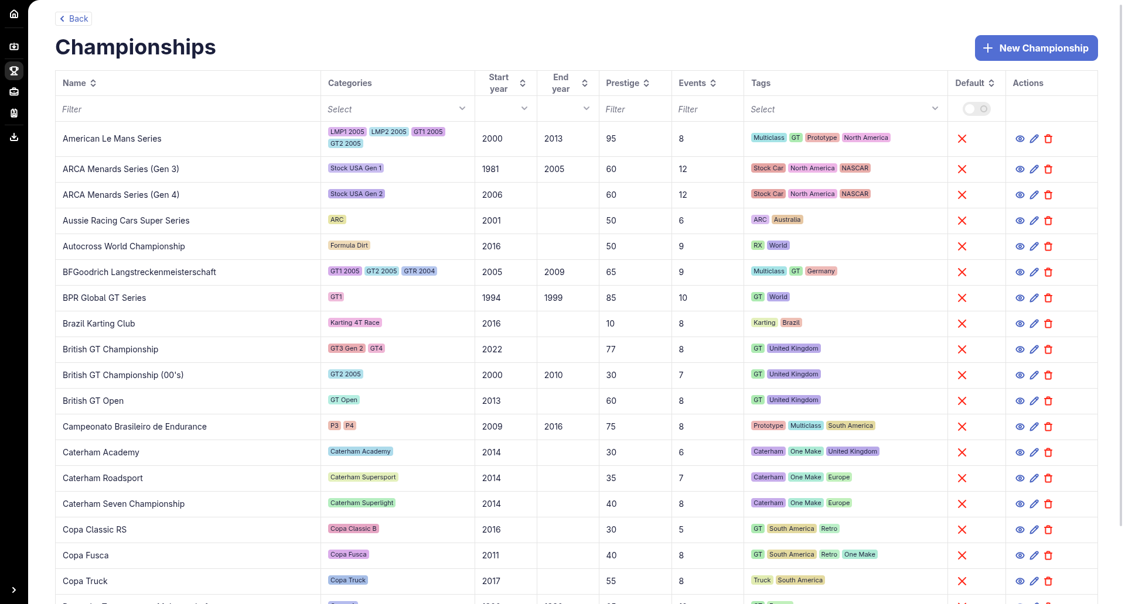
Figure 7 – Championships list

3.2 Viewing a championship
The View action opens a details page with four tabs: Global, Events, Cars and Drivers. Edit and Delete buttons are available at the top right.
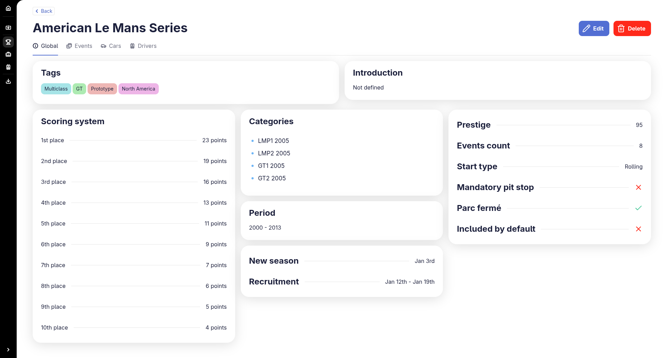
Figure 8 – Championship details: Global tab
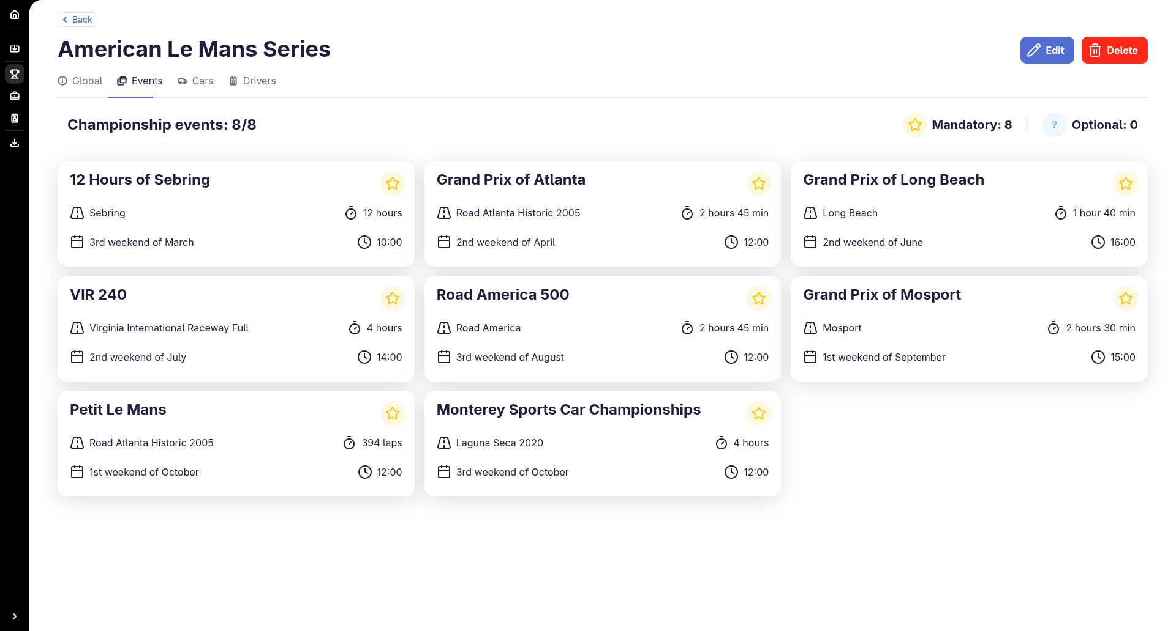
Figure 9 – Events tab, showing track, duration, date and start time for each event
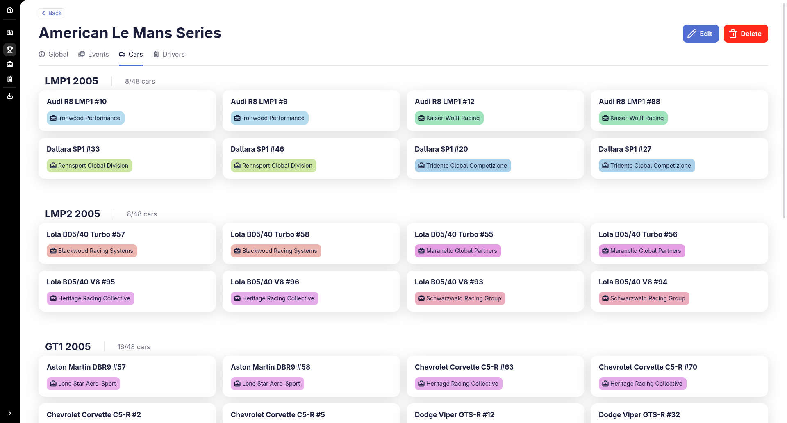
Figure 10 – Cars tab

3.3 Creating or editing a championship
New Championship and Edit open a three-step form: Global, Events and Cars.
- Global: name, period (start and end year), categories and tags, new-season and registration dates, prestige, events count, start type, mandatory pit stop, parc fermé, "included by default", an introduction text, and the scoring system (points per finishing position; use + to add positions and – to remove one).
- Events: add, edit or remove the events of the season.
- Cars: choose the cars available in each category.
Use Previous and Next to move between steps. Save as draft keeps your work in progress.
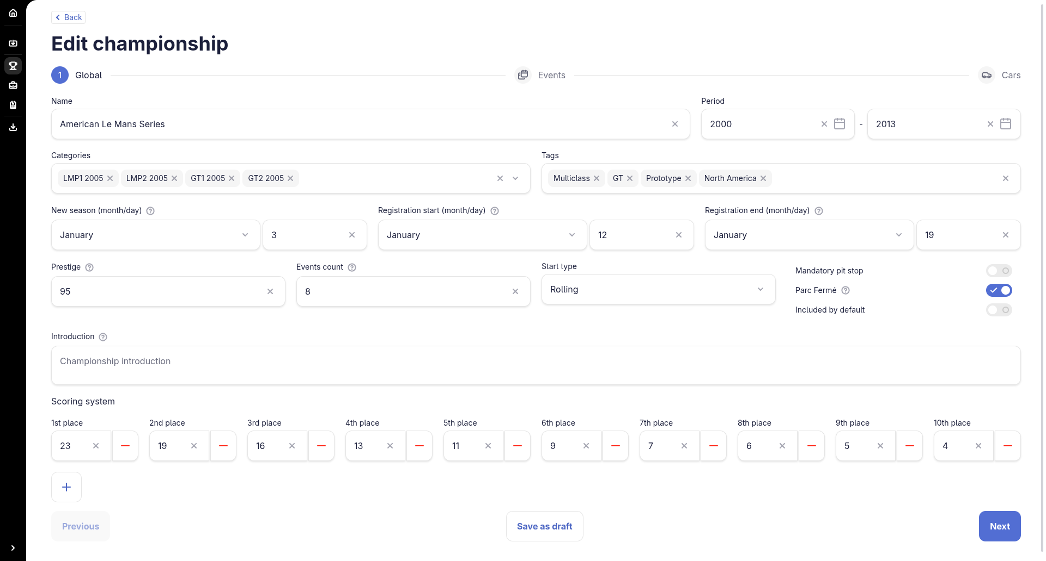
Figure 11 – Edit championship form (Global step)
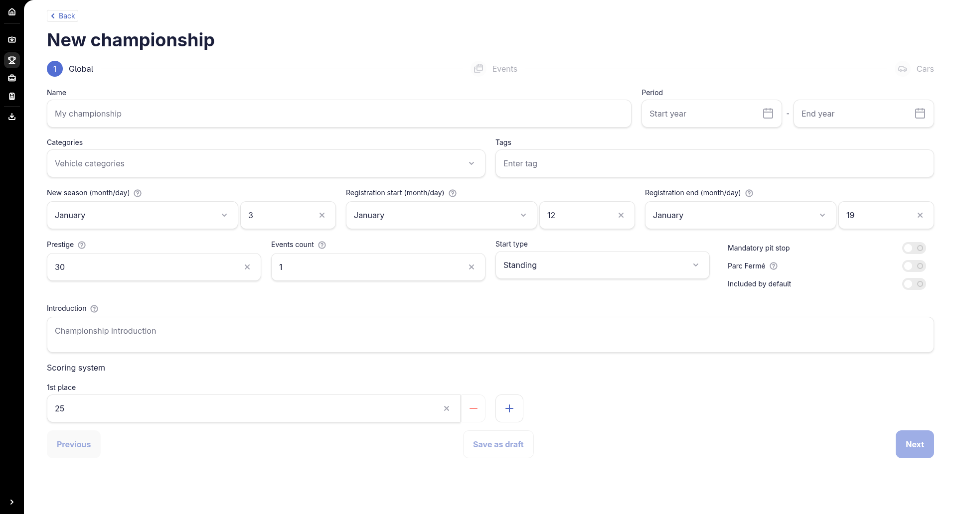
Figure 12 – New championship form

3.4 Deleting a championship
Click Delete in the list or on the details page, then confirm.

4. Managing teams
The Teams page lists teams with the tags of their championships, number of championships, cars and drivers, and start and end years. The row icons let you view (eye), edit (pencil) or delete (bin) a team. A team’s details page has Global, Cars and Drivers tabs.
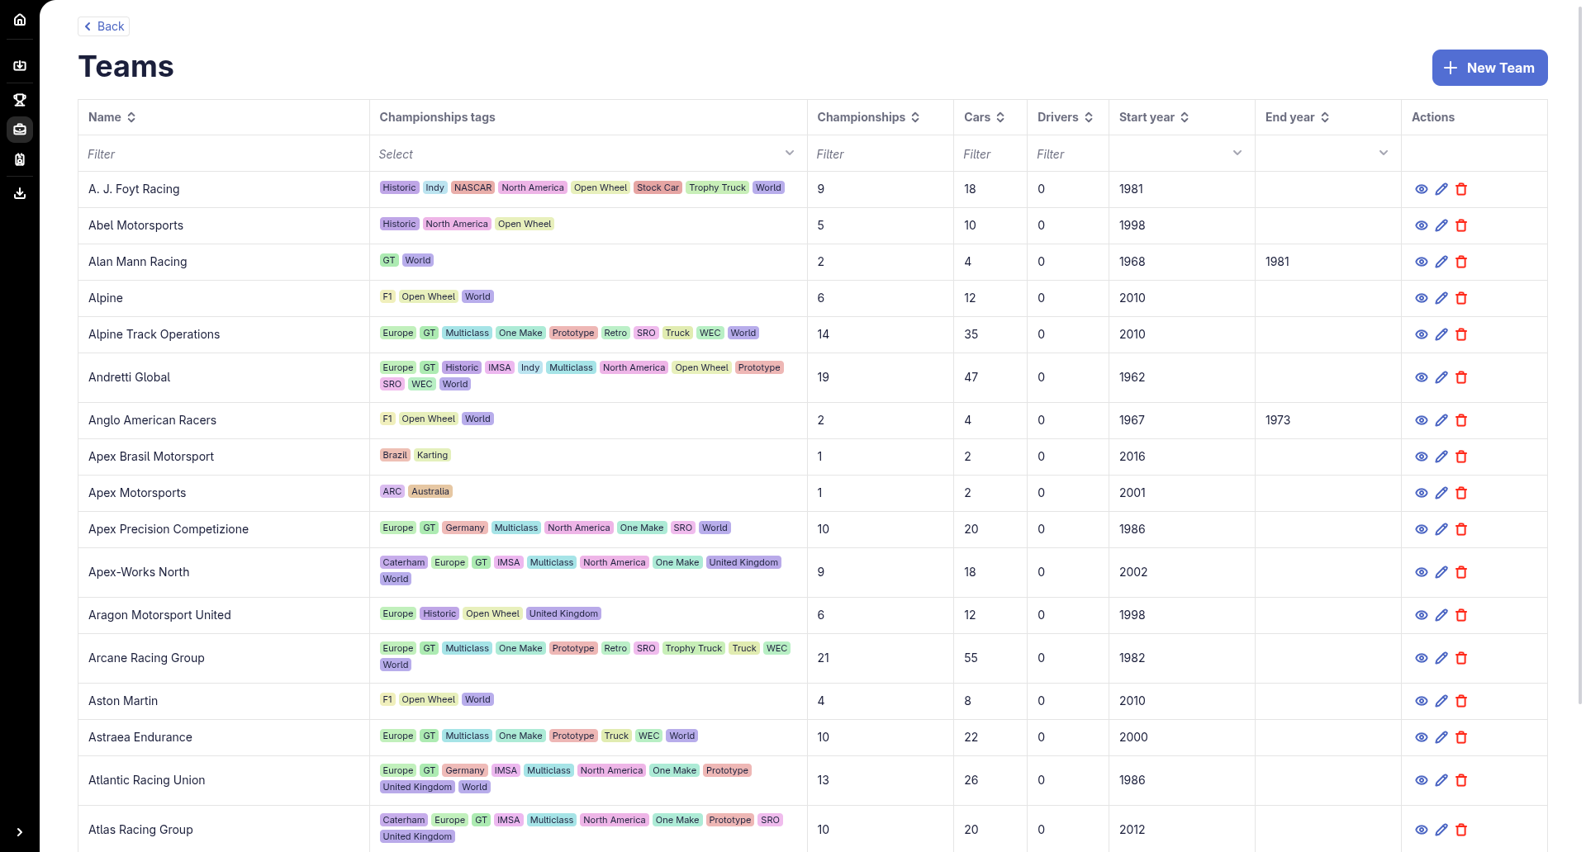
Figure 13 – Teams list
Click New Team to create one. Fill in the name and principal, then the ratings: driver loyalty, expectation level, performance rating, engineering weight, engineering drag and engineering power (the help icons next to each field explain them). Click Save.
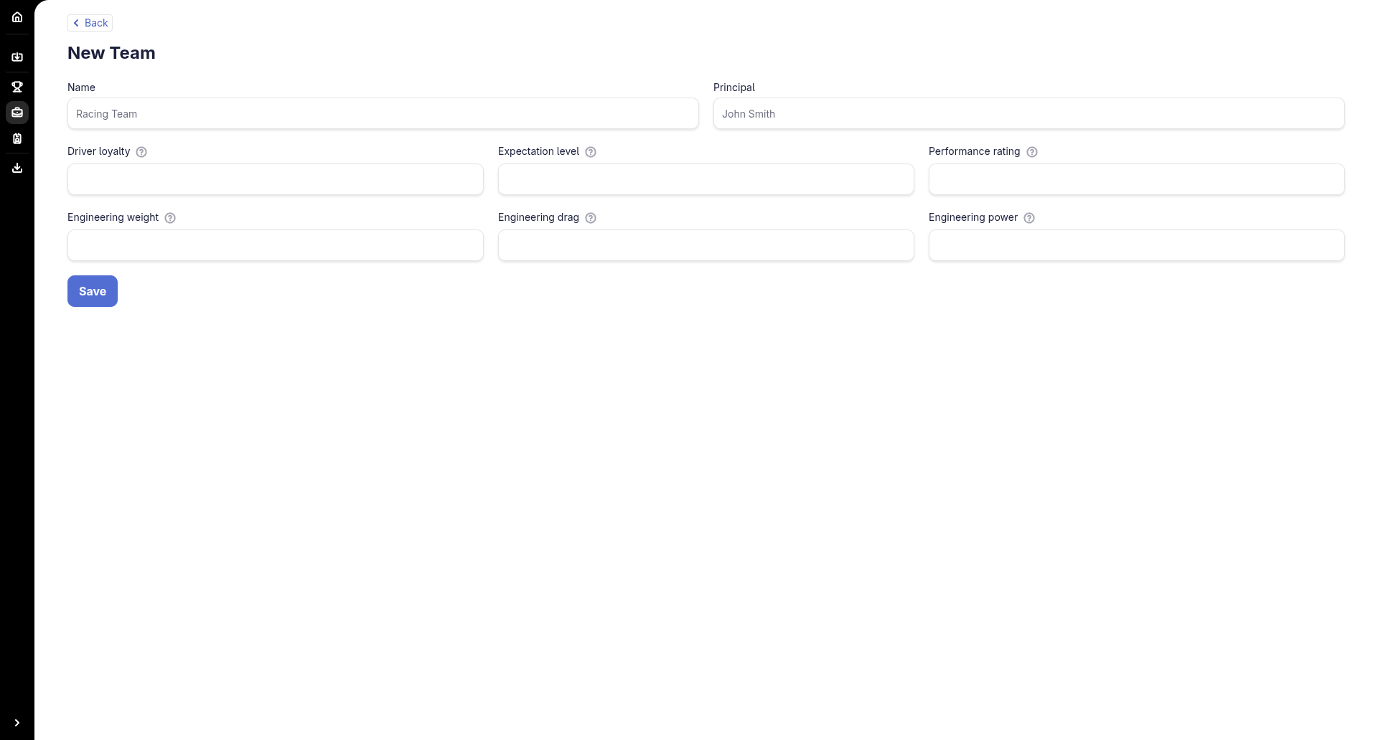
Figure 14 – New team form

5. Managing drivers
The Drivers page lists custom drivers with name, surname, championship, category, team, contract end year and ELO, with sorting and filters. It is empty until you import drivers or create your own. Use New Driver to add one.
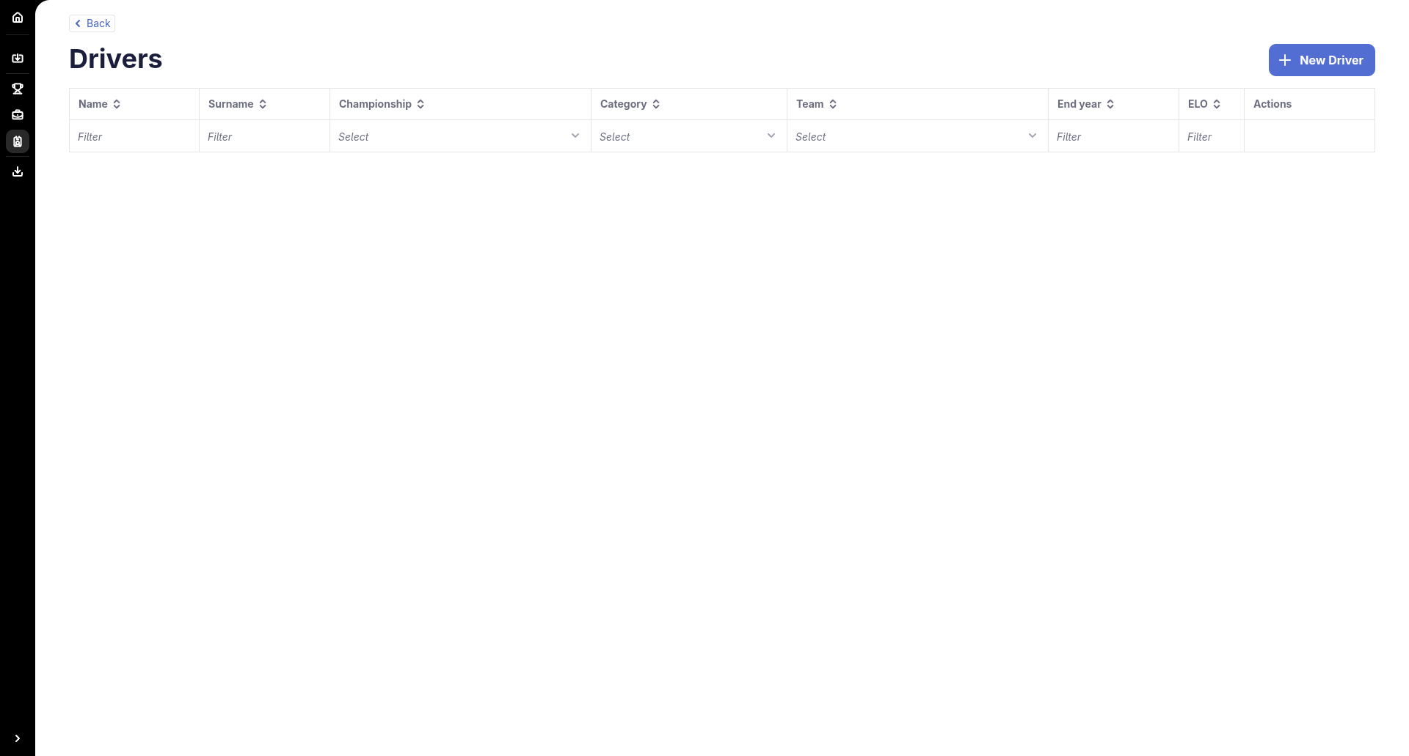
Figure 15 – Drivers list
The driver form has three sections:
- Identity: name, surname, date of birth, country, team loyalty and initial ELO. The F to A buttons generate a random ELO in the matching range.
- Contract: championship, category, team, contract end year and expected standing.
- Skills: sliders for race skill, qualifying, aggression, defending, stamina, consistency, start reactions, wet skill, tyre and fuel management and more. The buttons from Poor to Great generate a random set of skills at that level.
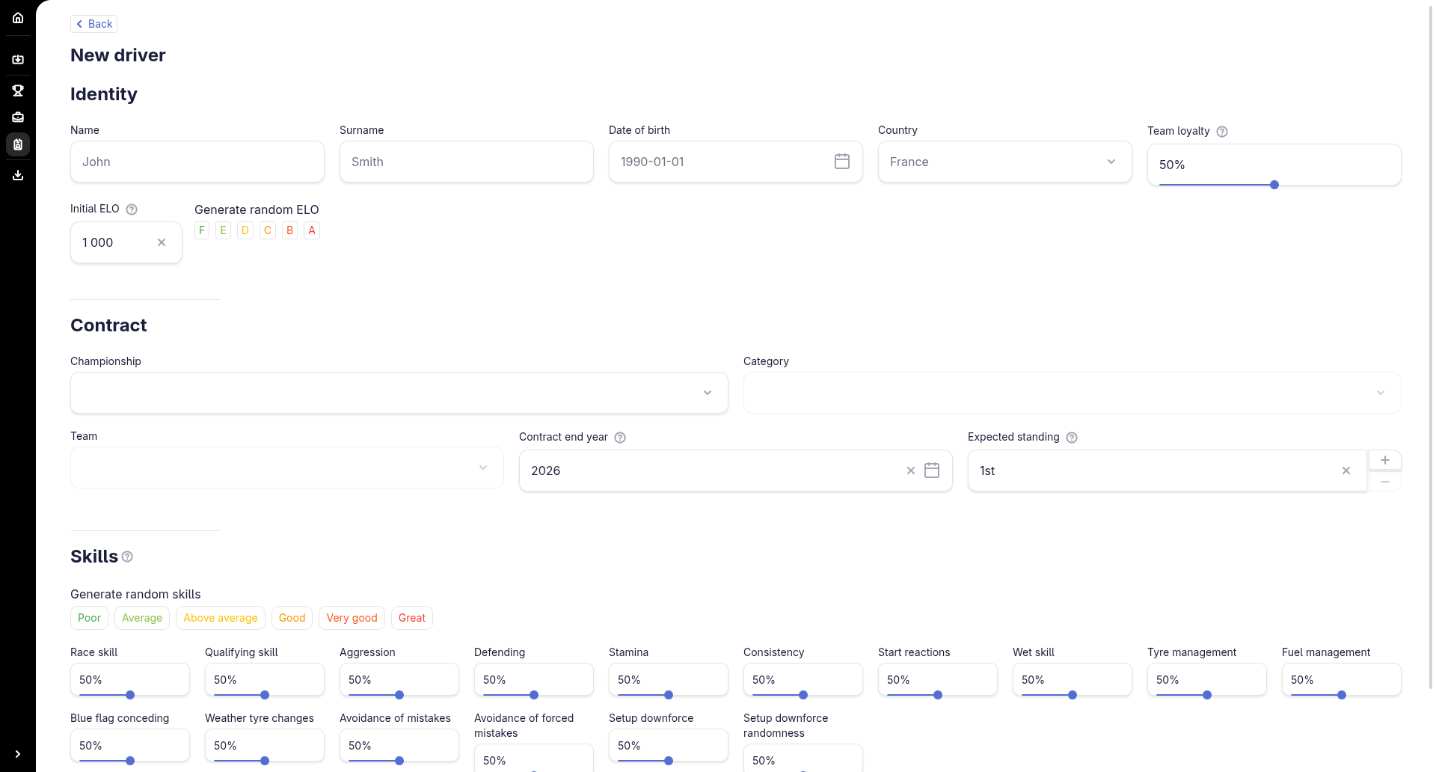
Figure 16 – New driver form

6. Exporting your championships
Open Export from the sidebar.
- Under Configuration, set the file name (default: race_pace_custom_championships).
- Toggle With drivers to include drivers, and With track mods to include track mods.
- Tick the championships to export in the table below.
- Click Export at the top right to download the file, which you can then use with the Race Pace app.
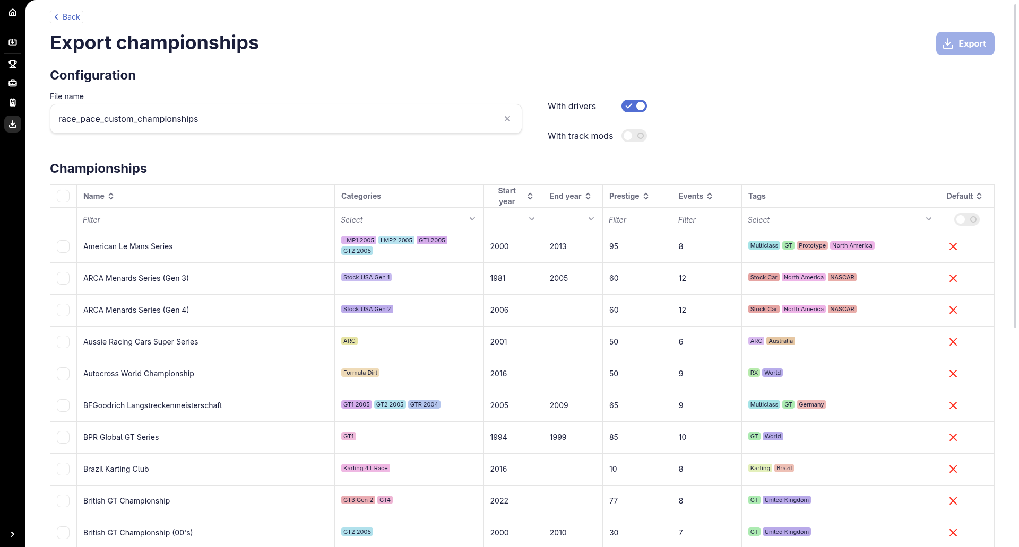
Figure 17 – Export page

7. Quick reference
- Import data: Sidebar > Import
- Edit a championship: Championships > Edit
- Create a team: Teams > New Team
- Create a driver: Drivers > New Driver
- Export: Sidebar > Export > select > Export

