BASIC AI CHESS GAME

Step 1: Render game board, create and apply pieces:
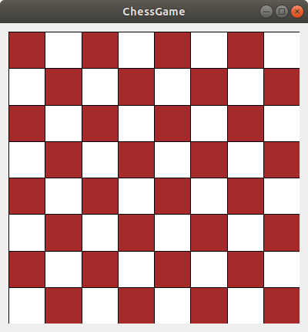

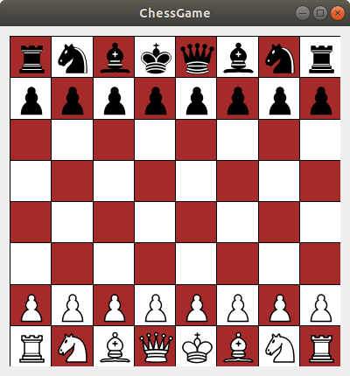
Step 2: Make move for pieces, check legal moves
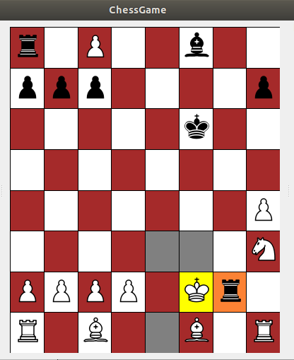

Step 3: Dead Piece Windows, History Windows.
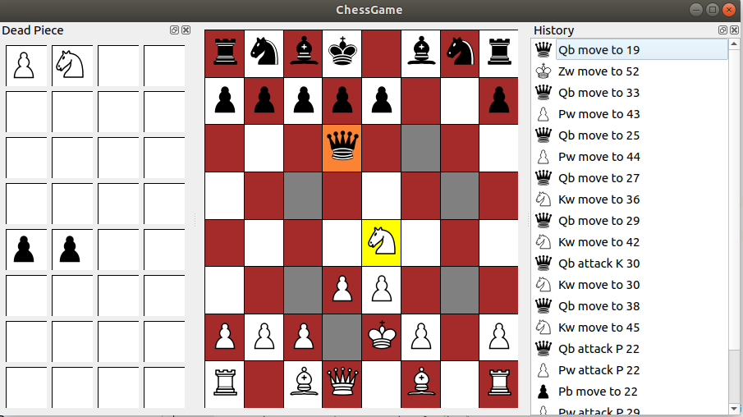
Step 4: Promote function:
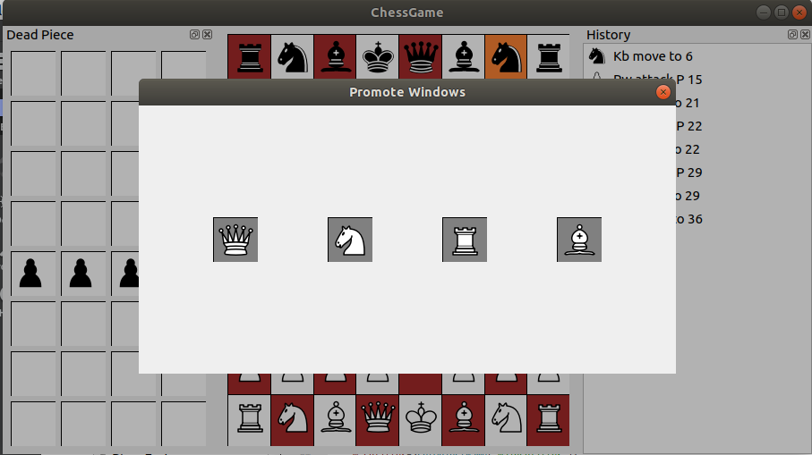

After select Queen at Promote Windows, the Pawn will be promoted to be Queen

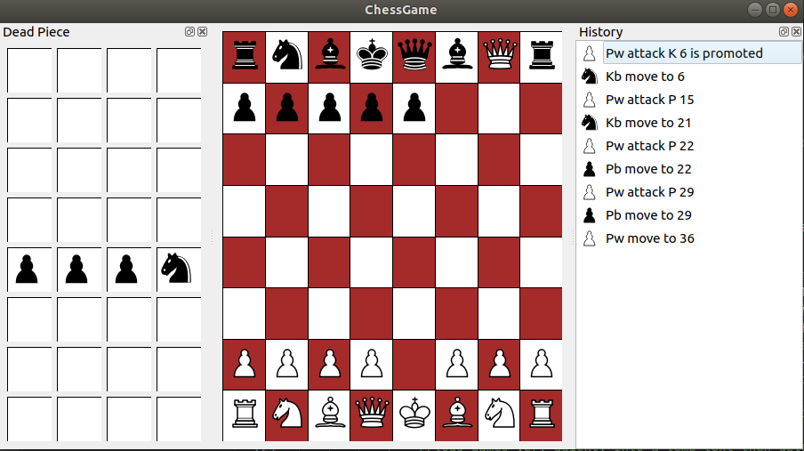

Step 5: Piece value and Position evaluation

Piece Value:

Piece Value



100



350




320



500



900



20000

*//////////////////////////////////////////////////////////*/

const int BonusSystem::WHITE_PAWN_PREFERRED_COORDINATES[] =
{
0, 0, 0, 0, 0, 0, 0, 0,
75, 75, 75, 75, 75, 75, 75, 75,
25, 25, 29, 29, 29, 29, 25, 25,
5, 5, 10, 25, 25, 10, 5, 5,
0, 0, 0, 20, 20, 0, 0, 0,
5, -5,-10, 0, 0,-10, -5, 5,
5, 10, 10,-20,-20, 10, 10, 5,
0, 0, 0, 0, 0, 0, 0, 0
};
const int BonusSystem::BLACK_PAWN_PREFERRED_COORDINATES[] =
{
0, 0, 0, 0, 0, 0, 0, 0,
5, 10, 10,-20,-20, 10, 10, 5,
5, -5,-10, 0, 0,-10, -5, 5,
0, 0, 0, 20, 20, 0, 0, 0,
5, 5, 10, 25, 25, 10, 5, 5,
25, 25, 29, 29, 29, 29, 25, 25,
75, 75, 75, 75, 75, 75, 75, 75,
0, 0, 0, 0, 0, 0, 0, 0
};
const int BonusSystem::WHITE_KNIGHT_PREFERRED_COORDINATES[] =
{
-50,-40,-30,-30,-30,-30,-40,-50,
-40,-20, 0, 0, 0, 0,-20,-40,
-30, 0, 10, 15, 15, 10, 0,-30,
-30, 5, 15, 20, 20, 15, 5,-30,
-30, 0, 15, 20, 20, 15, 0,-30,
-30, 5, 10, 15, 15, 10, 5,-30,
-40,-20, 0, 5, 5, 0,-20,-40,
-50,-40,-30,-30,-30,-30,-40,-50
};
const int BonusSystem::BLACK_KNIGHT_PREFERRED_COORDINATES[] =
{
-50,-40,-30,-30,-30,-30,-40,-50,
-40,-20, 0, 5, 5, 0,-20,-40,
-30, 5, 10, 15, 15, 10, 5,-30,
-30, 0, 15, 20, 20, 15, 0,-30,
-30, 5, 15, 20, 20, 15, 5,-30,
-30, 0, 10, 15, 15, 10, 0,-30,
-40,-20, 0, 0, 0, 0,-20,-40,
-50,-40,-30,-30,-30,-30,-40,-50,
};
const int BonusSystem::WHITE_BISHOP_PREFERRED_COORDINATES[] =
{
-20,-10,-10,-10,-10,-10,-10,-20,
-10, 0, 0, 0, 0, 0, 0,-10,
-10, 0, 5, 10, 10, 5, 0,-10,
-10, 5, 5, 10, 10, 5, 5,-10,
-10, 0, 10, 10, 10, 10, 0,-10,
-10, 10, 10, 10, 10, 10, 10,-10,
-10, 5, 0, 0, 0, 0, 5,-10,
-20,-10,-10,-10,-10,-10,-10,-20
};
const int BonusSystem::BLACK_BISHOP_PREFERRED_COORDINATES[] =
{
-20,-10,-10,-10,-10,-10,-10,-20,
-10, 5, 0, 0, 0, 0, 5,-10,
-10, 10, 10, 10, 10, 10, 10,-10,
-10, 0, 10, 10, 10, 10, 0,-10,
-10, 5, 5, 10, 10, 5, 5,-10,
-10, 0, 5, 10, 10, 5, 0,-10,
-10, 0, 0, 0, 0, 0, 0,-10,
-20,-10,-10,-10,-10,-10,-10,-20,
};
const int BonusSystem::WHITE_ROOK_PREFERRED_COORDINATES[] =
{
0, 0, 0, 0, 0, 0, 0, 0,
5, 20, 20, 20, 20, 20, 20, 5,
-5, 0, 0, 0, 0, 0, 0, -5,
-5, 0, 0, 0, 0, 0, 0, -5,
-5, 0, 0, 0, 0, 0, 0, -5,
-5, 0, 0, 0, 0, 0, 0, -5,
-5, 0, 0, 0, 0, 0, 0, -5,
0, 0, 0, 5, 5, 0, 0, 0
};

const int BonusSystem::BLACK_ROOK_PREFERRED_COORDINATES[] =
{
0, 0, 0, 5, 5, 0, 0, 0,
-5, 0, 0, 0, 0, 0, 0, -5,
-5, 0, 0, 0, 0, 0, 0, -5,
-5, 0, 0, 0, 0, 0, 0, -5,
-5, 0, 0, 0, 0, 0, 0, -5,
-5, 0, 0, 0, 0, 0, 0, -5,
5, 20, 20, 20, 20, 20, 20, 5,
0, 0, 0, 0, 0, 0, 0, 0,
};
const int BonusSystem::WHITE_QUEEN_PREFERRED_COORDINATES[] =
{
-20,-10,-10, -5, -5,-10,-10,-20,
-10, 0, 0, 0, 0, 0, 0,-10,
-10, 0, 5, 5, 5, 5, 0,-10,
-5, 0, 5, 5, 5, 5, 0, -5,
0, 0, 5, 5, 5, 5, 0, -5,
-10, 5, 5, 5, 5, 5, 0,-10,
-10, 0, 5, 0, 0, 0, 0,-10,
-20,-10,-10, -5, -5,-10,-10,-20
};
const int BonusSystem::BLACK_QUEEN_PREFERRED_COORDINATES[] =
{
-20,-10,-10, -5, -5,-10,-10,-20,
-10, 0, 5, 0, 0, 0, 0,-10,
-10, 5, 5, 5, 5, 5, 0,-10,
0, 0, 5, 5, 5, 5, 0, -5,
0, 0, 5, 5, 5, 5, 0, -5,
-10, 0, 5, 5, 5, 5, 0,-10,
-10, 0, 0, 0, 0, 0, 0,-10,
-20,-10,-10, -5, -5,-10,-10,-20
};
const int BonusSystem::WHITE_KING_PREFERRED_COORDINATES[] =
{
-30,-40,-40,-50,-50,-40,-40,-30,
-30,-40,-40,-50,-50,-40,-40,-30,
-30,-40,-40,-50,-50,-40,-40,-30,
-30,-40,-40,-50,-50,-40,-40,-30,
-20,-30,-30,-40,-40,-30,-30,-20,
-10,-20,-20,-20,-20,-20,-20,-10,
20, 20, 0, 0, 0, 0, 20, 20,
20, 30, 10, 0, 0, 10, 30, 20
};
const int BonusSystem::BLACK_KING_PREFERRED_COORDINATES[] =
{
20, 30, 10, 0, 0, 10, 30, 20,
20, 20, 0, 0, 0, 0, 20, 20,
-10,-20,-20,-20,-20,-20,-20,-10,
-20,-30,-30,-40,-40,-30,-30,-20,
-30,-40,-40,-50,-50,-40,-40,-30,
-30,-40,-40,-50,-50,-40,-40,-30,
-30,-40,-40,-50,-50,-40,-40,-30,
-30,-40,-40,-50,-50,-40,-40,-30
};

Step 6: Evaluate System

int StandardBoardEvaluator::evaluate(const BoardConfig board, int depth)
{
return scorePlayer(board, Alliance::WHITE, depth) - scorePlayer(board, Alliance::BLACK, depth);
}
int StandardBoardEvaluator::scorePlayer(const BoardConfig board, const Alliance alliance, int depth)
{
return pieceValue(board, alliance) + mobilityRatio(board, alliance)
+ check(board, alliance) + kingThreats(board, alliance, depth) + attacks(board, alliance);
}
check
mobilityRatio
kingThreats
depthBonus
kingSafety
mobility
attacks
pieceEvaluations
pawnStructure
rookStructure

Step 7: Iterative Deepening Search

