R_t_30April

**Cases by DHB**

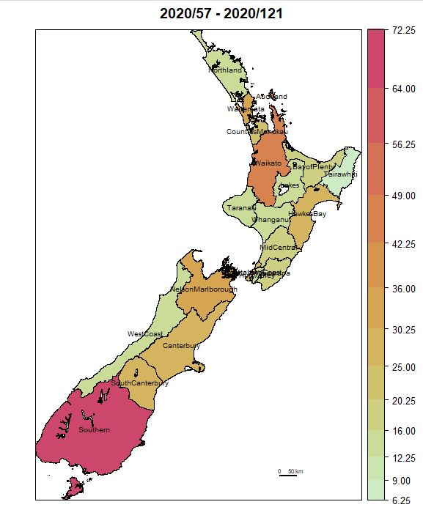

**The title looks as if it has day numbers (65 days)**

1. **Rt Using R0 Package (uses only initial part of the daily Covid-19 counts curve)**

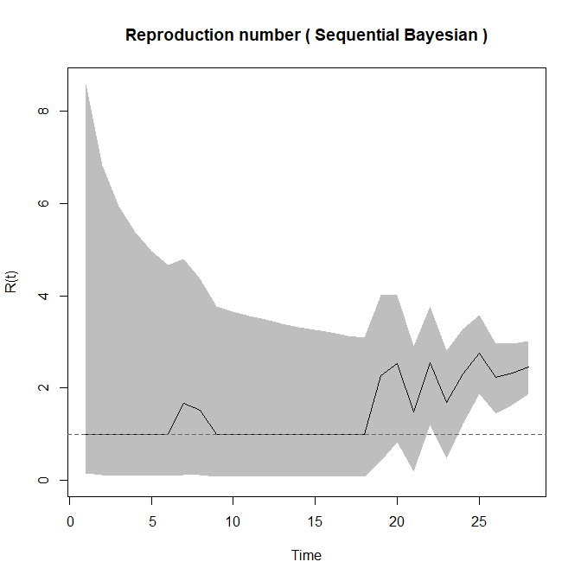

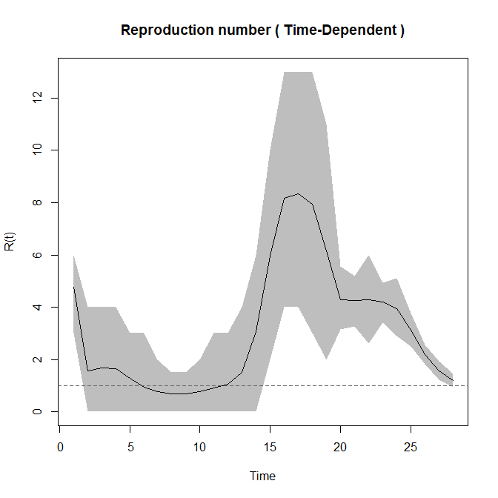

1. **"Measles" Model (logistic spatio-temporal count regression using German measles paper that uses "surveillance" package)**

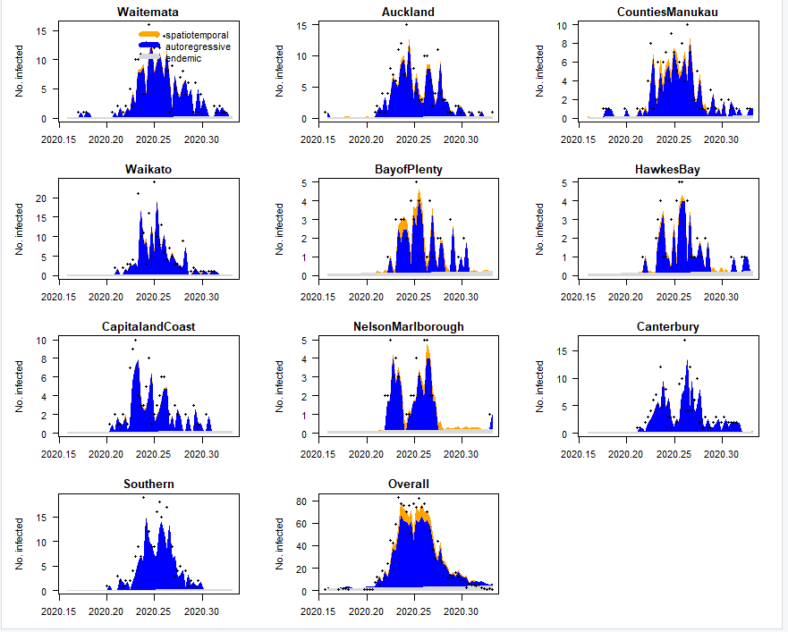

**Misc regression model info.**

If we had used Poisson instead of Negative Binomial (="basic" model) for the counts model:

df AIC

covid19Fit_basic 5 2637.877

update(covid19Fit_basic, family = "Poisson") 4 2995.703

I would say that the AIC difference of about 360 with 1 df is very significant, indicating that the NegBin model is the better choice.

confint(covid19Fit_basic, parm="overdisp")

2.5 % 97.5 %

overdisp 0.6956584 1.142745

The overdispersion parameter is estimated as 0.92, which is very small (1.0 = no overdispersion)

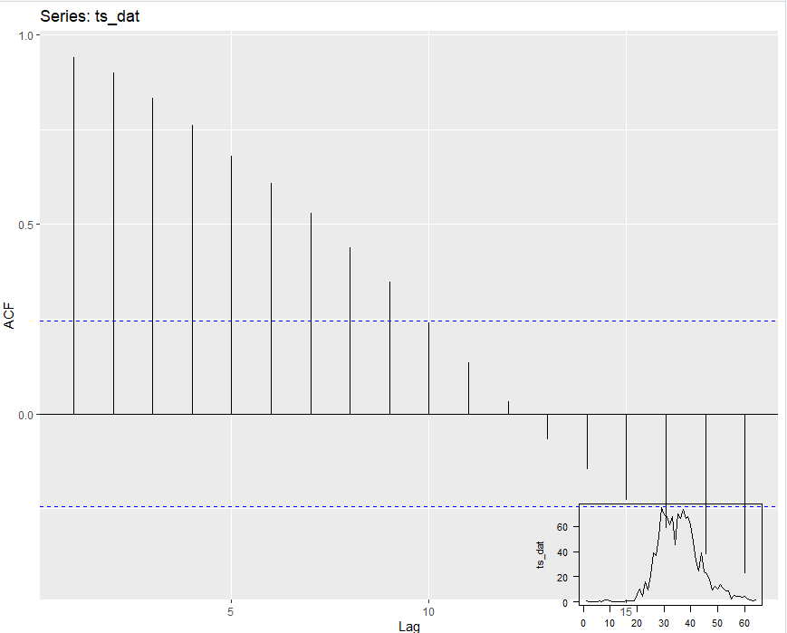

Auto-covariance function for the all-NZ daily counts data

1. **Using Poisson Max Likelihood formula to estimate R_t**

