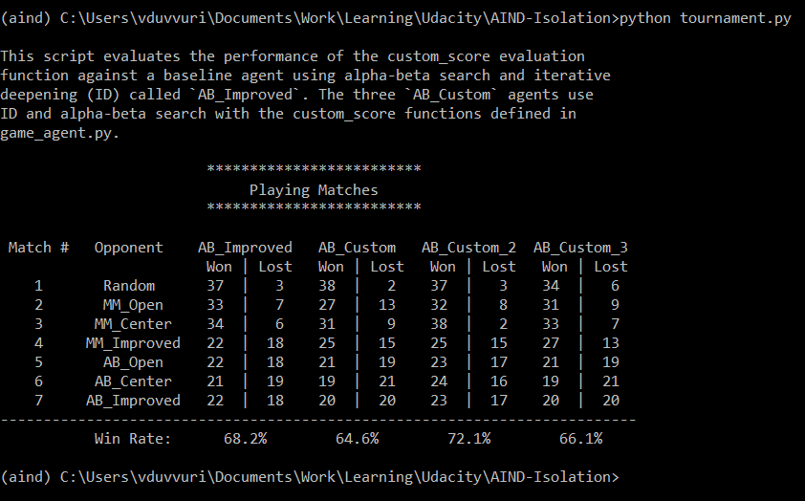

Overall Results Table (ORT): Jan 14, 10.00 PM ET

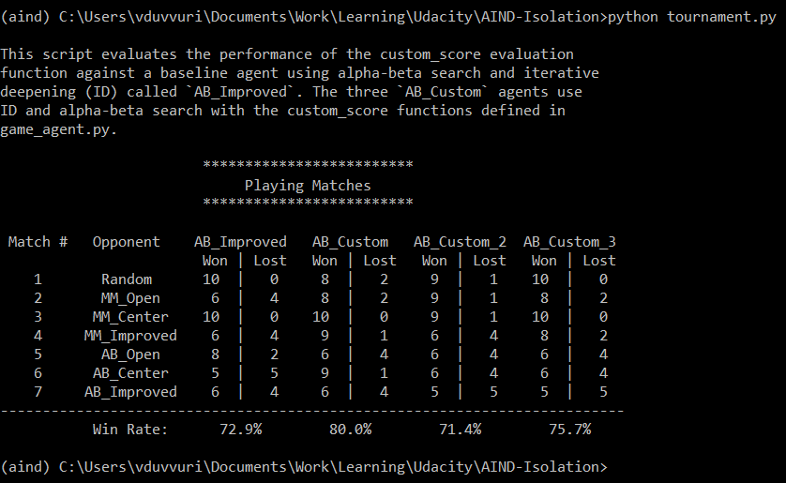

Overall Results Table (ORT): Jan 15, 11.43 PM ET

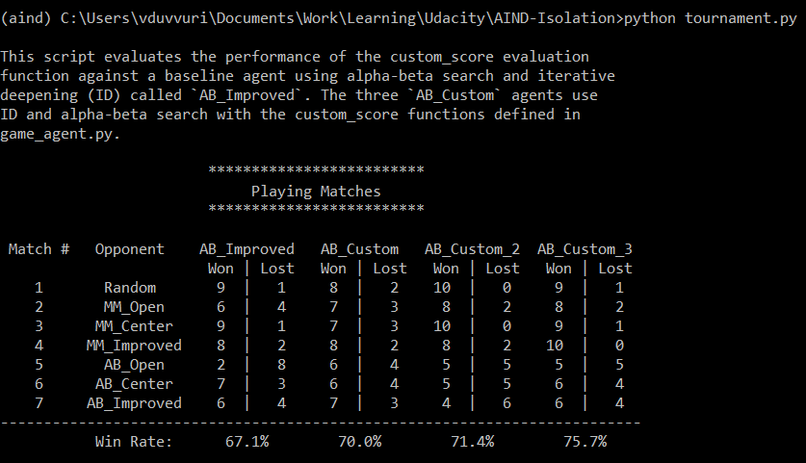

Overall Results Table (ORT): Jan 16, 12.17 AM ET

Heuristic 1: Difference of available moves

Result: AB_Custom performs worse than AB_Improved in 5 out of 7 , which is surprising given they both implement the same heuristic.

Analysis: The possible reasons for this result could be small sample and

Implementation:

Heuristic 1:

Result:

Analysis:

Implementation:

|  |  |  |  |  |  |  |  |  |
| --- | --- | --- | --- | --- | --- | --- | --- | --- |
|  | 0 | 1 | 2 | 3 | 4 | 5 | 6 |  |
| 0 | 2 | 3 | 4 | 4 | 4 | 3 | 2 | 0 |
| 1 | 3 | 4 | 6 | 6 | 6 | 4 | 3 | 1 |
| 2 | 4 | 6 | 8 | 8 | 8 | 6 | 4 | 2 |
| 3 | 4 | 6 | 8 | 8 | 8 | 6 | 4 | 3 |
| 4 | 4 | 6 | 8 | 8 | 8 | 6 | 4 | 4 |
| 5 | 3 | 4 | 6 | 6 | 6 | 4 | 3 | 5 |
| 6 | 2 | 3 | 4 | 4 | 4 | 3 | 2 | 6 |
|  | 0 | 1 | 2 | 3 | 4 | 5 | 6 |  |

Heuristic 1:

Result:

Analysis:

Implementation:

|  |  |  |  |  |  |  |  |  |
| --- | --- | --- | --- | --- | --- | --- | --- | --- |
|  | 0 | 1 | 2 | 3 | 4 | 5 | 6 |  |
| 0 | 4 | 9 | 16 | 16 | 16 | 9 | 4 | 0 |
| 1 | 9 | 16 | 36 | 36 | 36 | 16 | 9 | 1 |
| 2 | 16 | 36 | 64 | 64 | 64 | 36 | 16 | 2 |
| 3 | 16 | 36 | 64 | 64 | 64 | 36 | 16 | 3 |
| 4 | 16 | 36 | 64 | 64 | 64 | 36 | 16 | 4 |
| 5 | 9 | 16 | 36 | 36 | 36 | 16 | 9 | 5 |
| 6 | 4 | 9 | 16 | 16 | 16 | 9 | 4 | 6 |
|  | 0 | 1 | 2 | 3 | 4 | 5 | 6 |  |