Milestone 2 Meeting 2 Preparation
  - Baseline results outlier sensitivity and report readiness
Georgia Tech ISYE 4031 Fall 2026 Group 9
Bill Nguyen, Sarah Wang, Cindy Le, Phoenix Moore, Victor Wang
Prepared October 27 2026
Main finding. The original regression does not consistently improve on the training-mean forecast. Removing extreme-surprise or influential training events changes the errors but does not produce a consistent improvement across validation and 2025. The full-data baseline remains the primary model.
Meeting details. Group 9's second check-in is scheduled for Thursday, October 29, 2026, during 2:00-3:00 p.m. Eastern at George Tower 802 Collab. Bring this packet, the updated four-page report, runnable code and the result tables. The submission deadline is October 30 at 11:59 p.m. Eastern.

Response to Meeting 1
The notes supplied October 27 ask for more history per company, outlier identification and sensitivity, and a clearer explanation of data quality and informativeness. This branch adds large-surprise and influential-event tables, training-only sensitivity comparisons, errors by year/company/volatility, calendar-quarter stability checks, an older-history audit, and an audit of the group's proposed Kaggle dataset. The main sample remains 400 verified events; no expansion or synthetic data is claimed.

Question model and evaluation
We predict signed stock return over the five sessions after reaction-day close. Reaction day is the first trading day strictly after the report date; the initial jump is excluded. OLS uses 10 earnings, reaction, volume, momentum, market and volatility predictors plus an intercept. Redundant dollar EPS surprise is omitted. Scaling fits on 2016-2022 only (280 events); the fixed model is evaluated on 2023-2024 (80) and the inspected 2025 exploratory test (40). Boundary-crossing labels are purged; none cross here.
The training-mean forecast predicts the same value every time: +0.154% for raw return and -0.213% for SPY-adjusted return. A zero forecast predicts no change. MAE is average absolute error; RMSE gives larger errors more weight. Both use percentage points (pp), not percentages of the error. Lower is better.
Target and period | n | OLS MAE / RMSE | Mean MAE / RMSE
Raw 2023-24 | 80 | 2.906 / 3.838 | 2.662 / 3.572
Raw 2025 | 40 | 3.316 / 4.253 | 3.161 / 4.135
SPY adjusted 2023-24 | 80 | 2.381 / 3.085 | 2.099 / 2.818
SPY adjusted 2025 | 40 | 2.876 / 3.606 | 2.974 / 3.651

Table 1. Errors in pp. Raw OLS is worse than the mean in both periods. Adjusted OLS is worse in validation and slightly better in 2025. Raw direction accuracy is 57.5%/55.0%, versus 57.5%/60.0% for always predicting a positive return. The full CSV also includes zero forecasts and R-squared.

Potential outliers and sensitivity
Seven observations have absolute earnings surprise over 100%, all in training. Five are AMZN, one XOM and one WMT. These are flags for source review, not proof of erroneous observations. XOM's 960% surprise has estimated EPS of $0.05, illustrating the effect of a small denominator. The original raw model also has 17 training Cook's-distance flags above 4/n; the largest is AMZN April 28, 2022 (0.191). The adjusted model has 18 flags.
Company | Reported date | Surprise (%)
AMZN | 2018-04-26 | 166.67
XOM | 2020-05-01 | 960.00
AMZN | 2020-07-30 | 550.00
AMZN | 2022-02-03 | 672.22
AMZN | 2022-04-28 | -190.48
AMZN | 2022-07-28 | -266.67
WMT | 2022-11-15 | -116.67

We tested three alternatives to original OLS: exclude current surprise above 100% in absolute value from training; exclude original-fit Cook's-distance training flags; and clip current/prior surprise to training 1st/99th percentiles. Every treatment keeps all 80 validation and 40 test events. Cutoffs, clipping and scaling use training data only. Outcomes are never clipped.
Raw training treatment | Removed | 2023-24 RMSE | 2025 RMSE
Original OLS | 0 | 3.838 | 4.253
Large-surprise exclusion | 7 | 3.733 | 4.288
Influence exclusion | 17 | 3.898 | 4.108
Surprise clipping | 0 | 3.824 | 4.264

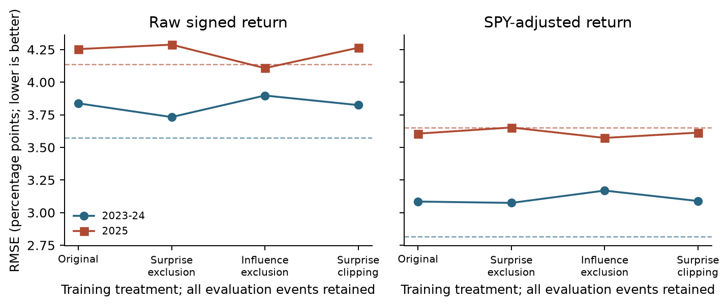
Figure 1. Sensitivity to training treatments on fixed evaluation sets. Dashed lines show training-mean RMSE; lower is better.
Surprise exclusion helps validation and hurts 2025. Influence exclusion helps 2025 and hurts validation. Clipping also has mixed effects. The adjusted-target comparison tells the same overall story: no treatment is consistently better across both later periods. These are sensitivity checks, not a new untouched test or grounds for selecting the most favorable result.

Residual evidence and preliminary answer
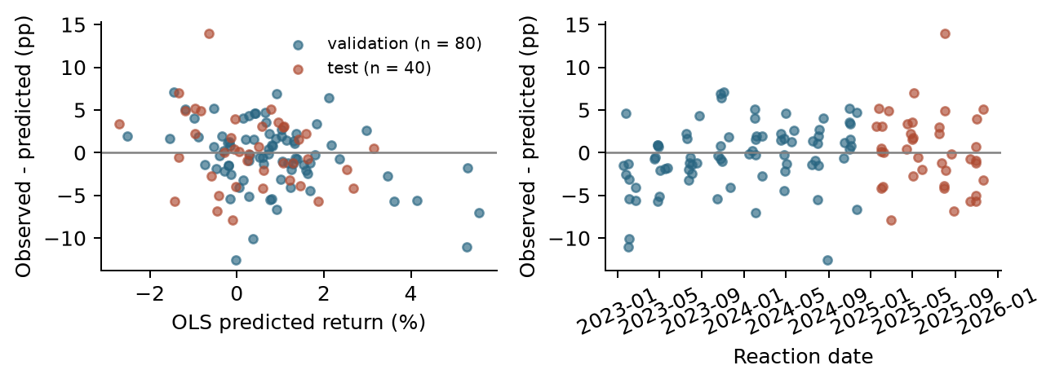
Figure 2. Raw-return errors versus predicted return and date. Residual means observed minus predicted; large errors remain.
Raw absolute errors exceed 5 pp in 16/80 validation events and 9/40 test events. AAPL July 31, 2025 returns +13.326% versus -0.649% predicted, a 13.975 pp miss. Errors are not a series of independent experiments: companies repeat and 597 target-window pairs overlap. Calendar-quarter deletion and group tables describe stability but do not establish statistical significance. The evidence supports weak predictive usefulness, not deployment or causal claims.

Data history and the Kaggle candidate
Existing earnings caches contain 675 pre-2016 records and 631 candidate events in 2010-2025, with one missing an earnings value. Older price lookbacks and targets remain unvalidated; these are not additional modeling rows. Extend history per company first, then broaden companies with a documented historical selection rule.
The proposed Kaggle version 7 summary covers 7,786 symbols. Its 168,603 earnings rows end June 14, 2021; 57,256 lack estimated EPS and 60,203 lack release-time labels. Pre/post-market labels could help after validation, but the dataset cannot supply 2023-2025 testing. The large price file and reuse terms need review. It is a separate candidate audit, not part of this model.

Remaining revisions and proposed owners
Member | Proposed next task
Bill Nguyen | Review year/company errors and rolling evaluation plan
Sarah Wang | Review large surprises, influence flags and sensitivity results
Cindy Le | Validate deeper histories and release-time availability
Phoenix Moore | Review interpretation, limitations and expansion rationale
Victor Wang | Verify reruns, documentation and final package

Confirm each member's actual completed work and agreed owners before submission. For Milestone 3, prioritize rolling evaluation, dependence-aware uncertainty and simple regularized or longitudinal models. More rows or outlier removal should not be used just to obtain favorable significance.
Questions for the TA. Are these training-only sensitivity rules appropriate? Is deeper Alpha Vantage history preferable to the older Kaggle candidate? Which dependence-aware inference and longitudinal approach best matches the course's scope?
Reproduce. Run .venv\Scripts\python.exe run_pipeline.py, then .venv\Scripts\python.exe run_milestone2.py. Optional: audit_kaggle.py --download. See MILESTONE2_README.md, reports/MEETING1_FEEDBACK.md and reports/DATA_EXPANSION_REVIEW.md. Sources: course brief; group-supplied Meeting 1 notes; Alpha Vantage and Yahoo/yfinance; tsaustin Kaggle version 7. OpenAI Codex assisted with analysis, code and writing; the team must review the work and follow syllabus disclosure rules.

