ASSIGNMENT 4

Vidyasagar Kummarikunta

2020-09-25

# Markdown Basics

## Favorite Foods

1. Chicken
2. Burgers
3. Indian food

## Images

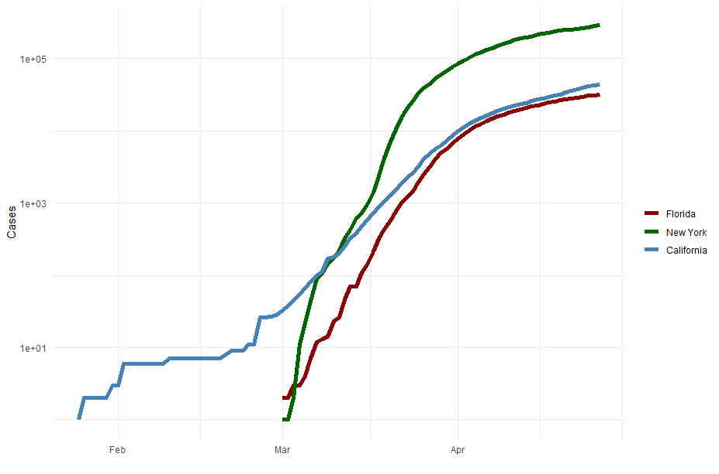

All Cases (Log Plot)

## Add a Quote

“If you fail, never give up because FAIL means”First Attempt In Learning".

## Add an Equation

$$∫\frac{dθ}{1+θ^{2}}={\text{tan}}^{−1}θ+C$$

## Add a Footnote

This is a footnote

## Add Citations

* R for Everyone
* Discovering Statistics Using R

# Inline Code

## NY Times COVID-19 Data

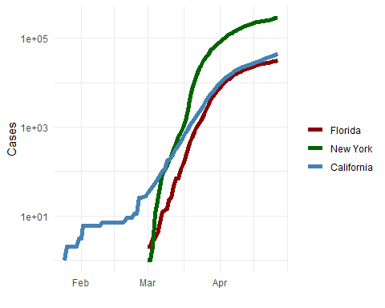

## R4DS Height vs Earnings

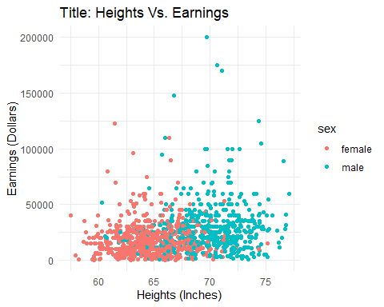

# Tables

## Knitr Table with Kable

One Ring to Rule Them all

|  |  |  |  |  |
| --- | --- | --- | --- | --- |
| name | race | InFellowship | Isringbearer | age |
| Aragon | Men | Yes | No | 88 |
| Bilbo | Hobbit | No | Yes | 129 |
| Frodo | Hobbit | Yes | Yes | 51 |
| Sam | Hobbit | Yes | Yes | 36 |
| Sauron | Maia | No | Yes | 7052 |

## Pandoc Table

## name race InFellowship Isringbearer age  
## 1 Aragon Men Yes No 88  
## 2 Bilbo Hobbit No Yes 129  
## 3 Frodo Hobbit Yes Yes 51  
## 4 Sam Hobbit Yes Yes 36  
## 5 Sauron Maia No Yes 7052

The Lord of the Rings

|  |  |  |  |  |
| --- | --- | --- | --- | --- |
| Name | Race | InFellowship? | Isringbearer? | Age |
| Aragon | Men | Yes | No | 88 |
| Bilbo | Hobbit | No | Yes | 129 |
| Frodo | Hobbit | Yes | Yes | 51 |
| Sam | Hobbit | Yes | Yes | 36 |
| Sauron | Maia | No | Yes | 7052 |

# References

<https://pandoc.org/MANUAL.html#tables> – Pandoc table  
R for Everyone. Pearson Education, 2017. 2nd Edition.