**GateWiz**

Traffic light controller



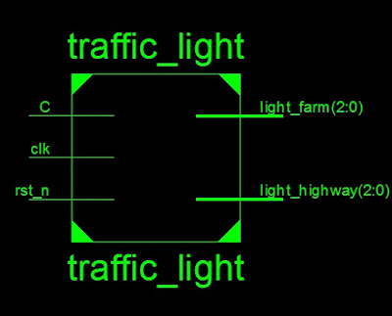

## Problem Statement:

## Design a traffic light controller for an intersection between a highway and a farm road, where the highway has higher priority. The system should ensure that the highway light remains green unless a vehicle is detected on the farm road.

## The traffic light controller should function as follows:

## 1. Highway Light (Green): By default, the highway light is green, allowing uninterrupted traffic flow.

## 2. Farm Road Light (Red): When the highway light is green, the farm road light remains red.

## 3. Vehicle Detection on Farm Road: A sensor is placed on the farm road to detect vehicles. If a vehicle is detected:

## - The system will change the highway light from green to yellow and then red.

## - The farm road light will then turn green, allowing the vehicles to pass.

## 4. Timing Delays: The system should introduce appropriate timing delays for each light change:

## - The highway light should stay green for a set period unless the sensor detects a vehicle.

## - After the farm road light is turned green, it should remain for a set time before the system reverts back to its default state with the highway light green.

## The controller must be designed using Verilog on FPGA to handle these transitions efficiently, ensuring smooth traffic flow based on real-time vehicle detection.

* Traffic Light Controller

module traffic_light(

input C,

input clk,

input rst_n,

parameter HGRE_FRED=2'b00, // Highway green and farm red

HYEL_FRED = 2'b01,// Highway yellow and farm red

HRED_FGRE=2'b10,// Highway red and farm green

HRED_FYEL=2'b11;// Highway red and farm yellow

output reg [2:0] light_highway,

output reg [2:0] light_farm

);

Inputs:

1. **C:**
   * **Role:** Sensor Input (Car Detection)
   * **Function:** This input represents a sensor that detects vehicles on the farm road. If a vehicle is detected (C is high), the system will change the light to give the farm road priority for a short duration. If no vehicle is detected, the highway light remains green.
2. **clk:**
   * **Role:** Clock Input
   * **Function:** This input provides the clock signal for the system. The clock signal drives the state transitions and the timing of light changes. It is typically connected to a 50 MHz clock for FPGA systems.
3. **rst_n:**
   * **Role:** Active-low Reset Signal
   * **Function:** This input resets the system. When rst_n is low, the system is reset to its default state, which is **Highway Green** and **Farm Red**.

#### Outputs:

1. **light_highway:**
   * **Role:** Highway Traffic Light Output
   * **Function:** This 3-bit output controls the highway traffic light. The three possible states are:
     + 3'b001 → Green (Highway)
     + 3'b010 → Yellow (Highway)
     + 3'b100 → Red (Highway)
2. **light_farm:**
   * **Role:** Farm Road Traffic Light Output
   * **Function:** This 3-bit output controls the farm road traffic light. The three possible states are:
     + 3'b001 → Green (Farm)
     + 3'b010 → Yellow (Farm)
     + 3'b100 → Red (Farm)

#### FSM States (State Machine):

1. **HGRE_FRED:**
   * **Highway Green, Farm Red:**
     + In this state, the highway light is green, and the farm road light is red.
     + If the sensor detects a vehicle on the farm road (C is high), the system transitions to **HYEL_FRED**(Highway Yellow, Farm Red).
     + Otherwise, it remains in this state.
2. **HYEL_FRED:**
   * **Highway Yellow, Farm Red:**
     + In this state, the highway light is yellow, and the farm road light is red.
     + After a delay of 3 seconds, the system transitions to **HRED_FGRE** (Highway Red, Farm Green).
3. **HRED_FGRE:**
   * **Highway Red, Farm Green:**
     + In this state, the highway light is red, and the farm road light is green.
     + The system allows the farm road to have priority for 10 seconds.
     + After 10 seconds, it transitions to **HRED_FYEL** (Highway Red, Farm Yellow).
4. **HRED_FYEL:**
   * **Highway Red, Farm Yellow:**
     + In this state, the highway light is red, and the farm road light is yellow.
     + After a delay of 3 seconds, the system transitions back to **HGRE_FRED** (Highway Green, Farm Red).