**Truck-Node**

Automotive controller to balance power consumption and provide baseline functionality for a connected vehicle.

**Key IP Remote Control Features**

* Report alarm status and intrusions
* Lock/unlock doors
* Arm/disarm alarm (OEM, or aftermarket)
* Alarm system functionality
* Auxiliary power control with warning for soft-shutdown of SBC
* Battery rundown protection
* Report supply voltage
* Remote start engine
* Temperature reporting

**Technical Features**

* Molex micro-fit headers
* ESP8266 Module
  + 802.11n Connectivity
  + Over-the-air firmware updates
* MQTT Client
* CAN Bus Interface

Design Notes

Inputs must be fully conditioned

Board should have a PTC fuse

Recall problems with input clamping protection when trying to float inputs; MCP IO expander cannot hi-z float inputs

Should add RFI suppression

I2C Address De-confliction

* 0100xxx0 MCP IO Expander
* 10010xx Temperature Sensor:

TM102 I2C Temperature Sensor

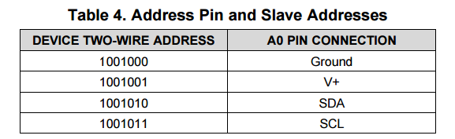

Voltage Monitoring

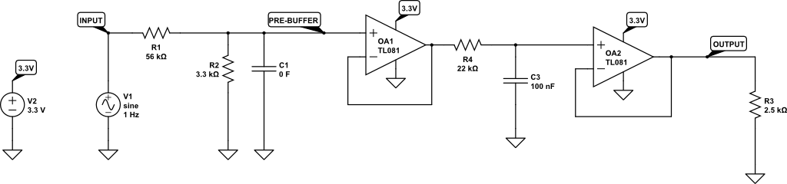

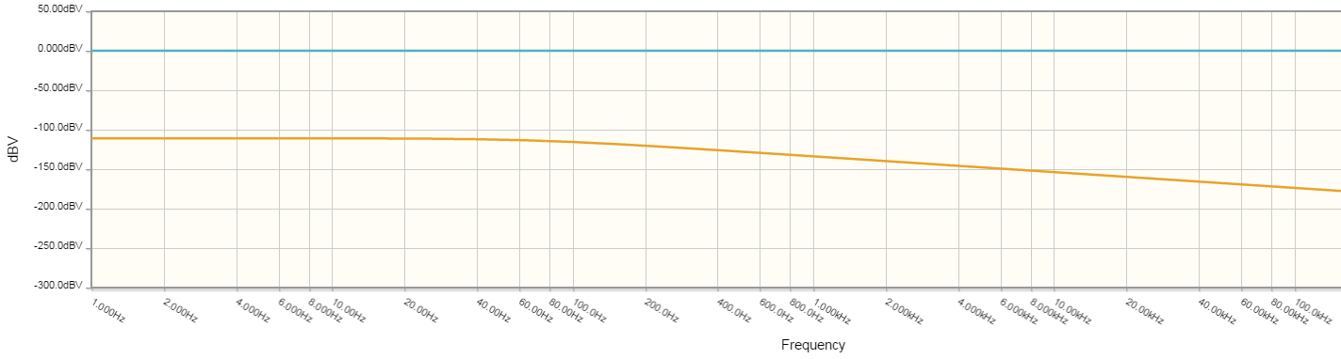

## MCP23017 I/O Expander

|  |  |  |  |  |
| --- | --- | --- | --- | --- |
| **MCP Pin** | **SW** | **Direction** | **Config** | **Description** |
| GPA0 | 0 | Input | Pullup | Accessory Ignition Detect |
|  |  |  |  |  |
|  |  |  |  |  |
|  |  |  |  |  |
|  |  |  |  |  |
|  |  |  |  |  |
|  |  |  |  |  |
|  |  |  |  |  |

# Logic Inputs

* High Voltage (0-20V)
* High Impedance (>= 10k Ohm)

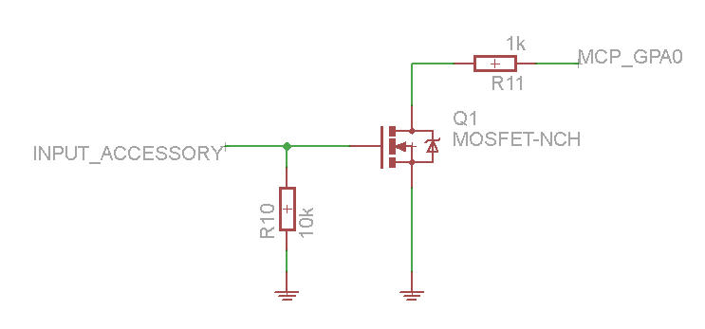

# Power Regulation

Murata Power Solutions Inc. OKX-T/5-D12N-C

Digikey: 811-2622-ND

**Input:** 8.3-13.8 nominal (15vdc max)

**Output Power:** 3A (25W)

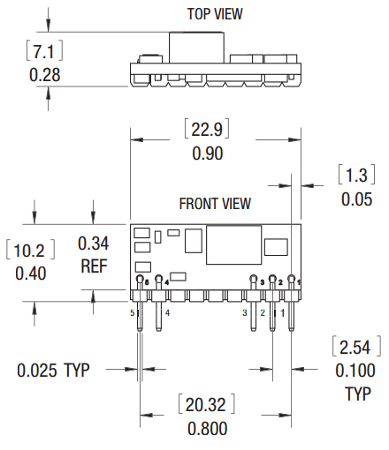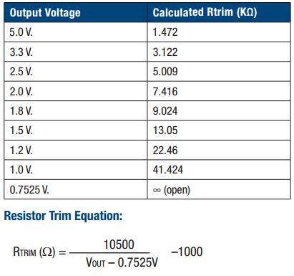

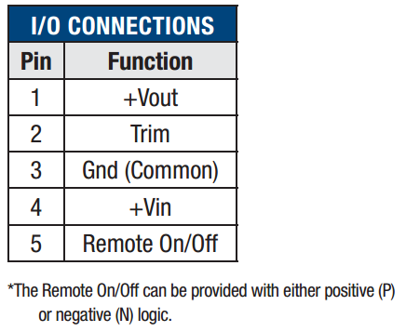

# USB Connectivity

Do not pass power through, or isolate it if-so

* ESP8266