# C1- S2-PRACTICE – WEP SERVER

# BEFORE START

* Team of 3 (or 2) students  
  For each activity:
  + 1 server
  + 2 (or 1) clients

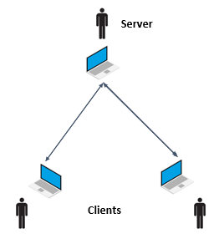

1. Check that you are all connected to the same WIFI network
2. Find your local IP address (explained in the pdf document) and write it down

|  |  |  |
| --- | --- | --- |
|  | Student Name | IP Address |
| Student 1 | Veak Khlorp | 192.168.56.1 |
| Student 2 | Rath Samrith | 192.168.56.1 |
| Student 3 |  |  |

# ACTIVITY 1

* *Student 1 is the server*
* *Students 2 and 3 are the clients*

The server:

1. In terminal, Go in the directory of the activity 1:  
   Use the command ***cd*** (‘change directory’)  
   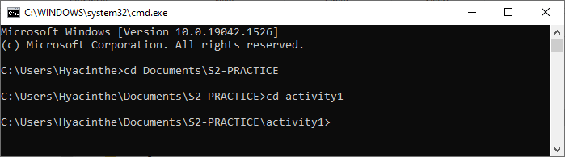
2. Execute the PHP file on terminal:  
   ***What kind of file is the output?***
3. Launch Server: *> php -S ip:port* (explained in the pdf document)
4. The server is now waiting for clients to connect. Look at the logs in terminal  
   ***What do you see when a client tries to get a file?***

The clients:

1. In browser, visit *http://ip:port/index.php****Which IP address and which port? Why?***  
     
     
     
   ***What happens if you use the wrong IP address? The wrong port?***
2. Look at the HTML in the Inspector in Chrome  
   ***What do you see in the Elements tab? Compare with the output that the server get when executing the PHP file (server step 2.)***

# ACTIVITY 2

* *Student 2 is the server*
* *Students 1 and 3 are the clients*

The server:

1. Go in directory of the activity 2
2. Launch Server: *> php -S ip:port*
3. Look at the logs in terminal  
   ***When a client tries to get a file, can you see the requested file and the HTTP status code of the response (***[***https://www.w3schools.com/tags/ref_httpmessages.asp***](https://www.w3schools.com/tags/ref_httpmessages.asp) ***)?***

The clients:

1. In browser open the Network tab and visit *http://ip:port/index.php****What do you see? (You must refresh the page)***
2. Try to visit   
   *http://ip:port/js/main.js*  
   *http://ip:port/css/main.css  
   http://ip:port/images/PHP-logo.png*  
   ***Can you access all the files from the server? What is the HTTP status of the response (***[***https://www.w3schools.com/tags/ref_httpmessages.asp***](https://www.w3schools.com/tags/ref_httpmessages.asp)***)?***
3. Try to visit *http://ip:port****Which file is returned by default if the path in the URL is empty?***
4. Try to visit *http://ip:port/images/bg.png*  
     
   ***Can you access this file? What is the HTTP status of the response?***

# ACTIVITY 3

* *Student 3 is the server*
* *Students 1 and 2 are the clients*

The server:

* 1. Go in directory of the activity 3
  2. Find the 2 passwords in the code that the clients should not be able to see for the security of the website
  3. Launch Server: *> php -S ip:port*
  4. Look at the logs in terminal  
     *What do you see when a client tries to get a file?*

The clients:

1. In browser visit *http://ip:port/home.php***Try to find the 2 passwords hidden in the website!**Can you see the PHP code? The JavaScript code?

# ACTIVITY 4

* *Student 1 is the server*
* *Students 2 and 3 are the clients*

The server:

1. Go in directory of the activity 4
2. Launch Server: *> php -S ip:port*
3. Look at the logs in terminal

The clients:

In browser open the Network tab and visit *http://ip:port/index.php*

***Look at the index.php code, find the 4 functions used to display some text and complete this table:***

|  |  |  |  |
| --- | --- | --- | --- |
| **CODE** | **LANGUAGE**  (PHP or JS) | **WHERE IT IS EXECUTED**  (CLIENT or SERVER) | **WHERE IT IS DISPLAYED?**   * BROWSER * CLIENT CONSOLE * SERVER CONSOLE |
| echo |  |  |  |
| error_log |  |  |  |
| console.log |  |  |  |
| element.textContent |  |  |  |

# ACTIVITY 5

* *Student 2 is the server*
* *Students 1 and 3 are the clients*

The server launches 2 servers in 2 terminals with different port numbers:

* Terminal 1 in folder server1:   
  *> cd server1*  
  *> php -S ip:8000*
* Terminal 2 in folder server2:  
  *> cd server2*  
  *> php -S ip:8888*
* One client goes to http://<ip>:8000
* The other client visits http://<ip>:8888

***Explain how the clients can access 2 different web services hosted on the same computer***