# C2- S1 - HOMEWORK

1 - Write the code to create (instantiate) an object Employee "**ronan**”, from "**paris**", with **0 year** in the company

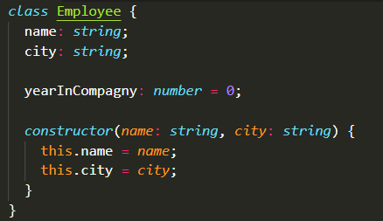

**Answer:**

|  |
| --- |
| let newEmployee = new Employee(“ronan”, “paris”); |

2- Write the code to create (instanciate) an object Employee "sovanda" , from "chacago ", with 3 yeasr in the compagny



**Answer:**

|  |
| --- |
| Let newEmployee = new Employee(“Sovanda”, “Chicago”);  newEmployee.yearInCompany = 3;­­­­­ |

3- What will this code display?

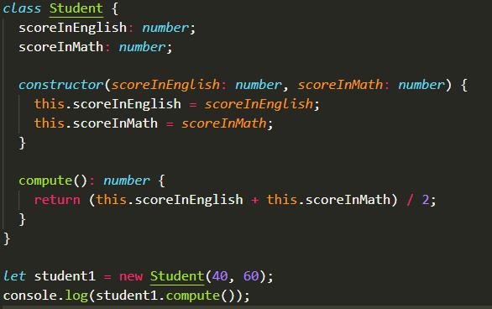

Answer:

|  |
| --- |
| 50 |

4. Create constructor(width,height) of the class Box and implement function getArea and getPerimeter

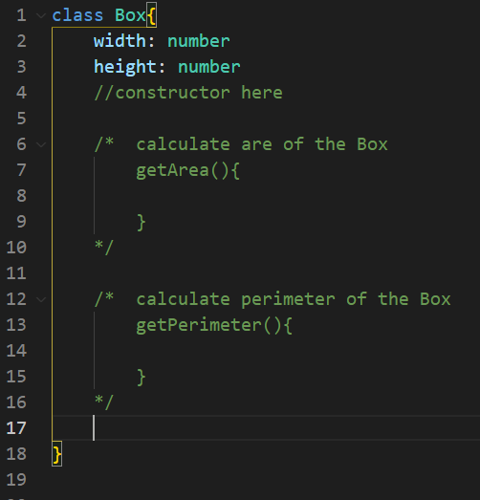

* Create constructor

|  |
| --- |
| constructor(width:number, height:number){  this.width= width;  this.height = height;  } |

* getArea function

|  |
| --- |
| getArea(){  (this.widht+this.height)*2  } |

* getPerimeter function

|  |
| --- |
| getPerimeter(){  this.widht*this.height  } |

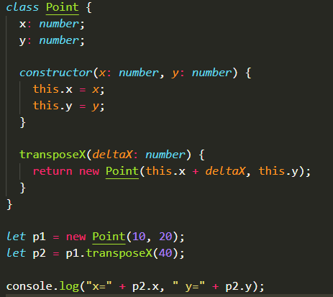5- What will be printed on console after this code execution?

**Answer:**

|  |
| --- |
| x=50 y=20 |