# C5- S4 – PRACTICE



 Your project must include a tsconfig.json file and build JS files in /dist folder

 Each class must be in a separate file *(example: Rectangle.ts)*

 You also need to create a Main.ts file to test all your shapes

A vehicle is defined with a weight and a plateID:

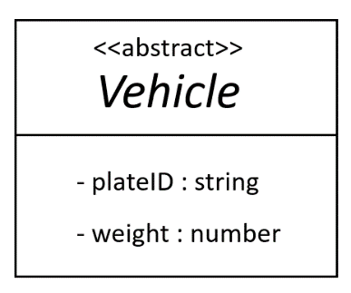

Some vehicles have also some specific properties:

* BatMobile
  + isBatmanHere true if Batman is inside the batMobile
* MiniVan
  + numberCustomers the number of passengers
  + numberLuggage the number of luggage
* TucTuc
  + numberCustomers the number of passengers

**Q1** Implement the class Vehicle and its children

* + Provide the methods to set up the objects
  + Test your code on Main.ts

The **speed of vehicle** depends on each specific vehicle, as explained below:

|  |  |
| --- | --- |
|  | SPEED |
| BatMobile | If Batman is in the car, the speed is 500, otherwise the speed is 110 |
| MiniVan | The speed is 130, but   * for each passenger in the van, the speed is decreased by 10 * for each luggage in the van, the speed is decreased by 5 |
| TucTuc | The speed is 130, but   * for each passenger in the tuctuc, the speed is decreased by 5 |

**Q2** Create an abstract method getSpeed() on Vehicle and implement it on each child according to the above explanations

* + Test your code on Main.ts

We define a convoy of vehicle (i.e. a list of vehicle following each other)

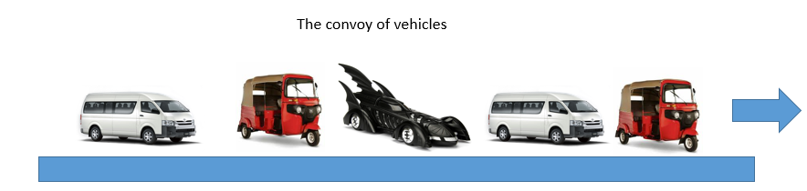

* A **convoy** of vehicles is a list of vehicles moving forward along the road.
* The speed of this convoy is the speed of the **slowest** vehicle of the convoy.

**Q3** Implement the class VehicleConvoy

* + Provide the method to add vehicles
  + Write the following methods :

// return the max speed of the convoy

* + - getMaxSpeed(): number
  + Test your code on Main.ts