**Midterm Exam: Vue.js**

**WEP 2024**

**{2h:00}**

24th May 2024

* All documents allowed during practice time.
  + Search google are forbidden.
  + Artificial Intelligence (AI) are forbidden.
* Chatting and talking to other students are forbidden.

|  |  |
| --- | --- |
| EXERCICES | POINTS |
| THEORY | 20 |
| EXERCICE 1 | 20 |
| EXERCICE 2 | 30 |
| EXERCICE 3 | 30 |
| **TOTAL** | **100** |

* Before proceeding with **exercises 1, 2, and 3**, please ensure you install the necessary dependencies by running **npm install**. After that, you can start the server by executing **npm run serve**."
* Just focus on the Vue.js code; you don't need to write any CSS or HTML

Ex1 20pts. In this exercise, you will engage with render data, v-for, v-bind, v-if and v-else in Vue.js

* We want to list information about teachers.
* Write code to display each teacher's ID, name, and image.
* For student scores, display "Fail" in red for scores below 50 and "Pass" in blue for scores 50 and above.

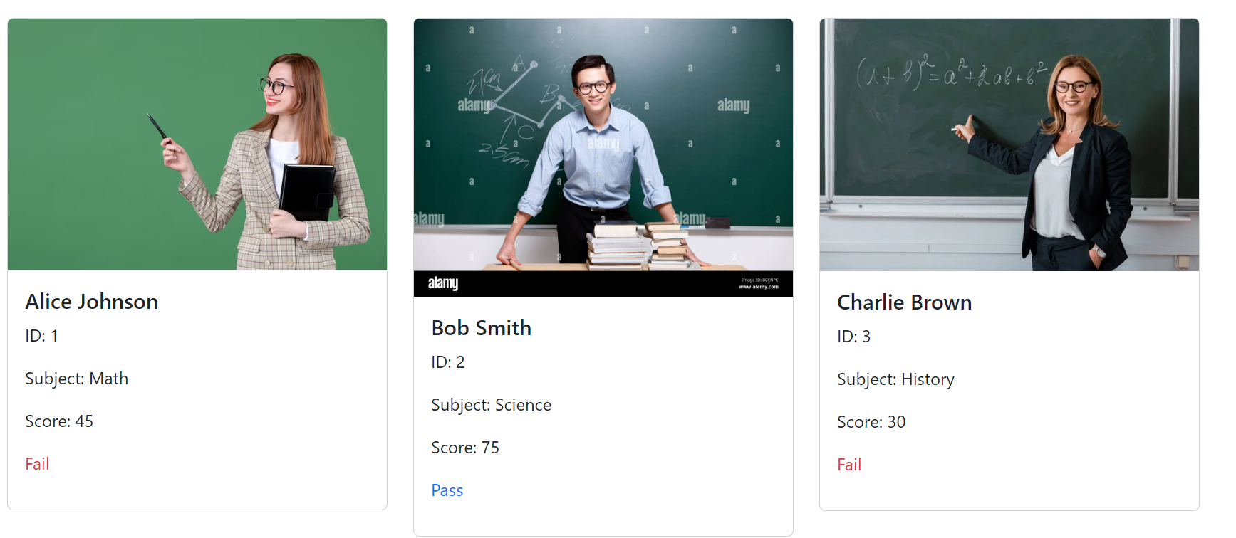

Ex2 30pts: In this exercise, you will engage with v-model and methods in Vue.js

* Please enter two input values.
* When you click the **'Plus' button**, the numbers will be added together.
* When you click the **'Subtract' button**, the numbers will be subtracted.
* When you click the **'Clear' button**, the **result and inputs will be reset.**"

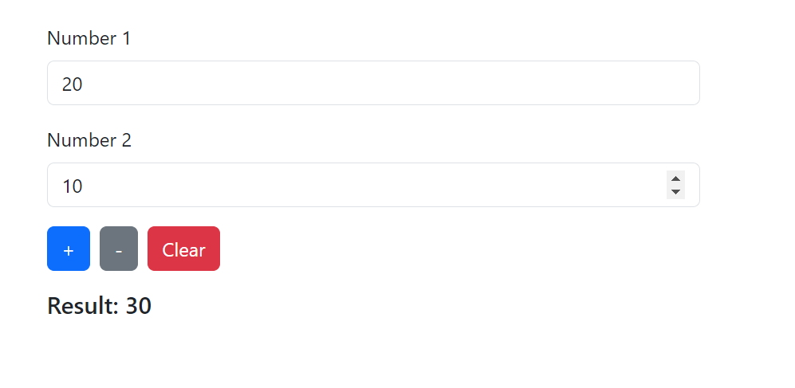

Ex3 30pts: In this exercise, you will engage with v-model and computed in Vue.js

* Please enter your information: name, gender, date of birth, subject, and score.
* Your information will be displayed in the 'Student Information' section.
* The status (Fail or Pass) will be computed, and the color will be displayed in red or blue if the score is below 50."

