**Midterm Exam: Vue.js**

**WEP 2024**

**{3h:00}**

14th Jun 2024

* All documents allowed during practice time.
  + Search google are forbidden.
  + Artificial Intelligence (AI) are forbidden.
* Chatting and talking to other students are forbidden.

|  |  |
| --- | --- |
| EXERCICES | POINTS |
| THEORY | 20 |
| THEORY | 10 |
| EXERCICE 1 | 30 |
| EXERCICE 2 | 40 |
| **TOTAL** | **100** |

* Before proceeding with **exercises 1, and 2**, please ensure you install the necessary dependencies by running **npm install**. After that, you can start the server by executing **npm run serve**."
* Just focus on the Vue.js code; you don't need to write any CSS or HTML

Ex1 30pts. In this exercise, you will engage with **props** and **emits** in Vue.js

* **[Step 1 - 10 points]:** Pass employee data from the List component to the Table component using props.
* **[Step 2 - 10 points]:** Pass data from the Table component back to the List component using events (emits).
* **[Step 3 - 10 points]:** Pass the selected employee data from the List component to the Card component using props.
* Display a list of employees with their information.
* Show detailed information of each employee when the “Detail” button is clicked.

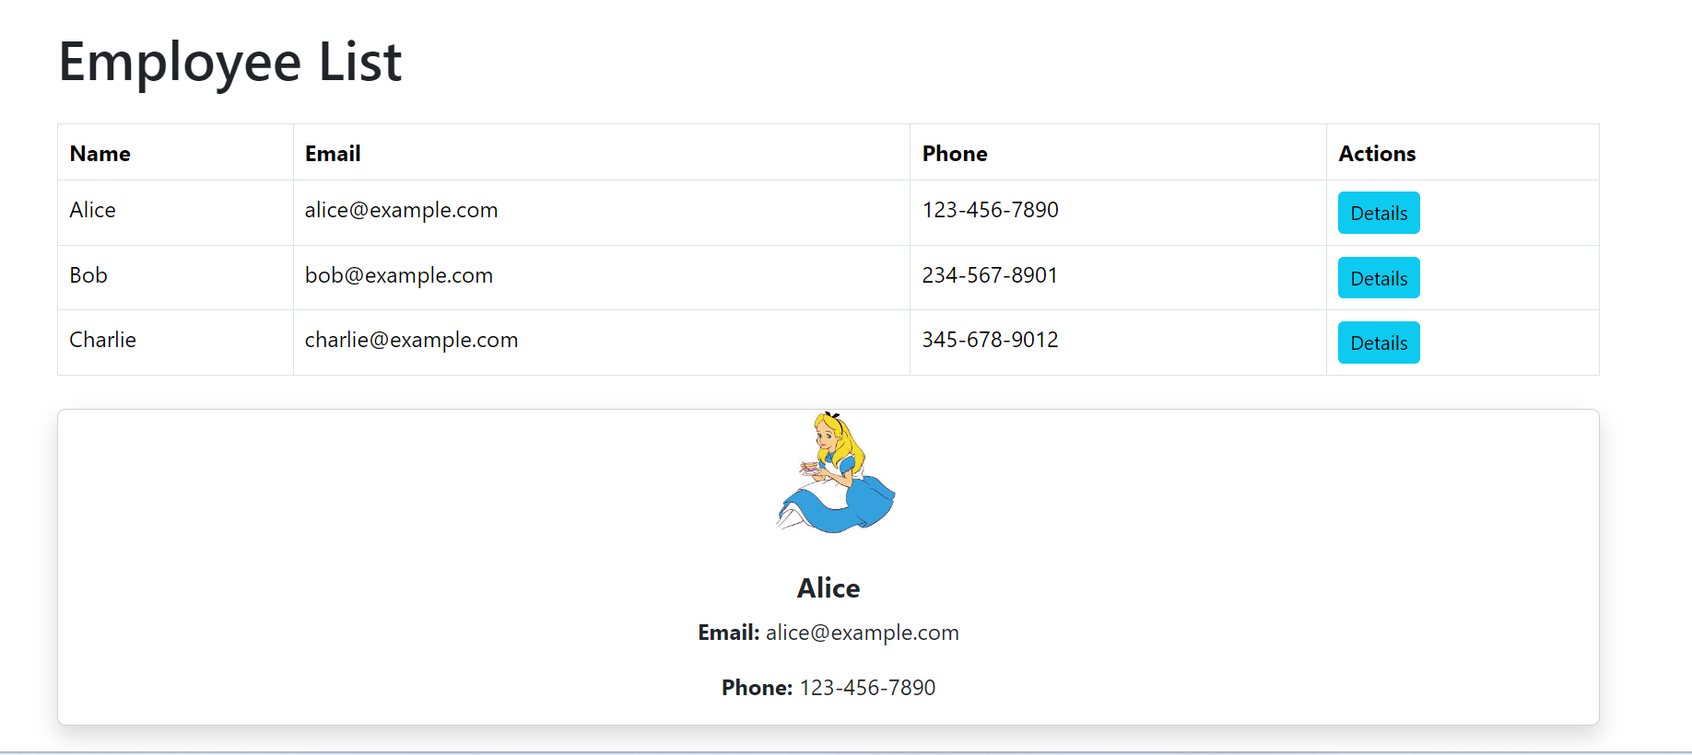

Ex2 40pts. In this exercise, you will engage with **v-for, method…**in Vue.js

* **[10 points]:** Display a list of users.

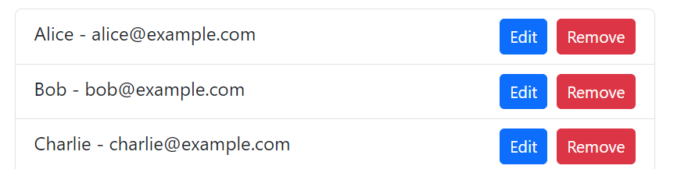

* **[10 points]:** Add a new user to the list.



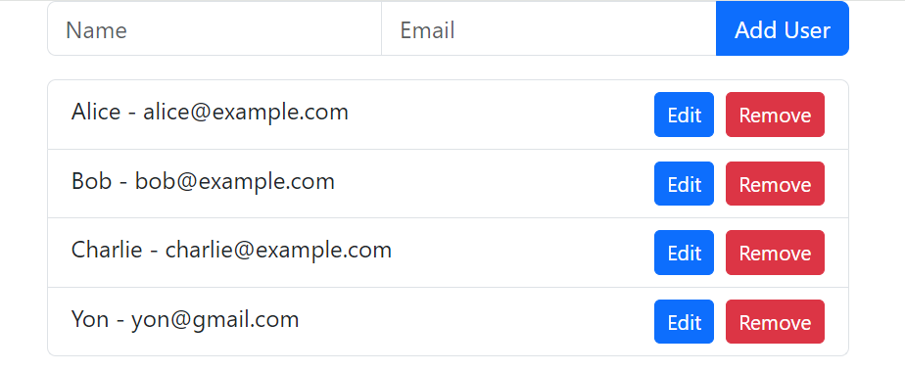

* **[10 points]:** Update user information by clicking the “Edit” button, making changes, and then clicking “Save”.

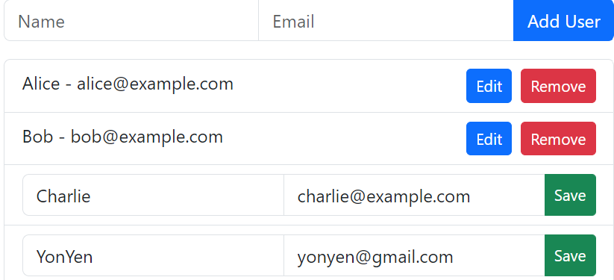

* **[10 points]:** Delete a user by clicking the “Remove” button.

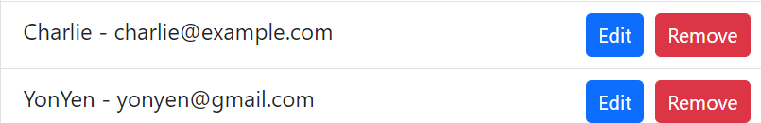

Good Luck!